Fatima bibi
Componet 2
PROFESSIONAL DEVELOPMENT IN HEALTH AND SOCIAL CARE.
Lchs4009_BIRM

Professional Development within Health and Social Care (LCHS4009_BIRM)

Professional Development within Health and Social Care (LCHS4009_BIRM)

Professional Development within Health and Social Care (LCHS4009_BIRM)

Task 1 of 4

Create a two-page professional CV that highlights your education, achievements, work and voluntary experience, key skills, interests and hobbies, and reference details. Your CV should be tailored to your chosen job role within the health and social care sector and presented in a clear and professional format.
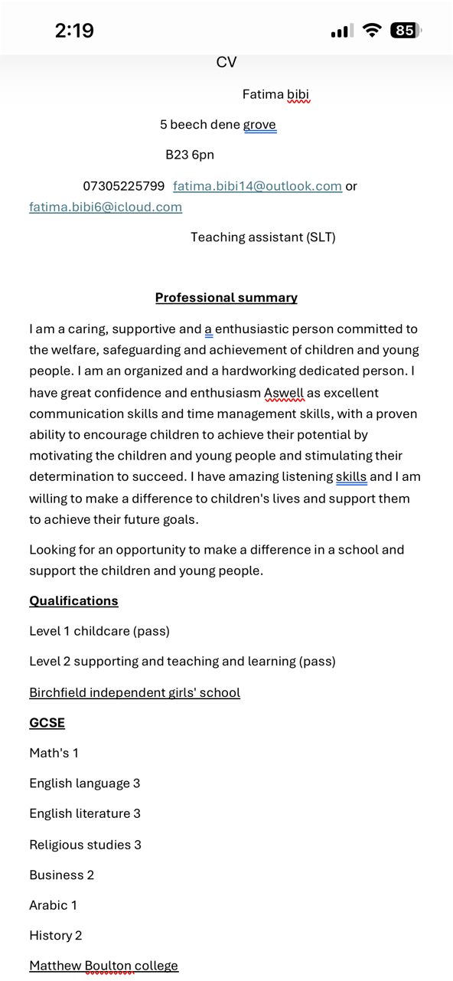
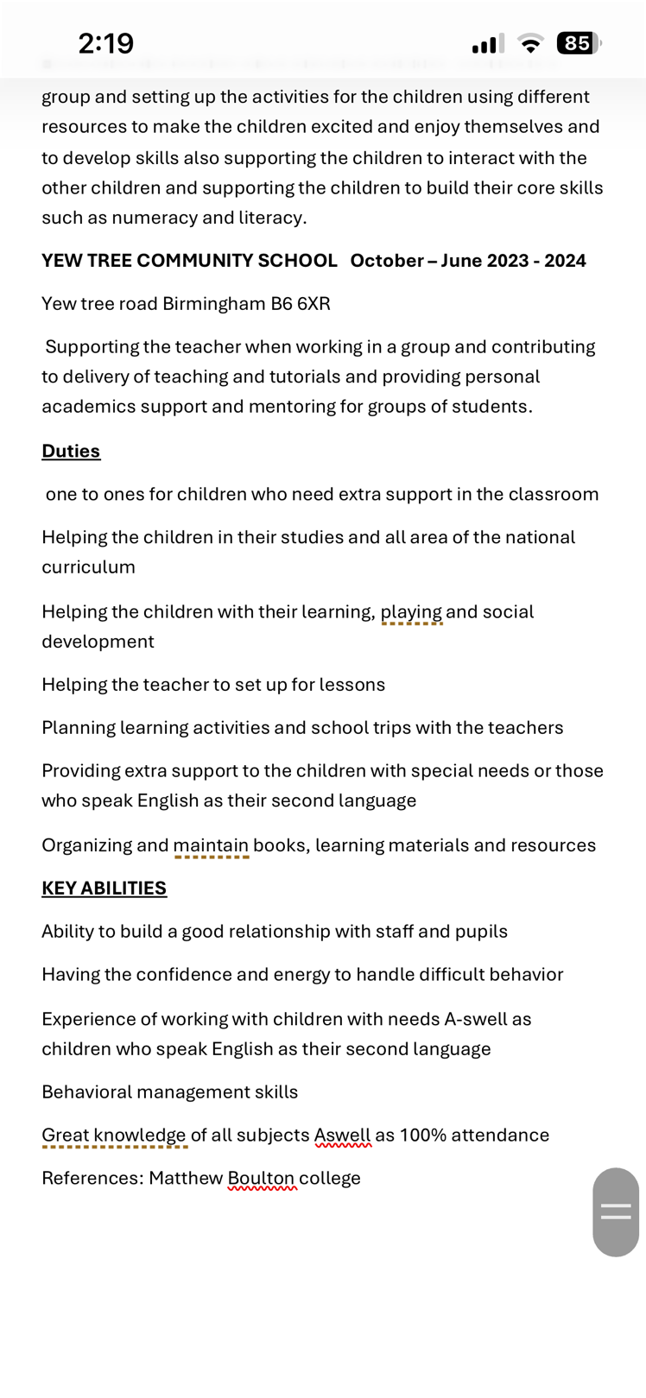
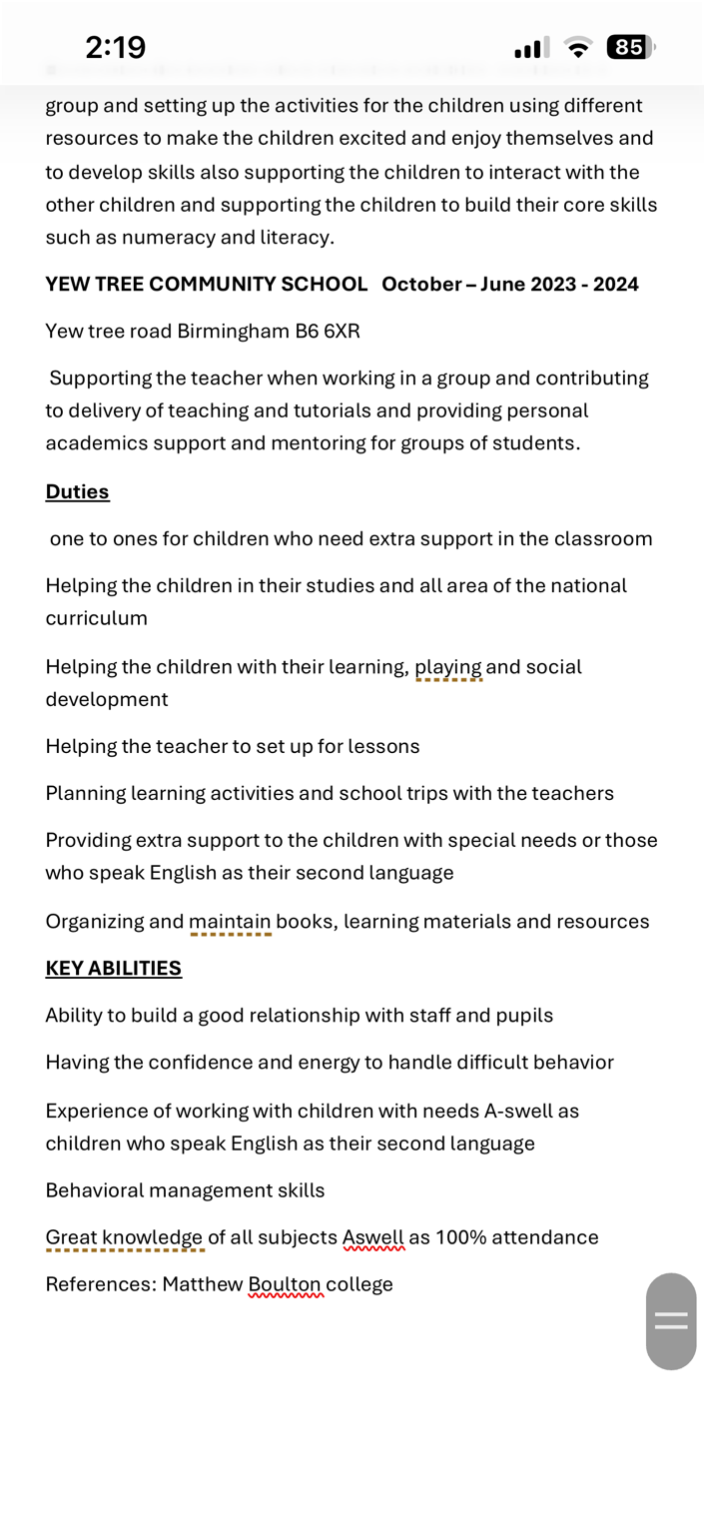
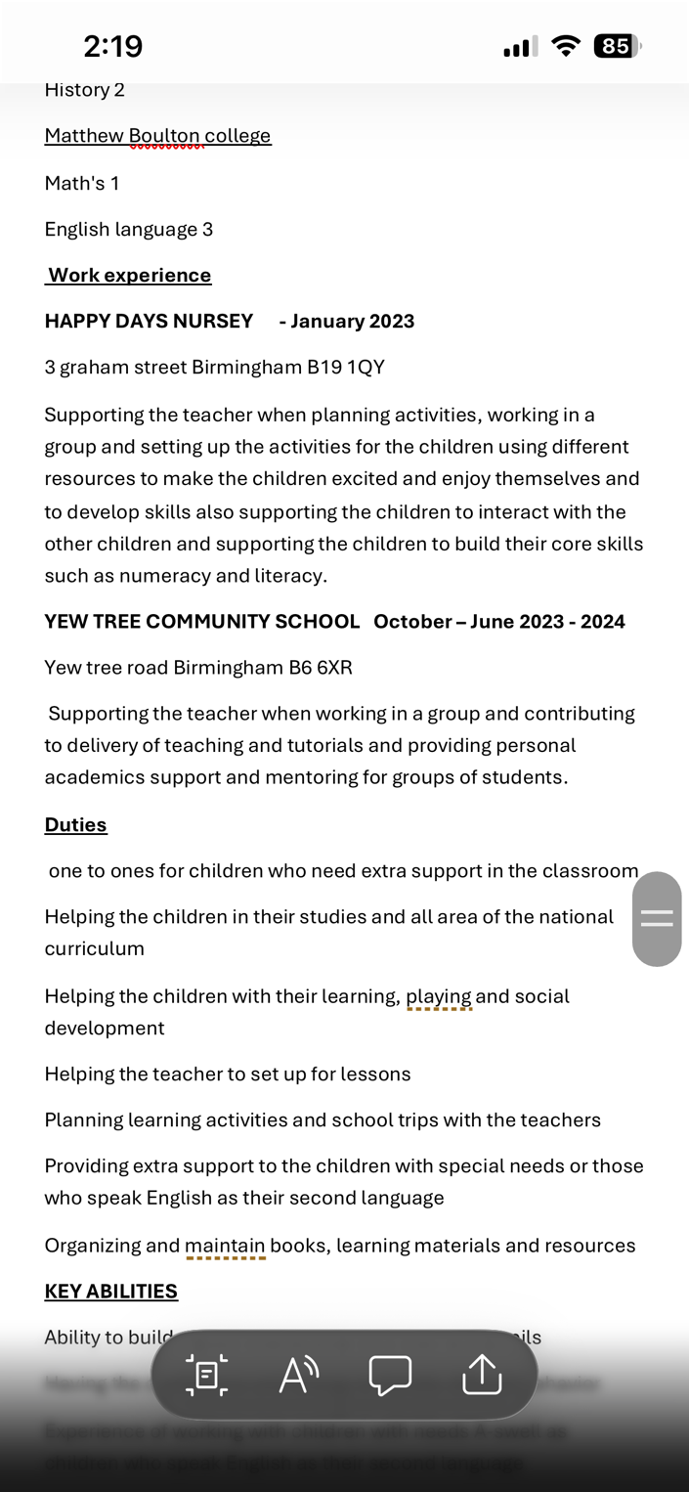

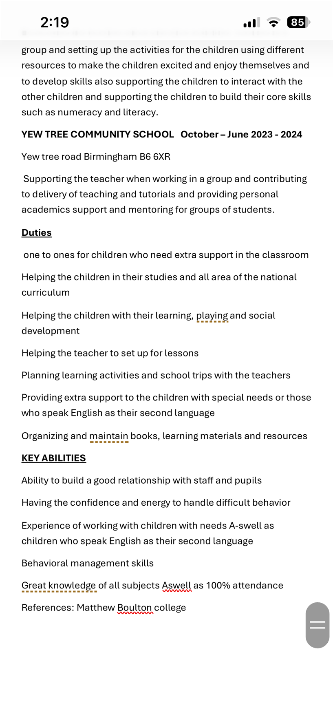
Task 2 of 4

Draft a 500-word personal statement to apply for your chosen job role, outlining your main career aims and experience. Include points about your education, personal strengths and professional skills and why these would be of value to an employer.

Word count: ~500

My drive to become a social worker comes from a deep wish to stand beside people when they’re struggling, help them find their strength, and make sure no one faces hardship alone. I’ve always cared about fairness and seeing people treated with dignity, and this career feels like the right way to turn those values into real, daily help for those who need it most.

I earned my degree in Social Work from [University Name], where I learned the law, ethics, and practical knowledge that sit at the heart of the job. My studies covered safeguarding, child and adult mental health, family support, and how poverty or inequality can shape people’s lives. I learned how to look at complex situations clearly, weigh up risks, and base decisions on what will truly help. I also spent 70 days on placement with a local children’s services team. There, I joined social workers on home visits, helped write assessments, sat in on family meetings, and saw first‑hand how to build trust with people who might be angry, scared, or let down by the system. I learned to listen well, stay calm under pressure, and stick to the rules that keep people safe.

Before university, I worked two years as a support worker at a local community hub. I helped young people and families sort out housing, benefits, and mental health support. This role taught me to speak clearly and kindly, to stand up for people who struggle to be heard, and to work hand‑in‑hand with teachers, nurses, and housing officers—because no one person can fix everything alone.

I bring empathy that doesn’t waver, even in tough moments; resilience to keep going when cases are hard; and respect for every person’s background, culture, and choices. I’m organised, good at keeping detailed notes and meeting deadlines, and I can explain difficult ideas simply so people understand their rights and options. I write clear, honest reports and speak up confidently in meetings. I’m ready to learn every day and fully committed to the ASYE year to sharpen my skills.

For your team, I offer a steady, reliable approach: I build relationships fast, spot risks early, and work with families rather than doing things to them. I follow the BASW Code of Ethics fully, protect privacy, and put people’s safety and rights first.

In the long run, I want to grow into an experienced social worker who steps in early to stop problems getting worse—especially with children and families. I’m eager to bring my heart, my skills, and my strong work ethic to your service and make a real difference to the people you support.
---

This version keeps it natural, direct, and human￼sounding—no stiff or over￼formatted phrasing. You can still drop in your university name, placement details, or specific experience to make it yours.

Task 3 of 4

- Complete a SWOT analysis that identifies your personal strengths, weaknesses, opportunities, and threats in relation to your chosen health and social care job role

b) Develop a Personal Development Plan (PDP) outlining at least three clear and achievable goals that will help you prepare for and progress within this specific role. Describe how you will develop these areas over the next two years and how you will monitor and evaluate your progress.

Strengths | Weaknesses
. Strong empathy and active listening skills, able to build trust with people from all backgrounds quickly even in difficult situations  . Soild knowledge of social worker law  safeguarding procedures and ethical practice from my degree and placements  . Comfortable working as part of a team, communicating well with other professionals like health visitors, teachers, and housing officers | • Sometimes spend too much time checking details to get things right, which can slow down report writing  Still learning how to manage my own stress when dealing with upsetting or heavy cases  Need more practice explaining complex legal points simply to service users who don’t know the system well
Opportunities | Threats
Local authority runs regular courses on mental health, child protection and working with specific groups like refugees or care leavers  Chance to shadow experienced social workers and learn from their practice  Birmingham has lots of community projects and specialist teams I can work with to broaden my experience | Risk of burnout if I don’t keep building good self‑care habits  High caseloads and tight deadlines in some teams, which can make it hard to give every family all the time they need  Emotional toll of seeing people face really hard situations, which can affect long‑term motivation if not managed
Personal SWOT analysis

Personal Development Plan Template
Goals | List the actions to complete to achieve the goal | Support/resources needed | Target date | Review date
1. Build confident formal communication & accurate, timely report writing | • Attend in‑house training on social work report writing and case conference skills  • Ask supervisor to review all draft reports and give specific feedback  • Start presenting small updates in team meetings, then move to larger case conferences  • Use a checklist to ensure reports cover all legal and safeguarding points clearly | • Line manager / supervisor  • Local authority training courses  • Sample report templates & practice guidelines  • Peer feedback from colleagues | End of Month 12 | Every 6 months (Month 6, 12, 18, 24)
2. Develop strong stress management & self￼care to prevent burnout | • Establish clear work‑life boundaries: fixed finish times, full breaks  • Join a social work peer support group to share challenges  • Attend resilience/trauma‑awareness training  • Keep a simple reflective journal to process difficult cases | • ASYE programmed & supervision sessions  • Trust/wellbeing resources  • Approved self‑care workshops  • Time for reflection in weekly schedule | End of Month 12 | Every 3 months initially; 6￼month reviews after that
3. Deepen safeguarding expertise & multi￼agency working skills | • Complete advanced child/adult safeguarding training  • Shadow experienced colleagues in inter‑agency meetings  • Build contacts with health, education & housing teams  • Learn to apply latest legislation & local procedures confidentl | • Safeguarding leads & team mentors  • Multi‑agency training events  • Case study materials & policy documents  • Shadowing opportunities | End of Month 24 | Every 6 months; formal progress check at 12 & 24 months

Task 4 of 4

Using an appropriate reflective model (Gibbs model), write a 600-word critical reflection on your LCHS4009 Component 1 presentation assessment. Your reflection should explore your thoughts, feelings, performance, and areas for improvement, incorporating verbal feedback received from your lecturer to support your analysis.

I chose Working in Teams as my topic because I know social work is never done alone. My presentation explained how we build trust, share roles, handle disagreements, and work well with other professionals—like nurses, teachers, and housing officers. I made clear slides, added real examples, and practised to keep it to 15 minutes. On the day, I covered all the main points and finished on time. The lecturer said my examples were very strong and showed I understood how teams really work; but I tended to speak too fast and didn’t look up from my notes as much as I should have. I also didn’t leave much space to talk about what I personally bring to a team.

Feelings

I felt nervous but also keen to show what I’d learned. Standing up, my hands shook a little and I worried I’d mix up my points or lose the thread. Once I started, I found my flow, but the rush stayed with me. When I finished, I was glad it was over, but also annoyed at myself for not connecting more with the room. Hearing the feedback was a relief—they liked my content—but I also felt determined to do better next time.

Evaluation

Good bits: I explained ideas simply and used real‑life stories that made teamwork feel real. My slides were easy to read and I stuck exactly to time. The lecturer said I showed real insight into how different roles fit together.
Not so good: I rushed through sections because of nerves, which made some parts hard to follow. I read from my script instead of talking with the audience. I focused on “teams” in general but didn’t say enough about my own place in a team—my strengths, my style, or where I fit best.

Analysis

Gibbs’ model helps me see why this happened. I relied too much on writing everything down because I was scared I’d forget; that made me hide behind my paper. The feedback about pace and eye contact hits home: in teamwork, just like in presenting, how you connect is half the job. If I can’t engage people here, how will I lead meetings or stand beside families in tough moments? The lecturer’s note about my own role shows I understand the theory, but I need to live it and speak from my experience, not just the books.

Conclusion

Overall, it was a solid effort. I got the message across that teamwork is the backbone of good care, and my examples proved I get it. But I also see I held back—from showing my personality, from speaking naturally, and from owning what I can contribute. If I could do it again, I’d swap the full script for cue cards and talk more about times I’ve worked in teams myself.

Action Plan

• Practise out loud, without reading every word, until I feel steady.

• Record myself or present to a friend to fix my speed and look up more.

• For any future work on teamwork, start with my strengths and experiences—how I listen, how I support others, how I resolve small issues.

• Ask for feedback specifically on engagement and personal input, so I can keep growing.

