BLOG ONE:
Is the current Covid-19 Pandemic is having on parents?
Within this weblog, the author plans to explore how the current situation, regarding the Covid-19 pandemic is impacting individuals. The author will be looking into how social status can have an impact on how you and your family cope with the current situation. Through-out the blog the author will be referring to her own personal experiences, through working closely with different parents, children and families within the community in a family centre through a family support worker role.
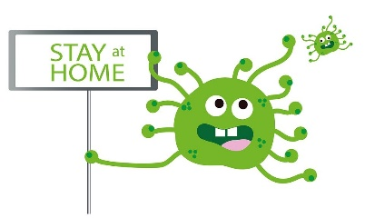
With the government’s Covid-19 current guidelines, everyone has had to alter their day-to-day life to abide by the rules. According to Gov:UK (2020), everyone is required to stay at home, unless they are a key worker. The only time individuals should be leaving their homes is to get food shopping, health reasons (required appointments, daily exercise) and necessary work (if you cannot work from home) (NHS.UK, 2020). This has had a major impact on everyone around the world. This pandemic has forced the closure of schools and businesses, whilst stopping socialisation with anyone who is not in your household. This is ultimately going to have an impact on an individual, whether that be financial, emotionally or mentally.
(Pixabay, 2020)

Is it easier to have resilience if you are of higher social class?
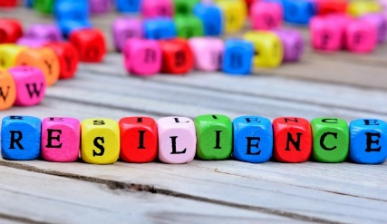
According to the Cambridge University Press (2020), resilience refers to having the capability to survive and recover quickly from difficulties or toughness. Resilience is an importance skill to have in the tough and uncertain times the world is facing. Mind (2020), states that resilience is something that everyone can achieve, and will benefit from. Having the ability to adapt and change to accommodate an individual’s surrounding environment, is key. Is this easier for those of a higher social class to maintain during a pandemic?
(Community Care, 2020)
The author has recognised that individuals from different social class backgrounds are coping with the current Covid-10 pandemic differently. It has been identified through work carried out, that those from a higher-class background have found it easier to adapt, as most of these individuals are able to work from home and continue to earn a wage. Whereas, many of individuals from a lower-class background, are now unable to work and earn money. This means that they are unable to provide food and basic resources such as electric for their family.
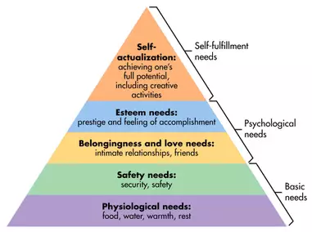

It was Maslow who stated that an individual has five main human needs, which came together to form the ‘Maslow’s Hierarchy of Needs’ (Mooney, 2013). As you can see in the picture, the first two stages of the pyramid are referred to as human’s basic needs: physiological and safety.
(Weiss, 2013)
It is vital to ensure that everyone’s basic needs are covered, in every circumstance. However, the current Covid-10 pandemic, can be seen to be hindering an individual’s ability to do so. This is where organisations such as family centres and food banks can help (Revie, 2020). The author can ensure that individuals who use the family centres basic needs are being met. This may be through food bank referrals food parcels, craft packages or mental health support through the internet. It has been observed that many individuals feel as though they should get priority over others, as they are of higher class. This can be linked right back to the Victorian era, where the poor were split into two categories: the deserving and undeserving poor (Bridges, 2020). Could this suggest that the world is going backwards? We are now stating that there are individuals more deserving than others? If so, what happens to equality.

Mental health issues on the rise…
(McLeod,2020)
It has been identified that further research must be carried out, into identifying the impact the Covid-19 pandemic is having/will have on an individual’s mental health and well-being (Davis. 2020). NHS (No Date), states that every individual live differently, however at least one in four will experience mental health problems. The author has identified an increase in the amount of service users and non-service users reaching out to get help and support regarding their mental health and well-being over social media. Could this be a positive thing?

To Conclude…
Through-out this weblog, there have been several key issues discussed when referring to how the current world pandemic has impacted parents across the world. The author has identified what it means to be resilient, and how this can differ depending on an individual’s social class. Whilst looking into how individuals such as family support worker can help ensure that everyone’s basic needs are being met, abiding by Maslow’s Hierarchy of needs. The current rise in mental health and well-being issues have been discussed, whilst exploring reasoning behind the increased use of food banks. It is evident that the world has been impacted as a result of this pandemic, the author feels as though there should be more help and support for parents and families during this difficult time.

References:
Bridges, K,M. (2017). The Deserving Poor, The Underserving Poor, and Class-Based Affirmative Action. [WWW] Available at: https://law.emory.edu/elj/_documents/volumes/66/5/bridges.pdf. (Accessed 24th April 2020).
Cambridge University Press., (2020). Resilience. [WWW] Available at: https://dictionary.cambridge.org/dictionary/english/resilience. (Accessed 23rd April 2020).
Davis, N., (2020). Urgent Studies Needed into Mental Health Impact of Coronavirus. [WWW] Available at: https://www.theguardian.com/world/2020/apr/15/urgent-studies-needed-mental-health-coronavirus-lockdown. (Accessed 24th April 2020).
Gov.Uk., (2020). Coronavirus (COVID-19): what you need to do. [WWW] Available at: https://www.gov.uk/coronavirus?gclid=EAIaIQobChMI7qH2oN6A6QIVhLHtCh31EwVWEAAYASAAEgL5tvD_BwE. (Accessed 22nd April 2020).
Mind., (2020). How to Manage Stress. [WWW] Available at: https://www.mind.org.uk/information-support/types-of-mental-health-problems/stress/developing-resilience/. (Accessed 23rd April 2020).
Mooney, C.G. 2013. Theories of Childhood, Second Edition. Redleaf Press.
NHS., (No Date). Possible Causes of Poor Mental Health. [WWW] Available at: https://www.nhs.uk/oneyou/every-mind-matters/possible-causes/. (Accessed 24th April 2020).
NHS.UK., (2020). Staying at home and away from other people (Social Distancing). [WWW] Available at: https://www.nhs.uk/conditions/coronavirus-covid-19/staying-at-home-to-avoid-getting-coronavirus/staying-at-home-and-away-from-other-people/. (Accessed 22nd April 2020).
Revie, E., (2020). Coronavirus has forced thousands to visit food banks in recent weeks. [WWW] Available at: https://www.independent.co.uk/voices/coronavirus-food-banks-help-the-hungry-trussell-trust-a9432501.html. (Accessed 24th April 2020).
Images:
McLeod, S., (2020). Maslow’s Hierarchy of Needs. [WWW] Available at: https://www.simplypsychology.org/maslow.html. (Accessed 24th April 2020).
Community Care., (2020). How to support your emotional resilience and wellbeing during the pandemic. [WWW] Available at:
https://www.communitycare.co.uk/2020/04/09/support-emotional-resilience-wellbeing-pandemic/. (Accessed 24th April 2020).

Pixabay., (2020). Stay At Home. [WWW] Available at: https://pixabay.com/illustrations/stay-home-stay-at-home-corona-5003067/. (Accessed 24th April 2020).
Weiss, M,D., (2013). The 4 Decisions Every Leader Makes. [WWW] Available at: https://www.credit.com/blog/the-4-decisions-every-lender-makes-71676/. (Accessed 24th April 2020).
Bibliography:
BBC News., (2020). Coronavirus: Foodbank Pressure ‘Mounting Daily). [WWW] Available at: https://www.bbc.co.uk/news/uk-wales-52050396. (Accessed 23rd April 2020).
Girouard, M., (1992). Victorian Values and the Upper Class. [WWW] Available at: https://www.thebritishacademy.ac.uk/sites/default/files/78p049.pdf. (Accessed 24th April 2020).
Mental Health UK., (2020). Managing your mental health during the Coronavirus outbreak. [WWW] Available at: https://mentalhealth-uk.org/help-and-information/covid-19-and-your-mental-health/ (Accessed 23rd April 2020).
Rethink Mental Illness., (2020). Managing your mental health during the Coronavirus outbreak. [WWW] Available at: https://www.rethink.org/news-and-stories/blogs/2020/03/managing-your-mental-health-during-the-coronavirus-outbreak/?gclid=EAIaIQobChMIrvvZyrSI6QIVBLp3Ch0XCw5dEAAYASAAEgKRx_D_BwE (Accessed 23rd April 2020).
The Trussell Trust., (2020). If you’re able to help. [WWW] Available at: https://www.trusselltrust.org/coronavirus-food-banks/get-involved/ (Accessed 23rd April 2020).

BLOG TWO:
Has the current lockdown situation impacted on a child’s right to play?
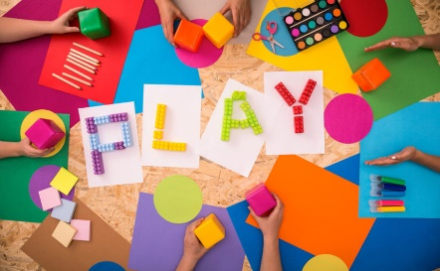
Play can be defined in many ways, Play Therapy United Kingdom (2017), states that play can be described as a leisure activity, whether that be physical or mental. Play should be undertaken purely for a child’s amusement or enjoyment, there should not be any other objective. According to Pathways (2020), play is one of the core aspects of childhood and is key for healthy development. It can be referred to “any spontaneous or organised activity that provides enjoyment, entertainment, amusement or diversion”. There are two different types of play, structured and unstructured, both having different objectives and structures.
(Learn and Grow Academy, No Date)
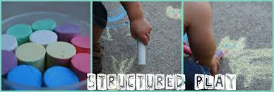
Structured Play refers to activities that are planned and adult led, ensuring that there is a clear concept to the activity (Playgroup SA, 2020). Wang and Aamodt (2012), refers to play being a fundamental aspect of the development of the brain. Structured play typically refers to a physical or cognitive activity, which has the sole purpose of furthering a child’s development (Playgroup SA, 2020).
(Structured Play, 2011)
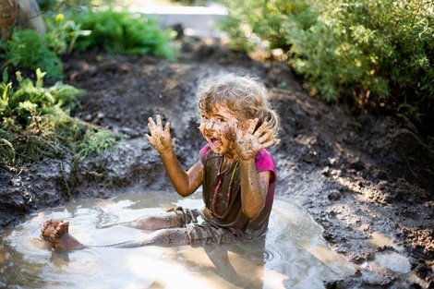
Unstructured play or free play (Playgroup SA, 2020), is a form of play that is child led, referring to creative or open free play which has no limits. It provides children with experiences in decision making, creativity and imagination, whilst developing their overall emotional and social skills (Play Therapy United Kingdom, 2017). This freedom of choice allows a child to grow and develop as their own individual without having influences from others.
(Plesco, 2017)

The origin of the right to play…
The concept that children had rights, first emerged in 1924, in which the ‘Declaration of the Rights of the Child’ were created, informing the United Nations Convention on the Rights of the Child (UNCRC) (Unicef, No Date). The UNCRC set out 54 articles of which cover all aspects of a child’s life, whether that be emotional well-being, education or socialisation rights. These articles provide every professional involved in a child’s life with rules and guidelines they must follow when working with a child to ensure the child’s best interest are put first (Unicef, No Date). Each article represents a different right that children should have (Children’s Commissioner for Wales, 2020). Article 31, refers to a child/young person’s right to play, it states that every child has the right to rest, leisure and play, and that everyone involved in a child’s life should respect and promote this right (Children’s Commissioner for Wales, 2020). In 2000, the Welsh Government created a framework for partnership for children and young people, which led on to the development of the Welsh Government’s 7 Core Aims (Hutt and Davidson, No Date). These seven core aims can be seen in the diagram below (Play Wales, 2020):

The fourth core aim is to ensure children ‘have access to play, leisure, sporting and cultural activities (Hutt and Davidson, No Date). This demonstrates the importance professionals feel that play has on a child’s growth and development (Barrance, No Date, p.p. 52-53).

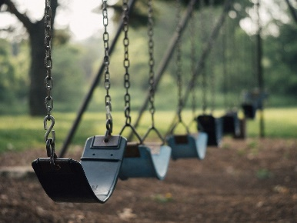
Current lockdown…
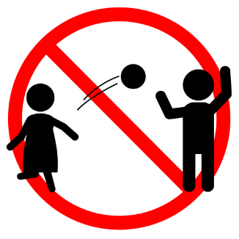
The current government guidance is that everyone should remain inside unless they are going to work, getting their food shop or participating in their daily exercise (Gov:UK, 2020). This means that children can no longer attend school, play outside (other than in their own gardens) or play with their friends. It would seem as though a child’s right to play is being limited with the current world pandemic. These current guidelines/restrictions are making it nearly impossible for parents/guardians to ensure that their child’s right to play is being met. Parents and Professionals should work together to do everything they can to ensure that their children are not deprived their right to play (Brown, 2013), after all it is their right. If a child is from a deprived area, they may not have access to a safe outside area which abides by the government rules, this means that they do not have the luxury of having a garden to play in, resulting in them being confined in the house (Playing Out, 2020). These ‘lockdown’ measures have been in place since the 23rd of March 2020 (Davies and Diver, 2020). Meaning that children have not been able to play outside, see their family or socialise with friends for over four weeks, and it does not seem to be being lifted any time soon (Knapton, 2020). According to Hedgecoe (2020), the Spanish PM promises to ease the confinement of children in Spain, in order to allow the children to ‘get some fresh air’. Could this be the first step towards allowing children to have free will over playing outside again?
(Global Toy News, No Date)
(Pixabay, No Date)

To conclude…
The author feels that the current lockdown situation will be having a negative impact on a child’s right to play, as children are being restricted as to where they can and cannot play or do. It appears the government are not fully considering the impact the current situation is having on the children of the world. The aspect of play is adapting though-out the years, and is changing as and when society changes, with aspects such as parents fears, media culture and social media having an impact on what is defined as play (Palmer, 2006, p.p.48). The authors feel’s that children should have the opportunity to play for play sake. Not every play opportunity should have a lesson to be learnt or growth and development to occur. After all, they are just children!

References:
Barrance, R., (No Date). The Human Rights of Children in Wales: An Evidence Review. [WWW] Available at: https://www.childcomwales.org.uk/wp-content/uploads/2018/10/The-Human-Rights-of-Children-in-Wales.pdf. (Accessed 25th April 2020).
Brown, F., (2013). Play Deprivation: Impact, Consequences and the potential of Playwork. [WWW] Available at: https://www.playwales.org.uk/eng/playdeprivation. (Accessed 25th April 2020).
Children’s Commissioner for Wales., (2020). United Nations Convention on the Rights of the Child: Full Text. [WWW] Available at: https://www.childcomwales.org.uk/united-nations-convention-on-the-rights-of-the-child-full-text/. (Accessed 25th April 2020).
Davies, G. and Diver, T., (2020). UK Coronavirus Lockdown: What are the rules, and when will it be lifted?. [WWW] Available at: https://www.telegraph.co.uk/news/2020/04/28/uk-lockdown-rules-restrictions-coronavirus/. (Accessed 25th April 2020).
Gov.Uk., (2020). Coronavirus (COVID-19): what you need to do. [WWW] Available at: https://www.gov.uk/coronavirus?gclid=EAIaIQobChMI7qH2oN6A6QIVhLHtCh31EwVWEAAYASAAEgL5tvD_BwE. (Accessed 22nd April 2020).
Hedgecoe, G., (2020). Coronavirus: Spanish PM promises to ease confinement of children. [WWW] Available at: https://www.bbc.co.uk/news/world-europe-52341728. (Accessed 25th April 2020).
Hutt, J., and Davidson, J., (No Date). Children and Young People: Rights To Action. [WWW] Available at: https://www.assembly.wales/Committee%20Documents/HSS(2)-02-04%20Paper%201%20%20Children%20and%20Young%20People%20Rights%20to%20Action-04022004-14558/n0000000000000000000000000016990-English.pdf. (Accessed 25th April 2020).
Knapton, S., (2020). When will the UK lockdown end? The four potential exit strategies. [WWW] Available at: https://www.telegraph.co.uk/news/2020/04/28/lockdown-uk-end-exit-strategy/. (Accessed 25th April 2020).
Palmer, S. (2006) Toxic Childhood. London: Orion
Pathways., (2020). Play. [WWW] Available at: https://pathways.org/topics-of-development/play/. (Accessed 24th April 2020).
Play Therapy United Kingdom., (2017). Definition of Play. [WWW] Available at: https://playtherapy.org.uk/ChildrensEmotionalWellBeing/AboutPlayTherapy/MainPrinciples/PlayDefinition. (Accessed 24th April 2020).
Play Wales., (2020). Play and the seven core aims. [WWW] Available at: https://www.playwales.org.uk/eng/playsevencoreaims. (Accessed 24th April 2020).
Playgroup SA., (2020). Structured Vs Unstructured Play. [WWW] Available at: https://www.playgroupsa.com.au/publications-blog/structured-vs-unstructured-play-226.html. (Accessed 24th April 2020).
Playing Out., (2020). Playing Out and Covid-19. [WWW] Available at: https://playingout.net/play-streets-coronavirus/. (Accessed 25th April 2020).
Unicef., (No Date). History of Child Rights. [WWW] Available at: https://www.unicef.org/child-rights-convention/history-child-rights. (Accessed 25th April 2020).
Wang, S., and Aamodt, S., (2012). Play, Stress and the Learning Brains. [WWW] Available at: https://www.ncbi.nlm.nih.gov/pmc/articles/PMC3574776/. (Accessed 25th April 2020).
Images:
Global Toy News., (No Date). What’s the opposite of Play?. [WWW] Available at: https://www.globaltoynews.com/2015/11/whats-the-opposite-of-play.html. (Accessed 25th April 2020).
https://pixabay.com/photos/swing-playground-swinging-toy-fun-846077/. (Accessed 25th April 2020).
Learn and Grow Academy., (No Date). How Structured Play Benefits Your Preschooler. [WWW] Available at: http://www.learnandgrowacademy.com/how-structured-play-benefits-your-preschooler/. (Accessed 25th April 2020).
Pixabay (No Date) Swing Playground. [WWW] Available at:
Plesco, T., (2017). How Getting Dirty Helps Kids To Be Healthier. [WWW] Available at: https://beautyzoomin.net/getting-dirty-helps-kids-healthier/. (Accessed 25th April 2020).
Structured Play., (2011). Structured Play. [WWW] Available at: http://structuredplay.blogspot.com/2011/08/september-apple-and-farm-theme.html. (Accessed 25th April 2020).

Bibliography:
Children & Young Peoples Commissioner Scotland., (2020). The United Nations Convention on the Rights of the Child. [WWW] Available at: https://cypcs.org.uk/rights/uncrc/full-uncrc/#31(Accessed 23rd April 2020).
Levison-King, R. (2020). Coronavirus: Should you let your children play with other children? https://www.bbc.co.uk/news/world-us-canada-51938537 (Accessed 24th April 2020).
Playful Childhoods,. (2020). Why Play Matters. [WWW] Available at: https://www.playfulchildhoods.wales/Pages/Category/why-play-matters?gclid=EAIaIQobChMIp4mM_f2K6QIViK3tCh0QnAkpEAAYASAAEgIcgvD_BwE (Accessed 23rd April 2020).
Right To Play., (2019). Play Saves Lives. [WWW] Available at: https://www.righttoplay.org.uk/en-uk/ (Accessed 23rd April 2020).
Save The Children., (No Date). You’re your Rights: All Children Have the Same Rights. [WWW] Available at: https://www.savethechildren.org.uk/content/dam/gb/reports/humanitarian/uncrc19-child-friendly.pdf (Accessed 23rd April 2020).
Staufenberg, J. (2020). The Schools Open During Lockdown:‘for some kids, it’s the only safe place’. [WWW] Available at: https://www.theguardian.com/education/2020/apr/14/the-schools-open-during-lockdown-for-some-kids-its-the-only-safe-place (Accessed 24th April 2020).
UNICEF., (No Date). The United Nations Convention on the Rights of the Child. [WWW] Available at: https://downloads.unicef.org.uk/wp-content/uploads/2010/05/UNCRC_united_nations_convention_on_the_rights_of_the_child.pdf?_ga=2.259398794.1092869586.1588021268-1191920052.1547593948 (Accessed 24th April 2020).
Wales Online. (2020). The Devastating Effect of Coronavirus Lockdown on the Mental Health of Children. [WWW] Available at: https://www.walesonline.co.uk/news/news-opinion/devastating-effect-coronavirus-lockdown-mental-17981510 (Accessed 24th April 2020).

BLOG THREE:
Does social media have an impact on a child’s mental health development?

Within this weblog, the author will be exploring the question ‘Does social media have an impact on a child’s mental health development’. Before diving into this topic, the term “social media” must first be explained. According to Cambridge University Press (2020), social media refers to an interaction among people through virtual communities and networks. It is a place where individuals can create, share and exchange information and ideas with their peers, Facebook, Snapchat and Instagram are just a few examples of social media platforms.
(Healthy Industry Hub, 2020)
The author will look at the positive and negative impacts social media can have on a child’s development. Whilst looking at what can be done to ensure that children stay safe and protected whilst using social media.
The use of social media is being normalised at a younger age, according to Ofcom (2019), children as young as 3 years old are being given access to a device that can access the internet and a social media account. Listed below are statistics to show the number of children with an active social media account (Ofcom, 2020);
- 1% of 3-4 Year Olds
- 4% of 5-7 Year Olds
- 18% of 8-11 Year Olds
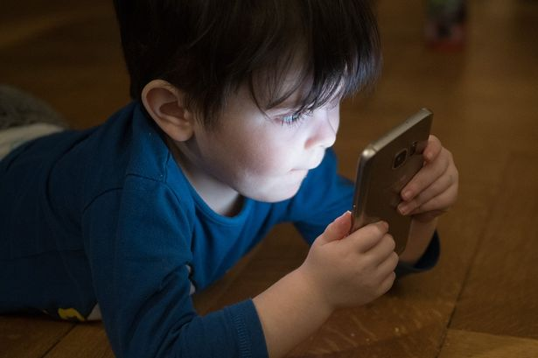
- 69% of 12-15 Year Olds
This is a clear indication that the use of social media is on the rise.
(Otter, 2019)

The positives of social media…
There are many positives individuals can benefit from using social media, one being the ability to form and maintain relationships with families and friends. Listed below are a few other benefits of using social media (Raising Children Networks, 2020);
- Sharing interests
- Exploring identities
- Developing relationships
- Digital media literacy
- Collaborating learning / educative
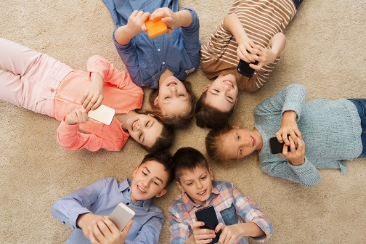
These are just a few of the positive uses of social media, it also allows children to communicate freely, and boost their confidence. One benefits, is that it allows children to reach out for support and help regarding their life, under the right circumstances they can build their mental health and well-being. The use of social media allows children, teenagers and adults to vitally socialise and communicate with others (Raising Children Network, 2020).
(SocialPubli, 2017)

The negatives of social media…
In contrast to this, there are also possible negatives involved with children and young people using social media, these can be seen listed below (Raising Children Network, 2020):
- Being exposed to inappropriate and upsetting content
- Having the ability to upload inappropriate images to the internet – exposing themselves
- Sharing their personal information with strangers
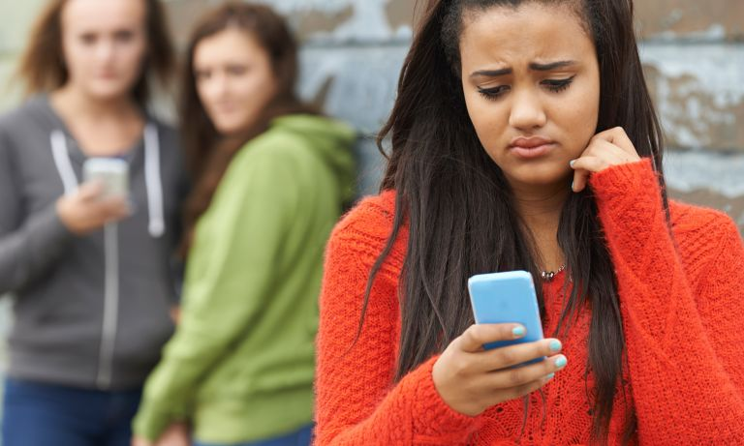
One of the main risk children face when using social media is cyberbullying. Cyberbullying is a form of bullying which uses devices and social media (Stop Bullying, 2019). Cyberbullying will have a negative impacted on a child’s mental health and wellbeing, therefore it is vital to ensure that every precaution is taken to ensure that children and individuals using social media are protected (Raising Children Network, 2020).
(Helpguide, 2019)

How to protect children when using social media…
There are guidelines and rules that can be set out to help protect children when using social media (Young Minds, 2020). These can include, but not limited to (Raising Children Network, 2020);
- Setting limits on when and where a child can use social media
- Ensuring that the privacy settings on the social media platform are activated properly
- Educating children on the importance of social media safety, and how they can ensure that they are safe on the internet
- Set up regular checks to ensure the child is being safe and not exposed to cyberbullying.
The above steps can be taken by parents, carers and professionals working with children and young people to ensure they are being safe on the internet (Young Minds, 2020).

To conclude…
Studies have been carried out into whether social media has an impact on a child’s mental health and well-being, research suggests that it does. However, further studies need to be carried out to get a clear picture on how it impacts an individual’s mental health and well-being (Bekalu,et.al, 2019).
The author feels that if social media is used correctly and appropriately it can have a positive impact on a child’s mental health development.
An example of the power of social media, is the impact it is having on the world today. Currently, the world is facing a pandemic, in which everyone is being isolated from their family and friends to ensure everyone’s safety. Social media and the use of devices has ensured that children and young people can maintain socialising with their friends and family during this difficult time. Individuals are using social media to communicate with others regarding their thoughts, feelings and fears, ensuring that they are receiving adequate support to help maintain a healthy mental health and wellbeing whilst going through this world pandemic. This is a prime example of how social media can benefit the world.

References:
Bekalu, M.A., McCloud, R.F., and Viswanath, K. (2019). Association of Social Media Use With Social Well-Being, Positive Mental Health, and Self-Rated Health: Disentangling Routine Use From Emotional Connection to Use. Health Education & Behavior. 46 (2S), 69S-80S.
Cambridge University Press., (2020). Social Media. [WWW] Available at: https://dictionary.cambridge.org/dictionary/english/social-media. (Accessed 26th April 2020).
Ofcom., (2020). Children and Parents: Media Use and Attitudes Report 2018. [WWW] Available at: https://www.ofcom.org.uk/__data/assets/pdf_file/0024/134907/children-and-parents-media-use-and-attitudes-2018.pdf. (Accessed 25th April).
Raising Children Network., (2020). Social Media Benefits and Risks: Children and Teenagers. [WWW] Available at: https://raisingchildren.net.au/teens/entertainment-technology/digital-life/social-media. (Accessed 25th April 2020).
Stop Bullying., (2019). What is Cyberbullying. [WWW] Available at: https://www.stopbullying.gov/cyberbullying/what-is-it. (Accessed 25th April 2020).
Young Minds., (2020). Social Media and Mental Health. [WWW] Available at: https://youngminds.org.uk/find-help/looking-after-yourself/social-media-and-mental-health/?gclid=EAIaIQobChMIzaC6pf6L6QIVdoBQBh3Kbg3lEAAYASAAEgIMj_D_BwE#how-can-i-deal-with-online-bullying?. (Accessed 25th April 2020).

Images:
Health Industry Hub., (2020). Expert tips for using social media as a PR tool in the Australian healthcare industry. [WWW] Available at: https://www.healthindustryhub.com.au/pharmaceutical-healthcare-marketing/expert-tips-for-using-social-media-as-a-pr-tool-in-the-australian-healthcare-industry/. (Accessed 26th April 2020).
Helpguide., (2019). Bullying and Cyberbullying. [WWW] Available at: https://www.helpguide.org/articles/abuse/bullying-and-cyberbullying.htm. (Accessed 26th April 2020).
Otter, S. (2019). Children as young as TWO are using social media. [WWW] Available at: https://www.manchestereveningnews.co.uk/news/uk-news/children-young-two-using-social-16411189. (Accessed 26th April 2020).
SocialPubli., (2017). Is Social Media Safe for Children? How to Delete and Account on Instagram. [WWW] Available at: https://socialpubli.com/blog/is-social-media-safe-for-children-how-to-delete-an-account-on-instagram/. (Accessed 26th April 2020).
Bibliography:
Fardouly, J., Magson. N, Johnco, C., Oar, E. and Rapee, R.. (2018). Parental Control of the Time Preadolescents Spend on Social Media: Links with Preadolescents’ Social Media Appearance Comparisons and Mental Health. Journal of Youth and Adolescence. 47 (47), 1456-1468.
Hinduja, S. and Patchin, J. (2010). Cyberbullying Research Summary. [WWW] Available at: https://cyberbullying.org/cyberbullying_and_suicide_research_fact_sheet.pdf. (Accessed 25th April 2020).
Kids Health., (2020). What is Cyberbullying?. [WWW] Available at: https://kidshealth.org/en/teens/cyberbullying.html. (Accessed 25th April 2020).
Knorr, C., (2020). 5 Reasons You Don’t Need to Worry About Kids and Social Media. [WWW] Available at: https://www.commonsensemedia.org/blog/5-reasons-you-dont-need-to-worry-about-kids-and-social-media. (Accessed 25th April 2020).
O’Dell, L, and Leverett, S. (2010). Working With Children and Young People: Co-constructing Practice. United Kingdom: Palgrave Macmillan.

