Community Engagement Project:

Part One: Community Profile

Introduction to ‘Townhill Ward’:

In this Community Profile, the Townhill Ward of Swansea City, as designated by the most recent available census (2011) will be examined. This Ward is designated as ‘Middle Layer Super Output Area’ (MLSOA) Swansea 019 in the Welsh Index of Multiple Deprivation (WIMD, 2019) and comprises of six ‘Lower Super Output Areas’ (LSOAs), named ‘Townhill’ one through six. These LSOAs were identified by the WIMD using census data and each have a population of roughly 1600 people.
This area has been selected for involvement in this Community Profile and the accompanying Community Project as it is recognised throughout various sources, which will be evaluated below, as one of the most deprived areas in Swansea and the whole of Wales. The data included below will provide a clear picture as to why providing opportunities for the community in this area is of upmost importance, in order to provide that that live in such a state of deprivation a chance to access experiences that they may otherwise not be able to for a number of reasons.
To begin, of the six LSOAs that comprise the Townhill Ward, five are ranked by the WIMD in the ‘overall’ category as being in the most deprived ten percent of the country, with the lowest being Townhill two which is ranked as the 16th most deprived area of Wales, and the remainder being ranked 58th at highest out of a total of 1,909. The exception to this, Townhill four, does not fare much better as it still remains firmly placed within the upper half of the 20% most deprived areas, at 362nd.
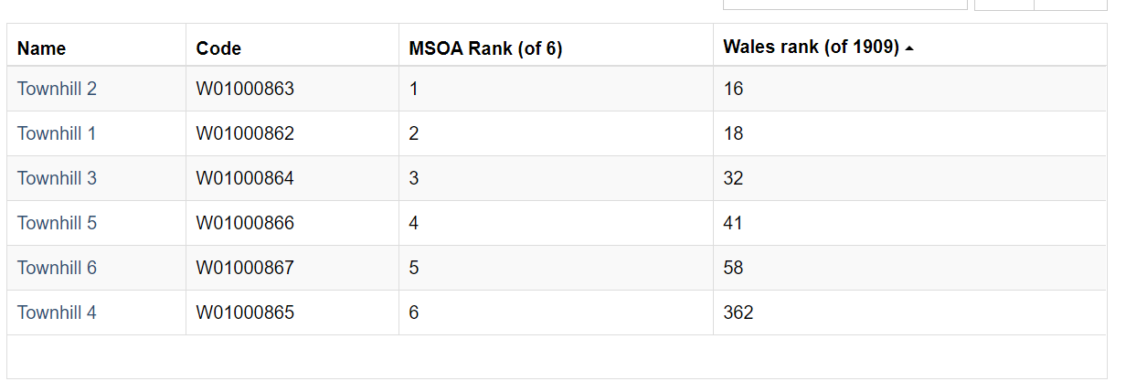

Fig 1: Constituent LSOAs of Townhill Ward, and their overall WIMD rankings.

The WIMD Index:
These ‘overall’ WIMD rankings are calculated by statisticians working for the Welsh Government and is the Government’s official method of analysing deprivation in Wales at the most detailed level. The index Is produced by assigning each LSOA with a score in each of eight comprising categories, which will be detailed below. These component scores are then combined into the overall ranking which places the LSOAs in comparison to then whole of Wales. It is important to acknowledge that the data provided by the WIMD is from 2019, as that is the most recent release. Furthermore, the WIMD website does contain a section which lists a number of factors that limit the indexes reliability as a comparative tool. The site notes that the WIMD is not an accurate tool to discern by how much one area is more deprived than another using the overall rank, as the differences between ranks can vary drastically. In addition to this, it is noted that rank cannot be used to denote absolute change over time as it is a combination of relative measures that can be influenced individually, and finally, amongst other limitations, the guide does note that it cannot be used to identify deprived people, stating that living in a deprived area is not in and of itself a sign of personal deprivation. Despite these limitations, in the context of this community profile and project the WIMD is appropriate for use, as it has been used for the purpose of identifying an area which experiences deprivation in the specific areas to which the Community Project proposed below aims to address.
In the following section, each of the eight domains will be elaborated upon, in order to provide an understanding of the factors which have contributed to Townhill Ward’s low ranking in the WIMD. It is important to note that each domain is assigned a weighting towards the overall index, which is assigned based on how important that particular domain is as a measure of deprivation, and also the quality of indicators used to discern it. These weightings will be included with each domain.

The Eight Domains: (WIMD, 2019)

Domain One: Income – 22% Weighting.
The Income Domain is described by the WIMD as being an indication of people in an area who have income below a defined point, which is specified as a person falling into one or more of categories such as that they are in receipt of income related benefits; in receipt of Working and Child Tax credits, with an income less than 60% of the Wales median; an Asylum Seeker or are in receipt of Universal Credit. The indicator used for this Domain is the percentage of population that are in receipt of income or tax-related benefits.

Domain Two: Employment – 22% Weighting.
This domain is intended to provide a scope of whether an area is affected by lack of employment, which includes those who are unable to work, due to ill health for example, along with those who are seeking work but currently remain unemployed. The indicator for this domain is given as being the percentage of working-age population who are claiming employment-related benefits.

Domain Three: Health – 15% Weighting.
The Health domain is the simplest in description, as it solely investigates the area in question’s good health or lack thereof, however this Domain is much more indicator intensive, being measured according to the following: Number of people with a diagnosis of a Chronic or Mental health condition; incidence of Cancer; prevalence of Limiting Long-Term Illnesses; and Premature Death Rate. These indicators are age and sex standardised in order to adjust for the expected prevalence of diseases within a population, it is noted by the WIMD that this allows the index to identify areas where health deprivation exists beyond the effect of age and sex. In addition to those stated above there are two further indicators which do not need to be age-sex standardised, these being measures of childhood obesity, and instances of Low Birth Weight.

Domain Four: Education – 14% Weighting.
This Domain is intended to reveal the extend of educational deprivation within an area, this is produced by the domain being a reflection of lack of qualifications and skills in an area. This is achieved using indicators that show low achievement amongst young people, and lack of qualifications in adults. The indicators used are Average Point Scores for the Foundation Phase through to Key Stage Four; Prevalence of repeat Absenteeism; Proportion of KS4 leavers entering Higher Education; and the number of adults aged 25-64 who hold no formal qualifications.

Domain Five: Access to Services – 10% Weighting.
The domain for Access to Services is intended to provide a measure of deprivation in the sense of a household’s ability to easily access a range of services which are considered essential to day-to-day living. The indicators for this domain are listed as being the average Public and Private travel times to services such as: food shops, GP surgeries, Schools, Post Offices, Public libraries, Pharmacies, and Sports Facilities; as well as travel time to Petrol stations by private transport only, in addition to the percentage unavailability of High-Speed Broadband.

Domain Six: Housing – 7% Weighting.
This domain is intended to identify if an area struggles with inadequate housing, both in the sense of availability, but also the standard of conditions within the housing in an area, which is measured in terms of health and safety, along with whether necessary adaptions have been made. The Indicators used for this domain are the proportion of people who live in overcrowded houses, and the prevalence of poor-quality housing which may be in dis-repair or containing a serious hazard.

Domain Seven: Community Safety – 5% Weighting.
The domain of Physical Environment is intended to be a measure of factors in the local area which may have an effect on the wellbeing or quality of life of the inhabitants of the area. This domain is measured using measures of concentration if three different pollutants, the area’s proximity to natural green space, the average green space score of the area, and finally the risk of an area to flooding.

Domain Eight: Physical Environment – 5% Weighting.
The Community Safety domain is intended to provide a measure of deprivation incurred by living in an area which is not considered to be safe. The domain is a measure of actual experiences of crime and fire, and also considers people’s perceptions of safety. The indicators used in this domain are instances of police recorded burglary, criminal damage, theft, violent crime, instances of Anti-Social Behaviour, and also incidents relating to fire.
An example of how the domains combine into the overall index score can be given using the LSOA ‘Townhill 2’, which has the following scores (Out of the 1909 LSOAs in Wales):
Domain: | WIMD Score: (/1909)
Income | 27
Employment | 27
Health | 9
Education | 47
Access to Services | 287
Housing | 605
Community Safety | 443
Physical Environment | 1018
Fig. 2: WIMD domain scores of LSOA Townhill 2, where the lower a score corresponds to a higher level of depravation.
These domain scores, when processed using the weighting system described earlier, result in ‘Townhill 2’ having an overall position of 16/1909, meaning that it is the 16th most deprived area in the whole of Wales. In addition to this it also holds the position of being the single most deprived LSOA within the Swansea Local Authority. These two statistics, combined with the similarly low scores of the other five areas of the Townhill Ward make the area a strong choice to offer the community project detailed below.

Part Two: Community Project Proposal.

Introduction to, and Purpose of the Project:

The foundation for the following Community Project proposal was a youth programme which was attended by the author of this proposal as a teenager. That programme has been adapted and built upon to fit the mission, functions, and necessities of the community project that follows, which is entitled ‘The Rock School Project’ (RSP) or ‘Rock School’ for short.
The RSP is intended to run over the course of nine days during the school holidays, with the first instance as described below holding provisional dates during the 2021 Christmas Holidays. The running of this programme during the school holidays was an intentional choice, as it allows the use of whole days as opposed to being an after-school programme. In addition to this the programme will also function to keep the participants busy and looked-after during the holidays, which may increase its viability for low-income areas as it would relieve families who had to continue to work during the holidays of the need for childcare for the length of the programme. Due ton the nature of the Christmas holidays however, the programme would take a three-day pause at its mid-point in order to allow the celebration of Christmas Eve, Christmas Day, and Boxing-day by the participants.
The format of the RSP allows for it to be highly adjustable in a number of areas such as its running dates, times, capacity, and content. This adaptability lends hope to the project becoming a recurring feature in the year, rather than a one-off occurrence. This repeatability is also a beneficial trait of the project as it is unfortunately limited in terms of capacity, the reasons for which will be elaborated on subsequently in this proposal. As a resolution to this issue, being able to run the RSP multiple times a year would enable the project to achieve its full potential in terms of outreach.
As will be detailed below, the contents and structure of the RSP aims to engage young people with the performative, managerial, and production perspectives of the music industry in both an enjoyable and informative manner. In addition to this however, the RSP does also carry a deeper purpose, as will be discussed in the following section.

The Target Group:

The underlying aim of the RSP is ultimately to encourage students up to GCSE level to remain in education beyond the compulsory level. The office for National Statistics (Office for National Statistics, 2011) reports, using the most recent available census data, that out of a total population of 197,627 in Swansea, 101,937 people have only received qualifications equivalent to GCSEs or below, with 47,316 of those holding no qualifications at all. Given this information, the RSP aims to encourage students to consider continuing their educational journey beyond age 16, and also aims to present subjects that may be considered non-valuable to learners from low-income backgrounds, such as music in this case, as viable and valuable opportunities. The RSP aims to do this by showing the participants that the music industry is much more than just the performers that appear on stage and does in fact have a wide variety of career and learning pathways that come with transferable skills. In order to do this, the RSP would reach out to, and encourage the involvement of post-16 colleges in the local Swansea area, such as Gower College for example. Ultimately, the RSP aims to show to students that subjects that are often considered to be the less-valuable, ‘fun’ subjects, can also provide opportunities for continued study, which will work towards reducing the attainment gap between those from low- compared to high-income areas.
As previously mentioned, the RSP will face one minor issue in the form of a limited capacity. This is due to the structure of the project being formed of a cohort of 25 participants, which are broken down as follows:
Five Vocalists, Five Drummers, Five Guitarists, Five Keyboardists, and Five Bass Guitarists.
The instruments assigned to each member would be given based on their initial application, within which they would be asked to rank their preference from one to five, with one being their first choice.
To start off with, the RSP would be offered to the intended group of students solely within the Townhill One Ward. This would be implemented by sending the full school registry for the Townhill Ward an invitation to apply to the programme, making it clear that whilst spaces are limited, there are no requirements or costs whatsoever. From the returned applications, the 25 successful candidates would be chosen, and the remainder of the applicants would, with their permission, be added to a reserve list that would be contacted should there be any withdrawals, and that would also take priority in subsequent iterations of the programme.

Project Details:

Structure of the Project:

The ‘Rock School’ Community Project will be a nine-day long programme intended to take place during the school holidays, ideally over the course of the Christmas Break or autumn half-term. This will allow the project to be viable for a group of 25 participants of its target age group of 13–16-year-olds, as by being during the first term of the school year it would not clash with the key revision periods that would be needed for the older participants who would be coming up on their GCSE examinations. Over the course of the eight days, the participants would be involved in several activities which are designed to give them a ‘first taste’ of working within the music industry, with the ultimate goal of producing and performing in a final ‘Gig’. This will be facilitated by splitting each day of the programme into two halves. The morning session of the day would be used to introduce the students to their chosen instrument and give them a ‘crash-course’ tuition in said instrument. Following this, the afternoon sessions would each be used to introduce the participants to other facets of the music industry, including workshops in areas such as stage and lighting design; sound engineering; recording and mixing; equipment care and set-up; and instrument care and maintenance. As you can see, this list of workshops does not encompass the full length of the nine-day programme, this is a deliberate choice as it would allow the remaining time to be used by the participants in forming their own band and preparing for the final concert!
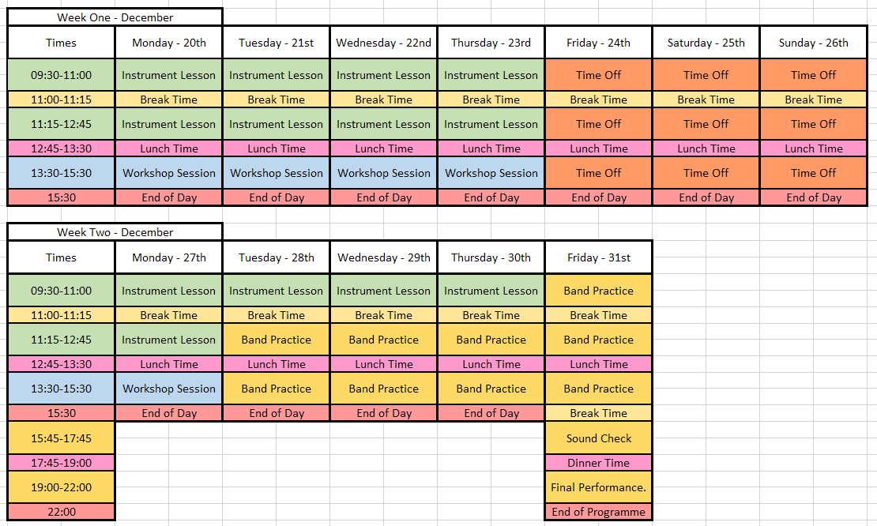

Fig 3: An example timetable using dates from December 2021.
The Image above, Figure Three, shows an example timetable for the Community Project using dates in December 2021. This timetable has been produced to fit around the prospective Christmas Holiday dates, whilst also working around Christmas itself.

Project Leadership and Facilitation:

This Community Project will require a significant amount of input from trusted and expert musicians and music industry professionals from the local Swansea area. As stated previously, the participants would be separated into five separate instrumental groups, each requiring an instrument ‘tutor’ who would be an established musician in their respective instruments. These instrumental tutors would be selected from the abundant pool of talented musicians from the Swansea area. Their roles would be to function as a tutor for their individual instruments in the morning sessions, and then during the first four days they would be tasked with assisting and offering their experience to the leaders of the workshop sessions. Finally, in the latter half of the project, they would each be assigned a group of participants, one from each instrumental group, with whom they would form a band, taking the role of band leader. Within the role of band leader, the five leaders would take suggestions from the participants as to their choice of songs to perform, however the leaders would hold the final say as to which songs would be both appropriate, and viable for the skill level of each of their bands.
In addition to the Instrument and Band leaders, there would also be a need to have Workshop Leaders who had industry experience and expertise in the areas specified previously in this proposal. These Workshop Leaders would be in charge of running the five workshops for all of the first five days, with the participants rotating in a carousel format in their instrumental groups in order to access all five of the workshop topics. Following this, the workshop tutors would be on hand to offer any assistance needed during the bands’ rehearsal times, and then would use their expertise to manage the production of the final performance. It is worth noting, that due to the nature of the RSP and that the tutors will be working with children, in order to volunteer they will need to have applied for and received an Enhanced DBS Check, which will be funded through the Projects budget.

Logistical Considerations:

Logistically speaking, the RSP is a project that will require a large amount of space, as to accommodate five groups of five participants, along with tutors, instruments, and further equipment will require plenty of room. This would be overcome by splitting the five instrumental and band groups over two separate venues as there unfortunately exists a lack of rehearsal spaces that can provide the amount of space needed for the project within one complex in Swansea. Therefore, the two music venues that would be used for the instrumental tutoring; band practices; and workshops, would be the Creature Sound Community Music Hall, and Sound Haven Studios, both of which have three rehearsal spaces. These spaces would provide ample room for the three types of session involved in this Community Project and would allow plenty of space for the workshops to take place.
In addition to the question of space, there would also be the challenge of sourcing the necessary instruments in order to adequately supply the project. In total, to support the capacity of five bands of five participants, there would be a need for five of each instrument, with the addition of one as an available spare this would total six drum kits, keyboards, guitars, bass guitars, and microphone set ups, in addition to the necessary equipment such as amplifiers and cables. Whilst the venues used would have ‘house’ instruments available to use, it is unlikely that there would be enough to support the full cohort of those involved, as a solution to this the project would first of all ask the instrumental and workshop tutors if they would be willing to bring any additional instruments that they owned for use within the project. Following this, any further instruments and equipment needed would be loaned from local music shops and other venues where appropriate and available.
Due to Townhill One’s nature as a highly deprived area, within this project there would be a budgeted transport service to allow all of the participants to be taken to and from the project sessions, and also be taken into the city centre for their lunch break, where they would then be organised into their groups for the afternoon sessions, this would ensure that the Community Project was accessible to all, and that transportation to and from the activities would not be a reason that someone could not take part. Further to this, should enough funding be available there would be an option for participants to be provided with a simple lunch time meal, in the case that they did not have the means to bring their own packed lunch, or purchase food during the break. This would ensure that all of the participants were able to eat well and have enough energy for the day’s activities.

Funding Sources:

As with any Community Project and given the extensive logistics that would be required, as listed above, the cost of running this Project as a single instance would be significant. This would then be compounded by aspirations of making the nine-day programme a thrice or four-time yearly programme that would evolve from the original form, should the programme prove to be successful in its initial incarnation. This initial form of the project would be intended to be mostly, if not completely, paid for by lottery funding with scope for there to be additional financial support from Welsh Government grants, or the potential to operate the programme under the umbrella of a supporting charity, such as the YMCA for example.
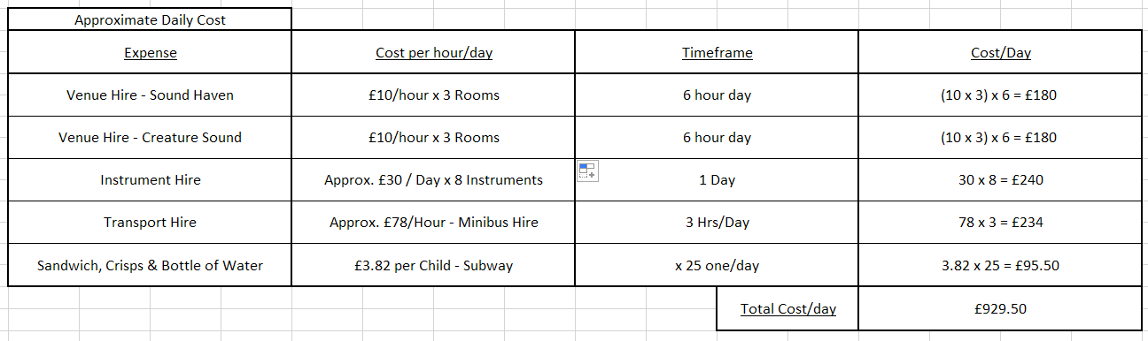

Fig. 4: An approximation of daily running cost.
Figure 4, included above, shows an approximate daily running cost of this project, this was calculated using the given prices for the music venues; an approximation of hire costs for a number of instruments which could change based on availability as previously mentioned; pricing for a two sandwich platters with crisps and a bottle of water for all 25 participants from Subway, which would also be subject to change depending on whether all 25 would need provision; and finally an estimated hire cost for a minibus to pick up and shuttle the participants in the morning, at lunch time, and at the end of the day. As these figures are an estimate of daily costs, there is one significant expense that would only occur on the final day of the Project, that being the hire of a venue. This would be the most significant expense, however as with all of the costs stated above there may be opportunity for negotiation of costs due to the extended nature of the project, and also that it could be considered as a charity programme, with one performance venue in Swansea, Hanger 18, offering their venue to charities free of charge.

Reference List:

Office for National Statistics, 2011. Highest Level of Qualification. [Online]
Available at: https://www.nomisweb.co.uk/census/2011/QS501EW/view/1946157393?rows=rural_urban&cols=cell
[Accessed 10 05 2021].
WIMD, 2019. Swansea 019. [Online]
Available at: https://wimd.gov.wales/geography/msoa/W02000186?lang=en#&min=0&max=10&domain=overall
[Accessed 10 05 2021].
WIMD, 2019. The Eight WIMD Domains. [Online]
Available at: https://wimd.gov.wales/about/domains?lang=en
[Accessed 10 05 2021].

