Module: Developing workplace critical thinking (BMSW 5101)
Tutor: Lect. Shehla Khan
Student: Adrian-Gigi Ciacareanu
Student number: 1710292
Due date: 13/12/2019

Key concepts in organizational culture

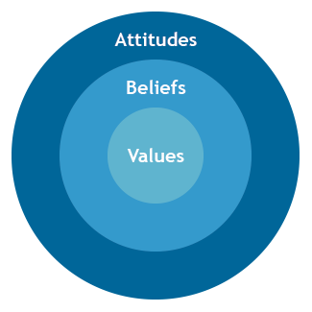


Executive summary

In the following report the author decided to talk about Google, a very successful business that acts like a magnet for the majority of graduate students in search for a job.
It all started in 1995, when a 22 years old student, named Larry Page decided to study for his Ph.D. at Stanford University. There he met his tour guide, Sergey Brin, who was already studying at the famous institution. In 1998 Google was born, but few know that it was initially called Backrub, and used a rented garage who acted as an office. (Zipkin, 2017)
Since 2015, the company majorly re-structured and re-named to Alphabet in order to help them focus more on its experimental work. (Griffin, 2015)
Nowadays Google owns more than 200 subsidiaries, which include YouTube, Nest and Pixel, and in the first quarter of 2019 it reportedly has 103,549 employees. (Fiegerman, 2019)

Table of contents

1.Introduction…………………………………………4
2.Findings………………………………………….5-13
3.Conclusion………………………………………….14
4.Recommendations………………………………...15
5.Reference list…………………………………..16-19

1.Introduction

It has been suggested that within organisational cultures, traits like values, beliefs and attitudes are considered to be elements of great importance that can bring various benefits for the organisations.
In the following report, the author will closely examine the values, beliefs and attitudes and will define them one by one and dissect them in front of the reader for a much better understanding.
To prove the importance of the notions presented above for any organisation, the researcher will connect them with some relevant management theories, as well as supporting any statements that will be made with reliable sources.
In addition to this, the author decided to use two crucial critical thinking methods, RED and Toulmin, two means through which the author will evaluate the facts and data introduced in this report.

2.Findings
2.1.Organisational culture

Organisational culture can be interpreted as an expression of social evolution of companies. The term “culture” somehow represents a system of values, beliefs, rules of behaviour, attitudes and thinking models which are brought together and accepted by a group of individuals, allowing it to clearly distinguish from other groups.
Each organisation partially has, consciously or unconsciously, its own culture. This can be defined through its model of values, representations and attitudes that are governing life inside the organisation. (Smircich, 1983)
Organisational culture represents a lifestyle, it is a result of internal practice, rules of conduct, values, attitude and beliefs specific to a certain organisation. The culture of an organisation is its personality and character, made up of assumptions about how people should behave and interact, how decisions should be made and how tasks should be carried out. Alongside the human resource, history and environment are fundamental factors in the culture of an organisation. (Managers.org.uk, 2019)

2.2.Values
Definitions.
As defined by Ethics Sage, “values are basic and fundamental beliefs that guide or motivate attitudes or actions”. (2018)
The author found another relevant definition, values are defined as the collective conceptions of what is considered good, desirable, and proper or bad, undesirable, and improper in a culture. (iEduNote.com, 2019)
Within organizations, the notion of values has become so omnipresent that it is almost impossible to find any CEO who doesn’t appreciate their importance. (Satell, 2015)
The researcher believes that values have a great significance for an individual because they are of great help in the process of development and progress. There are four types of values existent in an organisational setting: individual values, relationship values, organisational values and societal values.
Individual values are the ones that governs your day-by-day life, the ones that are important for your own interest, and can include: creativity, enthusiasm or personal satisfaction. (Barrett Values Centre, 2019)

Relationship values are formed by the actions taken by a person in relation to other people in his life, like family members, close friends or mates from the workplace. This kind of values are based on trust, honesty, kindness or altruism.
Organisational values are those that reflect the way your organisation acts in the world of business, and if it is interested in promoting teamwork, productivity, financial growth, demonstrate integrity and accountability for external stakeholders, provide a solid foundation for employment policies. (Worklogic, 2019)
The fourth type of value that the author brought into topic, the societal value, is considered to be formed by the way in which both the individual and the organisation behave in society. The values of this category are orientated towards future generations, environmental awareness, sustainability and quality of life. (Citizens Council Reports, 2014)

“Whenever I look at companies, I like to look at their values”, said J.D. Meier, director of innovation at Microsoft. He acknowledges that values are the key components of organisational cultures. (2017)

As any other company, Google has its own core values, and they must be really amazing and productive given the fact that the tech titan won the prize for being the company with the best corporate culture in 2018.
The “winning” values are:
- True flexibility
- Freedom to be creative
- Fun at work
- The people and their expertise
- Dog-friendly workplace
- Shared values across the organization
- Constant innovation
- Trust
- Alignment with employees’ wants and needs
- A dedicated focus on employee happiness
- Radical candour, and
- A clear purpose. (Forbes Technology Council, 2018)
2.3.Beliefs
Definitions.
Beliefs are a sum of suppositions and views that are considered to be true by an individual. (BusinessDictionary.com, 2019)
Core beliefs define and create culture and act as hallmarks to guide behaviour. The author believes that beliefs become stronger when an individual discovers that these are authentic truths, rather than being just simple opinions. Beliefs are mainly applied to individuals and groups, and only few organisations can describe the beliefs that are most relevant to them. From an organisational point of view beliefs are often invisible, but they are very efficient when it comes to guiding group performance. (Taylor, 2017)
The author found a very interesting article that presents Google’s beliefs, or the “ten things we know to be true” as are known amongst its employees.

1)Focus on the user and all else will follow
2)It’s best to do one thing really, really good
3)Fast is better than slow
4)Democracy on the web works
5)You don’t need to be at your desk to need an answer
6)You can make money without doing evil
7)There’s always more information out there
8)The need for information crosses all borders
9)You can be serious without a suit
10)Great just isn’t good enough. (Polski, 2019)

2.4.Attitudes
Definitions.
“Attitudes are evaluative statements or judgements concerning objects, people or events”. (Csus.edu, 2019)
Every single individual has its own attitudes in the workplace, and it can have an impact on the people around them. Employees with a positive can have a good impact on their workmates, while pessimistic individuals can lower the spirit of the group. The main idea in here is that attitudes can affect work performances of individuals and co-workers. In a work environment it is the manager’s job to identify negative attitudes, derived from long working hours or arguments between employees, and repair situations to encourage an effective work environment. Positive employees work better in order to reach deadlines and are more likely to find problem solving solutions and can display a loyal attitude towards the organisation even if it faces financial issues.(Drivers of Behaviours, 2019)

There are three main components of attitudes, often referred to as the ABC’s of attitude. These include:
- The affective component- the way one feels about the subject, an event or a certain person.
- The behavioural component, which is formed by the way in which attitudes affect your behaviour.
- The last, but not least is the cognitive component, this basically means the way you think about any subject. (Cherry, 2019)

2.5.Management theories X and Y
Definitions.
Theory X and theory Y are two contrasting management theories developed in the 1960s by social psychologist Douglas McGregor. These theories are based on two aspects of human behaviour at work, a negative one, called Theory X, and a positive one, called Theory Y. According to theory X, the average employee is lazy, he lacks ambition, dislikes responsibility, prefers to be led, is indifferent to organizational needs, and resistant to change. (Managementstudyguide.com, 2019)

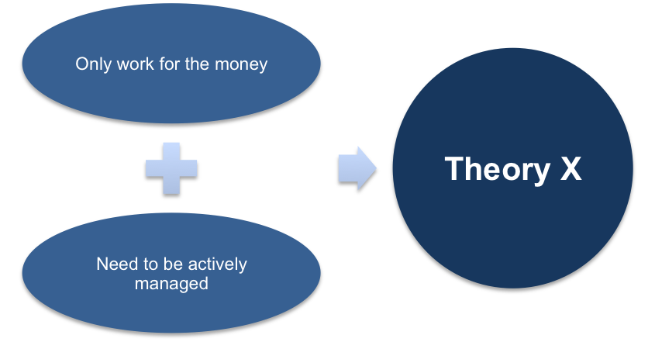

On the other hand, Theory Y, praises the hardworking employees who are in constant need of self-actualization. These are the employees that see work as satisfactory and embrace responsibility. Theory Y employees are not motivated by financial rewards, they appreciate instead a working environment that encourages creativity. (tutor2u, 2019)

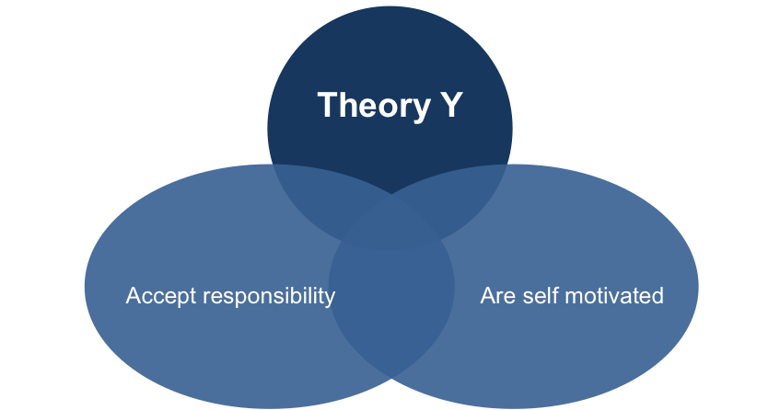

“Theory X and Theory Y are not managerial strategies. They are underlying beliefs about the nature of man that influence managers to adopt one strategy rather than another. Therefore, McGregor argued that it was essential for managers to analyse their own assumptions in order to effectively lead and motivate others”. (Kelly, 2000, p.144)

The author identified a resemblance between McGregor’s Theory X and Theory Y and Abraham Maslow’s Hierarchy of Needs, linking the bottom needs from Maslow’s pyramid, physiological and safety needs that employees engaged at work according to Theory X. As we climb Maslow’s pyramid, we find belonging, esteem and self-actualization, characteristics of employees according to Theory Y. (Organizational Communication Channel, 2016)

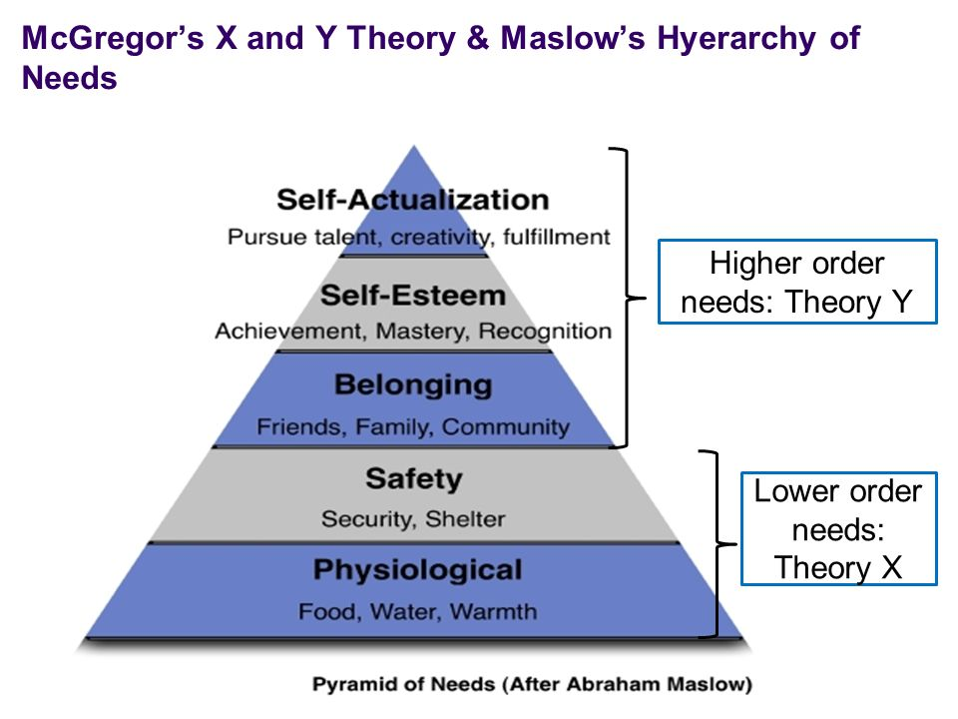
Google is the leader when talking about companies that are encouraging creativity at the workplace. As a result, freedom of creativity generates happiness amongst employees, and happiness enhances productivity. Google is famous for the incentives offered to employees, such as: free meals, gym memberships and a diversity of games that are meant to keep the staff happy and productive in achieving the main objectives of the organisation. (Coleman, 2016)

At Google, its staff is considered to be the most valuable asset, and for them, transparency, frankness, and trust are basic principles shared inside the organizational culture. (Strategos, 2019)
The author’s personal opinion regarding the successful applicability of Theory Y at Google, is given by two of the core values of the company: flexibility and innovation. The company is in continuous need of improving customer services and developing existing ones to keep up with the technological changes around the world.
So far, the researcher presented only the advantages of Theory Y for the organisations. Let’s have a look at the drawbacks that can occur for an organisation due to a poorly implemented Theory Y.
An important disadvantage is lazy leadership, due to the fact that managers delegate too many tasks to the employees and prefer to just sit and relax in their offices. Managers should be the ones to motivate people to work harder, not the job itself. Some employees may waste company’s time, using it for personal activities, unless carefully supervised. (Pros an Cons, 2019)

2.6.Critical thinking models
2.6.1.R.E.D
Pearson’s RED model is the most widely used assessment of critical thinking in the world. This acronym means: recognize assumptions, evaluate arguments and draw conclusions.
Recognizing assumptions basically means accepting a statement as being true in the lack of proof. One must differentiate the facts from personal opinions, using questioning to ensure good quality of evidence.
Evaluating arguments is a crucial part of critical thinking, and it teaches individuals to recognize confirmation-bias.
Chatfield believes that it is crucial to learn how to understand the arguments and how to efficiently evaluate the evidence. For this, useful and relevant materials must be found, recognize the agreements within different sources and know how to choose only the relevant details. (2018, p.14)
When the two previous stages of the model are met, it is time to draw conclusions based on the relevant evidence that were found. Drawing conclusions can be a matter of life and death. Drawing conclusions is totally different than “jumping to conclusions”, and the latter is a mistake that occurs due to the rush when making a decision. Conclusions must be drawn after an individual evaluates the information in a precise manner, analysing available data and identifying possible bias. (Chartrand et all, 2012, pp 72-73)

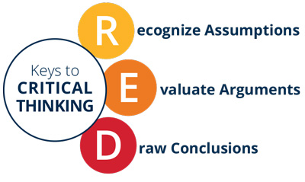

2.6.2.Toulmin’s method
The Toulmin model is a style of argumentation used to develop, analyse and categorise arguments by breaking them down in six parts. The six parts of the model are:
- Claim- it is basically an affirmation about a fact.
- Data- supports the claim with evidence.
- Warrant- it bounds the claim to the data.
- Backing- brings support for the warrant.
- Qualifier- the amount of assurance used in presenting the argument.
- Rebuttal- exceptions to the initial claim. (ThoughtCo, 2018)

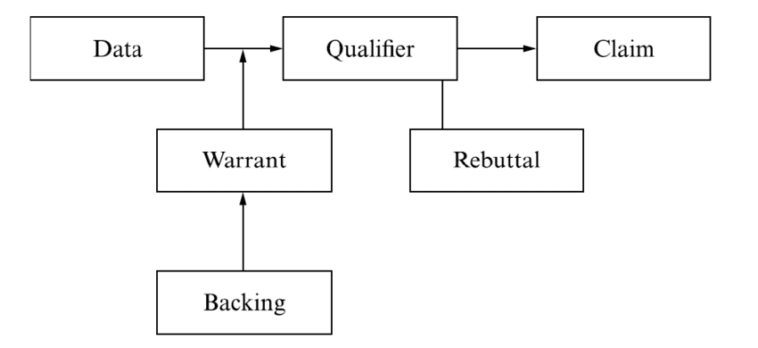

For a better understanding on how Toulmin model can be successfully applied on any argument, the author decided to start a debate on allegations against Google’s politically biased search results.
Claim
Google search results are politically biased.

Data
Google’s bias towards left-wing media outlets has been revealed by an algorithm which detected that it favours sites as CNN and The New York Times over others. Of the 6,302 articles appeared in November 2017 the three top places were taken by left-wing media outlets. Fox News, the most right-wing newspaper was fourth at a considerable distance.
1)CNN- 10%
2)New York Times- 6.5%
3)Washington Post- 5,6%
4) Fox News- 3.0% (Smith, 2019)

Warrant
During the 2016 presidential campaign in the United States, Google was accused of manipulating search results to favour Hillary Clinton’s candidacy. Research conducted at Harvard University found that search results are not objective, and in 2017, the company was fined billions of dollars by the European Union for manipulating search results. (Parscale, 2018)

Backing
In August 2019, Fox News aired an interview with former Google engineer Kevin Cernekee, who confirmed that Google had a problem with anti-conservative bias on its platforms. He then stated:

"They really want Trump to lose in 2020. That’s their agenda. They have very biased people running every level of the company. They have quite a bit of control over the political process”. (Garcia, 2019)

Qualifier
Robert Epstein, Ph.D., was called in front of the U.S. Senate Judiciary Subcommittee to explain why Google presents a serious threat to democracy and human autonomy. Mr. Epstein admitted that “In 2016, biased search results generated by Google’s search algorithm likely impacted undecided voters in a way that gave at least 2.6 million votes to Hillary Clinton (whom I supported)”. (Epstein, 2019)
Based on the evidence provided, the author’s personal opinion is that there were some interferences of Google to manipulate politically biased results.

Rebuttal
Google CEO, Sundar Pichai, appeared before the House Judiciary Committee, and reinforced the fact that the online search engine does not use any algorithms that may influence political views of American citizens.
He added: "I'm confident we don't approach our work with any political bias."(BBC News, 2019)

3.Conclusion
In this report, the author tried to express the importance that values, beliefs and attitudes hold in organizational cultures. In order to be very concise in his approach, the author decided to start with the definitions of the concepts, and then, using reliable sources, he explained the impact these can have in any organisation. An essential element for employees to integrate better in the organization is the alignment of personal values to the ones of the organisation, or to adhere to the ones that are promoted by the organisation.
This was followed by a series of organisational values, using Google as an example. It has been proven that there is a close connection between Google’s core beliefs, and McGregor’s X and Y theories, both parts involved in the report granting special attention to higher achievement and creativity.
Maslow’s theory fortified the fact that Theory X is focused more on the two levels of the pyramid, the basic needs of ordinary employees, whilst creative employees and the ones that are continuously looking to develop are linked with Theory Y.
Perhaps, the most important critical thinking models were infolded into this report, RED and Toulmin’s critical method. It was shown the benefits of Toulmin’s applicability when critically evaluating a statement.

5.Reccomendations
No matter how big and successful an organisation might be, there is always room for improvement. This can be made through a series of measures and actions taken that must be implemented with care and interest.
A transparent company builds trust amongst its employees, and the best way to do that is using an efficient communication system between management structures and its staff.
Reward and recognition, another measure that must be implemented by any organisation. These can be financial or non- financial, sometimes a simple “thank you for your hard work” means more than financial bonuses.
In reaching the goals that are set by the organisation, collaboration with work mates driven by the same purpose proves to be very efficient.
A successful way to keep employees informed about progress is the feedback programme. This keeps employees up to date and provides them with a feeling of satisfaction and belonging to the success of the company. (Andriotis, 2017)

5.Reference list

- Andriotis, N. (2017). 5 Ways for Improving Corporate Culture - eFront Blog. eFront Blog. Available at: https://www.efrontlearning.com/blog/2017/12/ways-improving-corporate-culture.html (Accessed 13 Dec. 2019).
- Barrett Values Centre. (2019). Why Values are Important - Barrett Values Centre. Available at: https://www.valuescentre.com/values-are-important/ (Accessed 11 Dec. 2019).
- BBC News. (2019). Google chief denies political bias claims. Available at: https://www.bbc.co.uk/news/technology-46521887 (Accessed 12 Dec. 2019).
- BusinessDictionary.com, (2019). What are beliefs? definition and meaning. Available at: http://www.businessdictionary.com/definition/beliefs.html, (Accessed 28 Nov. 2019)
- Chartrand, J. (2012). Now you're thinking. Upper Saddle River, N.J.: FT Press.
- Chatfield, T., (2018). Critical thinking : your guide to effective argument, successful analysis & independent study First ed.
- Cherry, K. (2019). How Can Our Attitudes Change and Influence Behaviors? Available at: https://www.verywellmind.com/attitudes-how-they-form-change-shape-behavior-2795897 (Accessed 12 Dec. 2019).
- Citizens Council report. (2014). No. 17, London: National institute for Health and Care Excellence. Available at: https://www.ncbi.nlm.nih.gov/books/NBK401707/ (Accessed 11 Dec. 2019).
- Coleman, A. (2019). Is Google's model of the creative workplace the future of the office? ,The Guardian. Available at: https://www.theguardian.com/careers/2016/feb/11/is-googles-model-of-the-creative-workplace-the-future-of-the-office (Accessed 12 Dec. 2019).
- Courses.lumenlearning.com. (2019). Drivers of Behaviour | Boundless Management. Available at: https://courses.lumenlearning.com/boundless-management/chapter/drivers-of-behavior/ (Accessed 12 Dec. 2019).
- Csus.edu. (2019). Chapter 3 Attitudes and Job Satisfaction. Available at: https://www.csus.edu/indiv/s/sablynskic/chapter3.htm (Accessed 11 Dec. 2019).
- Epstein, R. (2019). Available at: https://www.judiciary.senate.gov/imo/media/doc/Epstein%20Testimony.pdf (Accessed 12 Dec. 2019).
- Ethics Sage, (2018). What are Values? Available at: https://www.ethicssage.com/2018/08/what-are-values.html (Accessed 28 Nov. 2019)
- Forbes Technology Council (2018). Council Post: 13 Reasons Google Deserves Its 'Best Company Culture' Award. Available at: https://www.forbes.com/sites/forbestechcouncil/2018/02/08/13-reasons-google-deserves-its-best-company-culture-award/#562752783482 (Accessed 11 Dec. 2019).
- Garcia, V. (2019). Google wants Trump to lose in 2020, former engineer for tech giant says: 'That's their agenda'. Fox News. Available at: https://www.foxnews.com/media/fired-google-engineer-fears-company-will-try-and-influence-2020-election-they-really-want-trump-to-lose (Accessed 12 Dec. 2019).
- Griffin, A. (2015). Google is changing its name. The Independent. Available at: https://www.independent.co.uk/life-style/gadgets-and-tech/news/google-is-now-alphabet-search-giant-changes-name-to-avoid-becoming-a-conventional-company-10449227.html (Accessed 11 Dec. 2019).
- iEduNote.com. (2019). Values: Definition, Characteristics, Importance, Types of Values. Available at: https://iedunote.com/values (Accessed 11 Dec. 2019).
- Kelly, E.P. 2000, "Douglas McGregor, Revisited: Managing the Human Side of the Enterprise", The Academy of Management Executive, vol. 14, no. 3, pp. 143-145.
- Managementstudyguide.com. (2019). Theory X and Theory Y. Available at: https://www.managementstudyguide.com/theory-x-y-motivation.htm (Accessed 12 Dec. 2019).
- Managers.org.uk. (2019). Available at: https://www.managers.org.uk/~/media/Files/PDF/Checklists/CHK-232-Understanding-organisational-culture.pdf (Accessed 11 Dec. 2019).
- Meier, J. (2017). Brilliant Examples of Company Values (Amazon, Google, Microsoft and More). Available at: https://www.linkedin.com/pulse/brilliant-examples-company-values-amazon-google-microsoft-j-d-meier (Accessed 11 Dec. 2019).
- Organizational Communication Channel (2016). Douglas McGregor's Theory X and Theory Y. Available at: https://www.youtube.com/watch?v=CXAzZRnJo2o (Accessed 12 Dec. 2019).
- Parscale, B. (2018). Eu.usatoday.com. Available at: https://eu.usatoday.com/story/opinion/2018/09/10/trump-google-youtube-search-results-biased-against-republicans-conservatives-column/1248099002/ (Accessed 12 Dec. 2019).
- Polski, M. (2019). Google’s “Ten things" Philosophy and the Connection with SEO. Available at: http://www.mattpolsky.com/articles/googles-ten-things-seo-connection/ (Accessed 11 Dec. 2019).
- Pros an Cons. (2019). Pros and Cons of Theory Y - Pros an Cons. Available at: https://www.prosancons.com/education/pros-and-cons-of-theory-y/ (Accessed 12 Dec. 2019).
- Satell, (2015). How To Define Your Organization's Values. Available at: https://www.forbes.com/sites/gregsatell/2015/11/27/how-to-define-your-organizations-values/#65e155da4054 (Accessed 17 Nov. 2019)
- Seth Fiegerman, C. (2019). Google's parent company now has more than 100,000 employees. CNN. Available at: https://edition.cnn.com/2019/04/29/tech/alphabet-q1-earnings/index.html (Accessed 11 Dec. 2019).
- Smircich, L. (1983). Concepts of culture and organizational analysis. Administrative Science Quarterly.
- Smith, J. (2019). Google's left-wing media bias revealed. Mail Online. Available at: https://www.dailymail.co.uk/news/article-7020081/Googles-left-wing-media-bias-CNN-New-York-Times-Washington-Post-favorites.html (Accessed 12 Dec. 2019).
- Strategos – Strategy and Innovation Consulting Firm. (2019). How Google Manages Continuous Innovation in a Rapidly Changing World - Strategos – Strategy and Innovation Consulting Firm. Available at: https://strategos.com/google-model-managing-continuous-innovation-rapidly-changing-world/ (Accessed 12 Dec. 2019).
- Taylor, C. (2017). Shared organizational beliefs have many forms - can you see them? Human Synergistics. Available at: https://www.humansynergistics.com/blog/culture-university/details/culture-university/2017/03/28/the-unseen-force-that-s-shaping-your-culture-every-day (Accessed 11 Dec. 2019).
- ThoughtCo. (2018). What Is the Toulmin Model of Argument? Available at: https://www.thoughtco.com/toulmin-model-argument-1692474 (Accessed 12 Dec. 2019).
- Tutor2u. (2019). Motivation - McGregor (Theory X & Theory Y) Available at: https://www.tutor2u.net/business/reference/motivation-mcgregor-theory-x-theory-y (Accessed 12 Dec. 2019).
- Worklogic. (2019). Organisational Values - Worklogic. Available at: https://www.worklogic.com.au/services/organisational-values/ (Accessed 11 Dec. 2019).
- Zipkin, K. (2017). 19 Crazy Facts You Probably Didn't Know About Google. Available at: https://www.entrepreneur.com/article/246477 (Accessed 11 Dec. 2019).

