Sustainable Hospitality & Tourism Management BMIH5006

Lecturer: Ruth taylor davies
raluca soroceanu 2028572
2024

Executive Summary
This overall report has been prepared to answer three questions regarding sustainable hospitality and tourism management, in the context of Premier In. The response to the first question addresses the compliance procedures and criteria for receiving green accreditation for a sustainable hospitality brand. The discussion majorly focused on the 13 green criteria, set by the Green Key foundation. The answer to the second question discussed the benefits and challenges of integrating sustainability into the daily operations of hospitality businesses. The findings outlined how sustainable integration drives growth and improved brand image. However, sustainable integration is costly and there are challenges related to regulatory requirements. The findings revealed that the future of the hotel and hospitality industry is likely to be dominated by technology.
Table of contents

Introduction 3
Requirements for compliance adherence and sustainable accreditation 3
Benefits and challenges of sustainable integration 7
The future of the hotel & hospitality industry 10
Conclusion 11
References 12

Introduction
Considering the environmentally friendly aspects and ensuring business sustainability within the domain of tourism and hospitality industry is crucial. The Travel Foundation identifies that, in the growing concern of sustainability, the travel and tourism businesses need to take responsibility and make a positive impact on the environment, economy and society (Travel Foundation, 2016). In order to measure the green effort by the hospitality and tourism businesses, a set of sustainability operational criteria is led by foundations like Green Key. This foundation offers eco certificates for hospitality and tourism business operators by evaluating their sustainability performance or “green effort” (Green Key, 2024). Considering the context, the report will discuss significant aspects related to the green certificate in the hotel and hospitality industry. The discussion will begin with identifying and analysing the requirements for businesses to comply with and the path towards sustainable accreditation. The following sections will discuss the benefits and challenges of sustainable business integration while depicting a future vision of the hotel and hospitality industry.

Requirements for compliance adherence and sustainable accreditation
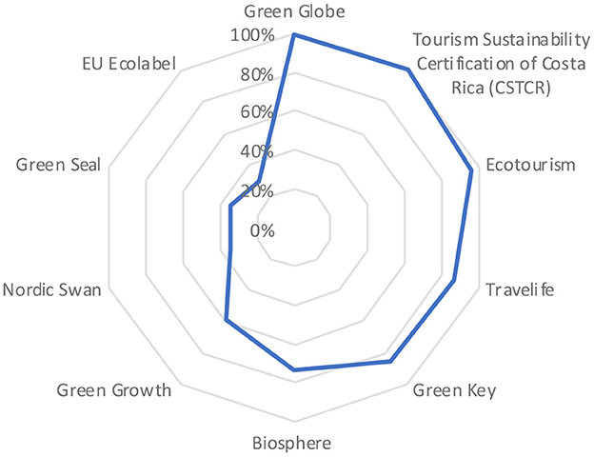
Figure 1: Comparative analysis of green accreditation in hospitality and tourism
(Source: Rodríguez-García et al., 2023)
The “Global Sustainable Tourism Council” acknowledges ten green certificates globally to support the hotels in designing their sustainable practices and improving sustainable performance with varying efficiency (Rodríguez-García et al., 2023). However, to narrow down the findings, only the green requirements of “Green Key” are presented for following compliance and receiving sustainable accreditation depending on the 13 sustainable criteria (Green Key, 2024). Based on these criteria and the standard of services, the performances of hotels and hospitality businesses are evaluated and assessed before certifying them as green businesses.
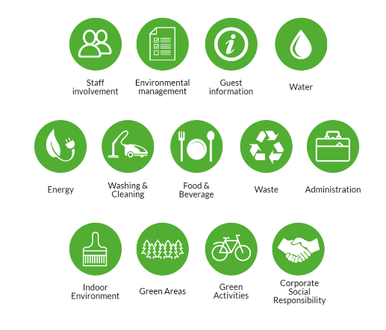
Figure 2: 13 sustainability requirements
(Source: Green Key, 2024)
- Sustainable environmental management
As sustainable efforts are meant to be “green”, the first criterion is sustainable environmental management by appointing environmental managers within the establishment who need to be responsible for the formality of sustainability policy (Green Key, 2024). Additional criteria include maintaining and reporting transparent documentation, collaborating with local stakeholders, calculating and reducing carbon footprint and abiding by the greenhouse gas protocol standard. According to UNFCCC, the hotel industry contributes to 1% of global carbon emissions, which needs to be reduced by 66% by 2030 and 90% by 2050 (UNFCCC, 2018). Hence it is significant to consider that environmental management needs to be according to the criteria for reducing carbon emissions and becoming a green Hotel.
- Staff involvement
Pham et al., (2019) commented that the involvement of staff in the decision-making improves organisational efficiency. The criteria for sustainable accreditation in the hospitality sector also include this requirement of involving staff in the sustainability procedure. The actions include transparent, clear communication about environmental issues with the staff, arranging yearly meetings, offering training to improve sustainability performance, and empowering them to evaluate their sustainable performance accordingly (Green Key, 2024). The theory of circular economy identifies that managing waste is an essential sustainable practice, where recycling, reuse and reduction of materials are performed to manage waste (Sorin and Sivarajah, 2021). However, waste management cannot be accomplished by implementing some policies without staff involvement. Hence, discussing the issues with the staff and delivering training to address the waste management issues in sustainability practices is mandatory and justified for receiving green certificates for hotels (Fernández-Robin et al., 2019).
- Guest involvement
Similar to staff involvement, involving guests in sustainability practices and management is essential for hotels to maximise the outcome (Kim et al., 2023). Examples of initiative include clear communication of the green award, and awareness and encouragement among customers to participate in the sustainability program. For instance, Premier Inn. encourages customers to be involved in in-room recycling by differentiating recycled and non-recycled waste (Premier Inn., 2024).
- Water, waste management, cleaning and washing
The criteria for sustainable accreditation in hotels include water and waste management by checking water consumption and controlling water usage across toilets, laundry, dishwashing, cleaning, washing and other service units. Legrand et al., (2022) recommended that hotels need to follow daily water usage limits to reduce water usage. Moreover, a significant sustainable practice of water management includes managing wastewater by investing in robust filtering technologies. The Soneva group of resorts in the Maldives operates 50% on repeat business, successfully applying the principles of the circular economy (UNGC, 2012). Waste water management and water filtration are significant aspects of this sustainable practice, where wastewater and seawater are filtered into bottled drinking water in the sites (Han et al., 2018).
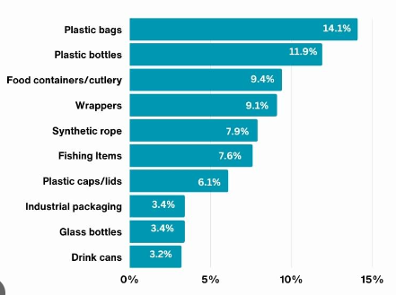
Figure 3: Plastic usage and waste contribution
(Source: Wayman and Niemann, 2021)
Along with food waste, chemical and hazardous waste needs to be managed to improve sustainable performance (Green Key, 2024). In this regard, the use of plastic is seen as a burden on the ocean as millions of tons of litter are dumped every day on the ocean as non-recyclable waste which further degrades the environmental impact of hotel businesses. The figure shows that plastic bottles, cutleries, and wrappers are the most dumped plastic waste in the ocean (Wayman and Niemann, 2021). Therefore, hotels need to reduce the usage of plastic for their service delivery and improve sustainability performance.
- Energy
Energy is another significant area, around which multiple requirements are formed to comply. One of the mandatory and essential sustainable practices is the prevention of fossil fuel as a significant source of energy. Instead, Sakshi et al., (2020) recommended that hospitality businesses need to source 100% energy from renewable energy sources and conduct energy audits to maintain transparency and consistency in performance. Additionally, implementing energy metres, following the rules of green building, and focusing on electric transportation are some of the sustainable requirements to improve environmental impact. For instance, UK-based Premier Inn., sources electricity from renewable energy sources 100% and prepared a property in the Swindon town centre by adhering to the green building parameters (Premier Inn., 2024).
- Foods and beverages, indoor environment, green areas, CSR, administration, and green activities
Additional requirements of sustainable accreditation emphasise organic food options to reduce food waste and collaborate with professional organisations and charitable agencies to distribute leftover food. These initiatives can be beneficial for an organisation such as Premier Inn. in the field of adequate waste management and contributing towards sustainability. Moreover, sourcing meat, dairy and fish needs to comply with sustainable standards and levels to prevent food waste from decomposition (Filimonau and Delysia, 2019). Besides, placing eco-friendly products and plants, increasing the number of smoking-free zones and landscaped gardens for green areas are sustainable indoor management practices. Embedding the CSR principles within the organisational strategy is core to sustainable practices in hotels (Ertuna et al., 2019). Initiatives include creating employment, reducing negative environmental influence, protecting human rights, taking care of the well-being of people, and associating with philanthropic duties Besides, paperless administration procedures and encouraging guests to be involved in green activities including bicycling and gardening are required to improve sustainability.

Benefits and challenges of sustainable integration
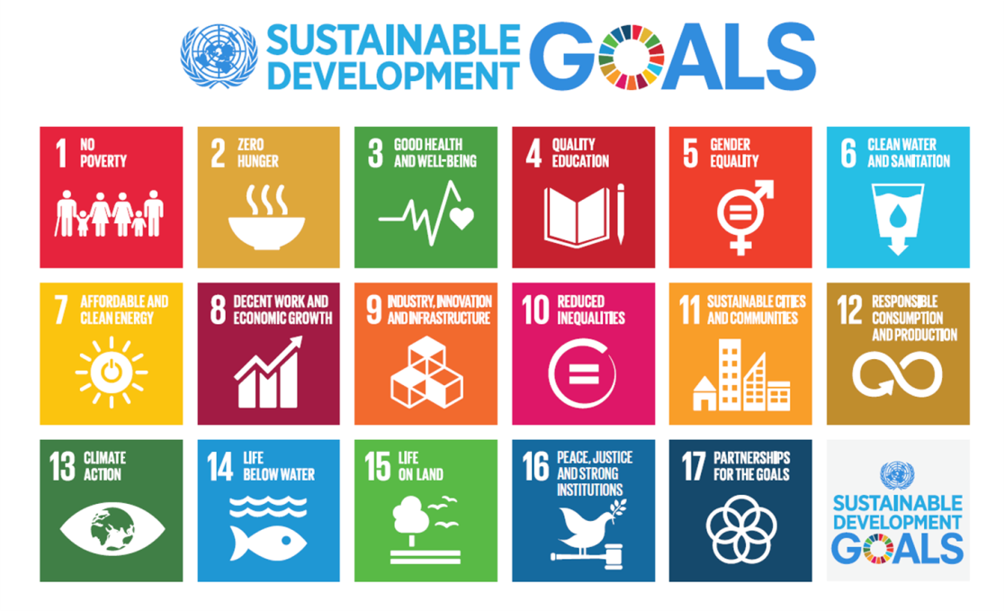
Figure 4: SDGs
(Source: United Nations, 2015)
As globalisation is driving consumer awareness related to environmental and social issues, organisations are progressively integrating sustainable practices within daily operations (Green Key, 2024). The integration is performed to improve sustainable development and ensure growth ethically and economically. The sustainable development goals by the United Nations are the frameworks for organisations to identify the areas of sustainable integration in the daily business and improve overall sustainability performance (United Nations, 2015).
Benefits
- Driving growth
According to Legrand et al., (2022), integrating sustainability in daily operations improves business growth as it implements sustainable practices that are designed to offer sustainable benefits including financial, social, and environmental aspects.
- Addressing risks
The key sustainable risks are negative influence on the environment, society, and profitability (Dos Santos et al., 2017). However, the integration of sustainability practices reduces carbon emissions, manages waste, improves human rights including ethical business practices and increases financial performance.
- Attracting investment
As the business grows more by implementing sustainable practices, an organisation succeeds in achieving its goals and meeting the interests of all the stakeholders including the shareholders (Walsh and Dodds, 2017). As the sustainable value increases the overall organisational worth, investors are attracted to invest more in sustainable initiatives and be a part of the noble movement.
- Improving organisational value
When organisations start acknowledging the sustainable benefits of embedding sustainability in daily operations, a hotel is equipped with the capabilities to increase more sustainable value creations (De Lange and Dodds, 2017). In this way, the value propositions of the organisation evolve and improve positively.
- Boosting brand image
Theoretically, higher value propositions and sustainable value creations are the two pillars of brand value and reputation (Wang et al., 2018). As a result, by creating meaningful value creations with sustainable integration, the appeal of the brand is enhanced in the market, which boosts its competitive position. Additionally, higher brand appeal supports positive employer branding to attract employees while integration of sustainable practices retains employees positively.
- Attracting wider audiences
Similar to the brand appeal to employees and investors, due to meaningful and sustainable value creations, hotels can attract wider customers (Han, 2021). Besides, by designing sustainable services, customer experience can be improved which enhances customer retention of hotel brands.
Challenges
- Cost and Investments
Implementation of sustainable initiatives requires higher upfront investments (Rodríguez-García et al., 2023). These initiatives increase the operational costs in the short term initially for hotels.
- Supply chain challenge
Maintaining transparency and ethical suppliers is a challenge for sourcing raw materials (Babu et al., 2018). However, implementing advanced digital technologies can alleviate the challenge by improving transparency in real-time.
- Rigid regulatory environment
The standard requirements for receiving a sustainable certificate in the hospitality industry are higher and the compliance procedure is strict (Mak and Chang, 2019). This rigidity in the regulatory environment often forces businesses to indulge in PR and marketing to greenwash their services.
- Lack of education and awareness
The consumers, employees and the general public are unfamiliar with the concept and importance of ESG in hospitality (Legrand et al., 2022). This lack of awareness creates challenges for businesses to communicate the value propositions and justify the price points according to the general public.

The future of the hotel & hospitality industry
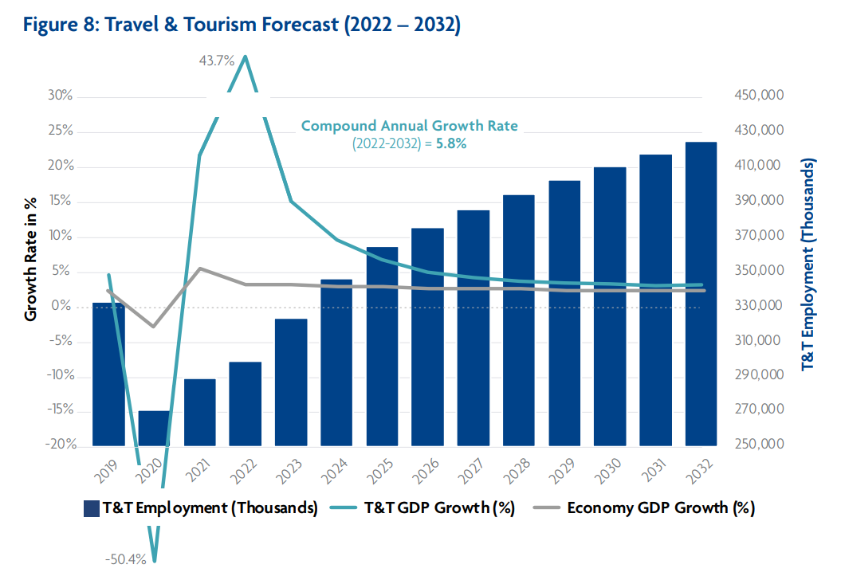
Figure 5: The travel and tourism forecast
(Source: Song et al., 2019)
The expected compound annual growth rate of the travel and tourism industry including the hospitality segment is 5.8% by 2032 with steady employment growth (Song et al., 2019). Therefore, the future of the hotel and hospitality industry can be argued as booming. The following are some of the trends that are likely to shape the future of the hospitality industry.
- Personalised hospitality services
Personalisation is the new normal in consumer behaviour across industries. The hospitality services will predominantly depend on creating personalised services for customers to improve the experience (Buhalis et al., 2019)
- Higher dependence on smart mobile technology
As the number of smartphone users is increasing globally, hospitality businesses will embed smart mobile technology to improve service delivery and customer experience in future (Buhalis et al., 2019).
- Growth of eco-friendly and sustainable practices
Due to higher awareness about climate change, sustainably conscious customers will see eco-friendly hospitality services (Kim and Jeong, 2018). The demand for properties with sustainable amenities, transparent reporting, environment-friendly services, and higher involvement will increase in future.
- Increased concern about safety and health
The recent Covid-19 pandemic offered a major lesson for both the hospitality businesses and customers (Jiang and Wen, 2020). Both parties are aware of superior safety and health practices in hospitality, which are likely to be normalised in future.
- Growth of Bleisure travel
Post-pandemic, a new market segment has emerged in the hospitality industry, which is likely to dominate the market dynamics in future. Bleisure is an amalgamation of business and leisure travel that extends work trips to leisure weekends (Walia et al., 2023). This growing opportunity will add to the predicted growth rate of the hospitality industry in future.

Conclusion
Overall, the report discusses the sustainability requirements to receive green certification in the hospitality industry. The findings identify that the range of requirements is huge and strict to receive a certification in hospitality. Sustainable integration in the hospitality business leads to significant benefits including business growth, positive brand appeal, higher value creation and others. However, the integration challenges include a rigid regulatory environment, lack of awareness about ESG, costly implementation and others. Despite the roadblocks, the predicted growth of the hospitality industry in the future is positive. The future of this industry is likely to be shaped by a wide range of factors. It is expected that sustainability will not be a future prediction anymore but a mandatory part of hospitality businesses.

References
Babu, D.E., Kaur, A. and Rajendran, C. (2018) ‘Sustainability practices in tourism supply chain: Importance performance analysis’, Benchmarking: An International Journal, 25(4), pp.1148-1170.
Buhalis, D., Harwood, T., Bogicevic, V., Viglia, G., Beldona, S. and Hofacker, C. (2019) ‘Technological disruptions in services: lessons from tourism and hospitality’, Journal of Service Management, 30(4), pp.484-506.
De Lange, D. and Dodds, R. (2017) ‘Increasing sustainable tourism through social entrepreneurship’, International Journal of Contemporary Hospitality Management, 29(7), pp.1977-2002.
Dos Santos, R.A., Méxas, M.P. and Meiriño, M.J. (2017) ‘Sustainability and hotel business: criteria for holistic, integrated and participative development’, Journal of cleaner production, 142, pp.217-224.
Ertuna, B., Karatas-Ozkan, M. and Yamak, S. (2019) ‘Diffusion of sustainability and CSR discourse in hospitality industry: Dynamics of local context’, International Journal of Contemporary Hospitality Management, 31(6), pp.2564-2581.
Fernández-Robin, C., Celemín-Pedroche, M.S., Santander-Astorga, P. and Alonso-Almeida, M.D.M. (2019) ‘Green practices in hospitality: A contingency approach’, Sustainability, 11(13), p.3737.
Filimonau, V. and Delysia, A. (2019) ‘Food waste management in hospitality operations: A critical review’, Tourism management, 71, pp.234-245.
Green Key (2024) Green Key Criteria. Available at: https://www.greenkey.global/criteria (Accessed on 10 May 2024)
Han, H. (2021) ‘Consumer behavior and environmental sustainability in tourism and hospitality: A review of theories, concepts, and latest research’, Journal of Sustainable Tourism, 29(7), pp. 1021-1042.
Han, H., Lee, J.S., Trang, H.L.T. and Kim, W. (2018) ‘Water conservation and waste reduction management for increasing guest loyalty and green hotel practices’, International Journal of Hospitality Management, 75, pp.58-66.
Jiang, Y. and Wen, J. (2020) ‘Effects of COVID-19 on hotel marketing and management: a perspective article’, International journal of contemporary hospitality management, 32(8), pp.2563-2573.
Kim, E., Kwon, E., Hong, S., Shoenberger, H. and Stafford, M.R. (2023) ‘Mollifying green skepticism: Effective strategies for inspiring green participation in the hospitality industry’, Frontiers in Psychology, 14, p.1176863.
Kim, H.J. and Jeong, M. (2018) ‘Research on hospitality and tourism education: Now and future’, Tourism Management Perspectives, 25, pp.119-122.
Legrand, W., Chen, J.S. and Laeis, G.C. (2022) Sustainability in the hospitality industry: Principles of sustainable operations. Abingdon: Routledge.
Mak, A.H., and Chang, R.C. (2019) ‘The driving and restraining forces for environmental strategy adoption in the hotel industry: A force field analysis approach’, Tourism Management, 73, pp.48-60.
Pham, N.T., Tučková, Z. and Jabbour, C.J.C. (2019) ‘Greening the hospitality industry: How do green human resource management practices influence organizational citizenship behavior in hotels? A mixed-methods study,’ Tourism management, 72, pp.386-399.
Premier Inn. (2024) About us. Available at: https://www.premierinn.com/gb/en/why.html (Accessed on: 9 May 2024)
Rodríguez-García, R., Ferrero-Ferrero, I., and Fernández-Izquierdo, M.Á. (2023) ‘Analysis of integration of sustainability in sustainability certifications in the hotel industry’, Frontiers in Sustainability, 4, p.1116359.
Sakshi, Shashi, Cerchione, R. and Bansal, H. (2020) ‘Measuring the impact of sustainability policy and practices in tourism and hospitality industry’, Business Strategy and the Environment, 29(3), pp.1109-1126.
Song, H., Qiu, R.T. and Park, J. (2019) ‘A review of research on tourism demand forecasting: Launching the Annals of Tourism Research Curated Collection on tourism demand forecasting’, Annals of Tourism Research, 75, pp.338-362.
Sorin, F. and Sivarajah, U. (2021) ‘Exploring Circular economy in the hospitality industry: empirical evidence from Scandinavian hotel operators’, Scandinavian Journal of Hospitality and Tourism, 21(3), pp.265-285.
Travel Foundation (2016) Making a positive impact. Available at: https://www.thetravelfoundation.org.uk/ (Accessed on 10 May 2024)
UNFCCC (2018) UN Works with Global Hotel Industry to Reduce Emissions. Available at: https://unfccc.int/news/un-works-with-global-hotel-industry-to-reduce-emissions https://unfccc.int/news/un-works-with-global-hotel-industry-to-reduce-emissions (Accessed on 10 May 2024)
UNGC (2012) Communication on Progress 2021: Soneva. Available at: https://unglobalcompact.org/participation/report/cop/active/478046 (Accessed on 10 May 2024)
United Nations (2015) THE 17 GOALS Available at: https://sdgs.un.org/goals (Accessed on 10 May 2024)
Walia, S., Kour, P., Choudhary, P. and Jasrotia, A. (2023) ‘COVID-19 and the bleisure travellers: an investigation on the aftermaths and future implications’, Tourism Recreation Research, 48(5), pp.657-667.
Walsh, P.R. and Dodds, R. (2017) ‘Measuring the choice of environmental sustainability strategies in creating a competitive advantage’, Business Strategy and the Environment, 26(5), pp.672-687.
Wang, J., Wang, S., Xue, H., Wang, Y. and Li, J. (2018) ‘Green image and consumers’ word-of-mouth intention in the green hotel industry: The moderating effect of Millennials’, Journal of cleaner production, 181, pp.426-436.
Wayman, C. and Niemann, H. (2021) ‘The fate of plastic in the ocean environment–a minireview’, Environmental Science: Processes & Impacts, 23(2), pp.198-212.

