Problem solving and decision making.
Charlotte wilkins (2234143
Table of Contents
Define a complex problem in the workplace, including its scope and impact​3
Analyse information on the identified problem, to help inform the decision making process​3
Propose a range of alternative solutions to the problem​4
Using a decision making technique, evaluate a range of solutions to identify the most appropriate option​4
Develop a detailed plan for implementing the solution​5
Communicate the plan to relevant stakeholders​6
Assess appropriate monitoring and review techniques to ensure successful implementation of solution​6
References​7
Appendix 1​8

Define a complex problem in the workplace including scope and impact

I. Introduction
In today's fast-paced and competitive business environment, complex problems are commonly encountered in the workplace.
The purpose of this essay is to explore the definition, scope, impact, and potential solutions for complex problems in the workplace.

II. Definition of a complex problem
. A complex problem in the workplace is characterised by its multifaceted nature, involving various interconnected elements and requiring intricate analysis.
The characteristics of complex problems include high uncertainty, ambiguity, multiple stakeholders, and the need for innovative approaches.
Examples of complex problems in different industries may include managing organisational change, addressing diversity and inclusion issues, and dealing with the impact of technological advancements.

Scope of complex problems in the workplace
Complex problems can arise in diverse organisational contexts, such as human resources, operations, marketing, and finance.
The complexity of these problems is attributed to a wide range of factors, including technological advancements, globalisation, organisational culture, and shifting market dynamics.
Complex problems often permeate and affect multiple aspects within a workplace, such as productivity, employee morale, and resource allocation.

Impact of complex problems in the workplace
Complex problems can have detrimental consequences on individuals, teams, and organisations, leading to increased stress, decreased job satisfaction, and decreased performance.
Unresolved complex problems can also have a financial impact, affecting profitability, operational efficiency, and resource utilisation.
Real-world case studies and examples can demonstrate how complex problems, such as a failure to adapt to changing consumer preferences, can lead to repetitional damage and loss of market share.

Solutions and strategies for addressing complex problems.
. Analysing and solving complex problems in the workplace requires the utilisation of analytical frameworks, such as systems thinking and root cause analysis.
Collaboration, communication, and incorporating interdisciplinary perspectives are crucial in effectively addressing complex problems.
Successful strategies for resolving complex problems include fostering a culture of continuous improvement, promoting knowledge-sharing, and leveraging technological tools for data analysis.

In order to tackle my complex problem in the workplace, I have decided to take a look at computer issues and how they may affect my small business in the near future.
A complex problem that small home-run businesses may come across is the lack of reliable computer systems that are required for their operations. There is no doubt that home-run businesses often have limited resources, which can make it difficult for them to keep up with the latest hardware and software solutions. Additionally, if the business does not have access to a reliable IT team and does not have the ability to troubleshoot and resolve technical problems, this can lead to a number of problems such as slow processing speeds, outdated technology, and compatibility issues.
A major concern with computer issues is how they will affect potential buyers in various ways, for example, buyers may experience delays in receiving their goods as a result of a malfunctioning website or system. There is also the possibility that they will not be able to access online services, resulting in a lack of information or inability to make a purchase. Computer problems may also lead to data breaches, which can also put buyers at risk of identity theft or financial loss.
Analyse information on the identified problem to help inform the decision-making process.
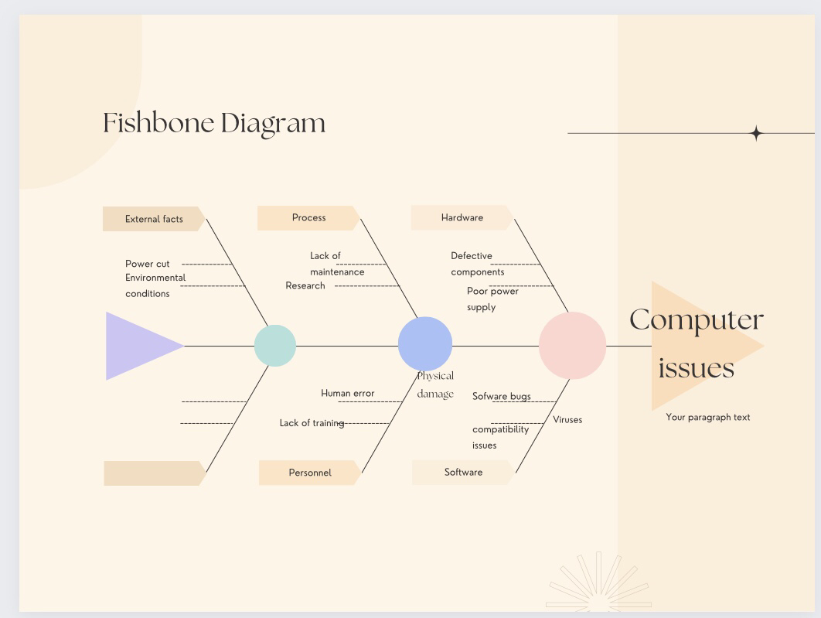
When confronted with computer issues the ishikawa chart proves to be a valuable tool for identifying and analysing the factors that contribute to the problem.
By providing a structured and visual approach the ishikawa chart helps users identify potential causes more efficiently and allows for a more comprehensive analysis of computer problems understanding the various categories of causes commonly associated with computer issues further strengthens this analysis, enabling a targeted and effective troubleshooting process.
Propose a range of alternative solutions to the problem.
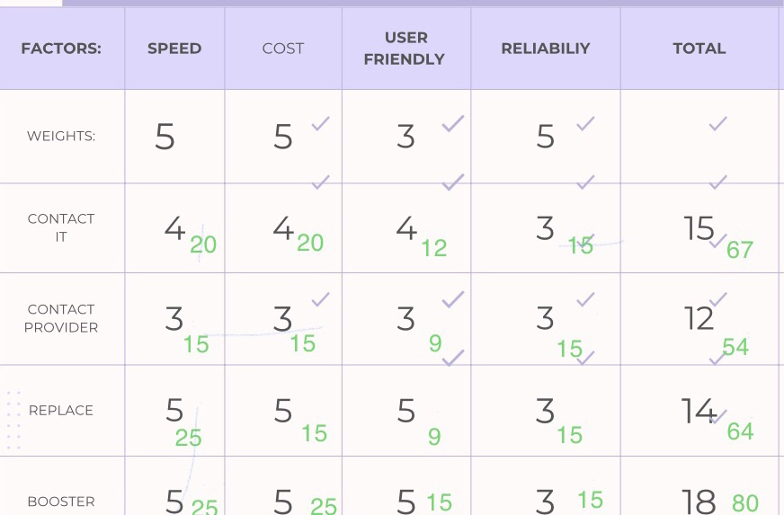

Cost of benefit analysis

The grid analysis technique is the most effective and very useful technique for the decision-making process in order to make the right decisions. This tool is most useful when there is so much information available that there are so many alternatives that can be used, and there are so many factors that should be taken into account. The first step in the process of making a decision is to identify and list out all the available options as well as all the factors that will be important when making a decision. There is also a second step that has to be carried out in order to identify the relative importance of all the factors that have been considered when making the decision. In order to determine the preference, all of these factors are considered and weighed in accordance with their importance. The following step is the one where every option is given a certain score based on the importance of factors that are included under each decision, and this is done after a certain amount of time has passed. Once the least preferred option has been scored out and eliminated from the possible options, the remaining options can be considered. Hence, in order to give the right weight to the decisions, each score will be multiplied by the values of how important the various decisions are in the overall scheme of things. In summary, once all the weighted scores have been calculated, they can then be added to the options, and then the option that is the most highly weighted must be selected.
.

Firstly, I could contact the IT department to troubleshoot the issue. They can help identify the cause of the problem and provide guidance on how to resolve it.
Secondly, contact your internet provider to ensure that your internet connection is strong and reliable. Ask them for troubleshooting tips and advice on how to optimise your connection. Make sure to inquire about any additional services or upgrades that may be available to further enhance your connection.

The final option would be to buy a new computer. This would be a more expensive option, but it could be worth it if the computer is needed for work or other important tasks. A new computer will have more power and be more reliable than a used one, so it could be worth the investment.

For computer issues, there are a variety of solutions available. For basic troubleshooting, users can try restarting their computer, updating their operating system, or running anti-malware scans. More advanced issues may require contacting the manufacturer or a professional computer technician. Additionally, users can look up online resources such as tutorials or forums to find solutions to their problems.
Another option is contacting a professional IT service provider for computer problems. Professional IT service providers can quickly diagnose and fix computer software and hardware issues in a timely manner. They can also provide support for setting up and configuring new computer systems as well as providing advice on the best practices for computer security and maintenance.
If none of the above options are available to you, you may need to purchase a new computer. However, before doing so, you should explore the possibility of upgrading your current system with additional memory or an improved processor. This could be a much more cost-effective solution than buying a completely new computer.
Develop a plan for implementing the solution
Problem Solving Strategies Chart

1. Gather Information: Collect data and facts to understand the problem.
2. Identify Root Causes: Analyse the data to find the source of the problem.
3. Generate Solutions: Brainstorm potential solutions to the problem.
4. Evaluate Options: Analyse each solution to determine its feasibility.
5. Select the Best Option: Choose the solution that is best suited to the situation.
6. Implement the Solution: Put the chosen solution into action.
7. Monitor and Evaluate: Track the results to assess the effectiveness of the solution.

 | Day 1 | Day2 | Day 3 | Day4 | Day 5 | Day 6 | Day 7
Phone It
Research
Fix computer
Set up new
Transfer data
Look for booster

I created a Gantt chart to help me plan and track the progress of my project. The Gantt chart allows me to clearly define tasks, set deadlines, and track progress on a timeline. It also helps me visualise the project's timeline and identify potential problems or delays. By using a Gantt chart, I can ensure that my project is completed on time and within budget. Businesses should develop an effective problem-solving process that encourages creative thinking and collaboration. This should involve brainstorming, breaking down the problem into manageable parts, researching potential solutions, evaluating those solutions, and implementing the best ones. Additionally, having a team of diverse individuals who can approach the problem from different perspectives can help to find the best solutions.
Brainstorming–This technique is mostly used by the organisation as this will help in evaluating numerous solutions for a problem by a discussion and group problem-solving. This is the most creative technique that will help in identifying the solutions for complex problems.you can also use this technique in order to find creative ideas to solve the problems. Through this technique, the most creative ideas that are-given by the employees of organisation and noted down and then evaluate-them to choose a most effective solution for a problem.This is also similar to the nominal group think but in brainstorming the solutions are frequently given by the employees and in the nominal group think they evaluate and take time to provide their ideas.

Communicate the plan to relevant stakeholders
.
It is very necessary for companies to communicate the plan to their stakeholders so that they are able to implement the plan effectively and effectively and also allot the finance accordingly. For communicating the plan to stakeholders, the company has to organise the meeting with stakeholders so that they easily understand the plan the Company also organises the conference with stakeholders and also provides annual report. In meeting, company will tell the importance of the plan so that they agree with the decision and helps in implementing the plan effectively.
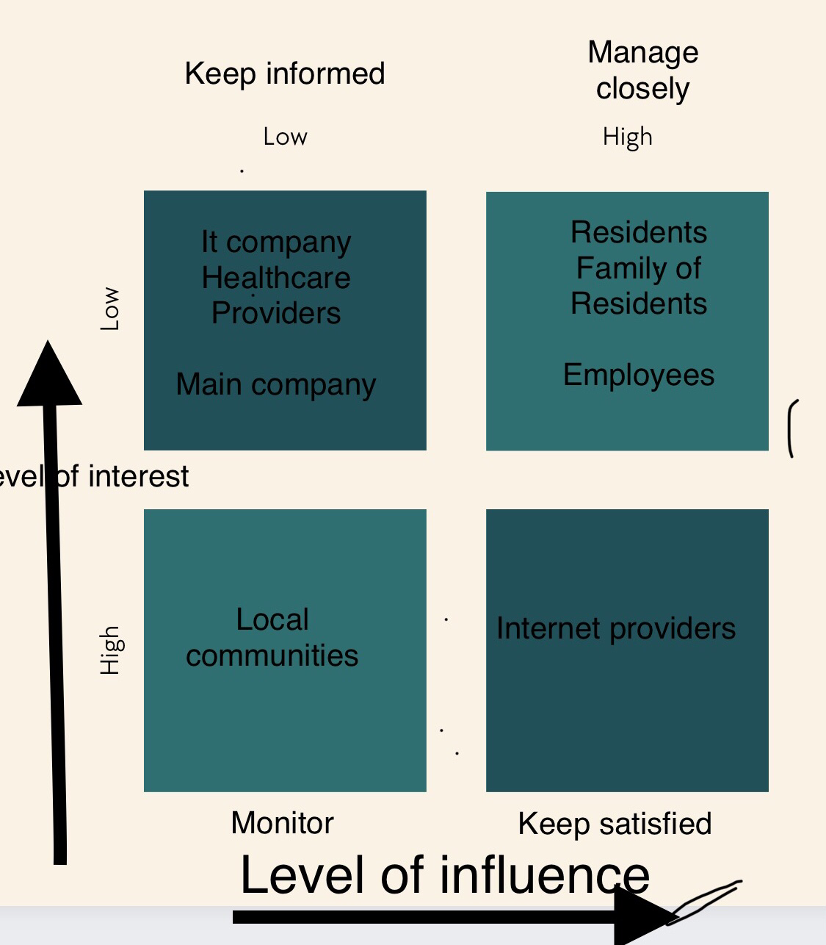
A stakeholders matrix chart is a useful tool for mapping out the power influence in a business. It is a visual representation that outlines the level of influence and interest a stakeholder has in the business. The chart is made up of four quadrants that represent the stakeholders’ level of influence and interest, ranging from high influence/high interest to low influence/low interest. By mapping out the stakeholders in this way, it is easier to identify the most important stakeholders and create strategies to ensure their needs are met.
Shareholders are a key stakeholder in a matrix chart as they have a financial interest in the success of the company. They provide capital to the business and are likely to have voting rights in major decisions. In order to make sure their needs and expectations are met; a q matrix chart should take their interests into account.
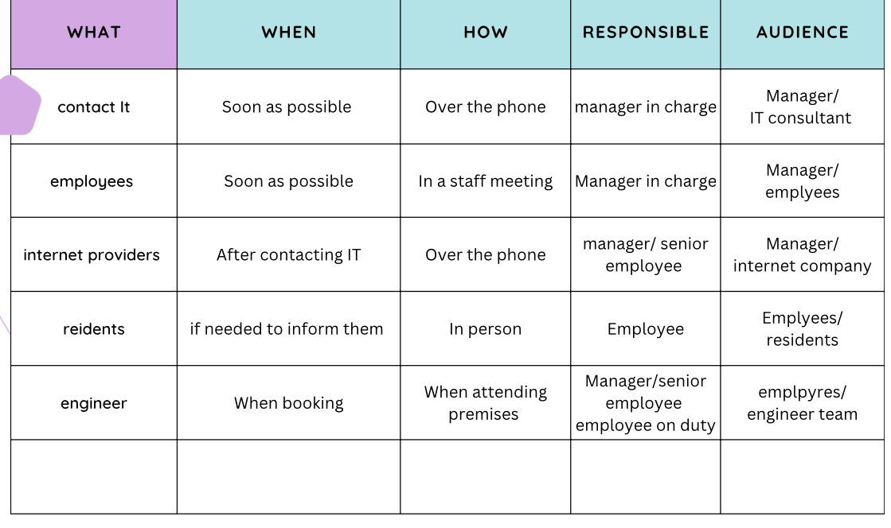
Assess appropriate monitoring and review techniques to ensure successful implementation of solution
A Gantt chart is a useful tool to assess the appropriate monitoring and review techniques to ensure successful implementation of a solution. It provides a visual representation of the tasks and timeline of the project, allowing for easy identification of potential issues or delays. It also allows for easy tracking of progress, enabling stakeholders to review and adjust their approach as needed.
References
Reference: Ishibashi, S. (2003). The Ishikawa diagram: An overview of its history, uses, and application. Quality Management Journal, 10(1), 17-23.
Gantt Chart: https://en.wikipedia.org/wiki/Gantt_chart
In the Journal of Applied Management and Entrepreneurship, Mary L. Gorman wrote a paper called "Matrix Charts: A Visual Tool for Project Management and Decision Making", which appeared in 2008. Reference: "Matrix Charts: A Visual Tool for Project Management and Decision Making," by Mary L. Gorman, Journal of Applied Management and Entrepreneurship, 2008.

