BMSW4006 _SWAN
Kersha May Davies
Student Number 1904

Table of contents.
Business Plan for Kitchen secrets. 1
Business Name- Kitchen Secrets. 1
Business Owner- Kersha May Davies. 1
Mission Statement. 2
Kitchen Secrets, “OFCI” (Organic, Fresh, Creative, and inexpensive). 2
Aims and Objectives. 3
S.M.A.R.T Goal Analysis. 3
Introduction. 5
Marketing activities. 6
Physical resources. 8
Human resources. 8
Financial resources. 9
Cash-Flow. 11
S.W.O.T 12
References. 14
Appendices. 15
Appendix 1 Cash flow Chart. 15
Appendix 1 website design. 16
Appendix 2 website for kitchen secrets. 17
Appendix 3. 18
Appendix 4. 19
Appendix 5. 20
.￼ 20
Appendix 6. 21
Appendix 7. 22
Appendix 8. 23
Appendix 9. 24
Appendix 10. 25
Appendix 11. 26
Appendix 12. 28
Appendix 13. 29
Appendix 14. 30
Appendix 15. 31
Appendix 16. 32
Appendix 17. 33
Appendix 18. 34
Appendix 19. 35
Appendix 20. 36
Appendix 21. 37
Appendix 22. 38
Appendix 23. 39
Appendix A Questionnaire results. 40
Appendix B. 41
￼ 41
Appendix C. 42
Appendix E. 44
Appendix F. 45
Appendix F. 46
Appendix H. 47
Appendix I. 48
Appendix J. 49
Appendix K. 50
Appendix k.1. 51
Appendix k.2 51
Appendix k.3. 51
Appendix k.5. 52
Appendix L. 53
Appendix H. 54
Appendix I. 55

Business Plan for Kitchen secrets.

Business Name- Kitchen Secrets.

Business Owner- Kersha May Davies.

Mission Statement.

Kitchen Secrets, “OFCI” (Organic, Fresh, Creative, and inexpensive).

The goal of this business concept is to promote healthy eating in our community. These foods will be organic, fresh, unique, and reasonably priced.
The goal of this business is to promote a nutritional product of healthy foods to the community and Gym members at a moderate cost.
There are limited healthy food sources in the community. Individuals will receive a Nutrional diet and a healthy lifestyle on the go when this service is open to the public.
This service will generate an atmosphere of enthusiasm throughout the community and encourage individuals to live a healthy lifestyle without having to purchase products from grocery stores or prepare their own meals.
Preparing and creating healthy meals can be time consuming. This service enables individuals to save time in their busy schedules by assisting them to manage their time.
With this option the service provides, individuals can pick up their meals or they may prefer their meals to be delivered to their home/ work address.
The aim of this business is to promote a healthy lifestyle and create time-management for individuals.

Aims and Objectives.

S.M.A.R.T Goal Analysis.

Specific-
The defined target of this organization is to provide a low-cost, healthy option for individuals. The estimated price of purchasing a catering business is around 5000 pounds, and monthly pitch rates from around £439 pounds. (How much does it cost to start a Street Food business?, 2021).
Local customers will be attracted to the business when the business is advertised via social media, website and an online questionnaire. This business's healthy cuisine will be displayed on the social media site and the secret kitchen website. This will improve revenues by instilling a sense of enthusiasm in the community and resulting in a significant increase in sales.
Measurable-
This company is measurable since it achieves its profit targets. The use of an innovative strategy called "Trailing Stop-loss" will exemplify when the company is accomplishing its profit goals and when it is not.
Setting a net income of 500-700 pounds per week will enable the company to reach the business's profit goals.
This will identify the company's profits as-well as its liabilities. Profit targets can aid in analysing profits and losses, reducing the possibility of a failed business.
Achievable-
The community has a limited selection of healthy food options. Creating a one-stop healthy choice for consumers by illustrating recipes on social media as well as ensuring that the food is organic, fresh, and innovative, and satisfying the customers, this can ensure that this goal is achieved.
Realistic-
With minimal healthy options, and the positive message on saving money and time this can be a successful business. Creating a Target profit chart can progress towards understanding the business profits and loses, this will illustrate how successful a business is (Setyawati, 2016).

Timebound-
The duration of this company's operation is one year. With the completion of the trading standards tests and the availability of pitch fees, this business should be ready to open within a year.
The business will open at 7.30 a.m., Monday to Friday and will close at 4 pm., on Sunday mornings it will open at 6 am., for breakfast until 12 pm. I as the proprietor, will arrive at 5.30 a.m. to sanitize the equipment, prepare the merchandise, and guarantee that the ground exceeds all safety regulations. (SWOT Analysis: – How to Develop a Strategy For Success, 2021).

Introduction.

There are limited healthy food trailers and there is a high demand for Healthy food produce within today's food industry. With a positive message on healthy living, this business can be suited to a variety of individuals who attain a busy lifestyle.
The service not only supplies Healthy meals but provides meal prep, protein shakes and smoothies. All the ingredients are organic and fresh this will be clearly stated on every product, this will be appealing to gym members saving them time and money.
The trailer will be based outside a popular local gym. This will be attractive to the gym members and the local public as there is easy access and on-site parking. There will be an attractive seating area with shelter for when the weather conditions are bad.
Loyalty cards will be provided for the public and gym members. This will entice customers to revisit every day for a free meal or smoothie at the end of the week.
There is an option for the meals to be delivered to a home or work address. This can provide the opportunity for elderly or disabled individuals who cannot leave their homes and have limited resources to assist them with. This can ensure these individuals attain a healthy lifestyle with this option of service.
The unique selling point of this business is that it provides Healthy, organic produce. The service is appealing to a variety of personnel. It saves individuals time and money.
The meals can be ordered to go, in advance or can be delivered to a home or work address. With loyalty cards the customers will be rewarded with one free meal of their choice at the end of the week.

Marketing activities.
The seven ps.
The seven Ps marketing strategy will give an overall breakdown of what the business needs to become successful within its production and services. The 7PS are;
- Product, Quality, image, branding, Features, variants, mix, support, customer service, occasions of use, warranty and availability.
Creating a website and Facebook page and enabling customers to take an online survey/ questionnaire will promote the attractive cuisine this will assist with the image and branding. Promoting the product, creating an attractive menu will illustrate the appealing cuisine the business has to offer.
Illustrating the menu via Facebook and the website will ensure customers to view exactly what types of produce the business provides.
- Promotion- Marketing communications, personal promotion, sales Promotion and Branding.
Creating a social media networking account and a website with an online questionnaire can encourage customers to take part, they are entitled to comment their views and opinions via Facebook, email, questionnaire or website page.
Implementing the various marketing communications will contribute towards an appealing image of the marketing branding.
Illustrating certificates of high standards via Facebook/website page will illustrate a personal promotion.
- Price, Positioning, lists, discounts, credit, payment methods, free or value-added elements.
Creating loyalty cards will promote a discount with a free meal at the end of the week. Gym members will have the same loyalty cards however these cards will include a reference of their gym member ship number, promoting these customers to discounts and value-added elements.
This will include a 20% discount on smoothies and protein shakes. Customers can purchase two smoothies and get one free, Aswell as receiving a free meal at the end of the week and a free smoothie or protein shake of their preference. Payment methods will be used via cash or card.

- Place, products and support.
The business will use the P2P service (peer to peer) this business will directly buy produce from this business. Deliver deeds is allocated 2 miles from the secret kitchen.
The meat fruit and veg are harvest on this farm. The produce is 100% organic and fresh. The business will receive support from the gym owner, gym members and the customers.

- People, individuals on marketing activities and customer contact, Recruitment, Culture/ image, training and skills, Remuneration.
I, as the proprietor, will manage the company. I will, however, require an assistant with the required expertise and certifications to operate and maintain the workflow. Employees will be trained to provide excellent customer service. Creating a positive customer experience will benefit this company's image and reputation.
Creating a social media page with an attractive menu via Facebook page with a link leading directly to the website with an online question air will promote the business name and give customers the opportunity to express their opinions.

- Process, customer focus, Business-led and Design features.
The business Delivery Deeds will be the sole distributer for this company. They have the correct storage facilities and containers to ensure no meats are contaminated. And fruit and veg are stored away from other produce.
Deliver deeds are based 2 miles from kitchen secrets, this is saving time and eco emictions.

- Physical evidence staff contact and their experience, product packaging online experience.
The kitchen secrets trailer has passed all the safety regulations. It has brand new fire safety interior such as unit's, cupboards, walls and has recently been installed with a fire safety roof.
It is a high-end style with and recently painted, with new interior, doors and serving window. The menu is clear to see for the customers and an attractive seating area with a cover when weather conditions are bad.
The online experience is an easy access for all customers to view and express their opinions. The produce can be viewed clearly online as well as the packaging (Febriansyah, 2019).

Physical resources.
This business is powered by a generator. Once the trailer is towed to the pitch it will be stabilised and remain in place. The generator will need to be moved every night. However, this transportable by car.
Security cameras are installed inside and outside the trailer, with security cameras facing the trailer from the gym, this will help fund an additional security system at no extra cost.

Human resources.
The trailer does not have simple access for individuals with physical disabilities. The company is unable to employ individuals with physical limitations.
The business and its employees will be covered by insurance. Individuals will be managed and used based on their capabilities.

Financial resources.
With a personal savings account of £1,000,000, the company is within reason produce a high profit. The trailer and generator cost a total of $10,000.
Cooking machinery is an additional 3000 trailer Maintenace is £5,000 per year. Pitch fees are estimated to £15,00 per year.
The National Federation of Enterprise Agencies (NFEA) is a non-profited agency that promotes entrepreneurships. NFEA will assist the company with its start-up costs. As the proprietor of the business, I am self-employed. The NFEA has offices across the country, this ensures that allocating them will be made easy.
The NFEA provides a low interest start up financing, this can save the company money because it is not devoting most of its resources to repaying the loan.
I as the sole trader of this copany will ask the NFEA for an additional five thousand pounds to assist the company with any start-up costs.
The National Federation of Enterprise Agencies (NFEA) represents, unifies, and supports all organisations dedicated to inspiring and developing an enterprise, including enterprise agencies, Chambers of Commerce, municipal governments, and other specialty providers.
When understanding the financial side of business, entrepreneurs must take into consideration these facts when operating a business.
The IRS (Internal Revenu Service) will perceive the business owner as professional if he or she registers a business account and keeps all profits separate from a personal account (Home page - National Enterprise Network, 2021).
Bookkeeping is one of the most fundamental components of a business as it ensures that records are maintained correctly and that company resources are managed correctly.
Maintaining detailed records of operations, businesses can monitor their cash flow and profitability. This enables companies to accurately forecast and plan for their future.
A financial statement is a summary of the company's financial performance at any specified period bookkeeping tracks Payroll and employees, Cash Flow, Accounts payments to suppliers, profit earnings and Monitors inventory Data.
Managing any or all the elements above can be stressful, Fortunately, there are a variety of useful accounting software alternatives available that can simplify several components of day-to-day financial administration.
These systems are cloud-based, therefore ensures users can view their accounting data from any device.
QuickBooks Online, FreshBooks, and Xero are examples of software that businesses can use to keep a record of their bookkeeping.

Individuals who apply their time-management skills will keep their accounting obligations current.
Devoting time each week to ensuring that the finance department has complete records of their data, the business owner will have a clear understanding of their outgoings and profits (Understanding the Financial Side of Your Business - GROW, 2021).
Marketing or attempting to sell any merchandise on the street is known as street trading. This incorporates any public road, walkway, beachfront, and other locations where the public has unrestricted access.
Street Trading Consent is required to trade on all Swansea streets. Kitchen secrets will need to contact trading standards before attempting to open the business.
Swansea has two specified trading locations: the internal zone, which encompasses all public and private land inside the local authority area outside the City Centre, and the external zone, which covers all public and private property outside the City Centre.
When deciding where to pitch this is important to the business owner. Outside of the city centre, the outer zone contains all public and private territory.
As vehicles will have access to the premises, Kitchen secrets will try to get a designated pitch within the outside zone. In the outside zone, there are no fixed pitches, therefore businesses can operate as a mobile trader or from a pitch with permission (Swansea - Street trading, 2021).

Cash-Flow.

The net balance of cash flowing in and out of a company at a specific moment in time is referred to as cash flow. It is possible to have a positive or negative cash flow. Cash flow demonstrates that a corporation is drawing in more money than it is paying out.
Kitchen secrets will need to estimate its prices on products and make a profit of 50% on each product. This will ensure the business manages stock Controle.
The cash flow statement divides its cashflows into three categories:
The first category is cash flow from operating activities, this is the fundamental quantity by which a company earns profits; earnings are generated from sales the estimated sales are 300-700 per week, minus cash paid to suppliers and employees, debt and financial loans, and government tax charges.
NFEA loans are a low-interest rate company the estimation of repaying this loan will cost around one hundred pounds per month.
Increasing the amount of money earned via running activities A growing CFO indicates that the firm is growing, but a declining CFO indicates that the business is faltering, and a negative CFO indicates that the business has failed.
By estimating the number of produce this business will sell this will give an estimation of how much money the business can spend on employee's debt repayments or loans and taxes. The estimation of paying employees is around 8 to 10 pounds per hour. This is an estimation of 0.8% of the company's profits.
The next level of classification is Money earned through investment activities The fee’s structure are the produce related to the purchase or sale of long-term assets, such as property, plant, or equipment
Kitchen secrets will include these fees for Maintenace on the trailer, a generator and delivery driver fuel. This can cost anywhere between 200-300 pounds per month.
Financing activities contribute to the final classification. This is where the corporation has made money via shar, bond, or loan investments.
A negative CFO will reveal the company's losses, indicating that it is repaying debts, stock buybacks, or dividends without creating enough earnings to be profitable.
Kitchen Secrets cash flow chart is in appendix 1 this will ensure the company foresees its income and outgoings, this will illustrate the company's profit margins (Mulier, Schoors and Merlevede, 2014).

S.W.O.T
Strengths-
The organic, fresh imaginative and low-cost produce is one of the company's strengths.
There are limited healthy food trailers within the area. it provides both take-out and delivery services.
Healthy nutritional meals, smoothies and protein shakes is the business unique selling point.
There are community loyalty cards which provide a free meal at the end of the week.
Gym members get 50% discount on smoothies, protein shakes and a free lunch at the end of the week.
The company is located near a local gym and has a well-equipped security system.
Kitchen secrets advertises produce and menus via social media, website, and an online survey.
Weaknesses-
Physically challenged individuals are unable for employment as the trailer is not accessible to them.
The workload can be stressful as there are only two employees. Discount will need to be withheld if the company does not make a profit.
The business will need to make enough profit to pay for legal fees and the pitch price, these prices differ from one country to the next and from one state to the next.
Opportunities-
The food truck industry is a newcomer. Although the market is competitive, it has not yet become overloaded.
There is enough market share for entrants to take advantage of. If they give good service and perform effectively, they will be able to capture a significant portion of the market.
The capacity and talent to experiment with new concepts and flavours and tastes will give the firm a positive image. If clients like it, the firm is profitable if it continues to provide excellent service.
The food trucks have a chance due of the Coronavirus (COVID-19) lockdown. People are stranded at home, and all hotels and eateries have closed their doors. Food trucks are like delivery services in that they can deliver food to people's homes.

Threats-
Permits for food trucks are difficult to obtain in some nations and states. Their legal requirements might be difficult to meet, and they vary from state to state.
A significant government lawsuit might follow from traveling across the city in a food truck and serving food to anyone without a permit. As a result, obtaining a driving permit is essential prior to travelling.
Because there are no copyright issues. A competitor might enter the market, copy a recipe, and sell the same product with the same flavour under a different brand name. This competition can result within a profit loss.
Some individuals are concerned about the sanitation of the food in the truck. If they see anything unhygienic, then they could report the company to or spoil the minds of others, this can result within the loss of the business (Empowerment of Micro, Small, Medium Enterprise (MSME) Using SWOT Analysis, 2021).

References.

Street Food UK. 2021. How much does it cost to start a Street Food business?. [online] Available at: <https://www.streetfood.org.uk/start-up-cost.html> [Accessed 28 June 2021].
Setyawati, C., 2016. Dampak Mentoring Pada Keberhasilan Start-Up Business: Studi Kasus Pada Start-Up Business di Indonesia [Mentoring the Impact of Success of a Start-Up Business: A Case Study of a Start-Up Business in Indonesia]. DeReMa (Development Research of Management): Jurnal Manajemen, 11(2), p.290.

National Enterprise Network. 2021. Home page - National Enterprise Network. [online] Available at: <https://www.nationalenterprisenetwork.org> [Accessed 25 June 2021].

GROW. 2021. Understanding the Financial Side of Your Business - GROW. [online] Available at: <https://www.growbusiness.org/blog/understanding-the-financial-side-of-your-business/> [Accessed 28 June 2021].

Swansea.gov.uk. 2021. Swansea - Street trading. [online] Available at: <https://www.swansea.gov.uk/streettrading> [Accessed 1 July 2021].

Mulier, K., Schoors, K. and Merlevede, B., 2014. Investment Cash Flow Sensitivity: The Role of Cash Flow Volatility. SSRN Electronic Journal,.

Mindtools.com. 2021. SWOT Analysis: – How to Develop a Strategy For Success. [online] Available at: <https://www.mindtools.com/pages/article/newTMC_05.htm> [Accessed 30 June 2021].

Febriansyah, R., 2019. Marketing Mix 7Ps in Islamic Perspective. KnE Social Sciences, 3(13), p.619.

European Journal of Business and Management, 2021. Empowerment of Micro, Small, Medium Enterprise (MSME) Using SWOT Analysis.

Appendices.

Appendix 1 Cash flow Chart.

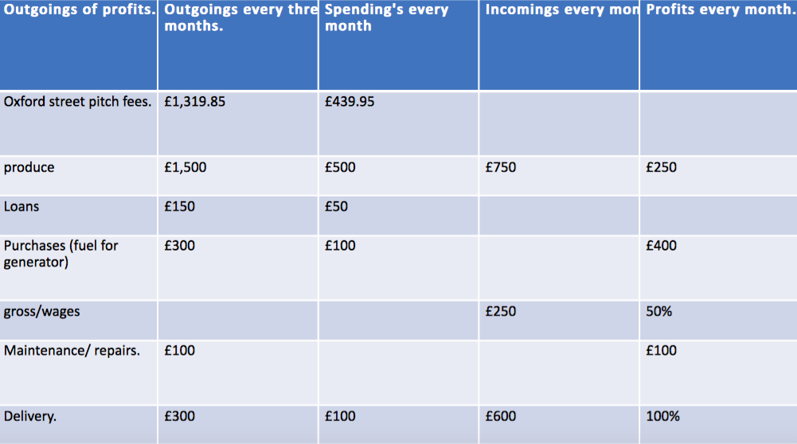

Appendix 1 website design.

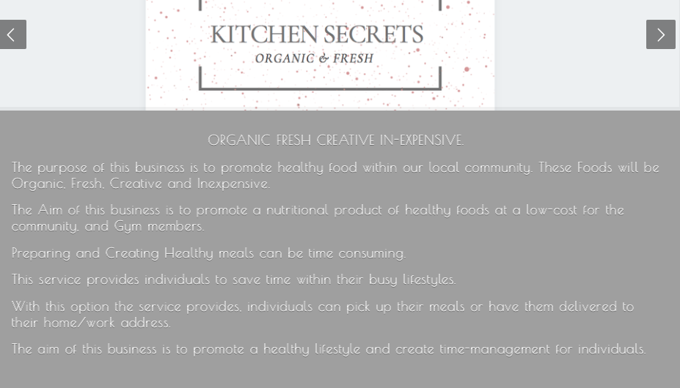

Appendix 2 website for kitchen secrets.
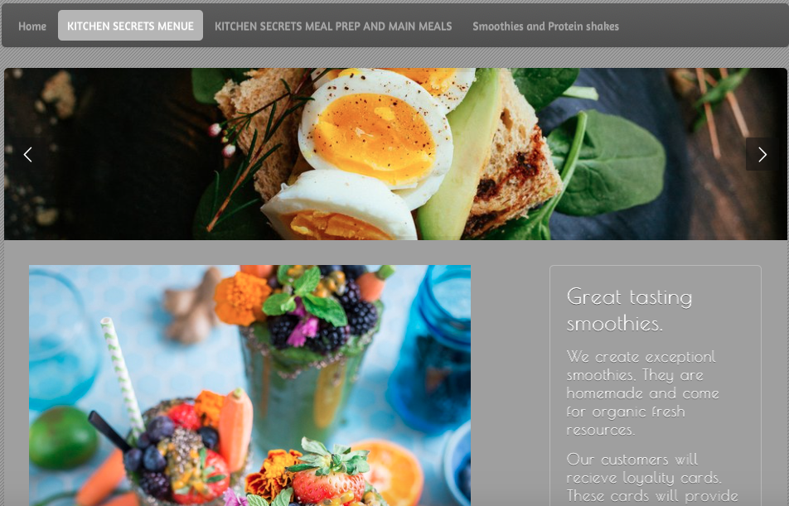

Appendix 3.


Appendix 4.

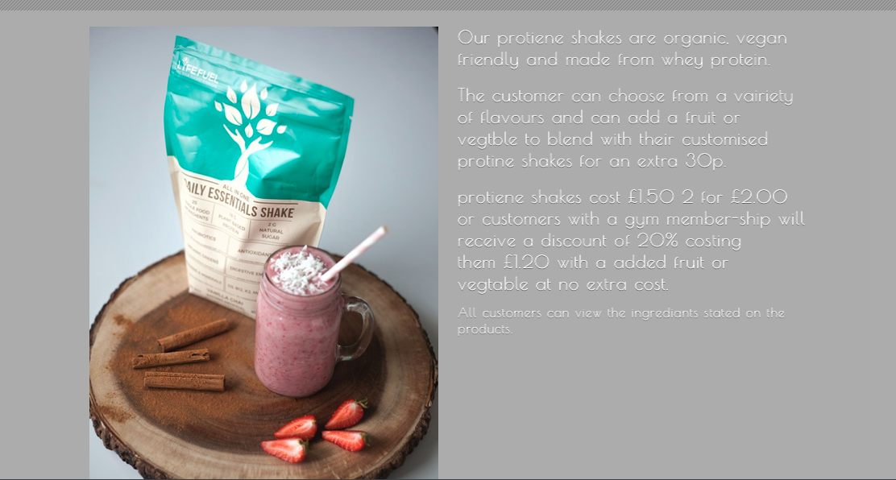

Appendix 5.

.

Appendix 6.

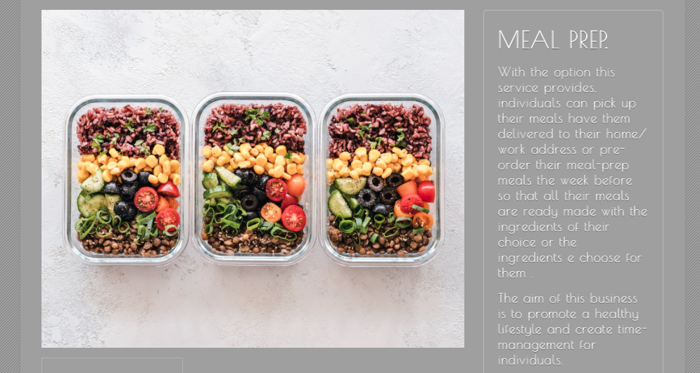

Appendix 7.

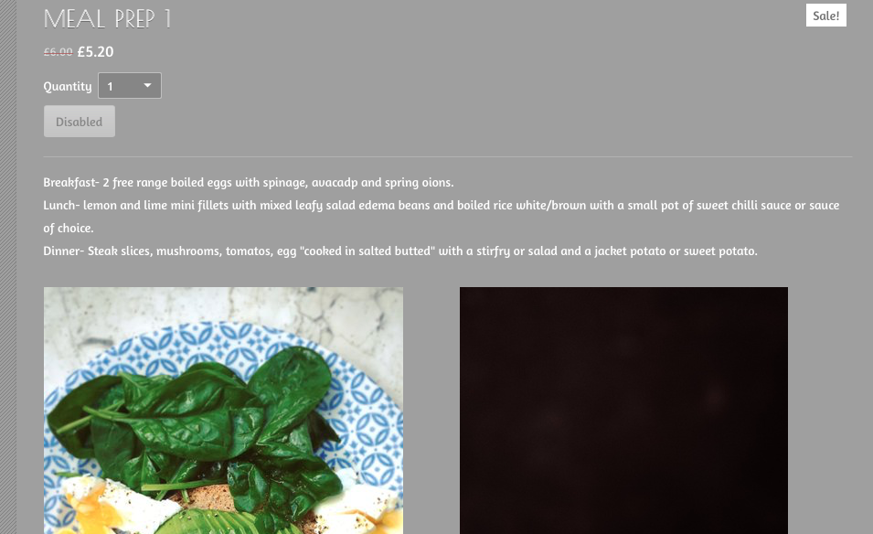

Appendix 8.



Appendix 9.

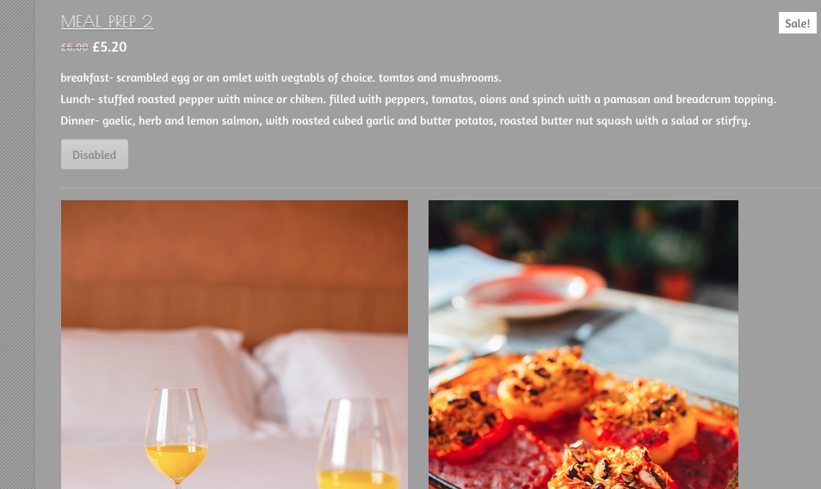

Appendix 10.

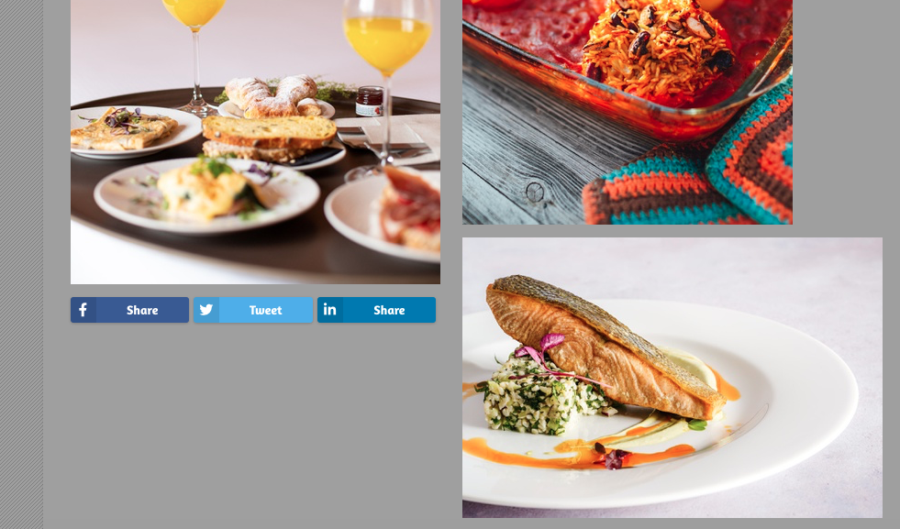

Appendix 11.

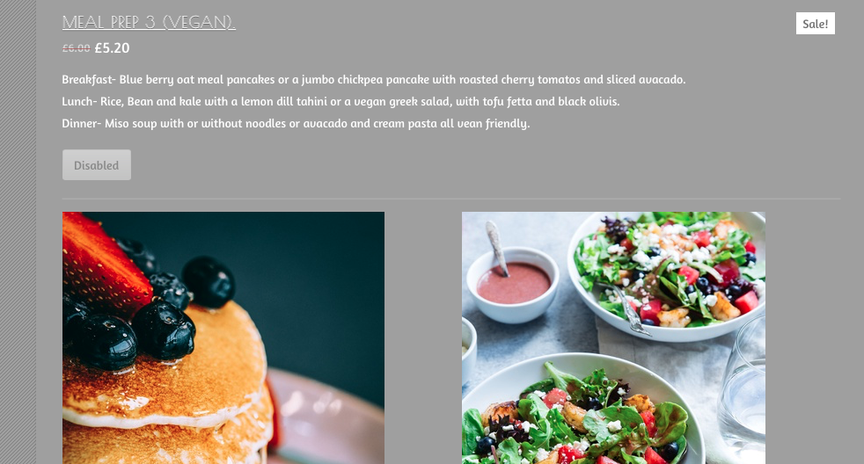

Appendix 12.
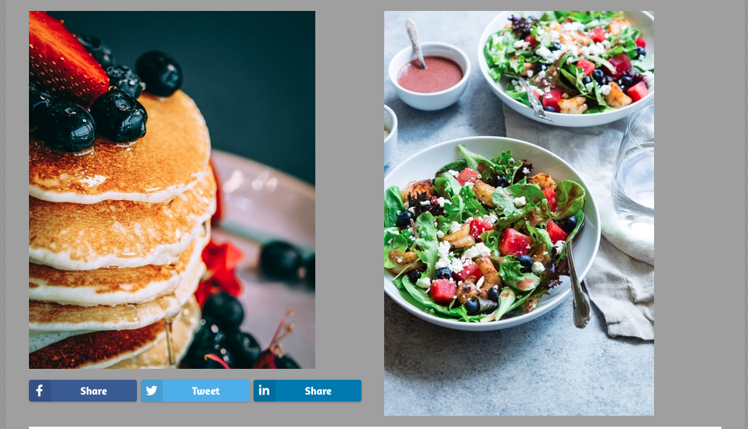

Appendix 13.

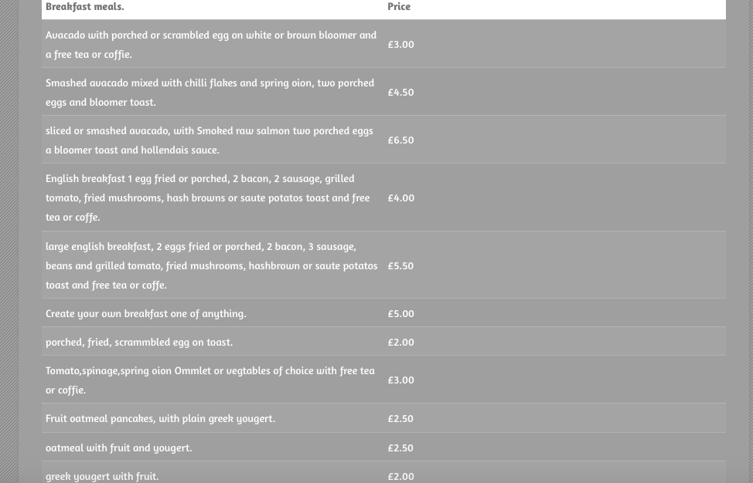

Appendix 14.

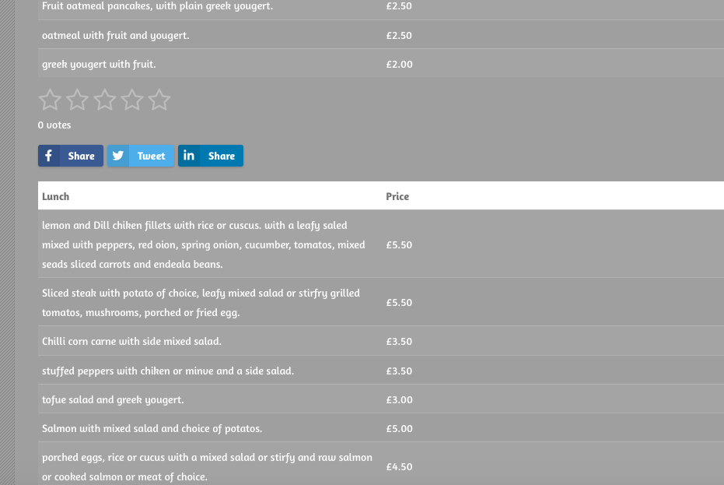

Appendix 15.

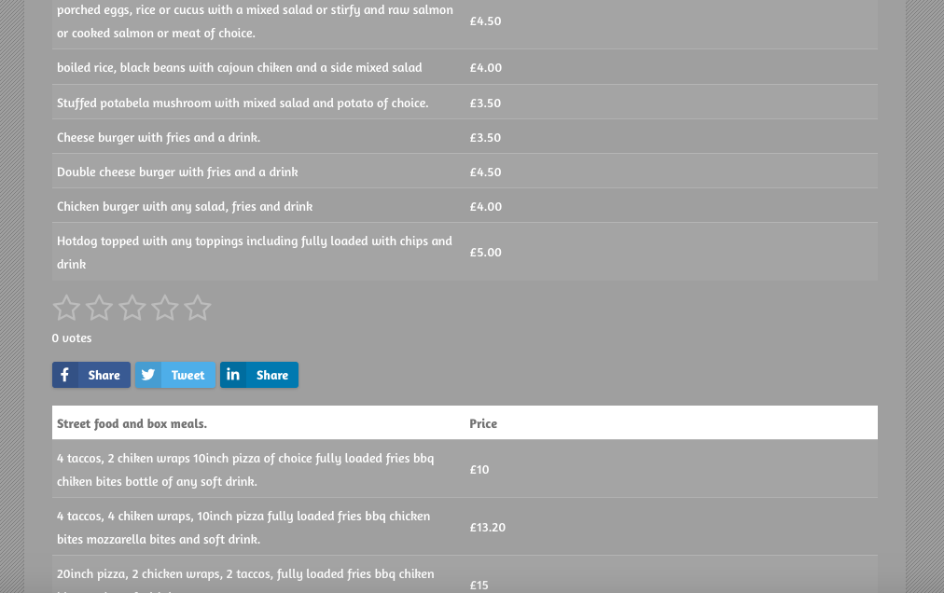

Appendix 16.

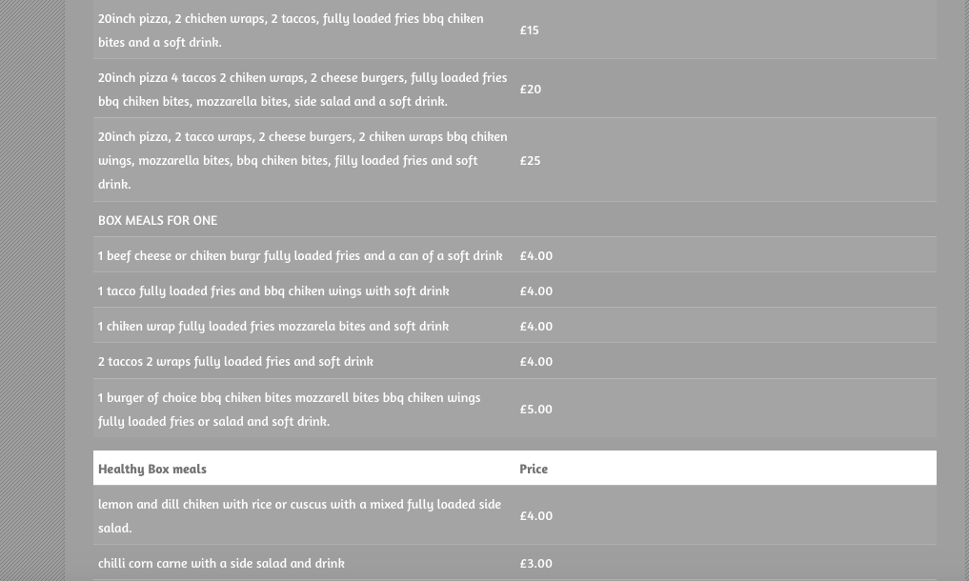

Appendix 17.

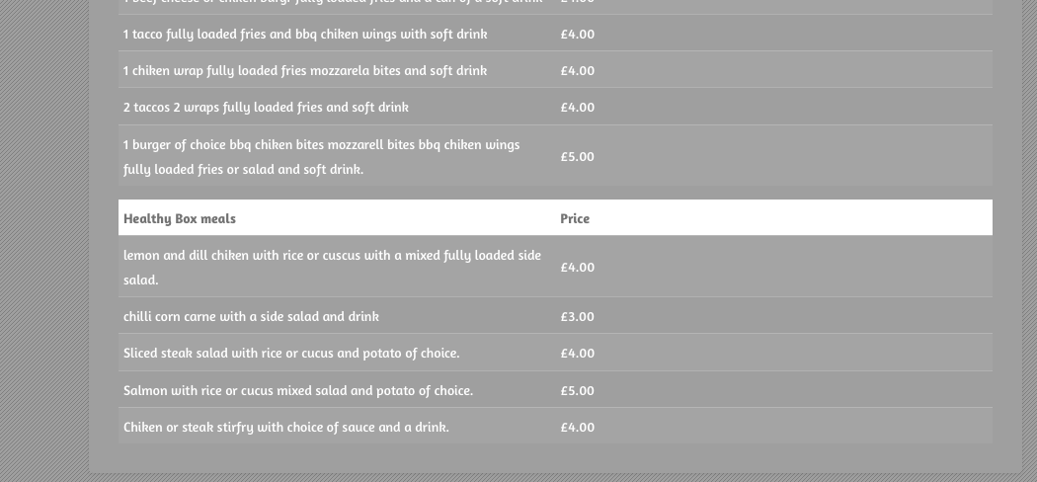

Appendix 18.

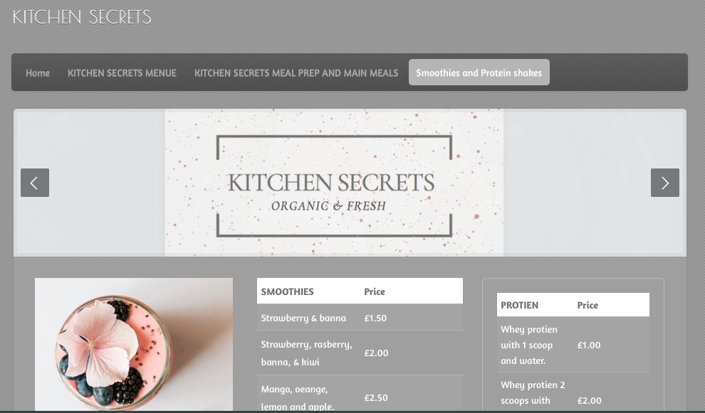

Appendix 19.

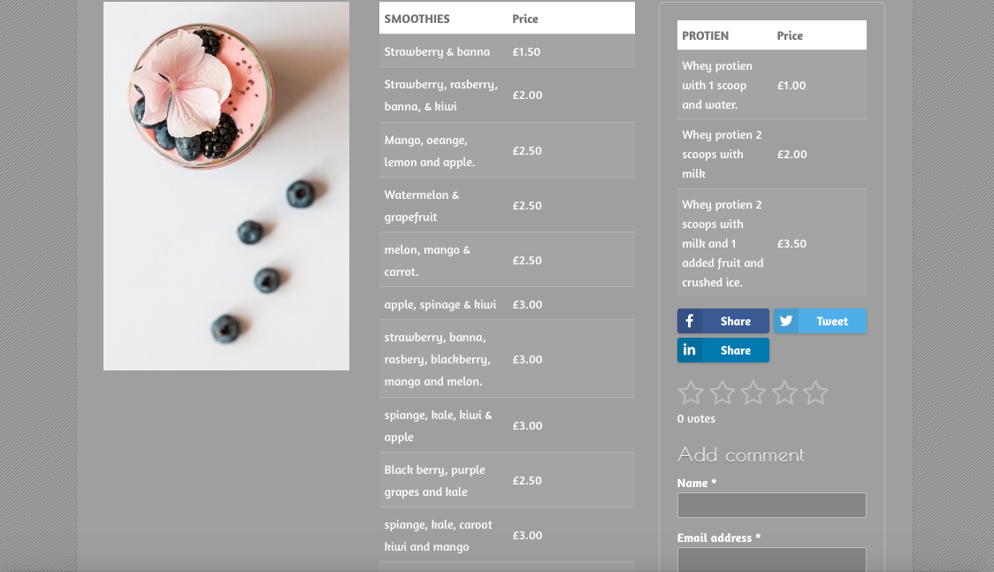

Appendix 20.

Appendix 21.

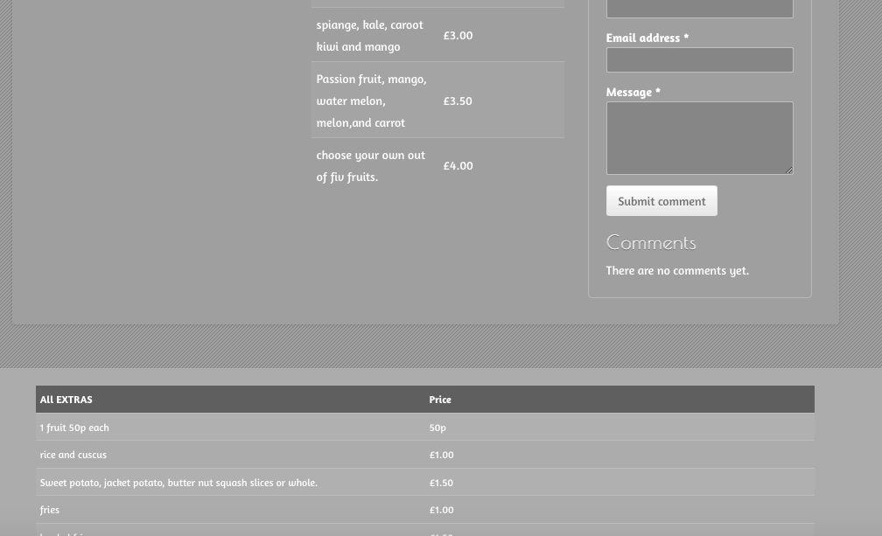

Appendix 22.

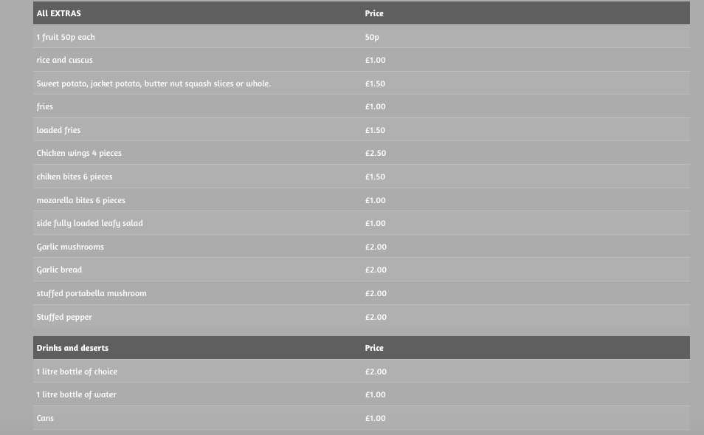

Appendix 23.

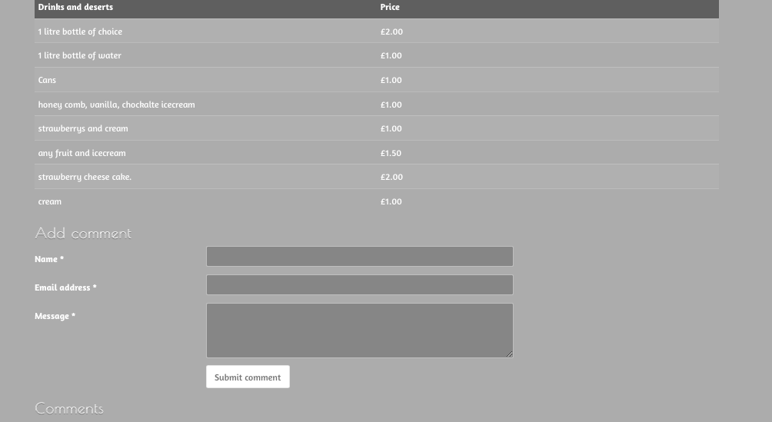

Appendix A Questionnaire results.

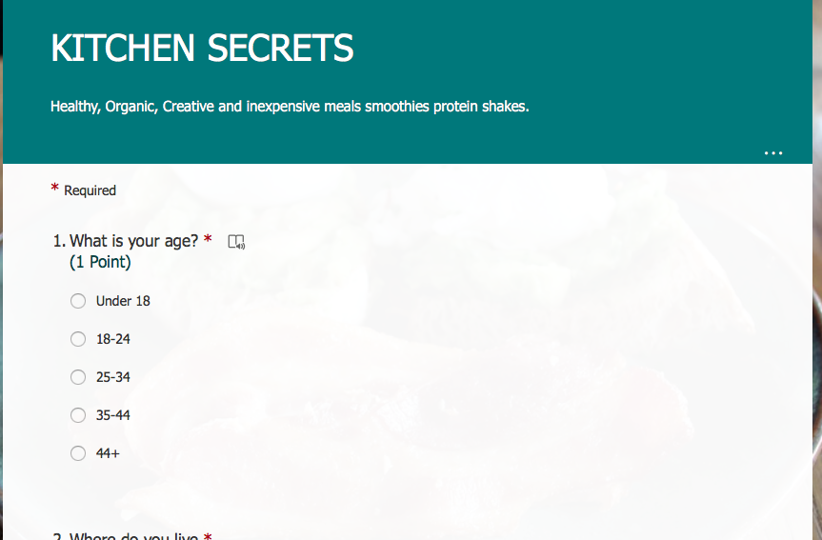

Appendix B.

Appendix C.

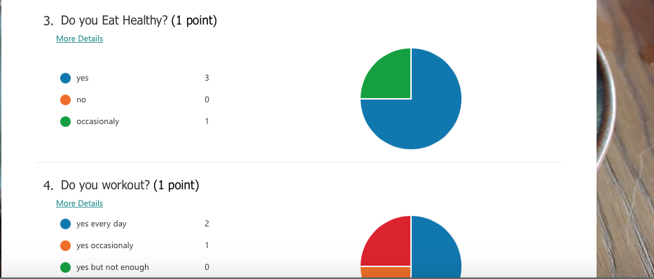

Appendix D.
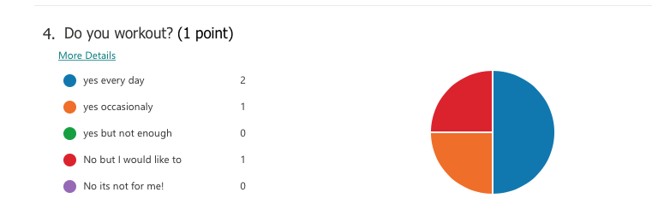

Appendix E.

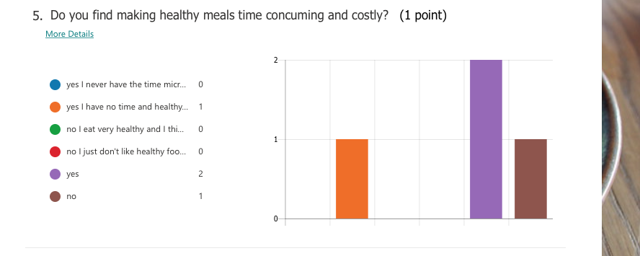

Appendix F.

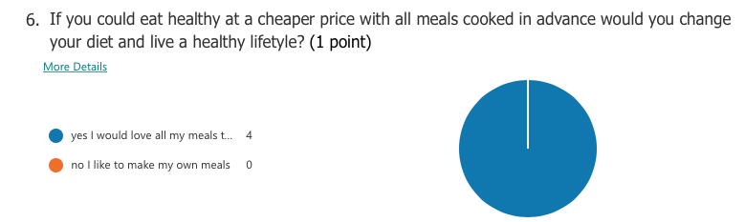

Appendix F.
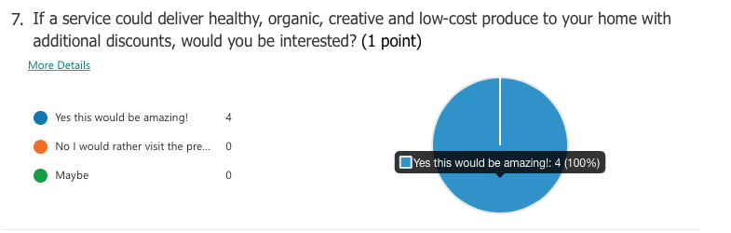

Appendix H.
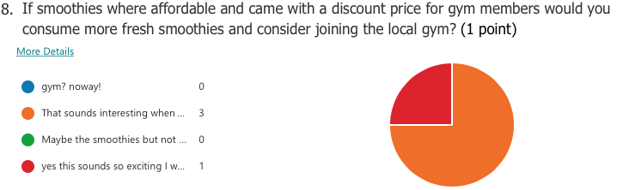

Appendix I.

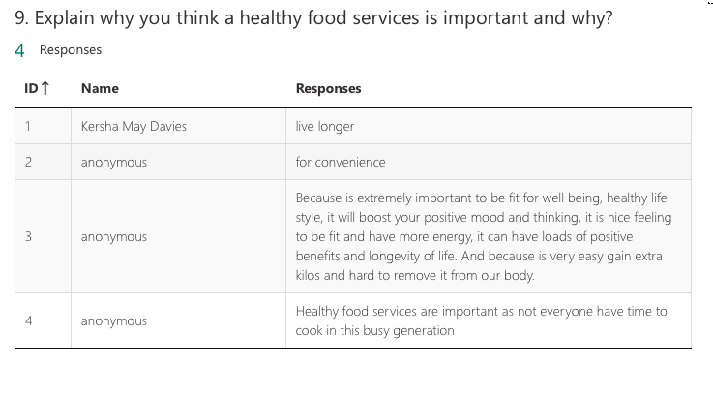

Appendix J.



Appendix K.

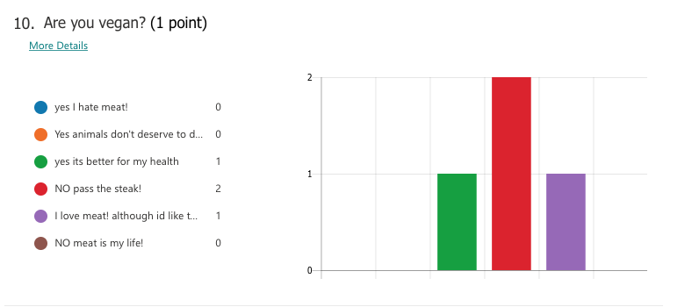

Appendix k.1.
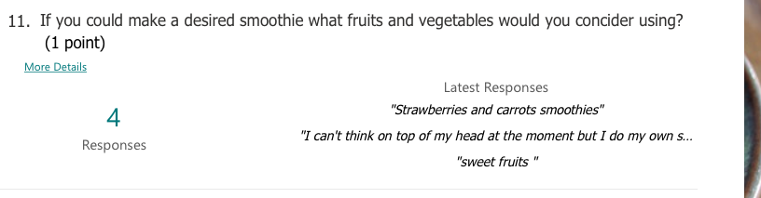

Appendix k.2
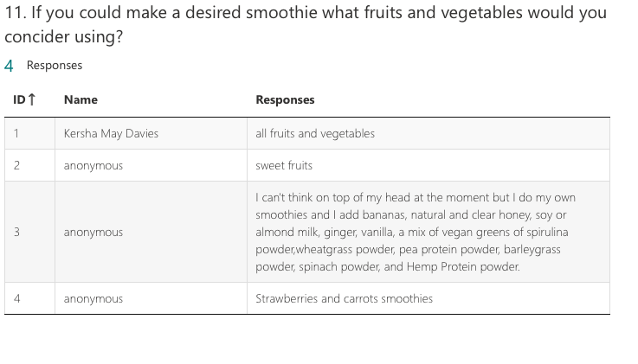

Appendix k.3.
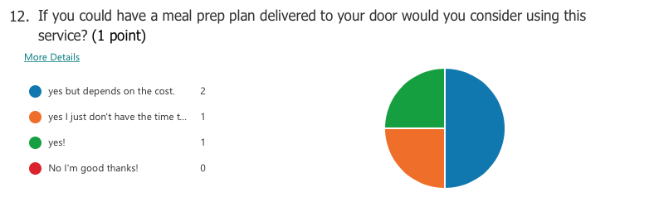

Appendix k.5.
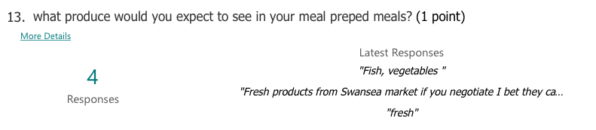

Appendix L.

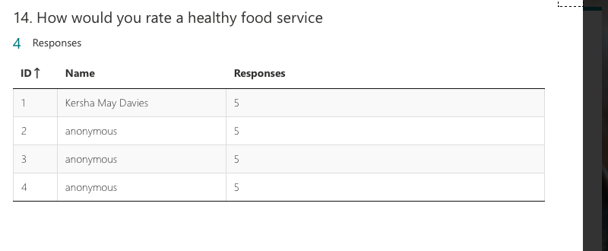

Appendix H.
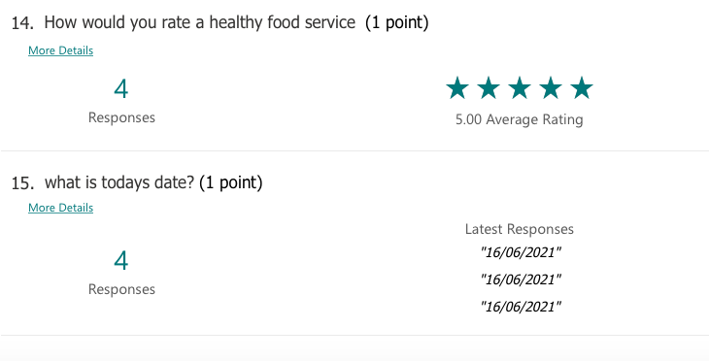

Appendix I.



