Student Name: Diana Stoyanova Student Number: 2007366 Module: Management Economics Module Code: LCBB5003 Lecturer: Vasilios Tavlaridis

IMPACT OF BREXIT ON UK TRADE POLICIES AND ITS COMPANIES’ DECISION-MAKING PROCESS

Introduction
The macroeconomic union of European nations is also known as the European Union (EU). It started as the European Communities, but it evolved into the gigantic organisation it is today with time. Almost four million square kilometres of land and nearly four hundred million people comprise the EU (Wallace et al., 2020). As a member of the European Union, individuals are subject to rules that the whole bloc enforces.

Following a referendum on June 23, 2016, the British people opted for their nation to exit the European Union. There is a lot at stake for both the British and European governments when it comes to Brexit. Many intuitive powers have been revoked since the EU voted to leave (Goodwin and Milazzo, 2017). Economic links to the EU will be drastically altered because Britain voted to exit the EU. When Britain steps away from stronger connections to its near neighbours, it may open trade agreements with countries outside of the European Union. Politicians and everyone interested in Brexit need to know how to evaluate the many economic estimates, what economists do and do not know about Brexit, and why different assessments have contradictory results.

It is essential to look at how Brexit will influence these relationships to evaluate Brexit's impact on UK trade and economic development. Many of the facets of the economy might be adversely affected by the outcome of the Brexit negotiations. This document describes each of them below to make it easier to understand. There are crucial synergies between these parts, though, why the EU was established. As part of the European Union, member nations may benefit from the 'four freedoms' - free movement of commodities, services, money, and people – to the possible fullest extent.

Effect of Brexit on UK Economy and Local Businesses
Trade
The UK's economic output is heavily reliant on exports and imports. Consumers and businesses in the UK make many purchases and sales from abroad. For decades, economists have asserted that international commerce may raise living standards in all nations involved. Each country's 'comparative advantage' may be used to create and consume more by concentrating on those commodities and services. If other nations' economies are large enough to purchase from the UK, and if the UK's products and services are more costly than those from other vendors elsewhere globally, they will buy more of another one, not the UK. They will be mostly untouched by Brexit since the economic development of other nations is expected to be less influenced by Brexit (Minford, 2019).
Customers in other countries pay more for UK goods and services because of three main factors apart from the obvious ones associated with the country of origin:
- When doing business with countries more than a few thousand kilometres apart, travel costs are vital in doing business. Sending goods across long distances is frequently more expensive than shipping goods closer to home.
- Tariffs, or import duties levied by another nation's government on British products, have raised the price of British goods purchased outside of the country. The EU does not impose tariffs on products moving inside its borders, but it does so on imports outside the EU, and non-EU nations do the same for EU imports (Chevassus-Lozza et al., 2008).
- Purchasing UK goods and services from outside the nation may also be more expensive due to several non-tariff restrictions.
As a result of the UK and EU starting with the same laws, non-tariff barriers between the two nations have been reduced (Cipollina and Demaria, 2020). However, there may still be some obstacles to overcome. For example, exporters who need to fulfil origin standards may face additional costs even if the UK is outside the EU Customs Union. In addition, businesses situated outside the EU's Single Market are also denied financial inclusion and other markets by the EU.
There are already preparations in place in the case of a no-deal Brexit for many British firms since they would lose access to their key markets. Innovation may also be hampered because of the more difficult access to capital and Europe. As a result of Brexit, creative industries, such as the British film industry, are also suffering. Filmmakers in the United Kingdom will have fewer options for working together if there is no agreement with Brexit. Artists from Europe may be unable to travel freely because of this. Viewership and money may also suffer (Portes, 2022).
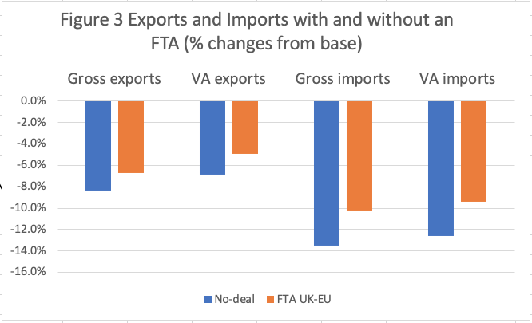
https://blogs.sussex.ac.uk/uktpo/publications/the-cost-of-brexit/
Foreign Direct Investment
Investment is vital to long-term GDP growth. On the domestic and international levels, private and public investment may help increase employee access to better equipment, facilities, and technology and speed up technological innovation and productivity. As trade barriers have been lowered across the globe, international investment has increased. Firms have more money to develop their operations because of foreign direct investment (FDI). Bringing in fresh ideas from across the world may also boost productivity (Gudgin et al., 2018).
Foreign direct investment (FDI) is an essential source of growth for the United Kingdom. European Union countries are responsible for more than half of all foreign direct investment in the United Kingdom. In terms of EU investment in the United Kingdom, The Netherlands is technically the largest. However, some of this investment may not originate in the Netherlands. Instead, be routed via the Netherlands for tax considerations. In 2011, EU investment in the United Kingdom was 49.9 per cent; by 2012, it had dropped to 48.8 per cent (Gudgin et al., 2018).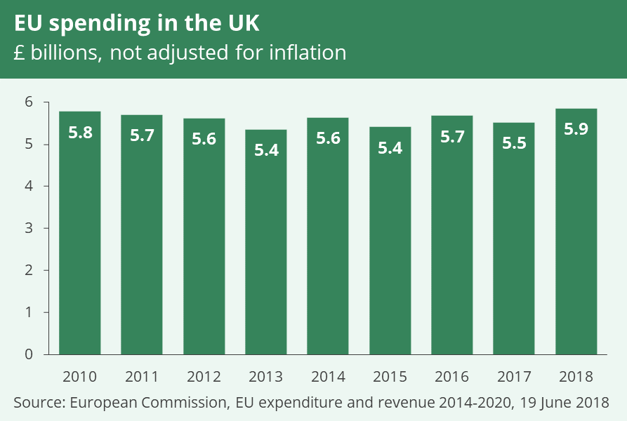
https://commonslibrary.parliament.uk/research-briefings/cbp-7847/

Brexit might cause an impact on the UK's attractiveness to international investors. It is necessary to analyse at least three possible explanations. Firstly, it is easier for foreign investors to invest in the United Kingdom because of the EU Single Market's 'four freedoms' of capital mobility. Secondly, the United Kingdom's membership in the EU Single Market is a desirable export destination for multinational corporations. They may take advantage of the favourable business climate in the UK while still being able to trade with the world of the EU without any issues.
Lastly, EU countries are ideal for major multinational firms with complex distribution networks or subsidiaries throughout EU countries. Because of the EU Single Market, which has consistent rules and allows workers to move freely between countries, coordination costs for these businesses are lowered.
They were increasing business, and investment ties with non-EU nations after Brexit is thus a legitimate strategy for promoting foreign investment. However, current free trade agreements (FTAs) fail to eliminate barriers to cross-border investment or facilitate the same level of frictionless mobility of services, funds, and persons between countries as the One Market's "four freedoms" have (Dhingra et al., 2016).
Because of these two factors, the negative economic impact on UK enterprises is more pronounced. Starting with trade agreements with practically all its trading partners, the UK will have to renegotiate with developed and developing nations. Clauses that are unfavourable to UK companies may result from these talks. The second effect of the UK's decision to leave the EU is that GDP will be harmed. A decrease in domestic demand for goods and services is expected because of the UK's exit from the European Union (EU). Even in the United Kingdom, FDI (Foreign Direct Investment) is expected to decrease (Dhingra et al., 2016).
As a result, foreign-affiliated UK enterprises may have their financing slashed. As a result, foreign direct investment inflows into the UK might drop by 22% because of Brexit, according to projections (Gudgin et al., 2018).

Productivity

The pinnacle of economic success is consistently rising productivity. Employees must generate more extensive and more significant amounts of high-quality output with less and less capital. It is essential to raise living standards to increase productivity. Unfortunately, there is a lack of understanding about what drives product development. After gradually increasing by roughly 2% per year before the financial crisis, productivity in the UK has stalled since 2007. Economists are baffled as to why this is happening (Kierzenkowski et al., 2016).
Brexit has impacted the UK's production efficiency and growth rate for various good theoretical reasons by changing levels of trade, FDI, and migration. Trade restrictions have been removed, and the so-called "static benefits" from trade have been shown. In theory, free trade enables nations to focus on creating commodities that they have a competitive advantage in providing, as David Ricardo initially proposed. As a result, it is possible to cut the mean cost of each output unit by increasing access to a broader market for enterprises. This aspect may help them take advantage of production returns to scale. Static effects offer a one-time boost to production after removing trade barriers but do not sustain that increase over time (Dhingra et al., 2018).

Trade also has "dynamic" advantages, such as higher levels of innovation, R&D, and productivity growth because of more openness to trade. There might be several causes for this:
- Firms may be more inclined to innovate if they face more rivalry from international competitors.
- Any investment in R&D might reap greater rewards if the product can be sold to a broader audience.
- When trading with other countries, local firms have a higher chance of being exposed to new technologies and learning from the practices of their international counterparts.
In the long term, gains in "dynamic" systems could have a much higher impact on economic output (Dhingra et al., 2018).

Businesses in the United Kingdom, on the other hand, have enjoyed the benefits of having access to the whole European Union market for many years. In the future, things will be different for everyone. An agreement on trade between two nations provides the basis for new rules of commerce based on the parameters of that agreement. If these conversations are successful, they will significantly impact UK businesses (Hodge, 2017). 0If they cannot access the single market; businesses may have to start from scratch. Trade and money flows may potentially decline because of this. EU finance is now available to British companies. Firms would likely have to look for new funding sources when Britain finally leaves the European Union. Borrowing and operational expenses may rise because of this (Charles, 2019). The EU is likely to put stricter controls on UK businesses to prevent other nations from leaving. As a result, there may be limited potential for growth in the United Kingdom.

Regulations

Businesses' ability to employ labour, money, and technology cost-effectively is influenced by domestic legislation. Also, as previously said, they have an impact on international commerce. Leaving the EU was argued to allow the UK to tailor legislation to its requirements, increasing economic production. As a result, various restrictions, such as competition and state assistance policies, are aimed to ensure that no one firm gains and exploits a dominating position in the market. A retired UK Office expresses fear for Fair Trading Director-General John Vickers. For example, should Britain withdraw its support for European Union policies, domestic interest groups may exert additional pressure on it to pursue policies that might distort the market (Presscott et al., 2020).

Besides maximising economic production, the UK has other rules in place to accomplish other goals as well. For example, the law mandates worker protections like paid time off and parental leave. In addition, businesses are limited in their capacity to harm the environment and must pay financially to those goals. Farmers, for example, must comply with criteria for animal care if they want to operate as a farm.

EU-level legislation has made it possible for these rules to be changed to fit the UK's requirements after Brexit better. As a result, businesses might increase their total production and productivity by reducing regulatory expenses. Such advantages, however, may necessitate a reduction in worker and environmental regulations (Lehmann, 2016).

Immigration

In addition, the number of persons born in the UK is influenced by several migrants who come to work in the nation. The UK could not stop EU citizens from working in the country since it was a member of the EU. As a result of a widespread belief that the UK government could not control immigration from other EU countries, many voters backed Brexit (Portes, 2022).
Changing immigration policy might be one way Brexit has influenced economic development. To attract specific categories of immigration, this might grow more restricted for EU citizens. Since many EU immigrants are in the country, immigration regulations for non-EU citizens may no longer be possible. Immigration may also harm the UK's productivity. The effect's direction is theoretically unclear. Alternatively, the entrance of migrant workers may drive native-born Britons to enhance their abilities, enabling them to produce more in tandem with businesses from the UK. Firms may have less motivation to invest in promising technologies and robots if they have easy access to a large workforce (Portes, 2022).

Conclusion

It was the goal of this research to assess the economic impact of Brexit on British businesses. According to the survey, companies in the UK face many economic and financial challenges because of the Brexit decision. An increase in interest rates is already on the agenda for many businesses. They are already grappling with regulatory difficulties. A scarcity of labour and a lack of access to foreign markets will make doing business in the United Kingdom more difficult. The details of the eventual deal agreed between the United Kingdom, and the European Union will significantly impact these consequences.
More than one group has come out with reports on the long-term economic impact of Brexit (typically up to 2030). Predictions abound that the UK economy would be worse off after Brexit than if the nation stayed in the EU. However, according to most analyses, there is extensive financial evidence demonstrating an increase in investment, trade, and migration between countries traditionally linked with economic growth because of Brexit.

References

Charles, A., 2019. Brexit: UK's Savior or Downfall? Marriott Student Review, 3(2), p. 4.
Chevassus-Lozza, E., Latouche, K., Majkovič, D. and Unguru, M., 2008. The importance of EU-15 borders for CEECs agri-food exports: the role of tariffs and non-tariff measures in the pre-accession period. Food Policy, 33(6), pp. 595-606.
Cipollina, M. and Demaria, F., 2020. The trade effect of the EU’s preference margins and non-tariff barriers. Journal of Risk and Financial Management, 13(9), p. 203.
Dhingra, S., Ottaviano, G., Rappoport, V., Sampson, T. and Thomas, C., 2018. UK trade and FDI: a post‐Brexit perspective. Papers in Regional Science, 97(1), pp. 9-24.
Dhingra, S., Ottaviano, G.I., Sampson, T. and Reenen, J.V., 2016. The consequences of Brexit for UK trade and living standards. UK: Springer.
Goodwin, M. and Milazzo, C., 2017. Taking back control? Investigating the role of immigration in the 2016 vote for Brexit. The British Journal of Politics and International Relations, 19(3), pp. 450-464.
Gudgin, G., Coutts, K., Gibson, N. and Buchanan, J., 2018. The macro-economic impact of Brexit: using the CBR macro-economic model of the UK economy (UKMOD). Journal of Self-Governance and Management Economics, 6(2), pp. 7-49.
Kierzenkowski, R., Pain, N., Rusticelli, E. and Zwart, S., 2016. The economic consequences of Brexit: a taxing decision. UK: Springer.
Martin, R. and Gardiner, B., 2019. The resilience of cities to economic shocks: a tale of four recessions (and the challenge of Brexit). Papers in Regional Science, 98(4), pp. 1801-1832.
Minford, P., 2019. The effects of Brexit on the UK economy (No. E2019/1). Cardiff Economics Working Papers.
Portes, J., 2022. Immigration and the UK economy after Brexit. Oxford Review of Economic Policy, 38(1), pp. 82-96.
Prescott, C., Pilato, M. and Bellia, C., 2020. Geographical indications in the UK after Brexit: an uncertain future? Food Policy, 90.
Wallace, H., Pollack, M.A., Roederer-Rynning, C. and Young, A.R. eds., 2020. Policy-making in the European Union. Oxford University Press, USA.
Winters, L.A. and Martins, P.M., 2004. When comparative advantage is not enough: business costs in small remote economies. World Trade Review, 3(3), pp. 347-383.

