Human Resource Management

Assessment 2

Table of Contents
Introduction 3
Reward policies to be implemented at The Hanoi Hat Company to increase employee engagement 4
Compensation based Individual Rewards 4
The presence of Motives: 5
Benefits based reward systems 6
Intrinsic Reward Policies 7
Organisational Rewards: 8
How the General Manager can persuade the line managers to understand that the reward policies can add value to the business 9
Merit pay, overtime, skill based pay, payment by results, performance pay can result in higher employee motivation and engagement: 9
Application of Maslow’s Hierarchy of Needs 9
Benefits based reward policies (healthcare facilities or services, retirement benefits, paid time off, recreational tours) play important role to motivate and engage employees: 10
Application of Maslow’s Hierarchy of Needs 11
Intrinsic reward policies (training, career development, performance management, succession planning and recognition) are important to engage and motivate employees: 11
Application of Herzberg’s Two-Factor Theory of Motivation 11
Organisational rewards (profit sharing, gain sharing, and shared ownership) plays at the highest level of motivation: 12
Conclusion 14
References: 15

Introduction
Every employees in an organisation undergoes with certain level of mental and physical efforts to achieve the goals and objectives of the organisation; in return the employees get certain fiscal and non-fiscal payments and benefits (Noe et al. 2017). Rewards are the most important motivational factor for which employees work in organisations. Therefore, reward is considered the key management level. Reward system is not limited to only to financial benefits; rather reward policies also cover non-financial benefits such as career progression, training or development. This report will mainly cover two issues: contemporary reward practices and demonstrating the importance of the reward practices. The issues and topics will be applied in an organisational named The Hanoi Hat Company. Established in Vietnam, the line managers of the company contradicts with the General Manager (GM), who had an MBA from a Western Business School, on the GM’s initiatives to appoint a Specialist HR Manager. This report will outline the contemporary reward practices to introduce in The Hanoi Hat Company to enhance employee engagement. The report will also provide an evaluative section, to convince the Line Managers at Hanoi, outlining how the reward policies can add value to the business of Hat manufacturing.

Reward policies to be implemented at The Hanoi Hat Company to increase employee engagement
Reward policies refer to how the organisation view the issue of rewarding employees for their contribution to the organisation as means to motive them and to keep them in organisation for sustainable results (Mondy & Martocchio, 2016). There are long-standing debate over the use of extrinsic rewards and intrinsic rewards and this impact on the organisations. Boxall & Purcell (2011) asserted that over the years, organisations have emphasized only on extrinsic rewards (such as financial rewards and tangible rewards) whilst extrinsic rewards (learning, recognition, career development opportunities etc.) also play significant role to motivate and engage employees. Below section outlines a range of different reward policies that can be introduced in The Hanoi Hat Company.

Compensation based Individual Rewards
Compensation based individual rewards are extrinsic rewards that play the most important role to engage employees and that are paid in financial terms such as basic pays, overtime pay, merit based payment, piece rate pay and so on (Noe et al. 2017).

Figure 1: Compensation based reward systems have fiscal elements (Mondy & Martocchio, 2016)

Above diagram 1 demonstrates a range of different compensation based payments can be implemented in an organisation. Basic pay, overtime, piece rate pays are the rewards that employees receive for their jobs for the company. Similarly, overtime, bonus, and commission are important to influence employees to work increasing hours and thus resulting in higher organisational performance (Noe et al. 2017).s Mondy & Martocchio (2016) asserted that basic payment or overtime payments are the least way to motivate and engage employees because these elements are not associated with intrinsic rewards. Still, these payment methods play important role to motivate the employees and workers at The Hanoi Hat Company. The reason is that the employees have less competitive opportunities in the industry (as per case study); thus if Hanoi pays regularly to the employees and workers these will play the greatest role to engage them. At the same fashion, overtime, bonus, and commission can contribute to employee engagement at Hanoi because the attractions of higher payments will make employees more motivated to work more and accurately.

The presence of Motives:
Dowling, Festing & Engle (2013) asserted that the presence of motives such as skill based payments, pay by results, and performance related pay can play significant role in a labour oriented industry. Therefore, these techniques will play significant role in The Hanoi Hat Company since this is a labour based garments company (Case Scenario).

Figure 2: Basic motives can play significant role to motivate workers at The Hanoi Hat Company (Dowling, Festing & Engle, 2013)
Expertise, performance is highly important at Hanoi; thus if the company starts a policy of pay rises based on enhanced performance and skills or results; the employees and workers will be highly engaged with the company and its activities.

Benefits based reward systems
Benefits are rewards that employees receive apart from the basic payments such as healthcare facilities or services, retirement benefits, paid time off, recreational tours sponsored by the company etc. (DeCenzo, Robbins & Verhulst, 2016). As the definition shows, most of these are extrinsic rewards by their nature.

Figure 3: Benefits based reward systems (DeCenzo, Robbins & Verhulst, 2016)
As the diagram above shows, health and welfare related pay relate to payments for illness on the job or off the job; recreation means tours or anything sponsored by the company etc. The nature of these benefits are to motivate employees and workers and these means of motives are evaluated highly than compensation based reward approaches discussed previously.
Above mentioned reward system can play significant role to engage and motivate employees at The Hanoi Hat Company because these rewarding techniques are perceived highly among employees earning low and who have less opportunities outside (Bratton & Gold, 2017). For example, implementation of the retirement benefits at Hanoi will let the employees remember that the amount of benefits will be mounting-up if they effectively perform at the same company for longer time. This will certain motivate and engage the employees and workers to stay for longer time at Hanoi Company because the longer the stay, the higher the retirement benefits.

Intrinsic Reward Policies
Intrinsic rewards are the non-financial and intangible benefits that employees or workers receive because of their superior performance and productivity (Armstrong & Taylor, 2010).

Figure 4: Intrinsic reward policies (Armstrong & Taylor, 2010)
The reward techniques demonstrated on above figure 4 shows a range of different intrinsic benefits that can play significant role to motivate employees. Training implies the initiative to develop specific capabilities of the employees by education or monitoring; effective performance management adopts an extensive and inclusive career development plans for employees from tracking the status of employees to making development plans for them and so on (Armstrong & Taylor, 2010).
Succession planning involves making the employees prepared to progress to higher ranks when there are scopes to make sure that leadership positions are never empty (Armstrong & Taylor, 2010). All these elements certainly have huge impact on employee concentration, attention and engagement. For example, if Hanoi Hat Company have proper practices on the workplace to enhance career succession, this will mean that the company will do internal recruitment. This will certainly motivate the workers and employees at The Hanoi Hat Company because they know that their efforts will be valued and they will be promoted ot higher ranks.

Organisational Rewards:
Organisational rewards work at the highest level of employee motivation by making them a part of organisational ownership by means such as profit sharing, gain sharing, and shared ownership (Harzing & Pinnington, 2010).

Figure 5: Organisational rewards (Harzing & Pinnington, 2010)
Profit sharing implies to distribute certain percentage of profits among employees; shared ownership means to distribute some portions of company’s share among the employees (Harzing & Pinnington, 2010). These definitions show that organisational rewards are the most influential manners of employee motivation and engagement because these techniques will motivate employees at the highest levels. For example, if The Hanoi Hat Company implements profit sharing reward policies for all the employees in a well-defined manner of who will receive what, this will potentially motivate employees of all levels to work with more attention and concentration. The reason of such enhanced engagement and ownership is that they know that their higher efforts and inputs will result in more profits which they will receive a fraction (Harzing & Pinnington, 2010).

How the General Manager can persuade the line managers to understand that the reward policies can add value to the business
The General Manager at The Hanoi Hat Company has been facing obstacles to convince the line managers of the company about the importance of advanced HR techniques and strategies. Now this section will use different ways of persuasive writing demonstrating how the discussed reward policies can contribute to ad business value which the GM can use to convince the line managers.

Merit pay, overtime, skill based pay, payment by results, performance pay can result in higher employee motivation and engagement:
The extrinsic individual reward policies such as Merit pay, overtime, skill based pay, payment by results, performance pay will certainly and equally play important role to motivate employee, which in return will result in business value addition (Marchington et al. 2016). To illustrate the situation, Hanoi Hat company percent by performance where performance can be defined as how effectively a worker can complete his task without making mistakes in shorter time. The company can declare that only 3 best performer will receive a 5% additional pay rise apart from regular pay rise. This will certainly enhance a competitive situation among all the employees and workers respectively in their positions to excel each other to be rewarded with the additional rise. As a result, Hanoi can make more hats at less time and with fewer resources (Snell, Bohlander & Bohlander, 2010). This clearly shows that the exemplified situation of implementing performance based play will add value to the business.
In the same fashion as above, merit based payment will also enhance employee engagement and motivation if the company is successful in applying the right techniques (Snell, Bohlander & Bohlander, 2010). For example, Hanoi can declare a reward policy such as if an employee come along with a really innovative technique of new product or unique design of hat, or way of completing a process in efficient manner; then the employee will get a payment of some amount. This technique will highly motivate employees at Hanoi to be engaged in innovation process and bring innovations to the manufacturing system. Thus, Hanoi will certainly be motivated by the efficient system or new design of hat.

Application of Maslow’s Hierarchy of Needs
The theory of Maslow’s Hierarchy of Needs can excellently explain how the need based system of motivation can motivate employees to perform certain jobs. The theory asserts that human being is motivated by need based system in which they strive to fulfil their needs based on stages: from psychological needs towards self-actualisation needs- step by step (Marchington et al. 2016).
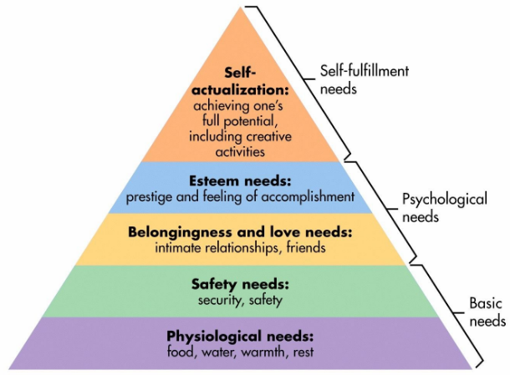
Figure 6: Maslow’s Hierarchy of Needs (Marchington et al. 2016)
Above diagram on figure 6 shows the concept of Maslow’s Hierarchy of Needs. The workers at The Hanoi Hat Company generally belong to the basic needs such as physiological needs or some at basic need stage. According to the theory, Hanoi can reward the workers with merit based pay, or performance based pay- these will ensure higher motivation for the employees because employees will strive to reach them. As a result, Hanoi will receive higher performance which will add to business value.

Benefits based reward policies (healthcare facilities or services, retirement benefits, paid time off, recreational tours) play important role to motivate and engage employees:
Extrinsic benefits such as healthcare facilities or services, retirement benefits, paid time off, recreational tours can significantly contribute to employee engagement and motivation because these are paid apart from the basis payment elements discussed above (Sparrow, Brewster & Chung, 2016). Therefore, they must add values to the business of Hanoi. For example, the retirement benefits will motivate many employees at Hanoi to stay in the same company for years with the hope that they will get higher amount when they retire. Such policy will play important role to make the business efficient because when employees are retained, they develop certain skills that enable them to be efficient and make further contribution to the company because they know the job, ways of doing work and how the company works (Sparrow, Brewster & Chung, 2016). This adds value to Hanoi.

Application of Maslow’s Hierarchy of Needs
This finding is also in line with the model of Hierarchy of Needs where employees are motivated to fulfil the higher stage needs. Referring to Maslow’s Hierarchy of Needs in figure 6; the mentioned examples of extrinsic benefits will meet the belonging or love needs of the hierarchy of need model. For example, offering recreational trips is a technique of extrinsic benefits; this will motivate the workers of Hanoi to reach the higher stage of the model- belonging or love needs (Sparrow, Brewster & Chung, 2016). Workers will be motivated to be socialised and find friends by going to outer trips. Thus, Hanoi will be able to retain its experienced workers and talents who will help the company to achieve higher returns.

Intrinsic reward policies (training, career development, performance management, succession planning and recognition) are important to engage and motivate employees:
Intrinsic reward policies such as training and development, career progression, performance management, succession planning, and recognition are non-financial reward techniques that motivate employees to perform better because companies develop their capabilities and skills by training and effective performance management strategies (Guest, 2011). Hanoi can implement the most suitable techniques to engage the motivate employees who can add value to the business. For example, training and career development opportunities enhance the skills of the employees and make them motivated and satisfied to Hanoi, enhancing the risks of employee retention. Such skilled and developed human capital will certainly make more contribution to the organisation and it will result in greater business value (Guest, 2011).

Application of Herzberg’s Two-Factor Theory of Motivation
Herzberg’s Two-Factor Theory of Motivation also nicely explains how advanced reward policies can enhance employee motivation towards a company (Mello, 2014).
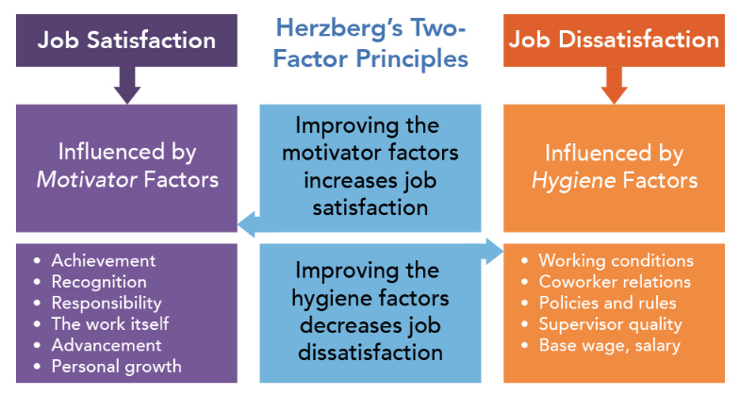
Figure 7: Herzberg’s Two-Factor Theory of Motivation- Intrinsic reward policies ensure job satisfaction (Mello, 2014)
Above diagram illustrates the concept of Herzberg’s Two-Factor Theory of Motivation which explains that employees are motivated by factors such as achievement, recognition, responsibility, advancement, personal growth etc. (Mello, 2014). If Hanoi implements the suggested reward policies recommended in this section (training and development, career progression, performance management, succession planning, and recognition etc.); it can certainly make employees motivated leading to adding more value to the business of hat manufacturing. For example, If Hanoi recognises good performers with some gifts or just publicly recognise employees; this will highly motivate employees of Hanoi because they are recognised. As a result employee retention will be high at the company; such retained and talented employees will certainly produce more value for Hanoi.

Organisational rewards (profit sharing, gain sharing, and shared ownership) plays at the highest level of motivation:
Organisational rewards play the most important role to motivate and engage employees and thus leading more value to the company (Lengnick-Hall et al. 2009). This is also supported by the theory of Maslow’s Hierarchy of needs. Below image has been reproduced.
Figure 8: Organisational rewards make employees reach the stages of Esteem Needs, or Self-Actualisation stages (Marchington et al. 2016)
If Hanoi shares a fraction of its profits or ownership with the employees; this will play the highest role than anything else to motivate and engage employees (Ehnert, 2009). The reason is that employees will feel that they are part of the higher management or they are part of the owners of the company. They will feel respected and honoured. At the same time, employees at Hanoi will care about the performance of the company and profit and loss statement which will make them more responsible about the performance of the business. Therefore, more value will be added to the business.

Conclusion
Employees work in an organisation for rewards. Thus, companies should carefully design rewards policies so that employees are effectively motivated and engaged. Compensation based individual rewards are extrinsic rewards that play the most important role to engage employees and that are paid in financial terms. Benefits are rewards that employees receive apart from the basic payments such as healthcare facilities or services, retirement benefits etc. Intrinsic rewards are the non-financial and intangible benefits that employees or workers receive because of their superior performance and productivity. All these reward policies play important role to add more values to the business by engaged and motivated employees. Above all above means, organisational rewards work at the highest level of employee motivation by making them a part of organisational ownership by means such as profit sharing, gain sharing, and shared ownership

References:
Armstrong, M., & Taylor, S. (2020). Armstrong's handbook of human resource management practice. Kogan Page Publishers.
Boxall, P., & Purcell, J. (2011). Strategy and human resource management. Macmillan International Higher Education.
Bratton, J., & Gold, J. (2017). Human resource management: theory and practice. Palgrave.
Dowling, P., Festing, M., & Engle, A. D. (2013). International human resource management.
DeCenzo, D. A., Robbins, S. P., & Verhulst, S. L. (2016). Fundamentals of human resource management. John Wiley & Sons.
Ehnert, I. (2009). Sustainable human resource management. A Conceptual and Exploratory Analysis from a Paradox Perspective, Heidelberg.
Guest, D. E. (2011). Human resource management and performance: still searching for some answers. Human resource management journal, 21(1), 3-13.
Harzing, A. W., & Pinnington, A. (Eds.). (2010). International human resource management. Sage.
Lengnick-Hall, M. L., Lengnick-Hall, C. A., Andrade, L. S., & Drake, B. (2009). Strategic human resource management: The evolution of the field. Human resource management review, 19(2), 64-85.
Mondy, R. W., & Martocchio, J. J. (2016). Human resource management. Pearson.
Marchington, M., Wilkinson, A., Donnelly, R., & Kynighou, A. (2016). Human resource management at work. Kogan Page Publishers.
Mello, J. A. (2014). Strategic human resource management. Nelson Education.
Noe, R. A., Hollenbeck, J. R., Gerhart, B., & Wright, P. M. (2017). Human resource management: Gaining a competitive advantage. New York, NY: McGraw-Hill Education.
Snell, S., Bohlander, G. W., & Bohlander, G. (2010). Principles of human resource management. South-Western Cengage Learning.
Sparrow, P., Brewster, C., & Chung, C. (2016). Globalizing human resource management. Routledge.

