Further Searching using forms

We have learned how to feed search data entered by the user from an HTML form through to a PHP query and return some results to the screen.
The database we have created has one table, people and looks something like this:

people
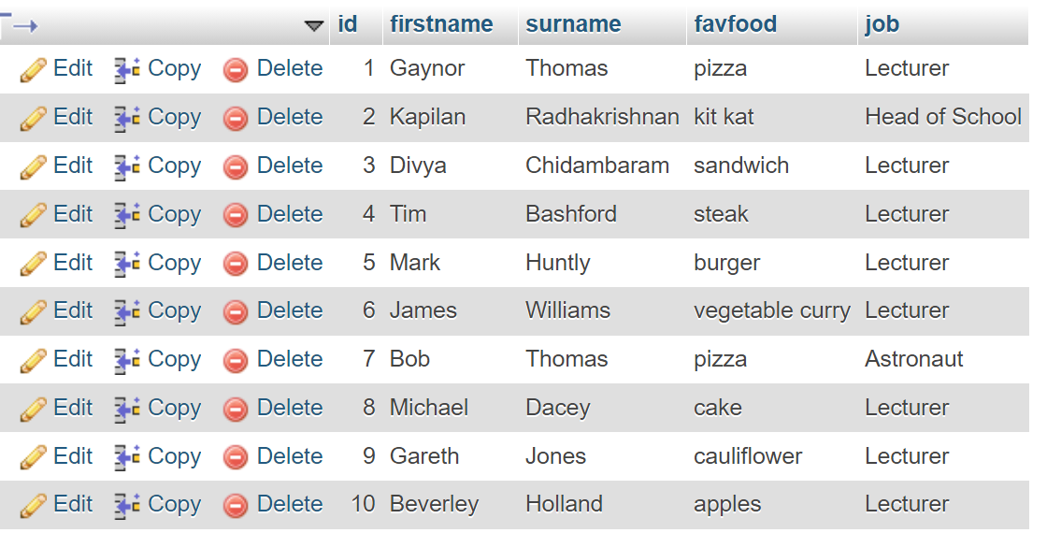

The code we used in class is shown below:
entersearch.php
<html>
<head>

</head>
<body>
<form action="dosearch.php" method="post">

Search: <input type="text" name="mysearch"><br><br>
<input type="submit">

Dacey
</form>
</body>
</html>

dosearch.php

<?
include "conninfo.php";

$theSearch=$_POST["mysearch"];
Dacey

$query="SELECT * FROM people WHERE surname like '$theSearch'";

$result=mysqli_query($link,$query);
$numrows=mysqli_num_rows($result);//how many rows were found?

if($numrows==0)//none found
{
echo "Sorry, nothing found";
}
else //print out rows found
{

while($r=mysqli_fetch_array($result))
{
echo $r["firstname"]." ";
echo $r["surname"]." ";
echo $r["favfood"]." ";
echo $r["job"]." ";
}
}
?>

Exercises for searching

- Extend your original search so it works on ANY field (not just surname). For example, if I enter “Thomas” or “pizza” or “Tim” etc it will return some results.

Example output:



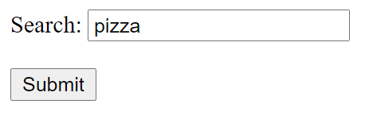







Q1 SOLUTION
Code as shown on p2 above, but with the following query change which searches more than one field:
$query="SELECT * FROM people WHERE firstname like '$theSearch'
OR surname like '$theSearch'
OR favfood like '$theSearch'
";

- Write a search so that you can search on both first name and surname.

- Write an exact match search (ie it will only find a match if both the exact first name and surname is entered)


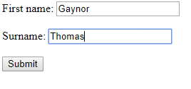

But not:

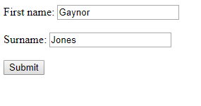

Q2a SOLUTION:
Add an input to your form on entersearch.php
Form: (entersearch.php)
<html>
<head>
</head>
<body>
<form action="dosearch.php" method="post">

First name: <input type="text" name="mysearch"><br><br>
Surname: <input type="text" name="mysearch2"><br><br>
<input type="submit">

</form>
</body>
</html>

Now we have 2 inputs - called mysearch and mysearch2

dosearch.php

- Pick up both pieces of information via $_POST
- Change query to search for both firstname and surname.

<?include "conninfo.php";

$search=$_POST["mysearch"];
$search2=$_POST["mysearch2"];

$query="SELECT * FROM people WHERE firstname like '$search' AND surname like '$search2'";

$result=mysqli_query($link,$query);
$numrows=mysqli_num_rows($result);//how many rows were found?

if($numrows==0)//none found
{
echo "Sorry, nothing found";
}
else //print out rows found
{
while($r=mysqli_fetch_array($result))
{
echo $r["firstname"]." ";
echo $r["surname"]." ";
echo $r["favfood"]."";
echo $r["job"]."<br>";
}
}
?>
- Change your search so that it is less exact, and will match on either field:



Q2b SOLUTION

As 2a) above, but using OR
$query="SELECT * FROM people WHERE firstname like '$search' OR surname like '$search2'";

- Radio button search

Using a radio button, allow the user to select the field of their choice.
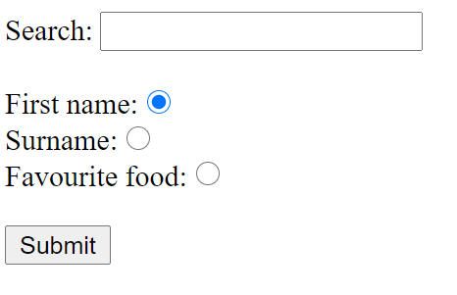

The code for your form might look something like this:

<html>
<head>
</head>
<body>
<form action="dosearch.php" method="post">

Search: <input type="text" name="search"><br><br>

First name: <input type="radio" name="fieldtype" value="f" checked="checked"><br>
Surname: <input type="radio" name="fieldtype" value="s"><br>
Favourite food: <input type="radio" name="fieldtype" value="o"><br><br>

<input type="submit">

</form>
</body>
</html>

Note that each radio button in a group has the same name, but are differentiated by their values.

The output would look something like this:


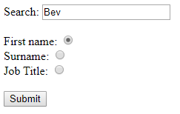



Try to work out how to make this functional.

Q3 SOLUTION:
- Get the data both search and fieldtype from your form:
- Use an if statement to set up different queries (f=firstname, s=surname, o=favourite food)
<?include "conninfo.php";

$theSearch=$_POST["search"]; 1
$ft=$_POST["fieldtype"];

if($ft=="f")
{
$query="SELECT * FROM people WHERE firstname like '$theSearch'";
}
else if($ft=="s")
{
$query="SELECT * FROM people WHERE surname like '$theSearch'"; 2
}
else
{
$query="SELECT * FROM people WHERE favfood like '$theSearch'";
}

$result=mysqli_query($link,$query);//run on database

$numrows=mysqli_num_rows($result);//how many rows were found?

if($numrows==0)//none found
{
echo "Sorry, nothing found";
}
else //print out rows found
{
while($r=mysqli_fetch_array($result))
{
echo $r["firstname"]." ";
echo $r["surname"]." ";
echo $r["favfood"]."";
echo $r["job"]."<br>";
}
}
?>

