Lewis Christopher
1909572

Control Technology

(ACMA6001)

Assignment 1

Task 1
PLCs are available in many different designs, with many different operating capabilities, dependant on the application in which they are required. They are now devices that have grown from their introduction in the automotive manufacturing trade and are now used in almost all sectors as a means of fast control of a wide range of intricate systems (Francis, 2020).
There are many different companies manufacturing their own brand of PLC, each with positive and negative aspects of their products. There are many factors that need to be considered when selecting the correct type of PLC for the application such as the compatibility of the PLC with other equipment you currently have installed and how those systems will integrate. Another factor that should be considered is what the PLC is required for and as a result of this, how complex, with how many inputs and outputs are needed, as this will impact costs and could be dictated by budgets. Another consideration to make is what interfaces are required, such as HMIs and how easy are these interfaces to navigate and control (Evora, 2016).

Review of Ladder Logic

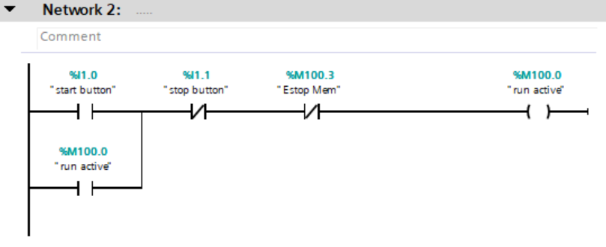
This network includes the start button which is used as part of a latching circuit with the run active memory. This allows the start button to be release and run active to stay healthy. It also includes the 2 different stop buttons included in the circuit, a normal stop and an emergency stop which will break the circuit and cause it to stop.

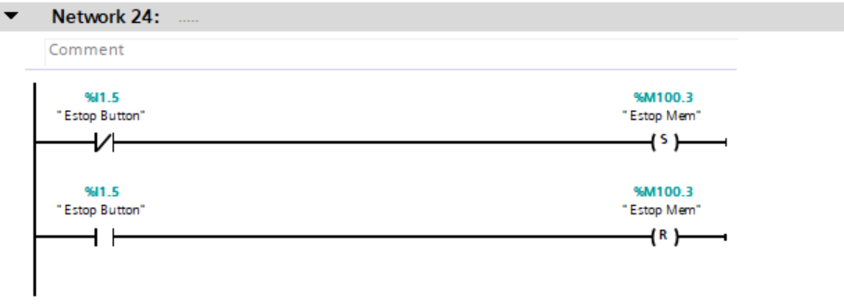
For safety reasons, when the emergency stop is pressed, the system should not be able to restart until the emergency stop has been reset. The set and reset output in this rung allow that to happen by using the memories which are set and reset, allowing the same output to be used twice.

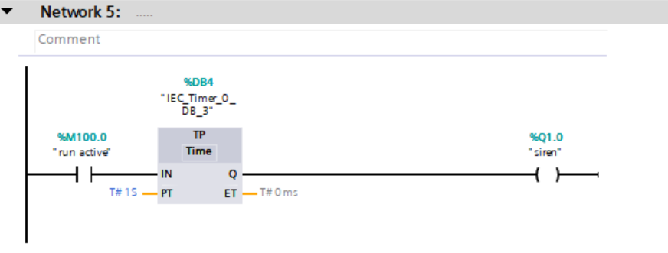
When the system is started, workers must be made aware that movement is about to start on the packaging unit. This rung is used to sound a siren, which is on a 1 second timer so it does not run for the whole duration of the application. This timer could be changed depending on the requirements of the application.

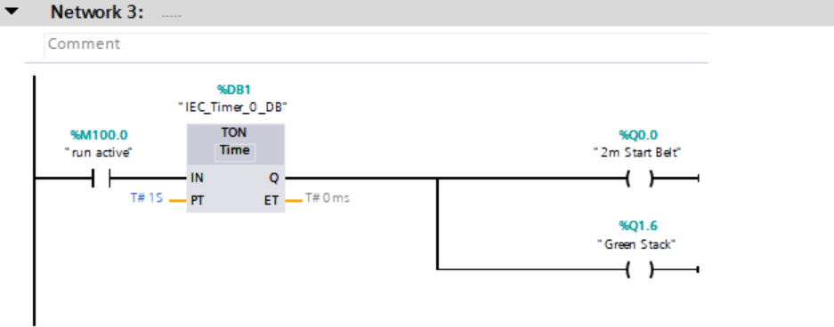

This network is where the conveyors are started, hence output to the 2m Belt. Along with the 2m belt a green light is also illuminated to show the system is running. The timer in this rung is because the belt should not be able to start until the siren has sounded to make everyone aware that the system is about to start.
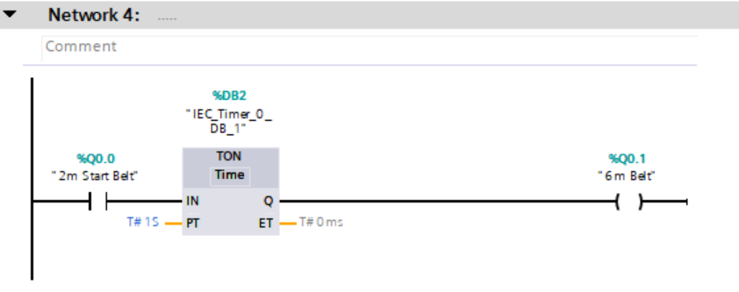During start up, this is the highest amount of current that a motor will draw. If all motors in the system are started at the same time, this could cause a current overload which would trip the system. In order to stop this, each conveyor is started individually. This has been done by using the first belt starting, as an input and then using times ranging from 1 second to 10 seconds to dictate when each of the other conveyors start in sequence. This offset should be long enough to allow the current to remain lower on start up of the conveyor systems.

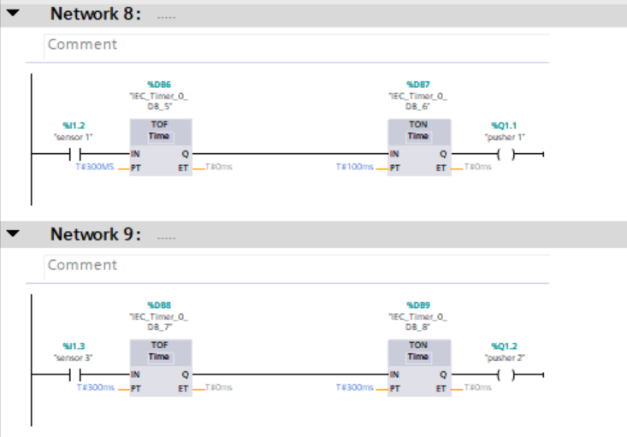
Networks 8 and 9 are very similar as they are both used to complete the same task in 2 different places. In both cases, the input is given from a sensor which will be activated in each case by a different sized box based on the height of the sensor. These inputs are used to trigger the output of the pusher arms, which push the boxes on to the required conveyors to be removed. The timers on these networks are used as there is a delay between when the sensor is activated and when the pusher is required to move, hence a small delay is required to ensure the box is pushed down the centre of the conveyor.
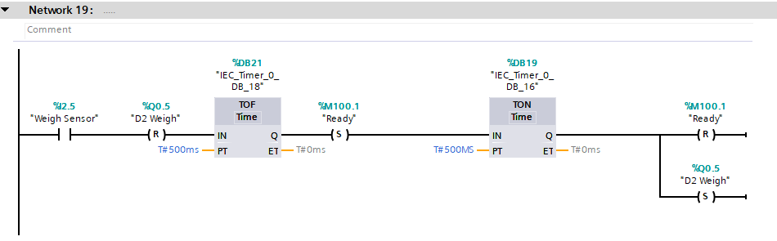
In order to decipher the weight of each box, the boxes must be stopped on the weigh conveyor. In this rung the sensor or the conveyor activates which switches the weigh conveyor to reset, this is done to stop the conveyor for the amount of time dictated by the timers in order to take a weight, after the timers reach their limit the conveyor will restart. The ready signal is also set after the first timer, this is used as an input later in the program to activate the scales, hence being reset by the next timer, when the conveyor starts to move again.

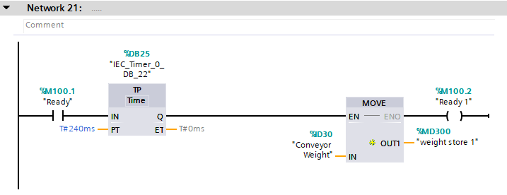
The input for this is given by the ready signal from above, as this recording needs to be taken when the conveyor has stopped. When the weight has been recorded, this information needs to be kept for long enough to give the correct run signal to the directional pop up conveyor. This can not be done by the scales because the signal changes as the box starts to move again, to overcome this a weight store is used, which records the weight and holds that information for long enough to give the correct signal for direction.

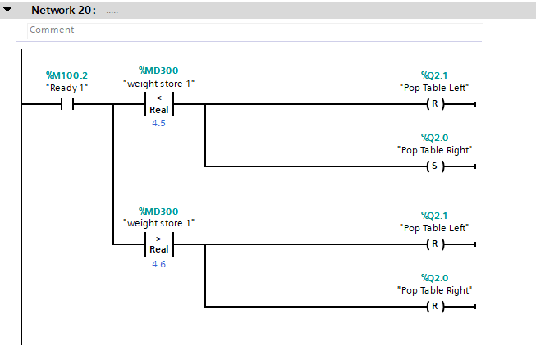
This rung of the program is used to determine which direction the boxes will go from the weighing scale. The input signal for this is given by the previous rung, which says that the weight has been stored. This weight store is used as part of a comparator function, where depending on whether the weight is greater than or less than the given value, a differing output will be given. The outputs on this are set and reset functions as the outputs are being reused but in different states depending on the input from the comparator. In this case the set function is only used in once to send the product right.

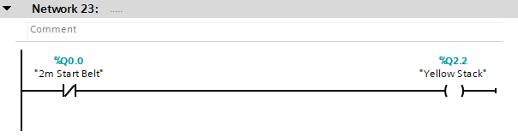
This rung is used to allow the yellow beacon to illuminate when the system is not running. This could either be that the system has not been started or someone has pressed the normal stop button. The first belt in the system has been used for this input as this is always the first thing to start and is also the trigger for the green light to come on, hence this was they will never both be on simultaneously.
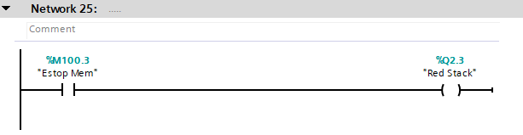
This rung is used to turn on the red light when the emergency stop button has been activated. Unlike the previous network, where a normally closed contact is used this uses a normally open contact. This is because this light will be activated when the button is pressed as it will stay pressed until reset rather than the orange light which is activated when something that is normally running has stopped.

Bibliography

Evora, A., 2016. How to Choose a PLC for Your Next Controls Project:. [Online]
Available at: https://affinityenergy.com/how-to-choose-a-plc-next-controls-project/

Francis, S., 2020. Top 20 programmable logic controller manufacturers. [Online]
Available at: https://roboticsandautomationnews.com/2020/07/15/top-20-programmable-logic-controller-manufacturers/33153/

