

Lighting Layout and Sound Index calculation

Lecturer- Allan Nantal

Contents
1.0 Executive summary 3
2.0 Procedure 3
3.0 Findings 3
3.1 Task A – The Lumen method of lighting design 3
3.1.1 Building regulation compliance for lighting (task related non dwelling) 4
3.1.2 Lighting design Task brief Question 4
3.1.3 Light loss factor 4
3.1.4 Room Index 5
3.1.5 Utilisation factor 6
3.1.6 Number of lamps required 7
3.1.7 Suitable layout (value of S) for the lamp fittings 7
3.1.8 Lighting plan layout drawing 8
3.2 Task B – Sound reduction Index 9
3.2.1 Sound reduction index task brief question and discussion brief 9
3.2.2 Sound reduction index calculation showing arithmetic development 9
3.2.3 Frequency and wavelength 11
3.2.3 Internal sound management, partition wall construction and insulation material. 11
4.0 Conclusion 13
5.0 References 14

Executive summary
This report identifies the mathematical answers to two task questions as set out in the task description for Lighting layout design and sound reduction index. Full arithmetic development of the answer showing algebraic expressions and formula descriptors are used to show understanding and show how the answers are generated. A Lighting design layout will accompany task A and written discussion to accompany task B.

Procedure
The content within this assignment has been derived from background reading, revision, following the uploaded lecture content from Moodle and Microsoft Teams, corresponding notes taken on the task topics and available data sheets given during lectures.

3.0 Findings

3.1 Task A – The Lumen method of lighting design
“The Lumen method is the most used lighting design method worldwide due to its simplicity, ready availability of design data, and economy of designers time. Erstwhile it has enabled the average illuminance to be provided over the horizontal working plane of an empty interior while attempting to limit the variation of illuminance by control of luminaire spacing” (D.J.Carter, 19/9/2013) . For the Lumen method the lights have to be mounted in a regular pattern as well as the luminous flux output of each lamp known, and details of the type of luminaire used and the surfaces within the room. The main objective of the design is to find out the required number of lights and spacing.
The Number of lamps can be drawn from the formula
N = E X A
F X UF X LLF
Where the above are as follows
N = Number of lamps required
E = Illuminance level required
F = Average luminous flux derived from each lamp
A = Area of the working plane in Meters squared
UF = Utilisation factor, an allowance for the light distribution of the luminaire and the rooms surface
LLF = Light loss Factor, the reduction allowance in light output caused by the lamp deterioration and dirt

3.1.1 Building regulation compliance for lighting (task related non dwelling)
Building regulation compliance for lighting falls in the way that Part L requires us to assess energy efficiency in lighting. In April 2014 the new amendment to Part L regulations came into effect. With Approved document L2A for conservation of fuel and power in new buildings other then dwellings, and L2B for conservation of fuel and power in existing buildings other than dwellings. Within this amendment of Part L it is said to “more creative in the way that it addresses the idea of Light In Use for non-domestic premises. For the first time, inspectors have been offered an alternative assessment method. This new method is very prescriptive but it offers the designer/building user far greater flexibility in the lighting design approach. This alternative method is known as the Lighting Energy Numeric Indicator (LENI)” (Greenspec, unknown)
Another document that sets out compliance is The HM Government -Non domestic building services guide 2013 edition Section 12. Within this document, section 12.4 states that the lighting in new and existing buildings should meet the recommended minimum standards for efficacy and controls in table 42 or the LENI in table 44, that the lighting is metered so that the consumption of energy can be recorded, and the lighting controls in new and existing buildings should follow guidance set out in BRE Digest 498 for selecting lighting controls (Goverment, 2013).
All lighting designs should also be designed and installed to the most up to date wiring regulations which are currently the 18th edition regulations BS7671.

3.1.2 Lighting design Task brief Question
A production area in a factory measures 60 metres x 24 metres x 8 metres in height. The factory’s work benches are set at a height of 1m above the floor level. The area’s reflectance’s are 0.3 for the ceiling and 0.5 for the walls. The Lighting design specifies Fluorescent lamps in recessed louvre with DLOR of 50%. (The actual size for the luminaires is 1200mm in length and 200mm wide.) A Lighting Design Lumen (LDL) output of 18,000 lumens is required. The illumination required for the factory area is 200 lux at the working plane. Light Loss Factor = 0.75
Calculate:
1) The Room Index
2) The Utilisation Factor (from tables), explaining exactly how this value was arrived at.
3) The Number of lamps required
4) A suitable layout (value of S) for the lamp fittings

3.1.3 Light loss factor
The light loss factor abbreviated within this assignment as LLF is the ratio of the illuminance provided from the luminaire over a given time compared to that of its initial illuminance.
The LLF is the sum of the Lamp maintenance factor x the luminaire maintenance factor x the room surface maintenance factor.
The figures can vary as the decline in output of a given lamp over a set time can not be given correctly neither can the amount of surface dust and dirt that the luminaire or surface encounters which affects the both the luminaire and room surface maintenance factor. “The maintenance factor is based on how often the lights are cleaned and replaced. It takes into account such factors as decreased efficiency with age, accumulation of dust within the fitting itself and the depreciation of reflectance as walls and ceilings age. For convenience, it is usually given as three options: Good = 0.70 Medium = 0.65 Poor = 0.55” (Tariq, 2012)

However, the figures have been estimated and can be used via a table to gain a value. In this instance the LLF as been given within the Task brief as 0.75, Which following the above option would indicate a good maintenance factor.

3.1.4 Room Index
“The Room Index is a measure of the angular size of the room, and is the ratio of the sum of the plan areas of the Floor cavity and ceiling cavity surfaces to the area of the Walls surface” (Edvard, 2015).For this calculation, the following formula is used;
RI = (L x W) / (Hm (L + W))
Where;
RI = Room Index
L = Length of room (In this instance the value given is 60m)
W = Width of room (In this instance the value given is 24m)
Hm = Height of the luminaire measured from the working plane (8m-1m = 7 m)
Therefore;
RI = (60 x 24)
(7 (60 + 24))
RI= (1440)
7 x 84
RI= 1440
588
RI = 2.45 (rounded up to 2.5)

3.1.5 Utilisation factor
The utilisation factor can be described as the ratio in which the total light flux hitting the working plane compared to the total flux output of the given lamp. There are factors that Can change this, these being;
• The properties of the luminaire itself with an emphasis on the light output ratio.
• The values of both the down and up light output ratios
• The reflectance of the room surfaces
• The geometric shape of the room, this is also known as the room index
• The downward illumination flux to directly hit the work area, this is known as the direct ratio. This can be highly influenced by the solid angle at which the light is emitted from the luminaire.
Using the light description of Recessed louvre with DLOR of 50% and the figures provided in the task brief of the area’s reflectance’s of 0.3 for the ceiling and 0.5 for the walls along with the Calculated Room index of 2.5, the figures are then utilised and inputted into the utilisation factor sheet provided to gain the UF as shown;

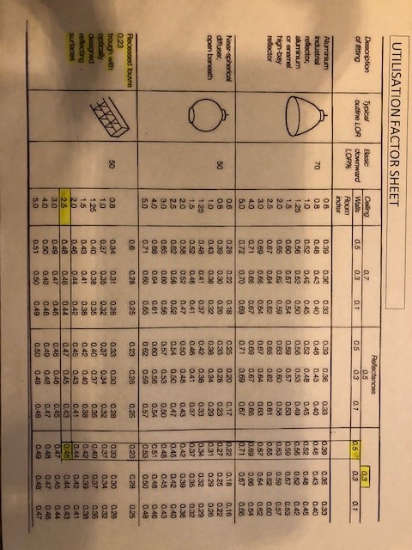

From this I can obtain the value of 0.46 as my Utilisation factor.

3.1.6 Number of lamps required
Having calculated the room index and utilisation factor I can now input the values into the formula previous explained in heading 3.1 along with the already known factors described in the task brief which was as follows;
N = E X A
F X UF X LLF

N = Number of lamps required
E= Illuminance level required (200 lux)
A= Area at working plane height (60m x 24m = 1400 m²)
F= Average luminous flux from each lamp (18000 lumens)
UF= Utilisation factor, an allowance for the light distribution of the luminance and the room surfaces (0.46)
LLF= Light loss factor, an allowance for a reduction in light output caused by lamp deterioration and dirt (0.75)
Therefore, I can show the formula as;
N= 200 x 140
18000 x 0.46 x 0.75
N= 288000
6210
N= 46.38
As this is the minimum requirement then the number of lamps needs to be rounded up to 47. For the purpose of uniformity, the number of lamps will be made 48.

3.1.7 Suitable layout (value of S) for the lamp fittings
The Task Description states the factory requires fluorescent lamps; this means the formula needed is;
S max = 1.5 x H _{m}
Where;
S max = The maximum spacing allowed between fittings
H_{m} = Height of the luminaire measured from the working plane

Given the ceiling height was stated as 8meters and the factories work benches set at 1meter above the floor level this would give my H_{m} of 7 meters
Substituting these values into the formula gives me;
S _{max} = 1.5 x H_{m}
S _{max} = 1.5 x 7m
S _{max} = 10.50m minimum spacing between lamps centre to centre
From the calculations I can conclude the best lighting design layout in this instance would be 4 rows of 12 luminaires.
.

3.1.8 Lighting plan layout drawing
My layout consists of 48 luminaires 1200mm by 200mm in size. The spacing is detailed as 5000mm from centre to centre of the lamps on the X axis and 6000mm on the Y axis. The distance off the walls in all directions are half the spacing values in 2500mm and 3000mm respectively.
Key- All Dimensions are in millimetres(mm)
X axis in mm
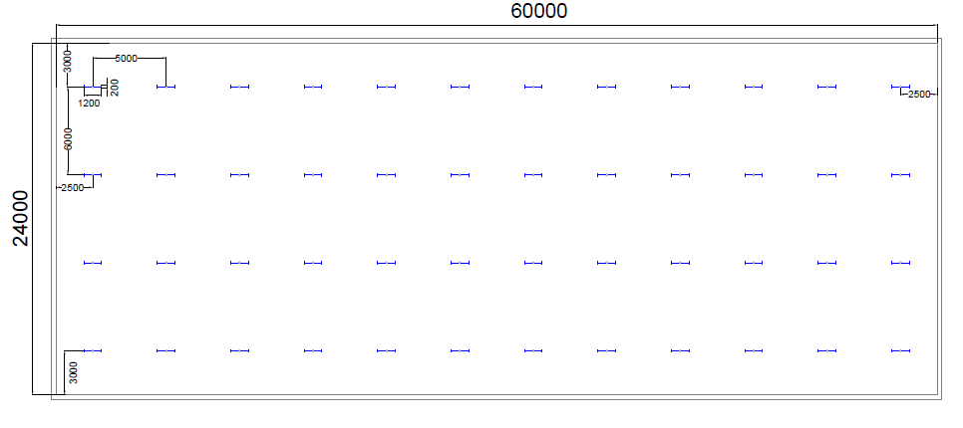
Y axis in mm
Your text here

3.2 Task B – Sound reduction Index

3.2.1 Sound reduction index task brief question and discussion brief
1.A brick wall of area 20m² contains a window of area 4m².The values of sound reduction indexes are 50Db for the brickwork and 10Db for the window.
Calculate the overall sound reduction index for the entire wall. Include the full arithmetic development of your answer.
2.Discuss the implications of the factors of frequency and wavelength in;
- Internal sound management
- Partition wall construction technique
- The insulation material choice

3.2.2 Sound reduction index calculation showing arithmetic development

The sound reduction index is a measure of the insulation against the direct transmission of airborne sound. The calculation for the sound reduction index, abbreviated to SRI in this assignment can be shown as;
SRI = 10 x (log₁₀(1/T)
Where T = Transmission coefficient for the partition under test.
The higher the completeness and uniformity of a partition will mean a better sound insulation. Partitions, or in this case a brick wall that contains a window will have a lower SRI than a complete wall not containing a window. The transmission coefficients can be averaged by calculations that include the area of the part by entering the data into the formula;

T0 = (T₁ X A₁) + (T₂ XA₂)
A₁ + A₂
Where:
T0 = Overall (averaged) transmission coefficient
T1 = Transmission coefficient of one component
A1 = Area of that component
As the partition wall may have many components the formula is extended as shown above for the second component. Any further components can be added as necessary by extending the formula in the same format. Using this formula and adding all the components of the areas being investigated, the overall transmission coefficient can be calculated to give the overall sound reduction index.
Firstly, utilising the known data from the task description, I can identify the needed values.
Brickwork -
- Area 1 = 20m² – 4m² = 16m²
- T₁ = ?
- SRI = 50dB
Window –
- Area 2 = 4m²
- T₂ = ?
- SRI = 10 Db
By using the formula for both components; SRI = 10 x(log₁₀(1/T) I can find the needed value of T₁ and T₂ as shown below;
Brickwork
SRI =10 x (Log ₁₀(1/T))
50 = 10 x (Log₁₀(1/T1))
5 = Log ₁₀ x (1/T1) (As I need to find T₁, the form of the equation can be changed from ( X=LOG _{A} x Y to Y=A^{x})
1/T1 = 10⁵
T1 = 10⁻⁵ This Can be shown as a numeral = 0.000010

Window
SRI =10 x (Log ₁₀(1/T))
10 = 10 x (Log₁₀(1/T₁))
1 = Log ₁₀ x (1/T1) (As I need to find T1, the form of the equation can be changed from ( X=LOG _{A} x Y to Y=A^{x})
1/T₁ = 10¹
T₁ = 10⁻¹ This Can be shown as a numeral =0.10
The next step is to substitute the values of the brickwork and window into the averaging formula as shown;
T₀ = (T₁ X A₁) + (T₂ XA₂)
A₁ + A₂
T₀ = (10⁻⁵ x 16) + (10⁻¹ x 4)
16 + 4
T₀ = 0.00016 + 0.4
20
Therefore, the average transmission coefficient = 0.040016/20
= 0.020008
By dropping this value into the SRI previously mentioned it can be expressed as;
SRI = 10 x (log₁₀(1/T)
= 10 x (log₁₀(1/0.020008))
= 10 x (log₁₀(49.980007))
= 10 x 1.69
SRI for composite partition = 16.9 (This is rounded up to 17dB)

3.2.3 Frequency and wavelength
Frequency is the number of complete cycles a sound wave can propagate in a given amount of time. Sounds that vibrate many times per second are called high-frequency" sounds, alternatively those which vibrate less frequently are known as low-frequency sounds. Wavelength, is defined as the distance from a particular point of one wave (sound wave, mechanical wave) to the same point of the next wave. Wavelengths of sound can range from very small distances to very long distances depending on the frequency. Wavelength is expressed by the Greek symbol lambda (Harada, 1999)

3.2.3 Internal sound management, partition wall construction and insulation material.
The type of Internal sound management depends on the required effect. For instances where sound needs to be propelled or kept undistorted from echo. Echoes can be defined as a reflection that arrives to the human ear 0.3 or more seconds after the direct sound was first picked up. The easiest way to combat this would be to install reflectors in designed locations. This is done by reverberation. This is when all the sound from the reflectors or reflection from surfaces collaborated together to produce a reverberant field. A reverberation is perceived when the reflected wave reaches your ear less than 0.1 seconds after the first direct sound. This is used to nullify the drop off in sound intensity. Very commonly used concept in music halls and theatres.
The opposite effect would be sound management for acoustic quality. “Sound absorption is the measure of the amount of energy removed from the sound wave as the wave passes through a given thickness of material” (Shrivastava, 2018). Within a room or enclosed space there are three main outcomes that can occur to the sound. It was be reflected, absorbed or transmitted. If the wavelength of an incident sound wave is small compared to the hardness of the surface, then the angle of reflection of the sound wave equals the angle of incidence. The choice of materials used in the construction and finishing of the room or enclosure will have a detrimental effect to the behaviour of the sound and how much of the sound is absorbed or reflected. Each surface has its own absorption coefficient. Differing materials, construction techniques also have differing coefficients. This means the higher the frequency the more absorption takes place because of the shorter wavelength. Equally the lower the frequency, the longer the wavelength and less absorption will occur. Building materials such as fabrics and carpets have high absorption rates were as bricks, glass, tiles have much less absorption and will reflect the sound back into the room. When taking into account sound there are Two types of sound transmission. Firstly, there is Airborne sound. Airborne sound radiates from a given source and travels to the human ear through the air. Secondly there is structure borne sound. This is the sound we hear through impact and sound passing through solid materials. “Impact sounds are created when the fabric of structure is vibrated by direct contact” (chudley, 2020) , although the transmitted sound will eventually turn into airborne noise to reach the human ear. Within construction there is a big demand at present to conserve fuel and power and the same methods used in the industry can help acoustic performance. Sound insulation, the objective of sound insulation is to lower the transmitted sound to an acceptable level. This intensity is measured in decibels. Within the Building regulations, Approved Document L gives compliance for resistance to the passage of sound. Additionally, the robust detail scheme is an alternative solution to pre-completion sound testing for complying with the requirements by “providing construction details that provide the necessary level of sound insulation for various applications” (chudley, 2020).Sound intensity of unwanted sounds that increases vibrations of a separating wall or floor can be reduced to some extent by attaching a lining to the building fabric. The most effective way to construct a partition wall with increased sound improvement is to create another wall or ceiling next to the original but separated from it. The main reason behind this is because it will form a break that will reduce impact sound passing through it, however, sound travels slower through air and gases than it does through water and solids but lower frequencies will still pass as less absorption occurs due to the longer wavelengths. Thicker walls can help reduce the sound transmission but very unlikely to stop it. Another consideration in regards to acoustics is that of services. Installation noise and vibration from building services can cause unwanted sound. Dampening materials can be used to absorb the sound but in my own experience, Double plaster boarding soil stacks and increasing the ceiling plasterboard to a denser thicker board helps with unwanted service noises. One aspect of the new building regulations that hampers the unwanted sound through air borne transmission is trickle vents. Due to greater emphasis on air permeability testing and fuel and power efficiency, the use of trickle vents is weakening the sound barrier between the internal and external environments.

4.0 Conclusion

To conclude. The Lighting design lumen method can be used in all aspects of lighting design regardless of the shape of building, also is not only solely down to one design and can be done in many ways as long as they fall within the design parameters. Regarding the sound index reduction formula and the lumen lighting method, the formulas shown in this assignment can be used by Any individual and not just up to designers. Regarding sound, its shown that regardless how well buildings are constructed, there will always be reflected, absorbed and transmitted sound energy with varying frequencies and wavelengths.

5.0 References

chudley, R., 2020. Building construction handbook. 12th ed. s.l.:s.n.
D.J.Carter, A. M., 19/9/2013. design calculations for eletric lighting in real interiors. journal of the illuminating engerneering society 1997, pp. 79-89.
Edvard, 2015. 7 key steps inlighting design process. [Online]
Available at: https://electrical-engineering-portal.com/7-key-steps-in-lighting-design-process
[Accessed 12 April 2021].
Goverment, H., 2013. Non domestic building services compliance guide. [Online]
Available at: https://assets.publishing.service.gov.uk/government/uploads/system/uploads/attachment_data/file/453973/non_domestic_building_services_compliance_guide.pdf
[Accessed 7 april 2021].
Greenspec, unknown. Lighting specification and Part L: 2013. [Online]
Available at: https://www.greenspec.co.uk/building-design/lighting-part-l-2013/
[Accessed 5 march 2021].
Harada, K., 1999. Basic sound principles. [Online]
Available at: https://harada-sound.com/sound/handbook/basicterms.html
[Accessed 18 April 2021].
Shrivastava, A., 2018. Plastic Properties and Testing. introduction to plastic engineering , pp. 49-110.
Tariq, H., 2012. Linkdin. [Online]
Available at: https://www.linkedin.com/pulse/lighting-design-lumen-method-examples-hasan-tariq
[Accessed 11 April 2021].

