Ann Dineen
Student Number: 1903613
Module: Independent project (ADAA6000)
Documentary Photography and Visual Activism
Word Count:
Tutor: Ryan Moule

Submitted in partial fulfilment of the requirements for the degree of BA (Hons) University of Wales Trinity Saint David, Swansea, (10th December 2021)

Contents:
Table of Figures
Introduction
Chapter 1
Chapter 2
Conclusion
Bibliography

Heading: How mainstream cinema has helped to reinforce stereotypical ideas of the role of women within society.

Introduction.
The inspiration for my Thesis comes from own experiences as a female growing up, living and working in a very different time culturally to how we live now. Born in the 60’s and predominantly educated in the 70’s and early 80’s my life was shaped by very sexist views of how women are seen, how they should behave and what is expected of them in life. I was certainly never encouraged or more appropriately allowed, to engage in subjects that were seen as for boys only, for example in secondary school boys were the only ones allowed to do woodwork or mechanics and us girls did home economics and commerce, no doubt the expectation was for the girls to look after the home whilst the boys went out to work. This whole idea of who or what a woman should be is explored in the book The feminine mystique (betty Friedan) Friedan explored the lives of middle class women in the 1950’s “role” in society was mainly to be a wife, a mother, and housewife and nothing else. This idea being reinforced by popular culture and magazines of the time. The mystique is a false idea of what femininity is, it states having a career or fulfilling a person’s individual potential somehow goes against women's pre-ordained role. The mystique is the constant barrage of homemaker-nurturer-mother images that esteem the virtue of keeping house and raising children as essential womanhood while criticising the “masculinity” of women who want to do other things, whether along with or instead of the feminine mystique approved duties.

“The feminine mystique has succeeded in burying millions of American women alive. There is no way for these women to break out of their comfortable concentration camps except by finally putting forth an effort – that human effort which reaches beyond biology, beyond the narrow walls of home, to help shape the future.” Friedan Betty, The Feminine Mystique (1963) London Penguin, 1992, p.293.

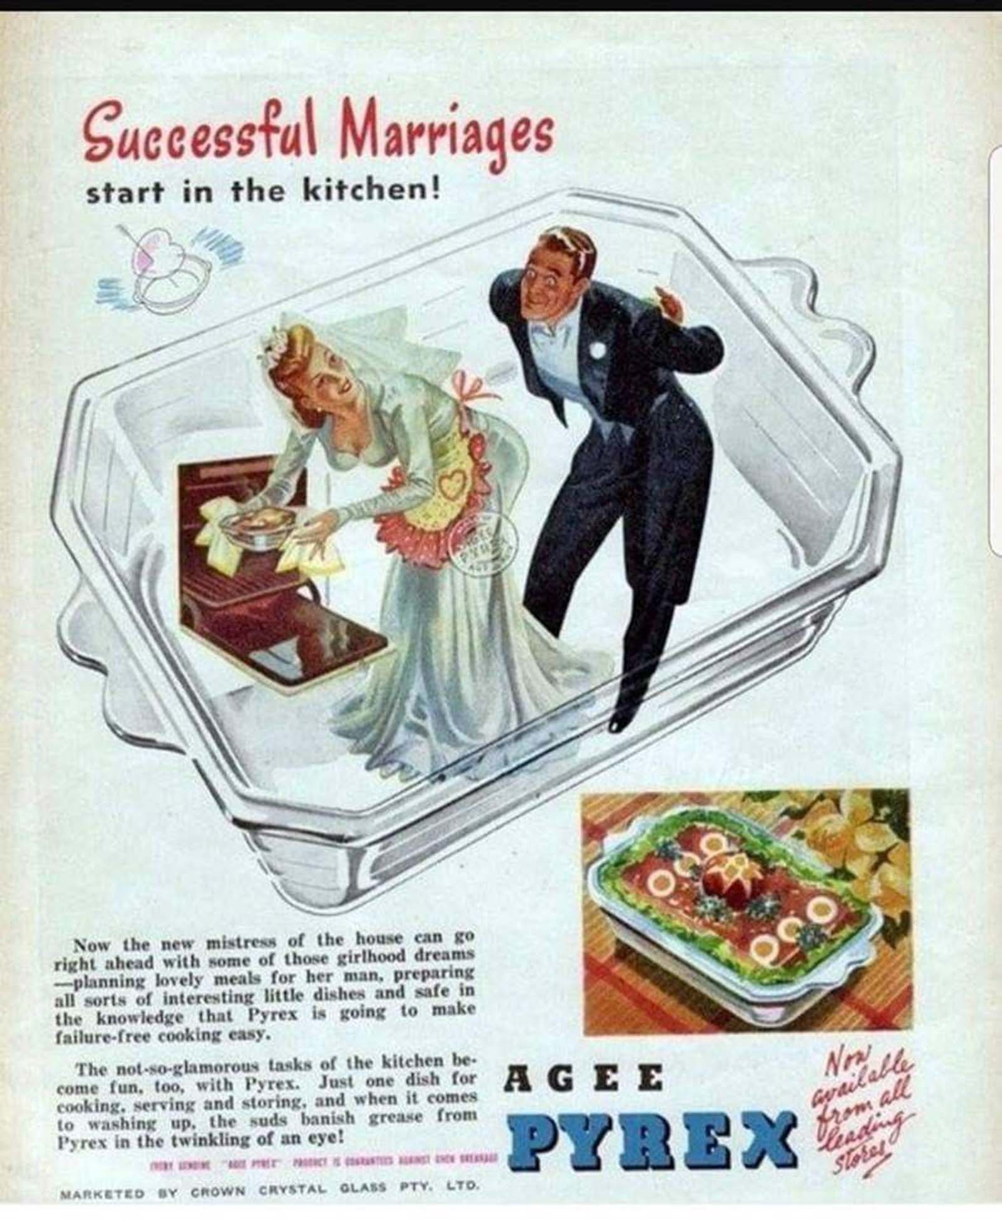
Fig 1.
Using the arguments from this book it would perhaps explain why at the age of 16
During a session with a a ‘Careers Advisor’ I should look for office work. I had spent the whole time explaining that I had aspirations to become a Police Officer and was really looking for guidance on how I could achieve this. Back in the 1980’ I thought nothing of referring to the role as wanting to become a Police Women, later in this paper I will be looking at the importance of not using genders to describe a persons job. If you consider the physcologist Gordon Allport who’s book ‘The Nature of Predujdice’ 1954 it was a look into how prejudices and stereotypes are reinforced and the impact it can have on a group. At the very lowest level there is anti locution, name calling or jokes expressing an opinion about an individual or group based on preconceived ideas that usually have no basis. He created Allports scale of prejudice
Starting with Anti locution and ending in extermination, so whilst making sexist jokes may seem like banter, left unchecked behaviours can escalate. I believe this can be linked to how important it is not to use genders to describe a job that can be done by anyone.
Thankfully I took no notice of the careers advisor and I did become a Police Officer but in 1987, the year I joined the Police service, it was a workplace shaped by men, for men, misogyny and sexism was common place. I want to explore why these behaviours were considered acceptable and how stereotypes helped reinforce them.
I’m very aware that my views and research are from my own point of view as a heterosexual female, no doubt others from different cultures, genders, abilities etc… views will differ and I can appreciate and understand that we all have different experiences that shape our lives.
In the first chapter of this essay I will firstly look at the historical references to women in both art and the written word, how these have helped to silence and marginalise women and how images of females throughout history have helped to shape the idealistic view of women. Its important to look at how the law of the land has also helped keep women chained to the kitchen sink so to speak. In the 2nd chapter I will be exploring the role women have played in films since from the 1950’s onwards and will be looking at theory’s around Social Cognitive Theory and Cultivation Theory (A, Bandura ( the theory being that people view films and roles people play and emulate that as being how to behave in the real world.

Chapter 1 – History
To better understand how women’s roles are viewed in western society it is necessary to look at the history and see where the ideas and values that have shaped our culture came from. It is clear when you start looking at the earliest forms of western literature woman have been silenced, their views and ideas have not been asked for or welcomed. In her book Woman and Power mary beard explores the history and cultural issues that have silenced women throughout time. She starts by looking at Homers Odyssey and in particular the son Telemachus who whilst listening to songs from a bard finds his mother appears from upstairs and asks him to sing a more cheerful tune to which Telemachus says to her
“‘Mother,’ he says, ‘go back up into your quarters, and take up your own work, the loom and the distaff … speech will be the business of men, all men, and of me most of all; for mine is the power in this household.’ And off she goes, back upstairs.” P.
Considering this is from writings of around 3,000 years ago I did consider is this still relevant in today’s world. In this quote he is assuming power over his mother, belittling her and silencing her, when you think about the Harvey Weinstein scandal that started the ‘Me Too’ movement that’s exactly what he did, using power over females to silence them, to shame them
He was a man who could make or break a person’s acting career and this was a tool he used to lure them into hotel rooms and other places where he was alone with them. It seems it is very much still relevant today.
On page ….. of her book Beard writes “One earnest Roman anthologist of the first century ad was able to rake up just three examples of ‘women whose natural condition did not manage to keep them silent in the forum’. His descriptions are revealing. The first, a woman called Maesia, successfully defended herself in the courts and ‘because she really had a man’s nature behind the appearance of a woman was called the “androgyne”” This in itself shows that despite a women being successful she has only achieved that because she is acting like a man.
Men have always been exerting power over women even when the women
themselves are successful, take for example Donald Trump during his campaign for
presidency in 2016 where he was portrayed as Perseus and Hilary Clinton as
Medusa, (fig 2.) he was portraying himself as the victor who had beheaded the
monster, a murderer who is associated with national ruin. Whilst it may appear to be
a classic reimaging of characters from the classical world, in using this image he is
utilising values and ideals from an ancient world in order to devalue Clinton and her
power and portray her as a villainous woman and thereby silence her.



Fig 2.
Trumps image is very Misogynistic ‘a person who hates or dislikes women or believes they are not as good as men’ as defined in the Oxford English dictionary, The mere fact he is male in a patriarchal society where men generally hold power over women, that power coming from privilege and from a society where the power structure is male dominated, therefore he ultimately holds power over Clinton, In Kate Millets book Sexual Politics she explains that women are socialised to accept patriarchal values in a society constructed by men.
Perhaps the most obvious example of a patriarchal society would be to look at the law of the land. Laws are created in Parliament where prior to 1918 women were not allowed to stand as an MP neither were they allowed to vote, it was only after The Reform Act 1918 was introduced it allowed women to vote but only if they were over 30, unlike men who only had to be 18 years of age and allowed them to stand as an MP. This doesn’t change the dynamic as up until the late 1980’s the proportion of women in the houses of parliament was less than 5% since then the numbers have increased steadily in every general election and it now stands at 34%, still a minority though. (Women in politics and public life Elise Uberoi Chris Watson Natasha Mutebi Shadi Danechi Paul Bolton
With this in mind laws have been made by men and generally reflect their own values and beliefs, hence why women didn’t have the vote until . In 1903 Emmeline Pankhurst founded the Women's Social and Political Union (WSPU) with the motto 'Deeds not words' the group campaigned for the vote.
Pankhurst along with others from the group got fed up with a lack of progress and decided to take a more direct approach, as a result many were imprisoned for their actions.
Despite all this attitudes towards women did not change, unequal pay for women was legal. The Ford women’s strike in Dagenham in June 1968 that resulted in the Equal Pay Act 1970 after the female employees became more aware of the injustice of not receiving the same pay as their male counterparts, in fact there were separate pay grades for women and men and women only received 85% of the male grade. Although the Equal pay Act seems like a victory they only achieved 92% of the male equivalent pay.
It seems mad to think that during this time women were continually discriminated against, for example women were not allowed to have a mortgage of their own unless they had a male backer, they were not allowed into Wimpey restaurants after 11pm unless accompanied by a man!
The Feminist movement of the 60’s and 70’s eventually led to legislation being introduced to try and promote equality between men and women, from The Equal Pay Act of 1970 that didn’t come into force until 1975 and the Sex Discrimination Act of 1975.

Chapter 2. – The Bond Franchise

As the subject of my thesis is looking at how imagery and in particular mainstream cinema has helped to reinforce stereotypical ideas of the role of women within society. Having looked at the historical role women have been subjected to I want to look at how this has been portrayed in films using the writings of Laura Mulvey for e. L, Mulvey (Visual Pleasure and Narrative Cinema) 1975 In her essays she coins the phrase ‘The Male Gaze’ which she goes on to explain that women are merely there to be viewed for the pleasure of men, in particular heterosexual men. Perhaps a classic example of this would be the Bond films, here I want to explore how women have been portrayed within this series of films.
Predominantly all the films have been written and directed by men, it has only been the very recent addition of Phoebe Waller Bridge into the writing team that the people started to believe the new Bond girls will develop into real characters with depth and purpose to them, however I am reminded of Laura Mulvey’s feminist film theory. We are at the fiftieth anniversary of the Bond franchise of films , and perhaps now is an ideal time to look back on the evolution of “the Bond girl”, from the very start in 1962 with Dr No to the most recent ‘No Time To Die’ in 2021. In Visual Pleasure and Narrative Cinema, Laura Mulvey (cite here). Her theory stated that cinema in particular was a patriarchal and misogynist medium, where women were sexualised and eroticised as objects of male desire. Mulvey describes the traditional exhibitionist role of women in cinema, who are “simultaneously looked at and displayed, with their appearance coded for strong visual and erotic impact so that they can be said to connote to-be-looked-at-ness”. (P.19 ) Mulvey states that all too often, female bodies are shown to be objects designed to please men and conform to mainstream ideals of femininity. Thus impling the physical appearance of a female must conform to masculine expectations of what is considered attractive, particularly for a heterosexual male. Mulvey goes on to explain that not only is the male gaze presented in the film’s storyline but it acts as a lens through which the audience themselves perceive the film. This in turn reinforces the idea, as uncomfortable as it is, that the role of females in a large number of films can only be seen as a demeaning role and they are generally prevented from playing characters that are seen as more progressive.

The James Bond franchise of films regularly shows women as eroticised objects, merely present for Bond’s pleasure, as a side line to the narrative of the film itself. Stereotypically a ‘Bond girl’ acts as a glamorous distraction for the male protagonist, playing to the “erotic impact” that Mulvey mentions. Professor James Chapman, a Bond specialist who states that the ‘Bond girls’, note the reference to females in the these films as always being referred to as ‘Girls’ or ‘Bond Girls’ the use of the term Girl further degrades the female role in the films as explained below from the Oxford Dictionary Woman is a mans counterpart, an equal, a girl refers mainly to a much younger woman usually a child.

“According to the Oxford English Dictionary, “woman” is defined as “an adult female human being. The counterpart of man.” (“Man,” on the other hand, is not defined as “the counterpart of woman.” Figures.) “Girl,” however, is usually meant to signify “young woman.” Technically, those are correct. But to some, their usage in the wrong context can range from being inappropriate to just plain offensive. (VALERIA M. PELET) In & Around Language: Girl vs. Woman Feb 21 2013
In the films women are there purely for decoration and is quite literally reduced to the level of an object to be used by Bond as someone to be playful with rather than as a serious character as can be seen In Goldfinger (1964) Bond despatches the female character ‘Dink’ from their conversation, by saying: “man talk”, before salaciously slapping her on her bum. It is clearly evident that this sexist behaviour and I would say discriminatory shows me that Bond is clearly a misogynist a person who sees women as intellectually inferior, or who has a dislike of woman and sees Men as being the superior.
You can clearly see examples of the male gaze in The Man with the Golden Gun (1974), as we see Bond staring at the character Andrea Anders’ in particular looking at her chest in a seedy and leery way, before saying: “tight in all the right places, not too many buttons”. There is no way we can ignore the very sexually suggestive names of the female characters. Laden with sexual overtones such as “Pussy Galore” or “Honey Rider” not forgetting, “Octopussy”, all very obvious references to female genitalia. Purely there for male enjoyment and no doubt playing to a juvenile sense of humour, in doing this the films are lowering the female roles to the very essence of their femininity purely for the entertainment of the men watching the films.
The classic scene from the first Bond movie Dr No (1962) where Ursula Andres who’s character name is Honey Rider, emerges from the sea in her white bikini, singing softly to herself and examining two large shells she has in her hands, while Bond watches from behind some undergrowth, very much in a voyeuristic way. As Rider becomes aware of his presence and challenges him as to why he is there she says ‘are you looking for shells’ to which Bond replies “No I’m just looking” it is very evident from his response the intonation in his voice and the way he looks directly at her that he is very much looking at her body and gaining pleasure from it. You would think over the years with the growth of the feminist movement, changes in legislation and many other such influences that perhaps the female characters in a Bond film would be created more equal, but even in 2002 in the film Die Another Day, Halle Berry’s character also emerges out of the sea in much the same way as Andres character does in Dr No, this time watched by Bond through binoculars, The Voyeuristic behaviour still there, as she walks in slow motion towards her sunbed, Bond gets to look salaciously at her large breasts, the viewer gets to see the scene from the same perspective as bond himself through the binoculars, it is an uncomfortable watch as you cannot get away the voyeurism portrayed, the character is unaware she is being watched and then as she steps into the bar and picks up her towel looking back out to sea, Bond quips “Magnificent view” clearly from the intonation and his gaze falling on her body, he is referring to her “is it” she replies, looking out to the ocean and the beautiful vista, she means the landscape in front of her.
The poor representation of women in the Bond films continues, in Skyfall (2012) The female character Severine tells Bond how she mistrusts men as she was a victim of sex trafficking, her character is obviously vulnerable and opening up to Bond who a short while later he watching her showering, again that voyeuristic behaviour is there, she has no knowledge of this, he then has sex with her and again a very obvious play to the Male Gaze where she is viewed and desired by bond. Later in the film she is tied up by the villain who places a glass of whiskey on her head before shooting her dead, to which Bond says “That’s a waste of good scotch” misogyny at its best, he clearly sees no value in the female character and can dismiss her death as nothing.
In short the degrading roles played by women in a Bond film hasn’t changed, however the inclusion of Phoebe Waller Bridge in the writing team for the latest film “No time to Die” 2021 maybe a turning point for female characters, her portrayal of women in FleaBag broke down barriers and the patriarchal structure, empowering women by appropriating the Male Gaze and focusing on the male body as an object of desire for a female viewer. As Mulvey states “the male figure cannot bear the burden of sexual objectification” p20

I have also use stats to show how the lack of female writers , directors and producers means that change is slow, for example in 2017 statistics from the British Film Institute revealed a history of gender imbalance in the UK film industry that has barely changed since 1913, less than 1% of films made between 1913 and 2017 had a majority female crew and only 7% since 2000, only 4.5% of all films have been directed by a woman. If the majority of films continue to be written by men for men then the role of women will always been seen from a male perspective.
I intend using films such as The Bond franchise to look deeper at how women in those movies are generally passive individuals with little depth to their character other than to please the male viewer.

