Dalanda Diallo (2025163)

Digital Skills and research methods
BMSW4003
Saqib Shamim

The Impact of Virtual Learning Experience of Students at University of Wales Trinity Saint David

Introduction

The aim of this report is to discuss and analyse the student’s virtual learning experience with Moodle at the university of Wales trinity saint David. First, it has conducted a questionnaire collecting all data needed furthermore, it has then been conducted as a survey asking students about their experiences at the University of Wales Trinity Saint David and their experience with the use of Moodle. In this report primary and secondary data will be collected as well, then be compared. This report will include the questionnaire in the appendix. This report will as well discuss the meaning of virtual learning environment, when it was introduced, who uses it the most and the importance of the research that has been made about technology. In fact, VLE is used as a tool to organise, manage, and deliver learning activities and content within educational institutions (the schools would then reach consensus depending on the requirements of its students and employees) virtual learning environment VLE have become well established.

Virtual Learning

These present days technology has changed human life significantly in all kinds of ways (Nejad, M.B. and Nejad, E.B., 2012). Schools have registered their biggest concerns from specialists in social and the economic area in the past ten years. Information has as well made a principal problem in political relations. To add more online learning is depicted as learning encounters utilising different electronic gadgets (for example Pcs, laptops, cell phones, and so forth) with web accessibility in coordinated or nonconcurrent ecological conditions. Digital training might be a phase in making the educational process, in fact, more students, innovative, and adaptive, internet training delivery is practical and efficient, mainly when delivering teaching programs to understudies in rural and remote areas. The organizations of learning have been extremely important in those past 3 years as it has been used by the clinical universities, schools for various inventive procedures to battle the emergency utilising different programming applications such as Google Classroom, Zoom, and Microsoft Teams to take online lessons to assure an education to their personnel during the pandemic COVID-19 (Marwa, et al.,2021). In fact, internet learning has been exceptional and useful since the pandemic (covid-19) has started. Among the most significant consequences of the approach towards the COVID-19 outbreak has been the interruption of traditional classroom learning and teaching. Yet, in many respects, the shift to online learning has highlighted what is important (and what is not) in the classroom, one of the major consequences of our response to the COVID-19 pandemic has been a disruption to traditional classroom learning and instruction. Learners in use of Virtual Learning can be given a "task" to do in classroom or from their own speed, time, and place, and they can engage into active and passive dialogues to progress their knowledge (Barker, J. and Gossman, P., 2013).

What Has been learned as result of VLE?

E-learning resulted in attempting towards recreating the intentional learning internet for students. In online learning, the organisation, tasks, and supplies are all replicated in a separate physical location. According to (Koskela, M., Kiltti, P., Vilpola, I. and Tervonen, J., 2005) Virtual Learning environments are becoming more popular. VLEs (Virtual learning environments) have been shown to be more successful as a teaching method than conventional lectures for a few case reports. Most schools, for example, have kept teachers and students in group class. Adjusted school schedules were followed in zoom class to replicate regular teacher-student interactions. Various teachers have used virtual lectures in novel ways and these educators should be recognized. The relevance of learning connections is emphasized in their efforts.

Can Virtual Education Benefit Online Learning platform?

Virtual learning is intended to broaden educational opportunities. It makes no attempt to imitate them. Students interact and access resources in virtual learning environments in ways they would not or could not in a physical classroom. Virtual learning is used by many educators and has been for some time. Here are some examples from the website Wearer Teachers: there seem to be virtual excursion accessible, online biology laboratories.
Authors who authored the books perform virtual read-aloud. It is worth noting whether these online learning connections were creating to demonstrating alternative methods of communication rather than to find unique ways to perform similar thing on the internet These connections were also made prior to March 2020.
Online learning enriches today's online educational experiences while also encouraging diverse ways of learning. Digital learning is not an "extra" or "online" formal classes. It's a "unique educational process," according to the press release. It's important to understand that when I say, "classroom teaching," I am not talking to a traditional classroom task which has been moved online; rather, I'm meaning to a teaching moment that has been designed particularly to be experienced online and is effectively implemented. It can be found online, whether in a traditional classroom or a virtual one. Students participate in core education work and procedures in a virtual learning organisation under study, which necessitates the use of a variety of computer devices. (Debra, M., 2020).

The purpose of VLE?

Digital marketing, teaching and instruction, student participation, student information administration, messaging services, collaboration software, and true (live) teaching components are all part of a VLE. The technology and elements that are accessible determined by the platform that is selected. Some larger organizations may create their customized VLE from the ground up, including only the tools that they require. Others may elect to invest in a commonly produced alternative. This necessitates further investigation to ensure that they have the necessary instruments for the company's requirements. VLEs often begin with a limited set of tools and gradually expand in terms of usage and capabilities. This is in keeping with the students' and staff's trust and involvement (Melanie, E., 2020).

What are the requirements of VLE?

This will be determined by the requirements of the school or university. The demands of the students are frequently prioritised when creating a VLE. In such circumstances, the demands of the personnel might take priority. This could be done, for instance, to facilitate inter-departmental communication. Even though, know two Learning environments remain alike, here are examples of how each equipment can be used, or component of E-learning might be utilized:
- Assessment’s documents: At a far more fundamental level, it functions similarly to a laptop's files. You could include lecture notes, Documents, movies, music files, slideshows, presentations, and a variety of other resources. Data may be organised in certain channels as well as other 'pages,' like a webpage. The major goal is to ensure that the appropriate class of people have access to educational resources. Some regions, pages, and folders may be restricted to staff and students enrolled in individual courses. E-learning can be compared to a hub for gathering information from a wide variety of sources. It makes everything more approachable yet structured.
- Education and grading: E-learning can be used to store teaching materials, grading and performance data, and curricular declarations. This allows professionals and/or pupils to easily obtain them and utilize them to customise the learning opportunity for people or organizations of pupils.
- Student’s participation: E-learning is used to keep students engaged in the studies when they are not in class. It could happen at home or during study time. Quizzes and multimedia elements motivate students to go over the material repeatedly. Videos from YouTube and Video can be added by professors. Teachers may even be able to create their own curriculum for their pupils. They may include external content and information connections. Students will be able to quickly locate the most relevant resources for their study because of this. Pastoral information may also be used to promote wellbeing and mental health. Traditional approaches can be improved by educators to make content more accessible and participatory.
- Maintaining student’s details: The internet is used by administration to keep track of students' progress, learning support data, lectures, or course materials. A Moodle can connect automatically to other devices like Information System (MIS) and learning software or apps. This makes it easier to gather all the information on the students in one spot.
- Ways of Communication: The internet feature information exchange for one or several communications. This could include internal message systems, like emailing. There could be 'live chat' features available. Teachers may be able to use the forum for instructional purposes, providing for open dialogue between professors and staff For different students all of whom are learning the same topic, there are communication rooms.
- Teamwork software: Documents may allow numerous learners to interact by allowing them to modify the same document. To explore the core curriculum, groups can be formed. They can leave comments on other staff/students' posts. Really Simple Syndication (rss), wikis, and blogs are all options for sharing material and receiving feedback and comments on some VLEs.
- Actual instructions component: Actual video or vocal conveying can be enabled in virtual classrooms. True education is possible because of this. This might entail some form of on-screen interaction, including screen sharing or the use of an online board.

The benefits of Virtual Environment?

The use of VLE has a lot of benefits. It's a website that gathers support and details for members (students or staff), as well as allowing for social interaction. When employing a combined learning method, this is useful when learners have time to read on their own but need guidance or resources.
Students can also use the internet could save money on things like downloading course materials and buying various textbooks. Many textbook publishers now offer educational institutions low-cost subscriptions. This is done so that course materials can be added to the VLE.
When students may access their learning from wherever, a VLE can have an impact on their results. This is especially useful while pupils are studying.

How difficult is it to begin utilising virtual learning environment?
In overall, widely accessible Virtual Learning Environments were designed with comfort in mind. The VLE, from the other extreme, starts out as a "blank canvas. “To begin making the VLE relevant for their pupils, the school or college must put in some effort. To get started, there are frequent opportunities to add some pre-made content packages. This makes the initial phase go more smoothly. The initial rollout of a VLE is based on training and then steadily expands over time. It is critical to begin with the most pressing needs. A VLE can begin with those instruments when communicating is also the most current concerns. Those features could be used if there is the need to deliver support to learners.

The survey

I have surveyed the students of UWTSD about their experience with Virtual learning and Moodle. It was first taken their gender and age range to start. It will be discussed the most important questions. Based on the survey below 12/12 students that have been questioned does not feel confident with distance learning. From my experience I feel the same as distance learning can be stressful sometimes. From the survey 8/12 says that their internet is not always liable. In fact, some students feel lost when doing their independent studies. Concerning Moodle, 5/12 says that is quite easy to use and understand. However, 6/12 students thinks that Moodle is complicated to access and understand and 1/12 thinks that Moodle is easy.12/12 students says that the UWTSD have been helpful in term of assistance and materials for independent studies.10/12 students state that the lectures at the UWTSD provide support and instruct them with tutorials concerning online learning.

Conclusion

This report has discussed all that is to do with Virtual learning and the disadvantages. How difficult is it to begin utilising virtual learning environment and the benefits of online virtual education via a learning platform. I have discussed about the survey and given an appendix of the survey. In these present times internet is extremely useful for everyone even though some people cannot access VLE without having internet.

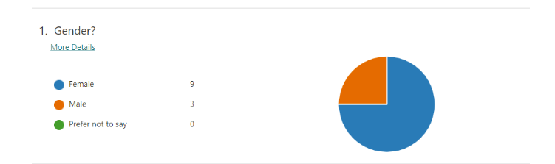

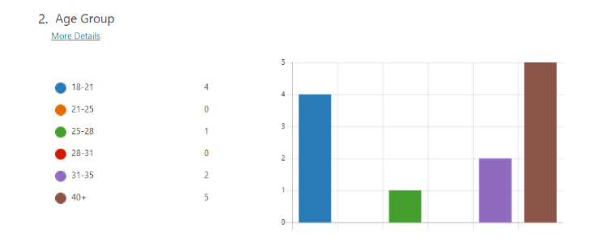
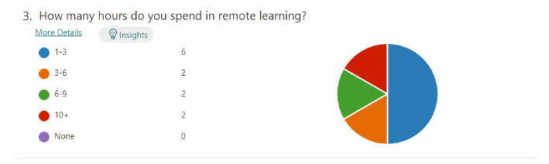

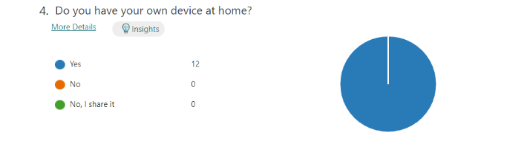
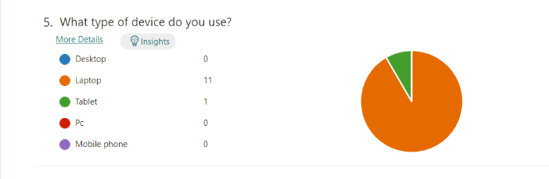

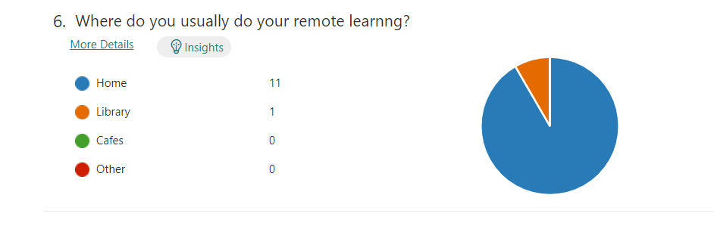

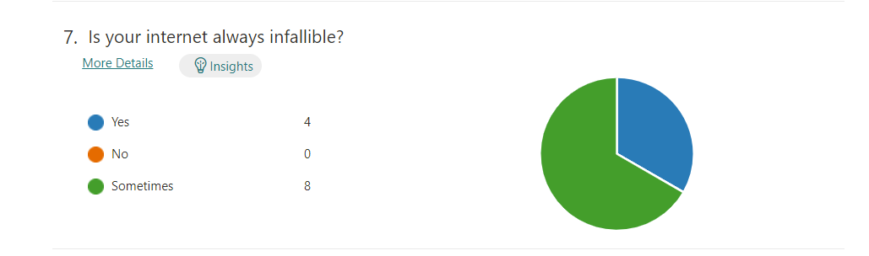

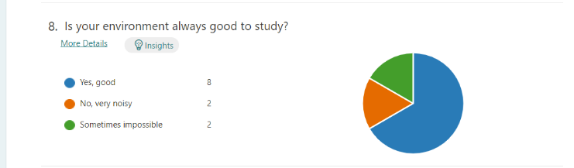

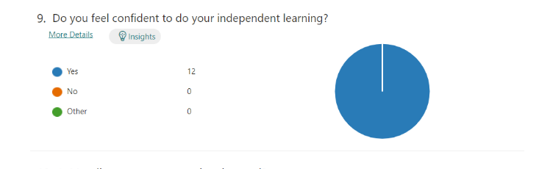

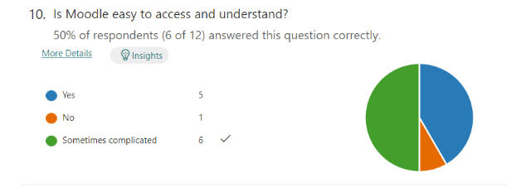

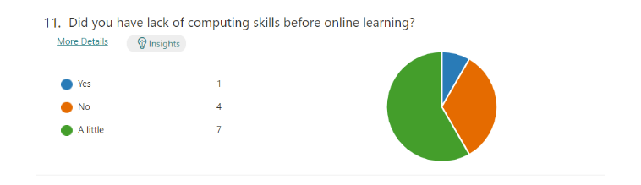

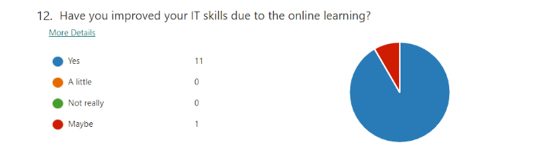

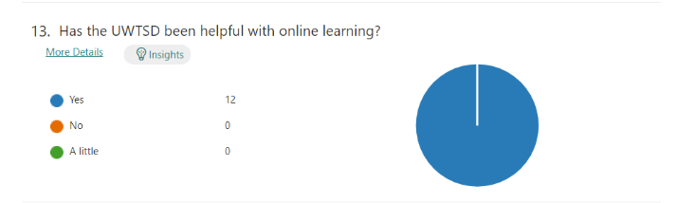

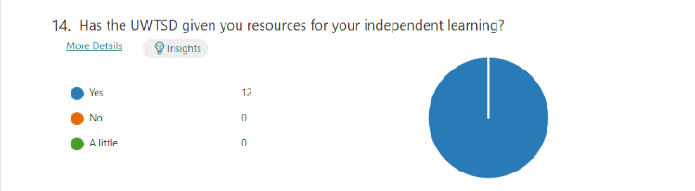

.

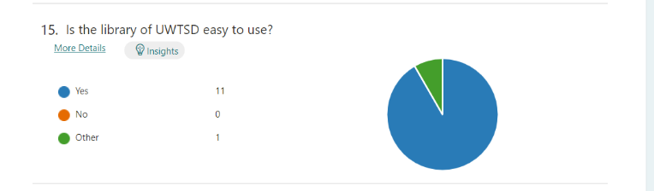

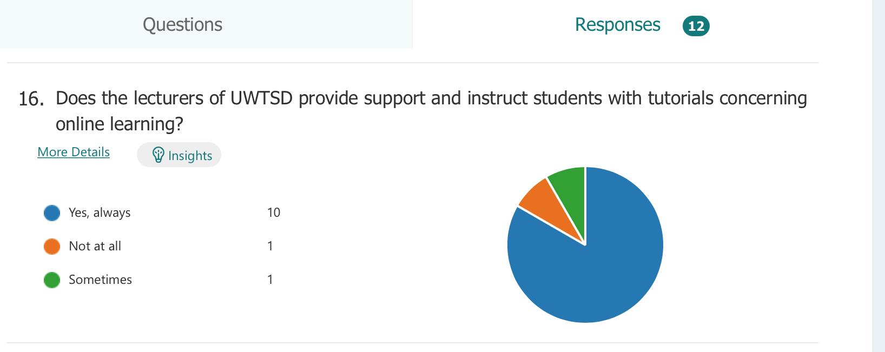

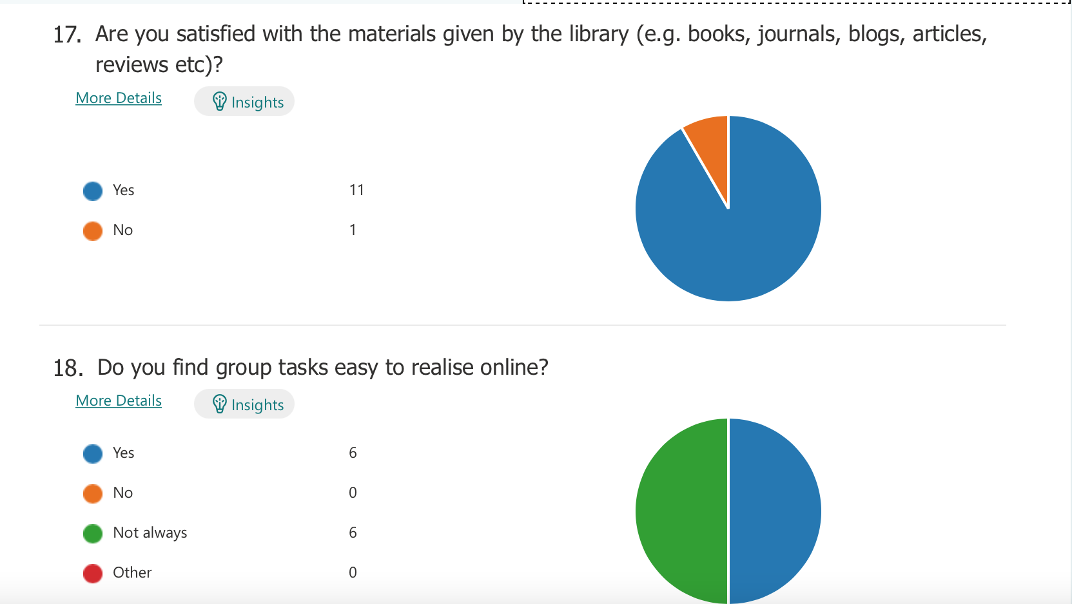

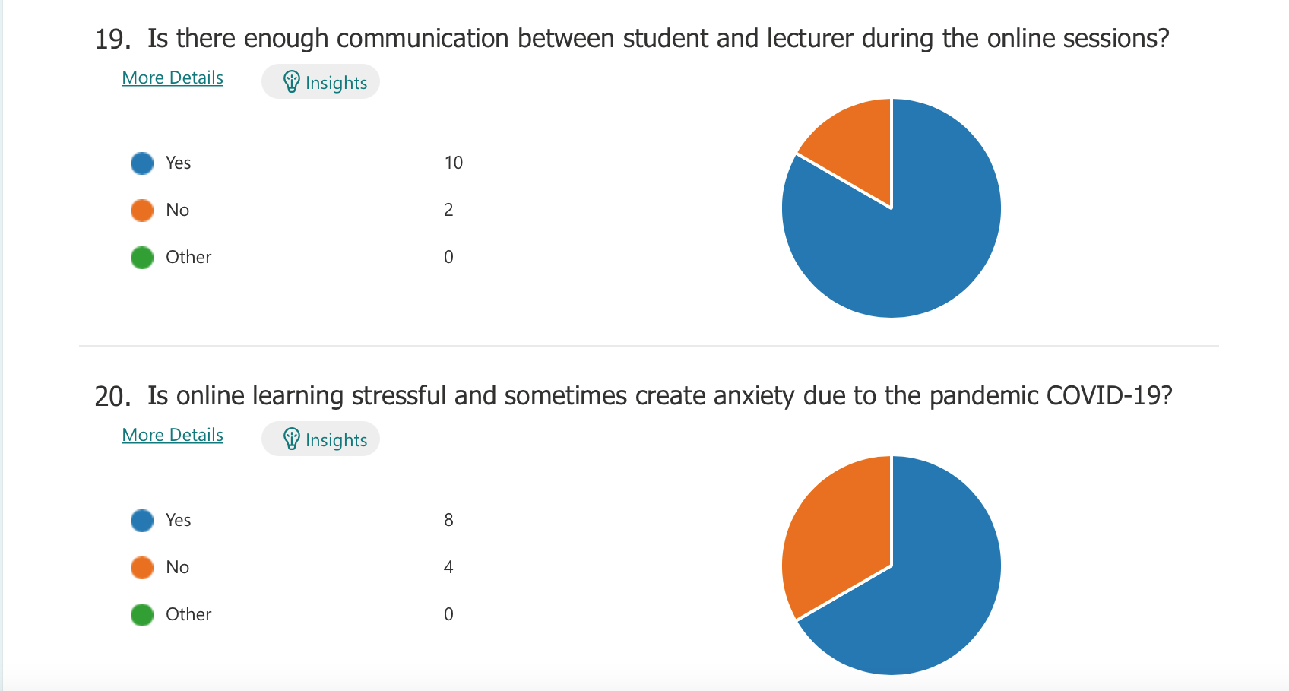

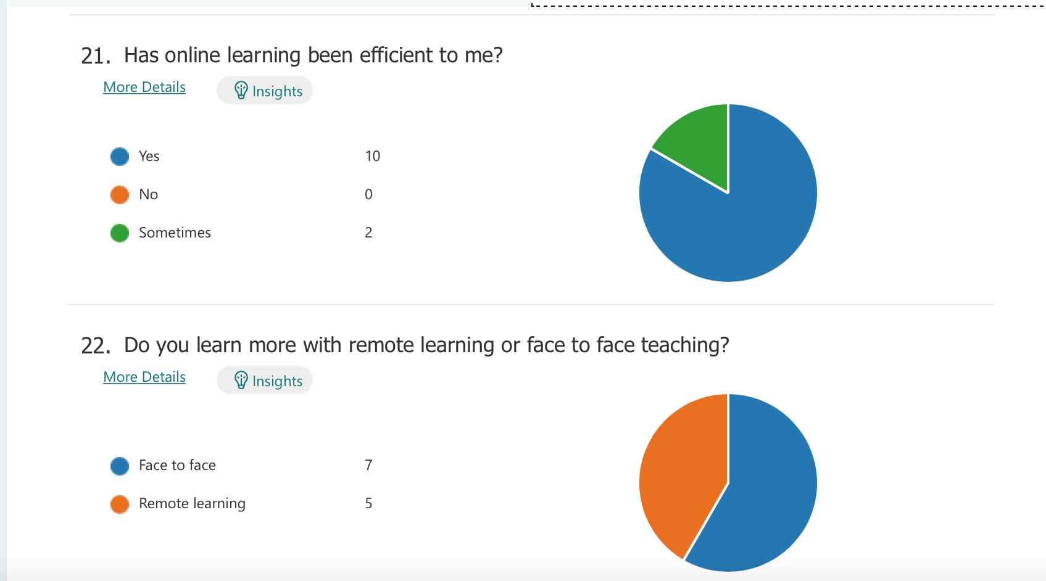

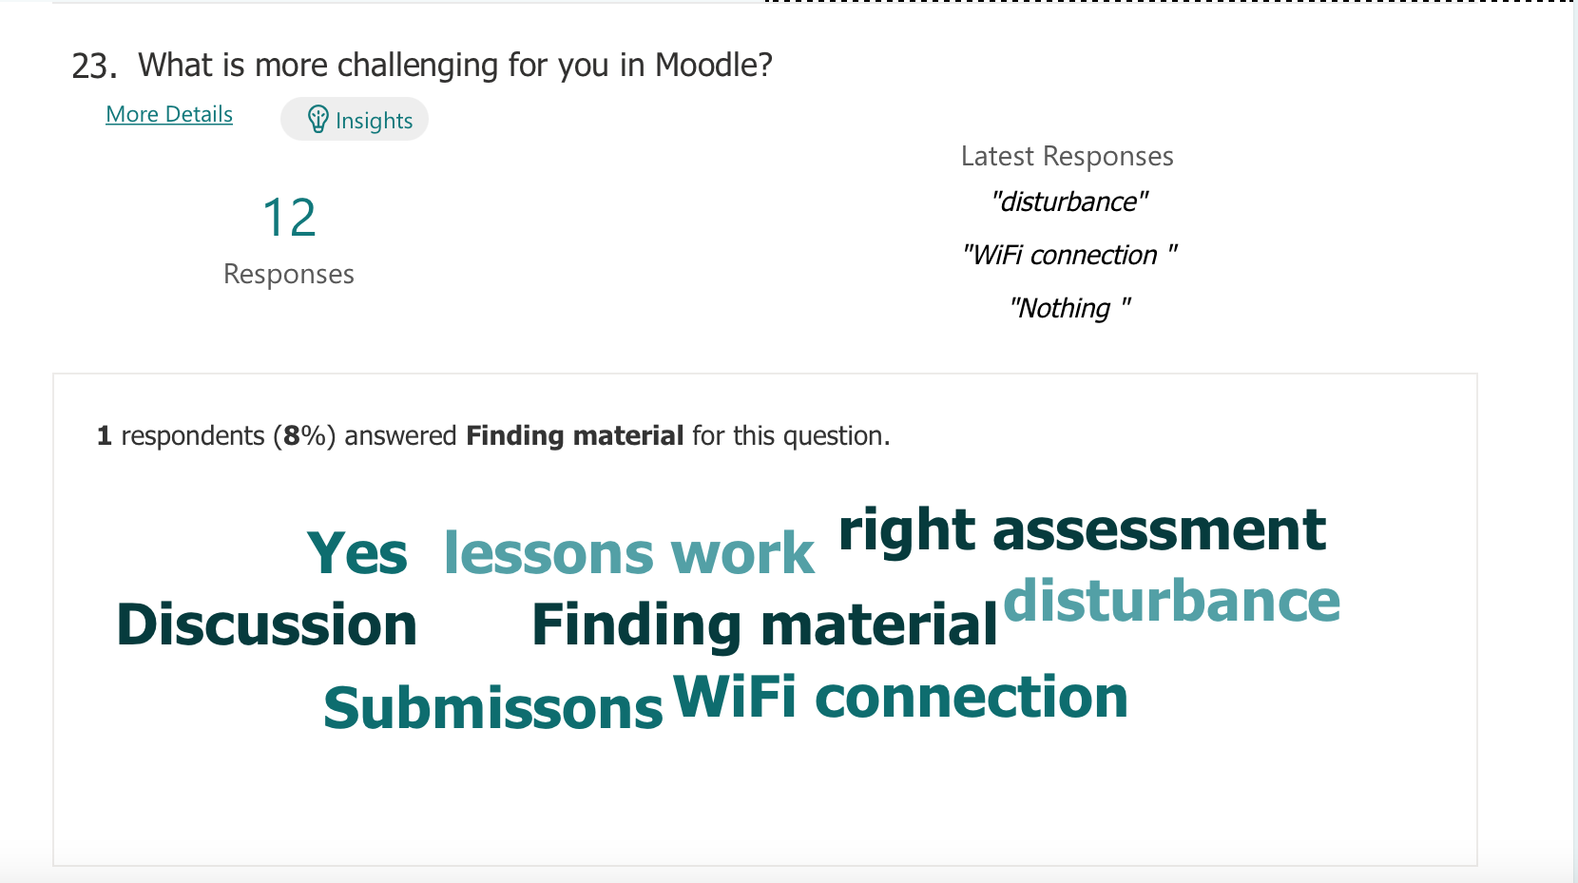

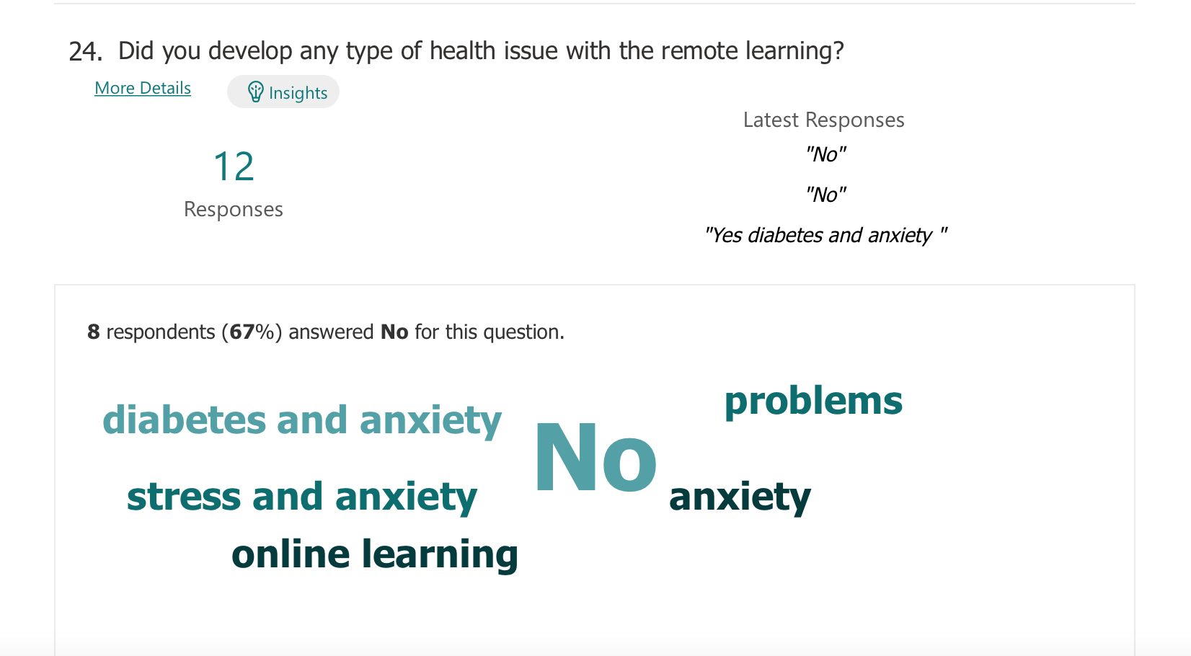

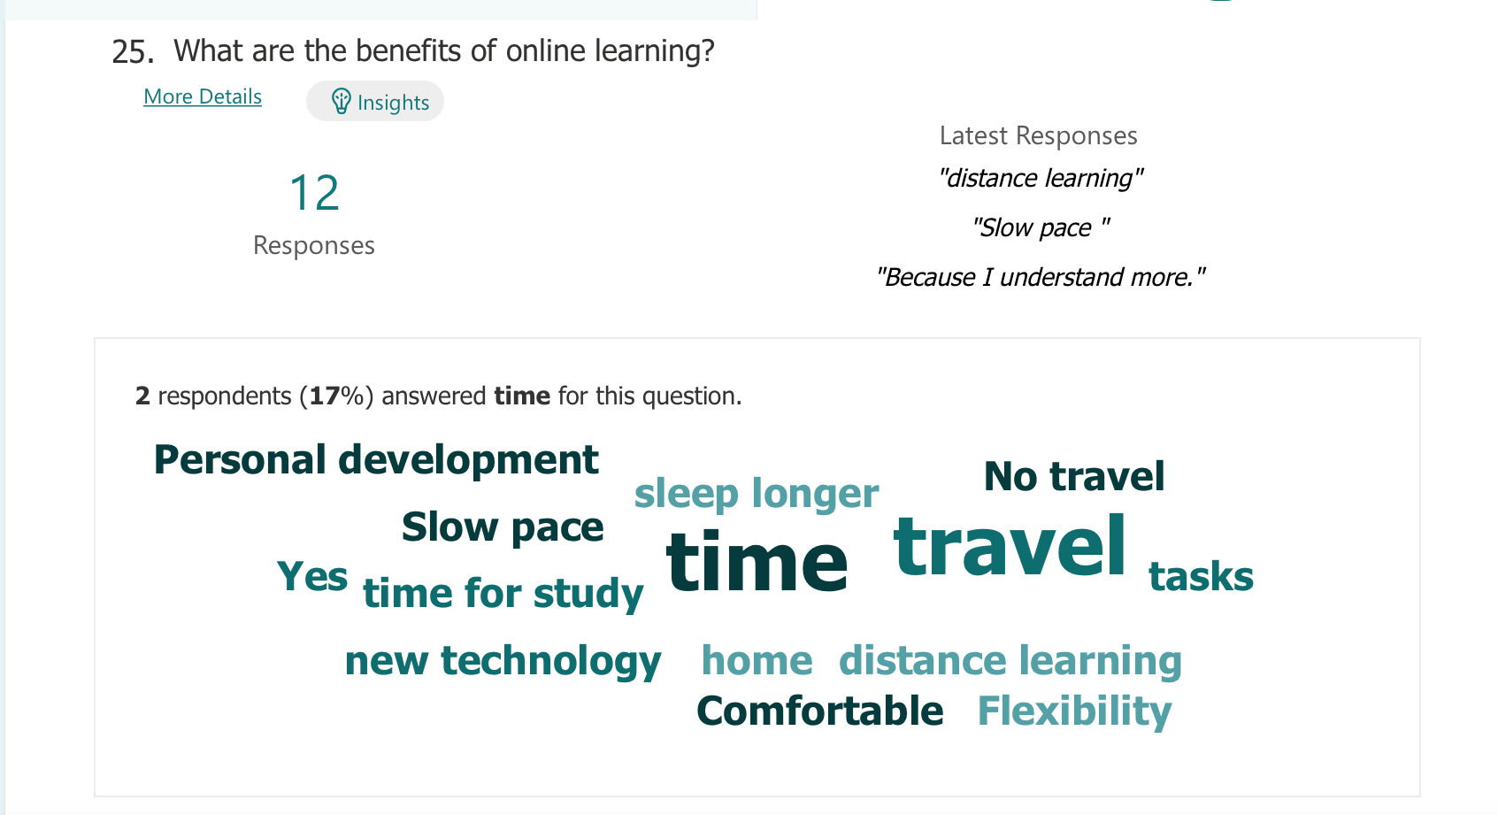

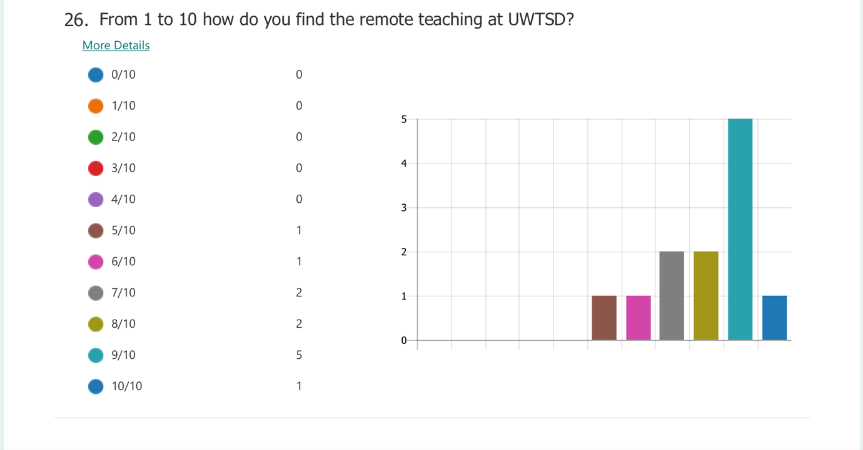

Reference list

- Barker, J. and Gossman, P., 2013. The learning impact of a virtual learning environment: students’ views. Teacher education advancement network journal (TEAN), 5(2), pp.19-38.

- Debra, M., (2020), How Virtual Learning Improves on Remote Learning, [Blog], Available at: https://www.elmhurst.edu/blog/virtual-learning/ Accessed:6th January 2022

- Dillenbourg, P., Schneider, D. and Synteta, P., 2002, September. Virtual learning environments. In Proceedings of the 3rd Hellenic conference information & communication technologies in education (pp. 3-18).

- Koskela, M., Kiltti, P., Vilpola, I. and Tervonen, J., 2005. Suitability of a Virtual Learning Environment for Higher Education. Electronic Journal of e-Learning, 3(1), pp.23-32.

Melanie, E., (2020), What is the benefit of a VLE? Available at; https://www.learningladders.info/news/what-is-a-vle/ Accessed; 6th January 2022

Melanie, E., (2020) What is a VLE (Virtual Learning Environment)? – 2021 Guide, learning ladders, Available at: https://www.learningladders.info/news/what-is-a-vle/ Accessed: 7th January 2022

- Nejad, M.B. and Nejad, E.B., 2012. Impact of E-Learning on Learning and Realizing Information Society. Research Journal of Applied Sciences, Engineering and Technology, 4(23), pp.5016-5020.

- Zalat, M.M., Hamed, M.S. and Bolbol, S.A., 2021. The experiences, challenges, and acceptance of e-learning as a tool for teaching during the COVID-19 pandemic among university medical staff. PloS one, 16(3), p.e0248758.

