

Assessment 1: Database Report term 2.
Assignment Title: Design and implementation of Relational Database System.
ACCA422-London.
Lecturer:Suresh Shan
UNIYVERSITY OF WALSE TRINITY SAINT DAVID (LONDON CAMPUS).
STUDENT NAME: AL NATHIR HAMED
STUDENT NUMBER:2525499
GROUP:1
DATE:

Contents
Contents 2
INTRODUCTION 3
Scenario Analysis 3
Entity relationship diagram: 9
Data Structure Development: 10
10
Normalisation Up to (3NF): 11
Sample Data Population: 13
Query Development: 16
Validation and Testing: 20
Report: 23
Forms: 25
Design Decisions: 31
Summary of the completed database: 31
Challenges faced: 31
Future improvements: 32
Conclusion: 32
References: 32

INTRODUCTION
Microsoft Access is a relational management system that facilitates effective data creation, administration, and organization. It is appropriate for managing commercial operations like parking services since it offers capabilities for creating tables, forms and reports. The design and implementation of Microsoft Access database for the Auto park management system are presented in this study. The entity relational diagram (ERD), database structure, entity and relationship identification, and normalisation to third normal form (3NF) are all explained. To show that the database satisfies the needs of the parking management system, the report also contains sample data, useful queries, and system testing.

Scenario Analysis
Parking sites, Parking Slots, Customers, vehicles, Booking, Payments. Are the main entities that managed by the Auto Park System database. These organisations are linked to one another, so that the business can track payments, keep an eye on slots availability, and record vehicle parking activity.
Entities and attributes:
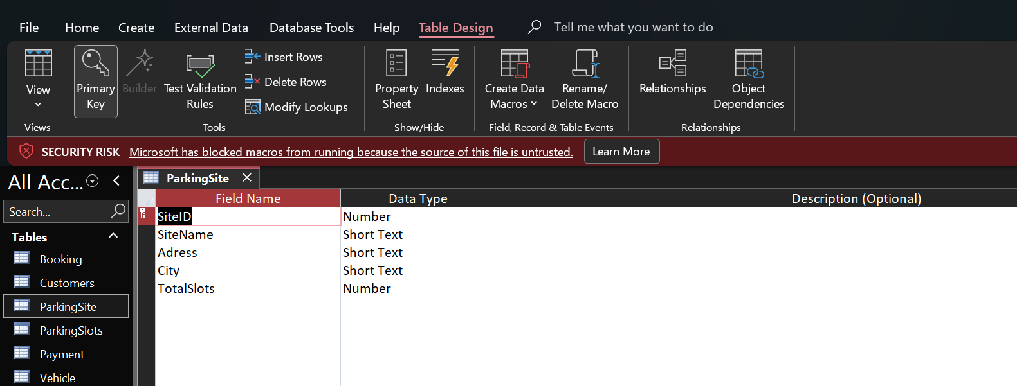
Parking Site:

Figure 1: Screenshot showing parking site table and its attributes of this entity.

Parking Slot:
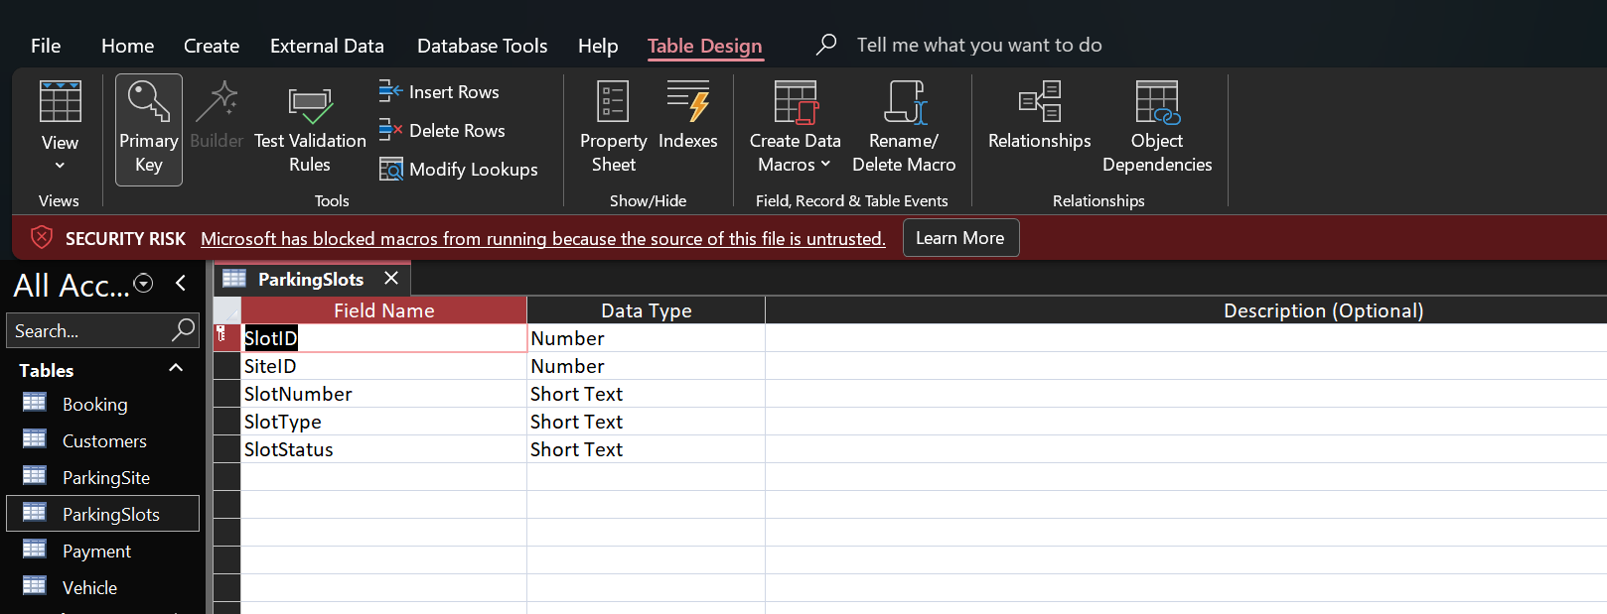

Figure 2: Screenshot showing an entity which’s Parking Slot and its attributes.

Customer:
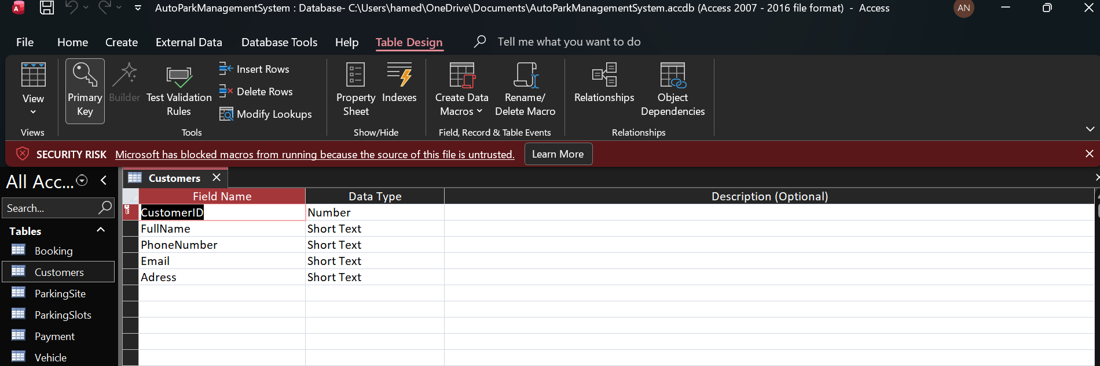

Figure3: Screenshot showing Customer which’s an entity and its attributes.
Vehicle
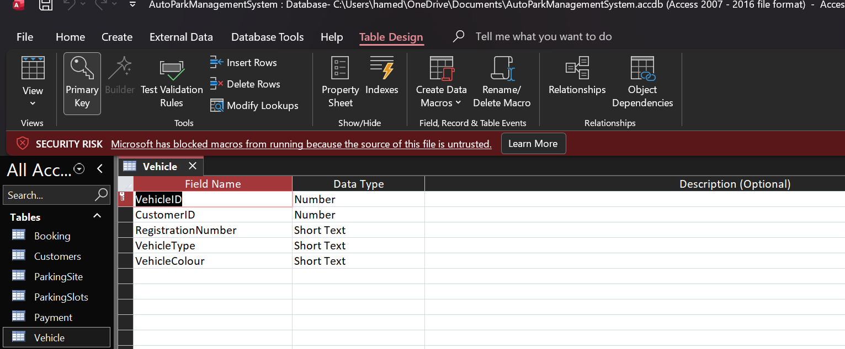

Figure4: Screenshot showing vehicle as an entity and its attributes.

Booking:

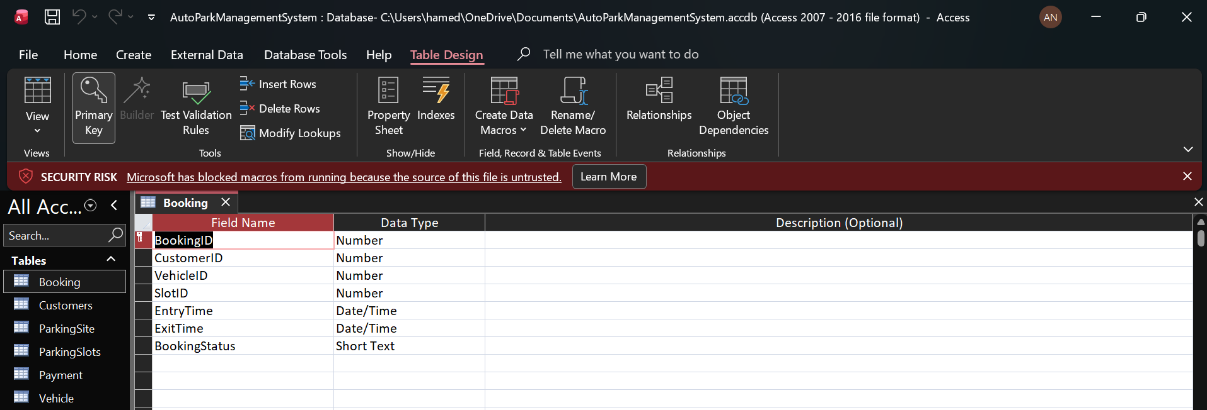

Figure5: Screenshot showing booking table as entity and its attributes.
Payment:
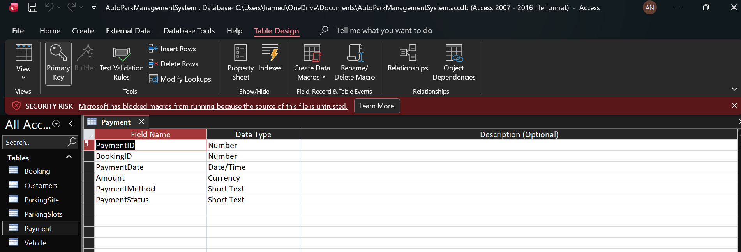

Figure6: The payment entity and its related attributes are shown in Microsoft Access in design view.

Relationships:
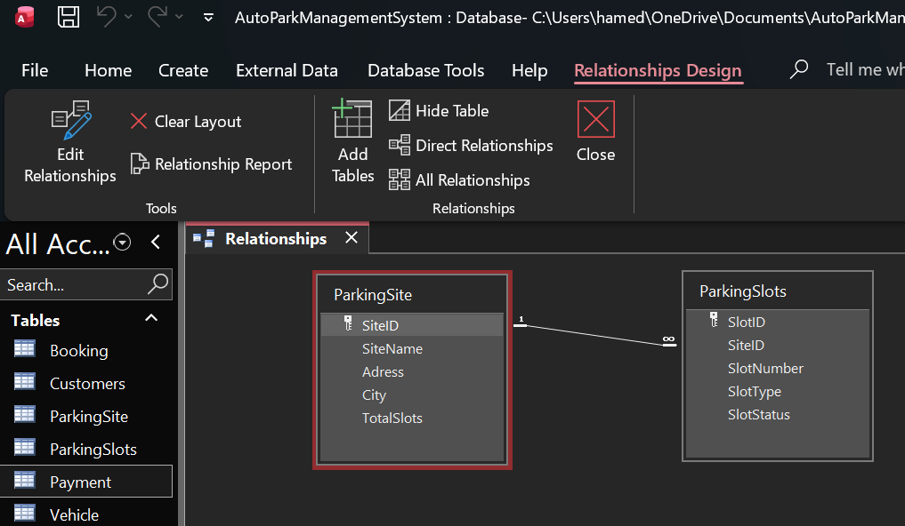

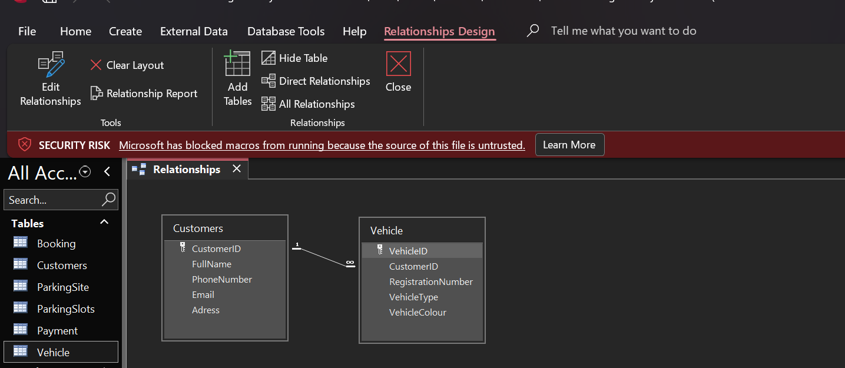
Figure 7: Screenshot shows One to Many relationships between Parking Site and Parking Slot.

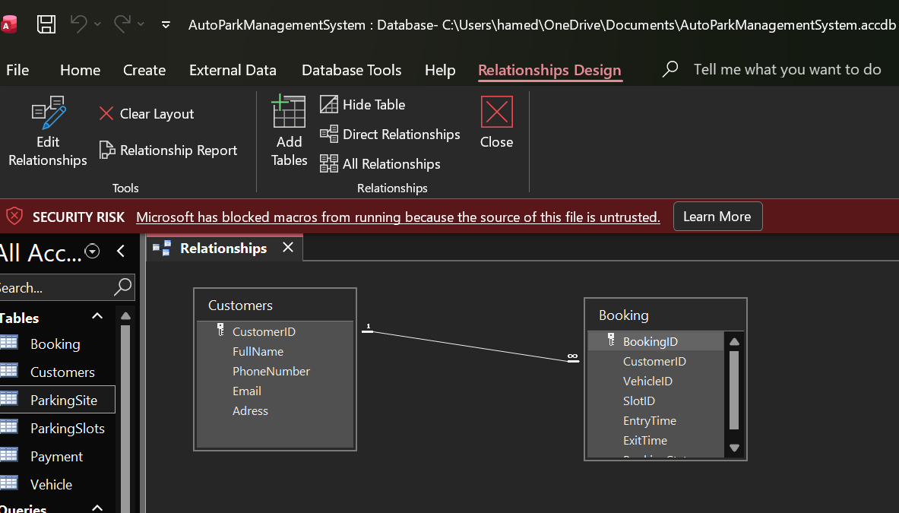
Figure 8: Screenshot shows One to Many relationships between Customers and Vehicle.

Figure9: Screenshot shows One to Many relationships between Customer and Booking.
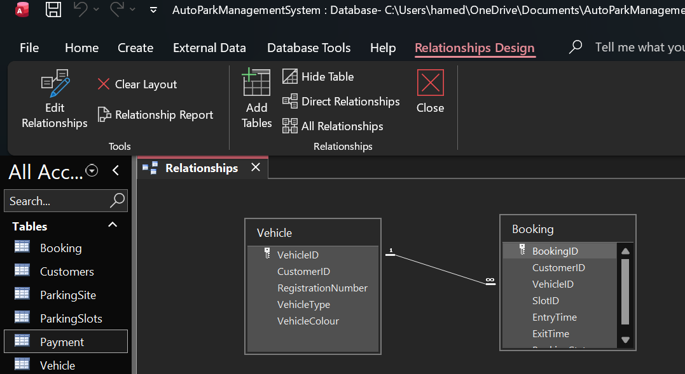
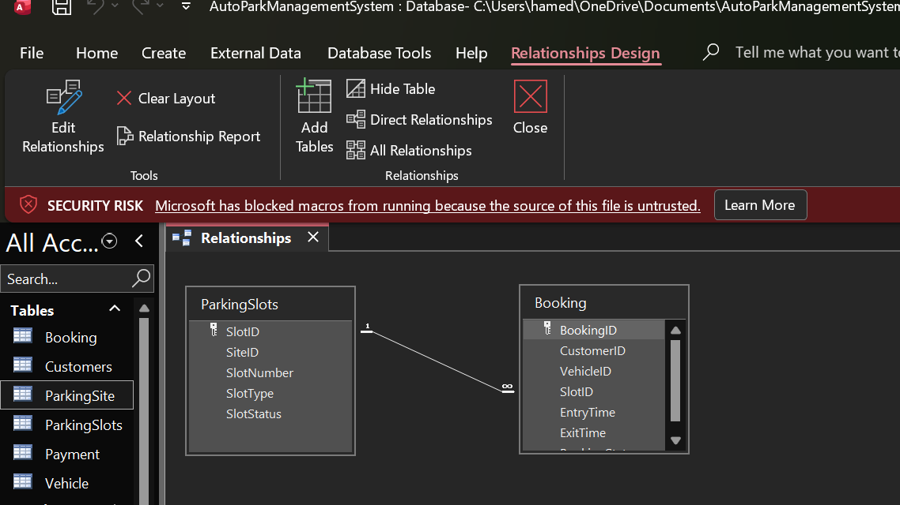
Figure10: Screenshot shows (One to Many relationships between Vehicle and Booking).

Figure11: Screenshot shows (One to Many relationships between Parking Slots and Booking).
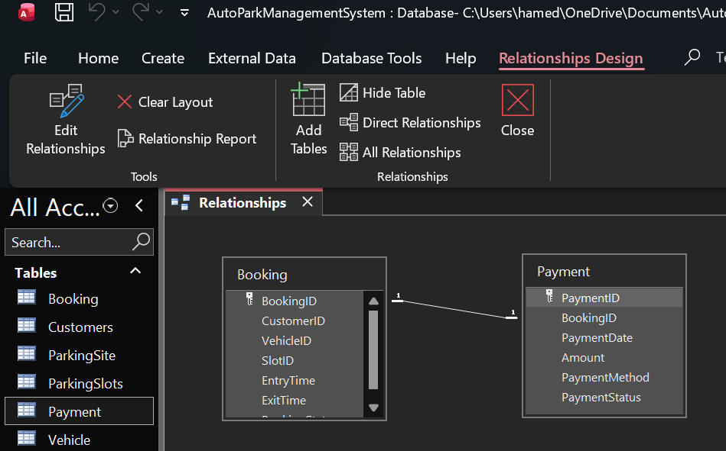
Figure12: Screenshot showing (One to One relationship between Booking and Payment).

Entity relationship diagram:
Diagram Link: https://lucid.app/lucidchart/ab8e151b-e805-49ab-a104-2a4e8780b5b6/edit?invitationId=inv_7f05ac47-1cd0-4d5f-9089-99232afe284c&page=0_
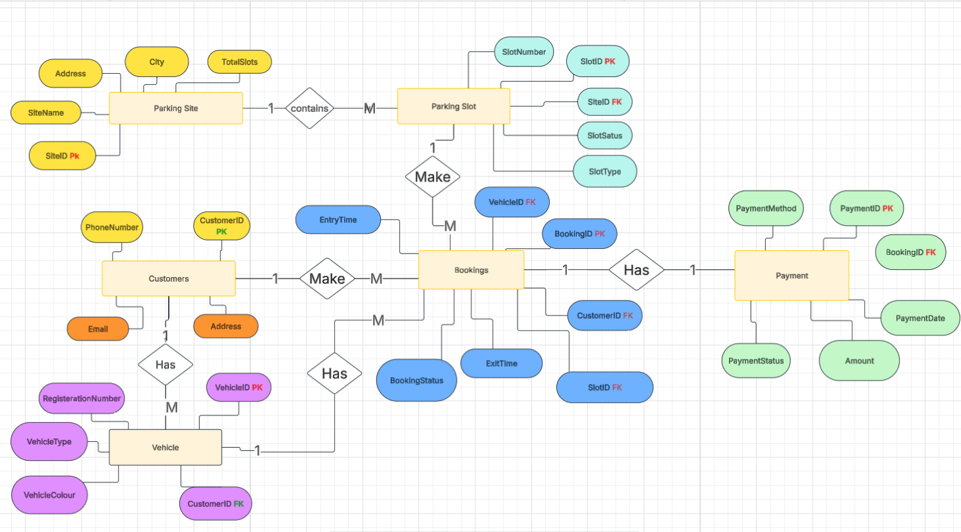

Figure13: Screenshot showing entity Relationship Diagram (ERD) for the Auto Park Management system.

Data Structure Development:

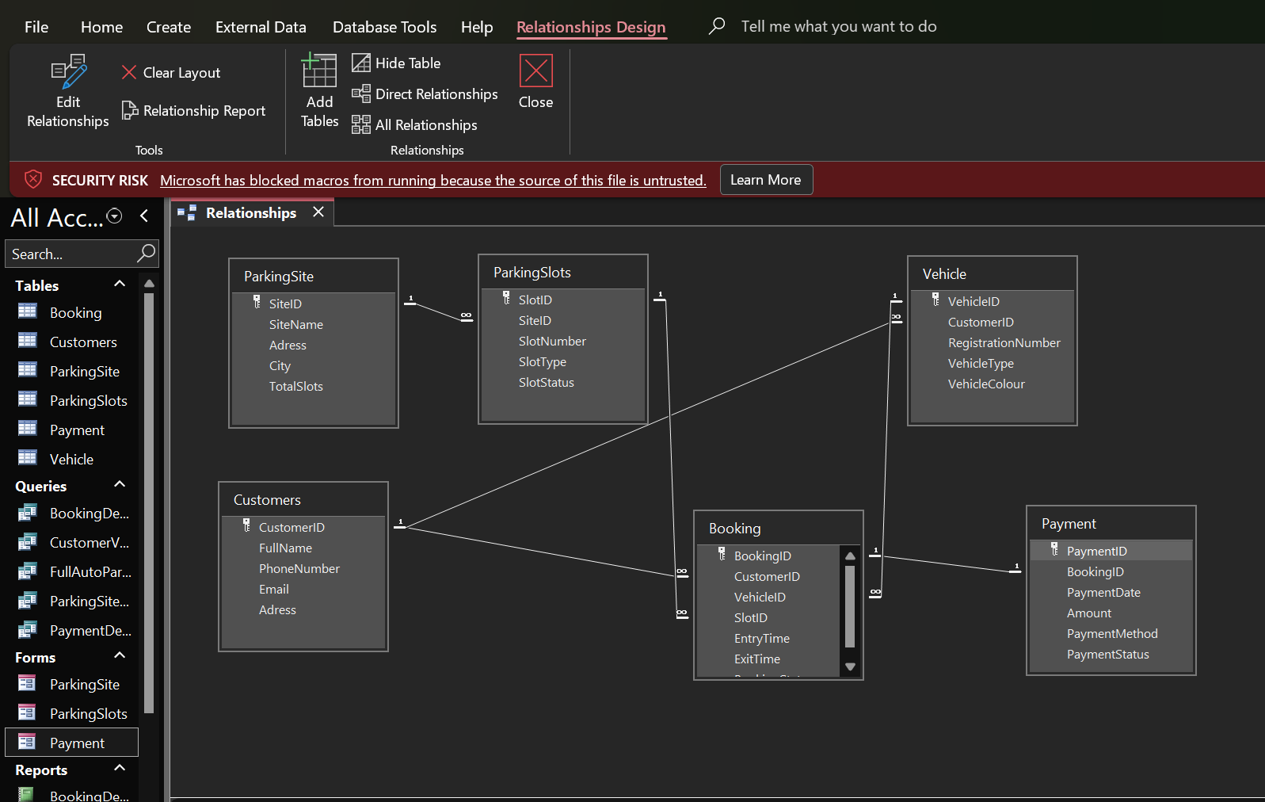

Figure14: Screenshot showing data structure development that illustrates the connection between database tables.

Normalisation Up to (3NF):
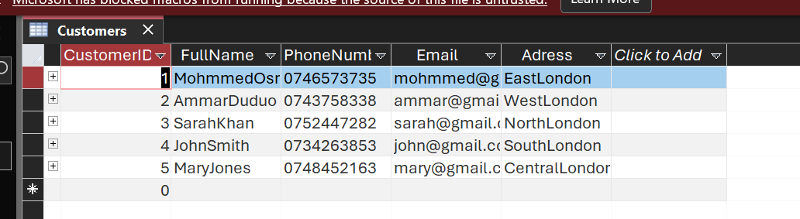
First Normal form:
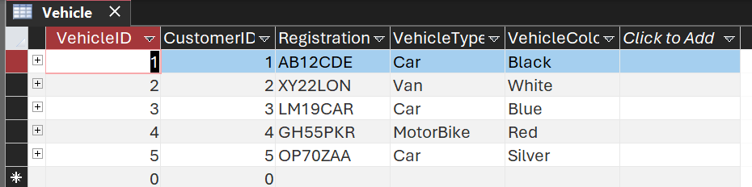
Figure15: datasheet view of customer table showing(1NF).
Figure16: datasheet view of vehicle table showing (1NF).
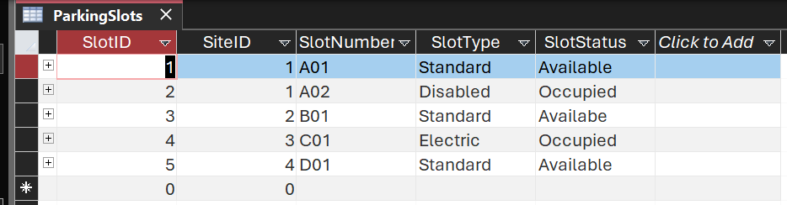
Figure17: datasheet view of Parking Slot table Showing (1NF)
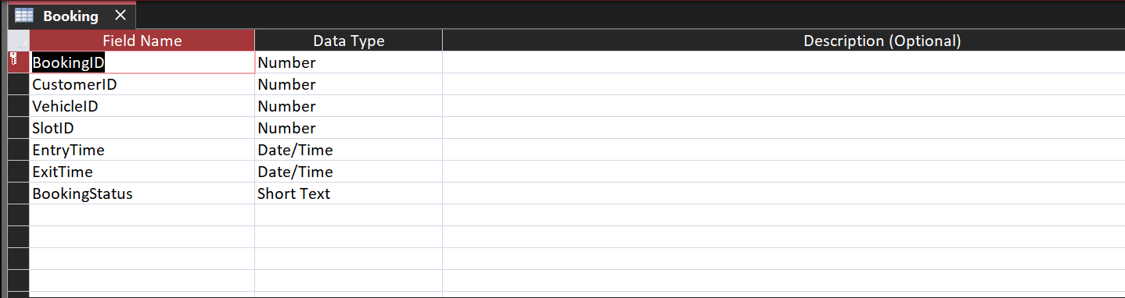
Second Normal Form (2NF)

Figure18: Design view of booking table showing (2NF).
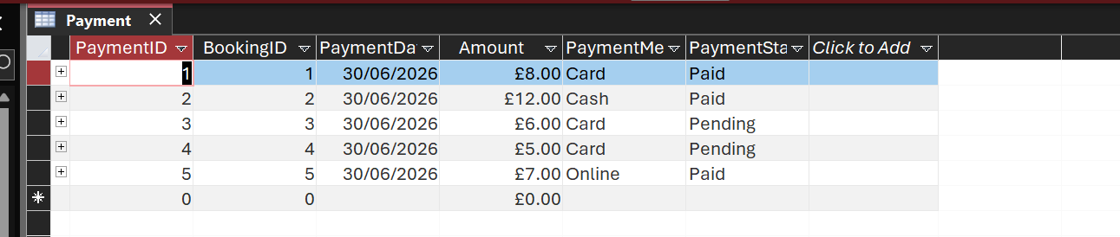

Figure19: Datasheet view of payment showing (2NF).
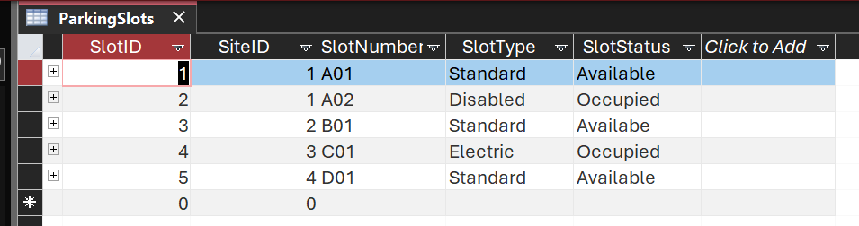
Third Normal Form (3NF).

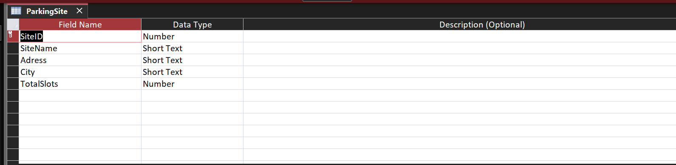
Figure 20: Design view of Parking Slot Table showing (3NF).

Figure 21: Design view of Parking Site Table showing (3NF).
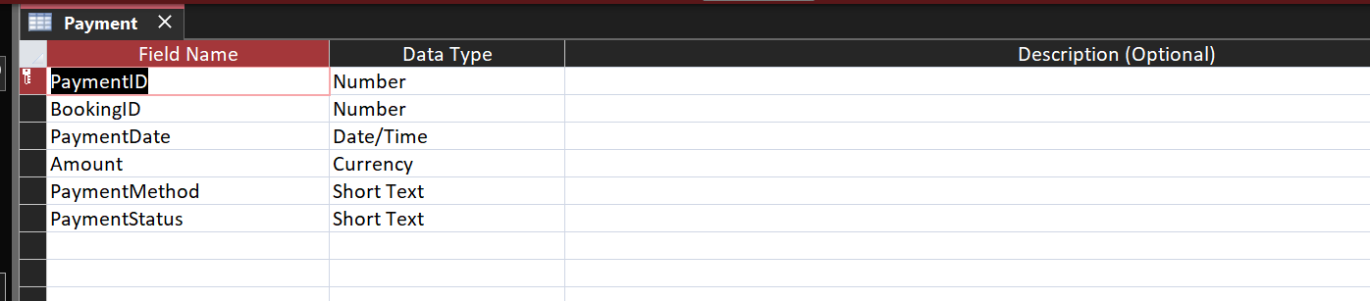

Figure 22: Design view of Payments table showing (3NF).

Sample Data Population:
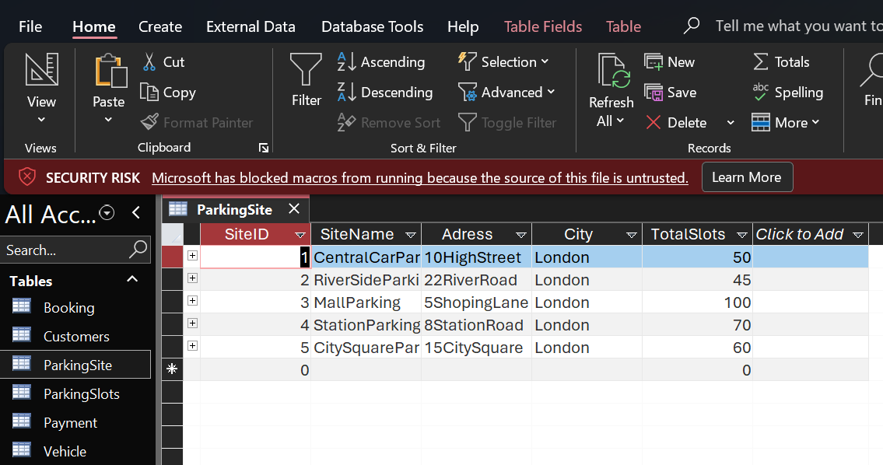

Figure 23: Screenshot showing Parking Site records.

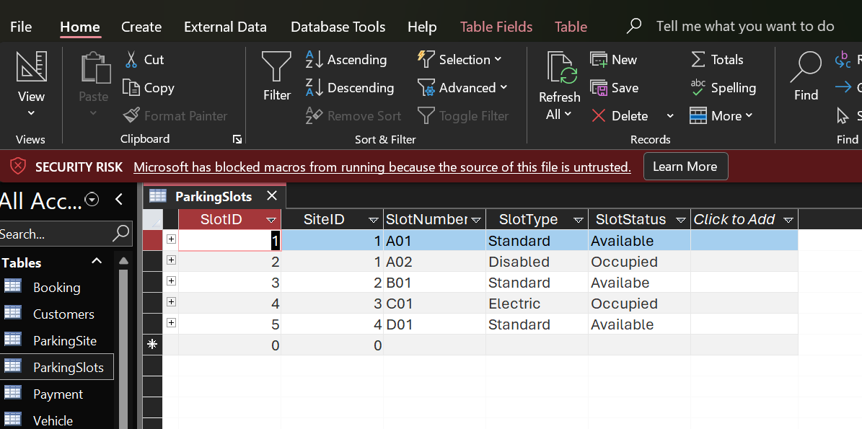

Figure 24: Screenshot showing five populated Parking Slots record displayed in this sample data population.
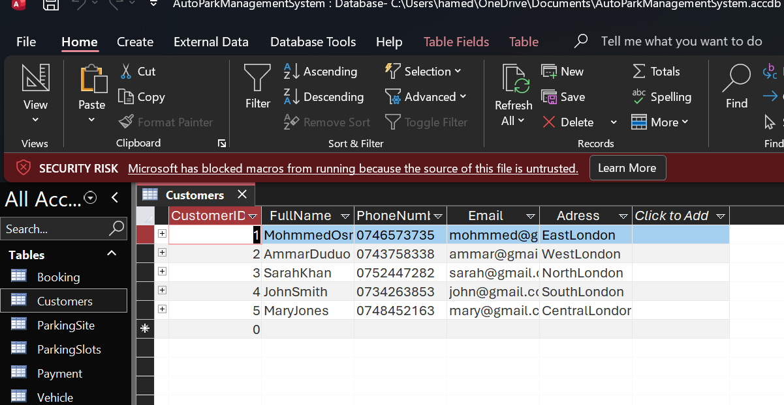

Figure 25: Screenshot showing five populated Customer record displayed in this sample data population.
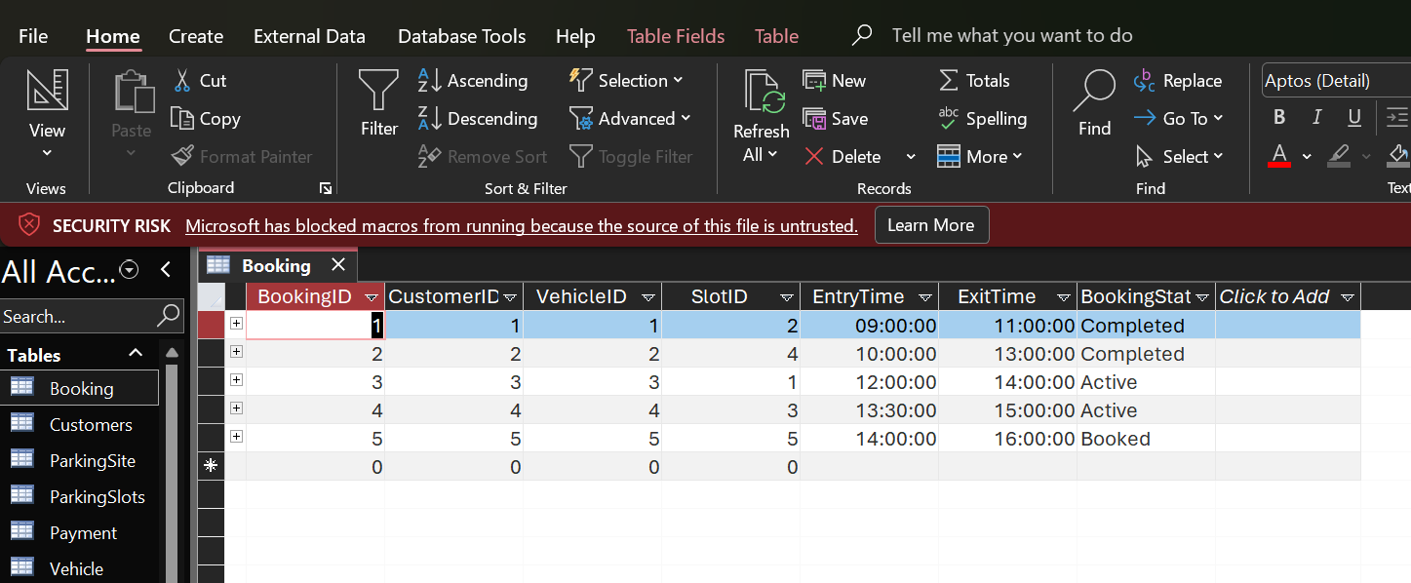
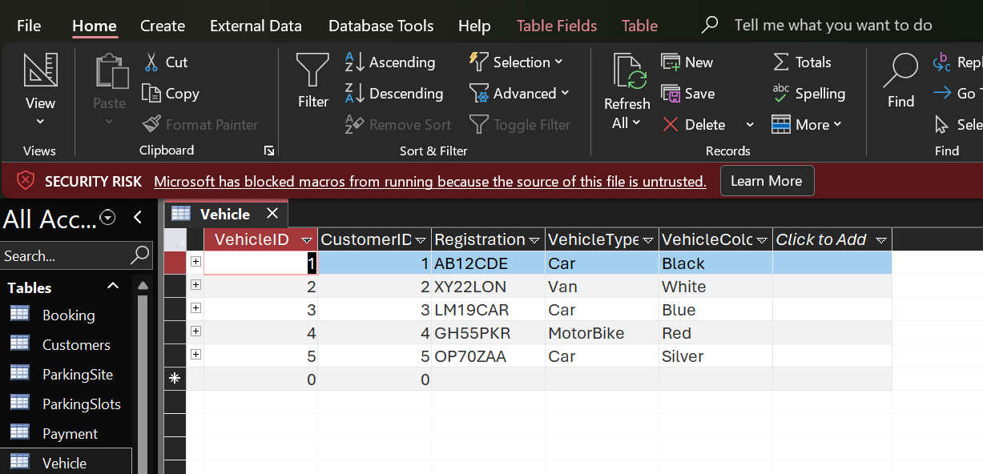
Figure 26: Screenshot showing five populated booking record displayed in this sample data population.

Figure 27: Screenshot showing five populated vehicle record displayed in this sample data population.

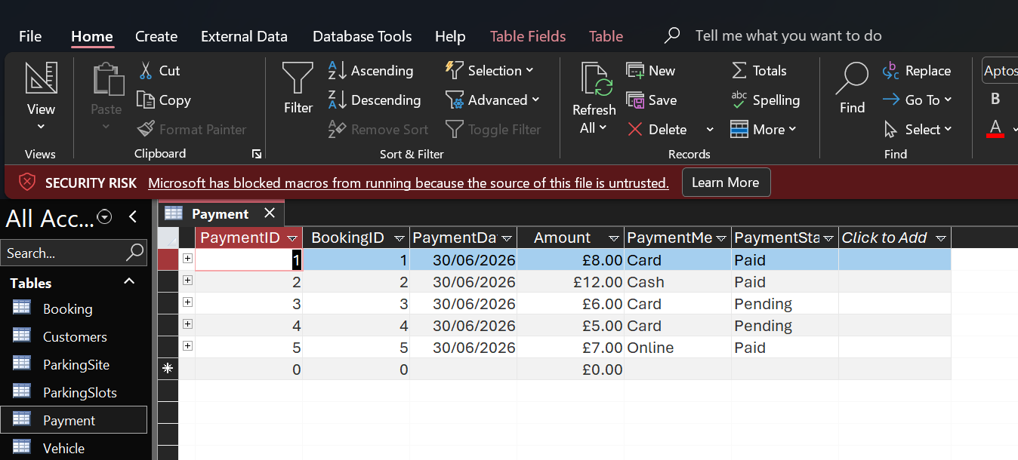
Figure 28: Screenshot showing five populated payment record displayed in this sample data population.

Query Development:
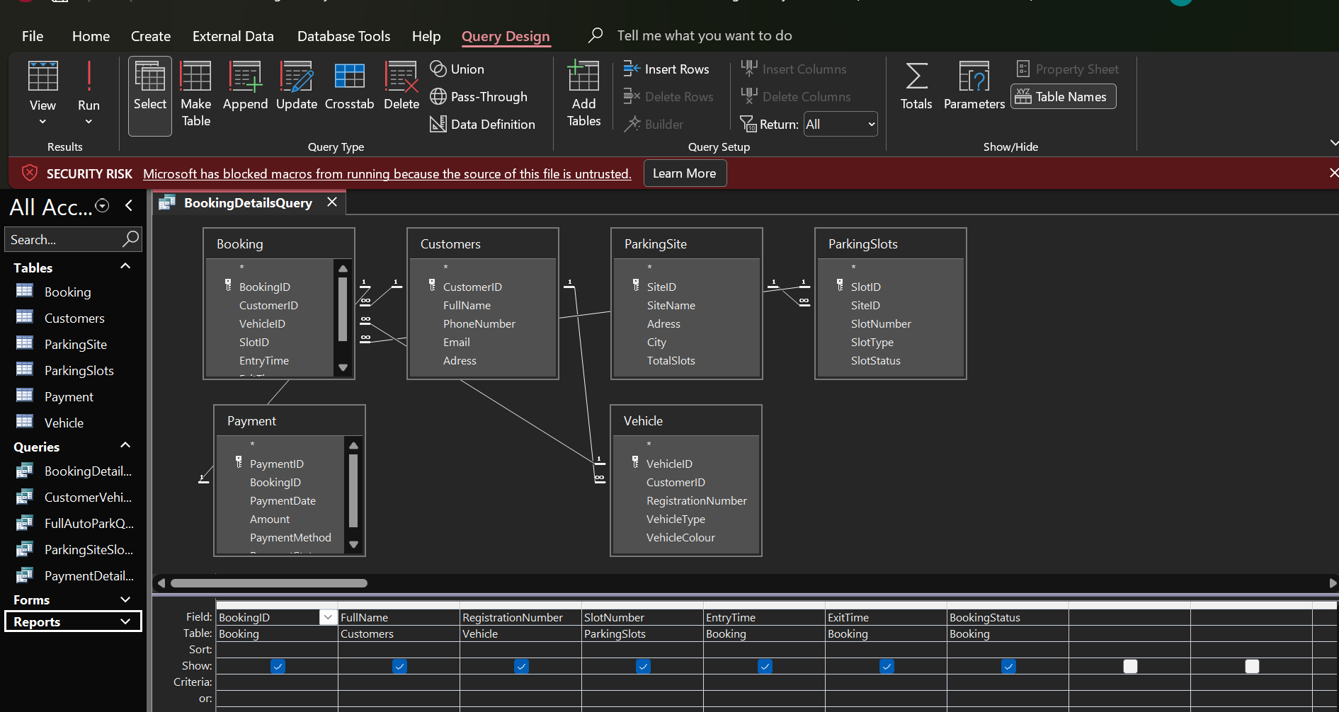

Figure29: Screenshot showing an example of multi booking details using design view.
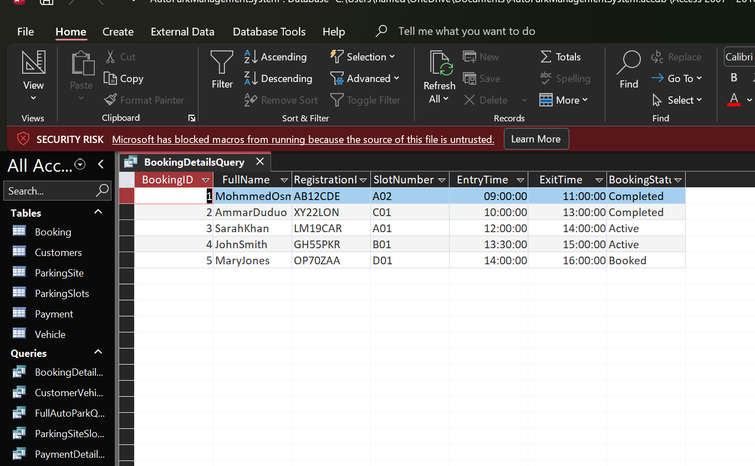
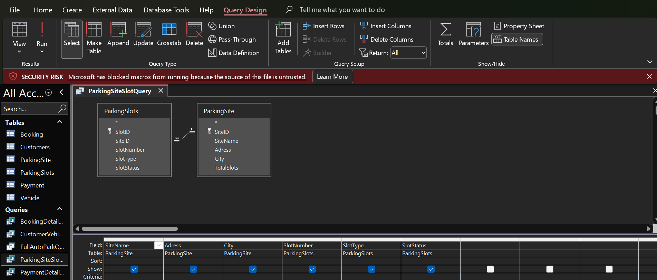
Figure 30: Screenshot showing the booking details query results are displayed in datasheet view.

Figure 31: Screenshot showing a query that connects the Parking Site and Parking Slot tables is shown in query design view.

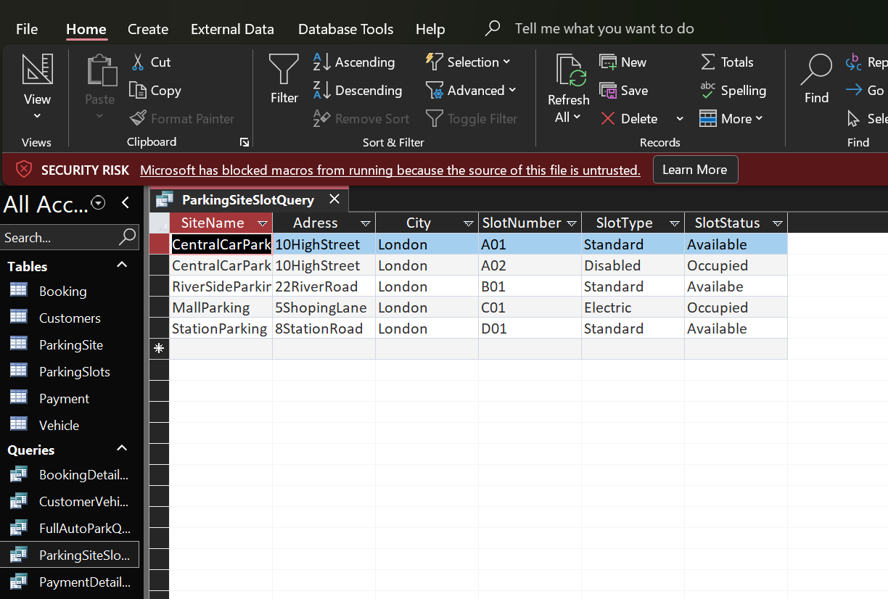
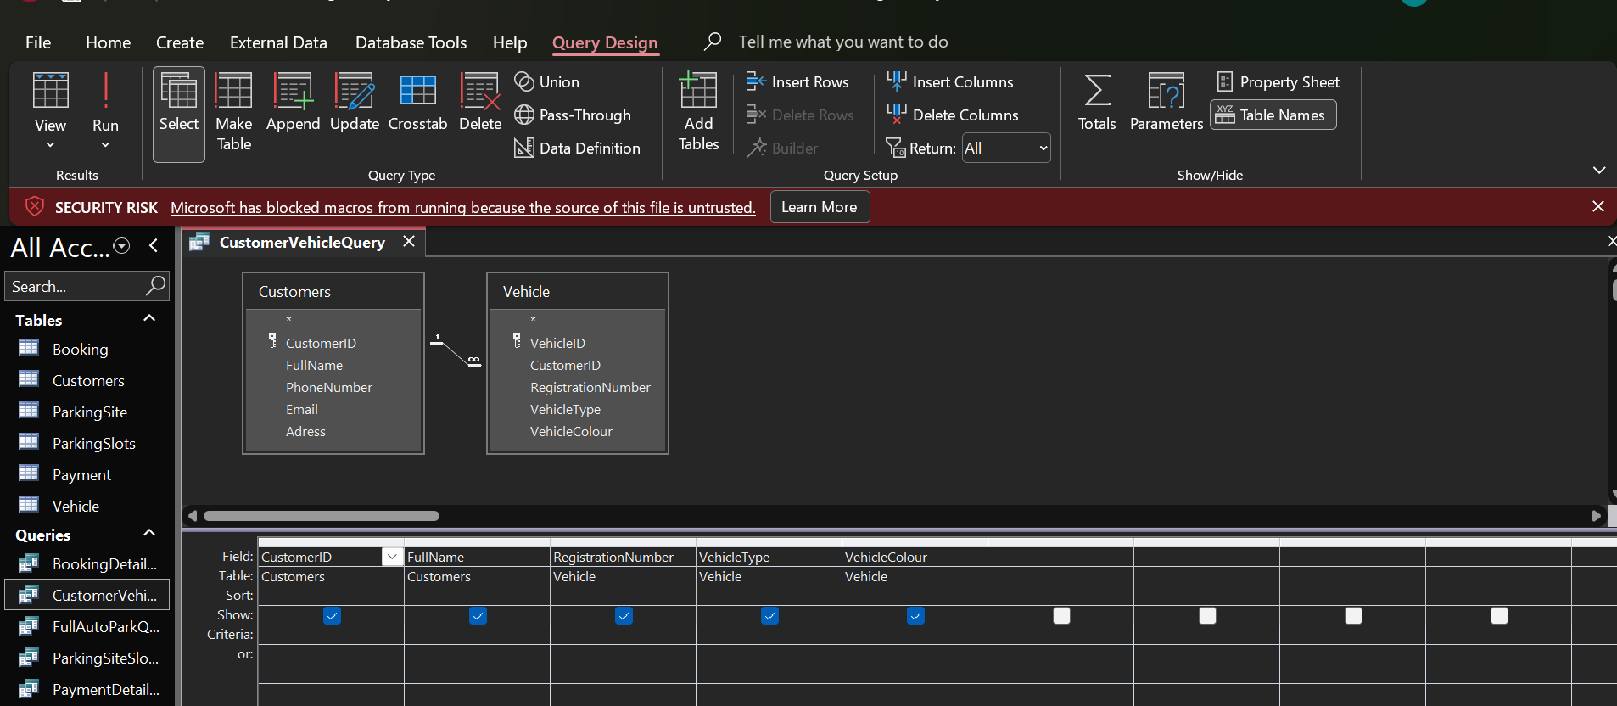
Figure 32: Showing screenshot, a query of parking site slot in a datasheet view.

Figure 33: Screenshot showing a query that connects customer and vehicle tables in design view.

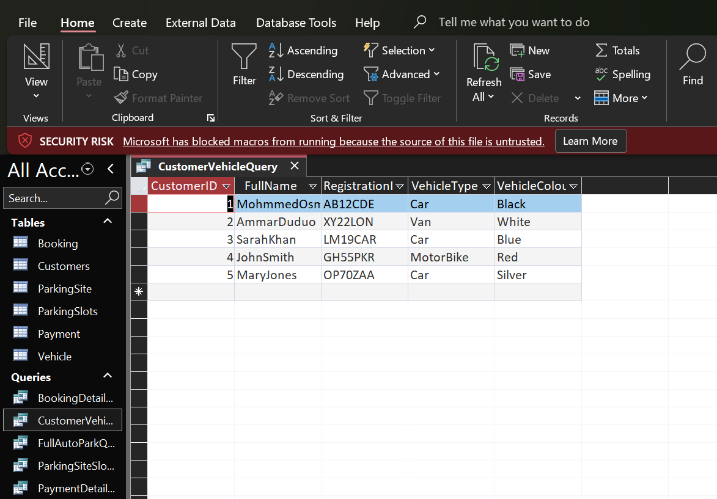
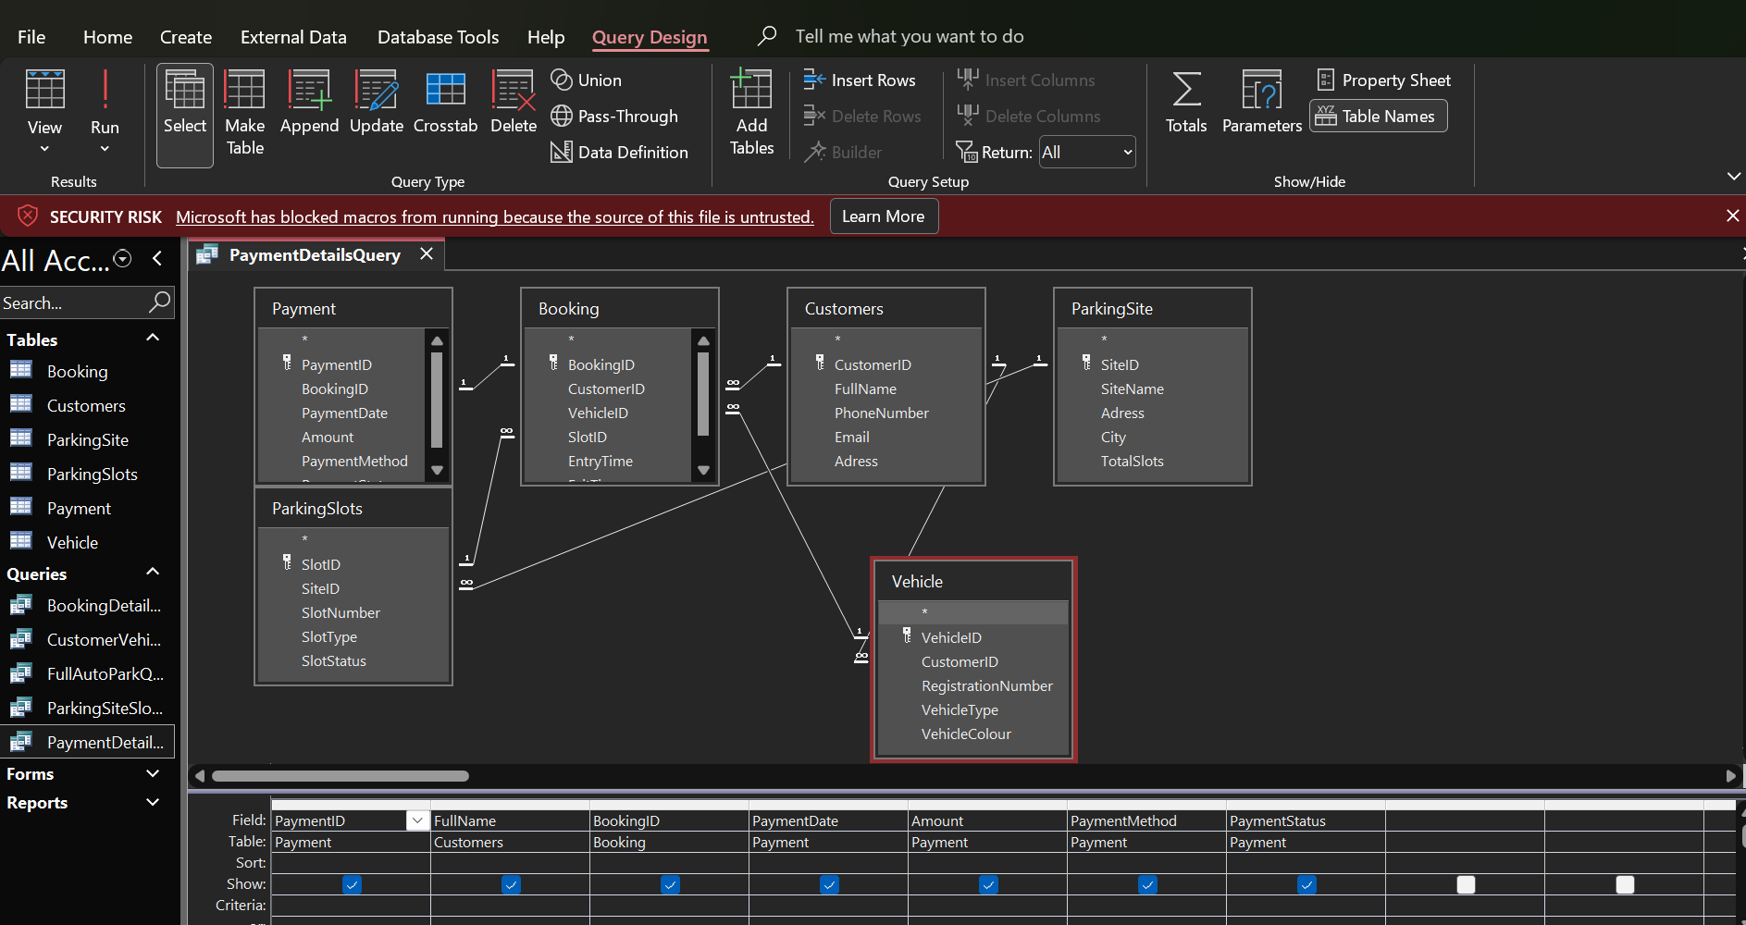
Figure 34: Screenshot showing a query of customer vehicle in a datasheet view.
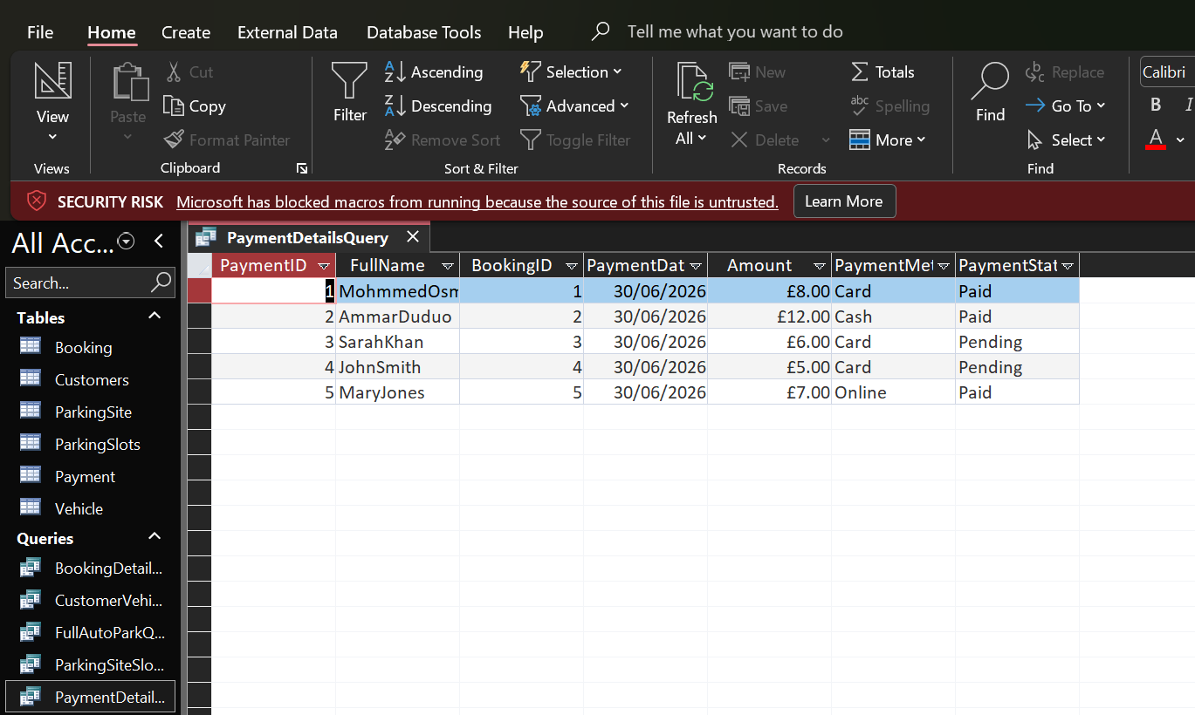
Figure 35: Screenshot showing a query of payment details in a design view.

Figure 36: Screenshot showing query of a payment details in datasheet view.

Validation and Testing:
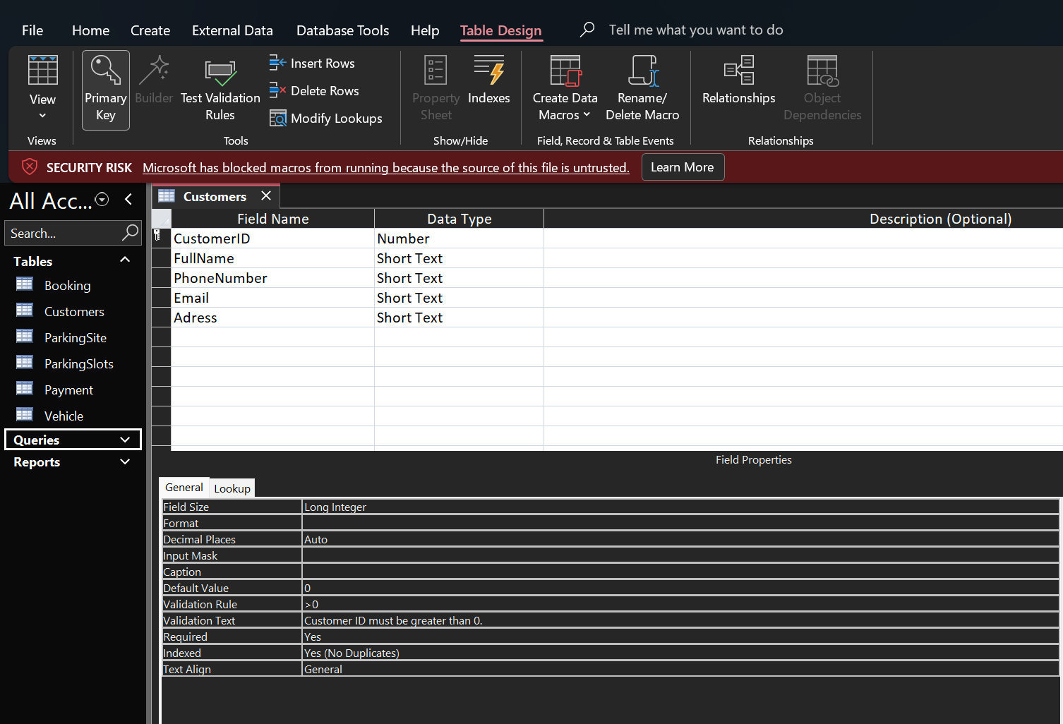

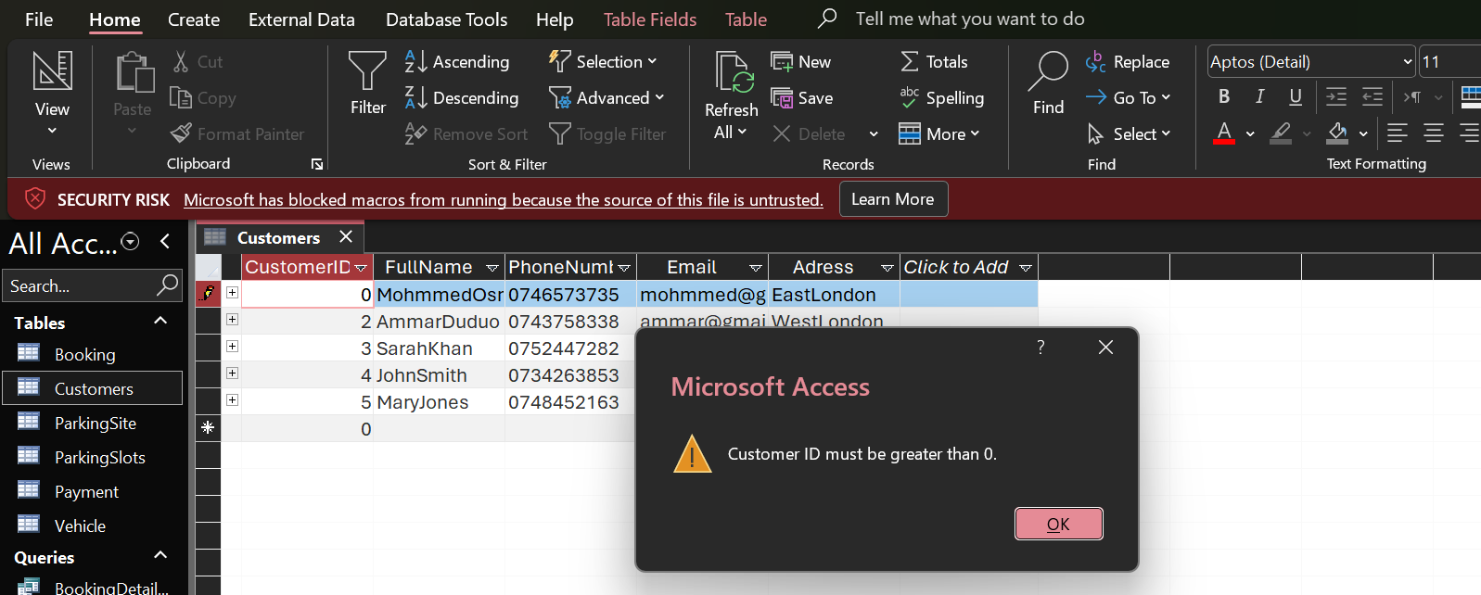

Figure 37: Screenshot showing validation rule has been applied to the customer’s table.

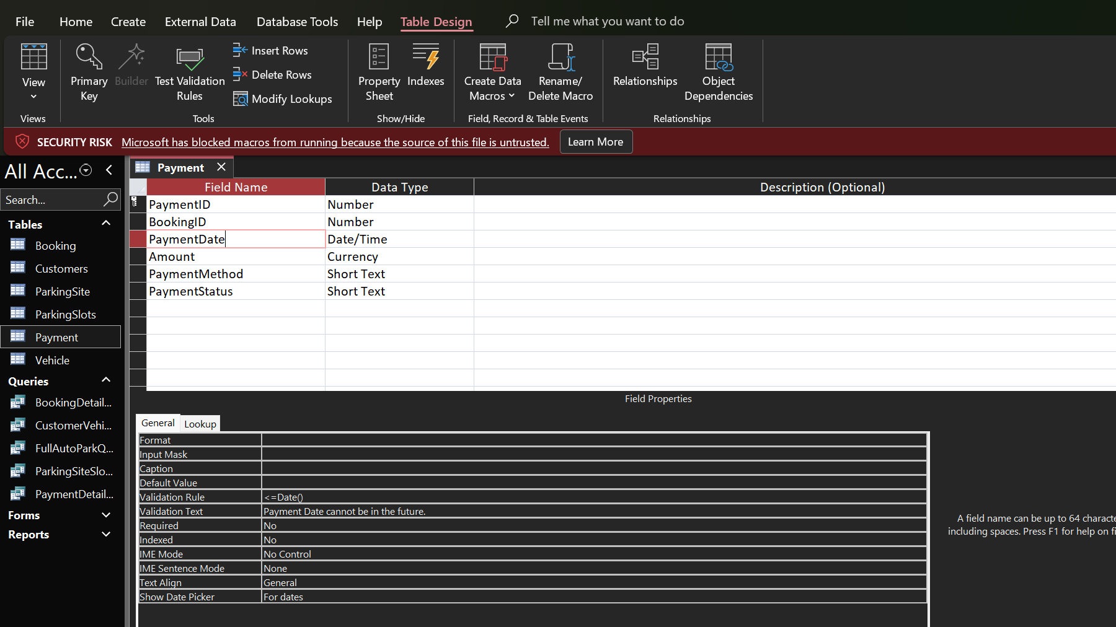

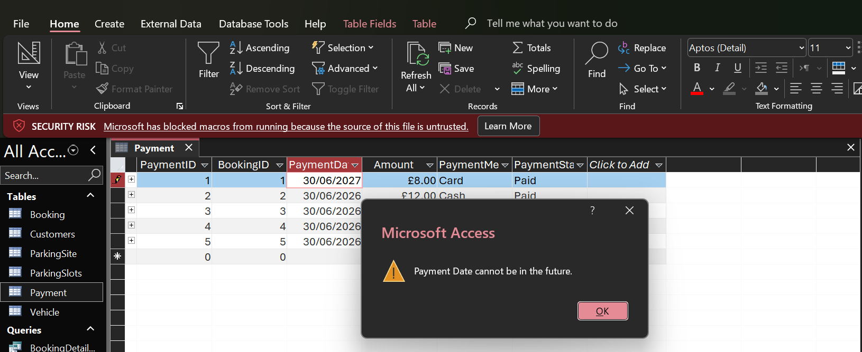
Figure 38: Screenshot showing validation rule has been applied to the payment table.
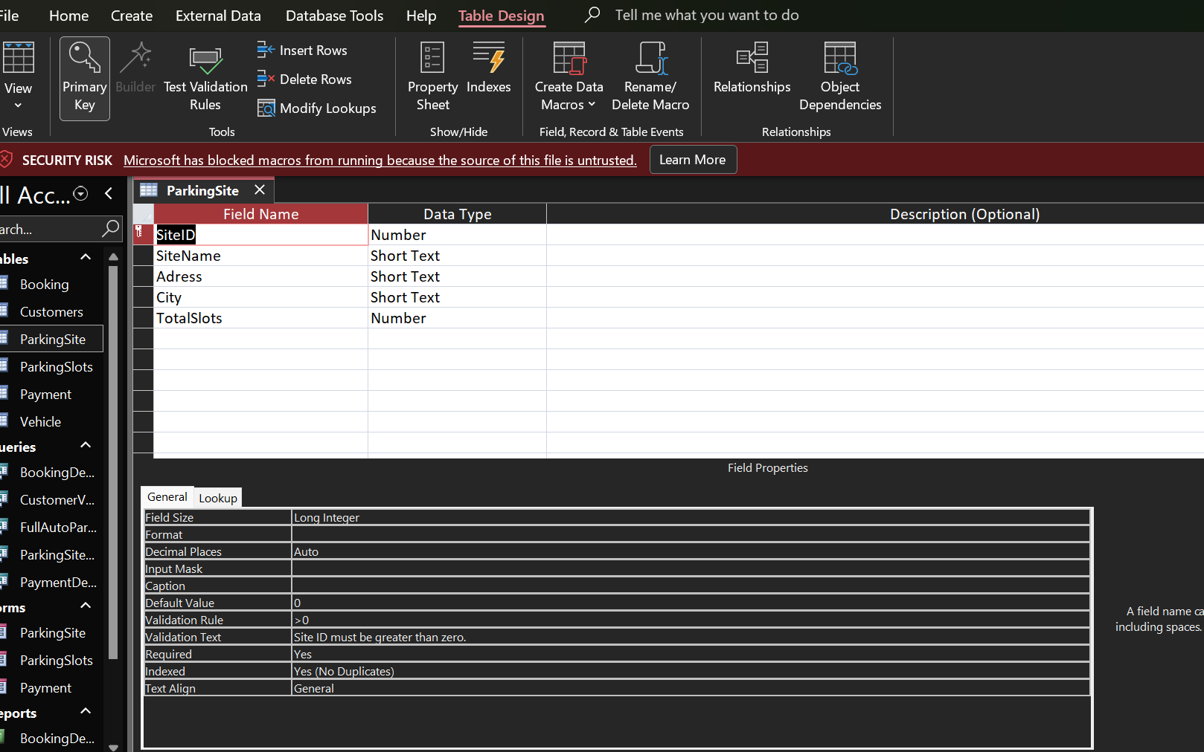

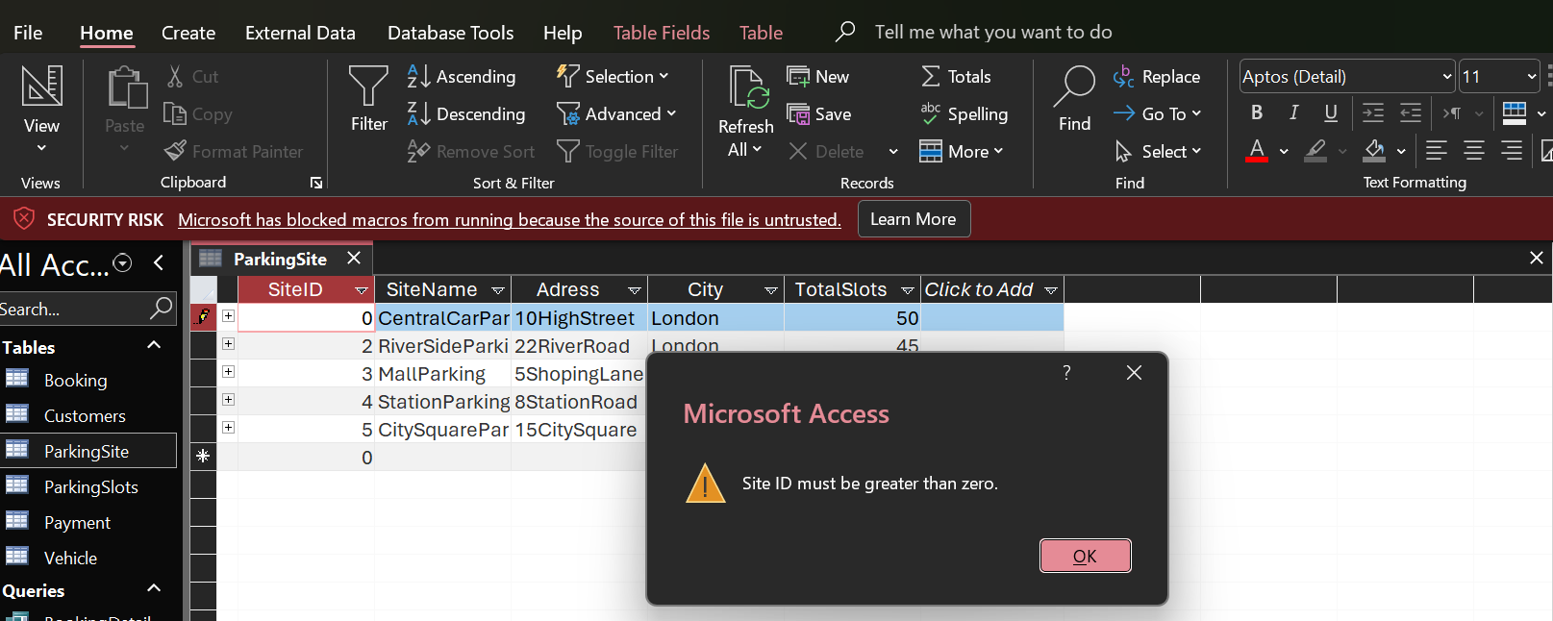
Figure 39: Screenshot showing validation rule has been applied to the parking site table.

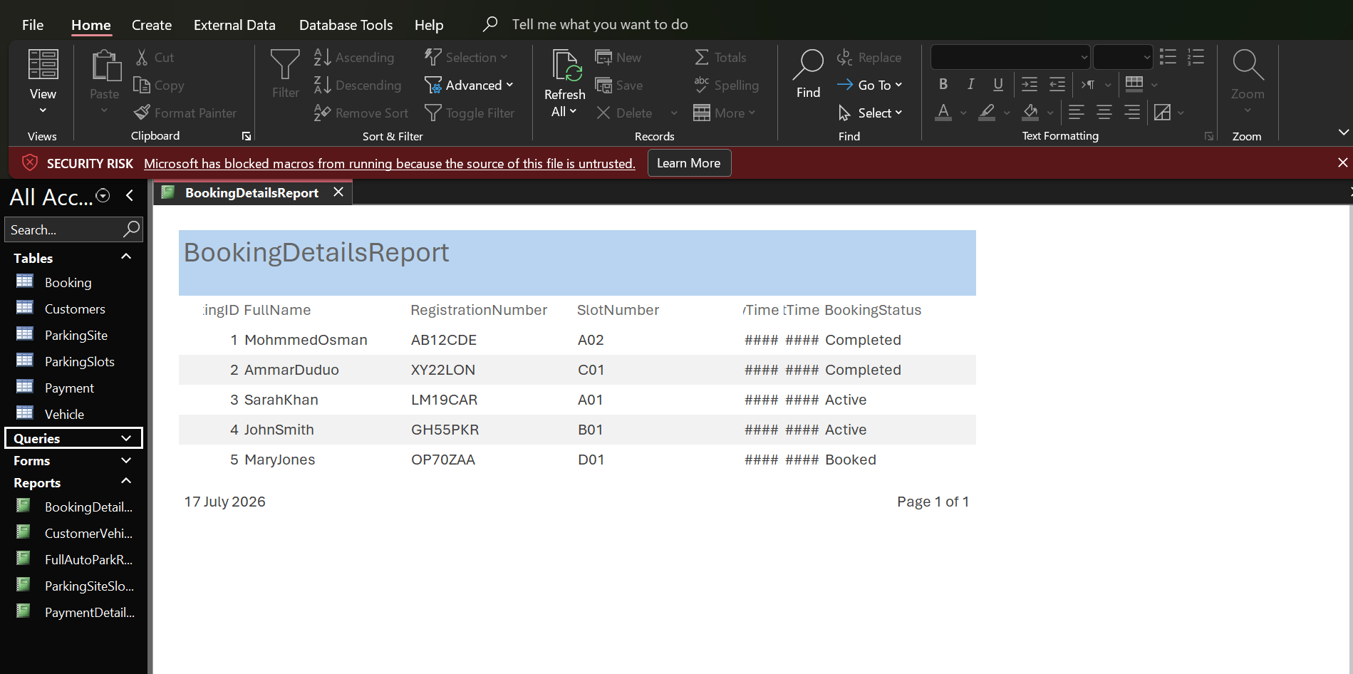
Report:

Figure 40: Screenshot showing Booking details as a report.

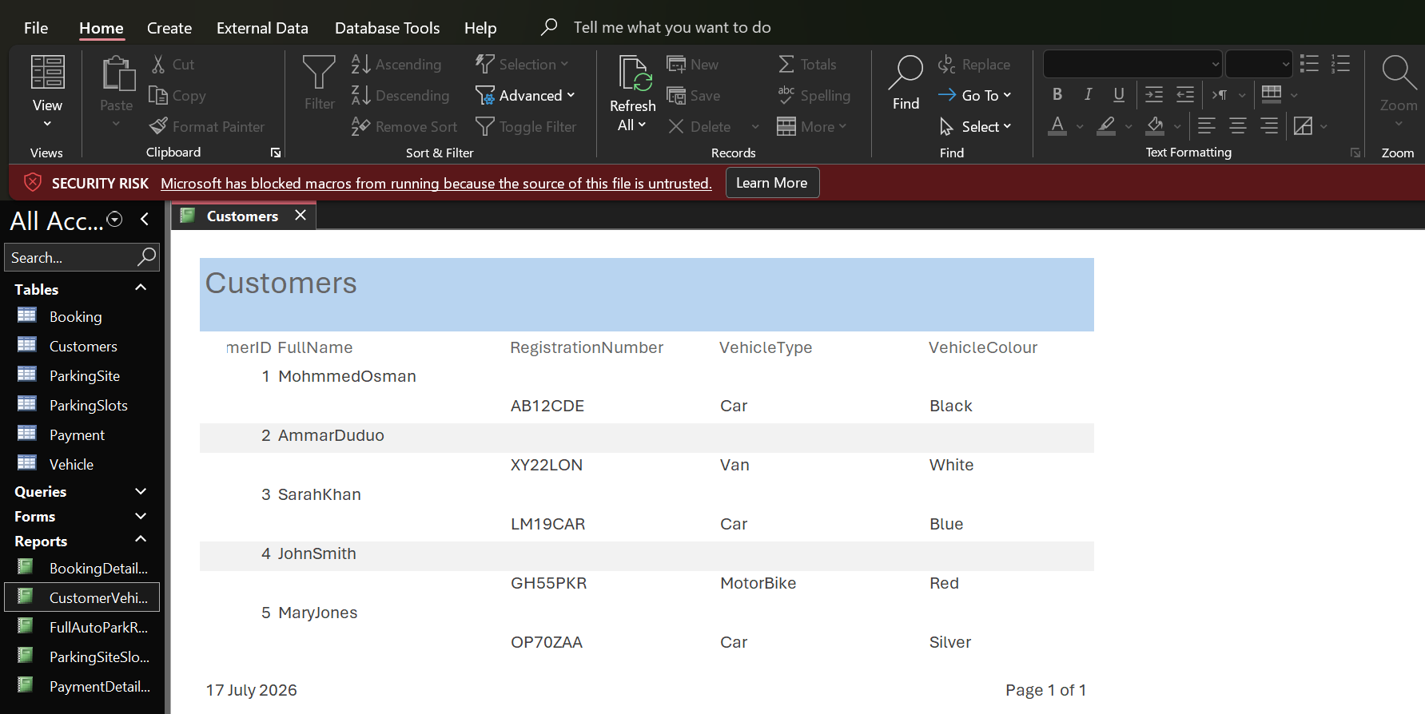
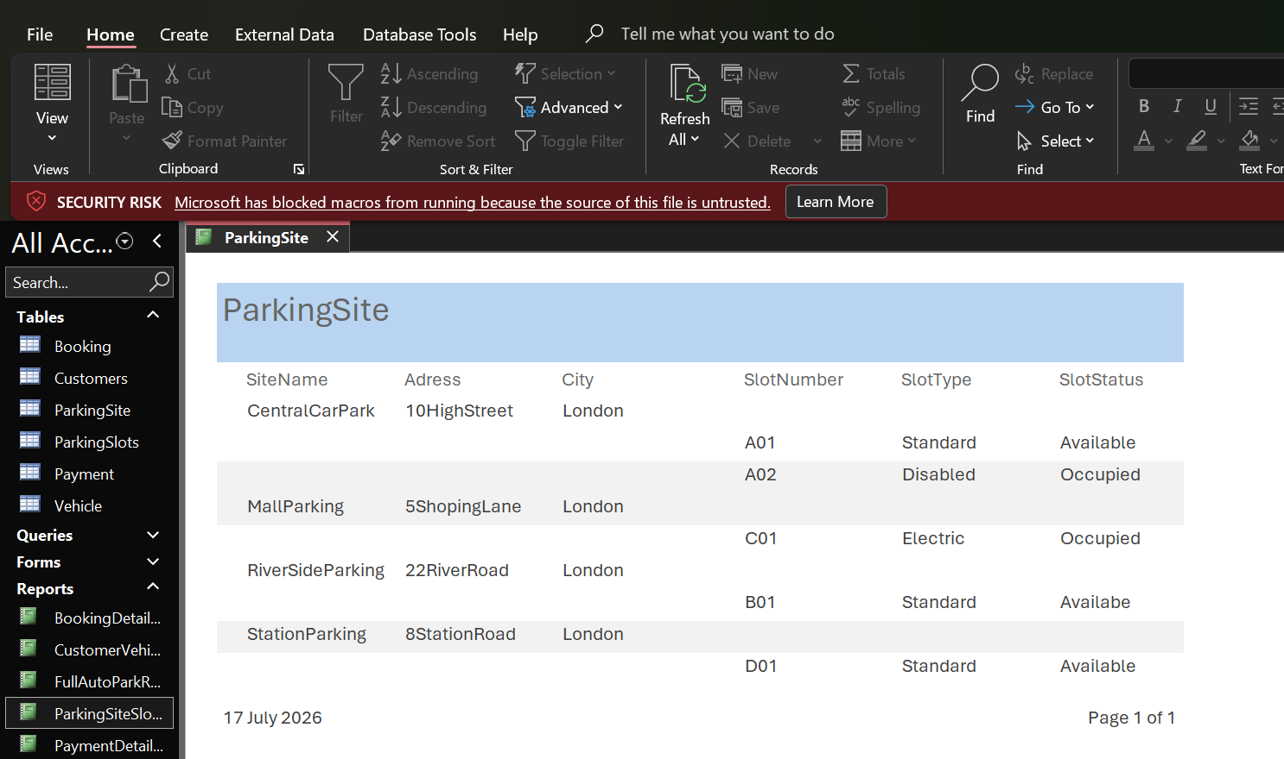
Figure 41: Screenshot showing customer vehicle report presented on Access.

Figure 42: screenshot showing parking site, slot report presented on access.

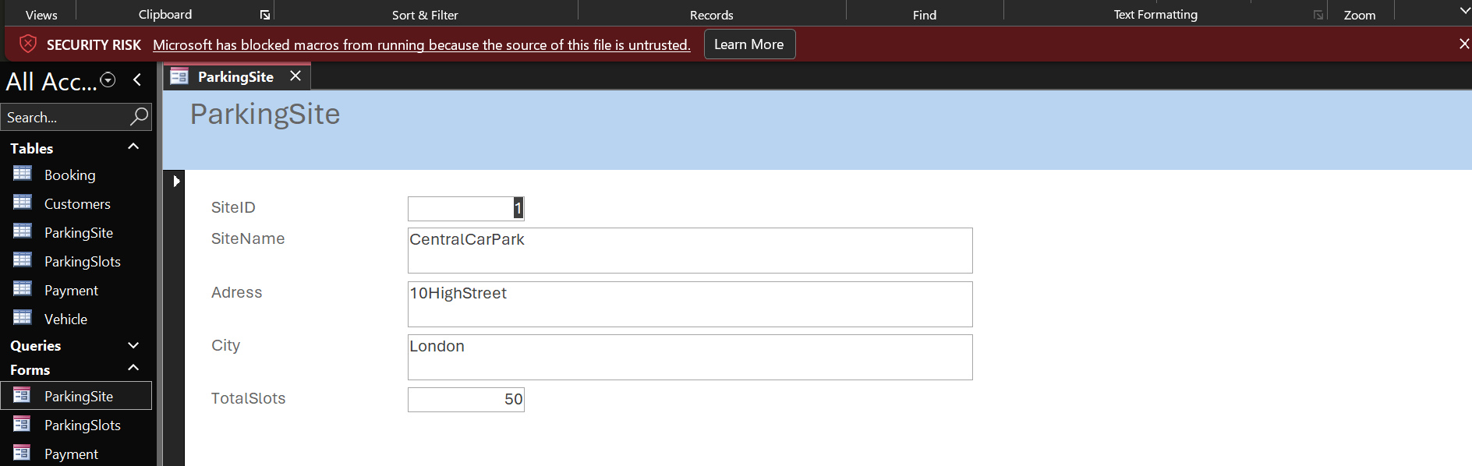
Forms:

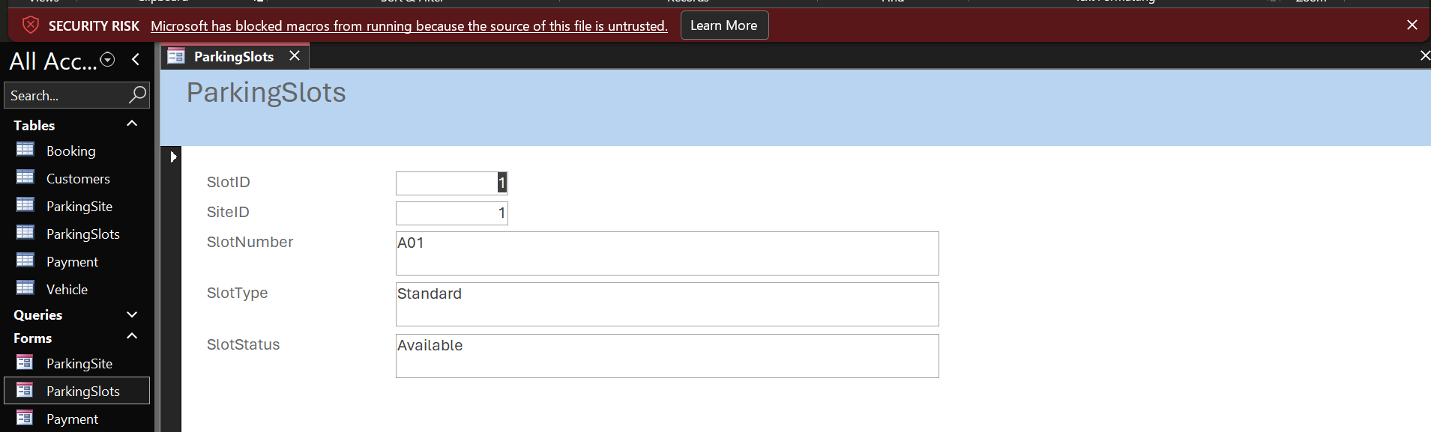
Figure 43: Screenshot showing Parking Site form presented on Access.

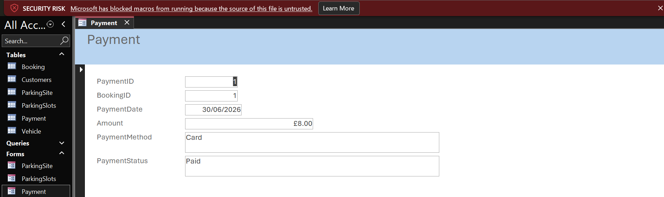
Figure 44: Screenshot showing Parking Slot has been created on Access.

Figure 45: Screenshot showing payment form been created on Access.

Report:
Scenario Analysis:
A parking provider called Auto Park Management system is in charge of overseeing a number of parking sites spread throughout the city. Numerous patrons utilise these parking slots on a daily basis to leave their cars for various durations. To guarantee that the parking service runs smoothly, the business must maintain precise records of customers, cars, parking site, booking, and payment. All of this data is currently manually recorded using handwritten records and papers. The manual system has proven more challenging to administer as the company has expanded.
The organisation faces a number of issues as a result of the present manual approach.
Employees spend a lot of the time recording reservations, looking up customer information and verifying the availability of parking slots. Records are readily lost misplaced, or damaged since information is kept on paper. Human mistake, such as duplicate client records, erroneous booking times, and inaccurate, is also more likely when data entry is done by hand. These problems make it harder for managers to keep an eye on day-to-day operations and lower the company’s efficiency.
Microsoft Access was used to create a relational database in order to address these issues. The database’s gaol is to consolidate all parking data into a single, well organised system so that employees can easily store, update, and access records. Employees can register clients, log vehicle information, assign parking sites, handle bookings, and precisely keep payment details, we should all appreciate this greatness of database.
Enhancing the general quality of business information is one of the system’s other key gaols. The database helps preserve consistency by preventing the entry of invalid records through the use of relationships between tables and validation rules. In order to track parking occupancy, customer activity, and business revenue, managers can also create reports and queries. All things considered, the database offers a more dependable, precise and effective solution than the earlier manual technique. [1]
Main Entities:
Six primary entities make up Auto Park Management system database, which collaborates to oversee the parking service. Relationships link the various pieces of information that each entity maintain to make a whole database.
The SIX Entities are:
- Parking Site.
- Parking Slot
- Customer
- Vehicle
- Booking
- Payment
Every entity was thoughtfully created to prevent redundant data and enhance database efficiency.
Parking Site:
Every parking site under the company’s management is listed in the parking site table. Along site its attributes and details, like the site name, address or city, and total slots, each parking site has a unique Site ID. This table enables the number of parking spaces at each site and identify various parking places.
The database is easier to update and better ordered when parking site data is stored separately. Only one record needs to be updated if a parking site’s details change.
Parking Slot:
Every single parking slot that is available within each parking site is listed in the parking slot table. Each slot is associated with a single parking site and contains details like slot ID, Site ID, Slot number, Slot type, and availability status. During the booking process, this table enables clients to be assigned appropriate parking spaces and aids staff in swiftly identifying available parking spaces.
Customer:
Customers that utilise the parking service have their personal information stored in customer table along with their first name, Full name, phone number, email, and address, every customer is given a unique customer ID. Since a single customer may own many vehicles and make multiples bookings, storing customer data separately minimises needless duplication.
Vehicle:
Customer’s vehicle information is kept in the vehicle table. Each car is owned by a single consumer and has information like the vehicle ID, customer ID, registration number, vehicle type, and vehicle colour.
Each customer registers serval vehicles without having to re-enter personal information because to the separation of vehicle and customer data.
Booking:
Because it links customers, cars, and parking slots, the booking table is among the most crucial tables in the database. Booking ID, Customer ID, Vehicle ID, Slot ID, Entry time, exist time and booking status are all recorded for each booking. The booking table enables employees to precisely track car movements and provide a comprehensive history of parking activities.
Payment:
Payments transactions for finished bookings are tracked in the payment table. Payment ID, Booking ID, Payment date, Payment amount, Payment method, and Payment status are among the data kept.
Maintaining payment details in a different table enhance financial documentation and makes it easier for management to keep an eye on a company revenue.
Relationships:
To link all the six tables together, relationships were established, by avoiding redundant data and guaranteeing the accuracy of connected records, relationships enhance database integrity.
- The relationships listed below were implemented:
- One Parking Site can have many Parking Slots.
- One customer can own many vehicles.
- One customer can make many bookings.
- One vehicle can be seen in many bookings one parking slot can be booked many different periods.
- One booking has one payment.
These relationships were created using primary and foreign keys, and referential integrity was activated to stop the entry of faulty records.
Errors would be more likely if duplicate customer data had to be recorded frequently in absence of relationships. Because related information may be obtained through queries, relationships also enhance data performance.
Entity Relationship Diagram:
Lucid chart was used to design an entity relationship diagram (ERD) prior to database construction. By displaying all entities, attributes, primary keys, foreign keys, and relationships, the ERD offers comprehensive visual depiction of the whole database.
Prior to implementation, the ERD was created to guarantee that all necessary entities were included and to make the data easy to grasp. Prior to building the tables in Microsoft Access, it also assisted in locating any missing linkages. Throughout the development phase, the ERD served as a guide and made sure the database complied with the assignment specifications. [2]
Data Structure Development:
Each table was constructed in Microsoft Access using appropriate field names and data types after the ERD was finished. To automatically create unique record numbers for primary keys, Auto number was chosen. Foreign keys were saved in number fields, names and descriptions were stored in a short text field, payment amounts were stored in currency fields, and booking time were stored in date and time fields. By choosing the right data types, input mistakes are decreased and storge efficiency is increased. For instance, booking dates must be recorded correctly, and payment values can only contain digits.
The data structure was thoughtfully created to accommodate future database growth while preserving high speed.
Normalisation Up to Third Form (3NF).
In order to remove redundant data and enhance database organisation, normalisation was implemented.
First Normal Form (1NF).
Because each table has a unique primary key, each field contains a single value, and there are no repeating groups, the database satisfies First Normal Form.
One customer, one customer, one car, one booking, or One payment is represented by each record.
Second Normal Form (2NF).
Because every table already meets 1NF and no key attributes is entirely dependent on the primary key, the database satisfies Second Normal Form. For instance, booking ID determines entry time, exit time, and booking status.
Third Normal Form (3NF).
Due to the absence of transitive dependencies, the database meets third normal form. Only the customer table has customer information, the vehicle table contains vehicle information, and the payment table contains information. This architecture enhances database consistency, eliminates redundant data, and makes updates easier.
By eliminating superfluous storge and simplifying updates, normalisation also enhances performance.
Sample Data Population:
Sample records were inserted to test the system after all tables had been created. Each table contained five records: parking site, parking slot, customer, vehicle, booking, and payment. Before the system could be utilised in a real parking business relationships, validation criteria, and queries could be tested using the sample data.
Query Development:
To show the database can obtain relevant data, a number of helpful queries were developed. To display all booking details, the booking details query merges the customer, vehicle, and booking tables. To show available parking slots, the parking site query joins the parking site and parking slot database. Each customer’s vehicle is displayed using the customer vehicle query. Management may keep an eye on business revenue by using the payment query, which shows payment data a lot with booking information.
Because queries allow users to instantly get specific information rather than painstakingly searching through multiple tables, they increase efficiency.
Validation and testing:
To enhance data quality and stop inaccurate information from being input, validation procedures were put in place. Examples include making sure payment amounts are positive, preventing empty parking sites names requiring customers IDs greater than zero, and verifying that exit time is later than entry time. Additionally, validation test was added to deliver unambiguous error warnings whenever incorrect data is entered.
To guarantee that foreign keys always refer to legitimate records, referential integrity connected tables. Both valid and invalid data were entered as part of the testing process. While faulty data exhibited the proper validation signals, correct entries were successfully accepted. [3]
Reports:
For printing and, evaluation, the reports produced in Microsoft Access display the database data in an understandable and structured manner. Customer names, car registration number, parking slot numbers, and booking status are all displayed in the booking details report.
The parking site report displays each parking site together with its parking slots and availability, while the customer vehicle report connects customer information with registered automobiles. These reports facilitate improved monitoring and decision-making by giving employees rapid access to crucial information.
Forms:
Microsoft Access form Wizard was used to generate the forms, which offer an easy-to-use interface for entering, viewing, and amending entries. To enable users to manage data without directly accessing the Parking Site, Parking Slots, and payment tables, separate forms were created. Employing forms increase data entry accuracy, lowers error risk, and facilitates staff usage of the Auto park management system. [4]

Design Decisions:
During development, a number of significant design choices were made. To cut down on redundant data, the database was split up into six related tables, because auto number fields provide unique record numbers automatically, they were selected as main keys.
Foreign keys were used to establish relationships in order to enhance data integrity, because it links customer cars, and parking slots, the booking table was chosen as the main table. To lower user mistakes, validation procedures were input in place. For management objectives, queries were created to swiftly access data.
Efficiency was increased and needless duplication was decreased by normalising the database to third normal form. These design choices produced a dependable and well organised database that meets the objectives of the task.

Summary of the completed database:
Six complete related tables, primary and foreign keys, one to many and one to one relationship, an entity relationship diagram, normalisation to third normal form, sample data, validation rules, testing protocols, and useful queries are all included in the finished Auto park management system. The database offers an organised way to manage parking operation and effectively replace the prior manual system.

Challenges faced:
During development, a number of difficulties were faced, because Microsoft Access first established one to many relationships between booking and payment, more testing was necessary to establish the proper one to one relationship. By making the booking ID field in the payment table unique, this problem was solved. Carful planning was also necessary for selecting the right data types, and developing validation criteria required testing a variety of inputs before they functioned properly.
Careful examination was also necessary while creating multi table queries and making sure each table complied with third normal form. My comprehension of relational database design and Microsoft Access has improved as a result of these challenges. [5]

Future improvements:
Future enhancements might include the addition of safe employee login accounts, the development of user- friendly forms, the generation of automated management reports, the automatic computation of parking fees, the integration of online booking, the support of automatic number plate recognition (ANPR), and the database’s connection to cloud services for various parking locations. The system would be better appropriate for a large commercial parking business with these enhancements.

Conclusion:
By substituting a structured Microsoft Access database for manual record keeping, the auto park management system database effectively satisfies the assignment criteria. Through relationships, validation rules, and normalisation, it improves data accuracy while offering effective management of parking site, parking slots, customers, vehicles, booking, and payment. My practical grasp of relational database design has improved as result of the project, which has also shown how Microsoft Access can be a useful tool for handling actual business activities. [6]

References:

References

[1] | C.Cornoel and S. Morris, Database System: Design Imlementation, & Management,13th ed. Bosto, MA, USA: Cengage Learning. 2019.
[2] | R. Elmasri and S.B Navathe, Fundamentals of Database System, 7th ed. Harlow, UK: Pearson,, 2016.
[3] | T.Connolly and C, Database System: A practical Approach to Design, Implmentation, and Management, 6th ed. Harlow, UK: Pearson, 2015.
[4] | P.J. Partt and M.Z. Last, Concept of Database Management, 9th ed. Boston, MA USA: Cengage Learning, 2018.
[5] | Microsoft Learn, Description of the Database Normalisation Basic. Available, https://learn.microsoft.com/office/troubleshoot/access/database-normalization-description.
[6] | Microsoft Support, Create, Edit or Delete a Relationship. Available:, https://support.microsoft.com/en-us/access/create-edit-or-delete-a-relationship?utm_source=chatgpt.com.

