Finding and using information
Identifying and using reliable sources of information is an essential component of the educational process and a critical life skill.
When searching for information, especially when conducting an independent study and concentrating on internet sources, it is crucial to plan your search properly.
You may find academic information using several helpful search tools, so carefully consider which one will assist you locate the information you require. [1]
Critical thinking is central component of thinking well, supported by discussion of a range of concepts and methods available to assist us in developing a critical attitude of mind. We considered critical thinking as a means of working towards understanding information and ideas, and linked criticality to ethical principles that might be used to guide critical action in the everyday, as well as in an academic context. Writing academically is a social enterprise. [2]
Digital skills for employment
The relationship between employment and digitalization is a hotly debated topic that is increasingly affecting policy. The widespread adoption of digital technology is widely recognized to be significantly altering the advanced economies' structure, the way in which industrial activities are organized, the dynamics of employment, and the need for skilled labour. [3]
Conclusion:
Gaining these fundamental skills while in school improves academic achievement and lays the groundwork for a successful career. Graduates who have mastered these abilities will be better equipped to deal with the demands of the contemporary workplace, adjust to rotations, and advance in their careers.

Bibliography

[1]1Available online at: https://www.ncl.ac.uk/academic-skills-kit/information-and-digital-skills/finding-information/
[2] Chapter 1 and Chapter 9 from E-book: Critical Thinking and Persuasive Writing for Postgraduates by Louise Katz also available online;
[3] Digitalization and the future of jobs Paragraph 2 of Journal Article-Digital technologies, employment, and skills by Reljic; Jelena; Evangelista; Rinaldo; Pianta; Mario
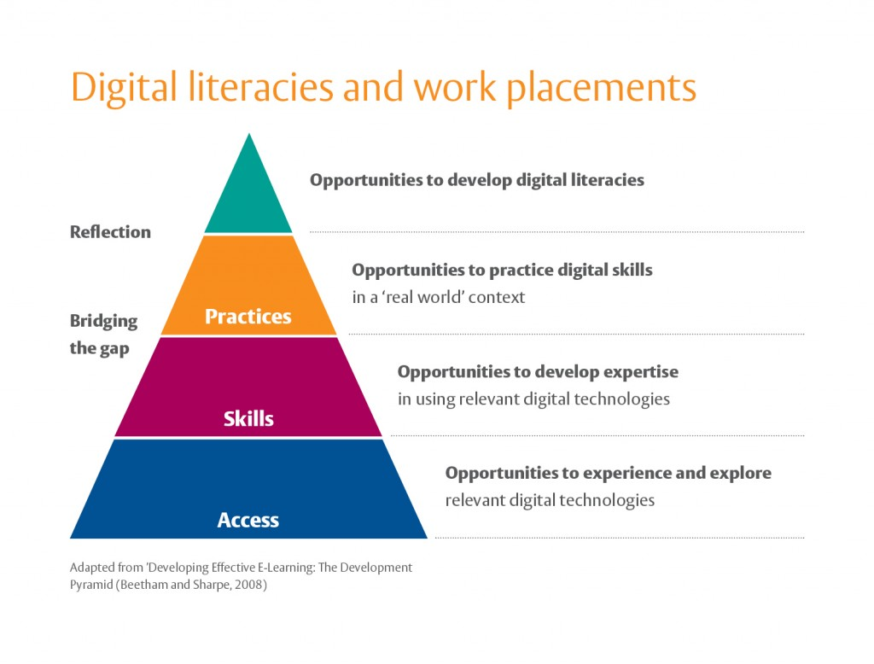
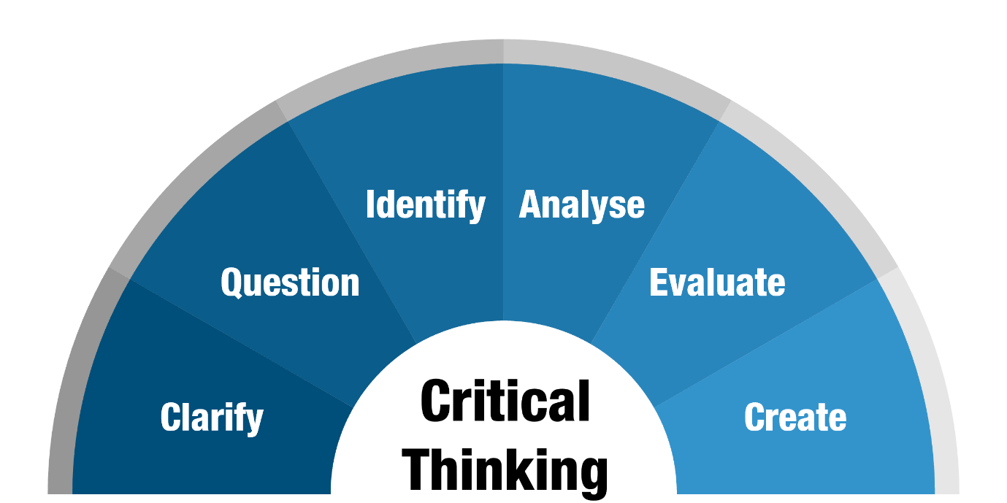
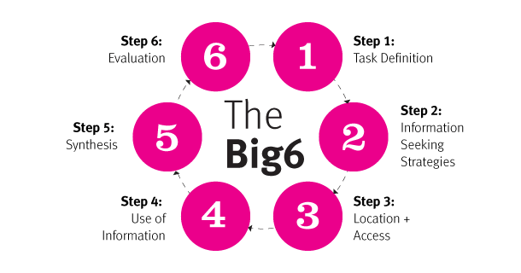
[4] [5]
Figure 2
Figure 3

