
Applied Leadership and Management in the Workplace
Module Assignment Submission
Student Name: | Kevin Richards.
Student Number: | 2515044.
Module No: | BMSK 4013.
Module Title: | Management communication.

Statement of Confirmation of Authenticity
By the act of making this submission, the student declares that this is the work of the student named above. The work has not, in whole or in part, been knowingly presented elsewhere for assessment, or where assessment has been built on a previous assessment, this has been identified. Where materials have been used from other sources it has been properly acknowledged. If this statement is untrue, the student acknowledges that an assessment offence has been committed.
Attention is drawn to the plagiarism and unfair practice policies of both the University and of ILM.

Table of contents
Table of contents 1
1. Introduction. 2
2. Communication models. (Analysis and Evaluation) 2
3. Workplace communication methods, tone, formality, and audience 11
4. Barriers to communication 13
5. Motivational theories 14
6.Motivation theory applied to workplace 19
7.Conflict, communication, and performance 20
8.Self -evaluation of your communication skills 21
9. Gap analysis 22
10. PDP and conclusion 23
References 25
Appendices 26

1. Introduction.
This report will look at communication, motivation, and conflict in the workplace and how they affect staff performance and the running of a business. Effective communication helps staff understand their roles, work effectively as a team, and provide good customer service. Poor communication can lead to mistakes, misunderstandings, and conflict, which can affect productivity and customer satisfaction.
The workplace experiences used in this report come from working in a coffee shop, house clearance business, military environment, and various retail jobs. These experiences showed me how important communication and teamwork are in different situations. For example, the coffee shop required quick communication during busy periods, while house clearance work relied on teamwork and planning.
The aim of this assignment is to evaluate communication models, communication methods, barriers to communication, motivation theories, workplace conflict, and reflective practice to assess how they influence effective communication and leadership in the workplace.
This report will apply communication and motivation theories, along with conflict management and reflective practice, to workplace situations and explain how they affect teamwork, performance, and service quality. It will also reflect on my own communication skills and identify areas for improvement through a Personal Development Plan (PDP).
2. Communication models. (Analysis and Evaluation)
Communication models help explain how information is sent, received, and understood in the workplace. They are useful because they show how feedback, misunderstandings and communication barriers can affect performance. From my experience in coffee shops, house clearance work, retail, and the military, I have seen how effective communication can improve teamwork and productivity, while poor communication can lead to mistakes, conflict, and reduced customer service.

2.1 Communication cycle
The Communication Cycle explains communication as a process where a sender creates and sends a message to a receiver, who then interprets it and provides feedback (Tubbs & Moss, 2008). Feedback helps confirm that the message has been understood correctly.
From my experience in a coffee shop, feedback was important during busy periods to ensure staff understood instructions and reduce mistakes.
One strength of the model is its focus on feedback and understanding. However, it can be limited because workplace communication is often affected by pressure, distractions, and different communication styles.
From my workplace experience, the Communication Cycle is the most useful model because it is simple and focuses on feedback. This is important in busy environments such as my vintage coffee shop, house clearance work, and military settings. One limitation I experienced was when a staff member misunderstood a price change, through a decoding issue resulting in incorrect pricing being given to customers. This highlighted the importance of checking understanding through feedback.
The communication cycle and Schramm's both emphasise feedback which is essential in my vintage coffee shop which was fast paced during busy periods. At certain times there would be two baristas working together one would take orders repeat the order from the customer and relay to the barista making the coffee, the barista would repeat the order back. This aligns more closely with Schramm’s two–way communication than Shannon and weaver’s model.
Using the communication cycle taught me that feedback prevents errors and builds confidence and trust.
Below is the communication cycle model it explains communication as a process where information is sent, received, and understood between people.
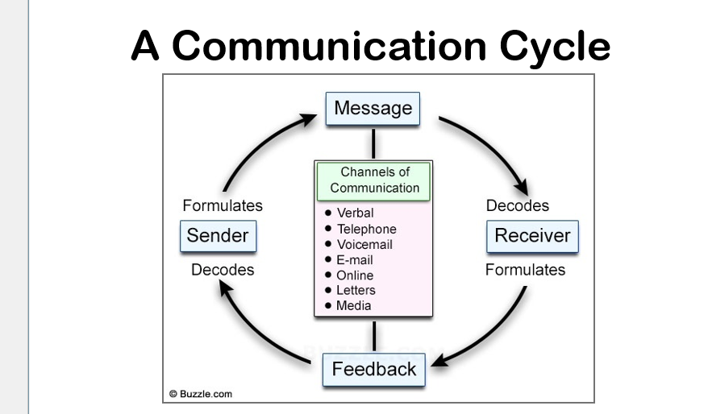
Overall, the communication model helps explain how communication is sent receives and understood in the workplace. The model highlights the importance of clear messages and feedback to reduce misunderstandings and improve communication between staff. However, it should not be used on its own, as real workplace communication is often affected by barriers, emotions, and relationships between people.
Compared with Shannon and Weaver's model, the Communication Cycle places greater importance on feedback, making it more suitable for workplace communication where understanding needs to be checked. However, unlike Schramm's model, it gives less attention to shared experience and how individual backgrounds can influence communication.

2.2 Shannon and Weaver Model
The Shannon and Weaver Model explain communication through a sender, message, channel, and receiver, while also introducing the idea of “noise”, which can interfere with communication (Shannon & Weaver, 1949). Noise can include distractions, stress or anything that affects a message being understood correctly.
This model links strongly to my workplace experience because noise and distractions regularly affected communication, especially in the coffee shop. During busy periods, noise from customers, coffee machines and music sometimes made it difficult for staff to hear instructions. In house clearance work, team members often worked in different areas of a property, which could also affect communication. In military environments, communication needed to be direct and clear because misunderstandings/noise/distractions could affect teamwork and safety.
One strength of the model is that it clearly explains communication barriers, particularly noise and interference. However, a limitation is that it focuses on one-way communication and does not fully explain feedback or shared understanding. Communication could be improved by reducing distractions, using clear instructions, and encouraging staff to confirm understanding through feedback.
This can improve teamwork, reduce mistakes, and increase productivity. However, poor communication can lead to misunderstandings, reduced customer service, and lower workplace performance.
Shannon and weaver’s model is helpful for explaining barriers such as noise and distractions.
In the military during exercise during an attack on an enemy position noise including gunfire/orders being shouted this would be the best model used, has it does not require feedback, but in environments such as a coffee shop it is less practical has staff must constantly check understanding has it can have a negative effect on business

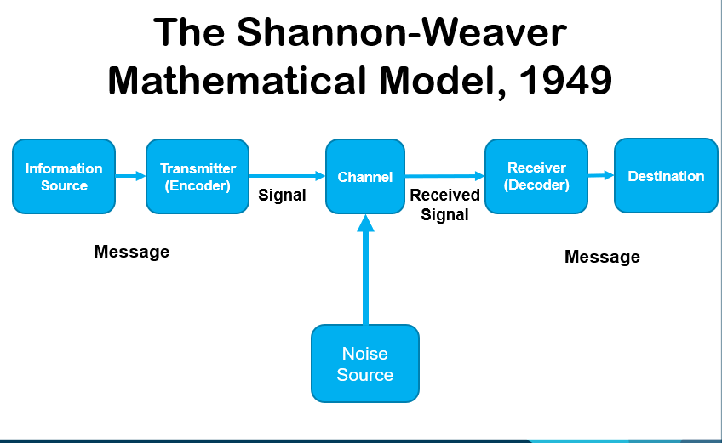
Overall, the Shannon and Weaver Model is useful because it explains how communication barriers can affect teamwork and performance. From my workplace experience, noise and pressure during busy periods can sometimes lead to misunderstandings and reduced productivity. Although the SHANNON AND WEAVER 1949 model is useful for explaining barriers such as noise and distractions, the communication cycle is more practical because it focuses on checking understanding and improving communication between staff.
Shannon and Weaver's model is useful for explaining how messages can be disrupted by noise, but it is less effective than Schramm's model because it views communication as mainly one-way and does not fully recognise the importance of ongoing feedback.

2.3 SCHRAMMS COMMUNICATION MODEL (1954)
Schramm’s Communication Model views communication as a two-way process where both sender and receiver encode, decode, and provide feedback (Schramm, 1954). It highlights the importance of shared understanding through a “field of experience.”
In my workplace experience—across coffee shops, retail, and military service—communication/feedback and teamwork were essential. Staff often repeated orders to confirm accuracy, while military communication relied on shared training and understanding, and feedback A key strength of this model is its focus on feedback and shared meaning, making it realistic for workplace communication. However, it overlooks barriers such as noise, stress, and distractions common in busy environments.
Improving the model by addressing these barriers would make it more practical. From experience, even with feedback, pressure and speed can cause misunderstandings, affecting performance, teamwork, and productivity. Effective communication, however, strengthens relationships and motivation.
Overall, Schramm's model and the communication cycle were the most useful in my coffee shop and military service because they highlighted feedback and shared understanding.

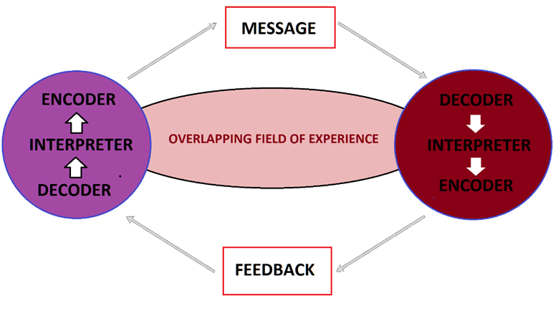
Overall, Schramm’s model is useful because it highlights the importance of feedback and teamwork in workplace communication.
Schramm's model provides a more realistic explanation of workplace communication because it includes two-way feedback and shared understanding. Compared with Shannon and Weaver's model, it better reflects how communication takes place in team-based environments such as my workplace.

2.4 BERLO’S SMCR MODEL
BERLO (1960) outlines four elements of communication: SOURCE, MESSAGE, CHANNEL, AND RECEIVER. It shows how communication is shaped by skills, knowledge, attitude, and culture.
In my workplace experience across the military, coffee shop, retail, and house clearance –communication styles varied by environment and recipient's. Military communication was direct and formal and feedback was essential, so everything was understood, while customer-facing roles required friendly adaptable interaction using the BASIC COMMUNICATION CYCLE. Clear verbal communication and teamwork were vital for safety and efficiency.
A strength of BERLO (1960) model is its focus on how personal factors affects communication. However, it lacks emphasis on feedback, which is crucial in fast-paced workplaces where communication is continuous.
The model could be improved by including two-way feedback to ensure understanding. overall, it effectively explains how communication styles change depending on the person, situation, and workplace, because it does not have feedback, it is less effective than Schramm’s model in situations requiring constant clarification.
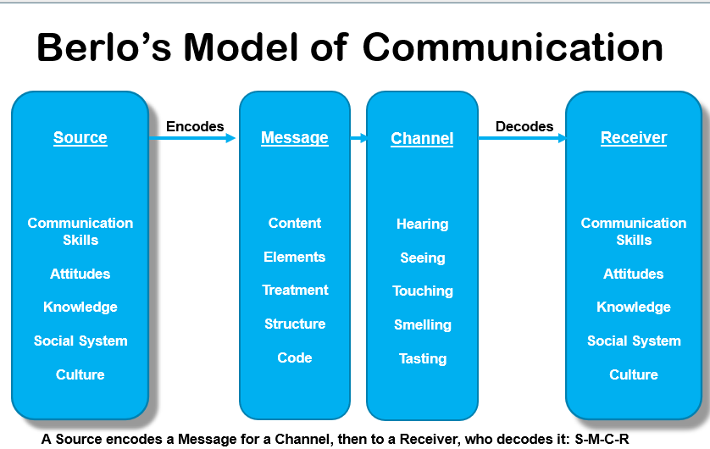
Overall, BERLO’S model is useful because it shows how communication styles can change depending on the person, workplace, and situation. From my workplace experience, demonstrates that adapting communication style to suit different people and situations.
BERLO’S SMCR model provides more detail than Shannon and Weaver's model by recognising that communication is influenced by the sender's and receiver's skills, attitudes, and knowledge. However, Schramm's model offers a more realistic explanation of workplace communication because it includes feedback and views communication as an ongoing two-way process. For this reason, Schramm's model is more applicable to my workplace experience, where checking understanding and responding to feedback are essential.
The table below compares four communication models by outlining their main ideas, workplace applications, strengths, and limitation. Comparing these models shows that each explains communication from a unique perspective. And highlight's where they are most effective in the workplace.
model | Main idea | Workplace example | strengths | limitations
COMMUNICATION CYCLE | Communication is a process with feedback between people. | In the coffeeshop, the manager gives instructions and checks staff understand during busy periods. | Simple and useful for everyday workplace communication. | Does not focus much on emotions or cultural differences.
SHANNON AND WEAVER (1949) | Communication can be affected by “noise” or distractions. | In retail or coffee shop noise and pressure can cause staff to misunderstand instructions. | Good for showing how barriers and distractions affect communication. | Too one-way and does not focus enough on feedback.
BERLO’SMCR MODEL (1960) | Communication depends on skills, attitude, knowledge, and culture. | Communication depends on skills, attitude, knowledge, and culture. | Explains how people and communication styles affect understanding. | Explains how people and communication styles affect understanding.
SCHRAMM (1954) | Communication works best when people share understanding and feedback. | In teamwork situations, staff checked understanding to avoid mistakes and improve teamwork. | Focuses on two-way communication and feedback. | Focuses on two-way communication and feedback.

Overall, each communication model focuses on several aspects of communication. The communication cycle and Schramm’s model both emphasise feedback and understanding, making them useful for teamwork. Shannon and Weaver’s model focuses on barriers such as noise and distractions, while BERLO’S SMCR model highlights how communication can be influenced by skills, knowledge, and attitudes. From my workplace experience, the communication cycle and Schramm's model are the most useful because they focus on feedback and reducing misunderstandings.
Compared with Shannon and Weavers model, Schramm’s model more useful in more useful in modern workplaces because it includes feedback. However, Shannon and weaver better explain communication barriers such as noise and distractions.
The communication cycle, Shannon and Weaver model, and Schramm’s model all explain communication but focus on different areas. The communication cycle is useful because it shows the importance of feedback and checking understanding which is important in workplace situations. Shannon and Weaver’s model is helpful because it explains how noise or barriers can affect the message, but it is limited because it shows communication as more one-way. Schramm's model is stronger has it focuses on two–way communication and shared understanding, although it does not fully explain power differences or confidence issues. However, no single model fully explains workplaces communication because real communication is affected by emotions, relationships, pressure, and the working environment all influence how messages are interpreted.

3. Workplace communication methods, tone, formality, and audience
Helps workplaces operate more efficiently and supports positive relationships between staff and customers. Communication in the workplace can take different forms, including verbal, non-verbal and written communication.
Choosing the correct communication method is important because it helps ensure messages are understood and reduces misunderstandings.
From my workplace experience, verbal communication was used most often in the coffee shop and house clearance business. In the coffee shop, staff needed to communicate quickly during busy periods to manage customer orders and support each other. In house clearance work, clear verbal instructions helped ensure tasks were completed safely and efficiently. Non-verbal communication, such as body language, facial expressions, and eye contact, also helped support verbal messages and improve understanding (Mehrabian, 1972).
Written communication was important for sharing information such as rotas, notices, emails, and workplace procedures. Written methods provide a record of information and can reduce confusion if instructions are clear (Bovee & Thill, 2021).
The tone and level of formality used in communication should be adapted to the audience and situation. In the military environment, communication was usually formal, direct, and structured because instructions needed to be followed accurately. In contrast, communication in coffee shops and retail settings was more informal and customer-focused while remaining professional. BERLO (1960) suggests that communication is influenced by the sender, receiver, and situation, meaning communication styles should be adapted accordingly.
Overall, using the correct communication method, tone and level of formality can improve teamwork, reduce mistakes, and increase customer satisfaction. Effective communication helps workplaces operate effectively and supports positive relationship between staff and customers.
Communication is important in the workplace because it helps people work together, share information, and get tasks done properly.
Communication helps staff share information, work together and complete tasks effectively. The main types of communication are verbal what we say, non- verbal and written communication which are all used daily in the workplace.
Verbal communication | Non –verbal communication | Written communication
Phone calls. | Facial expressions (smiling frowning) | Notices, memos, or workplace instructions.
Face to face. | Body language and posture. | Emails.
Team meetings. | Eye contact and gestures. | Reports.
Overall, all three types of communication are important. They help improve understanding, teamwork and workplace performance while reducing misunderstandings.
Communication is important because it helps develop positive relationships (Duck & McMahan, 2015)
Also, paralinguistic communication is the way a message is delivered through tone, volume, speed, and expression. It can affect how a message is understood and can sometimes be more important than the actual words being spoken.
Different communication methods work better in different situations. Verbal communication is effective when information needs to be shared quickly and feedback is required, such as during busy periods in a coffee shop. Non -verbal communication, including body language and eye contact, can help reinforce message and improve understanding. Written communication is useful when information needs to be recorded, such as rotas, emails, and workplace procedures. However, communication can be less effective when there are distractions, unclear instructions or message are misunderstood.
LISTENING LEVELS-COVEYS (2013)
COVEY (2013) identified five levels of listening, from ignoring to empathic listening. Active and empathic listening are the most effective because they improve understanding, teamwork and communication.in my workplace experience, repeating customer orders and listening carefully to colleagues helped reduce mistakes and improve customer service.
Level of listening | What it means | Workplace example
Ignoring | Not really listening to the other person. | looking at my phone while a member of staff trying to explain a problem.
Pretend listening | Acting like I am listening, but my mind is elsewhere. | Nodding during a team meeting but thinking about the next task.
Selective listening | Only paying attention to the parts that interest me. | Listening to instructions about my role but missing information that affects the rest of the rest of the team.
Active listening | Giving full attention asking questions and checking understanding. | Repeating a customer order back in the coffee shop to make sure its correct.
Empathic listening | Listening to understanding how someone feels as well as what they are saying. | Talking to a stressed colleague and taking time to understand their concerns before responding.

Overall, coveys level of listening shows that good listening is an important part of effective communication.
4. Barriers to communication
Communication barriers can affect how information is sent, received, and understood in the workplace. If barriers are not managed effectively, they can lead to misunderstanding, mistakes, and reduced performance. From my workplace experience, barriers such as noise, poor listening, stress, and various levels of knowledge can affect teamwork, productivity, and customer service.

Barrier | Workplace example | Recommendation | Impact on performance
Noise and distraction | In vintage coffee shop noise from customers and music sometimes made it difficult to hear instructions clearly. | Repeat valuable information and move discussions to a quieter area when possible. | Reduces misunderstandings  Improves teamwork and increases productivity.
Poor listening | Staff may hear instructions but not understand them. | Encourage active listening and ask staff to repeat key information back. | Improve accuracy, reduce mistakes, and improve customer relations.
Stress and pressure | During busy periods in the coffee shop or military environments, pressure and noise affect how messages are delivered and understand. | Remain calm, give clear instructions, and prioritise valuable information. | Helps staff work more effectively and reduces errors.
Various levels of knowledge and experience. | Inexperienced staff may not understand workplace procedures as well as experience staff. | Provide training, support, and clear explanations. | Improves confidence, teamwork, and overall performance.

However, communication barriers can affect teamwork, productivity, and customer service if they are not managed effectively. By reducing distractions, encouraging active listening, and adapting communication to different situations, organisations can improve communication and workplace performance.

5. Motivational theories
Maslow's Hierarchy of needs (1943) suggests that people are motivated by dissimilar needs, starting with basic needs such as food, safety, and security before moving on to social belonging, esteem, and personal achievement (Maslow,1943). The theory helps explain that employees are motivated by more than just money, as they also want to feel valued, supported, and able to develop their skills.
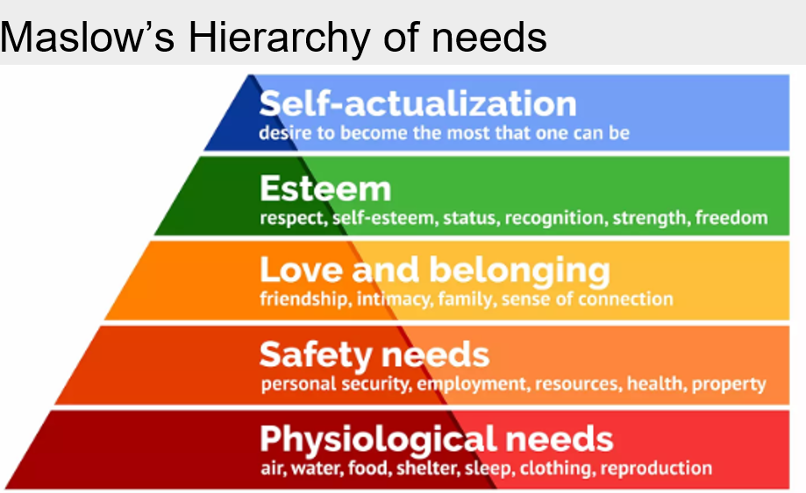

Overall, Maslow's theory helps explain employee motivation, but people do not always move through the hierarchy in the same order.
In the military, soldiers need basic needs such as food, rest, and safety before they can focus on teamwork, recognition, and career progression. As they develop, promotions, leadership opportunities and specialist training help them reach their full potential.
HERZBERG’S TWO –FACTOR THEORY (1969)
Herzberg believed that there are two factors that affect motivation at work:
Hygiene factors-these do motivate employees, but if they are missing, employees can become dissatisfied.
Motivators - These are the factors that increase motivation and job satisfaction.
Herzberg's two-way theory explains that employee's motivation is influenced by two factors: hygiene factors, such as pay and working conditions, and motivators, such as achievement and recognition.

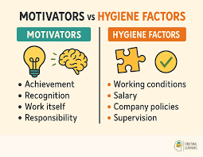

Overall, Herzberg's theory shows that good working conditions can prevent satisfaction, while achievement and recognition help increase motivation and job satisfaction.
In my vintage coffee shop paying staff fairly and providing a safe workplace are hygiene factors that help prevent dissatisfaction. Praising staff for good customer service and giving them more responsibility are motivators that can increase motivation and performance.
Overall, each motivation theory explains employee behaviour from a unique perspective. Maslow focuses on meeting various levels of needs, McGregor examines management assumptions about employees, McClelland highlights individual motivational needs, and Herzberg distinguishes between factors that prevent dissatisfaction and those that create genuine motivation. Of the four theories, Herzberg's model is the most relevant to my workplace experience because it explains why recognition, responsibility, and opportunities for development often a greater impact on motivation has than pay or working conditions alone.
McClelland’s theory of needs (1961)
McClelland believed that people are motivated by three main needs:
- Need for achievement.
- Need for power.
- Need for affiliation.
McClelland's theory of needs suggests that people are motivated by achievement, power, and affiliation. The theory explains that different individuals are motivated by unique needs.
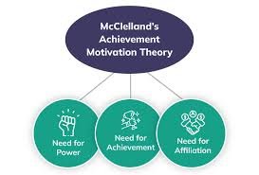

Overall, McClelland's theory helps explain why employees are motivated by several factors, allowing managers to use different approaches to motivate staff effectively.
A supervisor may be motivated by power because they enjoy leading the team. A barista may be motivated by achievement and enjoy meeting sales target.
McGregor's (1960) theory x and theory y
Mc Gregor (1960) suggested that managers have two different views of employees.
Theory x assumes that employee's dislike work, avoid responsibility and need close supervision. Managers using this approach tend to be more controlling and use this approach tend to be more controlling and use strict rules and monitoring.
Theory y assumes that employees enjoy work, are self-motivated and can take responsibility when given the opportunity. Managers using this approach encourage involvement, trust, and teamwork.
In the military, a theory x was needed in high pressure situations, stress and fear were present clear instructions and discipline are essential. However, in a vintage coffee shop or doing a house clearance, a theory y approach is more effective because staff work better when are trusted to make decisions and solve problems.
A strength of McGregor’s theory is that helps managers understand how their management style can affect employee motivation and performance.
But a limitation is that it assumes employee's fit into one or two categories, when most people need a mixture of direction and independence depending on the situation.
Overall, theory y best reflects my workplace experience because staff in my coffee shop and house clearance work were usually more motivated when trusted when given responsibility and freedom.

Theory x and theory y explains two different management styles and how managers view employee motivation. The theory suggests that management attitudes can influence employee behaviour and performance in the workplace.

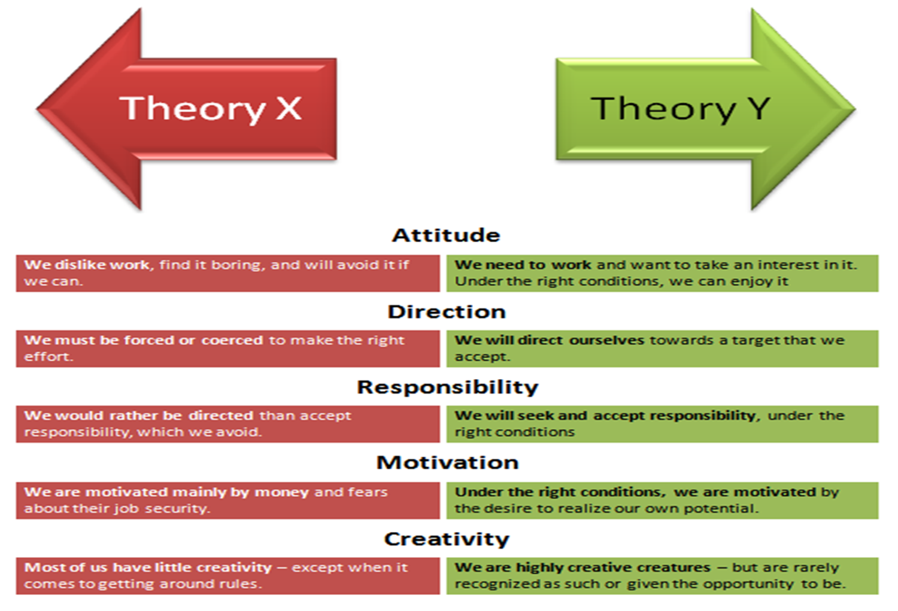
Overall, McGregor's theory shows that different management styles can affect motivation in diverse ways. From my experience, a theory y approach is often more effective because employees tend to perform better when this approach is used.
Herzberg's Two-Factor Theory best explains motivation in my workplaces. In the coffee shop, house clearance business and military environment, people were often motivated by recognition, responsibility and feeling valued rather than just pay. Staff usually performed better when they were trusted and appreciated for their work.
Maslow's Hierarchy of Needs has some limitations because it assumes people move through needs in a set order. People can be motivated by diverse needs at the same time, and what motivates one person may not motivate another.
Yes, Herzberg's theory explains staff behaviour better than the other theories because it focuses on factors that I have seen affect motivation in the workplace, such as recognition, achievement, and responsibility. However, McClelland's theory is also useful because it recognises that different people are motivated by unique needs, such as achievement, affiliation, or power.

6.Motivation theory applied to workplace
Herzberg’s Two-Factor Theory (1959) distinguishes between motivators that increase satisfaction and hygiene factors that prevent dissatisfaction. In my workplace, motivators such as recognition and responsibility have a stronger impact on performance than pay or conditions, supporting Herzberg’s view that intrinsic factors drive motivation. However, the theory can be criticised for underestimating how external pressures—like workload and stress—also influence motivation in fast-paced environments. Overall, Herzberg’s model is useful but should be applied alongside other approaches that consider both intrinsic and extrinsic factors.

7.Conflict, communication, and performance
Conflict in the workplace is when people disagree or misunderstand each other. It does not have to be a big argument — it can be something small like unclear instructions or different working styles. This is normal because everyone brings their own personality and way of doing things.
A common cause of conflict is miscommunication, especially when instructions are not clear or assumptions are made. Another cause is personality differences, where people have different approaches to work and struggle to meet in the middle.
Poor communication can make conflict worse. If someone uses the wrong tone, does not explain things properly or does not listen, it is easy for others to feel criticised or ignored. A new employee might take this personally or feel unsure of what to do, which can escalate the situation.
Low motivation also adds to conflict. When someone feels unsupported or unappreciated, they may withdraw or react negatively, which frustrates others. Motivated employees communicate better and are more willing to solve problems.
Conflict affects performance by slowing down work, creating tension, and lowering morale. A new employee may lose confidence, make more mistakes, or avoid asking for help, which impacts the whole team.
An effective way to resolve conflict professionally is the Collaborative Problem-Solving Approach. This involves talking openly, listening to each person’s point of view, acknowledging feelings, and working together on a solution. Once a plan is agreed, everyone checks in to make sure it is working.
This approach improves teamwork and performance because people feel respected and involved. It helps new employees settle in, builds trust and creates a more positive working environment. Clear communication, motivation, and structured conflict resolution all support better relationships and stronger performance.
A workplace conflict occurred during a house clearance of a large house when two members of staff disagreed about the workload. One person felt he was doing all the heavy lifting, and the other was being rushed by this other member of staff when sorting items for recycling, disposal.
This was causing to frustration and stress and a breakdown in teamwork and was affecting communication, safety, and overall progress.
By using the CLEAR model, it helped to manage the conflict in a calm and structured way. First thing was to CLARIFY the main issue by speaking to both team members and finding out what had caused the disagreement. I then LISTENED to each other's point of view without taking sides, as this helps people feel respected and understood. The next stage I EXPLORED the possible solution, such as sharing the physical work more fairly or rotating tasks during the day. I then AGREED a clear action plan, for example one person helps with lifting while the other sorts items out. And then swaps roles after a set period. Finally, I REVIEWED the situation later to check weather communication had improved and whether the team were working together more effectively. Effective resolution can turn it into an opportunity for growth and improved workplace relationships.

8.Self -evaluation of your communication skills
Open Question Responses
1. What do you think are my strongest communication skills?
- Person 1: Clear communication and good teamwork during busy periods.
- Person 2: Good at organising tasks and explaining what needs to be done.
- Person 3: Gives clear instructions and remains calm under pressure.
- Person 4: Friendly and approachable when communicating.
- Person 5: Good listener who takes time to understand others. ￼
2. What communication skills could I improve?
- Person 1: Delegate more tasks to others.
- Person 2: Be more confident when giving feedback. ￼
- Person 3: Delegate more effectively.
- Person 4: Provide more regular feedback
- Person 5: Encourage participation from quieter team members.
3. Can you provide an example of when I communicated effectively
- Person 1: During a busy day at the vintage coffee shop, you kept the team informed and organised.
- Person 2: During a house clearance service project, you coordinated tasks clearly and efferently.
- Person 3: During a military exercise while you give clear orders that helped the section complete the task.
- Person 4: You help explain a university assignment to me in a simple and understandable way.
The feedback showed that my strengths are clear communication, teamwork, professionalism, and listening skills. It also highlighted areas for my improvement, including delegating more tasks, encouraging quieter team members to contribute, and providing more regular feedback. Overall, the result suggests that I communicate effectively but still have opportunities to develop my leadership skills further.

9. Gap analysis
A gap analysis was carried out to compare my current communication skills with those required for effective communication and leadership. This helps identify my strengths, areas for my improvement and the actions needed to support my future development.
For more in-depth feedback results please see appendices.
Current strengths | Areas for improvement | What effective communication requires | Actions to close the gap
Clear verbal communication and ability to give instructions. | Delegate more responsibility to others. | Leaders should trust team members and share responsibilities. | Practise delegating tasks during group work activities.
Strong listening skills and professional attitude. | Encourage quieter individuals to contribute. | Effective communication should involve all team members. | Ask open questions and actively invite quieter people to share their views.
Remain calm under pressure and communicate clearly in busy situations. | Provide more regular feedback to colleagues and team members. | Feedback should be ongoing to support development and performance. | Schedule regular feedback discussions and offer constructive comments.
Good teamwork and approachable communication style. | Increase confidence in leading discussions. | Leaders need to communicate confidently and motivate others. | Take opportunities to lead meetings, presentations, and group tasks.

Overall, the gap analysis highlighted that I have effective communication skills but also identified areas where I can improve. By focusing on these development areas, I can become a more effective communicator and leader.
If these communication gaps are addressed, it should improve teamwork, staff engagement, and workplace performance. Delegating more responsibility will help develop others, encouraging quieter team members will increase participation, providing regular feedback will support development and improving confidence when leading discussions will strengthen communication and leadership skills.

10. PDP and conclusion
My feedback questionnaire and gap analysis indicated several areas where I can improve my communication skills. To address these gaps, I have created a SMART Personal development Plan (PDP) with realistic goals that will help me develop my confidence, leadership, and communication effectiveness. The feedback also showed that clear communication,teamwork and active listening are strengths, it also highlighted the need to delegate more responsibility, encourage quieter team members to contribute, provide more regular feedback, and build confidence when leading discussions. These are highlighted in my PDP ensuring that the actions I have identified are based directly on the feedback I received.
This assignment has improved my understanding of how communication, motivation and conflict management all work together to create an effective workplace. Studying different communication models has shown that successful communication is more than simply passing on information; it also depends on feedback, active listening, understanding, and reducing barriers. Of the models explored, I found Schramm's Communication Model the most useful because it recognises communication as a two-way process where feedback helps improve understanding and reduce misunderstandings. In relation to motivation, Herzberg's Two-Factor Theory best explains my workplace experience, as factors such as recognition, responsibility and opportunities for development have a greater impact on motivation than pay alone. I have also learned that poor communication can lead to conflict, lower morale and reduced performance, whereas clear and respectful communication can improve teamwork, trust, and employee engagement. Finally, my Personal Development Plan has highlighted areas where I can continue to improve, particularly by providing more regular feedback, delegating more effectively, and encouraging quieter team members to contribute. Developing these skills will help me become a more confident and effective manager in the future.

SMART Target | Actions | Measure | Resources/Support | Target Date
I will delegate at least one task each week to a colleague over the next 6 weeks. | Identify suitable tasks and provide clear instructions. | Review completion of delegated tasks and gather feedback. | Colleagues and manager feedback. | 6 weeks
I will ask at least one quieter person for their opinion during meetings over the next 8 weeks. | Use open questions and actively invite contributions. | Record participation levels and reflect on responses. | Team feedback. | 8 weeks
I will give constructive feedback to at least one colleague each week for 6 weeks. | Schedule informal feedback conversations. | Keep a record of feedback provided and responses received. | Feedback models and manager support. | 6 weeks
I will contribute at least one key point during meeting's and lead one discussion with in 8 weeks. | Prepare notes beforehand and practise communication skills. | Review confidence levels and seek feedback from colleagues. | Colleague’s manager feedback. | 8 weeks

Overall, this assignment has helped me evaluate my communication skills using communication theories, workplace experience, and feedback from others. It has shown that I already have strengths in areas such as clear communication, teamwork and remaining calm under pressure, while also identifying areas where I can continue to develop. Completing the gap analysis and PDP has given me clear and realistic actions to improve my communication and leadership skills. By putting these actions into practice, I will become a more confident communicator and more effective leader in both my workplace and future career.

References
Berlo, D. K. (1960). The process of communication: An introduction to theory and practice. Holt, Rinehart, and Winston.
Bovee, C. L., & Thill, J. V. (2021). Business communication today (15th ed.). Pearson.
Duck, S., & McMahan, D. T. (2015). The basics of communication: A relational perspective (2nd ed.). SAGE Publications.
Herzberg, F., Mausner, B., & Snyderman, B. B. (1959). The motivation to work (2nd ed.). John Wiley & Sons.
Maslow, A. H. (1943). A theory of human motivation. Psychological Review, 50(4), 370–396.
McClelland, D. C. (1961). The achieving society. Van Nostrand.
Mehrabian, A. (1972). Nonverbal communication. Aldine-Atherton.
Schramm, W. (1954). The process and effects of mass communication. University of Illinois Press.
Shannon, C. E., & Weaver, W. (1949). The mathematical theory of communication. University of Illinois Press.
Tubbs, S. L., & Moss, S. (2008). Human communication: Principles and contexts (11th ed.). McGraw-Hill.
Appendices
To evaluate my communication skills, I developed the following feedback form to gather structured responses from colleagues and friends.
My feedback results highlighted several areas where my communication and leadership skills could be improved. The gap analysis helped identify the difference between my current performance and the level required for effective teamwork and leadership. Each gap relates to the feedback i received and forms the basis for my PDP.
1.Delegation gap
Feedback: Colleagues noted that I often take on too many tasks myself.
Development need: Improve confidence in delegating tasks and trusting others to complete work independently.
Action: My PDP includes a goal to delegate at least once a week and review outcomes with colleagues.
2.Inclusion gap
Feedback: Quieter team members were not always encouraged to contribute during discussions.
Development needs: Strengthen inclusive communication by actively involving all my team members.
Action: My PDP includes an objective to use open questions and invite quieter individuals to share opinions during meetings.
3.feedback gap: colleagues said I communicate clearly but could give feedback regularly.
Development needs: Provide regular constructive feedback to support team development.
Action: My PDP includes a goal to give weekly feedback using positive communication techniques.

Communication Skills Feedback Questionnaire
Please rate the following statements from 1–5:
1 = Strongly Disagree | 2 = Disagree | 3 = Neutral | 4 = Agree | 5 = Strongly Agree

Statement | 1 | 2 | 3 | 4 | 5
I communicate clearly and effectively
I listen carefully.
I give clear instructions when required.
I encourage others to share their views.
I communicate professionally and respectfully.
I adapt my communication style to different situations.
I respond well to feedback.
I work effectively as a team.
I deal with conflict professionally.
Overall, communication skills are effective.

Open questions
- What do think are my strongest communication skills
- What communication skills could I improve? ￼
- Can you provide an example of when I communicated
- Any additional comments or feedback?
m

