Thomas Cahill

Programme: BA (hons) Computer Animation
Module code: M5X0251
Module: 3D Filmmaking
Lecturer: Phil Organ
Assignment title: From the top of the Mountain

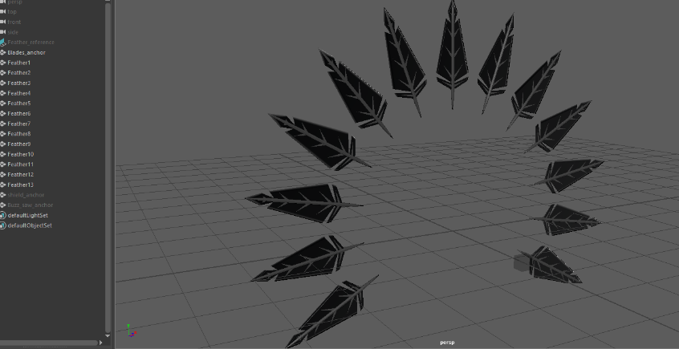
Specific posts
1. Prop Modelling - Feathers
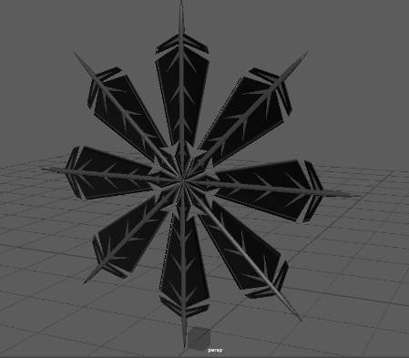
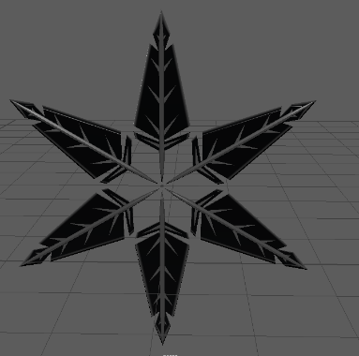
To model the feathers, I made an image plane using the references for the blades created during the preproduction stage, along with their different formations. Once in place, I extruded a variety of objects into the desired shape, which required a fair amount of detail. I then used some different shaders to recreate a metallic look. I haven't used textures as the characters and objects which only require simple, flat colours that reference a cartoon style. Next, I duplicated the feathers until I had the required amount and arranged them in the correct formations, which include their resting position, shield formation and buzz saw formation. After they were in place, I created small objects to serve as their anchor points when they are put into motion, which would allow me to move and rotate them both universally and individually so that it will appear they can move through 3D space.
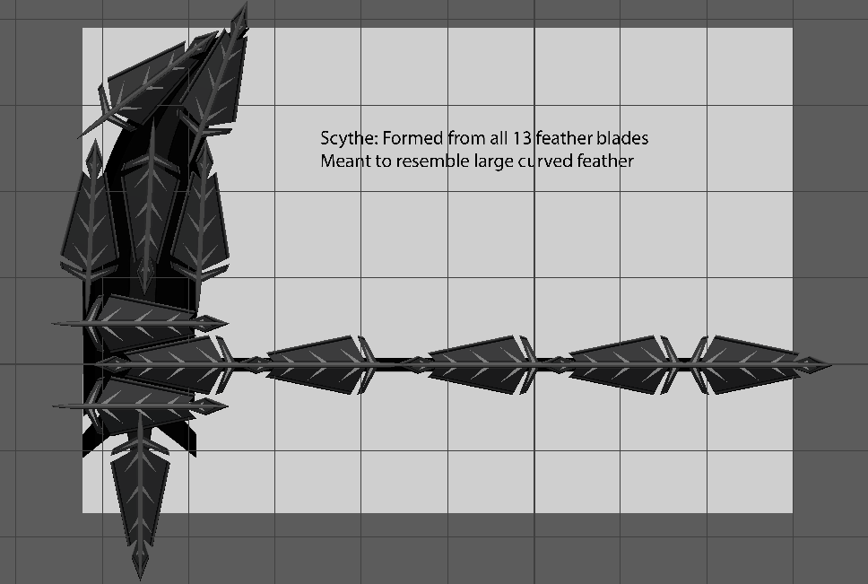
2. Prop Modelling – Scythe
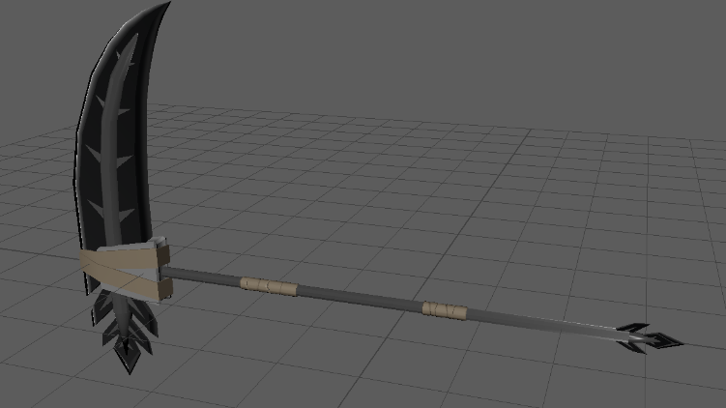
Like the feathers, I started with an image plane with the reference image, however I quickly realised that the design was too small in comparison with the feathers (which are supposed to combine to form the scythe), so I arranged them in the shape of the scythe, using them to make a slightly altered design which had better proportions and allowed for more visual traits shared between scythe and feathers. I also added wrappings around the blade and handle to make the weapon seem more personalised, which offered the opportunity to add some variance in materials. To mask the transformation between feathers and scythe, I used various twelve-sided Icosahedrons as clouds using a lambert where I slightly tuned the transparency so you could see the impression of what was inside.

4. Character modelling – Death and Raven
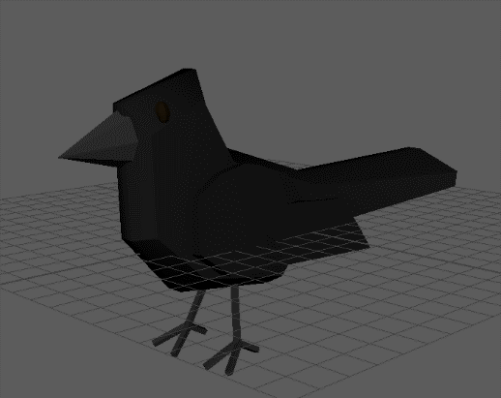
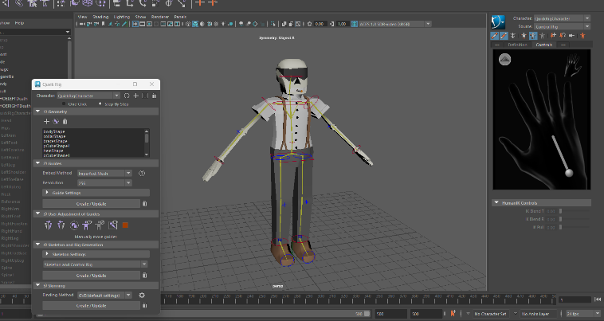
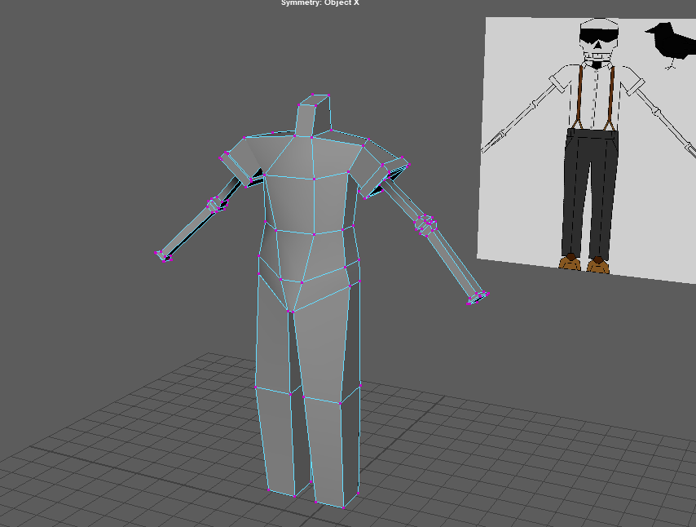
As my very first attempt at character modelling, I was daunted by the task ahead of me, having to learn all the relevant skills from scratch within a short timeframe, while still being up to par with the assignment criteria. I first looked up online tutorials which I followed step by step, adapting the directions to quickly build the model. Forming the topology itself was simpler than I’d expected, likely due to the deliberately lower polycount and my experience in hard-body models. I placed Death’s reference sheets in Maya as image planes and edited the vertices and subdivisions of cubes until the form was created. This took some getting used to but should be easier in future use. Since I intended to use pieces of Death’s model (trousers, skull etc) to make Cabone and the Henchmen, I decided to add the lambert shaders to Death’s model as colours, then making increment saves that will serve as the master files for the other characters, so that I do not have to remake each shader. Once this was complete, I researched tutorials on how to use Maya’s quick-rig feature, which I was glad to learn included IK’s. The only thing missing from the rig, was finger controls, which required another short tutorial to add to the rig. This was the first part I had trouble with, as the models for each character have mitt style hands (separate thumb and index finger, while remaining fingers are one piece), so I only required to add joints for these three shapes, but for reasons I still don’t know, Maya would not accept these joints and erase them every time I tried to add them to the control rig. I only “solved” this issue by making the joint chains for five digits. Once the rig was complete and the skin binded, it was time to fix the skin weights, which was a hassle as Maya erased the weight data a few times after I made progress... but I completed it in the end.
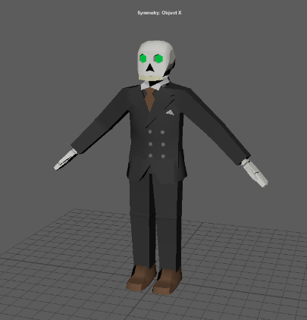
6. Character Modelling – Skeleton Henchmen
With the skills I learned and preparations I made making Death, the Henchman model certainly came along much faster than Death’s. The pieces that I would duplicate to assist the creation of these models were ones I expected when making my initial production plan, as they were intended to save time.
7. Character Modelling – Al Cabone (and cane)
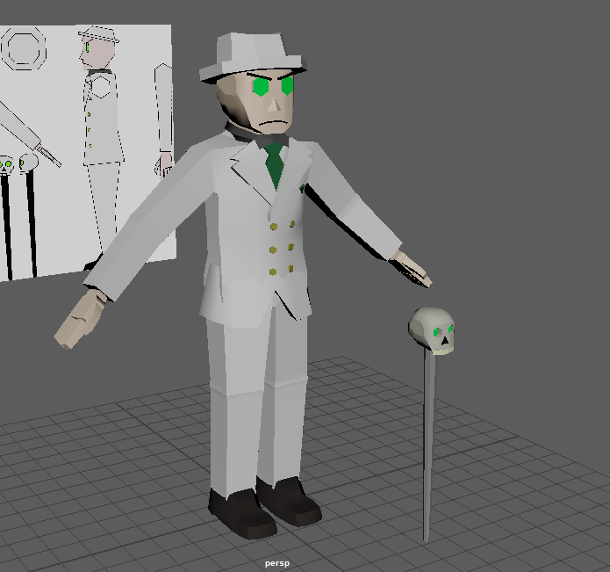
Using pieces of geometry from both previous models, I modelled, shaded and weight painted the model, then created the cane to be constrained to Cabone’s hand. I later realised during animation keyframing that my method of constraining did not make use of null objects, but it was too late to go back and change this, so I improvised the cane to move along with the character in more complex shots.’
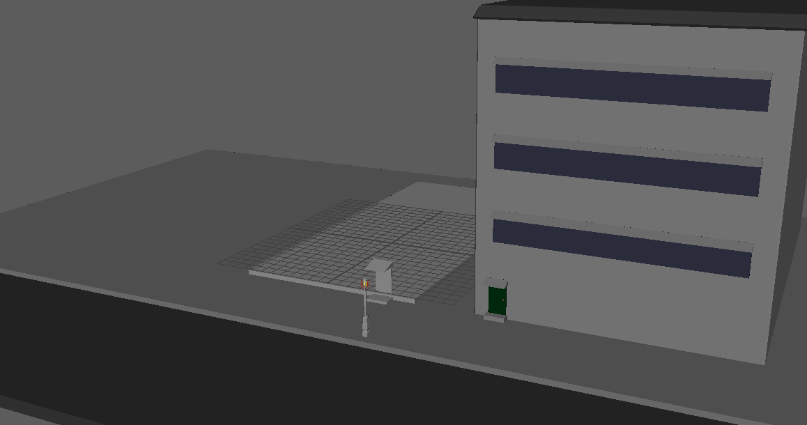
8. Set Development
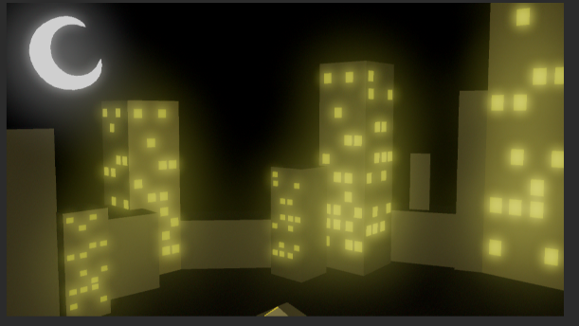
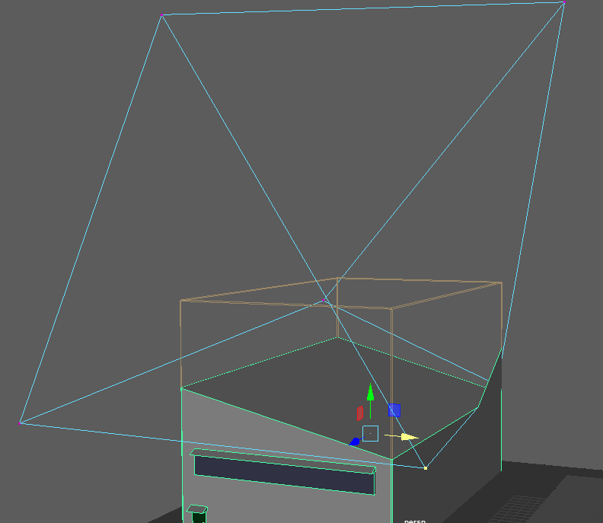
Using the background frames from my storyboard and the reference images from the time period, I began to layout the environment First, I made the ground plane, being the pavement and road, which I made sure stretched enough to fit multiple buildings and beyond the outside camera view. Second, a foundation for the main warehouse was blocked out using a large cube, before I made some facades for nearby buildings. To make the main warehouse, I used the same boolean method to cut doors and windows out of the wall’s topology, before making said doors and windows, followed by making some extruded cubes that resemble wooden crates. Another key part of the environment is the city night skyline which involved creating an elongated cube before using smaller cubes to make certain windows, some lit up, some not, before duplicating these shapes as various sizes and dimensions and arranging them to form the silhouette. The final piece of the environment was the crescent moon, which I shaped using the vertex tool on a subdivided cube before appying the smooth tool, to make its curve less jagged.

9. Changes to plan
In order see the moon through the main warehouse window, I used Booleans to carve away parts of an obstructing building which made it look heavily damaged and dilapidated. This also fit the mise en scene of the film, so it was a good use of judgement.
Upon animating the Henchmen for the first time, I realised I had made an error when rigging them, the placement of one elbow was much lower than the other, which made the arm bend awkwardly. Since I didn’t have time to redo the rig and weight painting, I made sure to animate the characters to barely show their right arms.

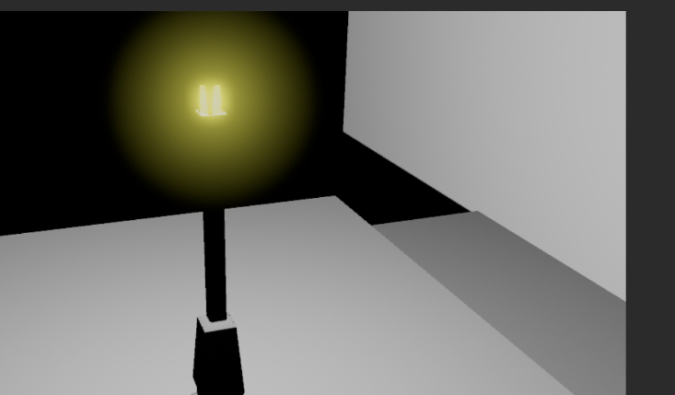
10. Lighting - spot lighting
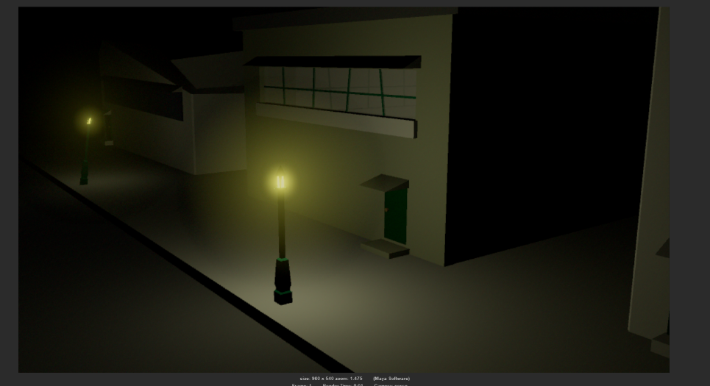
Lighting the scene was a challenge, as I tried various methods to work with lights and shadow. Initially, I tried making emissive shaders to try and light specific points in the environment, as using a directional light would illuminate the whole scene and ignore any surface in its path, making shadows in places I did not want them. Using emissive shaders on their own did not produce the right results, as it would only light a small area and increasing the intensity would blind the camera.
The Lamppost was the first object I wanted to emit light, and the first subject for my lighting tests. To fix the afore-mentioned problems with the light, I reduced the intensity of the emissive shader, while adding a point light to illuminate the surroundings more naturally and in line with a ‘film noir’ motif, film noir was a popular film making genre in America between the 1940’s and 50’s. Film Noir characteristics can be described as:
the constant fluctuation of identities, values, and the “normal” social order, along with the expressive use of darkness in “unbalanced and disturbing frame compositions, strong contrasts of light and dark, the prevalence of shadows and areas of darkness within the frame, [and] the visual tension created by curious camera angles” (22-23), as characteristic of the style of German expressionism (Place 41), function to mirror the abovementioned disorderly world in film noirs. [1]
Often a character would be haloed by the light of a lamppost creating low key lighting and introducing the character from within the shadows. This motif is usually used as an introduction to their character within the film.
I used elements of these two methods for the other lights in the environment, for example I made the skyline window lights using emissive shaders to create the silhouettes of buildings. I also used emissive for the crescent moon, to more clearly signify the night-time environment.
11. Colours and shaders
All of the geometry in my environment, character and prop models were coloured using simple lamberts and shaders, with the general palette being muted colours one would expect from the time period, and location.
All the characters wear clothing appropriate to the time period, such as Death with his shirt and slacks, or Cabone & Co’s mobster style suits. To differentiate Cabone more from his henchmen, (apart from not being a skeleton) was to give his clothes different colours that remained relevant to his themes, he wears a white suit with gold buttons to show status which contrasts the dark greys of his subordinates. To unify the group, the colour green is used sparingly throughout their designs, with elements of the colour from Cabone’s necromancy magic.
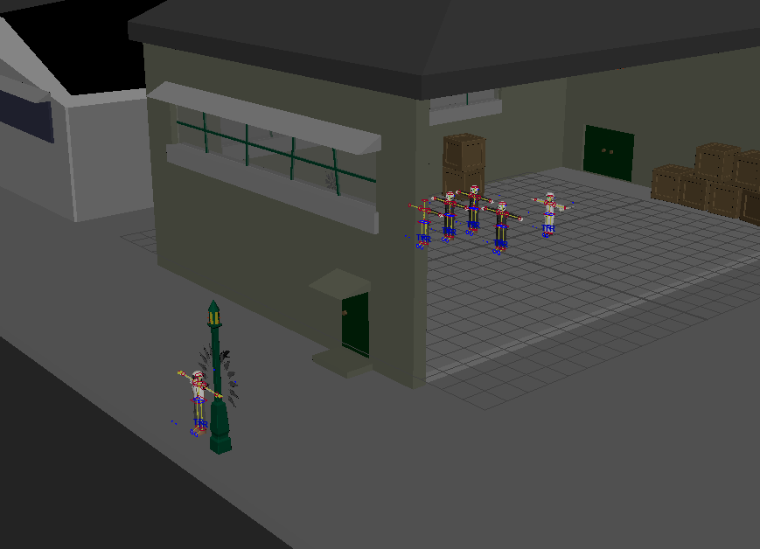
12. Animating
The final character animation was competed in a much shorter time than I had planned in my pre-production, so I had to cut some corners on many movements to save on already limited time. This will be noticeable due to the lack of walk cycles, easy ease, etc, however this was to prioritise the project’s completion within the time frame.
A lot of time was consumed by learning to model and rig characters, along with what constraints are and problem solving each of these new skills in order to use them effectively.
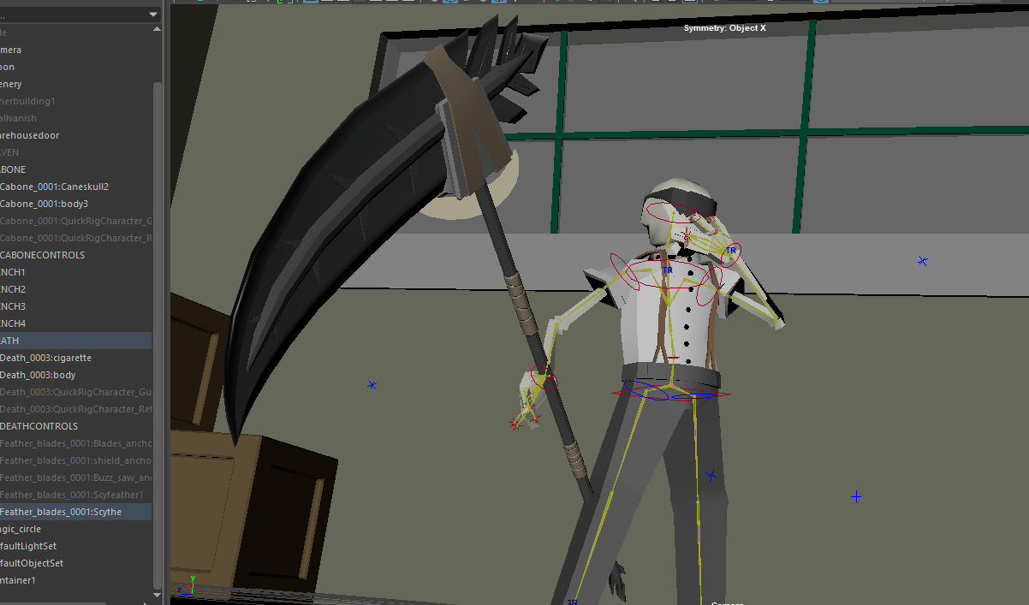
During the process, I encountered some further issues with props being constrained incorrectly, but I worked around them by improvising, for example, I learned you can constrain an object to multiple parents when I wanted Death’s cigarette to move around, or that you can’t keyframe geometry if it’s been constrained, which is why null objects are used as their proxy.

13. What can I learn
There was a lot of results I was unhappy with whilst working on this project, mostly the skills I had to learn from scratch, as the assets used in this animation were my very first attempts at most of these new skills. This is readily apparent with the lack of proper texturing and lacklustre character rigging. Another thing I’m unsatisfied with is my ability to manage my own time effectively, as it directly led to many of the aforementioned shortcomings despite making an action plan.
There were things that I was relatively satisfied with, such as the character models, which turned out much better than I expected for a first try and in future I want to improve this skill along with my lesser developed ones, which I can also use for personal projects. I also consider my animation planning to have been very thorough, as it allowed me various options to speed up my workflow in the event of unforeseen circumstances. I ended up using many of these strategies throughout production, such as the “low-poly” character designs, sharing assets between models, simple environments that make use of silhouettes and duplication of the Feather Blades to reach the desired amount. I really enjoy working with character animation, as when I start, its difficult to stop, mealtimes be damned for better or worse. I also enjoy successfully applying new skills to my own work, as it opens up many more possibilities for the the things I can achieve.
Most of all, I want to work on strategies in order to prevent myself from getting demotivated as it deeply effects my ability to work efficiently, along with some other personal issues it causes.

Lighting
Foundry (2020) “Lighting in animation: a dive in to the hand-drawn". Foundry, F. Insights Hub [Online] Available at: https://www.foundry.com/insights/film-tv/lighting-in-animation (Accessed: 08/08/23)
------------------
[1] E. Balint, "Animated Noir: Investigating Walt Disney’s Female Characters of the 1940s and 1950s". Journal of American Studies in Hungary , Americana. Vol X: 1., 2014. Available at: http://americanaejournal.hu/vol10no1/balint [Accessed: 08/08/23]
---------------
A. Silver and J. Ursini “Film Noir,“ P. Duncan, and J. Muller, Eds., London/ Los Angeles: Taschen, 2022

R. Nulph, “ Create Detective Style Films with Film Noir Lighting,” Videomaker , Nov, 1, 2008 [Online] Available at: https://www.videomaker.com/article/c13/13548-create-detective-style-films-with-film-noir-lighting/[Accessed: 11/08/23]

L. Han, “Pixel Noir: A Style for Cinematic Computer-Generated Lighting” MSc Thesis, Texas and A & M University, 2004. [Online] Available: https://citeseerx.ist.psu.edu/document?repid=rep1&type=pdf&doi=09894bd23dc19dc70c15e5c02f930dbbe0407d1c [Accessed: 08/08/23]
“Noir movies established some unique visual effects such as low–keylighting, harshhigh–light, high contrast and darkshadow, greater depth of field, and anti traditional mise-en-scene". (Place and Peterson, pp.65-75 L.Han, p.2 )
J.Place and L.Peterson, “Some Visual Motifs of FilmNoir”, Film Noir Reader vol.1,pp 65-75,1996
A. Cheperev, “Easy 3D Character Modelling in Maya - Part 1 – Body,” YouTube, Dec. 07. 2022. [Online]. Available: Easy 3D Character Modelling in Maya - Part 1 – Body [Accessed: 09/08/23]

Autodesk, “Outliner,” Maya 2023. Maya Forum, 2023 [Online] Available: https://help.autodesk.com/view/MAYAUL/2023/ENU/?guid=GUID-4B9A9A3A-83C5-445A-95D5-64104BC47406 [Accessed: 09/08/23]
Fixing missing Perspective Cameras
Autodesk, “Maya scene missing,” Maya 2023, Maya Forum. 2023 [Online] Available: https://forums.autodesk.com/t5/maya-forum/maya-scene-missing/m-p/7313983/highlight/true#M46033 [Accessed: 09/08/23]

