Shaping Culture and Behaviours (BMHR7013)

Task One
Word Count: 3,838
I hereby declare that the work presented in this assignment is my own and has not been copied from any other source except where due acknowledgement is made. All sources used have been properly cited and referenced in accordance with the required academic style.

Carly Butler Student Number: 2112602

Organisation Overview
Hywel Dda University Health Board serves the populations of Pembrokeshire, Ceredigion and Carmarthenshire, providing a high level of NHS healthcare across West Wales. The Healthboard has over 13,000 employees and say ‘our people are our strength’ in the 2024/25 report (HDUHB, 2025a).
HDUHB provides emergency care, community care and primary care in a range of settings and operates under the Agenda for Change Regulations along with all England and Wales NHS health boards, this regulates pay and grades for all staff and the framework for employees to progress.
The NHS is currently under scrutiny for long waiting lists and concerns over hospital standards. HDUHB actively seeks to reduce these waiting lists and with the use of new technologies works to improve the quality of care and standards of the settings where it is delivered.

Contents

Introduction ……………………………………………………………………… Page 3
Main Findings ………………………………………………………………….. Page 3
- Culture Theories ……………………………… Page 3
- Good Work Index ……………………………… Page 5
- Work-Life Balance …………………………….. Page 6
- Employee Voice………………………………… Page 7
- Career Progression and Sense of Purpose…. Page 9
Conclusion ………………………………………………………………………. Page 10
Recommendations ……………………………………………………………… Page 11
Task 2 ……………………………………………………………………………. Page 13
References ……………………………………………………………………… Page 18

Introduction
Organisational culture is defined by Adler et al, (2021) as the ‘norms, values and deep underlying assumptions’ or in its simplest form, ‘the way things are done round here’ (Deal and Kennedy, 1982). Buchanan and Huczynski (2023) suggest that just as we consider different countries to hold certain cultures we can also discuss the ‘personality’ of Disney, Mcdonald’s and the British Civil Service. Each holding a specific set of values and norms contributing to a ‘unique identity’.
Mats Alveson (2002, pg.3) notes that culture in itself can have such a vast set of meanings that it can be hard to pin down to any one definition but in a broad sense refers to the ‘norm system’ or ‘social pattern’ that most certainly exists in all organisations. These systems or patterns can shape the direction of an organisation, impact performance and ultimately impact the experience of every individual as they go to work.
Schein (2010) discusses the ‘shared learning’ of a group that works well enough to be passed to new members. Hywel Dda Healthboard (HDUHB) see this resonates with the large workforce and the norms and values adopted across the organisation, as well as the subcultures created in different departments and wards (Mannion & Davies, 2018).
A positive culture includes; collaboration, fair rewards for work done, low turnover and opportunities for employees (Waite et al., 2021). As an organisation we need to see these positive elements embedded in the workforce and this requires application of a culture model to help ‘define, shape and influence’ the culture of Hywel Dda (Personnel Today, 2023).
HDUHB staff base is just over 13,000 employees and the culture set amongst this workforce would have a huge impact on the patient care across a significant area of Wales.

Main Findings
Culture Theories
There are several cultural theories that can be used to consider the culture of our place of work and what impact that has on the ability for ‘good work’ as defined by CIPD, 2025. In considering these theories you could be drawn to Edgar Schein’s Model of culture (2004) referred to as the culture triangle or the iceberg theory (EPM, 2022).
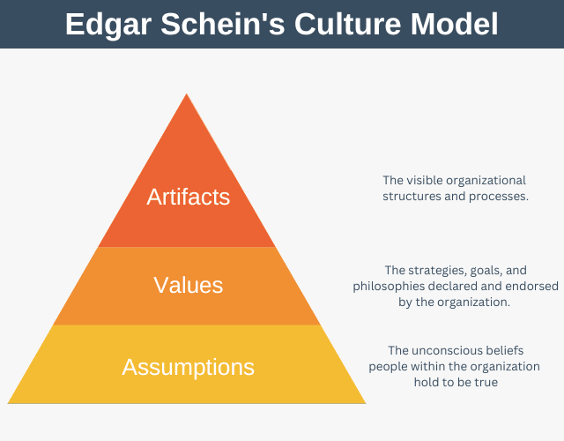
Fig, 1 (Geoghegan, 2022)
This is a detailed breakdown of areas of culture; Artifacts, Values and Assumptions. When considering the application of this model it does provide a clear visual if you have a business goal to set or problem to consider, you can look at each of these areas and attempt to ‘fix’ whatever appears to be going wrong (EPM, 2022).
However, on closer inspection it does seem this might not be broad enough to consider all the elements at play, it notes its deepest level as the underlying basic assumptions i.e. if something has worked enough times it will always be repeated (Schein, 2004). Though this can account for some behaviours it does not consider the control and power structures and systems of the Johnson et al., 2014 Cultural Web. Where Schein (2004) considers the artefacts as the rites and ceremonies that are on display it is possible when we look at the web Johnson et al.(2014) have created, that these can be both formal and informal, they can be underlying and secretive as well as displayed by the organisation.
This difference can be encapsulated by the contrasting culture ‘has’ versus culture ‘is’ views (Buchanan and Huczynski, 2023, pg.108). The contrasting views that culture can either be controlled by management as part of its core structures, technology and control systems (‘has’) or that it ‘is’ created by the individuals making up the collective and thus is not something to be managed or manipulated by the organisation.
Charles Handy (1993) also attempts to classify the types of culture present in any organisation, splitting into 4 main types; power, role, task and person. Though these cultures rarely exist solely in a business, unless it is particularly small. A larger business is much more likely to hold a mix of these cultures (Mullins and Rees, 2023, pg. 491) and so it would be hard to define the specifics of the cultures within different areas of an employer as large as HDUHB.
In contrast the Cultural Web (Johnson et al., 2014) has a mix of stories and symbols brought through from the individual as well as the control systems and structures that ultimately shape the culture holding it fixed by the organisation itself. All overlapping into one another and the paradigm of the organisation, reinforcing the behaviours contributing to it.
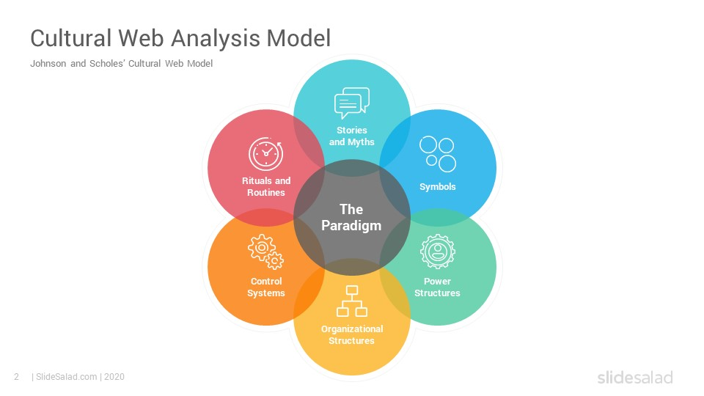
Fig. 2 (Slidesalad, 2020)
This Cultural web encapsulates HDUHB as an organisation most accurately, considering the many complex areas at play within the health board. It considers the impact of outside elements on the core organisational culture as well as the smaller subcultures formed with varying job roles, shaped by stories and rituals (Janse, 2022). It is recognised that these subcultures must still remain connected to the ‘whole’, overlapping this central paradigm, in order to maintain consistency and unity across the organisation. The paradigm acts as the central point within the organisation that can both influence and be influenced by the surrounding elements (Business Academy, 2021). Without this HDUHB would have a fractured and counter-productive culture, disconnecting from the strategy and purpose of the health board (Janse, 2022).
‘Good Work’ Index
CIPD’s Good Work Index (2025) lists 9 key elements when it comes to what ‘good work’ looks like.
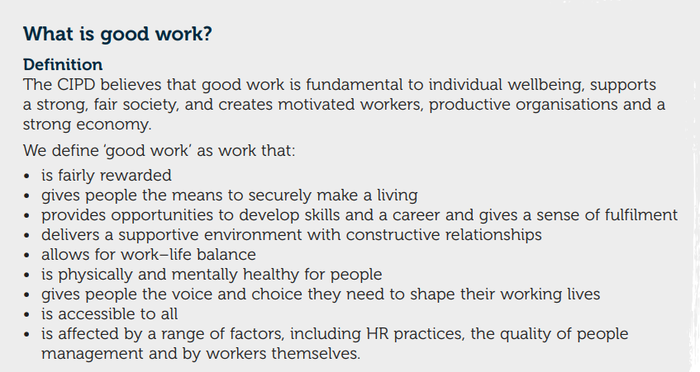
Fig. 3 (CIPD, 2025)
We will consider 3 of these in light of the Cultural Web to ascertain whether HDUHB has effectively managed the culture of the organisation to enable employees to feel positive about their work, and whether that positive culture will benefit the organisation as a whole.
Work-Life Balance
Work-Life Balance has been a focus for HDUHB since before the pandemic but this focus has grown and intensified since 2020 when workers from all sectors were encouraged to work from home. The Agile Working Strategic Plan (HDUHB, 2025) has been carefully crafted over these last 5 years and considers the People, Process and Place that is best and also possible for those in varying roles across the NHS. Within HDUHB there is no scope for certain roles to be working from home, however there are feasible options for them to also attain a healthy Work-Life Balance.
Within the Agile Working strategy there is a commitment from HDUHB to adopt working practices for all staff dependent on the directorate they work in. It recognises that work-life balance is wider than just flexible or agile working arrangements and as such signposts to the wellbeing service that is also available for consideration for all employees (HDUHB, 2025). It succinctly incorporates consideration of the long commute, the flexibility to attend a school run, to shift longer hours to less days and to provide any technology needed to enable all workers more flexibility for their base. This is a good example of the Job Demands-Resources model (Demerouti & Bakker, 2006) where it is considered that sometimes the reason employees may feel demand is too high is not just down to ‘hours in the day’ it may be that other resources such as emotional support, physical needs as well as, in this case caring needs, are not being met. This creates a feeling of overwhelm and that demand is exceeding the resources available to employees (Trueman, 2025).
Fray (2026) considers the need for ‘time autonomy’ versus location choice, he notes that there is a shift in employees where they do not consider where they work as the most important factor but freedom to flex hours, appropriate boundaries around work time and less expectation to be immediately available.
Adhvaryu, Mlina and Nyshadham (2022) and Wu and Liu (2021) as cited in De Neve and Ward (2025) note that job satisfaction comes from employee wellbeing and can be closely linked to retention figures. At a time when employee stress is high and retention is a challenge; wellbeing is top of the agenda for the health board. Within the stories and rituals elements of the cultural web in HDUHB lies a rich history of ‘better days’ when rules were more relaxed, there was less red tape and a greater freedom and autonomy in treating patients, new ideas were welcomed and strong and binding subcultures existed.
This links in with David Rock’s SCARF Theory (2008) where there is a consideration that greater autonomy leads to a more motivated and resilient workforce. With this in mind its possible there is a negative impact to these stories, where staff feel power structures have reduced autonomy in decision making. Lack of consultation regarding new medications, computer systems and procedures with such regularity could reduce the resilience and adaptability within the HDUHB teams.
The control systems and management heavy approach from health board executives, has created a sense of mistrust; when the directive goes out for wellbeing initiatives, agile working strategies and an emphasis on work-life balance, it is considered a tick box exercise rather than something which will be implemented on the ground. HDUHB would want to see an increase in employer engagement. High job demands coupled with low job control are found to be the combination that has the worst effect on an employees’ wellbeing (Bakker and Demerouti, 2007). The essence of the Job demands-resources model is that if employees have the resources they need to meet the demand of their role then they will remain engaged and positive in the work place. To remove the resources will ‘evoke a cynical attitude towards work’ (Bakker and Demerouti, 2007).
Those resources include; management support, reasonable deadlines and workload, informed feedback and ‘decision latitude’ (Bakker and Demerouti, 2007). We will look at how these can be best applied in the recommendations at the end of this report.
Employee Voice
The CIPD stipulates another fundamental to ensuring ‘good work’ is that the organisation ‘gives people the voice and choice they need to shape their working lives’ (CIPD, 2025).
Employee engagement and employee voice is a symbol of HDUHB. Terminology is moving from whistleblowing to ‘speak up’ and more confidential and safe platforms for this are being regularly developed. The OD department are working hard to create rituals and routines that centre around safe speaking spaces and psychological safety for every employee.
Psychology safety is described by Schein (1993) as the reason employees would put a greater focus on the shared goals of the team or organisation, as well as thinking how issues could be detected and prevented rather than existing in self-preservation mode (Capezio et al., 2024). The link then is strong between employees feeling psychologically safe and so speaking up with ideas for improvement and concerns (Edmondson and Lei, 2014 as cited in Capezio et al., 2024). We have seen other workforces do a similar thing, such as Macmillan and the results have been much higher engagement for the workforce where they feel they can speak up and there will not be any negative repercussions for them in doing so (Macmillan, 2025).
Yet again we see this sit within a wider Wellbeing strategy, where employees have a voice and greater autonomy in terms of choice and flexibility as to how to manage workload there is an increase of; *A healthier and more inclusive culture. *Better work-life balance. *Better employee morale and engagement (CIPD, 2022, Health and Wellbeing at work survey). With employee voice and choice present there is an increase in the fundamental wellbeing of staff and a more positive culture within the organisation.
CIPD (2026) states the high importance placed on employee voice not just for the employee but also the employer. They note the improved relations this can bring and as a result the more positive climate at work. Noting the importance of the individual and collective voice feeds into the integral role of trade unions. HDUHB is a heavily unionised workplace and we do see the effective change and challenge that is constantly brought to the fore by the voices of the RCN, Unison, Unite, BMA and others. The HDUHB partnership forums were introduced in 2009 as a mechanism to consult trade unions and key stakeholders through the county meetings held bimonthly, on all decisions, proposals, change programmes and to agree ‘local priorities at the earliest opportunity’ (HDUHB, 2022).
This runs through every element of Johnson’s cultural web (2014) as we see the rituals and routines, stories and symbols embedded in the union voice as well as the consideration of this voice as systems and structures are adapted for the future. The trade union voice contributes at the highest level to enabling employees of HDUHB to have good work in terms of choice, voice, wellbeing and a level of autonomy both individually and collectively.
John Drew (NHS, 2023) states the importance of this employee voice across all areas of the NHS as he advocates the importance of the annual staff survey. An opportunity for all 1.5 million employees of the NHS to have their voice heard, the good, the bad and the ugly. Not only can the results of the survey have a huge impact on the understanding of culture and where we may be going awry, but also what is going well and where we are getting it right. Though it is important to consider the voices that are not heard in these results. There are many staff groups who may choose not to complete the survey or simply cannot access it for differing reasons, this could mean there is a culture left unidentified and potentially unconsidered. Feedback channels and other less formal opportunities throughout the year will form part of the recommendations for this element of ‘good work’.
As we look at further recommendations we will also have to consider the diversity of offerings for employee voice to take into account the different staff groups, neurodiversity, disability and other barriers both visible and invisible that may mean the full range of employee voice is not being heard currently.
Career development and Sense of Purpose
A third element of ‘good work’ from the CIPD’s Good Work Index, 2025 is the opportunities for career development and sense of purpose.
De Neve and Ward (2025) identify these 3 key areas for employees to assess their overall wellbeing at work; Job satisfaction levels (Evaluative), how happy or stressed staff feel (Affective) and Eudaimonic wellbeing i.e. the overall sense of purpose. When we consider HDUHB employees within this framework we realise how subcultures play such an important part in overall feelings of wellbeing. Mannion and Davies (2018) describe these overlapping subcultures as a ‘mosaic’ largely derived from the many occupational groupings and ‘professional hierarchies’ as they consider the main two groupings of medical and managers. The power structures in our cultural web (Johnson et al., 2014) play a part in fracturing the wellbeing within the health board staff by allowing an inconsistent picture of the 3 areas identified by De Neve and Ward (2025). I.e. the sense of purpose on a ward for the healthcare staff will be apparent on a daily basis, whereas an administrator based in a community hub building may not have that Eudaimonic wellbeing due to remoteness from the organisation strategy and feelings of disconnection.
Ryan (2019) discusses the learning strategies considered by Schunk & DiBenedetto, 2016; Usher, 2015 as well as Banduras (1977b, 1986, 1997, 2001) as an understanding of the influence self-efficacy has on behaviour choices, i.e. the effort and persistence a person would put in and be motivated to continue with. Ryan (2019) notes the importance of overt encouragement from a power system, so the ability for HDUHB to actively (through strong line management) give opportunity and encouragement to staff to be ambitious and try for more is a key element for the culture to embrace if we want to see employees increasing opportunities.
Ryan (2019) also notes the influence of social factors as referenced by Schunk (2012). This considers the degree to which individuals are affected by the group environment and vice versa. Therefore, creating rituals and rites that reinforce collective improvement, moving ‘up the ladder’ and CPD opportunities will create a stronger sense of motivation for the collective and the individual at HDUHB.
Nudge Theory suggests we can shift employee behaviour ‘without them even realising it’ (Burt, 2019) this can impact the extent to which stories affect employee’s belief that management are ‘for’ them. Chkonia (2025) states ‘According to LinkedIn research conducted over the last five years:’94% of employees would stay at a company longer if it invested in their career’.’
These management nudges could include; line managers mentioning the next level up of opportunities for employees in 1:1’s and ensuring they have a link to the internal job page. These could lead to increased sense of motivation for career development and purpose.
The intrinsic purpose of the health board is to serve the patients with the highest level of care. Considering our cultural web this would be highly represented by the symbols of the organisation, employee’s pride in wearing their professional uniform and attending the local hospital each day. As such we have the gift of a clear purpose for every employee, though there may be some that feel distanced from that eventual output. This is synonymous with the self-determination theory (Deci and Ryan, 1985) that says those with an intrinsic motivation will be more satisfied in their work, not for extrinsic reward but for the fulfilment of the work itself. HDUHB have built on this to some extent by using content from patients’ stories to provide a reminder to staff of the ‘why’ they do what they do. This can be built on further in the recommendations.
Conclusions
As we consider the effectiveness of the Cultural Web (Johnson et al., 2014) in assessing the culture of HDUHB and the impact this culture has on the health board’s ability to provide ‘good work’ to our employees, we see gaps in the effectiveness of certain policies and programmes. The intentions appear to be good from the organisation; agile working policy, making a difference workshops, trade unions at the table for key decision making meetings (HDUHB, 2025). However there is a disconnect at times between the power structures and organisation control compared with the rituals, routines and stories of the staff. Brown (2025) compels us ‘to improve patient safety and quality of care, we must prioritise people and culture’. She reminds us that in the NHS ‘the people are the system’ and that a renewed focus on employee wellbeing is imperative to improving the NHS systems as a whole. This is a call to action that HDUHB cannot ignore if the measure of success is improved patient care and a renewed trust from the communities we serve.

Recommendations
The key to improving what good work looks like in HDUHB is considering what we can do to further increase the three elements set out in this report. These will be practical ways we can shape a more positive culture therefore increasing job satisfaction amongst health board employees (Human Capital Hub, 2025).
- To effectively promote improved work-life balance HDUHB will lead by example, Jessica Leyshon (Sage, 2023) notes the importance of this according to outcomes from their research. If managers and directors are leaving work on time and have clear boundaries regarding emails, work calls and Microsoft Teams, then the workforce will follow suit. Implementing clearly stated boundaries through;
- email signatures, answerphones being switched on and out of office applied to Microsoft Teams will send a clear message to staff that it is not expected for employees to be ‘on call’ 24/7.
Linked to this will be the suggested resources from Bakker and Demerouti (2007) to reduce the feeling that demand is unmanageable.
- Management 1:1’s on a fortnightly or monthly basis that discuss deadlines and workload and give valuable feedback to staff, as well as coaching conversations allowing staff to decide how changes can be made.
The costs linked to this recommendation will be time for managers diarise 1:1 meetings effectively, as well as opportunities for them to attend the 2 day coaching conversation course provided internally.
Costs for Recommendation 1:
Managers team sizes vary but on average a band 7 would be meeting with 5-8 employees twice a month.
£28 x 8 = £224 x 24 = £5,376 per annum
Band 7 managers in HDUHB 1500 approx
1500 x 5,376 = £8,064,000 per annum
This would not be an increase in total as many managers are already making this a priority across the health board but this would mean consistency. As a result we would expect to see a reduction in sickness costs and increased retention producing cost savings overall for each year of implementation.
Internal attendance to coaching conversation training;
Attendance for 2 days for 1000 managers to attend would be;
£28 x 15hours = £420 £420 x 1000 = £420,000
This would be a one off cost and enable managers to go confidently into conversations with employees to lead them to be making the best decisions within their role with a level of desired autonomy.
- Less formal forms of employee voice need to be offered for employees to feel we really want to hear from all staff. As such a recommendation for a QR code to be displayed throughout the hospital and clinic sites as well administration offices, this will link straight to a page where you can have your say about anything from ‘how is your day going?’ to reporting an issue or concern. This would increase psychological safety and enable all staff to have their say throughout the year without the need for formal survey and feedback. Though the formal route would still have it’s place.
This QR code would feedback to the Culture and OD team for action where needed.
Costs for Recommendation 2:
Time for Band 6/7 staff in OD to go through data and analyse/group results appropriately.
In house Band 6 Culture practitioners - £23 per hour
10 hours per week = £230 per week
Annually - £12,000
Band 7 internal data analyst – 2 – 4 weeks work per year
£28 x 150 hours = £4,200
This would be a relatively low cost action that could increase the voice and choice of every individual in HDUHB.

- To increase the career opportunities for employees thus increasing their motivation (Chkonia, 2025) HDUHB will nudge employees towards the L&D pages and internal Job Vacancy alerts. This can be enacted through our internal IT network and the intranet pages as well encouraging managers who have less digitally based staff to display paper updates for notice boards and share in team briefings.
We want to instil the belief that HDUHB always wants employees to be striving for excellence, continuing with CPD and has our support using the already existing higher awards programme to support those who wish to continue in their studies.
There would be no tangible cost for this as it will need to be a golden thread that runs through management training and organisation communications at all levels. HDUHB believes you can do more and wants to help you thrive and grow.

Shaping Culture and Behaviours (BMHR7013)

Task Two

Word Count: 1029


Carly Butler Student Number: 2112602

Line Managers Culture Plan
Work-Life Balance - HDUHB wants to see an improved opportunity for all employees to have a good work life balance. As managers you will set the best example, please add a line into your email signature stating ‘I recognise that the working hours I have may not match yours, there is no requirement or expectation for you to reply outside of your own working hours’.
In the CIPD Good Work Index Report (2025) there was a strong link between those who felt they had flexibility to take time off when needed (70%) and displayed higher performance and discretionary effort.

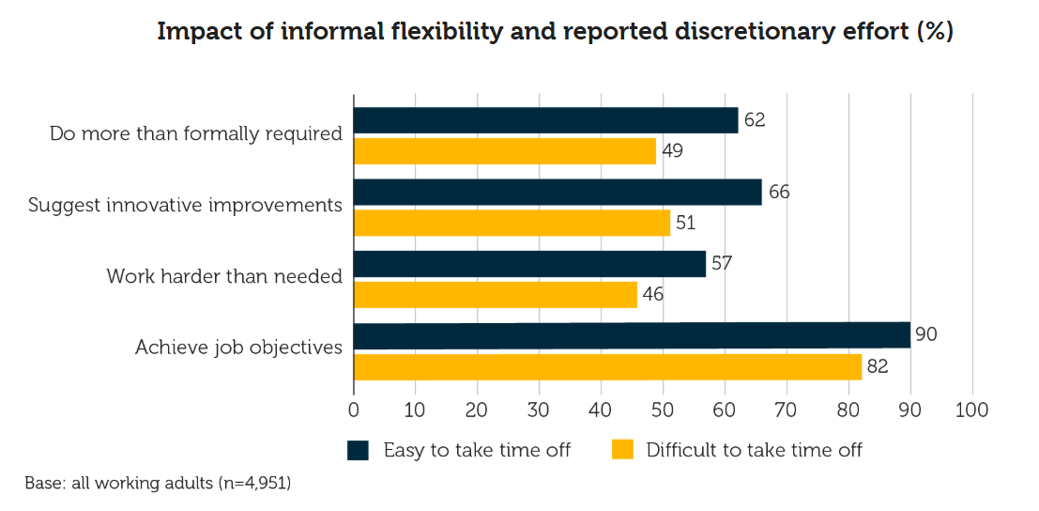
Fig 1. (CIPD, 2025)

Further to this we find from research conducted by Gallup (2021) cited by the British Safety Council (2023), the relevance of the location of work was less important to employees than good feedback from managers.
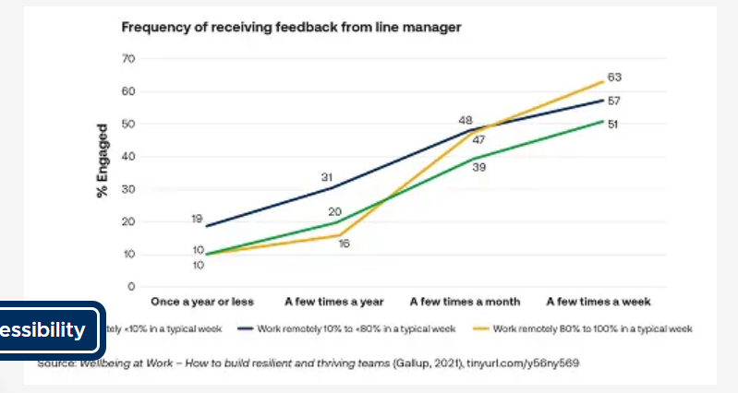
Fig 2. (British Safety Council, 2023)
HDUHB would ask all line managers to schedule a fortnightly 1:1 meeting with each member of your team, where possible. Giving an hour of time to give helpful feedback, actively listen and coach employees to consider what options they want to pursue will have a positive impact on the individual and therefore the team (HDUHB, no date).
Robinson-Hayes (2026) reports stress at work is losing the UK 22.1 million working days, she highlights the role of managers in active listening and the importance of time for an employee to air their concern to a good manager. HDUHB wants all managers to feel equipped for these conversations. Enrolling on the internal ‘Coach Approach training’ will be an invaluable set of tools to have for all management conversations (Inglis, nd). This is an opportunity to learn a new skill that will elevate your 1:1 meetings with team as well as the skill needed to lead yourself well. This could positively impact on sickness within your teams and trust between the manager and employees.
There is a good response from teams when there is a balance from line managers of consistency; meeting with every member of the team with planned regularity and a common agenda. But also ‘individual responsiveness’ i.e. hearing from each employee what their individual struggles are and guiding them to bespoke solutions (Fu et al., 2018).
Employee Voice – HDUHB currently has the speak up platform on our intranet page which we would ask all managers to encourage full use of (HDUHB, 2026c). In addition to this, the annual survey is an opportunity for teams to take time out of their busy day and reflect on the elements of their role and health board they are celebrating and also concerns they have (HEIW, 2025).
As a health board we want to encourage all staff to interact using their voice, regardless of computer access, the shifts they work, and any other barriers there may be. As a step towards this we have introduced this QR code:


HDUHB would request that all line managers please display the QR code in all staff areas, this will take staff to the speak up page detailing what they can use this platform for. We would also like to see paper copies held by each manager in a place staff could access and use anonymously in order for all staff to have their voice in HDUHB. Porter-Williams (2025) advocates the use of QR codes for recruitment and onboarding, where multiple documents can be stored within one code. This could be something we consider for the future once some data has been collected.

Career Development – As line managers it is important for all staff to be encouraged to progress, should they wish to. Employees have several avenues to develop their careers with HDUHB. There is a job page on the intranet (HDUHB, 2026a) that is refreshed everyday with the newest vacancies in the health board. This link should be viewed with some regularity to ensure your team are aware of current opportunities. This can be communicated in 1:1 meetings as well as at yearly PADR meetings to ensure the staff know they can progress and will be supported to do so.
The Access Group (2025) considered data from The UK’s best Workplaces for Development, 2024 and found retaining talent in the current job market was more prevalent in workplaces where career progression was encouraged and prioritised.
Zulfiqar et al. (2023) considered international nurses hired in US and Canada and found the lack of progression and use of their previously attained skills created low job satisfaction and poor performance. In a healthcare setting with staff from countries across the world serving the HDUHB community, it is important for us to appropriately mentor those who will want to progress within the NHS using skills they have already acquired in home countries.
Line managers can encourage CPD at all levels using digital and paper forms, sharing information of the higher awards scheme (HDUHB, 2026b) for those who wish to pursue a professional qualification. Encouraging all staff to visit our People Development Pages (HDUHB, 2026a) will guide them through career pathways for clinical and non-clinical pathways.

Targeted internal training can also increase productivity and a sense of purpose amongst employees, Heinrich (2025) reports a ‘17% increase in productivity’ when staff access high-quality, relevant training programs. This has to be more than just the basic e-learning provided to all staff. As line managers we want to identify the need in our employees and source something excellent that will help them flourish and build a strong team with a positive purpose driven culture.
Conclusion – All Line Managers in HDUHB are invaluable to creating the positive culture within our workforce that makes us proud to serve our communities and prioritise the highest levels of care to the people of West Wales. This starts with considering the Wellbeing and opportunities of the staff we employ and managers have the unique opportunity to shape this day to day experience at HDUHB. Our OD team regularly lead us all to ask the question ‘What is a good day at work?’ (HDUHB, 2025). The answer to this will be impacted by the work we do today with those in our team to encourage, listen to and coach towards a better day.

Reference list
Academy, B. (2021) YouTube. Available at: https://youtu.be/rtfOIpj6atA?si=9FhwIDmlT0DaZ2k2 [Accessed 6 Feb 2026].
Adler, A.B., Bliese, P.D., Barsade, S.G., Sowden, W.G. (2021) ‘Hitting the Mark: The Influence of Emotional Culture on Resilient Performance’, Journal of Applied Psychology, 107(2), pp. 319–327. Available at: https://doi.org/10.1037/apl0000897
Bakker, A.B. and Demerouti, E. (2007) ‘The job demands‐resources model: State of the art’, Journal of Managerial Psychology, 22(3), pp.309–328. Available at: https://doi.org/10.1108/02683940710733115
Brown, I. (2025) Culture more important than ever at a time of transformation Available at: https://nhsproviders.org/resources/culture-more-important-than-ever-at-a-time-of-transformation [Accessed 6 Feb 2026].
Buchanan, D.A. and Huczynski, A. (2023) Organizational Behaviour. 11th ed. Harlow: Pearson.
Burt, E. (2019) Nudge theory can help change your employees’ behaviour, People Management. Available at: https://www.peoplemanagement.co.uk/article/1742167/nudge-theory-change-employees-behaviour-without-realising [Accessed 31 Jan 2026].
Capezio, A., Barends, E., Rousseau, D. and Wietrak, E. (2024) Psychological safety An evidence review Scientific summary, CIPD. Available at: https://www.cipd.org/globalassets/media/knowledge/knowledge-hub/evidence-reviews/2024-pdfs/8550-psychological-safety-scientific-summary.pdf [Accessed 6 Feb 2026].
Chkonia, S. (2025). The Role of Development Opportunities in Employee Motivation and Retention. Linkedin.com. Available at: https://www.linkedin.com/pulse/role-development-opportunities-employee-motivation-salome-chkonia-pprof [Accessed 6 Feb 2026].
CIPD (2023) CIPD | Health and wellbeing: Macmillan Cancer Support. Available at: https://www.cipd.org/uk/knowledge/case-studies/health-wellbeing-macmillan/ [Accessed 3 Feb 2026].
CIPD (2025) CIPD Good Work Index 2025. Available at: https://www.cipd.org/globalassets/media/knowledge/knowledge-hub/reports/2025-pdfs/8868-good-work-index-2025-report-web1.pdf. [Accessed 6 Feb 2026].
CIPD (2026) Employee Voice CIPD. Available at: https://www.cipd.org/uk/views-and-insights/cipd-viewpoint/employee-voice/. [Accessed 3 Feb 2026].
Deci, E.L. and Ryan, R.M. (1985) Intrinsic motivation and self-determination in human behavior. New York: Plenum.
Drew, J. (2023) Staff voices matter | NHS Employers. Available at: https://www.nhsemployers.org/articles/staff-voices-matter. [Accessed 4 Feb 2026].
EPM (2022). Edgar Schein’s Culture Model Explained with Example. YouTube. Available at: https://www.youtube.com/watch?v=HM89E6ltVOg.
Fray, M. (2026) Employees now value work-life balance more than money. Available at: https://qz.com/work-life-balance-pay-salary-hybrid-remote-office [Accessed 6 Feb 2026].
Fu, N., Flood, P.C., Rousseau, D.M. and Morris, T. (2018) ‘Line Managers as Paradox Navigators in HRM Implementation: Balancing Consistency and Individual Responsiveness’, Journal of Management, 46(2), pp. 203–233. Available at: https://doi.org/10.1177/0149206318785241.
Geoghegan, D. (2022) Edgar Schein’s Organizational Culture Model. Available at: https://expertprogrammanagement.com/2022/09/edgar-schein-culture-model/ [Accessed 6 Feb 2026].
HDUHB (2025)‘Hywel Dda Intranet’. Hywel Dda University Healthboard. Unpublished.
Heinrich, A. (2025) 5 Benefits of Corporate Employee Training & Development. Available at: https://online.hbs.edu/blog/post/employee-training-development [Accessed 8 Feb 2026].
HEIW (2025) NHS Wales Staff Survey. Available at: https://heiw.nhs.wales/workforce/nhs-wales-staff-survey/ [Accessed 7 Feb 2026].
Herbert, M. (2023). Why line managers play a vital role in workplace wellbeing. [online] British Safety Council. Available at: https://www.britsafe.org/safety-management/2023/why-line-managers-play-a-vital-role-in-workplace-wellbeing [Accessed 7 Feb. 2026].
Human Capital Hub. (2025) Why Workplace Culture Matters for Employee Satisfaction. Available at: https://www.thehumancapitalhub.com/articles/why-workplace-culture-matters-for-employee-satisfaction [Accessed 6 Feb 2026].
Hywel Dda Intranet Page. (2025) Hywel Dda University Health Board Annual Report 2024/25. Available at: https://youtu.be/PCkxK2C6YtM?si=uj2edKxz8R7jryc5 [Accessed 6 Feb 2026].
Hywel Dda University Health Board. (2022) Health Board Partnership Forum. Available at: https://hduhb.nhs.wales/about-us/governance-arrangements/advisory-groups/health-board-partnership-forum/ [Accessed 6 Feb 2026].
Hywel Dda University Health Board. (2025) Meet the Teams. Available at: https://nhswales365.sharepoint.com/sites/HDD_Organisational_Development/SitePages/Relationship [Accessed 8 Feb 2026].
Hywel Dda University Health Board. (2026a) Current vacancies. Available at: https://hduhb.nhs.wales/working-for-us/current-vacancies/ [Accessed 8 Feb 2026].
Hywel Dda University Healthboard. (2026b) Higher Awards. Available at: https://nhswales365.sharepoint.com/sites/HDD_Workforce-development/SitePages/Higher-Awards.aspx [Accessed 8 Feb 2026].
Hywel Dda University Healthboard. (2026c) People Development. Available at: https://nhswales365.sharepoint.com/sites/HDD_Workforce-development/SitePages/AWCF.aspx [Accessed 11 Feb 2026].
Inglis, Y. (n.d.) Hywel Dda Coach approach. Available at: https://nhswales365.sharepoint.com/sites/LeadershipDevelopment/SitePages/Coac.aspx [Accessed 7 Feb 2026].
Jan-Emmanuel De Neve and Ward, G. (2025) Why Workplace Wellbeing Matters. Harvard Business Press.
Janse, B. (2019) Cultural Web Analysis by Gerry Johnson and Kevan Scholes | toolshero. Available at: https://www.toolshero.com/management/cultural-web-analysis/ [Accessed 6 Feb 2026].
Johnson, G., Angwin, D., Pyle, S., Regnér, P., Scholes, K. and Whittington, R. (2014) Exploring strategy. Pearson.
Leyshon, J. (2023) 12 ways to support a better work-life balance for your employees. Available at: https://www.sage.com/en-gb/blog/hr-support-better-work-life-balance-workplace/ [Accessed 4 Feb 2026].
Mannion, R. and Davies, H. (2018) ‘Understanding Organisational Culture for Healthcare Quality Improvement’, British Medical Journal, 363(363), pp.1–4. Available at: https://doi.org/10.1136/bmj.k4907
Mats Alvesson (2002) Understanding organizational culture. London ; Thousand Oaks, Calif.: Sage.
Mullins, L.J. and Rees, G. (2023) Organisational Behaviour in the Workplace. Pearson.
Personnel Today (2023) What are the models of organisational culture? Available at: https://www.personneltoday.com/hr/what-are-the-organisational-culture-models/ [Accessed 6 Feb 2026].
Porter-Williams, S. (2025) How HR Teams Can Use QR Codes for Multiple Links to Improve Employee Experience. Available at: https://hrnews.co.uk/how-hr-teams-can-use-qr-codes-for-multiple-links-to-improve-employee-experience/ [Accessed 7 Feb 2026].
Robinson-Hayes, M. (2026) Are your managers truly equipped to deal with the stress epidemic? Available at: https://www.peoplemanagement.co.uk/article/1947430/managers-truly-equipped-deal-stress-epidemic [Accessed 7 Feb 2026].
Ryan, R. (2019) The Oxford Handbook of Human Motivation; 2nd edition. Oxford University Press.
Schein, E.H. (2010) Organizational Culture and Leadership. 5th ed. Hoboken, New Jersey Wiley.
The access group. (2025) 10 Strategies to support employee progression. Available at: https://www.theaccessgroup.com/en-gb/blog/hcm-10-strategies-to-support-employee-progression/ [Accessed 8 Feb 2026].
Trueman, L. (2025) Trueman Change. Available at: https://youtu.be/rADjeQpkhAg?si=_tEfuG93CGksUX1- [Accessed 6 Feb 2026].
Waite, K., Beevers, K., Small, N., Tomlinson, K. and Hussain, S. (2021). People Practice : A Complete Guide. 1st ed. London, United Kingdom : Kogan Page, p.47.
www.slidesalad.com. (2020). Slidesalad Available at: https://www.slidesalad.com/product/cultural-web-model-powerpoint-template/ [Accessed 29 Jan 2026].
Zulfiqar, S.H., Ryan, N., Berkery, E., Odonnell, C., Purtil, H. and O’Malley, B. (2023) Talent Management of International Nurses: A systematic Review. Available at: https://librarysearch.uwtsd.ac.uk/permalink/44WHELF_UWTSD/igoone/cdi_plos_journals_3069280395 [Accessed 8 Feb 2026].

