Management Accounting for Managers
LCBB5010

Student ID:2314051
Student Name: Iulian Marius Zegheru

Table of Contents
1. Introduction 3
2. Cost Analysis and Business Model 4
3. Budgeting and Financial Planning 5
4. Performance Measurement and Decision-Making 8
5. Sustainability and Ethical Considerations 10
6. Conclusion and Recommendation 11
7. References 12
8. Appendices 14
Appendix 1: Percentage Change 14
Appendix 2: Ratio Calculations 15

Table of Figures:
Figure 1: Inflation Rate targeted at 2% (Source: Author) 6
Figure 2: CPIH remained above 4.1 in August 2025 ONS, 2026) 7

Introduction
Netflix, Inc. is the world's largest subscription video-on-demand (SVOD) and digital entertainment company that offers streaming services to over 190 countries. In 2025, the company's total revenue amounted to more than US$45.18 billion, marking a 16% growth from 2024, and it had more than 325 million paid memberships, showcasing its significant global presence and market dominance. It has the following main products: feature films, television series, documentaries, live programming, mobile games, and ad-supported and premium subscription plans. Content, technology, and international expansion are all on the agenda and critical to the success of all investments made in the business, which makes management accounting a critical aspect of strategic decision-making. Management accounting helps Netflix to enhance operational efficiency, maintain a competitive edge and optimise long-term shareholder value by providing support in cost analysis, cost budgeting, measuring performance and allocating resources.

Cost Analysis and Business Model
Netflix has a subscription-based digital streaming business model, with its revenues derived primarily from subscriptions and consumer products and experiences, plus advertising. Subscription prices vary from the equivalent of US$1 up to US$37 per month, depending on country, and Extra Member subscription accounts start at US$2 up to US$9, allowing prices to take into account local purchasing power in over 190 countries. Membership fees are paid upfront and recognised over the term of the subscription, giving predictable recurring cash flows, helping to improve budgeting, rolling forecasts and long-term financial planning. Revenue grew from US$39.00 billion in 2024 to US$45.18 billion in 2025 (16%, or 17% foreign exchange neutral) due to a mix of increased memberships, strategic price increases, and growing advertising revenue (Netflix, 2025). The revenue diversification and cost control of the company resulted in higher operating income, which jumped from US$10.42 billion to US$13.33 billion (28%), and net income, which grew from US$8.71 billion to US$10.98 billion (26%). In addition, financial and non-financial data, such as subscribers' engagement, viewing habits and regional demand, are also used by management to manage revenue forecasts, pricing, investment appraisal and strategic investment planning.
Cost behaviour analysis is an important part of management accounting as the costs of Netflix are high fixed costs and comparatively low variable costs. Cost of revenues includes the largest cost of content amortisation, followed by content acquisition, content production, content licensing, streaming delivery, and customer service/payment processing. Original content, live programming, technology infrastructure, artificial intelligence, research and development, and corporate administration are all fixed costs, while payment processing, cloud streaming, customer support costs, and parts of marketing are variable. This means substantial operating leverage, which would boost the operating margin from 26.71% in 2024 to 29.49% in 2025. But significant content investments also carry financial risk, which is why Netflix uses Cost classification, budgetary control, variance analysis, capital budgeting, profitability analysis, and strategic cost management techniques to assess the returns to be expected, to prioritise the allocation of resources, and to ensure a long-term competitive advantage (Drury, 2022).

Budgeting and Financial Planning
Netflix's basic management accounting responsibility is budgeting, which involves transforming strategic goals into financial plans to measure and help manage resources and long-term value creation. Given Netflix's subscription-based business model that demands significant investment in original content before subscription revenues are realised, careful budgeting will be important to ensure it remains financially sustainable and grows its business. The company allocates resources for content production, technology infrastructure, marketing and advertising activities, and international operations through operating budgets, capital budgets, and rolling forecasts, budgetary control, and variance analysis (Kaplan and Atkinson, 2023). Management continually adjusts forecasts using financial metrics and non-financial metrics, including subscriber growth, viewing engagement, content popularity, and regional demand, to stimulate change that will lead to greater planning accuracy and better decision-making based on financial and non-financial data.
These practices are proven to be effective, as seen in the financial performance of Netflix in 2025. The operating expenses have risen from US$28.58 billion in 2024 to US$31.86 billion in 2025, a 11.5% jump (Netflix, 2024). Revenue grew by 16% to US$45.18 billion, operating income increased by 28% to US$13.33 billion, net income was up 26% to US$10.98 billion, and operating margin improved to 29.49% from 26.71%. The rise in this performance is due to increases in both memberships and strategic subscription price increases, and also due to increased advertising revenue, reflecting positive operating leverage – revenue growth exceeding operating expenditure growth.
Netflix's financial performance indicators show a relationship, which indicates the efficiency of the budgeting and financial planning processes. Revenue increased by 15.85%, from US$39,000,966 thousand in 2024 to US$45,183,036 thousand in 2025, while operating expenses increased by only 11.45%, from US$28,583,352 thousand to US$31,856,433 thousand (Netflix, 2025). Consequently, operating income grew by 27.92%, rising from US$10,417,614 thousand to US$13,326,603 thousand, and net income increased by 26.05%, from US$8,711,631 thousand to US$10,981,201 thousand. This is a sign of good budgetary control and high operating leverage between revenue and operating expenditure – revenue has increased much faster than the operating expenditure. However, from the management accounting point of view, these outcomes are the successful application of strategic budgeting, rolling forecasting, variance analysis and resource allocation, which demonstrates that expenditure can be matched to proportionately greater profitability across the budget and that sufficient budget is available to meet long-term sustainable shareholder value.
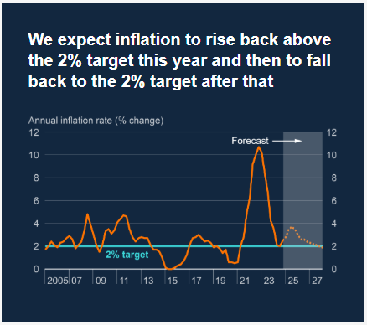
Figure 1: Inflation Rate targeted at 2% (Source: Author)
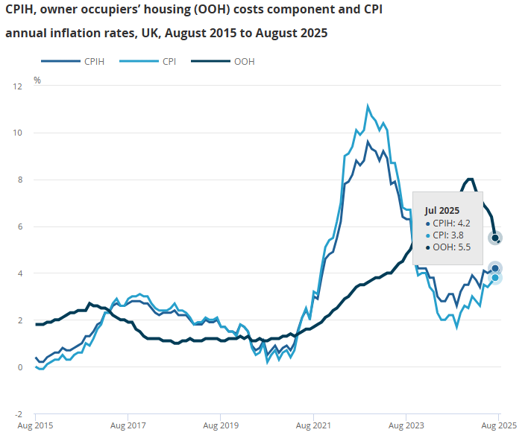
Figure 2: CPIH remained above 4.1 in August 2025 ONS, 2026)
The rise in operating costs was not due to poor efficiency, but rather to a strategic investment. Netflix expanded investment in original content, live programming, games, artificial intelligence, recommendation algorithms, and advertising technology from within, where rigorous capital budgeting, investment appraisal, profitability analysis, and customer lifetime value analysis were a must. On the outside, the continual rise in inflation, higher labour costs, and exchange rate volatility raised production costs. The Bank of England reported that inflation stayed above the 2% target, while the CPIH inflation was at 4.1% in August 2025 (Bank of England, 2025; Office for National Statistics, 2025). Thus, Netflix was able to follow flexible budgeting, rolling forecasts, and continuous variance analysis to direct investments to those areas with greater returns, maintain financial discipline, and assist in a sustainable long-term flow of shareholder value (IFRS Foundation, 2023).

Performance Measurement and Decision-Making
Ratio | 2025 | Industry Average
Operating Margin | 29.49% | -6.89%
Net Profit Margin | 24.30% | 0.54%
ROE | 41.26% | 33.62%
Asset Turnover | 0.83 | 0.63
ROA | 20.11% | 4.25%
Performance measures are one of the most integral components of Netflix's management accounting system that aids the management to monitor their strategic objectives, evaluate the performance of the organisation, and provide assistance for data-driven decisions. Netflix uses KPIs as part of their strategic performance dashboard, with their financial and non-financial KPIs to measure their profitability, operational efficiency, and ultimate value creation (Atrill and McLaney, 2025). Among the five, the following KPIs are particularly relevant: Revenue growth, operating margin, Return on equity (ROE), Earnings per share (EPS), and customer engagement. In 2025, revenue increased from US$39.00 billion to US$45.18 billion (16%), operating income rose from US$10.42 billion to US$13.33 billion (28%), and net income increased from US$8.71 billion to US$10.98 billion (26%). This led to an increase in operating margin from 26.71% to 29.49% and ROE of 41.26%, ROA of 20.11%, asset turnover of 0.83, and net profit margin of 24.30%, which are higher than the industry averages and show the efficient use of shareholders' money and company assets (Investing.com, 2026). While profitability improved, management kept investing in content and technology, representing a strategic balance between short-term profit and long-term value creation.
As the hours spent watching, content completion, retention, and engagement with advertising-supported memberships are directly tied to customer lifetime value and future revenues, customer engagement continues to be Netflix's top non-financial KPI. In response, management uses a mix of engagement metrics and financial KPIs to underpin benchmarking, value driver analysis, investment appraisal, rolling forecasts and variance analysis, and prioritises budgets for high-return content and technologies within a Balanced Scorecard. Thanks to high KPI results, further investment was made in original programming, live show production, games, advertising technology, personalised recommendation algorithms, local language productions, WWE programming, NFL Christmas Day games and the Extra Member programme. Instead of the typical approach of cutting costs, Netflix limited the growth in operating expenses (11.5%) to less than the growth in revenue (16%), while still being profitably innovative. Management also takes account of inflation, foreign exchange movements, and resilient consumer spending data, provided by the U.S. Bureau of Labor Statistics and the U.S. Bureau of Economic Analysis, respectively, when making budgets and allocating resources between more than 190 countries, thus illustrating the value of management accounting in the context of sustainable strategic decision-making and long-term shareholder value (U.S. Bureau of Labor Statistics, 2026).

Sustainability and Ethical Considerations
Instead of being just a corporate responsibility program, Netflix incorporates Environmental, Social, and Governance (ESG) factors into its capital budgeting, enterprise risk management, strategic resource allocation, and investment appraisal processes, all in the name of sustainability, taking centre stage in financial decision-making. Netflix recorded revenue of US$45.18 billion, operating income of US$13.33 billion, and an operating margin of 29.5% in 2025, which included investments in sustainability efforts (Netflix, 2025). Netflix's financial strength enabled it to invest in sustainability efforts while maintaining a profitable operating income of US$13.33 billion and an operating margin of 29.5% in 2025. The company's business activities involve handling climate-related risks in enterprise risk management (ERM) processes, reporting within the framework of the TCFD and SASB, and are present in over 190 countries. Netflix has further pledged to cut its absolute scope 1 and 2 GHGs by 50% by 2030 (from 2022) and its absolute scope 3 GHGs by 20% by 2030 (from 2022). Through capital budgeting, sustainability accounting, life-cycle costing and strategic cost management, these initiatives are assessed from a management accounting perspective and ensure sustainability investments complement long-term value creation, operational resilience and profitability. A Balanced Score Card approach also embeds ESG and financial KPIs, thereby further improving the measurement of performance and allocation of resources.
Netflix also takes ethical factors into account in its pricing and budgeting. In 2025, management has taken steps to reduce subscription prices in some segments and increased advertising-supported subscription and Extra Member programme to diversify revenue and make the offering more affordable. These decisions were backed by profitability analysis, forecasting demand, rolling forecasts, variance analysis and balancing revenue growth with customer retention. Price increases boosted investment in content, AI and live programmes, but led to concerns about affordability. In the spirit of PwC's focus on embedding ESG into financial planning and governance, Netflix's measurement of financial KPIs also includes financial engagement and retention data to support ethical budgeting, responsible capital allocation and long-term shareholder value (PwC, 2025).

Conclusion and Recommendation
The overall performance of Netflix in 2025 illustrates the critical role of management accounting in strategic and financial success in the global streaming market. The company has optimised resource allocation, enhanced its operating efficiency, and assisted with evidence-based strategic decisions through effective cost behaviour analysis, budgeting and performance measurement, as well as sustainability accounting. The successful application of management accounting is reflected in the strong revenue growth, higher profitability, and cost management. But this achievement will need to be maintained and continuously adjusted to the changing conditions of the market and competition. Thus, Netflix should further leverage the AI-enabled rolling forecasting to improve the accuracy in budgeting, add financial, operational, and ESG KPIs to its performance dashboards, and conduct post-investment reviews of major content initiatives to strengthen investment appraisal, variance analysis, long-term value creation, and capital allocation.

References
Atrill, P. and McLaney, E. (2025) Management Accounting for Decision Makers. 11th edn. Harlow: Pearson.
Bank of England (2025) Monetary Policy Report – August 2025. London: Bank of England. Available at: Monetary Policy Report - August 2025 | Bank of England (Accessed: 14 July 2026)
Drury, C. (2022) Management and Cost Accounting. 11th edn. Andover: Cengage Learning.
‌IFRS Foundation (2023) SASB Standards. London: IFRS Foundation. Available at: IFRS - IFRS Sustainability Standards Navigator (Accessed 14 July 2026)
Investing.com. (2026) Netflix (NFLX) Financial Ratios. Available at: https://www.investing.com/equities/netflix,-inc.-ratios (Accessed 14 July 2026).
Kaplan, R.S. and Atkinson, A.A. (2023) Advanced Management Accounting. 4th edn. Harlow: Pearson.
Netflix, Inc. (2024) Annual Report 2024 (Form 10-K). Los Gatos, CA: Netflix, Inc. Available at: 0001065280-25-000044 (Accessed: 14 July 2026)
Netflix, Inc. (2025) Annual Report 2025 (Form 10-K). Los Gatos, CA: Netflix, Inc. Available at: 0001065280-26-000034 (Accessed: 14 July 2026)
Netflix, Inc. (2025) Environmental, Social and Governance (ESG) Report 2025. Los Gatos, CA: Netflix, Inc. Available at: Netflix 2025 Environmental, Social & Governance (ESG) Report (Accessed: 14 July 2026)
Office for National Statistics (2025) Consumer price inflation, UK: August 2025. Newport: ONS. Available at: https://www.ons.gov.uk/economy/inflationandpriceindices/bulletins/consumerpriceinflation/august2025 (Accessed 14 July 2026).
PwC (2025) Global Entertainment & Media Outlook 2025–2029. London: PwC. Available at: Perspectives: Global E&M Outlook 2025–2029 (Accessed 14 July 2026)
U.S. Bureau of Labor Statistics (2026) Consumer Price Index: 2025 in Review : The Economics Daily: U.S. Bureau of Labor Statistics. [online] Available at: https://www.bls.gov/opub/ted/2026/consumer-price-index-2025-in-review.htm (Accessed 14 July 2026).

Appendices

Appendix 1: Percentage Change
1) Revenue Growth
Year | Revenue (thousands $)
2024 | 39000966
2025 | 45183036
Change = ((45183036-39000966)/39000966)*100 | 15.85%
2) Operating Income Growth
Year | Operating Income (thousands $)
2024 | 10417614
2025 | 13326603
Change = ((13326603-10417614)/10417614)*100 | 27.92%
3) Net Income Growth
Year | Net Income (thousands $)
2024 | 8711631
2025 | 10981201
Change = ((10981201-8711631)/8711631)*100 | 26.05%
4) Operating Expense Growth
Year | Operating Expenses (thousands $)
2024 | 28583352
2025 | 31856433
Change = ((31856433-28583352)/28583352)*100 | 11.45%

Appendix 2: Ratio Calculations
Ratio Calculations
Amounts in (thousands $)
Operating Margin
Particulars | 2024 | 2025
Operating Profit | 10417614 | 13326603
Revenue | 39000966 | 45183036
(Operating Profit/Revenue) *100 | (10417614/39000966) *100 | (13326603/45183036) *100
Ratio Calculations | 26.71% | 29.49%
Net Profit Margin
Particulars | 2024 | 2025
Net Profit | 8711631 | 10981201
Revenue | 39000966 | 45183036
(Net Profit/Revenue) *100 | (8711631/39000966) *100 | (10981201/45183036) *100
Ratio | 22.34% | 24.30%
Return on Equity
Particulars | 2024 | 2025
Net Profit | 8711631 | 10981201
Shareholders' Equity | 24743567 | 26615488
(Net Profit/Shareholders' Equity) *100 | (8711631/24743567 | 10981201/26615488
Ratio | 35.21% | 41.26%
Asset Turnover
Particulars | 2024 | 2025
Revenue | 39000966 | 45183036
Average Total Assets | 51181183 | 54613684
Revenue/ATA | 39000966/51181183 | 45183036/54613684
Ratio | 0.76 | 0.83
Return on Assets (ROA)
Particulars | 2024 | 2025
Net Income | 8711631 | 10981201
Average Assets | 51181183 | 54613683.5
(Net Income/ ATA) *100 | 17.02% | 20.11%

