
A CRITICAL ANALYSIS OF JØRN UTZON’S PHILOSOPHIES AND IDEAS IN THE CONTEXT OF HIS DESIGN OF CAN LIS, PORTO PETRO, MALLORCA.

SCHOOL OF ARCHITECTURE, BUILT AND NATURAL ENVIRONMENT
Course: BSc Architecture

Name: Rhianwen Jones
Student number: 2405060
Module code: ACAA5003
Word count: tbc
Date: 23th of March, 2026

Contents

A CRITICAL ANALYSIS OF JØRN UTZON’S PHILOSOPHIES AND IDEAS IN THE CONTEXT OF HIS DESIGN OF CAN LIS, PORTO PETRO, MALLORCA.

SCHOOL OF ARCHITECTURE, BUILT AND NATURAL ENVIRONMENT

Course: BSc Architecture

Introduction

Methodology

Aims and objectives

Detailed critical analysis of Jørn Utzon’s architectural philosophy and practice

Case study:
Can Lis, Mallorca 1971-1973

Conclusion

Bibliography

List of Figures
Figure 1: Barcelona Chair ……………………………………………………………….…6
Figure 2: Utzon Stool ……………………………………………………………………….6
Figure 3: Inspiration, Additive Architecture …………………………………………….…7
Figure 4: Can Lis, Mallorca ……………………………..……………………………….… 8
Figure 5: Plan and Elevation of Can Lis ………………………………………..……….… 8
Figure 6: Can Lis, Mallorca ………………...…………………………………………….…9
Figure 7: Can Lis ……………………………………………………………………..……10
Figure 8: Can Lis House ….……………………………………………………….…10
Figure 9: Utzon archives ……………………………..…………………………….…10
Figure 10 & 11: Can Lis House…..……………………………………………………11
Figure 12: Can Lis House …….…………………………………………………….…11
Figure 13: Can Lis..………………………………………………………………….…11
Figure 14: Two ways of being together, or alone…………………………………….12

Introduction
Jørn Utzon was a Danish architect, born in 1918. His childhood maritime background and his father’s influence as a boat designer were key to his later life in architecture. (Carter & Tyrrell, 2012, p. 2). He describes how the waterfront at Klostermarkskolen became, “his playground and source of inspiration”. (Utzon Center,2026). It was probably there that he learnt some of the craft and construction skills that led to an architectural philosophy that combined innovation and ambition with adaptability. At the heart of his vision is a “site specific and poetic” approach, “informed by a profound appreciation of nature” (Carter, 2014, p. 238). There are several key philosophical aspects to Utzon’s architectural practice including the idea of additive architecture and his fascination with platforms as captured in his essay, Platforms and Plateaus (Utzon, 2016, n. p). This essay will explore how these philosophies are expressed in Can Lis, Utzon’s Mallorcan home. According to Arquitectura Viva, (2026), the house became so popular that it lost its original character as a domestic haven and became, “a pilgrimage site for architects”. There is no doubt that much of Utzon’s work, such as The Sydney Opera House, is world-leading but the celebrity status of his buildings means that even the most private of his designs, such as Can Lis, become public property. Can this be explained by showing how Utzon’s principles of design foster a practice of viewing rather than living? Might it be that despite the importance of nature and the principle of natural growth in his architecture, Utzon’s failure to navigate the challenges of weather and climate at Can Lis, made it less inhabitable?

Methodology
This essay will present the development of Utzon’s architectural ideas over time and will talk about the influences on him. The focus will be on Alvar Aalto, Mies van der Rohe and Frank Lloyd Wright and how they have influenced Utzon’s design style and thinking. The work will discuss his Mallorcan home, Can Lis, Perto Porto. The essay will outline the key design elements in this home and analyse the extent to which the project delivered a practical home for Utzon and his family.

Aims and objectives
The aim of this essay will be to bring Utzon’s philosophies to life to ask challenging questions about how effective his design principles were in a domestic setting and whether Can Lis delivers on his vision of spatial harmony, and nature-inspired architecture. According to the Utzon Center, (1948), Utzon believed that something like the inevitability of nature’s principle of growth should be a fundamental concept in architecture. We see this philosophy embodied in the way Can Lis works as a series of inter-linked units, all guiding sightlines from the interior to the exterior of the building, as if at one with nature, as part of an organic process of gazing and experiencing place and space. The essay will detail and celebrate this feat but will also asks questions about whether Can Lis demonstrates the gap between comfortable day to day living and life and Utzon’s spectacular manipulation of the human gaze.

A detailed discussion of Jørn Utzon’s architectural philosophy, ideas and influences
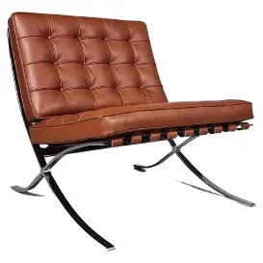
Jørn Utzon’s architectural philosophy was quite a complex one that developed over time. He was influenced by Mies van der Rohe who made an important contribution to the development of a minimalist, modernist architectural style. Jon Astbury (2018) discusses how Van der Rohe became the third director of the famous Bauhaus during its final phase before Nazi domination. During that period, he shifted the focus from arts, crafts and performance to architecture and continued to work in the minimalist style, represented effectively by the Barcelona Chair, designed for the Barcelona Pavilion by Van der Rohe and his partner Lilly Reich.
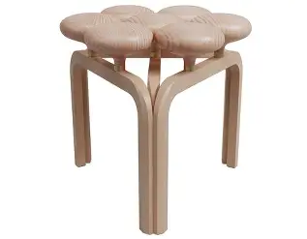

Figure 1: Barcelona chair. Figure 2: Utzon stool. (Available: online) (Available: online)
We see his influence in the Utzon Stool, put into production by Fritz Hansen as part of a contemporary furniture and home décor range. Lee (2024) discusses how the stool echoes Van der Rohe’s minimalist approach, representing, “modernist … influences in the designer’s work … choosing pared down and organic forms over the decorative and man-made”.
Utzon developed an architectural approach that was rooted in the minimalist tradition championed by Van Der Rohe but included interesting ideas about how architecture worked with nature. He was influenced by Frank Lloyd Wright’s concept of organic architecture. This was a nuanced concept but is described by Graff (2018), as, “for some, it is an architecture rooted in nature’s forms and principles, for others, the focus is on the connection from interior to exterior’. Davies, (1982 p. 121), describes it as an, “organic form grows its structure out of conditions as a plant grows out of soil … both unfold similarly from within.”
Chen-Yu, Kilincer and Niskanen (2020), argue that Aalto played, “an important role in the maturity of Utzon’s architectural philosophy and design”. It was this relationship that led to his ideas around platforms and plateaus. According to Andresen, (1999), working with Aalto, Utzon began to think of architecture in terms of, “recurring forms, reconfigured as ‘room’ and ‘platform’” that express the human desire to be, “centre-bound or horizon-bound”. Andresen (1999) goes on to explain that in a lot of Aalto’s work, a single room carries the, “essential architectural idea for the whole collection of rooms that make up the building”. Utzon’s mature theories focused on additive architecture where he talked about the growing principle:
Architecture demands an ability to create harmony from all the demands made by the undertaking … to persuade them to grow together to form a new whole- as in nature; nature knows of no compromise, it accepts all difficulties, not as difficulties but merely as new factors which … evolve into a whole. (Utzon, 1948, n. p).
He talked about how animal formations in nature such as herds of deer came together as a lot of individual units to form a collective shape and tried to bring this principle into his own architectural design. (Aalborg University & Utzon Center, Utzon Archives MS).
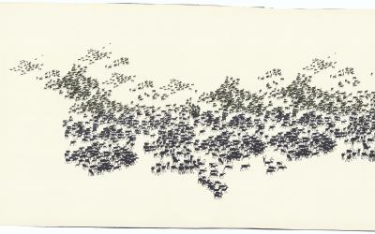

Figure 3: Inspiration, Additive Architecture, (Utzon Archives MS, 2026.)
His work with Aalto also led to his fascination with platforms. He felt that platforms represented another planet. “A high platform”, he argued, “completely changed the landscape and supplied … visual life with a greatness corresponding to the greatness of … Gods”. (Utzon, 2026, n. p).

Can Lis, Mallorca
Can Lis, Utzon’s family home, built between 1971 and 1973, is positioned 20 metres above the Mediterranean Sea at Porto Perto. Looking from the sea, the house is hidden behind a jagged wall making it discreet and mysterious. According to ArchEyes, (2025), the house doesn’t dominate its environment but grows from the landscape. The building’s striking location is clearly influenced by Utzon’s fascination with platforms.
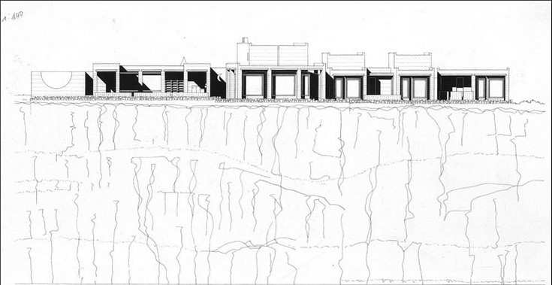
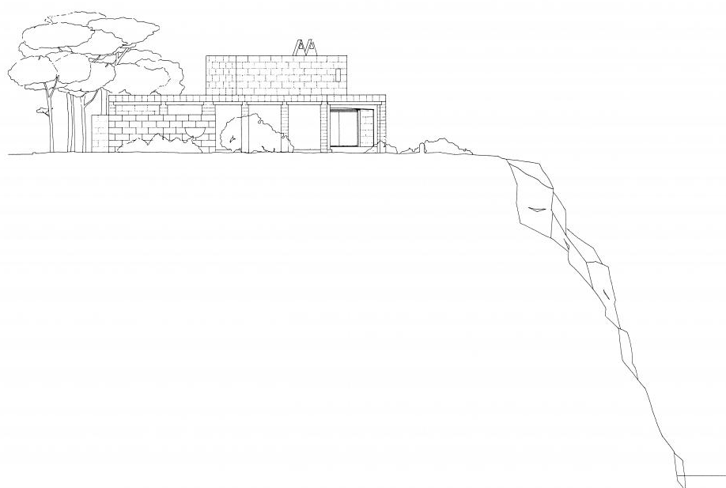

Figure 4: Can Lis, Mallorca (Utzon Archives MS, 2026.)
Figure 5: Plan and Elevation of Can Lis Rethinking the Future. (Rethinking the Future, 2026.)
Utzon talks about how, “the platforms in Mexico were positioned with great sensitivity to the natural surrounding and always with a deep idea behind”. (Utzon, 2026, n. p). He goes on to explain how in Yucatan temples were built on high platforms that created, “a strong feeling of remoteness and complete calmness”. (Utzon, 2026, n. p). The building is not aligned with the sea, instead it is placed specifically to respond to the sun’s positioning, existing trees and the general overall environment. Morris (2013) explains that Lin, Utzon’s daughter felt that her father’s “genius was in responding to the topography of a site and developing the technology to achieve the best solution”. According to Arch Eyes (2026), at Can Lis, shaded areas offer shelter from the sun, and strategic openings provide natural ventilation. However, as time passed it became clear to Utzon’s family that the building’s position was a problem in terms of heat and climate. According to Morris, (2013) as Utzon grew older the glaring surface of the sea was a challenge for his eyes this was one of the reasons why they had to move to Can Felis.
The well-hidden building is made up of several cave-like structures. The main ideas and philosophy of this design is based on echoing human habitats and considering traditional Mallorcan materials. Each section of the building is designed as a protected, cave-like shelter. The house reproduces the habitat of the first dwellers, for whom life took place in the open air and the cave was a shelter. (Utzon, 2026). The deep and thick wall openings emphasised the sense of shelter. The circulation of the building occurs through an outdoor route that connect courtyards and individual volumes. According to Morris (2013), Utzon developed the idea for Can Lis by placing sugar lumps on a plan of the site in five staggered blocks along the cliff edge. The house is made of 4 different fragments (living, dining, sleeping and working). The floorplans follow a specific scheme called tripartite which was used a lot in ancient Egypt (UCL, 2000). Floorplans show how each interlinked section moves from the public to the private in a way that is typical of the tripartite Egyptian system. This system links different sections of one cluster of buildings to each other moving from the public to the private.
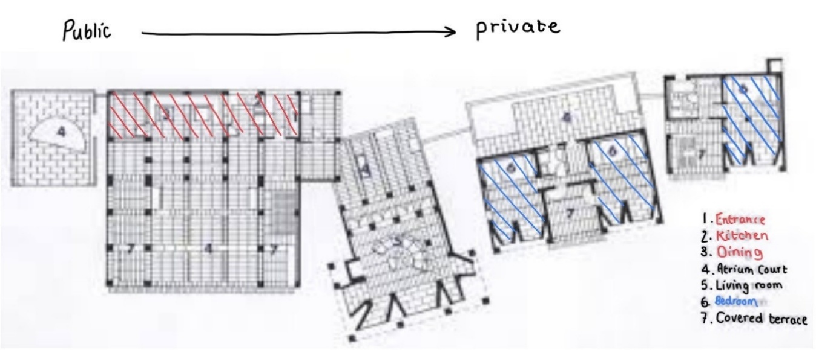

Figure 6: Can Lis, Mallorca (adapted from Utzon, 2026).
The courtyard is a prominent feature of the home, and the floorplans show that there was a courtyard in even the most private of spaces, the bedroom areas. There were also covered terraces in the bedroom quarters showing how Utzon wanted to bring the external environment into the home as an integral living part of the house. The images below show just how aesthetically pleasing these spaces were but also emphasise the fact that the home has been designed to create a continuous flow of energy from indoors to outdoors. Not only are the large, airy spaces between the courtyard columns echoed in the large windows but you can also see that there is no formal separation between the building’s foundation and the rock base on which it sits.
The key motif of additive architecture is evident everywhere, not only do the interconnected cave like site layout and floorplans operate on the basis of an organic, flowing motion that mimics nature’s growth principle but the way in which the building manipulates the human gaze is also a means of creating a steady flow from indoor to outdoor that denies any separation between the two. This house concentrates on its landscape and magical views looking from inside to outside rather than the features and feels of its interior. (Divisare, 2026). The house frames nature like a series of images, each window is a deliberate act of looking towards the beautiful surrounding landscape. The windows have no frame and all have individually different angles and viewpoints.

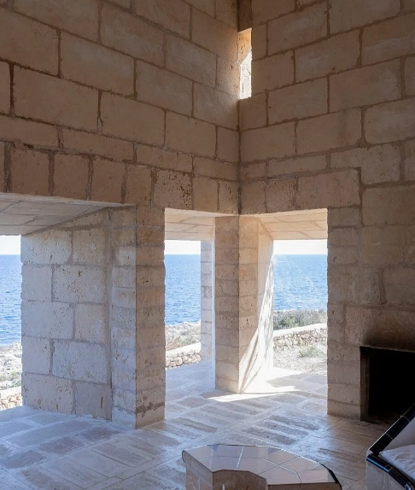
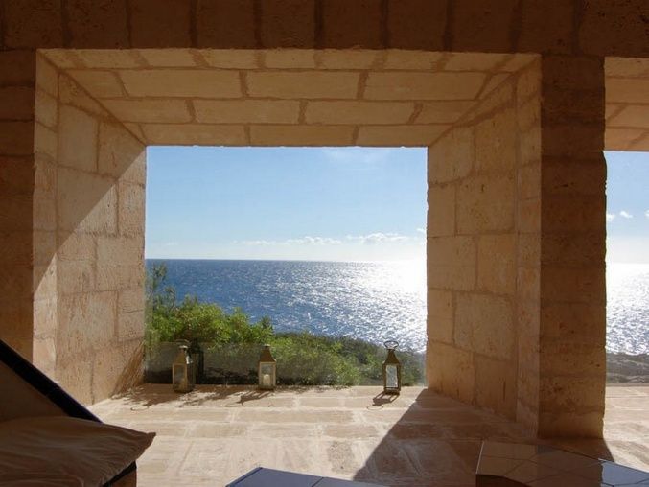

Figure 7: Can Lis (ArchEyes,2025)
Figure 8: Can Lis House (Rethinking the future, 2026)
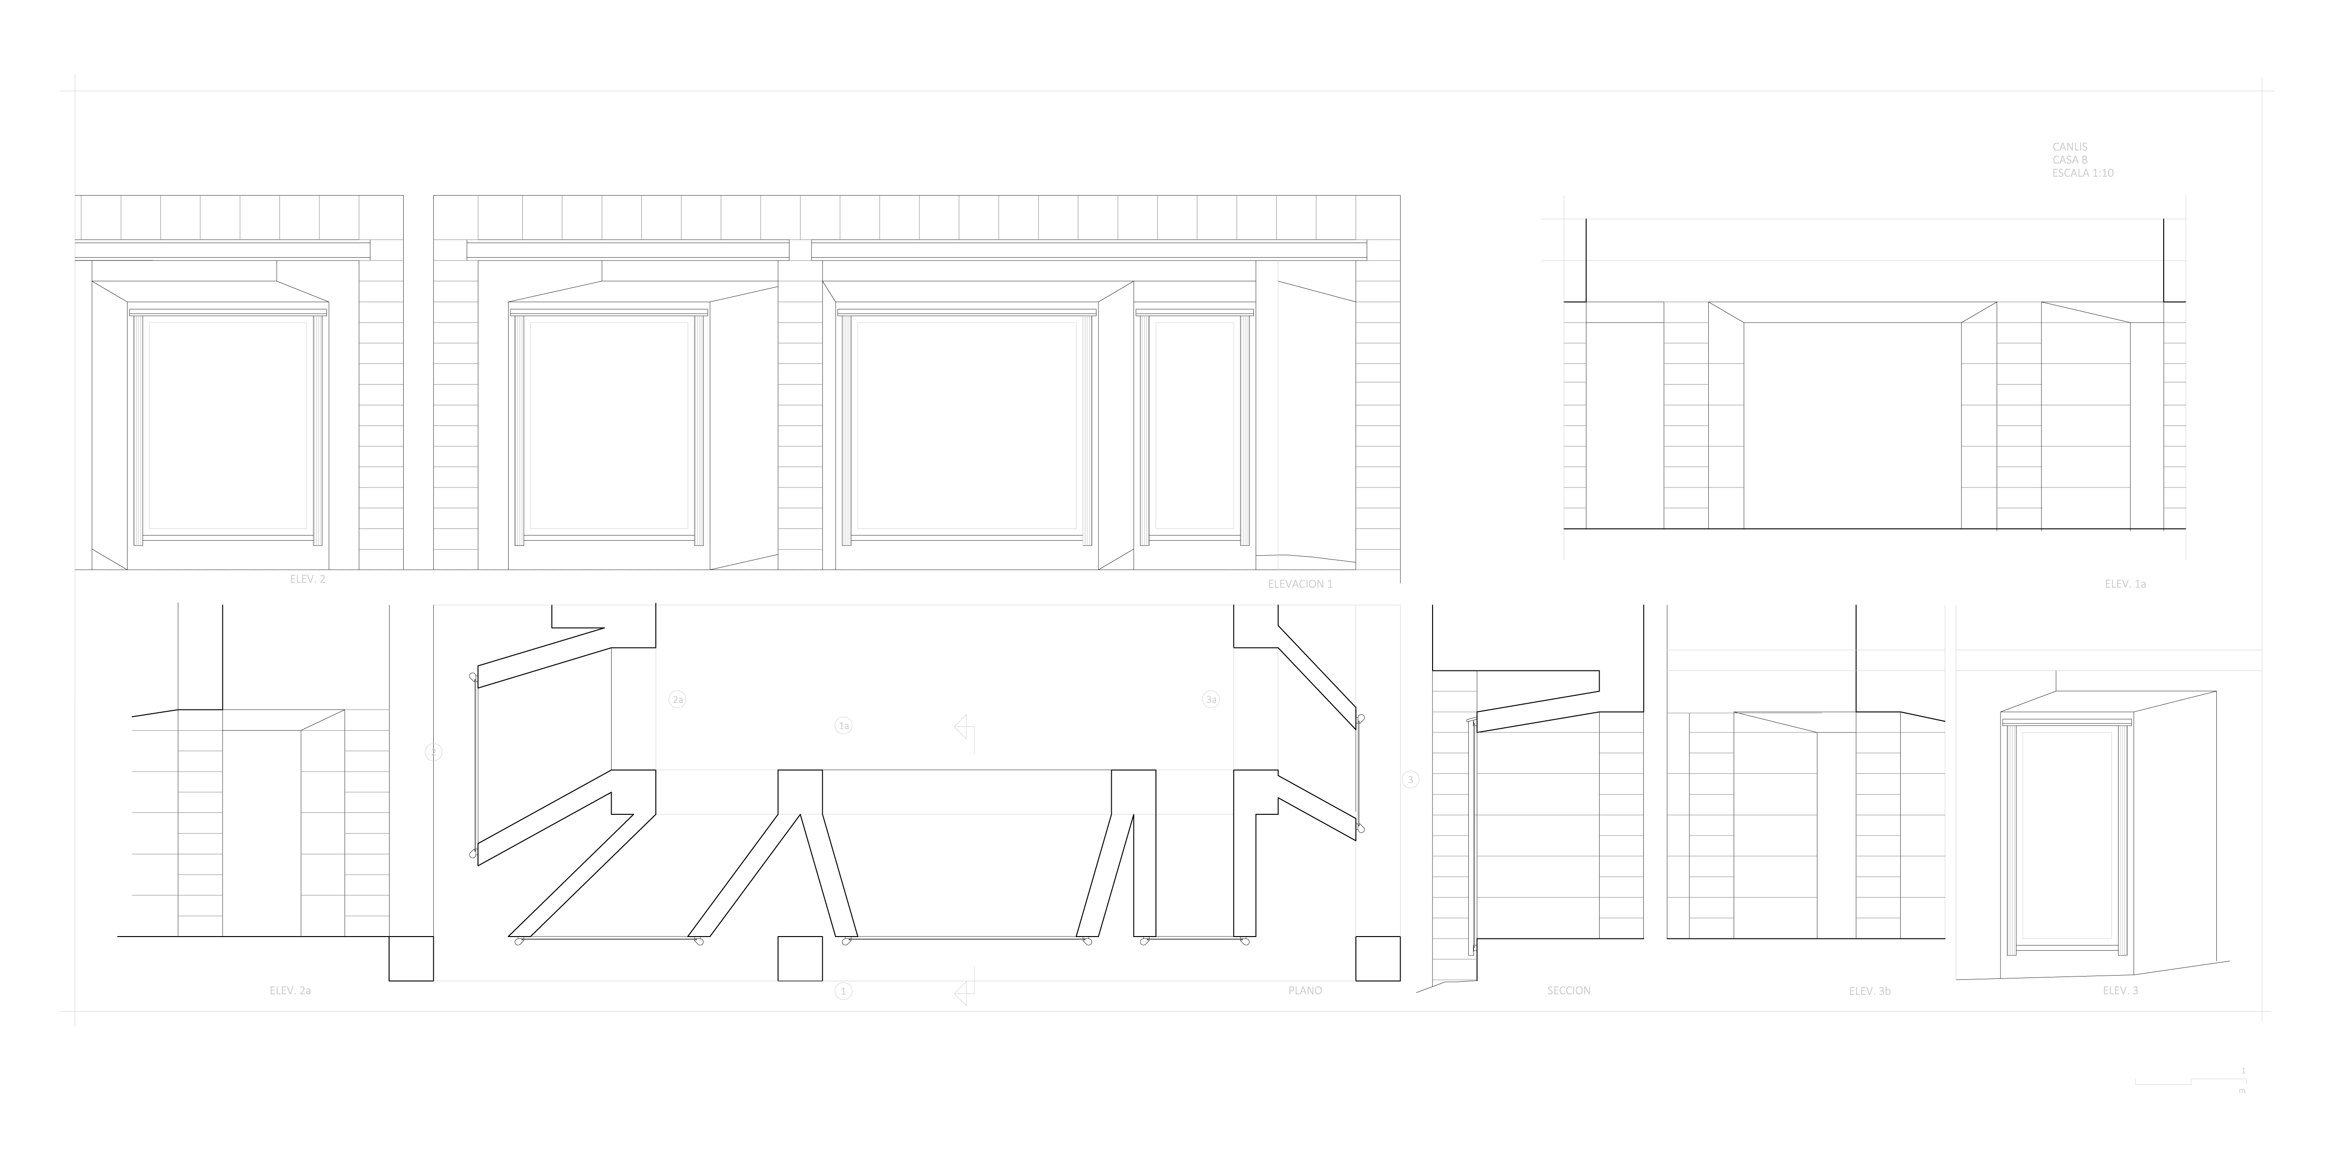

Figure 9: Utzon Archives. (2026)
These plans of the windows show how Utzon designed the windows not just as a physical aspect of the building but in terms of how they managed the human gaze or sightline. The lower section of the plan illustrates the windows’ angled placement to ensure the viewer has optimum vistas from all stand points within the room. This is one of the ways the house becomes a place where architecture dissolves, leaving only the experience of nature . (Architecture Viva, 2026). Lin talks about how her parents sat for hours enjoying the views and discussing how the house served those views, but it is worth asking whether the home sacrificed some of its sense of shelter, its domestic privacy to the pull of the outdoors.
The materials used to create this magical place are also true to the external environment and culture. (Architecture Viva, 2026). Utzon spent a lot of time researching the traditional Mallorcan construction and adopted a new system which used local sandstone blocks and brick slabs. Floors are made of santanyi stone slabs that mirror the ceiling geometry (same as sea mirrors the sky), reinforcing the link between indoors and outdoors. The building is built almost entirely of local mares sandstone, a porous limestone which provides thermal regulation, soft light absorption and visual integration with the site. The simple, tiled furniture is fixed, however, everything is designed to create spectacular views and not interrupt the external view. There is no furniture in the normal sense with beds and seating built into stone to, “bring the surrounding natural colours indoors”. (Morris, 2013).
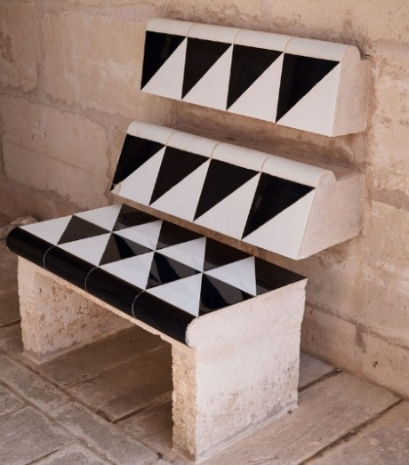
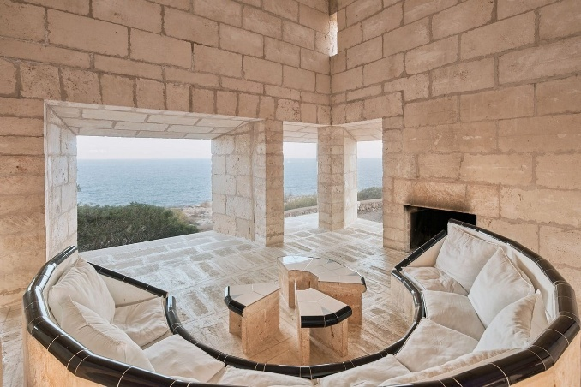

Figure 10 & 11: Can Lis House (Rethinking the future, 2026)
A crescent-moon motif appears throughout, referencing the former street name “Avinguda Media Luna”. It appears throughout the house: semi-circular living room seating, courtyard wall profiles, tiles seating patterns, a moon-shaped window aligned with the front door and the moon window offers an immediate framed view of the sea upon entry. This is one of the ways that the home, “combines qualities of an ancient temple with a modernist house”. (Rethinking the Future, 2025)
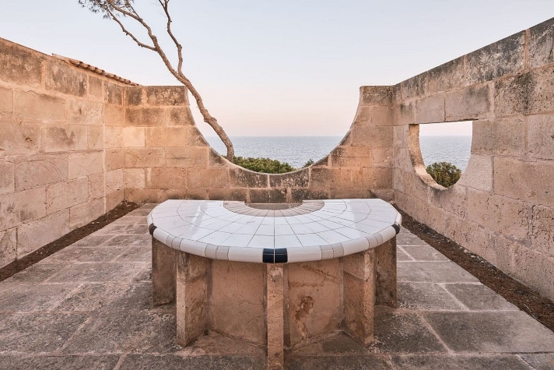
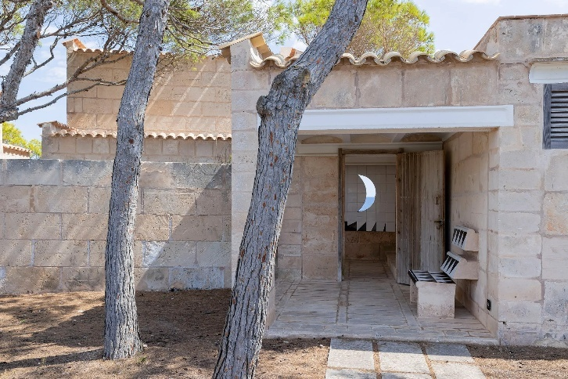

Figure 12: Can Lis House (Rethinking the future, 2026)
Figure 13: Can Lis (ArchEyes,2025)
There can be no doubt that Can Lis is a masterful project that brings many of Utzon’s key theories to life, however as we enjoy its aesthetic appeal, its seamless relationship with nature on a grand scale and its innovative use of light and other environmental elements, it is worth asking ourselves whether Can Lis lost some of its sense of shelter, its domestic quality to the pull of the outdoors. We have noted that Utzon himself became unable to deal with the sun’s glare on the sea, and it is further claimed that, “[he was] increasingly bothered by the continual pounding of the waves.” (Everything explained today, n. d). It is also recognised that the popularity of the site as a pilgrimage played a part in the decision to leave Can Lis and build a new home, Can Feliz. Perhaps this is a helpful point at which to return to consider some of the differences between Aalto and Utzon. The most useful distinction might be that:
Aalto’s most poetic works tend to embrace ancient forms thar gather us in towards a centre; and Utzon’s most memorable works are based on ancient forms that invite us to gaze outward towards the horizon. (Andresen, 1999, p. 44).
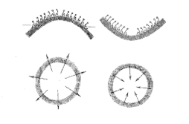

Figure 14: Two ways of being together, or alone. (Scribd, n. d)
This outward-looking gaze may be at the root of Can Lis’s innovative appeal and its attraction for other architects, but it may also be why it did not make a perfect home. Despite Utzon’s brilliance perhaps his genius is best suited to spectacular public buildings such as the Sydney Opera House, rather than the domestic space of shelter, comfort and privacy. Utzon had a magnificent ambition for the Opera House and wanted it to reflect the greatness of those who presented in it:
We had somehow understood and felt that all the musicians … all the singers, the big artists, were striving for excellence in their life and we thought a house for them, there’s no limit to the excellence it should have because it should match their strive for perfection. (2022, n. p).
Perhaps Utzon’s idea of a house was not fundamentally that of a home.

Reference list

Aalborg University & Utzon Center, Utzon Archives MS.

Andreson, B. (1999) Alvar Aalto and Jørn Utzon: An Architecture of Ancient Gathering Forms, pp. 44 – 58. Available at: https://www.scribd.com/document/82223785/Brit-Andreson-Alvar-Aalto-and-Jørn-Utzon (Accessed: 9 March 2026).

ArchEyes (2025) Can Lis by Jørn Utzon: Contextual Architecture and Spatial Harmony. Available at: https://archeyes.com/can-lis-by-jorn-utzon-contextual-architecture-and-spatial-harmony/ (Accessed: 12 March 2026).

ArchEyes (2022) The Sydney Opera House by Jørn Utzon: An Architectural Masterpiece of Modernism. Available at: https://archeyes.com/sydney-opera-house-jorn-utzon/ (Accessed: 23 March, 2026)

Arquitectura Viva (2026) Can Lis, Mallorca. Available at: https://arquitecturaviva.com/works/can-lis-2 (Accessed: 15 March 2026).

Astbury, J. (2018) Mies van der Rohe: the modernist architect who led the Bauhaus to its end. Available at: https://www.dezeen.com/2018/11/19/mies-van-der-rohe-modernist-architect-third-director-bauhaus-100/ (Accessed 15 March 2026).

Carter, A. (2014) ‘Transcultural Tectonic Connections: The Utzon Paradigm’, ARCC/EAAE, Beyond Architecture: New intersections and connections, pp. 238 -246. Available at: https://www.arcc-journal.org

Carter, C & Tyrrell, R (2012) ‘The Utzon Paradigm: A humane, transcultural, tectonic and innovative approach within contemporary architecture’, Fourth international Utzon Symposium: What would Utzon do now? Sydney, Australia. Available at: https://www.academia.edu/64732112. (Accessed: 13 March 2026).

Chen-Yu, Ch. Niskanen, A. and Kilincer, N.Y. (2020) ‘Aalto through the Young Utzon's Eyes: The Role of Alvar Aalto in developing the Artistic Maturity of Jørn Utzon’, Nordic Journal of Architectural Research, 32 (1), pp. 35-73. Available at: https://arkitekturforskning.net/na/article/view/1189

Davies, M. (1982) ‘The Embodiment of the Concept of Organic Expression: Frank Lloyd Wright’, Architectural History, Vol 25, pp. 120 -130. Available at: https://doi.org/10.2307_1568417

Everything Explained Today (n. d) Can Lis Explained. Available at: https://everything.explained.today/Can_Lis/ (Accessed 12 March 2026).

Graff, S. (2018) Organic Architecture and the Sustaining Ecosystem. Available at: https://wrighttaliesin.info/life/article-1/ (Accessed 15 March 2026).

Lee, A. (2024) Introducing the Modernist Utzon Stool Presented by Fritz Hansen. Available at: https://design-milk.com/introducing-the-modernist-utzon-stool-presented-by-fritz-hansen/ (Accessed 16 March 2026).

Morris, T. (2013) Jorn Again: The Best Summer House in the World? Available at: https://www.architectsjournal.co.uk/buildings/jorn-again-the-best-summer-house-in-the-world. (Accessed: 1 March 2026).

University College London (2000) Digital Egypt for Universities Available at: https://www.ucl.ac.uk/meuseums-static/digitalegypt/Welcome.html. (Accessed 19 March 2026).

Utzon Archives / Aalborg University & Utzon Center. Available at: 250-bred | Can Lis, Mallorca | Drawings | The Utzon Archives. Accessed: 12 March 2026).

Utzon Center (2026) The waterfront and the water as a playground. Available at: https://utzoncenter.dk/en/about-jorn-utzon-94 (Accessed: 13 March 2026).

Utzon Center (1948) The Innermost Being of Architecture. Available at: https://utzoncenter.dk/innermost-being-architecture-95 (Accessed 17 March 2026).

Utzon, J. (2016) ‘Platforms and Plateaus’, T-RANSFER Global Architecture Platform, n.p. Available at: https://www.transfer-arch.com/monograph/platforms-and-plateaus/

Utzon, J. (2016) Platforms and Plateaus. Available at: https://www.transfer-arch.com/monograph/platforms-and-plateaus/ (Accessed:11 March 2026).

