Developing Innovation and Creativity for Business Advantage

Executive Summary
Innovation and creativity is the best way to lead to higher overall success in the competitive marketplace. The report has explained the product or service to improve customer expectations. Apart from this, it demonstrated the ways to sell the products or services in the competitive marketplace. The report has highlighted the sustain of innovative products or services in the competitor and differentiated their products from competitors. It has explained the eCommerce channel to propose a setup for an online website to improve the organizational value among customer minds. Apart from this, new ventures mainly focus on the marketplace, content, and payment services to deal with compliance issues. The presentation demonstrated the way to promote the products or services of Nozti and target customers for organizational success. The Company uses social media channels like Facebook and Instagram to improve the customer experience. Apart from this, the report has explained the security and its importance for providers and users of the channel.

Table of Contents
Introduction 4
Task1: Individual Report 5
A. The Innovative Product 5
B. E-Commerce 8
Conclusion 12
Reference List 13
Appendix 15
Task2: Presentation 15

Introduction
Creativity and innovation is the best feature for developing idea in a new way and forming an idea to improve the customer experience (Wibowo et al., 2023). The report has explained the innovative products or services like advanced cameras with iconic features to grab the attention of customers. Apart from this, the report has demonstrated the potential customer, products, or service, innovative business proposition, competitor, and differentiation from existing products. The report has explained the eCommerce channel to develop a website and marketplace to promote the products or services for organizational growth. It has explained social media channels to engage clients for better growth in the competitive marketplace.

Task1: Individual Report

The Innovative Product
Innovative Product
Nozti is a new start-up of camera manufacture and other products at the best cost to fulfill customer needs. The Company mainly focuses on manufacturing mini cameras and high-tech cameras for security purposes (Wibowo et al., 2023). Nozti camera is a special kind of camera designed to see and understand images the way humans are able. The Company offers smart cameras used in a range of industries or computers to make decisions. Nowadays, Nozti will engage in adding new features like photosensor and flash memory to improve the customer experience. The Company employs smart cameras to capture visual information from surrounding, and under potentially challenging lighting conditions (Funaki, 2023).

Source: (Padli et al., 2023)
- Customer Needs and Wants: The Company will speak to lots of customers about distinct categories and brands. Through innovation, Nozti creates innovation in the first place and creates the customer desire for technology innovation (Tomin, 2023). The Company mainly focus on understanding the customer's expectation about everything, technology these day, and wants to expect. Nozti focuses on real consumer expectations and emotional intelligence to improve organizational performance. Nowadays, the customer wants mini cameras for security purpose of their house and office (Vijayalakshmi et al., 2022). Through these cameras, the customer mainly tracks or monitors every activity held within the premises.
- Target Customer: Nozti is monitoring that the digital camera market grows annually by 1.26%. Apart from this, the target audience of Nozti is millennials from younger years of age for organizational success. In addition, the Company will identify the new audience, and adventure people as a key audience to grow their business (Ling, 2023). To become successful, Nozti anticipates the showcase of the growth rate of the target audience. The Company is adopting devices by the country's people to drive the market growth in the competitive marketplace. Nozti decided to target local customers, houses, residential areas, and offices for security purposes.
- How will sell your product: Nozti has the potential to reach the customer and understand the changing behavior of the customer. Nowadays, the Company decides to manufacture devices like mini cameras to raise the sales margin (Wibowo et al., 2023). The Company mainly focuses on determining the strong candidate who uses the products or services at the best cost to meet the customer needs. Nozti mainly saves time, and effort while focusing on products to increase sales and market share. With the help of the latest technology, Nozti decided to survey to identify the problem of candidates in the context of cameras. Moreover, the Company decided to manufacture mini spy cameras for current customers to explore the target audience (Weese et al., 2022). The Company also increases awareness of products with their unique features to grab the customer's attention. Nozti also offers pre and post-sale services to their customer to increase the sales margin of new products or services.
- Venture Name (Nozti): The Company name is Nozti which is a sole trader of unique mini cameras to capture quality video with voice recording (Padli et al., 2023). Apart from this, Nozti is different from the market camera's name so it helps to grab the attention of potential clients and raise the sales margin. The Company will share a personalized email to their customer about the new cameras to expand the market.
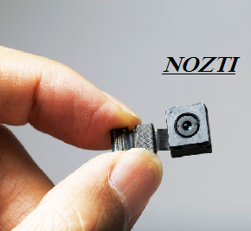
Source: (Tomin, 2023)
- Unique Selling Point: Nozti mainly engages in the production of the mini camera enabling it to wind obstacles and within lumen. The Company mainly focuses on combination with the mother endoscope vehicle. Nozti mainly focuses on unique selling points for better than the competitor (Ling, 2023). Business is deliberate toward branding and other marketing strategy to improve the customer experience. Nozti's USP is the biggest strength for customer value and target audience. The Company mainly focuses on understanding the powerful USP to get the right things and learn for organizational success. To understand the difference, Nozti often product on the quality, vision, and pricing of the product or service for better success in the market.
- Sustain Innovative Business Value Proposition: The manager of Nozti mainly focuses on digital transformation for value proposition. In response to the trend, Nozti focuses on innovative products to enjoy video clarity and creative ways for organizational growth (Jin et al., 2022). The Company mainly focuses on innovative products to gain experience in their lives and growth in fresh as well as exciting ways. Nozti mainly focuses on effective marketing to improve customer satisfaction. A value proposition is a clear promise of tangible results a client will get from using the service for organizational success.
- Competitor: It is the best way to know the products or service offerings, while also knowing the marketing and selling methods of those products. Nozti decided to enter into a highly competitive market to deliver maximum value to customers. The Company consults with deriving informative and actionable data to fulfill the organizational requirement (Al and Alajlan, 2022). Nozti faced tough competition with local and international camera manufacturers which affected the sales margin. Canon and Nikon are the leading competitors in the camera industry. The Company mainly focuses on continuous manufacture and innovative products to improve the organizational value. Nozti focuses on undoubtedly some of the best on the market right away (Vijayalakshmi et al., 2022).

E-Commerce
Nozti mainly focuses on e-commerce channels for trading products or services on the Internet. The Company decided online channel is the best way to purchase and sell things in the retail market (Padli et al., 2023). Nowadays, Nozti mainly focuses on the development of social media channels and websites to create a digital store to expand the market. The Company will facilitate transactions among buyers and sellers for organizational growth. An e-commerce channel of Nozti generates revenue from selling advanced cameras with unique features (Weese et al., 2022). The Company also maintains a strong connection with buyers through different electronic channels.
- Using SaaS: It is the best way of delivering applications over the internet as a service. The Company mainly focuses on installing software, and accessing it on the internet (Ling, 2023). Through this software, Nozti is freed from the complex hardware and software management in the camera industry. In the digital world, the Company mainly focuses on digital applications to manage the sales and purchase of new products or services. Shopify platform stands for the crowd in a digital store. So, Nozti decided to open an account on Shopify to offer a wide range of products or services designed to meet customer requirements for organizational growth (Crawford et al., 2022). Moreover, the Company mainly focuses on integration with various marketing tools and social media platforms to reach the audience. Nozti's use of this platform increases the chance of attracting organic traffic and potential customers.
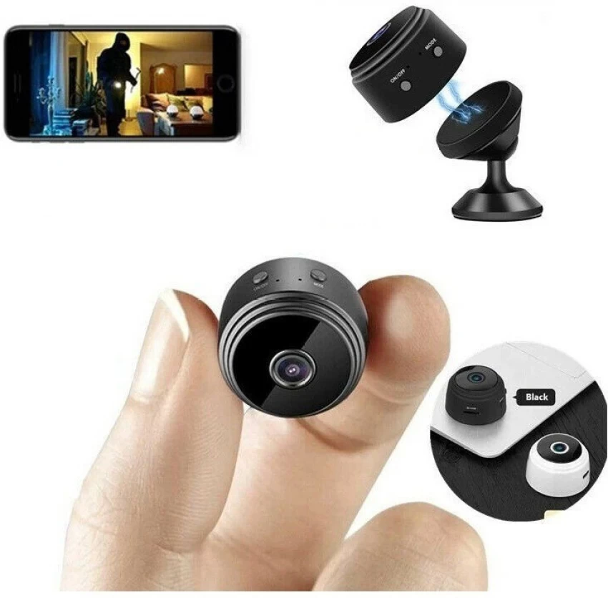
Source: (Tomin, 2023)
Shopify store design plays a significant role in attracting and engaging potential customers for organizational growth. The Company mainly focus on creating a unique design to maintain its brand image in customer mind. Shopify is used by Nozti to offer customized, fonts, and layouts for a unique look to the target audience (Jin et al., 2022). The Company mainly focuses on the development of user-friendly features to improve the customer experience. Moreover, Nozti also developed a keyword related to mini cameras and optimized the website for organizational growth. The Company provides valuable information and product descriptions on the platform to target audiences in local and international markets.
- Using Marketplace: Nozti mainly focuses on existing and largest marketplaces like Amazon to raise sales margins. The Company knows that Amazon's platform is a leading e-commerce-owned and is operated to sell other products. Nozti mainly focuses on creating an Amazon Seller Central Account and using the platform to reach a customer base. The Company mainly focuses on the creation of accounts, active sellers, and a list of products or services to fulfill the order on time. Amazon also develops its policies and workflow to improve the customer experience. Due to popularity and reach, Nozti decided to create an account on the Amazon platform to stay competitive in the market (Al and Alajlan, 2022). To gain a competitive edge, the Company mainly focuses on social media channels to share attractive content and images to fulfill customer requirements. With great results, Amazon showed their products on the search result page and individual products to improve organizational performance (Vijayalakshmi et al., 2022). To avoid common symptoms, Nozti should decide to adopt strategies to survive in the highly competitive environment.
- Creating Content: The Nozti mini camera is not an easy but attractive product for customers. The Company mainly focuses on writing attractive content with images to improve the customer experience (Padli et al., 2023). Simply, mini means small while, these cameras are too small to maintain the security of premises. Therefore, Nozti mainly focuses on digital content creation for new products or services to improve the customer experience. The Company focuses on attractive words, phrases, and images to create content for mini cameras to post on social media channels for better growth. Managers of Nozti use Instagram pages to share stories and reviews of customers about the product or service (Crawford et al., 2022). The Company mainly makes a high-quality, self-serve video without the help of a video producer to improve the client experience.


Source: (Ling, 2023)
Through attractive content, the manager of Nozti mainly focuses on video quality and price to grab the attention of the target audience. The Company provides details information and schemes on social media channels to improve organizational performance (Funaki, 2023). Nozti will render the whole project pointless to maintain a strong position in the current marketplace. It is the procedure of generating new ideas and making information accessible for organizational growth. To generate ideas, Nozti focuses on YouTube offering a unique platform for businesses to engage and connect with their audience. The Company focuses on comments, respond to question, and create personalized interaction for the viewer.
- Using Payment Service: Nozti also focuses on the development of the best and most trustworthy payment system for the customer. Nowadays, PayPal lets small businesses accept and process payments in person and online for organizational growth (Jin et al., 2022). The Company knows that PayPal is secure, fast, and the best payment method online for better growth in the competitive marketplace. Nozti used personal data strictly following the rules that are introduced by the GDPR Act 2018 during the payment. If a company or individual uses personal data and information, it is too important for them to comply with the seven principles that are mentioned in this act. Moreover, it specifies the purpose of the organizations and provides accuracy and many more. Understanding any act is an important part; many firms face difficulties in dealing with requirements. There is handling and processing of huge amounts of data is not only a responsibility but also a legal requirement. The Company mainly follows the rules and regulations of the Safety Act to make payments online (Al and Alajlan, 2022). Nowadays, Nozti mainly focuses on the development of online payment channels to improve the customer shopping experience for organizational growth. The Company also tracks, manages, and creates an effective report of a potential customer for the projection of future sales. Nozti also decides to accept the card payment for reasonable fees without any charges for organizational growth (Wang et al., 2022).

Conclusion
In conclusion, the report has examined the innovative products or services of Nozti to improve organizational performance. The report has evaluated the potential customer, service, and name of the venture. Apart from this, it has analyzed the competitors and ways to differentiate from competitors and sell their products in the market. The report has examined the e-commerce channel to sell products or services in the competitive market of the camera industry. It has analyzed the SaaS, marketplace, and created content marketing for organizational development in the local marketplace. Nozti mainly focuses on the development of online channels and card payment systems to improve customer satisfaction.

Reference List
Al Rassan, I. and Alajlan, H., 2022, December. The approach of migrating SAAS applications to password-less authentication. In 2022 International Conference on Computational Science and Computational Intelligence (CSCI) (pp. 1341-1345). IEEE.
Crawford, G.S., Courthoud, M., Seibel, R. and Zuzek, S., 2022. Amazon entry on Amazon marketplace. CEPR Discussion Papers, (17531).
Funaki, K., 2023. Product Automation and Innovation. In Springer Handbook of Automation (pp. 561-584). Cham: Springer International Publishing.
Jin, J., Jia, D. and Chen, K., 2022. Mining online reviews with a Kansei-integrated Kano model for innovative product design. International Journal of Production Research, 60(22), pp.6708-6727.
Ling, Y., 2023, May. SaaS-based Intelligent Conference Management System using Facial Recognition. In 2023 IEEE 3rd International Conference on Information Technology, Big Data and Artificial Intelligence (ICIBA) (Vol. 3, pp. 438-441). IEEE.
Padli, P., Setiawan, Y., Soniawan, V. and Mardela, R., 2023. Developing Robotic Cricket Batting Test Technology with a Camera Sensor and Grid System. International Journal of Interactive Mobile Technologies, 17(7).
Tomin, M., Török, D., Pászthy, T. and Kmetty, Á., 2023. Deformation analysis in impact testing of functionally graded foams by the image processing of high-speed camera recordings. Polymer Testing, 122, p.108014.
Vijayalakshmi, C., Gokulakrishnan, D., Prakash, G. and Ponmalar, A., 2022, March. Face Detection for Secure Online Payment with Proxy Detection. In 2022 International Conference on Communication, Computing and Internet of Things (IC3IoT) (pp. 1-4). IEEE.
Wang, M., Li, J., Lai, B., Gong, X. and Hua, X.S., 2022. Offline-online associated camera-aware proxies for unsupervised person re-identification. IEEE Transactions on Image Processing, 31, pp.6548-6561.
Weese, W.J., El-Khoury, M., Brown, G. and Weese, W.Z., 2022. The future is now: Preparing sport management graduates in times of disruption and change. Frontiers in Sports and Active Living, 4, p.813504.
Wibowo, A., Setiawan, J.D., Afrisal, H., Mertha, A.A.S.M.M.J., Santosa, S.P., Wisnu, K.B., Mardiyoto, A., Nurrakhman, H., Kartiwa, B. and Caesarendra, W., 2023. Optimization of Computational Resources for Real-Time Product Quality Assessment Using Deep Learning and Multiple High Frame Rate Camera Sensors. Applied System Innovation, 6(1), p.25.

Appendix

Task2: Presentation



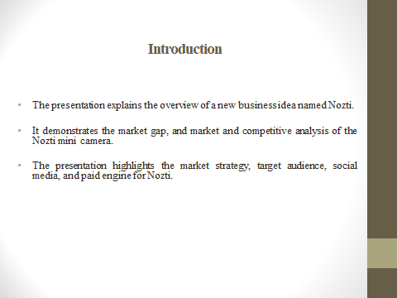
The presentation explains the overview of a new business idea named Nozti. The Company is dealing with quality mini cameras for organizational growth. The presentation explains the market gap, market target, competitive analysis, and biz business model to improve the customer experience. It demonstrates the marketing channels like social media, and search engines, and the role of the customer journey of Nozti to become profitable. The presentation highlights the use of email marketing and privacy as well as the security policy of Nozti for organizational growth. Nozti mainly focuses on marketing channels to promote products or services in a competitive market. The presentation examines security and privacy policies to survive in the competitive marketplace.
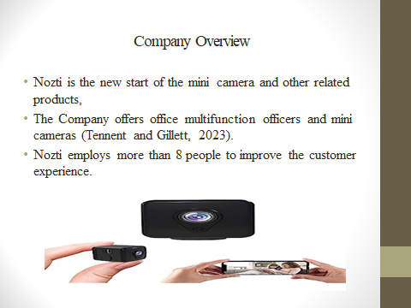

Nozti is a new business idea of manufacturing a mini camera with the latest features. The Company employs more than 8 people to improve the organizational performance. Nozti offers office multifunction officers and service providers to enhance the user experience. The Company offers mini camera support with or without Wi-fi and records high-quality video with sound to improve the customer experience (Tennent and Gillett, 2023). The Company also offer charging camera with light weight at the best price to meet customer demand. Nozti also develops an online and offline marketplace to get better results for organizational growth. The Company develops people reimaging and pushes to develop new products to fulfill the customer demand effectively. Nozti's main purpose is to become a leading digital camera provider in London and the international market.

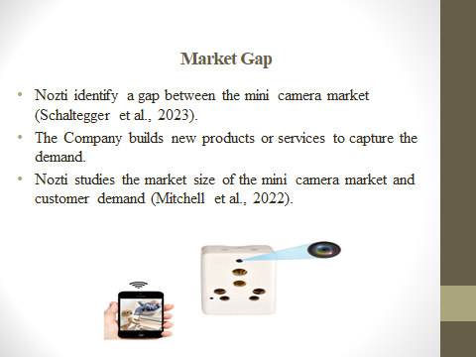

Today, Nozti mainly focus on studying the market gap in the digital camera and accurate information on the current demand for specific products or service. The Company mainly focus on an investigation to understand the demand of local customer toward the mini camera for professional purpose. Nozti also noticed the challenges that arise while using the camera which does not record the voice note and clear image of the surroundings (Schaltegger et al., 2023). So, Nozti's main purpose is to offer high-quality video cameras to deliver a good experience to customers. Currently, the Company also studies the quality gap between digital cameras of distinct sizes. To survive in the market, Nozti mainly focuses on manufacturing of mini cameras i.e. easy to handle, high-quality, voice, and other features to improve customer expectations.

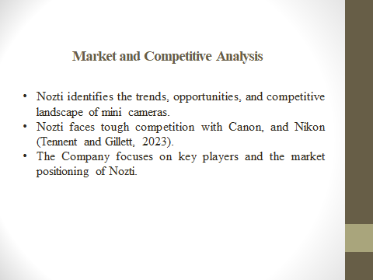
Nozti mainly focuses on identifying the trends, market opportunities, and competitive landscape of mini cameras for organizational growth. Moreover, the Company identifies mini camera market is wide as compared to other camera industries. The Company mainly focuses on recognizing the driver, and competitive analysis along with the driver. Currently, Nozti faces tough competition with local and international camera manufacturers. Canon and Nikon are major competitors of digital cameras in the marketplace (Tennent and Gillett, 2023). The Company mainly focuses on the development of new products or services to improve the customer experience. To become successful, Nozti focuses on continuous innovation in their mini camera and their pricing to meet the demand of the potential customer. The Company focuses on forces to gain a market segment and understand market segments to improve the organizational value among customer mindset.

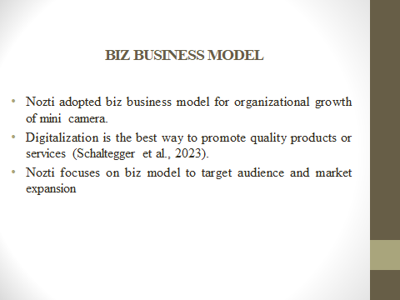
Nozti mainly focus on biz business model for strategic plan to make money and succeed in the competitive marketplace. The Company mainly focuses on determining the business to take products, offer them to market, and drive sales. To become successful, the Manager of Nozti wants to promote their products or services for better customer satisfaction (Schaltegger et al., 2023). Nozti digitalization is to offer quality products or services at the best price for organizational growth. For the competitive landscape, Nozti promises to adopt biz model to manufacture quality products or services to satisfy the demands of existing clients. The Company mainly focuses on technological development and innovation to bring changes in mini cameras for better customer experience. This mini camera enhances the quality of video and offers voice note recording to enhance the experience of the user.
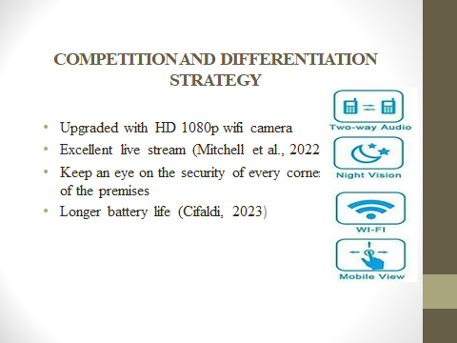

Nowadays, Nozti mini camera is updated with the latest features to improve the customer experience. The Company mainly focuses on built-in strong magnet and live video and voice notes for better growth in the marketplace. Nozti focuses on excellent live streaming and support to the customer for organizational success. The Company keeps watch on the security of every corner of the premise for better growth in the competitive marketplace (Mitchell et al., 2022). Nozti offers a mini camera with a Wi-Fi router and a network with high-quality for starting records and saving SD files for future evidence. With the help of a mini camera, customers easily monitor the environment and continuously record for organizational growth. Nozti also offers a long-lasting battery to keep using the spy camera. The customer uses the hidden camera for security purposes and protects the children from the third party.
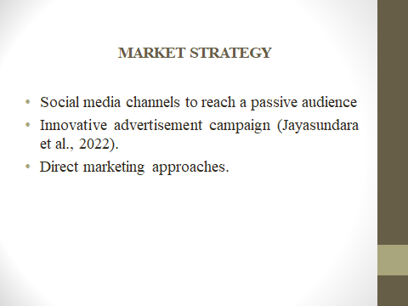

The manager of Nozti mainly focuses on social media channels to reach the passive audience. The Company focuses on marketing strategies to grab the attention of local and international customers. Nozti focuses on the development of advertisement campaigns to showcase the abilities for organizational growth (Jayasundara et al., 2022). The Company mainly focuses on digital channels like Instagram, Facebook, and Twitter to grab the attention of camera users. Nozti focuses on the development of attractive content with image and videos to satisfy customer demand. The Company explores the inspiration for other companies looking to make their customer happy. Nozti focuses on the development of a friendly environment for a new camera with unique features to improve the customer experience.

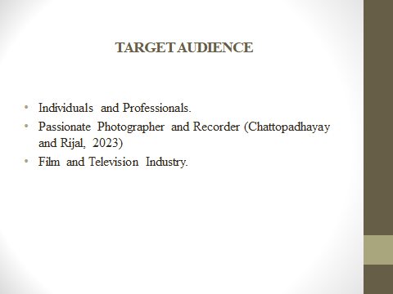
Nozti mainly focuses on the target audience including individuals, professionals, and photographers to improve the organizational value. The Company mainly focuses on an extensive product line to cater to the diverse needs of the audience. The camera is purchased for self-shooting and recording purposes to satisfy their demand (Chattopadhayay and Rijal, 2023). Nozti also targets professionals who appreciate the value of quality video experience equipment to fulfill the demand of the current market. Apart from this, the Company mainly targets an audience with high-quality equipment for capturing video. Nozti also targets professionals in the film and television industry to gain a competitive edge.
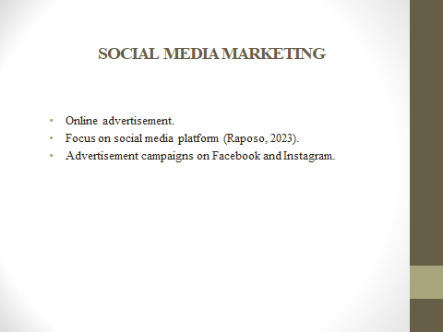
Nozti is focused on social media marketing channels to promote quality products or services for organizational growth. Through an online advertisement, Nozti focuses on promoting its mini camera with attractive images to grab the customer's attention. To become successful, the Company also shares the image of a mini camera to engage people for direct growth in the marketplace (Raposo, 2023). Nozti focuses on social media channels like Facebook, Instagram, and Twitter to expand their likes, and followers for organizational growth and presence in the market. The Company mainly focuses on an effective promotional mix for a round approach to make sure and highly desired customer. Apart from this, Nozti's social media marketing reaches a wide range of customers and engages them in meaningful ways.
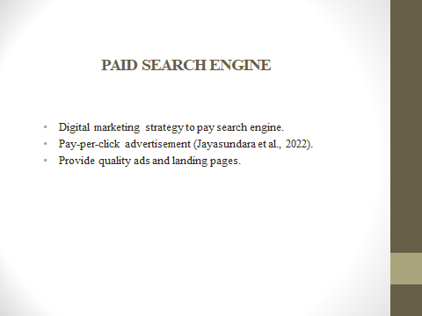

Nozti mainly focuses on digital marketing strategy to pay search engines for organizational growth in the competitive marketplace. Therefore, the Company focuses on PPC advertisement to accomplish the desired outcome. Nozti mainly focuses on the development of keywords and phrases to attract potential customers. Nowadays, Google will assign a keyword after scoring the quality of ads on the landing page to improve their presence on social media (Jayasundara et al., 2022). The Company mainly focus on the development of promotional channel to reach user actively searching on the platform for mini cameras. The Company mainly focuses on advertisement budget and search engines to maximize worldwide growth. Nozti mainly focuses on search marketing as the best option for every organization to become successful across the world.
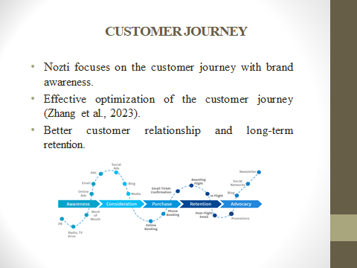
The Company mainly focuses on monitoring the customer journey to increase brand awareness for organizational growth. The manager of Nozti leads to purchase and eventual customer loyalty for future development. The Company mainly focuses on the effective utilization of the customer journey at every touch point (Zhang et al., 2023). Apart from this, Nozti provides the customer with a positive experience with their attractive mini cameras with quality to improve the experience. The Company may lead to better customer relationships, loyalty, and long-term retention for organizational growth. Through the customer journey, the manager of Nozti interact with customer and provide information about products or service for organizational enlargement.
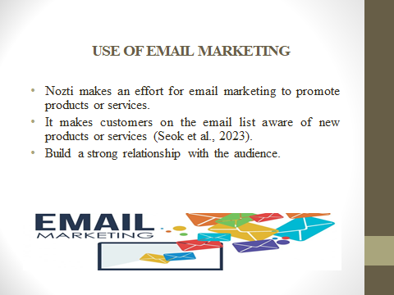
Email marketing is an effective way to promote business products or services for organizational growth. To become successful, the Manager of Nozti mainly focuses on the use of email marketing to share details about mini cameras to engage customers (Seok et al., 2023). The Company is building strong relationships with potential customers and automation efforts. Email is the most popular marketing strategy to achieve the desired objective. Moreover, Nozti mainly focuses on drafting an attractive email with content and a list of emails and sending messages to see the most. The Company mainly focus on the development of email marketing channel to promote products or service for organizational success.

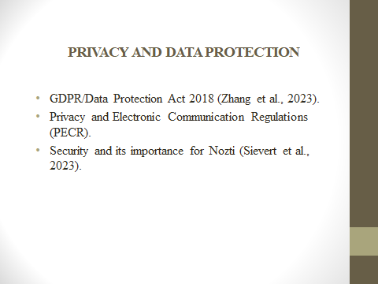

Data protection is one of the important matters in today's rapidly growing era of technology and the protection of Nozti. Data privacy and security requirements are directly connected with the basic principles of GDRP. This data protection act was implemented by the United Kingdom in 2018. Data protection means the security and control of personal data and information of individuals and organizations as well (Zhang et al., 2023). This Act controls the information of organizations and individuals used by them. This act is completely based on these seven principles. There are seven principles of the Data Protection Act 2018 data minimization, accuracy, limitation of storage, accountability, integrity, limitation of purpose, and Lawfulness, fairness, and transparency. This regulation act ensures that the data used by organizations are fair, legal, and transparent. For example, all the principle works at the time of creating an online newsletter. If any enterprise or individual can follow these rules and principles they must pay a huge fine and they may lose their goodwill. Therefore, everyone needs to understand these principles of the Data Protection Act. It is a significant step in protecting individuals' and organizations' privacy in the digital era.
Electronic communication regulation is also an important action taken to provide electronic privacy to everyone. This act was driven by European law. This law was implemented in the European constituency in 2002/58/EC. This act is also called the 'e-privacy directive'. It balances general data protection and sets out more specific rights of privacy on electronic communications (Sievert et al., 2023). This act identifies audiences globally assess to digital mobile networks and the internal opens up new opportunities for businesses and e-network users. But also the drawback of this act is a risk of privacy. Then in 2019, there were further changes made to ban cold-calling of pension schemes in certain situations and to align with the UK GDPR definition of consent. This guide covers the most recent version of PECR, which became effective on March 29, 2019. This amendment is keeping up with the developing background of confidentiality and marketing regulations. PCER provides the safeguarding against privacy interventions by businesses. Additionally, it lays down guidelines, rules, and regulations for United Kingdom and European Union organizations to comply, with and follow.

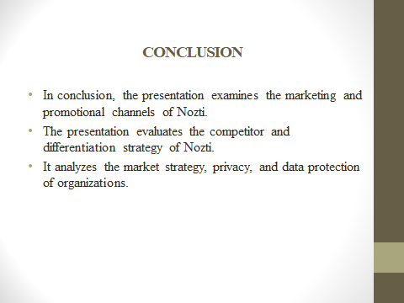
In conclusion, the presentation examines the marketing and promotional channels to resolve the demand for mini camera. It has evaluated the market and competitive analysis of Nozti to improve the organizational performance. The presentation analyzes the differentiation strategy and privacy and data protection of Nozti. In 2018, there were some important changes made to e-directive regulations regarding cold-calling of claims management services of Nozti. Moreover, this introduces the director's liability for serious gaps in marketing rules.



