Name: Kamran Sultan
Student number: 2331353
Module code: BMHP5014
Module title: Changemakers: Creativity and Value Creation
Module Lead: Precious Igbinigie
Assignment title: Component 2: Written Assignment (Report)
Word Count: 1875 words

Contents

Poster: Project Breath Better UK Pg 3
Pitch Pg 4
References Pg 7

Breath Better UK 🚭

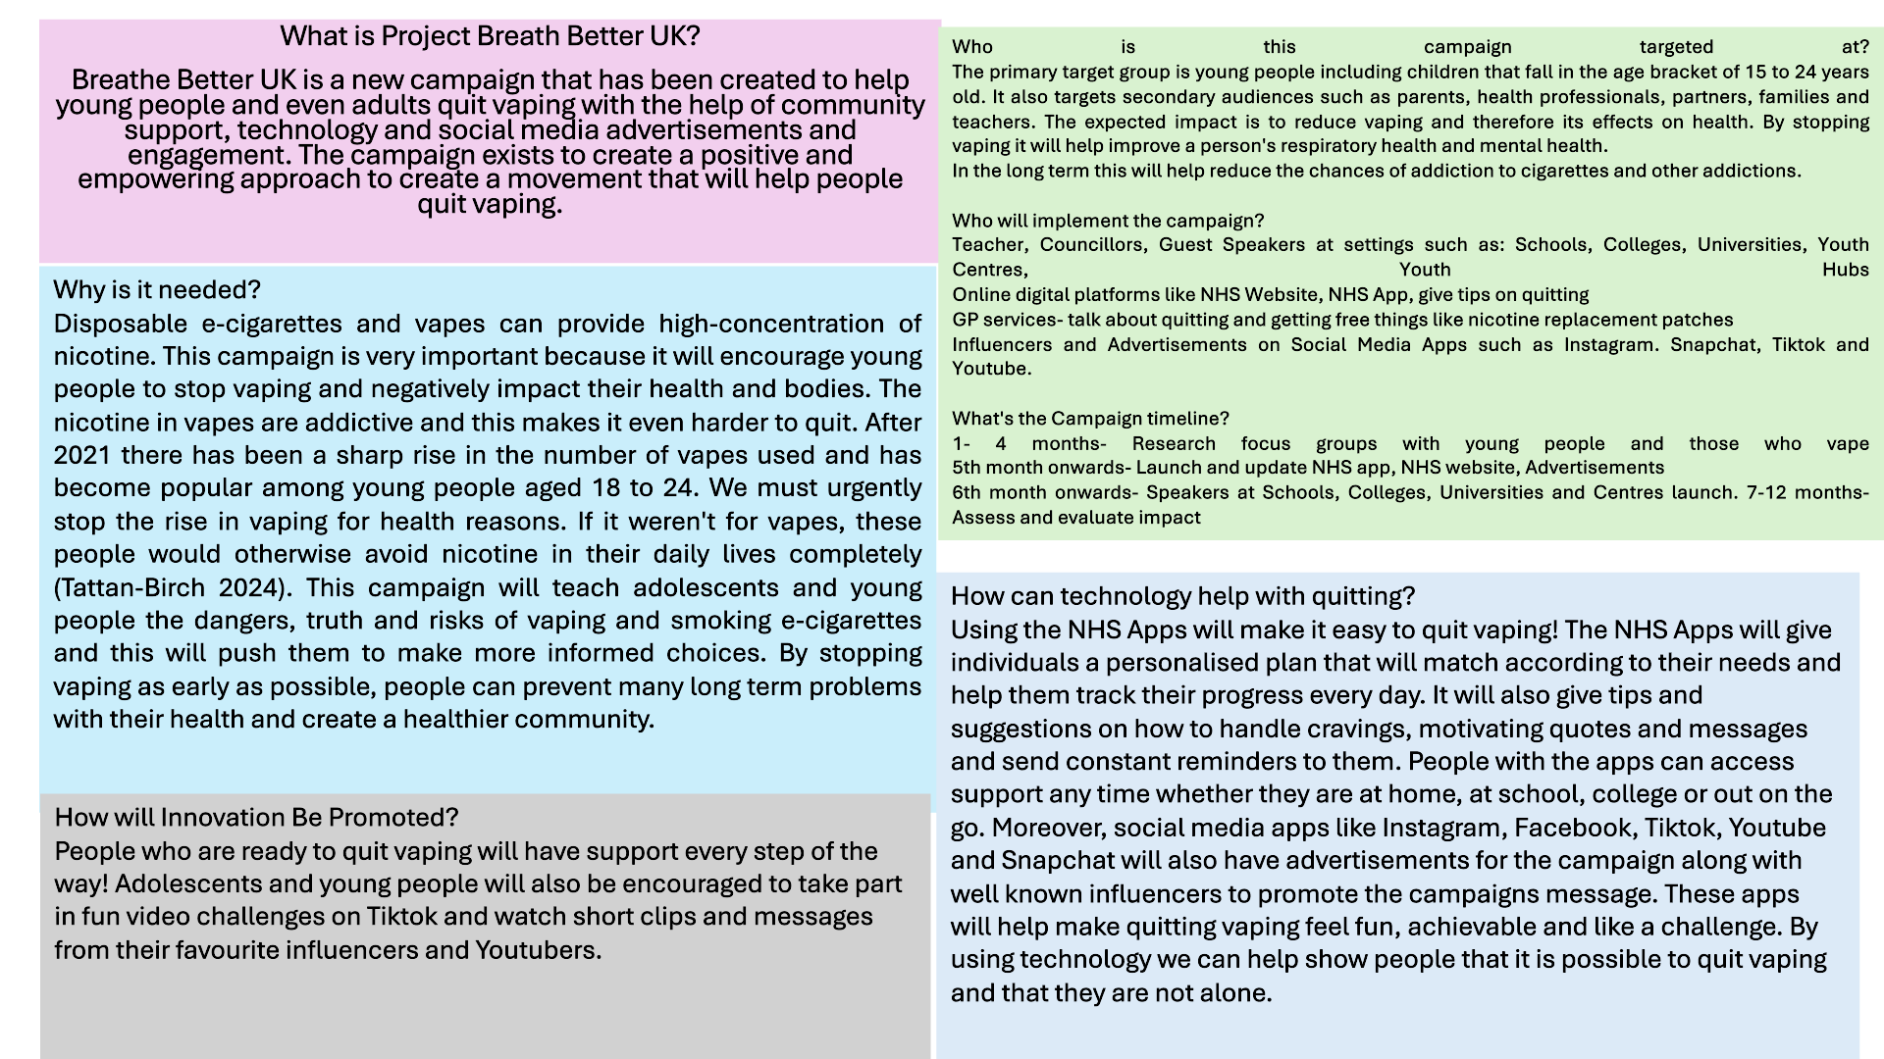

Important Regulations:
Certain important regulations like the Tobacco and Vapes Bill 2024 and NHS Digital Data Protection for Data Protection Laws are helpful to the campaign and using the law will also show people how there are strict prohibitions and rules in place to protect the community. The rules created by the NHS are vital to keep people's personal and health information safe. The Tobacco and Vapes Bill 2024 has made it illegal for young people under the age of 18 years to buy vapes. Recently, the government has also banned the sale of disposable vapes.
Conclusion:
The Breath Better UK Campaign is important because it represents a practical, empowering and fresh approach to assisting people with getting rid of vaping and using e-cigarettes. It is important to have this campaign because so many people see it as a harmless habit but it is actually spreading and becoming quite common. We need early intervention in place. The main strength of the campaign involves combining real life practical supportive methods and honest information and education. In order to really persuade people to quit they must be educated and given facts about the financial risks and the health risks of vaping. By using the correct tools and providing accessible resources to the community, the campaign will encourage people to feel motivated and positive. Young people need to understand why it is important to stop this habit and replace it with better and healthier ones. Doing so will help them improve their health, mental clarity, confidence and their overall quality of life.
Pitch:

In the United Kingdom (UK) vaping and using ether grits has become a huge public health issue. Although some people may believe that it is safer to vape than to smoke, vaping still has its own risks and health concerns especially for young people and teenagers. People who are vaping put themselves at a risk of developing long-term mental health and physical health consequences. In order to try and address this health issue I have created the campaign called Breathe Better which is designed to encourage and support young people to understand the implications of vaping and quitting it. They can get assistance in quitting by combining a range of different support methods such as community support, social media engagement and the use of technology and apps.

There is no doubt that vaping by using e-cigarettes has become a big issue in our Society and it
It is extremely detrimental to the health of the people who are using them especially if used over the long term (Jackson 2024). It has been found that in the UK vapers aged between 11 to 17 years old used disposable vapes and that increased significantly from 7.7% in 2021 to a staggering 69% in 2023. (Meehan 2024).

Many young people who vape have reported issues such as anxiety, sleep disturbances, lack of concentration and anxiety. There is no doubt that this will have negative long term effects on the brain development of young people and can even go on to cause a risk of addiction because youngsters who are vaping have a three to five times higher chance of starting smoking tobacco as compared to those who don't vape (Meehan 2024).

The UK Government found that disposable vapes were always thrown away after use and the government wanted to stop the sale of them especially as young people and adolescents were regularly using them. This was introduced in the Tobacco and Vapes Bill 2024. However studies have found that the actual ban itself has not stopped or reduced the number of smoking and Vaping full stop instead only the type of vape was changed so people have now started to use the fillable e-cigarettes and devices (Jackson 2025). This clearly shows us that there is still an issue of vaping and how as a society we must work together to try and control this as much as possible before it takes over the health and well-being of so many individuals.

Additionally it has been noted that some vapes are also single use devices so that means they will have a huge impact on the environment as they are generating more waste (Jackson 2024).
Even though there are some anti-smoking initiatives that have existed, there is still a big gap in the amount of support that is available for people who vape, especially young adults and teenagers. The traditional and typical campaigns for smoking have always focused on creating fear amongst smokers by discussing and depicting images of risks of cancer and potential long damage. However in today's day this approach has not had much effect on the younger audiences and instead they are more influenced by things like social media engagement, influencers, trends, behavior of peers and lifestyle image.

We can use a more behavior based approach over the course of a year which will include research, focus groups, launching the campaign online and in educational settings. Towards the end the outcome and results will be assessed to see how efficient the campaign was. The implementation of the campaign will be by different professionals like teachers and lecturers at schools, colleges and universities and youth centers and hubs. They will be given help, tips, motivation and recommendations. Guest speakers or people who have influence especially on social media will use popular social media apps like snapchat, Youtube, Instagram, Tiktok to send messages through encouraging videos and skits. As young people spend a lot of time online, social media will be an extremely powerful tool and short clips, videos and challenges about smoking can show that it's cool to not do it. Whilst following the NHS Digital Data Protection for Data Protection Laws, the NHS Website will have information on it and informative links about help quitting and the NHS App will also have a personalised plan for individuals. This includes support and help from GPs who can encourage quitting and even provide nicotine replacement patches. Health professionals can also work in education settings and help provide leaflets and posters too to raise more awareness. The Health Workers and professionals can also share their real experiences and stories of how they quit smoking and vaping and discuss the impact on health. They will give tips and ways to reduce smoking cravings and not fall into peer pressure. It has been found that sending text messages can help many young people under the age of 24 years to quit smoking (Butler 2025). The whole community can also help with this campaign. Parents, neighbours and friends can support the campaign by sharing messages or even volunteering to help. This way young people in society will see how the whole community is working together and how it's normal to not smoke and give value to quitting. By working together, the community will show people that their health and future is vital.

Therefore the Breath Better UK Campaign has been designed to be innovative and have an impactful attitude towards youngsters. It is necessary to try and create a solution. By combining different approaches such as technology, community support and the use of social media engagement, the campaign will be able to address the information or questions that people may have. People will be able to make the correct informed choices when it comes to their health. It will aim to lower the addiction to nicotine and reduce the usage of vapes and even try to create a different culture where quitting vaping and e-cigarettes is seen as being more empowering. This campaign is a movement that will push the community towards good health, clear Minds and overall improved well being.

References:

Butler A.R, Lindson N, Livingstone-Banks J, et al (2025) ‘Interventions for quitting vaping’, Cochrane Database of Systematic Reviews. CD016058. Available at: https://pubmed.ncbi.nlm.nih.gov/39777614/ [Accessed on 1 November 2025]

Jackson S.E, Shahab L, Tattan-Birch H et al (2025) ‘Changes in vaping trends since the announcement of an impending ban on disposable vapes: A population study in Great Britain’, Addiction, 120(9), pp. 1876–1883. https://pmc.ncbi.nlm.nih.gov/articles/PMC12319654/ [Accessed on 3 November 2025]

Jackson S.E, Tattan-Birch H, Shahab L et al (2024) ‘Trends in long-term vaping among adults in England, 2013-23: population-based study’, BMJ 2024;386:e079016. Available at: https://www.bmj.com/content/386/bmj-2023-079016 [Accessed on 4 November 2025]

Meehan K., Keane H, Gallagher, A et al (2024). The adverse effects of vaping in young people. Global Pediatrics, 4, 100118. Available at: https://www.sciencedirect.com/science/article/pii/S2667009724000587?ref=pdf_download&fr=RR-2&rr=99a05e973bd0b14f [Accessed on 5 November 2025]

Tattan-Birch H, Brown J, Shahab L, Beard E & Jackson SE. (2024). ‘Trends in vaping and smoking following the rise of disposable e-cigarettes: a repeat cross-sectional study in England between 2016 and 2023’, The Lancet Regional Health – Europe, 42, 100924. Available at: https://www.thelancet.com/action/showPdf?pii=S2666-7762%2824%2900091-7 [Accessed on 5 November 2025]

UK Parliament (2024) Tobacco and Vapes Bill 2024. Originated in the House of Commons. London. UK Parliament. Available at: https://bills.parliament.uk/bills/3879 [Accessed on 1 November 2025]

