

Marketing communication plan
Hiut Denim Company

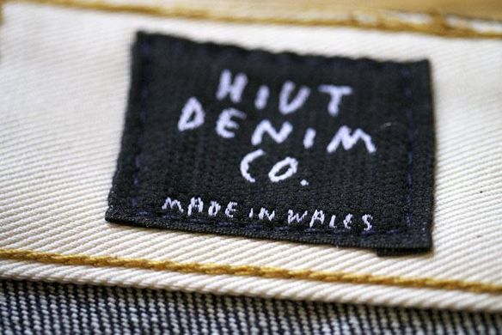

Executive Summary

This report is going to talk about the Hiut Denim company and its new marketing strategy planning framework for the next 12 months. This company was founded in 2013.

In a first part, we will make a marketing communication planning framework for the company through the COSTAC model and in a second part we will see what the Hiut Denim company can improve in its marketing communication strategy. A budget of 5 million has been set for 12 months.

Contents page

I) Introduction: The Hiut Denim company 1
II) Why using Marketing communication? 1
A. Definition 1
B. Marketing communication planning framework process 2
III) Marketing communication planning framework for Hiut Denim 3
A. Context analysis 3
B. Promotional objectives 8
C. Promotional strategies: 10
D. The promotional mix 11
E. Implementation 13
F. Evaluation and control 14
IV) Conclusion 15
A. Conclusion 15
B. Recommendations 15
References 16

Introduction: The Hiut Denim company

The Hiut Denim Company is a clothing brand producing eco-friendly jeans. The jeans company make quality its first choice, to offer to their customers the best jeans with good products and an equity production, hence the expensive prices of the jeans, between £130 and £230 for one (Hieatt, 2018). Currently, “Hiut Denim Company is now one of the most luxury jeans manufacturers in the world” (Halls, 2017). The company doesn’t work as the global fashion industry which produces thousand and thousand pair of jeans each week, here, in Cardigan the city of production, only 120 pair of jeans per week are produced to sale in the UK or to export somewhere else in the world (Smale and Brosnan, 2017). In having an important role in the city of Cardigan, after the closing time of a previous big jeans company and thus the loss of many jobs for the inhabitant of the city, the Hiut Denim Co established a positive image of the brand, because it allows the city to have a new jeans production activity and recreate jobs in the field (Hieatt, 2018).

The company is using the internet to sell directly and keep more of the profit margin and having more easily access to global audiences. Thus, through the internet, social media and especially a sales website available in different languages, they can sell to international customers. David Hieatt, the CEO and advertising executive of the brand, has introduced new promotional techniques as “The No-Wash club” and “The Denim breaker club”. Now, the company should use the partnership to see the brand on other websites. They currently using Facebook feeds and arty photos to promote their products on Internet, and they using influencers, they send to them free jeans and then these people write and talk positively about the brand (Smale and Brosnan, 2017). However, it can have downsides and disadvantages of only using the internet to sell products. Many jeans are refunded because they don’t fit customers, this is representing 14% of sales. Now, we have to highlight that Hiut is exploring using technology that can accurately tell from a photo of a person's perfect jeans size (Halls, 2017). Today, the company want to implement a new promotion campaign for the next 12 months.

Why using Marketing communication?

Definition

Marketing communications, or promotion, is used to “communicate elements of an organisation offering to a target audience” (Fill C, 2009). A marketing communication campaign “refers to actions and activities that are aimed at promoting particular products, business or services by spreading a specific message through different media of promotion, designed step by step beforehand and in a planned way during a particular time period” (MBA, 2018). Digital marketing allows to manage, monitor and measure the performance of the campaign (Swan, 2012).

Marketing communication planning framework process

There are different tools to create an appropriate marketing communications plan. Marketing Communication Planning Framework is hierarchical in nature and encourages an integrated approach, a logical and methodical sequence, and provides a rationale for marketing communications decisions. In addition, Hiut denim does not have to ignore people who work for them. The plan is created stage by stage; each has its specific role to play. First, there is the analysis step to know where is the company now, secondly the planning step to target where do the company want to be, then the implementation one to find which way is best, and finally the control step to understand how can the company ensure arrival (Fill, 2009). The principles of the framework are ordered, considered to make good decisions, resourced, which means timings, finances, manpower and physical resources are planned in advance, and documented, a physical plan can be presented to the business, for example. Marketing communication strategy uses the marketing mix tools to engage with the public (Picton and Broderick, 2004):
- Advertising
- Public relations
- Sales promotion
- Direct marketing
- Personal selling
Each tool work through social media, print media (magazines, newspaper), broadcast media (radio and TV), electronic media (web page), and network media (mobile and wireless) (UK essays team, 2016).

The Hiut company must use the brand building to have a bigger marketing impact through its brand. The brand allows the company to be identified and make a product differentiation and create loyalty (Kotler and Armstrong, 2001). The key factors for success are understanding the audience, in focusing on existing customers and potential customers, mix media tools, and the brand strategy. Companies need a big budget to have a real impact. Marketers use web 2.0 to show the brand engagement. The online sales promotion allows to be creative, create relationships with customers and establish promotions, price deals, and online competition. However, digital marketing is difficult to manage and cost a lot, this is important to be very aware. People are emotional and fallible, is important to take into account these things. Companies have to take risks in the marketing campaign and use group influences, like cultural influences.

Marketing communication planning framework for Hiut Denim

This third and main part of the report will provide the marketing communication planning framework, which is composed of six sections. Thanks to a value of 5 million as the sum of money for a period of 12 months, the campaign has to properly promote the products of the Hiut Denim company taken into account market situation and the business strategies.

A. Context analysis

The first part of the MCPF is the context analysis, that means understanding the key market and communication drivers and the company itself through business analysis, a customer analysis, and then an external and internal analysis (Fill, 2009).

Business

The business context allows a company to understand how the market works, to find a good segmentation and targeting, and follow the market trends in terms of performance and predictions (Smith and Taylor, 2011).

- The marketplace

Regarding the marketplace, the jeans market is in booming since 2017, after a small slowed in the UK during previous years. There is a growth of the global jeans market (QY, 2016), especially in North America, Europe, and the Asia Pacific. There are even more competitors so the prices increase. The Asia retail industry is changing and the e-commerce industry is growing. Moreover, “relaxation in export/import laws by various governments have boosted the inflow and outflow of fabrics” (PS, 2018). People’s expectations are low prices and various design, fashion jeans, print, and design from 90s and 2000s. People also want trendy jeans. However, consumers become aware of the pollution of the denim materials, hence the growth of sustainable products (Euro monitor, 2019). People want casual-wear, which generate the growth of the premium demand for jeans. Jeans have to be honest, contemporary, fashion, approachable, comfortable, universal, style and independent. The all-time favourite brand is Denim (UK essays team, 2016). There is a diversification in the market in terms of jeans shape and style. The jeans are creating under innovative and design new forms, like jeans skirt, jeans jacket, and trousers jeans diversify themselves under flare, slim, mom, boyfriend design.

Regarding the positioning of the market, and the Hiut Denim company specifically, the products of the company are creating, assembly and finishing in a fair way in small manufacture with natural and ethical materials. Then, they are packaging and storing before been used by the consumer. At the end of their long life, the products are recycling to be recreated and have a new life through waste management (Hieatt, 2018). However, the company try to make his own place on the international market thanks to innovative marketing strategies, despite the fact that they currently have a small part on the market (Smale and Brosnan, 2017).

- Competition analysis

Regarding competitors, it’s important to know the different strategies, strengths, weaknesses, actions reactions, and customer attitudes towards our competitors. In this market, leaders’ competitors are principally premium brand, that is to say, Levi Strauss and co, Tommy Hilfiger, Calvin Klein, Diesel, Lee Cooper, and Guess. But the mass market is constantly in growth because of their low prices, in this way H&M, Zara, Primark, Marks and Spencer, Next, and other brands distinguish themselves (Euro monitor, 2019). The clientele of these two different stages of the market is different and have distinguished behaviours.

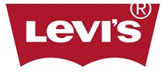

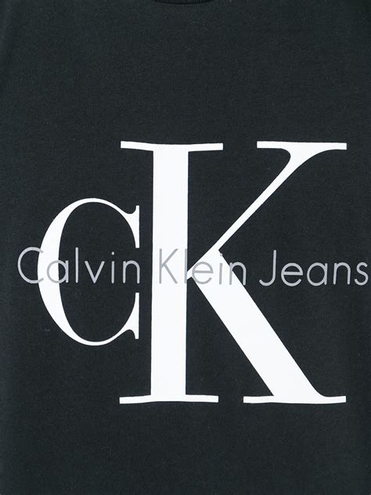

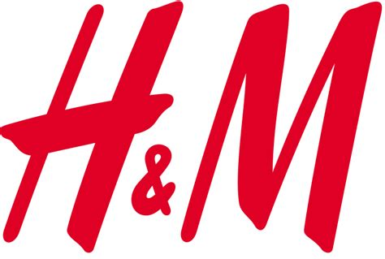



- Supply chain

Regarding the supply chain, that is to say, the relationships with the suppliers and the logistics chain of the company, it differs according to the company and where product is sales and where materials are come from. Many mass market company are produced their products in Asia because of the low prices. Supply chain is also a question of stock, here, the Hiut Denim doesn’t have a lot of stock because they have a small production and producer more or less according to the demand. In terms of production, the company work with cotton’s suppliers.

- Intermediaries

In terms of intermediaries, there is no one for Hiut Denim because the company is the only seller of its products, on the factory and on the website. However, from a general point of view, many jeans company like Levi’s have their own shop but also sales to intermediaries to resale their products like for example Asos.

Customer:


Customer analysis is important to enabling a business to target clientele and positioning themselves on the market (Fill, 2009). Hiut Denim company has to understand the customer’s behaviours and interests, know why and how do they buy. What people think about the brand is also essential to improve the awareness and image of it. In the end, the purpose is to satisfy them, and take risks to attract prospects, especially through communication strategies. Regarding the customers of this market, most of them are part of the 13-17 group and 25-34 age groups, because of the fashion side of the products and the online sales and digital promotion. They are from every origin and come from all over the world thanks to the exportation, and principally from developed countries. Customers are influencing by the fashion and culture trends, but also by psychological and environmental factors (Céline, 2014a). Marketing and advertising have a certain influence on them. Most of them are in good social class because of the current high prices of several types of jeans, but people, in general, prefer low prices unlike middle age people and are influenced by brands, so prices (Céline, 2014b). Premium users purchase less regularly than mass brands users because of the price and the product’s quality, this category of people prefer quantity as quality and vice versa. Men are more jeans users than women, but the numbers are very close. Women have more variety of clothes, unlike men who can wear principally trousers, like jeans. This situation can come from the fact that many men use jeans in work. Both of gender have different attitudes, their shopping behaviour is different, but they are both of them increasingly looking for equity producers and eco-friendly products. Furthermore, in a general point of view, jeans users want comfortable jeans (QY, 2016). Today customer’s motivation is to be part of the fashion world, have a more dependent style, or just be comfortable. People want to learn about the benefits of new jeans and their contents and materials of production, and the perception and the message of the brand (UK essays team, 2016).

Internal

The internal analysis favours the business to see its capabilities in terms of marketing strategies and good performance, but also threats and weaknesses. “The development of integrated marketing communications has to be based on internally generated communications blending and reinforcing externally orientated communications” (Fill, 2003). Hiut Denim needs to know the organisation’s competences and capabilities in detail, in terms of strategic, functional and individual level. Hiut Denim has just one small factory to produce its high-quality jeans thanks to skilful employees and a manual production. The products are only sold on the internet and directly on the little shop of the factory. Products are sold with high price be owing to the high quality and a small production per week (Hieatt, 2018). The company has a high impact in its region, especially people touch by the closing time of the previous jeans factory of the Welsh city Cardigan (Halls, 2017). Hiut Denim has only a few employees and the director David Hieatt and his wife are the managers of the company. It’s important for their management style that members of the staff feel good at work and share the value of the business. All employees are trained during a long period, 3 years, before really working inside the company, it’s important for David Hieatt to have skilful employees and jeans makers (Hieatt, 2018). The McKinsey 7S which includes staff, skills, style, strategy, structure, systems, shared skills, must be totally follow on their management process. The company want to share, with employees and customer, strong values, in terms of social, cultural and environmental level. Regarding the financial constraints, the brand is not enough well-known on the market. In Wales, the company made places but not many abroad. Thus, despite the fact that the business is properly working for the moment, their financial resources are fragile. According to the marketing expertise, the CEO of Hiut Denim is a previous marketing manager, he knows communication and promotional processes and strategies, which is a strength for the business.

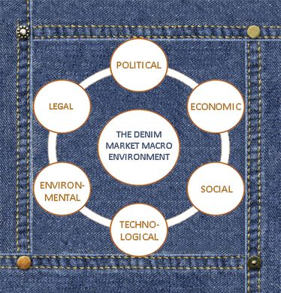
External

In this part, a macro-environmental analysis will be done through a PESTLE approach. Social norms, family roles, culture value, brands, company recognition, trends, and legal and political policies and rules must be taken into account. In advertising, the company must consider all these factors and make a well-message value (UK essays team, 2016).
POLITICAL  - Legislation about the regulation of the promotional activities  - Ending of import quotas of textile (Evariste, 2013). | TECHNOLOGICAL  - Development of online shopping, we talk about e-commerce.  - Development of social-media marketing and new forms of advertising.  - New ethical methods of producing jeans to take care of the health and the environment (Céline, 2014b).  - Modernisation of the industry.
ECONOMIC  - Global economic crisis, the purchasing power have decreased.  - Distribution channels are affected.  - High competition in the market.  - Increase in cotton prices. | LEGAL  - “Confiance Textile” label, which is certified Oeko-Tex and guarantee textiles without risks to health.  - European regulation REACH (Registration, Evaluation and Authorization of Chemicals) which forces in 2005 the textile industry to be « clean » and control chemicals utilisation.  - SVHC (substances of very high concern) substances are allowed at 0.1% rate in textile industry (Céline, 2014b).  - Employment laws
SOCIAL  - Cultural differences and needs, between fashion and high quality.  - Different design according to the cultural origin (Céline, 2014b). Denim is at the heart of fashion (Evariste, 2013).  - Consumers become sensitive to the environmental effect of the fashion industry, thus they want more ethical and sustainable clothes. | ENVIRONMENTAL  - Huge used of water during the denim jeans production, especially in the treatment of the cotton  - Pollution in terms of CO2 in the atmosphere (rejection of 2kg for one denim) (Céline, 2014b).  - The industry must provide products which are sustainable, ethical and respect the planet (Céline, 2014b).  - Biodegradable clothes using recycled materials and reducing packaging (Evariste, 2013).  - Pressure group, global warming.

Promotional objectives

Promotional objectives refer to “how the communications should affect the mind of the target audience, in generate awareness, attitudes, interest, or trial (Smith and Taylor, 2011). The role of communication objectives is to provide a balance to the plan and take away the sole emphasis on sales, they indicate positioning strategies, and highlight the required balance of promotional mix (Fill, 2009). The purpose is to evaluate performance and state new goals to achieve for the future, in the mind of the customer and relative to the competition. Objectives have to be specific, measurable, achievable, realistic, and time-specific, which is essential to implement good strategies.

Corporate level

The corporate objectives are assumed by the business itself. “They refer to the mission and the business area that the organisation believes it should be in” (Fill, 2009).
To provide a profit of 20 % by May 2020.
To hire 5 new employees to increase of 10% the company performances by May 2020.

Marketing level

The marketing objectives are also assumed by the business itself. “They can be considered as sales-related objectives” (Fill, 2009).
To increase the customer number of 15% by May 2020.
To gain 10 places on the marketplace by May 2020.

Marketing communication level

The marketing communication objectives are chosen by the company (Fill, 2009). They can be about awareness, image, or reposition.
To establish 3 open days of the sewing workshop to the press, to show to the public how jeans are created in the HIUT Denim industry, share values of employees and increase brand visibility, by May 2020.
To introduce one customer’s competition events each month to win free jeans by May 2020.
To improve awareness of customers to 10 % by May 2020.

Positioning strategies

“Positioning is not about the product but what the buyer thinks about the product or organisation” (Fill, 2009). “Positioning is the act of designing the company’s offering and image so that they occupy a meaningful and distinct competitive position in the target customers’ minds” (Kotler, 2003). It’s important to create a positioning statement, according to attribute, benefits, price and quality, product user, competitor, and cultural symbol of the brand.

Regarding the positioning statement, Hiut Denim is part of the Upmarket because of its high quality jeans. The company is in the good reputation side, even the fact that the brand is not truly recognised internationally. Hiut Denim take a risk in terms of a marketing strategy because of the small campaign of advertising and the using of influencers and TV people partnerships. Perhaps, the company can use repositioning strategies to change buyer attitudes and develop the value-shared of the brand to gain market shared.

This is the positioning Map of the Hiut Denim, to see where the company is located regarding the competitors.

Fashion




High-quality
Upmarket
High prices
Low-quality
Mass market
Low prices

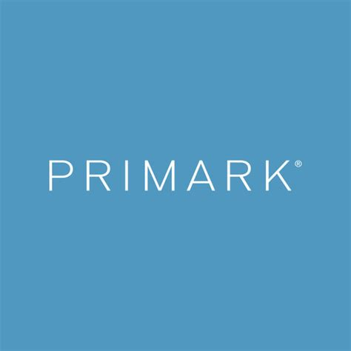
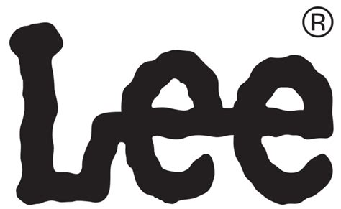


Classic

Promotional strategies:

The promotional strategies must “be geared to the communication needs of the target audience” (Fill, 2020). Strategy summarises how the objectives will be achieved and integrate all of the tactical communications tools (Smith and Taylor, 2011). Strategy is about an approach, a way, a method, a direction.

Push

Push represent the promotional strategy which influence intermediaries and the trade channel. Given that there is no intermediary in this case, the company can’t use this type of strategy and have to directly touch customers in terms of promotion.

Pull

Pull strategy means influencing the end user customers and understanding customer behaviour (Studio wide, 2019). The Hiut Denim can use this strategy through B2C models and the DRIP factors: to achieve awareness, to encourage trial, to support brand strategy, to reduce risk, and to change attitudes. The company could reinforce its position on social media to create customer loyalty through discount and promotion after the first purchase on the website for example. In addition, Hiut Denim can create collaboration with some well-known celebrities, in constantly highlight on the fact that jeans are really comfortable. It’s important to integrate engagement strategy to touch the audience in using online tools, social media, email, website, … (Swan, 2012). The promotion of the brand can also be establishing thanks to customer’s online digital contests to win jeans. The company can show its quality of its products in offer coupons to prospects, thus the company can touch the cottons and see the quality of the material.

Profile

To finish, the profile strategy influences a range of stakeholders to have a better image, and support the brand (Studio wide, 2019). Hiut Denim have to institute internal communication strategy to increase the awareness of the employees through annual meetings for example. It’s important that all the company’s members shared the same values to deliver a good image at best, and the brand have to create partnership with other organisation having the same values.

The promotional mix

“The promotional mix defined all the forms of communication that an organisation uses to establish meaning for its products or services as well as a way to influence the buying behaviour of targeted customers” (Lake, 2018). The choice of methods has to be clearly state. (Fill, 2009). The promotional mix, or marketing mix includes (Marketing mix, 2018):
- Advertising, that means “provide the means by which appropriate messages are devised and delivered to target audiences who then act in appropriate ways” (Fill, 2009).
- Public relations represent the “management activity that attempts to shape the attitudes and opinions held by an organisation’s stakeholders” (Fill, 2009).
- Sales promotion offer additional value to generate an immediate sale (Fill, 2009).
- Direct marketing is used to “create a personal and intermediary-free dialogue with customers" (Fill, 2009).
- Personal selling, that means create a direct dialogue between two persons, that is to say seller and customer (Fill, 2009).

All these factors have to be co-ordinated. Thus, the company has to wonder some questions as how can it communicate with customer? Which method used? What media customer prefer? How can the company get customer to remember our message, and which message? Regarding what the company want to share, the message of the brand is that the company produces one unique type of product, jeans, with quality and ethical materials in respecting people who wear their jeans and the planet itself.
Today, thanks to technology and through digital methods, the company should be able to advertising at best. In addition, creativity is essential to a good marketing campaign, “be creative, think creative, act creative, use the communications creatively”. There are agencies which are specialised in the creative creation of promotion campaign, like Just Creative.

StrategIES | Objectives | Promotional mix
Pull | - To provide a profit of 20 % and gain 10 places on the marketplace by May 2020.  Increase sales, customer satisfaction, referecing. | Advertising:  - Email  - Radio  - Poster  - Social media posts
Pull | - To increase the customer number of 15% by May 2020. | Attract customer through advertising:  - Email  - Radio  - Poster  - Social media
Pull | - To introduce one customer’s competition events each month to win free jeans by May 2020. | Public relation:  - Sponsorship  - Promo events  Sales promotions:  - Contests
Pull | - To hire 5 new employees to increase of 10% the company performances by May 2020.
Profile | - To improve awareness of customers to 10 % by May 2020.  Develop brand image and reputation, and improve customer relationship. | Personal selling:  - Email  Media advertising:  - TV, press, radio  - Social media  - SEO
Profile | - To establish 3 open days of the sewing workshop to the press, to show to the public how jeans are created in the HIUT Denim industry, share values of employees and increase brand visibility, by May 2020. | Direct marketing:  - Events  Media advertising:  - Press

Implementation

This part considers the resources of the company but also the schedule and actions to implement. “The resources necessary to support the plan need to be determined” (Fill, 2009), it’s important to identify them in terms of staff, skills, and materials. The 5M’s approach have to be used, it includes manpower, that is to say consider employee’s capabilities and an agency or not for example, then materials, that means physical equipment, best-fit strategy, structure, working policies and procedures, and finally measurement, money and minutes, so timing, anticipating, and scheduling, through Gantt chart for example.

This is the marketing communication plan from May 2019 until May 2020 with a budget of 5 million pounds:

 | Months 2019 |  |  |  |  |  |  |  | Months 2020 |  |  |  |  | Budget
 |  | J | J | A | S | O | N | D | J | F | M | A | M | Budget
Pop-up store in London, to highlight new collection |  |  |  |  |  |  |  |  |  |  |  |  |  | 1million£
Radio campaign |  |  |  |  |  |  |  |  |  |  |  |  |  | 600,000£
Sponsorship with Instagram influencers |  |  |  |  |  |  |  |  |  |  |  |  |  | 20,000£
Customer contest on social media, especially Instagram  1 customer’s competition events each month to win free jeans |  |  |  |  |  |  |  |  |  |  |  |  |  | 10,000£
Teaser email for new collection |  |  |  |  |  |  |  |  |  |  |  |  |  | 1,000£
Editorial publicity |  |  |  |  |  |  |  |  |  |  |  |  |  | 300,000£
Increase the website visibility, SEO |  |  |  |  |  |  |  |  |  |  |  |  |  | 1million£
3 Open days of the sewing workshop to the press, to show to the public how jeans are created in the HIUT Denim industry and increase brand visibility |  |  |  |  |  |  |  |  |  |  |  |  |  | 3,000£
Collaborate with eco-friendly companies |  |  |  |  |  |  |  |  |  |  |  |  |  | 1,000£
Conferences about the important of choice of cotton |  |  |  |  |  |  |  |  |  |  |  |  |  | 10,000£
Newsletter and internal meetings |  |  |  |  |  |  |  |  |  |  |  |  |  | 5,000£
Publicity campaign on bus shelter |  |  |  |  |  |  |  |  |  |  |  |  |  | 700,000£
TV ad (once a week, time peak) |  |  |  |  |  |  |  |  |  |  |  |  |  | 1million£
Increase visibility of social media posts |  |  |  |  |  |  |  |  |  |  |  |  |  | 20,000£
Total expenditure (excluding the sales force) |  |  |  |  |  |  |  |  |  |  |  |  |  | 4,670,000£

Evaluation and control

“The success of a promotional strategy and the associated plan is the degree to which the objectives set are achieved” (Fill, 2009). Control is the monitoring process to manage and evaluate what the company is doing and understand how well the Marketing Communication is working. Thus, it’s essential for a good promotional campaign to evaluate and control each actions and resources to establish concrete actions to control frequently the process and the strategies. In addition, the company has to considerate the climate conditions and controlled benefits and potentials brand’s issues. The control can be done through analysis of customer purchase and attitudes, market trends, company’s performance, and financial statement.

An annual plan control must be implemented in terms of profitability, efficiency, and strategic control, through meetings, reports, audit, and reviews in terms of marketing effectiveness (Jaideep, 2017). There are a several number of tools which can be use: Google references, customer survey, rate of visibility, account assessment, volume of distribution, spending, repurchase rate, advertising value, consistency of the message, cost effectiveness, market share, profit, turnover.

Then, to control and readjust strategies after evaluation, it could be wise to make changes and take actions, for example in rescheduling and change advertising media if it’s necessary.

Conclusion

Conclusion

To conclude, the Marketing communication planning framework is essential to establish a good communication campaign. Thanks to a good analyse of the market, the company, its capabilities, and the establishment of objectives and strategies, concrete actions can be made. The main purpose is to communicate better with customers. Distinguished product and strong brand’s identity have to be properly promote (Céline, 2014), and the Hiut Denim is now ready to begin a strong marketing communication planning framework during the 12 next months. In applying this MCPF, the company will connect itself with the audience and reinforce its production and share its values.

Recommendations

Some recommendations have to be considerate. The Hiut Denim should create a return customer service to create a customer loyalty, because purchase online is taking risk to not order the good jeans fit for example. Moreover, the company have to develop its social media advertisement and visibility. The purpose is to connect the brand with the audience in using specific tools like hashtag, influencers sponsorship or collaboration, be consistent, and show what the company do better than anything else, a fair production. All social channels have to be combine between each other. Using the internet enables competitors to respond even faster to the customers’ changing demand, thus, it’s more easy to have customer return and view. In addition, internal communication methods can be used to reinforce the link inside the organisation, through reports, conferences, notice boards, newsletters, intranet, e-mails, and training and development. They must be based on previous performances, business relationships, key issues, resources and capabilities.

References

Céline, 2014a, Nevada and Son, Porter’s Five Forces Analysis of the Denim Industry, available at: https://brandsandco.wordpress.com/2014/11/22/porters-five-forces-analysis-of-the-denim-industry/ Accessed: the 13th March 2019

Céline, 2014b, Nevada and Son, PESTLE analysis of the Denim Industry, available at: https://brandsandco.wordpress.com/2014/11/14/pestel-analysis-of-the-denim-industry/ Accessed: the 20th March 2019

Chaffey, D., Smith, P R. (2013), E-Marketing excellence, Planning and optimizing your digital marketing. Accessed: the 1st May 2019

Clow, K E., Baack, D. (2016), Integrated advertising, promotion, and marketing communication, 7th edition. Accessed: the 1st May 2019

Dahl, S. (2015), Social Media Marketing, Ltd: Theories and application. Accessed: the 1st May 2019

De Chernatony (2010) From Brand Vision to Brand Evaluation: The Strategic Process of Growing and Strengthening Brands Strategically branding and sustaining brands Butterworth –Heinemann: Oxford. Accessed: the 1st May 2019

Euro monitor, 2019, Euro monitor International, Jeans in the United Kingdom, available at: https://www.euromonitor.com/jeans-in-the-united-kingdom/report Accessed: the 13th March 2019

Evariste, 2013, Word press, PESTLE analysis of the macro-environment, available at: https://levisvsdiesel.wordpress.com/2013/11/19/pestel-analysis-of-the-macro-environment/ Accessed: the 20th March 2019

Fill, C. (2009) Marketing Communication: Interactivity, Communities and Content, 5th edition, FT Prentice Hall: Essex. Accessed: the 1st May 2019

Flemming, 2019, Marketing communication strategy, Lecture.

Jaideep, 2017, Your article library, Marketing control, available at: http://www.yourarticlelibrary.com/marketing/marketing-control-top-4-methods-of-marketing-control/48751 Accessed: the 3rd May 2019

Halls, 2017, GQ, Your new favourite pair of jeans come from a tiny, rural town in Wales, available at: https://www.gq-magazine.co.uk/article/best-jeans-for-men-hiut-denim Accessed: the 13th March 2019

Hieatt, 2018, 20 Hiut Denim Co, available at: https://hiutdenim.co.uk Accessed: the 13th March 2019

Lake, 2018, Small business, The impact promotional mix can have on your marketing, available at: https://www.thebalancesmb.com/what-is-promotional-mix-2295546 Accessed: the 3rd May 2019

Marketing mix, 2018, The promotional mix concept, available at: https://marketingmix.co.uk/promotional-mix-2/ Accessed: the 2nd May 2019

MBA, 2018, MBA Skool, Marketing communication campaign, available at: https://www.mbaskool.com/business-concepts/marketing-and-strategy-terms/16669-marketing-communication-campaign.html Accessed: the 13th March 2019

Ogilvy, D (2007), Ogilvy on Advertising Multimedia Publications, London. Accessed: the 1st May 2019

Picton, D. And Broderick, A. (2004) Integrated Marketing Communication, 3rd Ed., Ft/Prentice Hall: Harlow. Accessed: the 1st May 2019

PS, 2018, PS Market research, Denim market, available at: https://www.psmarketresearch.com/market-analysis/denim-jeans-market Accessed: the 13th March 2019

QY, 2016, Globes news wire, Denim Jeans Market 2016, available at: https://www.globenewswire.com/news-release/2016/06/23/850926/0/en/Denim-Jeans-Market-2016-Share-Trends-Analysis-Growth-Sales-Demand-Research-Survey-and-Industry-Forecast-to-2021.html Accessed: the 13th March 2019

Smale and Brosnan, 2017, BBC News, How a Welsh jeans firm became a cult global brand, available at: https://www.bbc.co.uk/news/business-42237426 Accessed: the 13th March 2019

Smith, P R, Taylor, J (2011) Marketing Communication: Integrating Offline and Online with Social Media Kogan Page Ltd: London. Accessed: the 1st May 2019

Studio wide, 2019, Studio wide, Push, Pull and Profile strategies, available at: https://www.studiowide.co.uk/push-pull-profile-strategies/ Accessed: the 2nd May 2019

Swan, 2012, Smart Insights, Creating an integrate marketing strategy, available at: https://www.smartinsights.com/digital-marketing-strategy/digital-strategy-development/planning-an-integrated-marketing-strategy/ Accessed: the 13th March 2019

West, 2014, The guardian, Selvedge job: jeans company helps Welsh town get back in its stride, available at: https://www.theguardian.com/business/2014/feb/11/selvedge-jeans-company-welsh-town Accessed: the 13th March 2019

2010, Mintel, Jeans - Consumer attitudes to buying and wearing - UK, available at : https://store.mintel.com/jeans-consumer-attitudes-to-buying-and-wearing-uk-november-2010 Accessed: the 13th March 2019

UK essays team, 2016, UK essays, Market segmentation of jeans brans, available at: https://www.ukessays.com/essays/marketing/market-segmentation-of-jeans-brand-marketing-essay.php Accessed: the 13th March 2019

