Module : BMSS5007
Developing your Professional Profile

Modiwl : BMSS5007C
Datblygu eich Proffil Proffesiynol



Asesiad / Assessment :
E-portfolio prep for CPD / Work

Gan / By: Samuel Chamberlain, 2404338

Arweinydd Modiwl / Module lead : Heddwen Davies

CV :

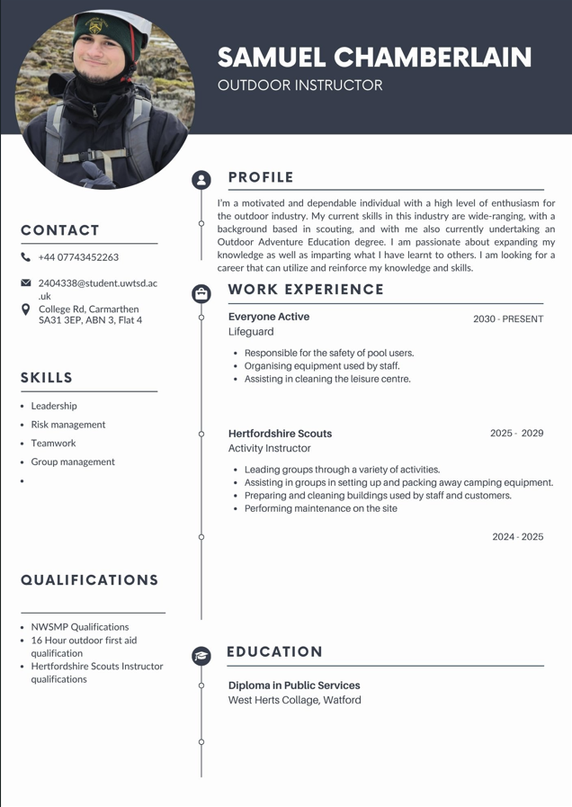

Llythyr / Letter for a post “ ……………………………… “

Mr Sam Chamberlain
UWTSD, Carmarthen
2404338@student.uwtsd.ac.uk
07743 452263

The Outward Bound Trust
Loch Eil Centre
Achdalieu
near Fort William
PH33 7NN

Dear Hiring manager

I am writing to you to express my interest in applying for an instructor role with your team at Loch Eil.

I am currently a Second-year student studying Outdoor Adventure Education at the University of Wales, Trinity St David. I am hoping to work in the Outdoor Adventure industry when I graduate. As a student of Education, I have an up-to-date DBS certificate and have developed risk assessment skills and completed first aid training. I am looking for work in this industry to expand my knowledge.

I have been a member of Hertfordshire Scouts since I was a Beaver scout, aged 6 years old, and am now an adult member of the Network. I have spent many happy weekends over the years at Phasels Wood Activity Centre as a participant. I enjoy seeing young people develop their outdoor skills and am keen to be part of a team providing amazing experiences to visitors.

I am a Kings Scout and hold the Gold Duke of Edinburgh award. Through these awards I have developed skills in many outdoor activities.
I was a member of the Hemel Scouts Bushcraft group for many years and am experienced in fire lighting, outdoor cooking, building bivouacs and shelters.
I held a Personal permit for canoeing and have many hours paddling on both canals and rivers. I completed both my bronze and silver DofE expeditions on water.
I was a member of the Climbing Club at Everyone Active in Amersham and spent many years doing the NICAS climbing awards.

I enjoy hiking and have completed the Yorkshire 3 Peaks challenge and climbed Ben Nevis, Scarfell Pike and Snowdon, and hope to complete the National 3 peaks challenge one day.
I was a member of the volunteer crew at Phasels for 4 years and thoroughly enjoyed being involved with all aspects of the running of the Centre, including site maintenance, car park duties and supporting activities on site, to name a few.

I was a Young leader at Apsley Scout Group for 4 years and completed the Scout Young Leader belt. This experience provided me with skills and experience in running activities for both Beavers and Scouts.

I have previously worked for Everyone Active as a Recreational Assistant (Lifeguard). This primarily involved ensuring the safety of the public who were using the leisure Centre. The role also included customer service, setting up equipment, cleaning and running fun sessions for children on the inflatable. My lifeguarding qualification NPLQ (now lapsed) involved Water safety and First Aid knowledge and skills.

I am a reliable team player and am willing to undertake any type of work required. I am flexible with working evening and weekend shifts.

Yours Faithfully,

Samuel Chamberlain

Focus Statement:

My career ambitions are to become a freelancer and establish myself as a reliable outdoor practitioner. This would open doors to many areas, for example, Duke of Edinburgh’s Award (DofE) and Camps International.

After completing a SWAT analysis, I have found that my strengths support my ambition and will help me move forward to reach my goal. I consider myself to be a patient, resilient and compassionate person with a diverse set of skills that will aid me in my development. I have many years of experience in the fields of navigation and bushcraft, enabling me to confidently teach people the basics in these areas, for example, fire lighting in bushcraft and how to orient a map for navigation. While these skills are valuable for my development, I am always eager to learn more in order to expand my horizons and enable me to explore the outdoor industry, with a wealth of knowledge to rely on. Some skills I wish to learn to forward my aspirations are developing my leadership skills in different environments, for example, being trained in mountain leadership (Mountain training, 2025). Another skill I wish to learn is how to drive vehicles under a category D1 license so that I can expand where I can take people (GOV.UK, 2025).

Based on my training needs analysis I know what qualifications and experience I need to acquire or maintain. I am First aid trained with a 16-hour outdoor first aid course. This shows that I am capable of first aid, this is a vital skill for an outdoor practitioner to possess if they want to take a group of people into an outdoor environment. I will need to continue refreshing myself personally and complete a renewal of the training in 2027. I am also experienced in dealing with clients as I have worked for Phasels Wood Activity center (Phasels Wood Activity Centre, 2025) for 4 months as an activity instructor. I have led multiple different types of groups, for example scouts and schools in a variety of activities ranging from tunnelling and orienteering to bushcraft and low ropes. These experiences are ongoing, helping me obtain the knowledge and understanding of how to work with people as a leader and a team member. I need to continue to gain experience so that I can become an even more effective leader, and to achieve that, I must continue to work with a variety of groups as an activity instructor.

Based on my personal development plan, I know what I am striving for in the short and long term. This includes completing Ropes training for activities such as climbing and abseiling, as well as completing air rifle training so that I can lead groups in air rifle shooting. These different qualifications are part of my short-term goals, enabling me to expand my expertise and offer more activities to participants. My long-term goals are to continue to build my professional portfolio, making myself an experienced, competent and confident outdoor practitioner. To achieve this, I must continue to expand my knowledge of outdoor skills and progress in a variety of activities.

Moving forward, I aim to develop all aspects that contribute to making someone an effective outdoor leader and instructor.

Reference list:

Mountain training (2025) Mountain Leader. Available at: https://www.mountain-training.org/qualifications/walking/mountain-leader/ (Assessed: 29 October 2025).

GOV.UK (2025) Driving a minibus. Available at: https://www.gov.uk/driving-a-minibus (Assessed: 29 October 2025)

Phasels Wood Activity Centre (2025) About Us. Available at: https://www.phaselswood.org.uk/ (Assessed: 29 October 2025)

Appendices:

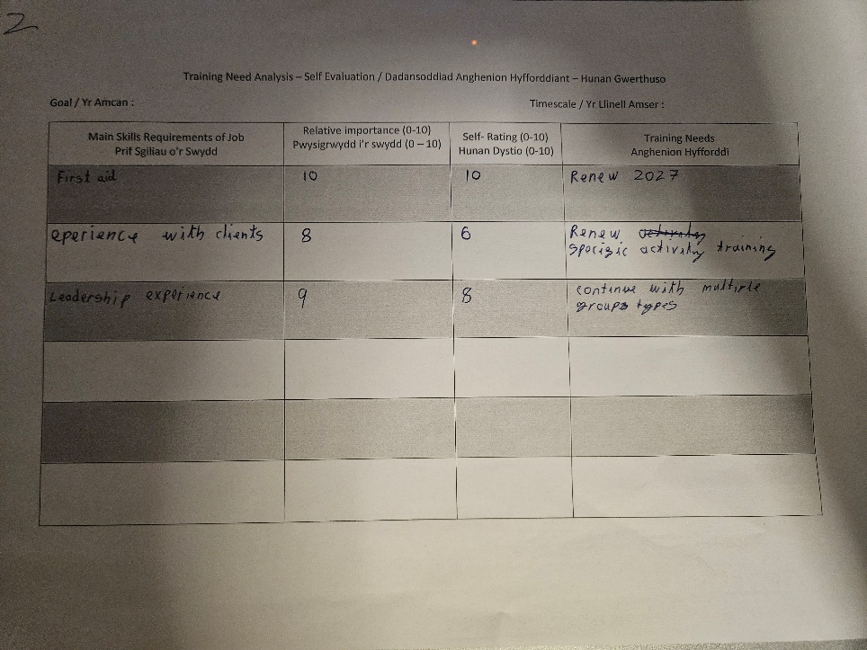

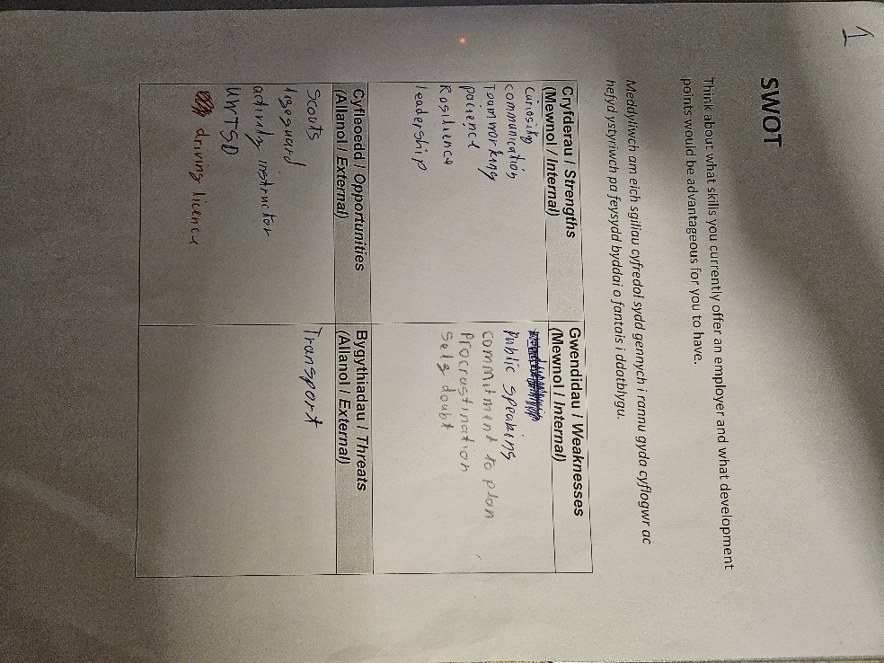
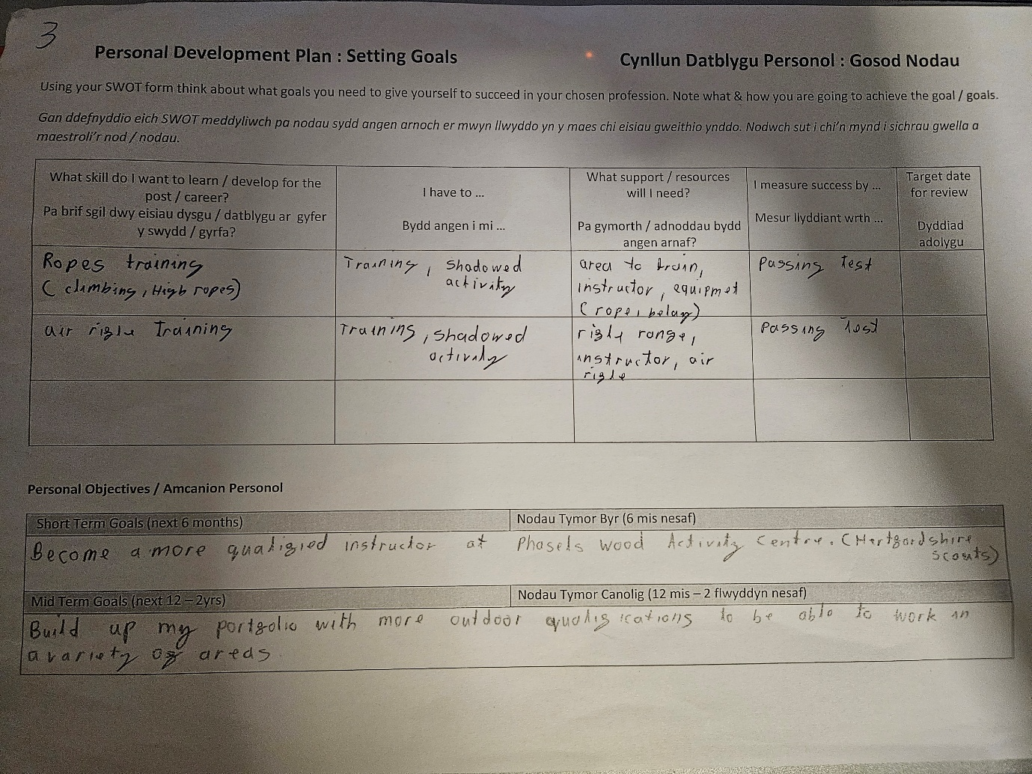
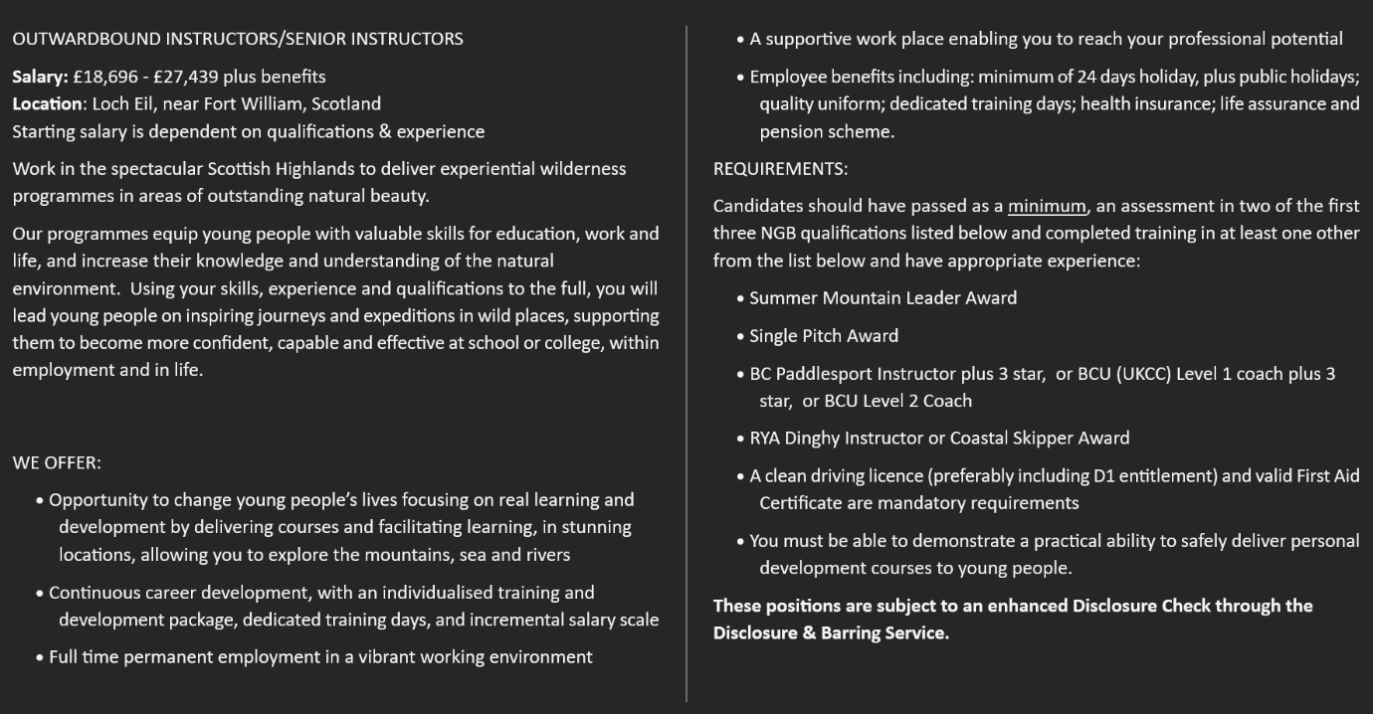
AI tool used (With url) | Date used | Why did you use this tool | Example of prompt
https://www.grammarly.com | 29/10/2025 | Check my work | Does this text read well

