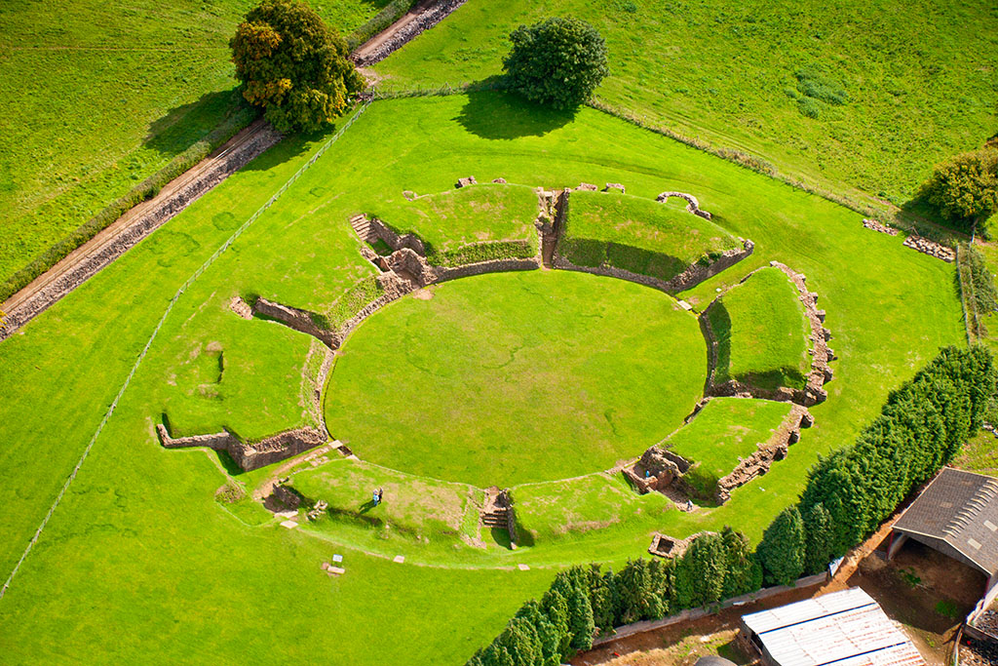
The Amphitheatre at Caerleon
The Amphitheatre at the town of Caerleon, near Newport, is said by some to be the location of King Arthur’s Round Table told of in legend.
However, it was built by the Romans around the year of 90CE, on the outskirts of the Roman fortress built around 74CE.
Events that would take place in the amphitheatre would include popular sports at the time, including gladiatorial combat, animal hunts and fights (humans against animals, and animals against each other- such as bears, dogs and wolves, bulls and bears.), and even military parades.
Wooden seats built on earth and stone wall foundations could house around 6000 spectators, which is far more than the amount of people serving in the local fort, as members of the Roman Legion housed there.
The Amphitheatre
- In the year 74CE, the Roman fortress at Isca (now Caerleon) was founded by the II Augusta Legion in the territory of the Silures, Wales’ most powerful tribe.
- This was a move made by the Romans in order to make a statement of power in the wake of Boudicca’s rebellion and sacking of London 14 years before.
- The building of the amphitheatre signifies that the area of South Wales must have been under total Roman control.
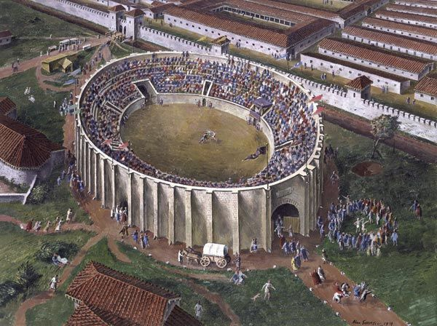
- The 184ft long and 136ft wide amphitheatre, made up of eight sections of seating areas suitable for 6000 people, including space for priority seating for dignitaries, and holding areas for animals and fighters, shows through its scale and setting, just how popular this form of entertainment had become- a pastime for many a Roman citizen to enjoy.
An artist’s rendition of what the amphitheatre would have looked like in its heyday.

It’s Wider Implications
The construction of the amphitheatre was a tool to assert Roman influence over the area, however its use was still an important part of life for residents of the fort, and its surrounding areas.
Our understanding of Roman culture and life in Britain at this time is broadened by this building, and helps us figure out further aspects of Roman history, paired with analysis of the remains of the fort- such as the quality of life for the legion stationed there, its indigenous tribal peoples, and the state of political control in Roman occupied Wales at the times of construction of the fort, the Roman baths and of course, the amphitheatre.
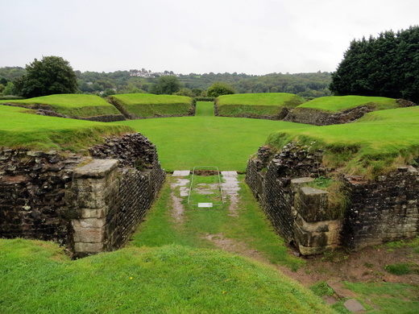

Bibliography:

Atlas Obscura, Caerleon Amphitheatre, Caerleon, Wales, <https://www.atlasobscura.com/places/caerleon-amphitheatre>, [17/02/20]

David Ross, Caerleon Roman Fortress, Baths, and Amphitheatre, Britain Express, <https://www.britainexpress.com/wales/wye/roman/caerleon.htm>, [17/02/20]

