Tabassum Ali
2433454
BSc Health and Social Care
Changemakers: Creativity and Value Creation
BMHP5014
Component 1: Online Portfolio of Set Exercises

Content Page
Task 1 Concept Map................................................................p,3,4
Task 2 reflection .....................................................................p,4,5
Task 3 Cast Study ..................................................................p,5,6
Task 4 Digital Exclusion .........................................................p,6,7
Task 5 Podcast.......................................................................p,7
Task 6 NHA Leadership Framework.......................................p,7,8
Task 7 Creativity Reflection...................................................p,8,9
Reference List.......................................................................p,10

Task 1

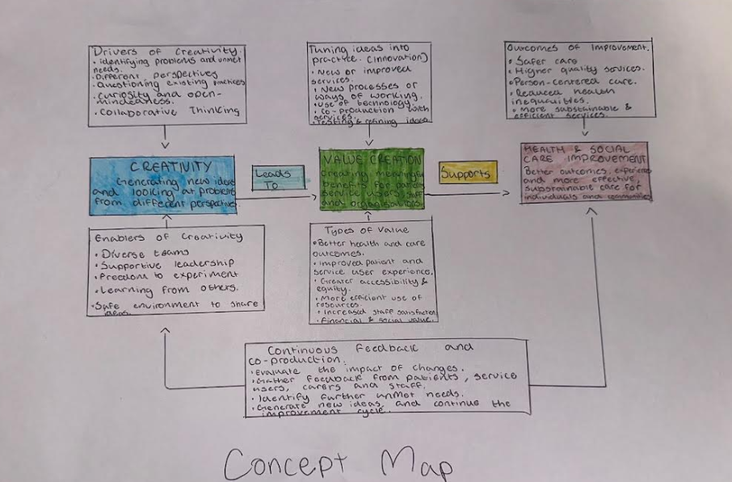

Concept Map Explanation
Creativity, value creation and improvement are closely connected within health and social care. Creativity involves generating new ideas and viewing existing problems from different perspectives. This is particularly important within health and social care because services must respond to changing population needs, increasing demand and pressures on available resources. Creative thinking can therefore encourage professionals to question established practices and explore alternative approaches to care.
Creative ideas can lead to innovation when they are transformed into practical changes. These may include new technologies, redesigned services or different ways of working. Importantly, innovation should involve the people affected by these changes. NHS England (2023) identifies co-production as an approach in which service users, carers, communities and professionals work in partnership during the design, development and evaluation of services.
Value creation occurs when creative ideas and innovations generate meaningful benefits. These benefits can include improved outcomes, better experiences, increased accessibility, safer care and more effective use of resources. However, innovation should not be considered valuable simply because it is new; its effectiveness and impact on service users must also be considered. Research on co-production suggests that combining the expertise of professionals with the lived experiences of service users can contribute to more effective and sustainable outcomes (Batalden et al., 2016).
Therefore, creativity generates potential solutions, innovation puts these ideas into practice, and value is created when resulting changes lead to meaningful improvements. Feedback and evaluation can then identify further needs, creating a continuous cycle of creativity and improvement.
Task 2
Reflection Using Gibbs’ Reflective Cycle
Description
During the group paperclip activity, we were asked to think of as many alternative uses for a paperclip as possible. The activity demonstrated divergent and convergent thinking. Divergent thinking involved generating different ideas, while convergent thinking involved evaluating these ideas and selecting the most practical ones (Cropley, 2006).
Feelings
Initially, I found it difficult because I focused on obvious uses and worried that unusual suggestions might be incorrect. As other group members shared their ideas, I became more confident and realised that creativity requires openness to different possibilities.
Evaluation
The activity was useful because working as a group generated more ideas than I would have produced independently. However, I noticed that I sometimes judged ideas too quickly, which could restrict creative thinking.
Analysis
Using Gibbs’ (1988) reflective cycle helped me recognise that effective problem-solving requires both exploration and evaluation. This is relevant to health and social care because professionals often face complex problems where one solution may not meet every service user's needs.
Conclusion
I learned that divergent thinking allows different possibilities to be explored, while convergent thinking helps identify the most appropriate solution. Both approaches are therefore important when developing improvements.
Action Plan
In future health and social care practice, I will try to remain open-minded when generating solutions and avoid dismissing ideas too early. I will then use evidence, professional judgement and service-user needs to evaluate which solution is most appropriate.
Task 3
Case Study: NHS Home Testing for Chronic Kidney Disease
Chronic kidney disease (CKD) is an important health concern because it can develop without obvious symptoms, meaning some individuals remain undiagnosed until the condition has progressed. Early identification is therefore important for enabling appropriate monitoring and treatment. In 2023, NHS England expanded an innovative home-testing approach using smartphone-enabled kidney testing technology. Approximately 30,000 people considered at increased risk of CKD were initially offered access to home testing (NHS England, 2023).
The initiative demonstrates creativity through redesigning the traditional approach to kidney testing. Rather than requiring patients to attend a GP practice or healthcare setting to provide a urine sample, the technology enables testing to be completed at home. Patients use an albumin-to-creatinine ratio (ACR) urine test kit alongside a smartphone application, which uses image-recognition technology to analyse the test strip (NICE, 2020). Results can then be made available for clinical review. This represents creative service redesign because an established diagnostic test has been combined with digital technology to make testing more convenient and accessible.
The innovation can create value for patients and healthcare services. NHS England (2023) estimated that the initial programme could identify approximately 1,300 previously undiagnosed cases of CKD. Earlier identification may enable healthcare professionals to introduce monitoring, lifestyle interventions or treatment before further deterioration occurs. Home testing can also reduce the inconvenience associated with travelling to appointments, particularly for people with employment, caring responsibilities or mobility difficulties. For healthcare services, remote testing may support more efficient use of face-to-face appointments.
However, innovation does not necessarily create equal value for every service user. Griffiths et al. (2024) examined remote ACR testing across South East London and reported a test-completion rate of 46.8%. Older people and individuals living within the most deprived areas were less likely to complete testing. This suggests that smartphone-based healthcare may present barriers for people experiencing digital exclusion, limited confidence with technology or socioeconomic disadvantage. Another consideration is patient confidence in completing the test correctly without direct professional support. Clear instructions and accessible technical support are therefore important. Healthcare professionals must also ensure that abnormal results lead to appropriate follow-up, as earlier identification only creates meaningful value when patients can access further assessment and treatment.
Therefore, NHS home CKD testing demonstrates how creativity can transform an established healthcare process into a more flexible and patient-centred service. Although it offers potential value through convenience, earlier identification and improved access, its success depends upon equitable implementation. Alternative testing options and appropriate support remain important to ensure that technological innovation reduces barriers to healthcare rather than unintentionally widening existing inequalities.
Task 4

Digital Exclusion and Access to Healthcare
Digital exclusion is a current concern within health and social care as services increasingly rely on online appointments, smartphone applications and remote consultations. Although digital healthcare can improve convenience, individuals without suitable technology, internet access or digital skills may experience greater difficulty accessing services. This can particularly affect people who already experience social and health inequalities.
Zhang et al. (2023) investigated digital health inequalities across 6,356 primary care providers in England. The study examined the use of two digital services, including the NHS App and online primary care services. The researchers found a significant association between higher levels of socioeconomic deprivation and lower use of both digital services. Their analysis indicated that deprivation was associated with non-activation of the NHS App among a substantial number of patients. These findings suggest that digital engagement is influenced by wider socioeconomic circumstances rather than simply an individual's willingness to use technology. Consequently, increasing reliance on digital healthcare could disadvantage populations already experiencing inequality.
Similarly, Verity and Tzortziou Brown (2023) explored experiences of remote general practice among 21 people from inclusion health groups in East London. Participants included vulnerable migrants, people experiencing homelessness, sex workers and members of Gypsy, Roma and Traveller communities. The researchers identified barriers including digital exclusion, limited translation availability and difficulties navigating complex healthcare systems. Participants also highlighted the importance of trust and retaining face-to-face consultation options. However, some valued remote access because it could save time and provide greater convenience.
Both studies demonstrate that digital exclusion results from interconnected social, economic and practical barriers. While digital healthcare can improve accessibility for some patients, a digital-first approach may unintentionally increase inequalities for others. Health and social care services should therefore provide flexible access, including non-digital alternatives, while offering appropriate support to individuals who experience barriers to using technology.
Task 5
Podcast
Task 6
Summary of the NHS Leadership Framework
The NHS Leadership Framework identifies seven domains that support effective leadership in healthcare: demonstrating personal qualities, working with others, managing services, improving services, setting direction, creating the vision and delivering the strategy (NHS Leadership Academy, 2011). These domains recognise that leadership involves more than managing staff and resources.
Demonstrating personal qualities focuses on self-awareness, integrity and effective self-management, while working with others emphasises teamwork, communication and professional relationships. Managing services involves planning resources, managing people and monitoring performance. Improving services focuses on encouraging innovation and transforming services to achieve better outcomes. Setting direction requires leaders to use evidence and understand the wider healthcare environment when making decisions. Creating the vision involves developing a shared purpose, while delivering the strategy focuses on turning organisational goals into practical actions.
Together, the seven domains encourage leaders to combine personal effectiveness, collaboration and strategic thinking with continuous service improvement. West et al. (2015) suggest that effective healthcare leadership can influence staff engagement, organisational culture and quality of care. Therefore, leadership behaviours can directly affect how successfully NHS organisations respond to challenges and improve patient experiences.
Applying ‘Improving Services’ to Creativity and Care
A leader could use the improving services domain to encourage staff to identify problems and develop creative solutions. The NHS Leadership Framework highlights innovation and transformation as important elements of service improvement (NHS Leadership Academy, 2011).
For example, when addressing long patient waiting times, a leader could involve frontline staff and patients in identifying causes and generating possible solutions. Staff could contribute knowledge from their daily practice, while patients could highlight problems within their experience of care. Promising ideas could then be tested on a small scale and evaluated before wider implementation.
Supportive leadership is important because staff are more likely to contribute ideas when they feel involved and valued. West et al. (2015) emphasise the importance of collaborative leadership and staff engagement in achieving high-quality healthcare. By encouraging participation, experimentation and evaluation, leaders can turn creative ideas into practical improvements while ensuring that changes remain focused on patient safety, experience and quality of care.
Task 7
Reflection on Creativity and Value Creation
Before completing this module, I mainly associated creativity with developing completely new ideas or technologies. Throughout the module, I have learned that creativity within health and social care can also involve adapting existing practices, solving everyday problems and finding more effective ways of meeting service-user needs. Batalden et al. (2016) demonstrate that improvement can be strengthened when professionals and service users work together to develop healthcare services.
My understanding of value creation has also developed. I previously viewed value mainly in relation to efficiency and financial savings. I now recognise that value can include improved experiences, better outcomes, accessibility, safety and meaningful involvement in decision-making. This has helped me understand why an innovation should not be considered successful simply because it is new.
The module has also influenced my professional practice. I have become more aware of the importance of listening to different perspectives before deciding how to respond to a problem. The NHS Leadership Framework highlights the importance of improving services through innovation and transformation (NHS Leadership Academy, 2011). In my future practice, I will be more willing to contribute ideas, listen to colleagues and service users, and consider whether proposed changes genuinely create value. I will also reflect on possible limitations to ensure that improvements remain inclusive and person-centred.

Reference List
Batalden, M., Batalden, P., Margolis, P., Seid, M., Armstrong, G., Opipari-Arrigan, L. and Hartung, H. (2016) ‘Coproduction of healthcare service’, BMJ Quality & Safety, 25(7), pp. 509–517. doi: 10.1136/bmjqs-2015-004315.
Cropley, A. (2006) ‘In praise of convergent thinking’, Creativity Research Journal, 18(3), pp. 391–404. doi: 10.1207/s15326934crj1803_13.
Gibbs, G. (1988) Learning by Doing: A Guide to Teaching and Learning Methods. Oxford: Oxford Polytechnic.
Griffiths, K., Taylor, S., Bramham, K. and Molokhia, M. (2024) ‘Can remote testing for chronic kidney disease improve outcomes without widening existing health inequalities? A collaborative quality improvement project in primary care’, British Journal of General Practice, 74(Suppl. 1), bjgp24X737997. doi: 10.3399/bjgp24X737997.
National Institute for Health and Care Excellence (NICE) (2020) Healthy.io test for home testing of urine albumin to creatinine ratio. Medtech Innovation Briefing MIB221. London: NICE.
NHS England (2023a) Co-production: an introduction. NHS England.
NHS England (2023b) NHS trials home testing for chronic kidney disease. NHS England, 26 December.
NHS Leadership Academy (2011) Leadership Framework: A Summary. Coventry: NHS Institute for Innovation and Improvement.
Verity, A. and Tzortziou Brown, V. (2023) ‘Inclusion health patient perspectives on remote access to general practice: a qualitative study’, BJGP Open, 7(2), BJGPO.2023.0023. doi: 10.3399/BJGPO.2023.0023.
West, M., Armit, K., Loewenthal, L., Eckert, R., West, T. and Lee, A. (2015) Leadership and Leadership Development in Health Care: The Evidence Base. London: The King’s Fund.
Zhang, J., Gallifant, J., Pierce, R.L., Fordham, A., Teo, J., Celi, L. and Ashrafian, H. (2023) ‘Quantifying digital health inequality across a national healthcare system’, BMJ Health & Care Informatics, 30(1), e100809. doi: 10.1136/bmjhci-2023-100809.

