
12/17/2025
Marzena Lucyna Zerek (2439102)
[company name]
Assignment 2
[Document subtitle]
Module Name: Computer Architecture and Operating Systems

Module Code: ACCA4022

Student Name: Marzena Lucyna Zerek

Student ID: 2439102

Groupe: 2

Lecture’s Name: Dr Redhwan Al-amri

Table of Contents
Introduction: 2
Main Body: 2
Key functions of general Operating Systems 2
1.0 Process management 2
1.2 Memory management 3
1.3 File system and storage management 3
1.4 Device or I/O management 4
2. Use of Windows OS CLI commands. 5
3. Use of Linux OS CLI commands. 8
4. Use of Windows OS scripts. 14
5. Use of Linux OS scripts. 17
Conclusion: 19
Reference: 19
Bibliography 19

Introduction:

This report explains the vital role of modern operating systems (OS) in managing today’s computers. It begins by outlining the core functions that all operating systems share, such as managing processes, memory, and files. The focus then shifts to practical application, where we will demonstrate the power of the command line and scripting in both Windows and Linux environments. Using clear examples and screenshots, this analysis will highlight how an OS enables users to perform complex tasks and automate workflows, showcasing its importance from both a theoretical and a practical standpoint.

Main Body:

Key functions of general Operating Systems

An operating system (OS) provides a mediating system between resources and user programs, enabling applications to function efficiently and securely. According to IBM, the OS “manages a computer’s hardware and applications by allocating resources, such as CPU, memory, input/output devices and file storage [1]. The main functions of general operating system can be categorized as process management, memory management, file system and storage management, device management, user interface support, etc.

1.0 Process management
Process management is the group of functions through which an operating system manages the execution of processes or programs. It schedules these processes for CPU time, controls inter process communication, and fixes problems such as deadlock or starvation. The OS ensures that processes can run synchronously without conflict which is achieved by allocating CPU time through scheduling algorithms like First-Come, First-Served (FCFS) or Round-Robin [2]. One example is modern Oses, which employ scheduling algorithms for responsiveness while maximizing CPU utilization.

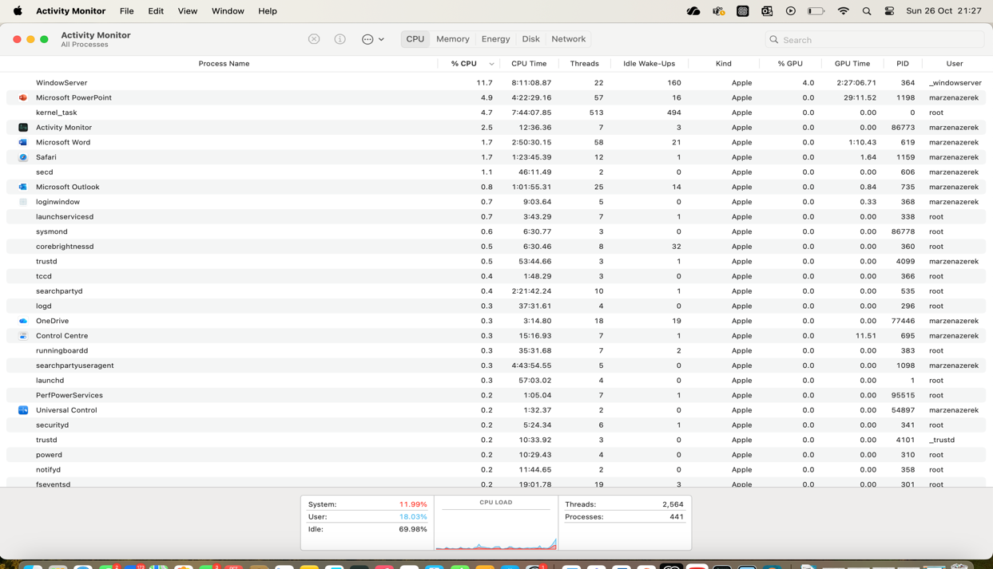

Figure 1: This screenshot shows the Activity Monitor’s CPU tab, which lists all currently running processes and their real time CPU utilization, demonstrating the OS’s control over process scheduling.

1.2 Memory management
Memory management is another function which relates to the allocation and deallocation of main memory to processes. It maintains isolation between processes while making sure that the utilization of available memory is optimized. Techniques such as paging, segmentation, and virtual memory is limited [3]. Memory management directly impacts the system’s performance because it decides how promptly the CPU accesses data and commands.

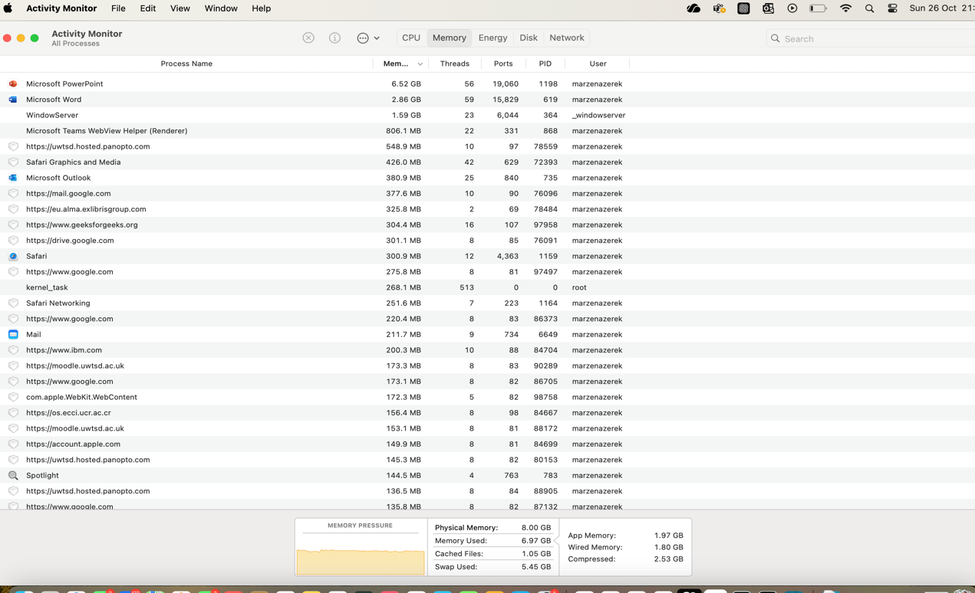

Figure 2: This screenshot displays the Activity Monitor’s Memory tab, illustrating how the OS manages physical memory, compressed memory, and swap space to optimize system performance.

1.3 File system and storage management
File system and storage management provides users and applications with a comprehensive view of files and directories as it breaks down underlying storage devices and enables creation, reading/writing, deletion, and protection of files. File management also maintains data integrity as data is shared between users and applications. It also sets the basis for persistent storage and allows the retention of information between sessions.

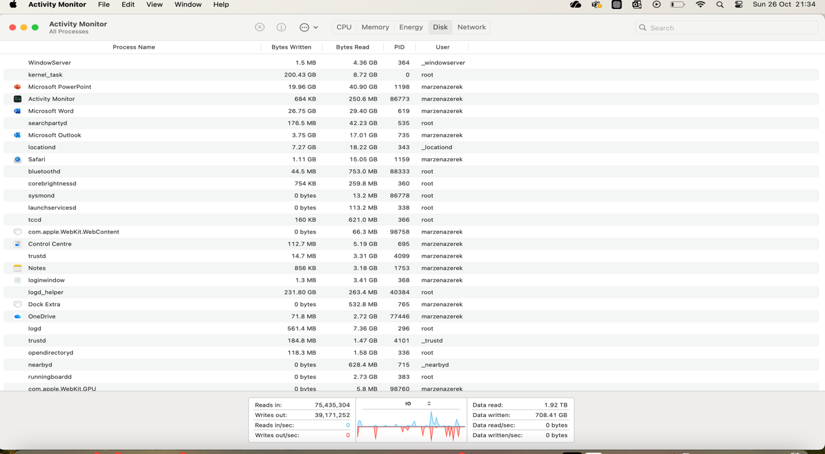

Figure 3: This screenshot captures the Disk Utility application, which allows users to view, manage, and physical storage devices connected to the mac.

1.4 Device or I/O management
Device or I/O management is the process through which an operating system handles peripheral devices (which include printers, disk drives, network interfaces, keyboards, etc). This is done through device drivers, buffering, spooling and handling interruptions or direct memory access (DMA) transfers. The OS uses these drivers to convert generic OS commands to more specific commands which are understood by the hardware components and translated to actions [4].

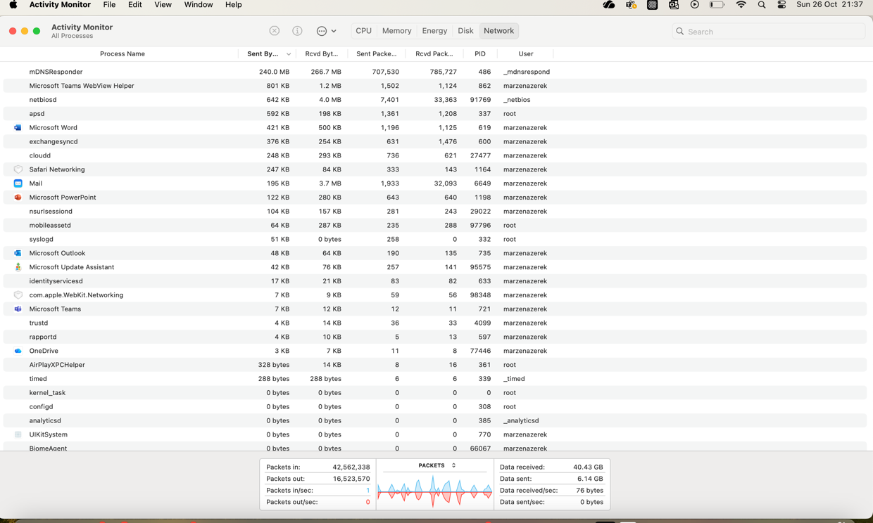

Figure 4: This screenshot shows the Activity Monitor’s Disk tab, which monitors the input/output (I/O) rate of data being read from and written to the storage devices, a key aspect of device management.

1.5 Protection, security and resource control

Protection, security and resource control are also integral functions of operating systems. It is essential for the OS to have mechanisms which prevent unauthorized access, maintain the integrity of data and resources, monitor system performance and detect errors. Authentication, access control lists (ACLs), and encryption are usually employed to ensure data protection. Furthermore, the OS provides user interfaces (graphical (GUI) or command-line CLI)) which allow users to interact with the system and efficiently run commands.

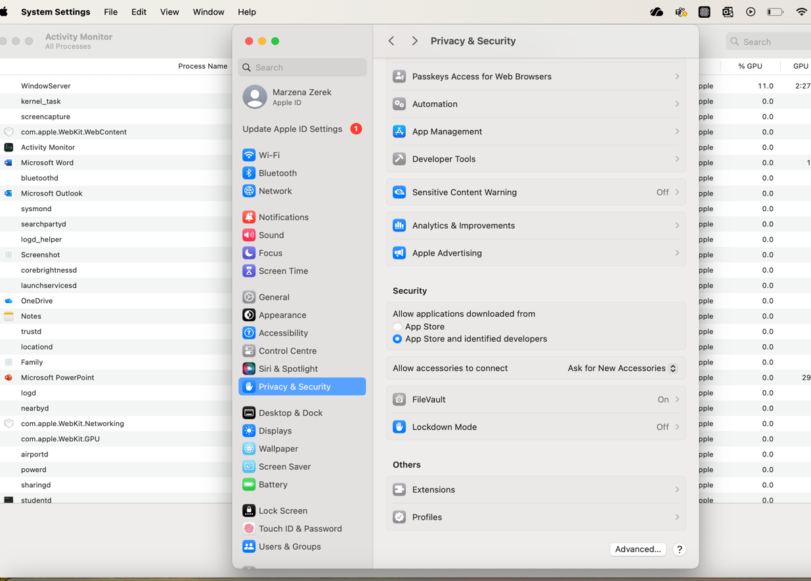

2. Use of Windows OS CLI commands.

Command | Description
dir | A list of the files and folders in a directory is shown by the 'dir' command. It displays the serial number and volume label of the disc when it is used without any parameters. It also shows file sizes, last-modified dates, and file and folder name [5].
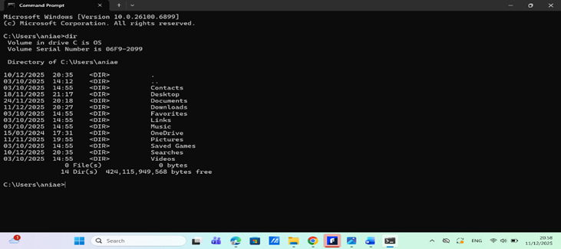
Fig 1: List of Directories.

Cd pathname | In Windows CMD, the cd (chdir) command modifies the shell's current working directory within the file system [6].
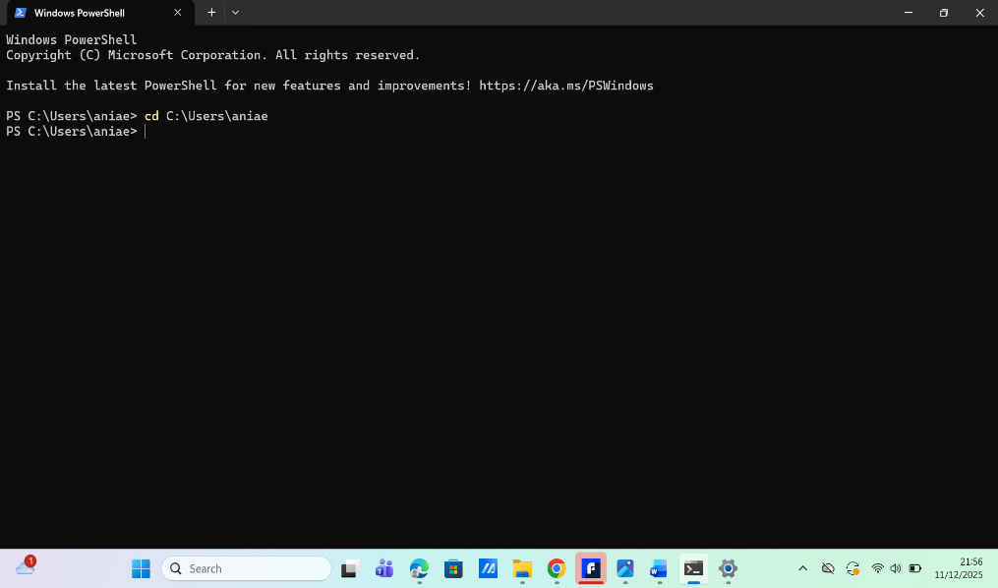
Fig 2: Using the ‘cd’ Command to Change Directories.

Cd / | This enables navigation to start from the top-level folder by moving the user to the current drive's root directory in Windows CMD [7].
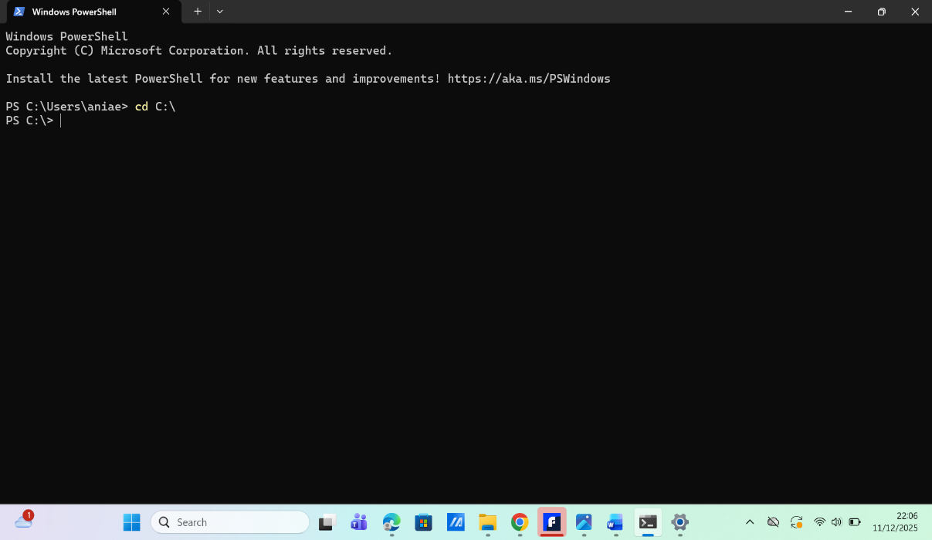
Fig 3: Using the cd / command to navigate to the root directory.

Cd .. | It enables rapid navigation out of nested folders by moving the user up one level in the directory hierarchy [8].
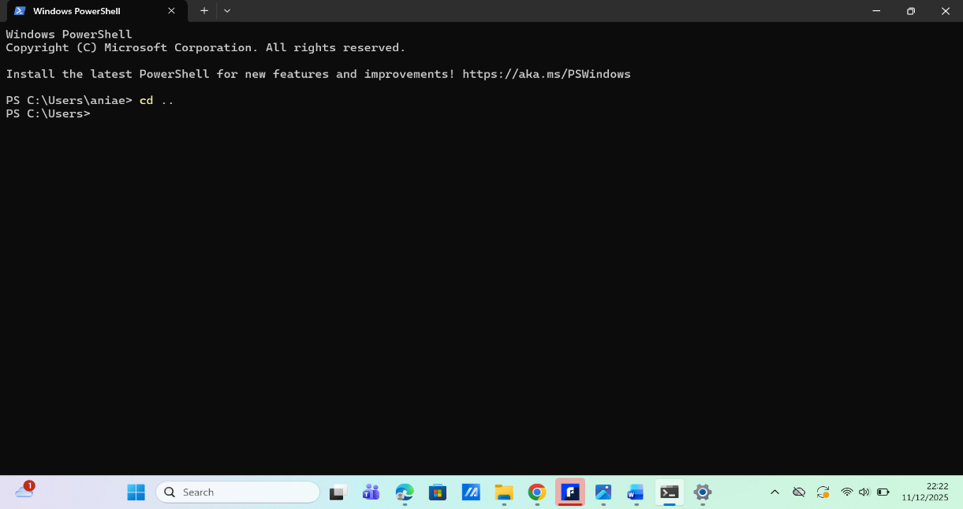
Fig 4: Using the cd .. command to move up one directory level in PowerShell.

copy | The copy command, which is frequently used for file transfers or backups, copies files from a source to a designated destination. By default, directories are not copied but files are [9].
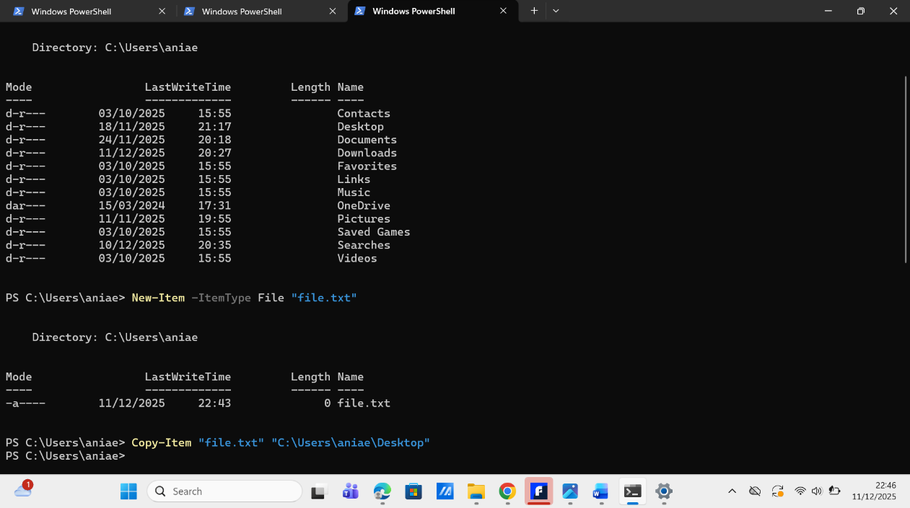
Fig 5: Successful use of the Copy-Item command in PowerShell to duplicate a file.

Move | Files or directories can be moved using the move command. It can also give a file or folder a new name when used within the same folder [10].
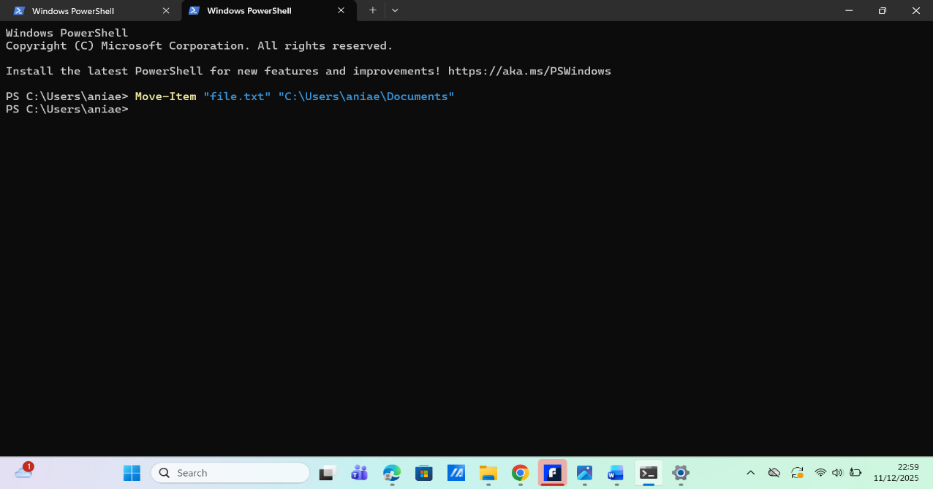
Fig 6: Use of the Move-Item command in PowerShell to relocate a file.

Type filename | The type of command is helpful for quickly reviewing file information without opening an editor because it shows the contents of a text file directly in the command window [11].
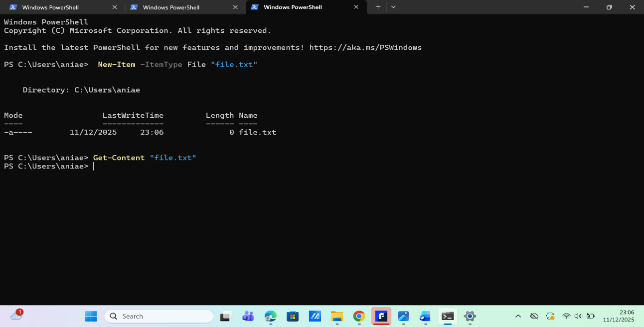
Fig 7: Example of the Get-Content command displaying a file’s contents in PowerShell.

mkdir | The mkdir (or md) function helps users arrange files into distinct folders by creating a new directory at a specified location. Setting up project or storage directories in CMD is a popular usage for it [12].
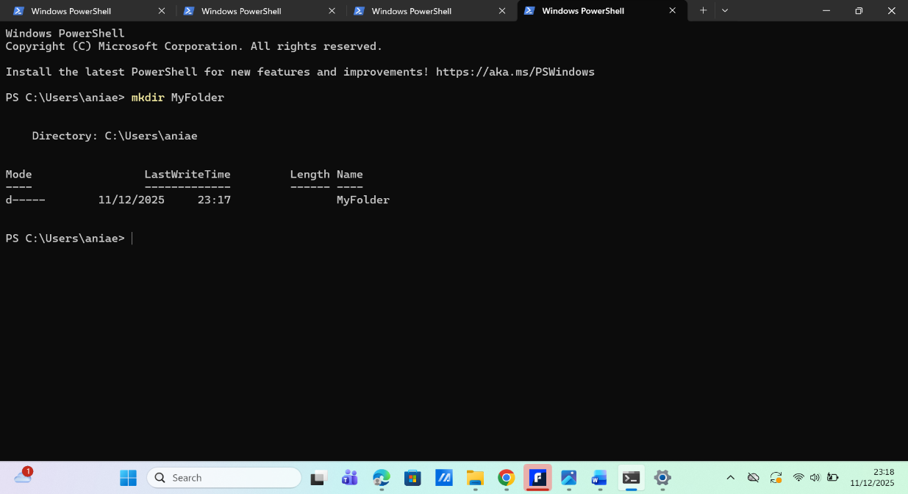
Fig 8: Creating a new directory using the mkdir command in PowerShell.

Rmdir or rd | A directory can be deleted using the rmdir/rd command, and its contents can be optionally removed with PowerShell's equivalent Remove-Item cmdlet [13].
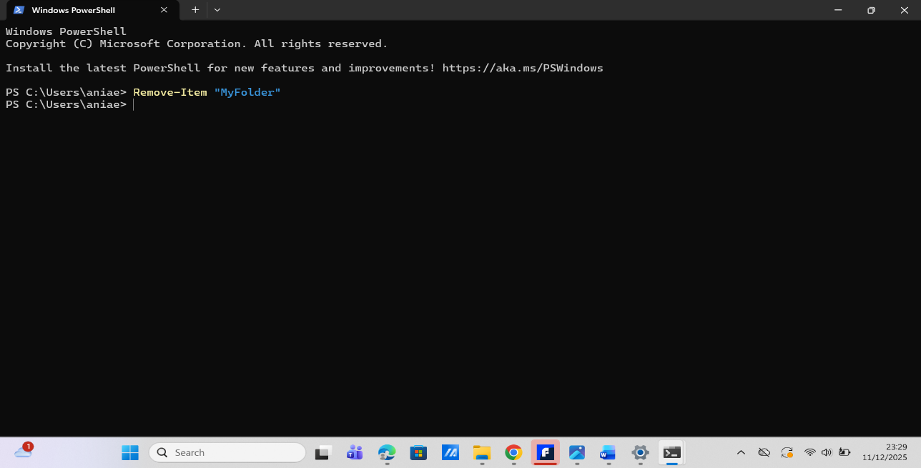
Fig 9: Deleting a directory using the Remove-Item command in PowerShell.

help | For a given command, the help command shows comprehensive details, syntax, and options [14].
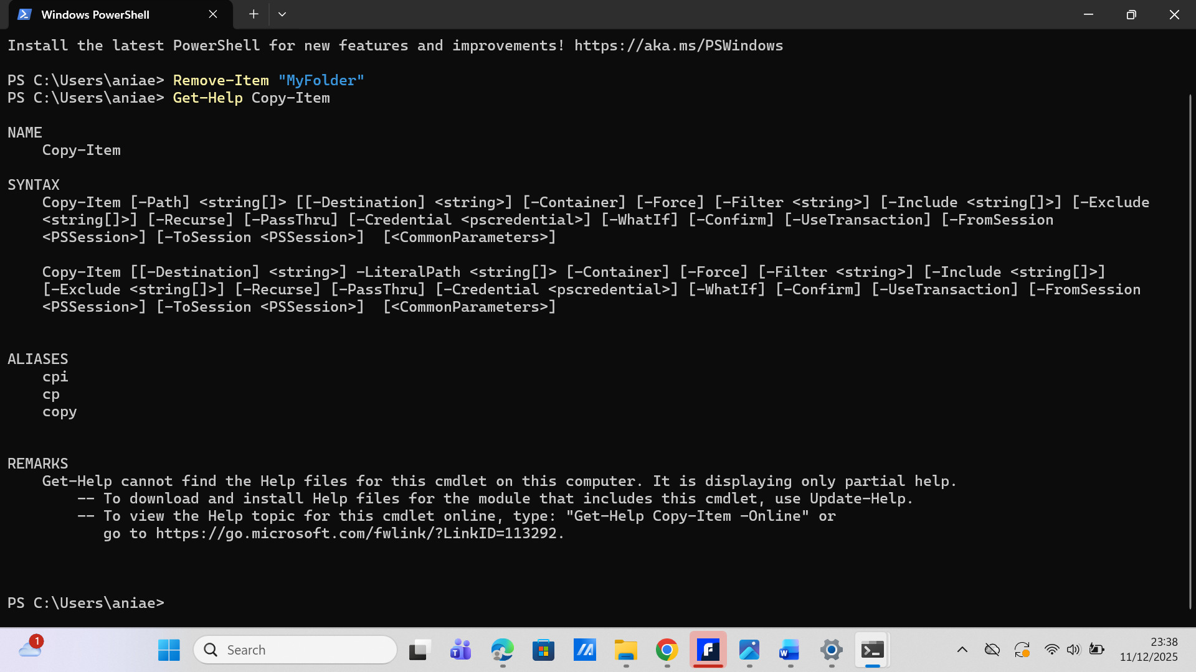
Fig 10: Using Get-Help in PowerShell to display command documentation.

3. Use of Linux OS CLI commands.

Command | Description
pwd | The pwd command in Linux displays the full path of your current working directory from the root directory [15].
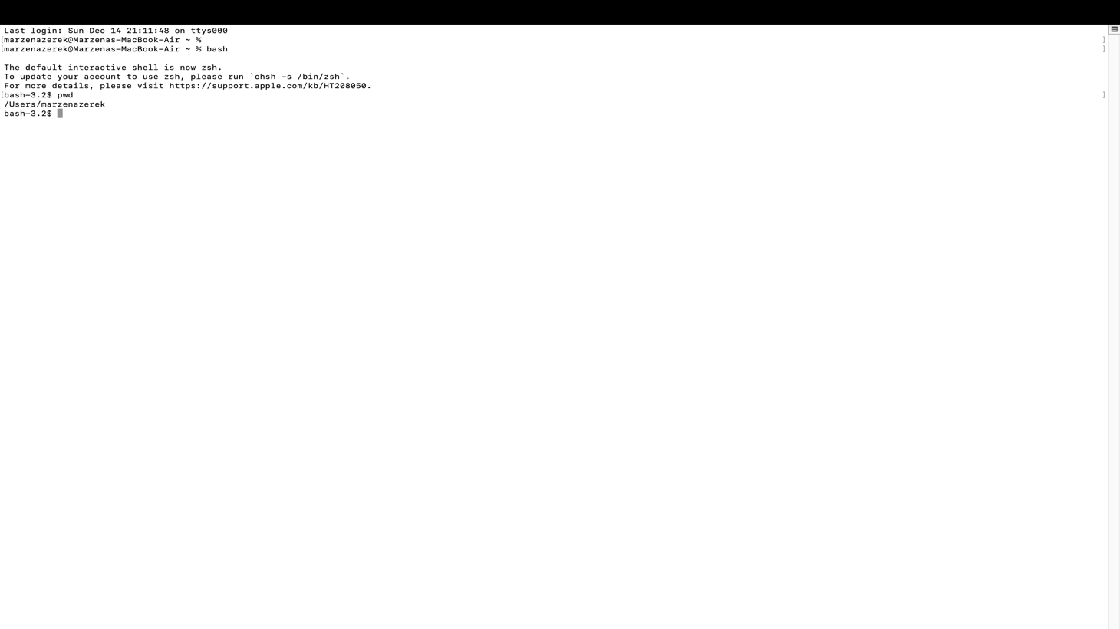
Fig 1: Displaying the Current Working Directory Using the pwd Command.

ls | The ls command in Linux is used to list the contents of a directory. List information about the FILEs (the current directory by default). By default, ls can sort entries alphabetically [16].
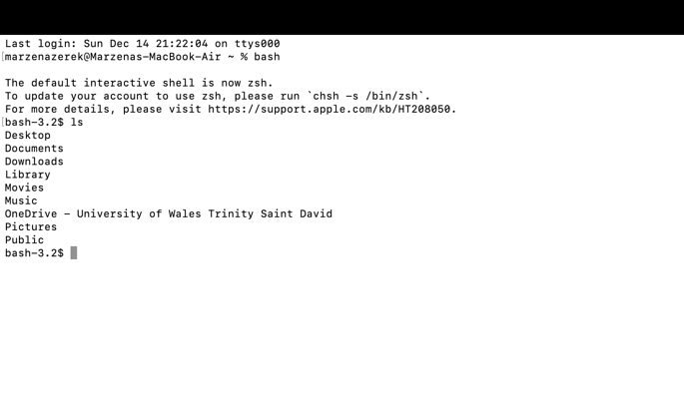
Fig 2 | Displaying Files and Directories Using the ls Command.

cd | cd changes the current working directory to directory. If the directory is not found, the unit of the home shell variable is used as the directory. cd searches each directory name in CDPATH for a directory, with alternative directory names in CDPATH separated by a colon (‘:’) [17].
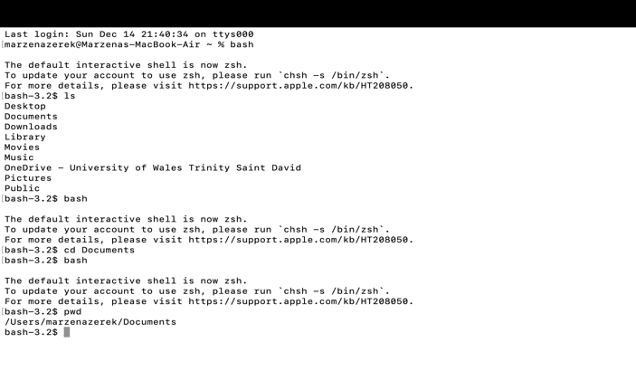
Fig 3: Changing the Current Working Directory Using the cd Command.

mkdir | "Make directory" is what the Linux mkdir command stands for. It is used to add one or more new filesystem directories [18].
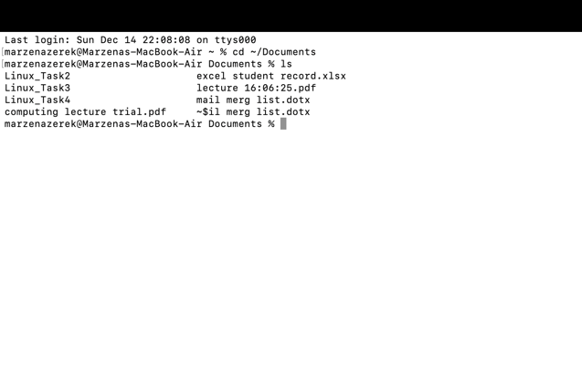
Fig 4: Creating Directories in Linux Using the mkdir Command.

touch | In Linux, the touch command can be used to update the access and modification timestamps of already-existing files or create new ones. Touch creates a new, empty file if the specified file does not already exist [19].
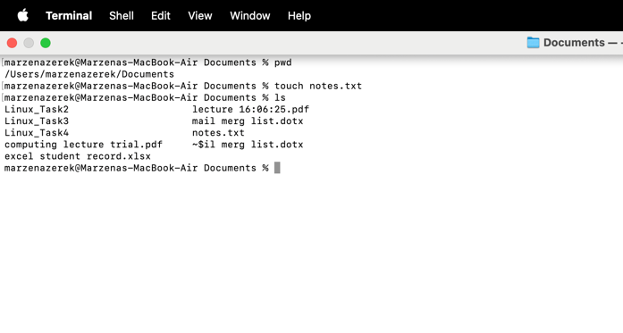
Fig 5 | Creating Empty Files with the Linux touch Command.

cp | In Linux, the cp command stands for "copy." It is used to move files and directories around the filesystem. One file, several files, or entire directories can be copied using this command [20].
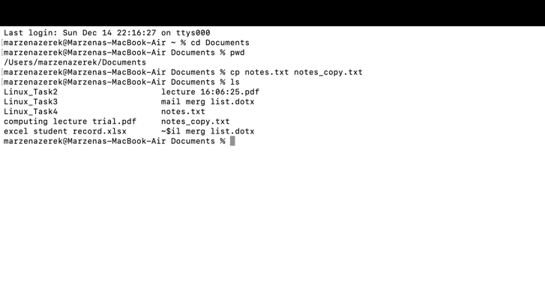
Fig 6 | Copying Files and Directories in Linux Using the cp Command.

mv | In Linux, "move" is represented by the mv command. Moving or renaming files and directories within the filesystem is one of its uses. The command moves a file from one place to another [21].
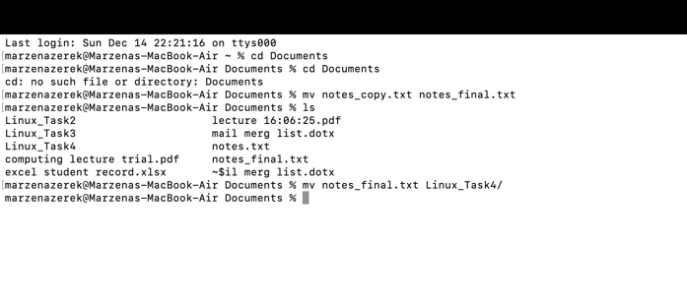
Fig 7: Moving Files and Directories in Linux Using the mv Command.

Cat | "Concatenate" is what the cat command in Linux stands for. Its primary purpose is to display the contents of one or more files to standard output. The command can also be used to create new files or combine multiple files into one by rerouting output [22].
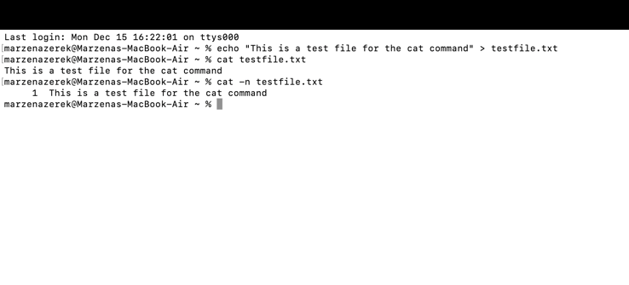
Fig 8: Displaying and Combining Files with the Linux cat Command

Df | The Linux df command stands for "disc free." On mounted file systems, it shows information about how much space is being used on the disc [23].
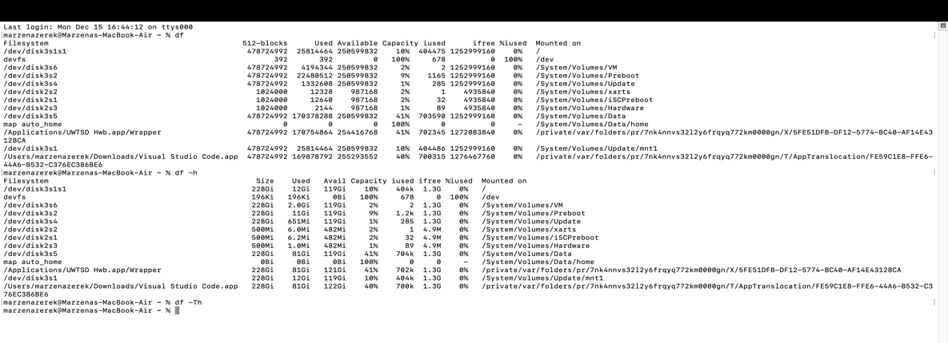
Fig 9: Viewing Available Disk Space Using the df Command

file | The file command in Linux tells you what kind of file it is. Instead of relying on file extensions, the tool looks at the file's contents and metadata to figure out what kind of file it is: text, executable, picture, compressed archive, or binary data [24].
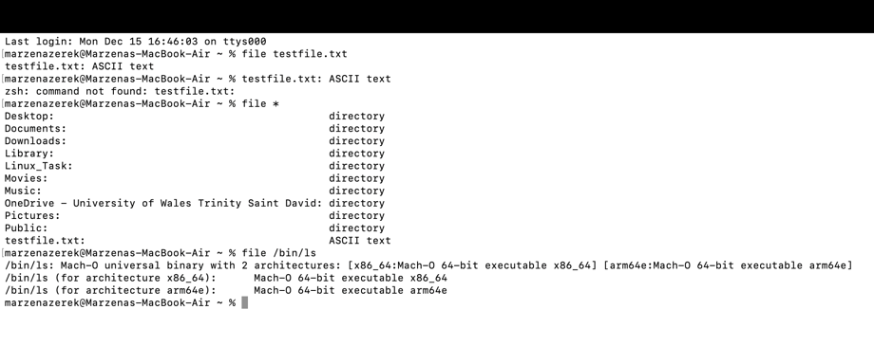
Fig 10: Determining File Types in Linux Using the file Command

4. Use of Windows OS scripts.
Directory navigation and File Listing

The first Windows Batch script was made to show how the Windows Command Prompt could be used to manage files and navigate the system. Batch scripting makes it possible to automate simple tasks by letting you run several commands in a single script file in order. The @echo off command at the start of the script makes the output cleaner by stopping command lines from showing up while the script is running. You can use the REM keyword to add comments that make it clear what the script is supposed to do.
The cd command shows the current working directory, which tells the user where they are in the Windows file system. The dir command then shows how Batch scripts can get and show information about the file system by listing all the files and directories in the current directory. This script shows some important parts of batch scripting, such as how to control output, browse directories, and run commands. The script showed how easy it is to run Batch files in Windows by running them straight from the Command Prompt without needing any extra permissions [25].

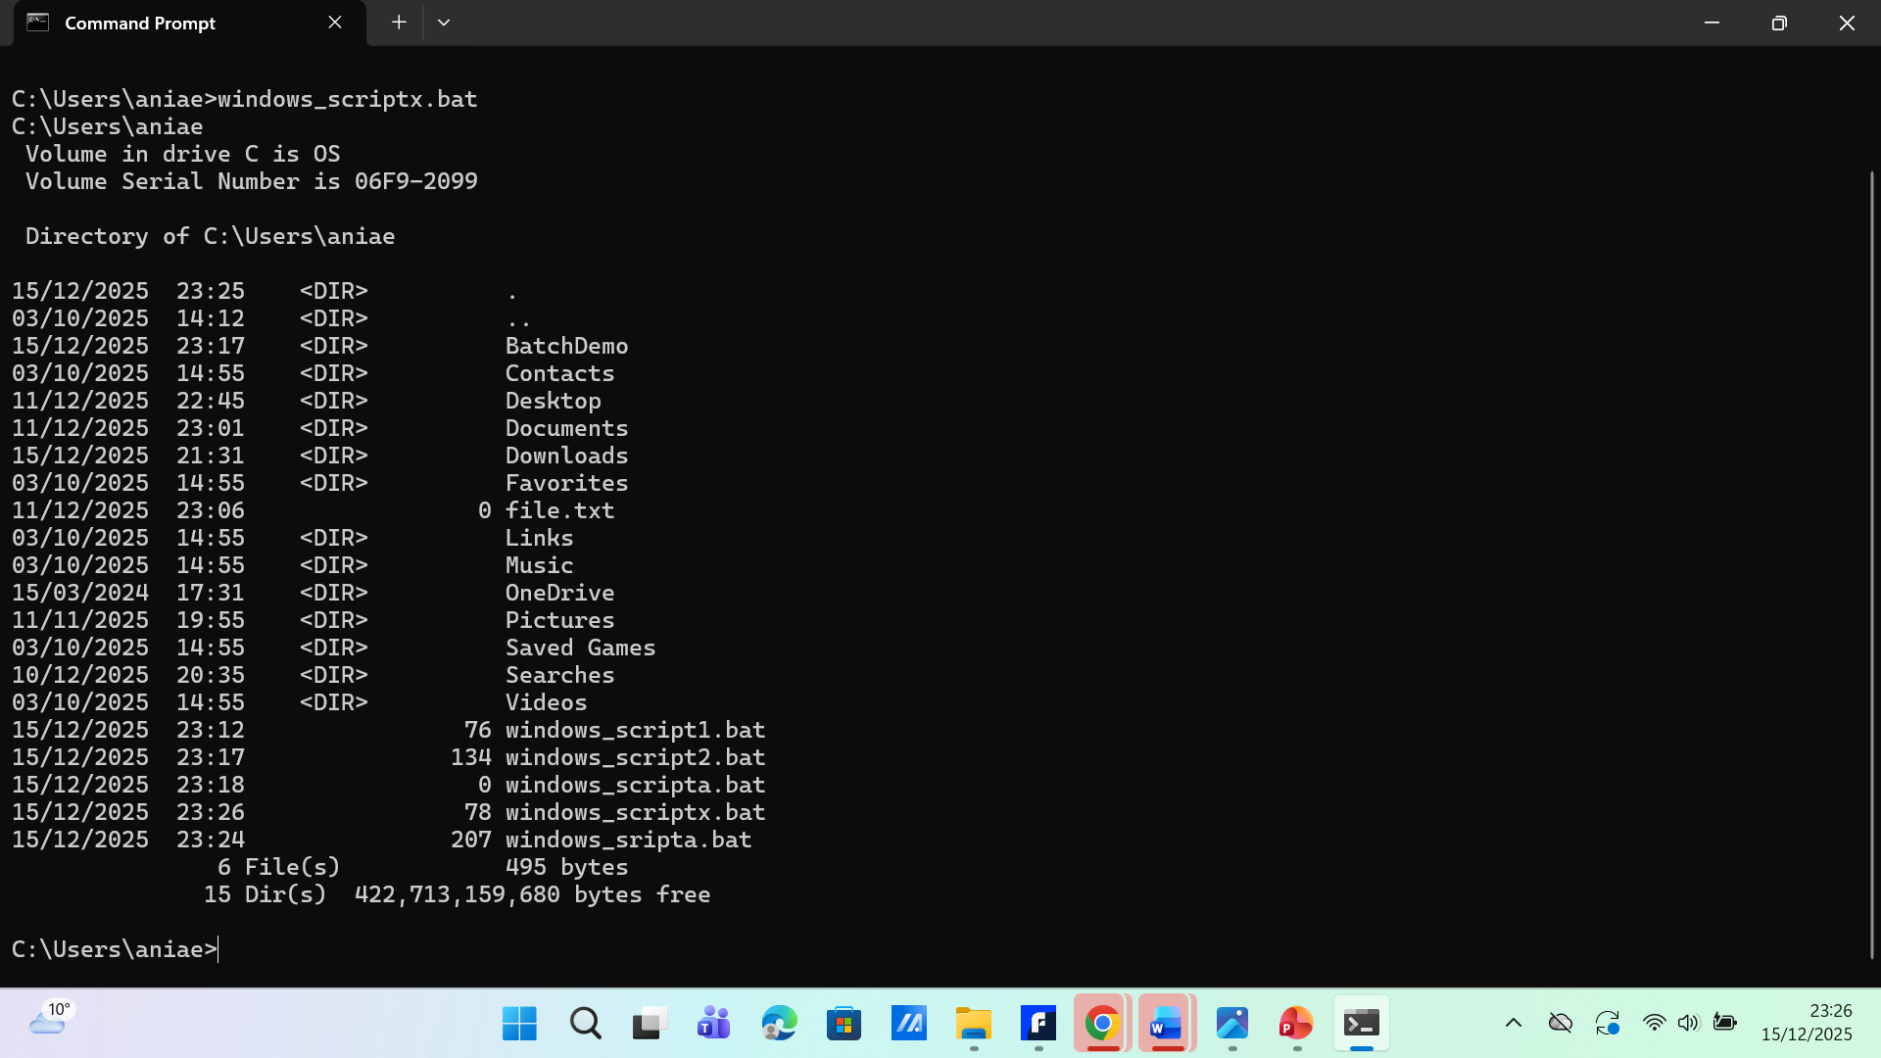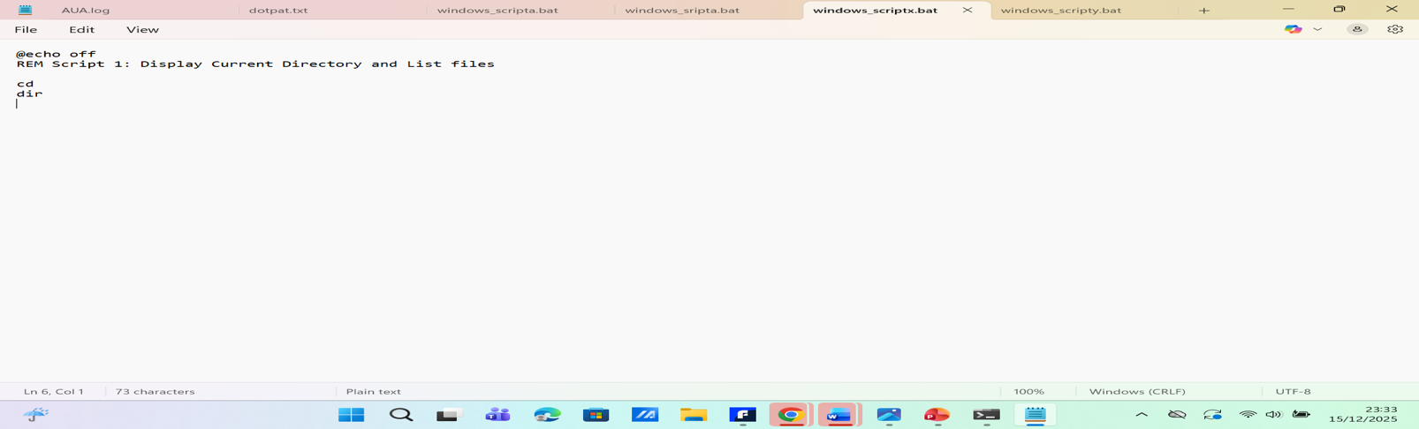

Windows Batch Script 2: User Interaction and Variable Handling

The second Windows Batch script shows off more advanced Batch scripting skills by adding variable management and user interaction. The set /p command in this script asks the user for personal information like their name, age, and gender. These inputs are stored in variables and used again later in the script to show how Batch scripts can work with and show data that users provide.
The script also gets system information by using the %date% and %time% environment variables to show the current date and time. The echo command takes care of formatting the output, making sure that the data is easy to read and understand. The pause command is added at the end of the script to give the user time to look at the output before the Command Prompt window closes. This script is a good example of how to use interactive scripting in Windows because it shows important Windows Batch scripting features like assigning variables, using environment variables, handling user input, and controlling when the script ends [26].

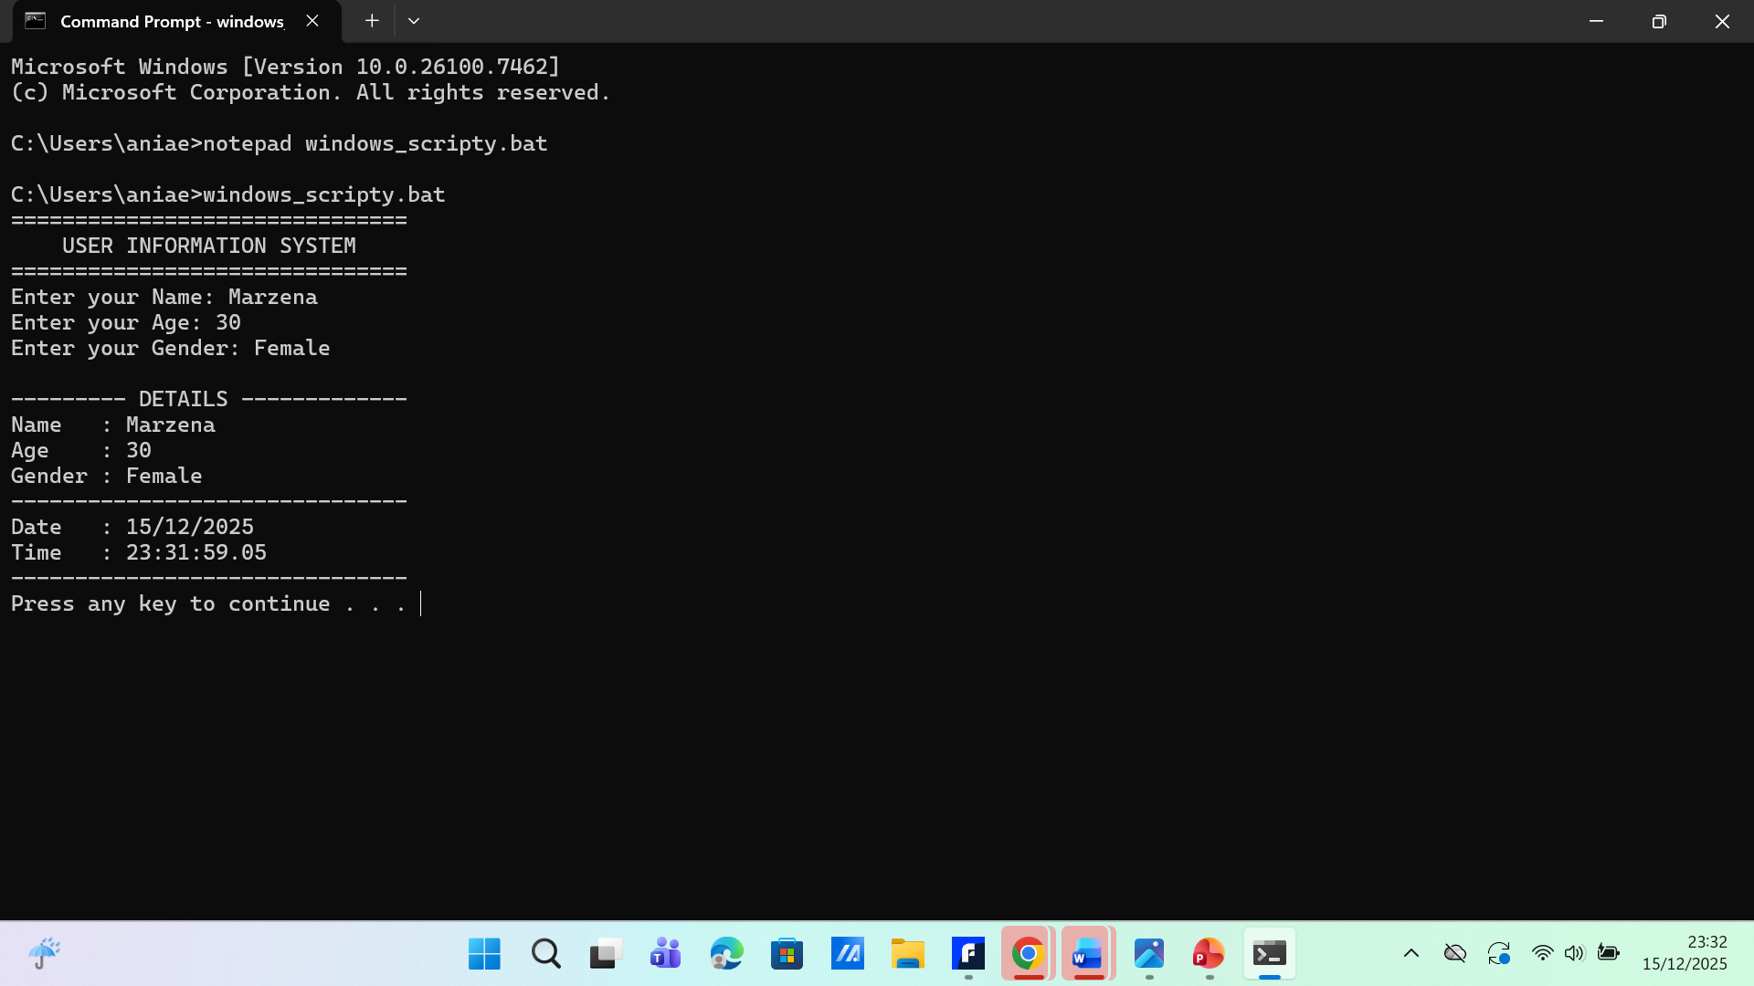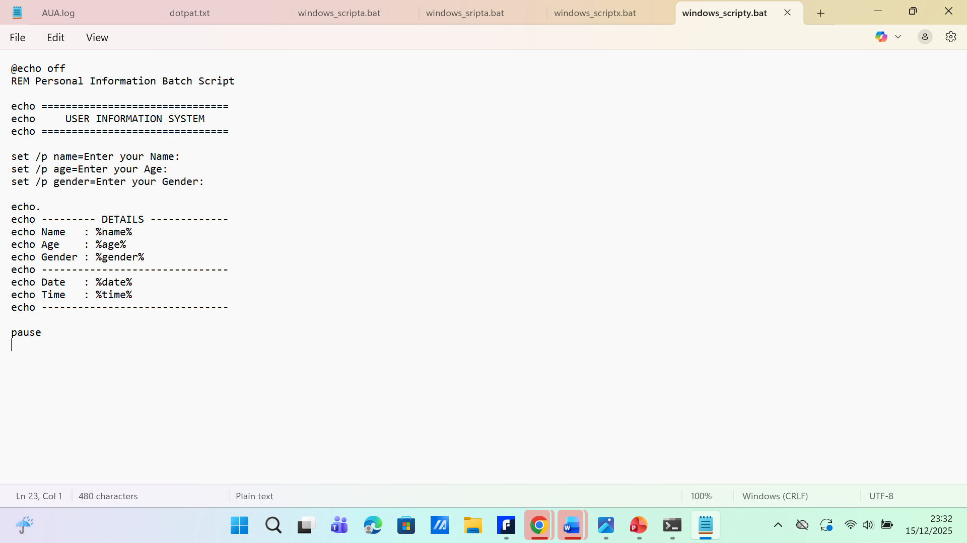

5. Use of Linux OS scripts.

Basic Bash Scripts Demonstration

The first Bash script was made to show how basic Linux shell scripting works in a Unix-based environment. Bash scripting is a Basic Part of Linux operating systems. It is often used to automate tasks that you do over and over again on the command line. The shebang line (#!/bin/bash) at the beginning of the script tells the Bash interpreter to run it correctly. This is an important part of Linux scripting because Linux scripts use interpreters instead of built binaries.
The script runs a lot of Linux commands that are used a lot. The pwd tool shows the current working directory, while the ls command helps users find their way around the file system by listing files and directories. The touch command makes a new file to show how to make files with scripts. The echo command prints a message to the terminal to confirm that the command was run. Adding the # sign to comments makes them easier to read and keep track of. We showed how to manage Linux file permissions and run scripts by making the script executable with the chmod +x command and then running it with ./script name [27].

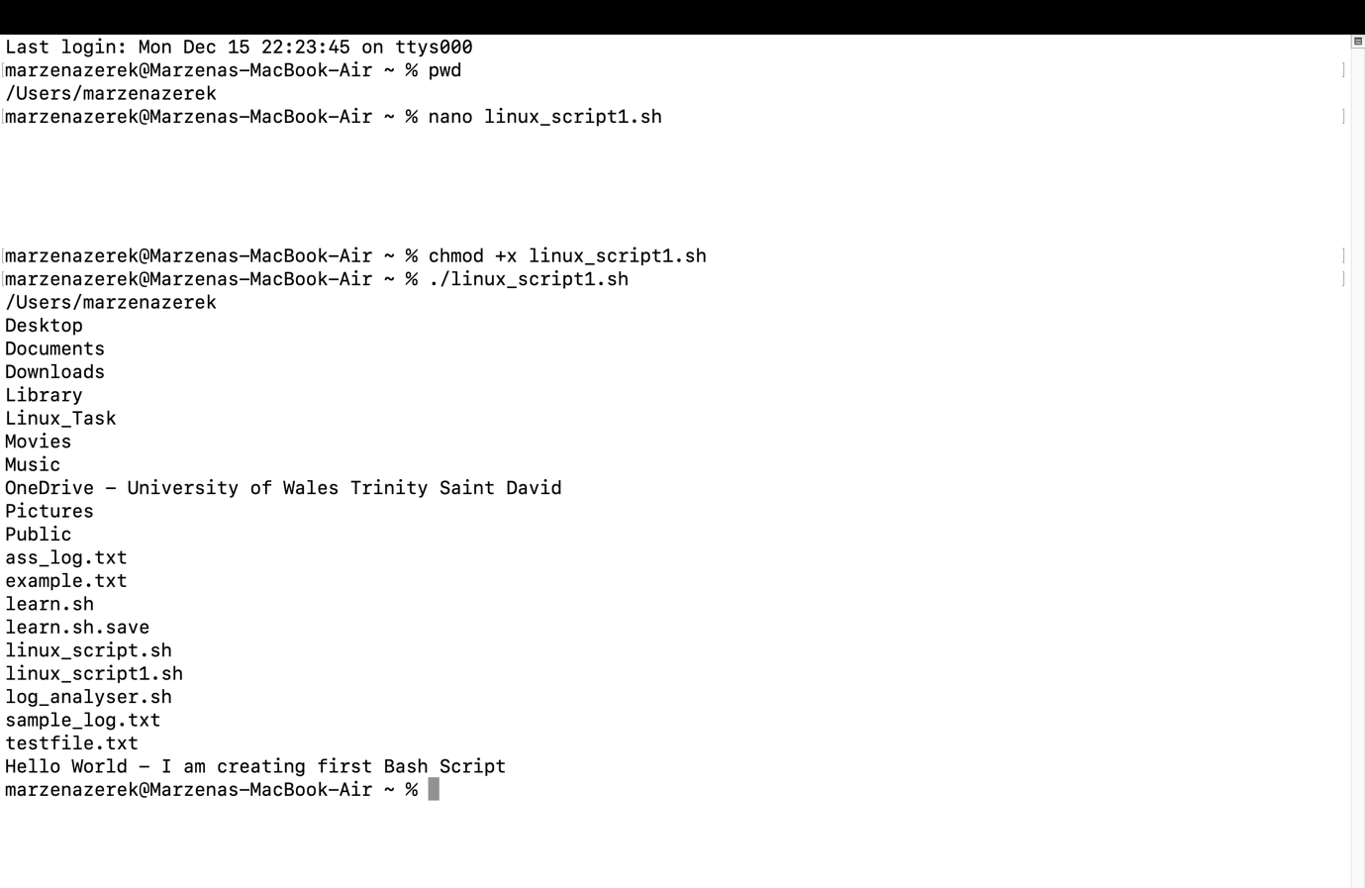

Log File Analyser Bash Script

The second Bash script is a log file analyser that shows off more advanced Linux scripting skills. Log analysis is an important administrative task that keeps track of what happens on a system and finds problems. This operation used a sample log file so that elevated system access wasn't needed. The script shows how to use variables in Bash scripting by putting the name of the log file in a variable.
The script shows how to use the wc-l command to count the total number of log entries in a file. The grep program and the -i parameter are used to search for error messages in the log file without caring about case. Using grep and wc-l together is a good way to count the number of error entries. This shows how command piping works. You can use echo statements to format the output so that the results are easy to read. The terminal was used to run the script, and chmod was used to give it permission to run, just like the first script. This script shows how to use important Bash features like file management, pattern matching, variables, and command chaining [28].

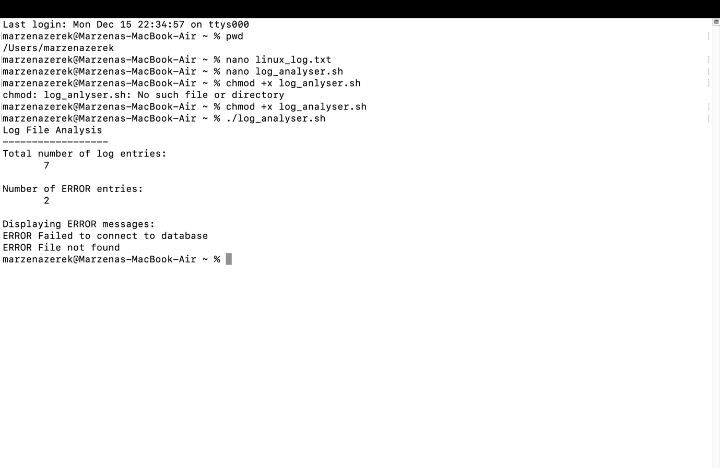

Conclusion:

In summary, this report has shown that an operating system is much more than just what you see on the screen; it’s the powerful engine running everything. We started with the basics, like how an OS handles tasks and memory. Then, we put that knowledge into practice by using the command lines in both Windows and Linux. This showed that both systems have amazing tools for automating tasks and taking control. The main point is to get the most out of a computer; it’s vital to understand how the OS works, from its basic jobs to its powerful command line tools.

Reference:

Bibliography

[1] | IBM Think, “What is an Operating System?,” IBM, [Online]. Available: https://www.ibm.com/think/topics/operating-systems?. [Accessed 26 october 2025].
[2] | W. Stallings, “Operating Systems: Internals and Design Principles,” Harlow, England, Pearson, 2018.
[3] | A. S. Tanenbaum and H. Bos, “Modern Operating Systems,” Harlow, England, Pearson, 2023.
[4] | A. Silberschatz, P. B. Galvin and G. Gagne, “Operating System Concepts,” Hoboken, NJ, Wiley, 2018.
[5] | Microsoft, “Windows Commands - dir command (PDF),” Microsoft Learn, 2025. [Online]. Available: https://learn.microsoft.com/pdf?url=https%3A%2F%2Flearn.microsoft.com%2Fen-us%2Fwindows-server%2Fadministration%2Fwindows-commands%2Ftoc.json. [Accessed 10 12 2025].
[6] | GeeksforGeeks, “Cd cmd command,” GeeksforGeeks, 30 September 2020. [Online]. Available: https://www.geeksforgeeks.org/operating-systems/cd-cmd-command/. [Accessed 10 December 2025].
[7] | Microsoft, “cd (chdir) command,” Microsoft Learn, 30 september 2020. [Online]. Available: https://learn.microsoft.com/en-us/windows-server/administration/windows-commands/cd. [Accessed 10 December 2025].
[8] | Microsoft, “cd (chdir) command,” Microsoft Learn, [Online]. Available: https://learn.microsoft.com/en-us/windows-server/administration/windows-commands/cd. [Accessed 10 December 2025].
[9] | Microsoft, “copy command,” Microsoft Learn, [Online]. Available: https://learn.microsoft.com/en-us/windows-server/administration/windows-commands/copy. [Accessed 10 December 2025].
[10] | Microsoft, “move command,” Microsoft Learn, [Online]. Available: https://learn.microsoft.com/en-us/windows-server/administration/windows-commands/move. [Accessed 10 December 2025].
[11] | Microsoft, “type command,” Microsoft Learn, [Online]. Available: https://learn.microsoft.com/en-us/windows-server/administration/windows-commands/type. [Accessed 10 December 2025].
[12] | Microsoft, “mkdir command,” Microsoft Learn, [Online]. Available: https://learn.microsoft.com/en-us/windows-server/administration/windows-commands/mkdir. [Accessed 10 December 2025].
[13] | Microsoft, “rd (rmdir),” Microsoft Learn, [Online]. Available: https://learn.microsoft.com/en-us/windows-server/administration/windows-commands/rd. [Accessed 10 December 2025].
[14] | Microsoft, “help command,” Microsoft Learn, [Online]. Available: https://learn.microsoft.com/en-us/windows-server/administration/windows-commands/help. [Accessed 10 December 2025].
[15] | GeeksforGeeks, “pwd command in Linux with examples,” GeeksforGeeks, 2025. [Online]. Available: https://www.geeksforgeeks.org/linux-unix/pwd-command-in-linux-with-examples/. [Accessed 15 December 2025].
[16] | M. Kerrisk, “ls(1) list directory contents,” Linux manual pages , man7. org, April 2025. [Online]. Available: https://man7.org/linux/man-pages/man1/ls.1.html. [Accessed 15 December 2025].
[17] | The Open Group, “cd - change the working directory,” The Open Group Base Specifications Issue 7, 2017. [Online]. Available: https://pubs.opengroup.org/onlinepubs/9699919799/utilities/cd.html. [Accessed 15 December 2025].
[18] | M. Kerrisk, “mkdir(1)- make directories,” Linux manual pages, man7.org, 2025. [Online]. Available: https://man7.org/linux/man-pages/man1/mkdir.1.html. [Accessed 15 December 2025].
[19] | Linuxize, “Linux Touch Command,” Linuxize, 10 May 2019. [Online]. Available: https://linuxize.com/post/linux-touch-command/. [Accessed 15 December 2025].
[20] | M. Kerrisk, “cp(1) - copy files and directories,” Linux manual pages, man7.org, 2025. [Online]. Available: https://man7.org/linux/man-pages/man1/cp.1.html. [Accessed 15 December 2025].
[21] | M. Kerrisk, “mv(1) - move (rename) files,” Linux manual pages, man7.org, 2025. [Online]. Available: https://man7.org/linux/man-pages/man1/mv.1.html. [Accessed 15 December 2025].
[22] | M. Kerrisk, “cat(1) - concatenate files and print on the standard output,” Linux manual pages, man7.org, 2025. [Online]. Available: https://man7.org/linux/man-pages/man1/cat.1.html. [Accessed 15 December 2025].
[23] | M. Kerrisk, “df(1) - report file system disk space usage,” Linux manual pages, man7.org, 2025. [Online]. Available: https://man7.org/linux/man-pages/man1/df.1.html. [Accessed 15 December 2025].
[24] | M. Kerrisk, “file(1) - determine file type,” Linux manual pages, man7.org, 2023. [Online]. Available: https://man7.org/linux/man-pages/man1/file.1.html. [Accessed 15 December 2025].
[25] | Microsoft, “Command-Line Reference,” Microsoft Learn, 2025. [Online]. Available: https://learn.microsoft.com/en-us/windows-server/administration/windows-commands/windows-commands. [Accessed 15 December 2025].
[26] | SS64, “Windows CMD Commands,” SS64, 2025. [Online]. Available: https://ss64.com/nt/. [Accessed 15 December 2025].
[27] | Linux manual pages, “bash(1) - GNU Bourne-Again SHell,” man7.org, 2025. [Online]. Available: https://man7.org/linux/man-pages/man1/bash.1.html. [Accessed 15 December 2025].
[28] | Z. .. Hira, “Bash scripting tutorial - Linux shell script and command line for beginners,” freeCodeCamp, 20 March 2023. [Online]. Available: https://www.freecodecamp.org/news/bash-scripting-tutorial-linux-shell-script-and-command-line-for-beginners/. [Accessed 15 December 2025].

