

STUDENT NAME: JANOSNE BARBARA HORVATH
STUDENT NUMBER: 2113586
MODULE CODE: BMSW4003_LON
MODULE TITLE: DIGITAL SKILLS AND RESEARCH METHODS
LECTURER’S NAME: SOBAN SADIQ
ASSIGNMENT TITLE: ASSESSMENT 2 INDIVIDUAL REPORT

TABLE OF CONTENTS
INTRODUCTION 3
BACKGROUND 4
AIMS AND OBJECTIVES 6
METHOD 7
RESULTS 8
DISCUSSION 12
CONCLUSION 14
REFERENCES 15
QUESTIONNAIRE 16

INTRODUCTION
Moodle the virtual learning environment platform is the place where students and teachers and other staff can interact and access the study material with other curriculum data. This platform is also used for submitting assignments for students.
Research Topic: To analyse the impact of Virtual Learning Environment (VLE) – Moodle on students’ learning experience at the University of Wales Trinity Saint David London Campus.
Research Purpose: This research is carried out to determine the influence of the virtual learning environment that is VLE in special relation to Moodle on the experience of learning of students studying in University of Wales Trinity Saint David London Campus.
Research Rationale: This research was carried out using both primary and secondary data collection methods. It is essential to explore virtual learning with advanced technologies and its impact on the student's learning for differentiating the pros and cons of the online teaching world.
Research Questions: The research questions for this study are:
- What will be the impact of using Moodle on students' growth and development?
- What are the pros and cons of Moodle- VLE?

BACKGROUND
Future of VLE
According to Rosyadi et al., (2021) Moodle is a virtual learning environment acronym for the modular object-oriented dynamic learning environment which is a platform for virtual online learning. It can be used by students and teachers to interact manage the courses, submit assignments and so on. According to the author, it contributes effectively to the educational experiences and provides a more flexible learning environment and allows the latest information from friends and teachers easily. However according to author Sarkhel, virtual learning will change the traditional educational system in future and soon the education system worldwide will shift to online learning to gain its advantages (Rosyadi et al., 2021). As per the views of Lacka and Wong (2021), modern and advanced technology connects societies to share resources in unique ways. Online education connects everyone regards their geographic location. Quality virtual learning courses or programs provide meaningful education and the resources for teaching and access to specialised programs for the students and teachers. The future of the virtual learning environment includes enhanced career and technical education, improved focus on competency-based learning, superior communication and collaboration between the pupils, recovered digital literacy, improved language learning and so on (Lacka and Wong, 2021).
Pros and cons of the virtual learning environment – Moodle
As per the views of author Dung (2020), COVID-19 has changed the traditional way of learning globally and students are shifting towards virtual learning. The major pros of using Moodle are it saves the individual from contacting each other physically to avoid the transmission of the virus, save the travelling time for learning and teaching, provides new ways of learning and teaching and offers extra time for self-study to students. However, the identified challenges or the cons of using this are it consumes excessive time digitally and creates barriers in interaction among the students and the teachers. To this author, Govindarajan and Srivastava (2020) said the technological advancement and the outcomes of the COVID-19 pandemic shifted society and its way of working to new heights. Virtual teaching and learning are an indicator of crisis but can be converted to a positive outcome (Dung, 2020).
According to Becerra-Romero et al., (2019), the major motive behind using Moodle is its low-cost accessibility and easy implementation. The author recommended individuals should be aware that Moodle is open source, has a great community, provides customization, is widely available, sells content online, is familiar and consists of loads of content. In the list of its advantages, it allows the various many kinds of content formats for the teachers and students to access and upload the available information. The disadvantages of Moodle are it is not completely developed with the ability to cope up with large files or big projects. This platform is useful for only small and medium-size colleges or universities as this will not work effectively for large universities (Becerra-Romero et al., 2019).
Management in Virtual teaching and learning
From the perspective of Pérez-Pérez et al., (2020) the high education is consisting of a strong management system for the procedure of teaching and learning. There are many impacts on the student's learning by using the virtual learning environment. The management system should be strong for successfully teaching outcomes. However, author Buntak et al., (2021) affirmed the expansion of higher new technologies and the execution of the same in all sectors of the person's existence particularly in education and teaching is vital to comprehend and admit. The perception of the online learning surroundings can improve and progress the excellence of learning and the course of action for education. Besides, it will decrease the price and improve the communication between the educator and pupil. Mefi and Asoba (2021) highlighted the quality virtual learning courses or the programs that provide meaningful education and the resources of teaching and access to the specialised programs for the students and teachers. Virtual classroom management tactics can be used the teachers are treating webcams like a person, putting the distractions away and addressing the issues related to discipline fast (Buntak et al., 2021).

AIMS AND OBJECTIVES
This research aims at determining the learning experience of students studying in the University of Wales Trinity Saint David London Campus by using Moodle – a virtual learning environment. The objectives of the study consist of:
- To explore the understanding of Moodle-VLE
- To classify the pros and cons of Moodle- VLE
- To evaluate factors influencing student’s experience of learning by Moodle platform

METHOD
The research method is the realistic approach to analyse the conclusion on any topic. It is the procedure used in identifying, selecting and analysing the data or the information required to the chosen topic or area of the subject (Nayak and Singh, 2021). The data is collected through both secondary data and primary data collection methods for analysing the impact of Virtual Learning Environment (VLE) – Moodle on students' learning experience at the University of Wales Trinity Saint David London Campus
Secondary data: It refers to the data collected from already existing sources; it may be books, articles, research papers and so on. In this research, secondary data is collected by reviewing the pre-existed kinds of literature (Nayak and Singh, 2021).
Primary data: It is the fresh new data collected at a time of research for recent and accurate answers. Primary data is collected through a questionnaire survey for which the sample size of 12 students at the University of Wales Trinity Saint David London Campus was approached. The review is done by a questionnaire for collecting the numerical data and information. It includes a set of questions to evaluate the responses on the topic of the research (Davis and Pimenta, 2021).
Sampling: For this survey using a questionnaire and determining the results Google form has been used by keeping the set of variables and constants for evaluating the variables.
Ethical considerations: To maintain the security and credibility of the information researchers are required to maintain ethical considerations. The Data Protection Act 2020 was made to secure the data and information given by the participants.

RESULTS
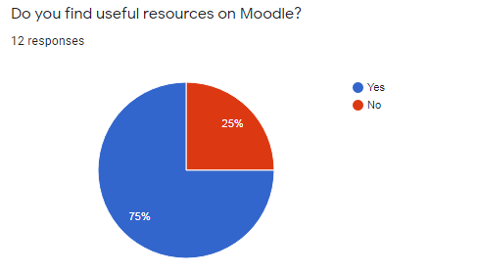
The above graph depicts 25% of 12 respondents did not find Moodle as a useful resource while 75% finds it useful in their education.
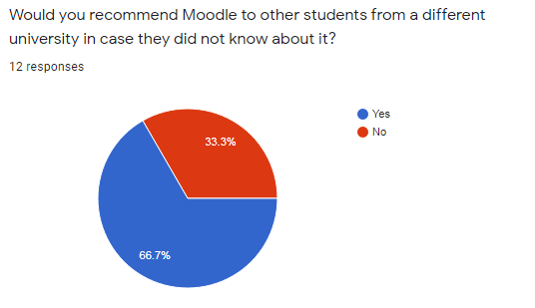
According to the above graph, 66.7% of students are ready to recommend Moodle to other students at different universities while 33.3% are do not want to recommend it.
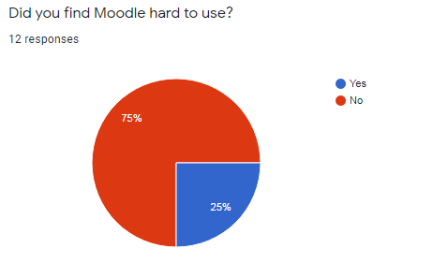
According to the respondents, 75% of students find Moodle easy to use and 25% find the platform difficult to use for learning.
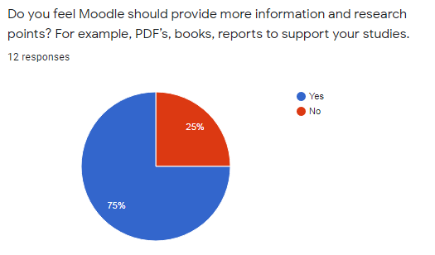
According to 75% of respondents, Moodle should provide more information like pdf and books while 25% of students do not feel Moodle requires providing more information.
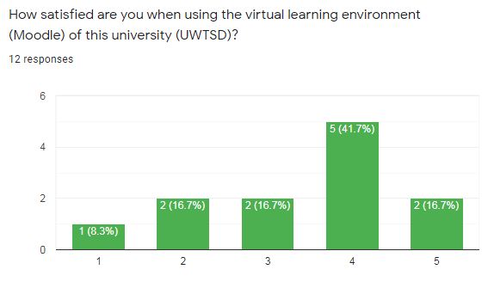
41.7% of students are satisfied using VLE and 16.7% students are very satisfied in using the Moodle while 8.3% students are very dissatisfied with it.
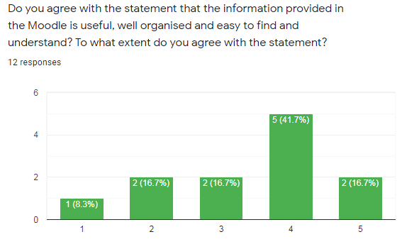
Out of 12 respondents, 2 are very satisfied with the statement that the information provided in the Moodle is useful, well organised and easy to find and understand, while 5 respondents are satisfied, and 1 student is very dissatisfied.

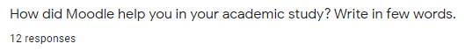
Through responses to this question, it is determined most of the students find Moodle is helpful in academic study because it has a user-friendly interface, easy to access and provides blended learning features.
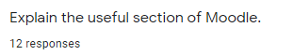
Most of the students find the hiding sections, editing sections and weekly format are useful sections of Moodle – VLE.

DISCUSSION
The questionnaire was designed to analyse the impact of the virtual learning environment special reference to Moodle VLE platform. The above analysis and interpretation show that 25% of 12 respondents that is 3 students did not find Moodle as a useful resource while 75% of students find it useful in their education. When asking about would you recommend Moodle to other students from a different university in case, they did not know about it, 33.3% of the respondents do not want to recommend it, maybe because they did not find it suitable for their learning and development (Davis and Pimenta, 2021). The result shows Moodle the useful section of Moodle are the sections for course setting, weekly format, editing sections and the hiding section. It depicts students are more concerned about scheduling their work weekly. Moodle helps the students in various divisions of their academic education. The reason behind it is its user-friendly interface, management of the content, features of the blended learning and easy access to throughout the platform. Students were asked about their satisfaction using the virtual learning environment, to this 41.7% of students are satisfied using VLE and 16.7% of students are very satisfied in using the Moodle while 8.3% of students are very dissatisfied with it. It is observed out of 12 respondents 2 are very satisfied with the statement that the information provided in the Moodle is useful, well organised and easy to find and understand, while 5 respondents are satisfied, and 1 student is very dissatisfied. It has been identified by research the major pros of using Moodle are it saves the individual from contact with each other physically to avoid the transmission of the virus, save the travelling time for learning and teaching, provides new ways of learning and teaching and offers extra time for self-study to students. However, the identified challenges or the cons of using this are it consumes excessive time digitally and creates barriers in interaction among the students and the teachers.
It is suggested that Moodle the virtual learning platform may be improved by teaching with consistency as the courses offered by Moodle are consistent it will allow the students to focus on their learning. Moodle can implement this by using the convention naming, providing clear and reliable instructions and showing the students the requirements for completing the course. By adding the variety for increasing the engagement by giving the personalised feedbacks to pupils by small audio or videos, encouraging the collaboration among the learners, using the video content to engage the students and interacting with them in a live chat. the quality virtual learning courses or the programs provide meaningful education and the resources of teaching and access to the specialised programs for the students and teachers. The future of the virtual learning environment includes enhanced career and technical education, improved focus on competency-based learning, superior communication and collaboration between the pupils, recovered digital literacy and improved language learning (Nayak and Singh, 2021).

CONCLUSION
The research concludes that the quality virtual learning courses or programs provide meaningful education and the resources of teaching and access to the specialised programs for the students and teachers. The future of the virtual learning environment includes enhanced career and technical education, improved focus on competency-based learning, superior communication and collaboration between the pupils, recovered digital literacy and improved language learning. 66.7% of students are ready to recommend Moodle to other students at different universities, while 33.3% are do not want to recommend it.

REFERENCES
Becerra-Romero, A., Díaz-Rodríguez, M. and González-Estrada, O.A. (2019). Development of a virtual learning environment for the subject Numerical Methods under Moodle. In Journal of Physics: Conference Series (Vol. 1161, No. 1, p. 012010). IOP Publishing.
Buntak, K., Mutavdžija, M. and Kovačić, M. (2021). Differences of E-Learning Systems With the Focus on Moodle and Blackboard Systems. International Journal of E-Services and Mobile Applications (IJESMA), 13(1), pp.15-30.
Davis, K. and Pimenta, J.M. (2021). Case studies: Examples from primary data collection. In Pragmatic Randomized Clinical Trials (pp. 427-442). Academic Press.
De Mey, K., OPEN MOODLE (VLE) LEARNING OBJECT AND REPORT.
Dung, D.T.H. (2020). The advantages and disadvantages of virtual learning. IOSR Journal of Research & Method in Education, 10(3), pp.45-48.
Govindarajan, V. and Srivastava, A. (2020). What the shift to virtual learning could mean for the future of higher ed. Harvard Business Review, 31.
Lacka, E. and Wong, T.C. (2021). Examining the impact of digital technologies on students’ higher education outcomes: the case of the virtual learning environment and social media. Studies in Higher Education, 46(8), pp.1621-1634.
Mefi, N.P. and Asoba, S.N. (2021). AN INVESTIGATION OF THE PERCEPTION OF OFFICE MANAGEMENT AND TECHNOLOGY STUDENTS ON VIRTUAL TEACHING AT WALTER SISULU UNIVERSITY IN IBIKA SITE. Academy of Entrepreneurship Journal, 27(3).
Nayak, J.K. and Singh, P. (2021). Fundamentals of Research Methodology Problems and Prospects. SSDN Publishers & Distributors.
Pérez-Pérez, M., Serrano-Bedia, A.M. and García-Piqueres, G. (2020). An analysis of factors affecting students perceptions of learning outcomes with Moodle. Journal of Further and Higher Education, 44(8), pp.1114-1129.
Rosyadi, B.R., Nisa, K., Afandi, I., Rozi, F., Fawaid, A., Fajri, Z., Hasanah, U. and Helmiati, S.S. (2021), February. Self-Regulation using Moodle Virtual Learning Environment (VLE) in Solar System Practice. In Journal of Physics: Conference Series (Vol. 1779, No. 1, p. 012072). IOP Publishing.
Sarkhel, J.K., Towards a Model for Large-scale Online Evaluation: Application of Moodle in Designing VLE.

QUESTIONNAIRE
- Do you find useful resources on Moodle?
- Yes
- No
- Would you recommend Moodle to other students from a different university in case they did not know about it?
- Yes
- No
- Did you find Moodle hard to use?
- Yes
- No
- Do you feel Moodle should provide more information and research points? For example, PDF's, books, reports supporting your studies.
- Yes
- No
- How satisfied are you when using the virtual learning environment (Moodle) of this university (UWTSD)?
- Very dissatisfied
- Somewhat dissatisfied
- Neither satisfied nor dissatisfied
- Somewhat satisfied
- Very satisfied
- Do you agree with the statement that the information provided in Moodle is useful, well organised and easy to find and understand? To what extent do you agree with the statement?
- Strongly agree
- Agree
- Neutral
- Disagree
- Strongly disagree
- How did Moodle help you in your academic study? Write in a few words.
- Explain the useful section of Moodle.

