

Unit Code: | BMMB7006D
Unit Title: | Global Business Challenges
Tutor’s Name: | Anthony Burns
Student Name: | Vicky Collard
Student Number: | 1709530

A critical assessment of the environmental forces currently impacting McDonald’s
Table of Contents
Executive Summary 3
Introduction 3
1 Critically evaluate the main features which contribute to the international business environment with the focus on macro-economic conditions 4
1.1 Macro-Economic Analysis 4
1.1.1 PESTLE Analysis 4
1.1.2 SWOT Analysis 9
2 Assess micro-economic structures with respect to decision making in global organisations 10
2.1 Micro-Economic Analysis 10
2.1.1 Porters 5 Forces 10
3 Critically evaluate issues in trade theory relevant for the conduct of international business and the internationalisation of organisations. 12
Conclusion 13
References 14
Appendix 1 16
Appendix 2 17
Appendix 3 18
Appendix 4 19
Appendix 5 20
Appendix 6 21

Executive Summary
The purpose of this report is to look at the macro and micro factors that affect McDonald’s international trading ability. Evidence suggests they are one of the largest fast-food brands in the world by operating out of 118 countries.
This report looks at a PESTLE analysis, SWOT analysis and Porter’s Five forces to identify the economic conditions for McDonald’s.
While there are a lot of factors which need to be looked at, McDonalds is able to overcome barriers such as culture and political to be the success that they are.

Introduction

Critically evaluate the main features which contribute to the international business environment with the focus on macro-economic conditions
Any actions involving trade and investment activities across national borders are referred to as International Business. A person’s quality of life and economic wellbeing is hugely affected by international business as it enables them to connect to the global economy and in doing so allows people to complete daily activities like browsing the internet, shopping, and watching a movie (Cavusgil et al., 2014).
The growth of the international business has been significantly larger than that of domestic economies. The digital economy continues to grow and through technology, businesses can reach further and can trade internationally with further growth in the future (Czinkota, Ronkainen and Gupta, 2021).
Social media is one of the platforms that has enabled the international business to increase rapidly. It gives businesses an insight by keeping an eye on global trends for various products (Nixon, 2021). It also allows businesses to market their plans through these platforms where they gain likes and comments on a worldwide level.

Macro-Economic Analysis
An organisation looks at the economy in general when looking at the Macro environment. These factors will affect all businesses and how they operate.
A PESTLE and SWOT analysis have been used to evaluate McDonald’s macroenvironment.

PESTLE Analysis
Political
As McDonald’s have locations in 118 countries around the world (FAQS | McDonald's UK, 2021), they must be aware of the political views and changes that can affect them in all the countries in which they operate from. In some countries the way they operate is controlled by the government which would make it difficult for some businesses to operate, countries like Bermuda have banned McDonald’s as they are against fast food.
When McDonald’s entered India in 1996 they were faced with the challenge that eating beef was not permitted. They encountered protesting and attacks on their branches. Initially, McDonald’s offered a vegetarian menu but due to the cultural difference and different communities, they realised they needed to change their approach. They adapted their burgers to suit the Indian taste and market ensuring that their products did not contain beef or pork. The aggressive expansion strategy used by McDonald’s allowed them to be successful in their attempt at establishing themselves in India. McDonald’s kiosks can be found in many schools and colleges and almost every food court (Tilwani et al., 2020).
There is a lot of pressure on fast food companies due to the amounts of salt and sugar found within their food which is linked to diseases such as heart disease and type 2 diabetes.
Children’s meals from McDonald’s, KFC, and Burger King were compared by experts at Chewgum.com to check the calorie content. McDonald’s were found to have had the highest average calories with 381.71 KCALS and four spoonsful of sugar in a meal, they were also found to have the highest fat content per serving (Hodge, 2020).
The most recent attempt by the UK government to tackle obesity is to ban junk food adverts appearing on TV before 9 pm (Parkinson, 2021). Businesses can still advertise using their websites, blogs, and social media pages. McDonald’s has a large social media presence with 4.1 million followers on Instagram and 81m likes on Facebook. While the ban will have some impact on McDonald’s ability to advertise, due to their social media presence it is unlikely to have an impact on the revenue. In August 2020, McDonald’s cut their media budget by 97% on TV, radio, outdoor, and cinema advertising due to coronavirus restrictions.
Economic
All countries have their own economy, and these will affect their companies and their success within that country.
A county’s economy is measured using the gross domestic product (GDP). This figure shows the value of the total economic activity within a country each year. Appendix 1 shows the current GDP growth according to the Organisation for Economic Co-operation and Development (OECD) and the expected growth over the next two years.
The global economy struggled because of the pandemic with many people having lost their jobs or had their wages cut. Appendix 2 shows the changes in unemployment from 2019 to 2020. The US was hit the hardest by unemployment (Jones, Palumbo, and Brown, 2021). The author is surprised to see the levels of unemployment as she works for the Local Authority and they have been experiencing difficulties in filling empty posts due to the lack of applications received for the posts, even those posts which don’t require any experience.
The recovery following the COVID-19 pandemic is continuing but some countries are recovering quicker than others. The countries recovering the slowest are those where vaccinations rates are lower. Food and energy prices have risen which means households have less disposable income to spend on things like fast food.
Bulgaria is one of the countries that are recovering slowly from the pandemic. Inflation continues to rise due to the increase in energy prices. Their inflation rate is expected to reach 2.25% in 2023 which is the highest rate since 2010 (Boone et al., 2021).
In 2020 McDonald’s had 41 (see Appendix 3) restaurants operating in Bulgaria out of a total of 9056 restaurants in Europe. Although McDonald’s is well established in Europe almost 37% of their restaurants worldwide are in the United States, which contributed almost $7.66 billion of McDonald’s global revenue of over $19 billion (Lock, 2021). With GDP growth set to strengthen further in 2022 and the improvement to public health in the US, an increase in the labour market should be seen. This should allow businesses to increase stock to allow for higher consumption by households (Boone et al., 2021). These improvements are set to strengthen McDonald’s position within the US.
Supply issues in the UK have been an issue due to the shortage of HGV drivers. McDonald’s had to remove bottled drinks and milkshakes temporarily from their menu due to supply chain issues
Fluctuation in currency and the constant changes in prices for raw materials means that McDonald’s would need to constantly look at different ways for procuring materials. Where possible the company purchases their goods in local currencies to avoid the exchange rates.
Social
In 2021 the World Health Organisation (WHO) reported that obesity figures had tripled since 1975. They state that the food industry can promote healthy diets by reducing fat, sugar, and salt content in their foods, affordable healthy choices are available (Obesity and overweight, 2021).
McDonald’s has been working with a 3rd party to change their Happy Meals to promote a balanced choice for children. They are continuing their focus on Happy Meals globally intending to deliver choices from recommended food groups with simpler, better-quality ingredients to encourage parents to feel good about giving their children a Happy Meal which they aim to achieve by the end of 2022. An interim report was published (see Appendix 4) showing the outcomes at that time (Nutrition & Marketing Practices, 2021).
The figures published by WHO reports that 39% of adults in 2016 were obese, meaning they are at risk of cardiovascular diseases, diabetes, and some cancers. With a higher percentage of adults being in this category, should McDonald’s be looking at the adult’s menu first? McDonald’s serve on average 3.8 million customers a day in the UK. Children are unable to go by themselves therefore there will likely be at least one adult with every child buying food. The cost of an adult’s meals is much higher than that of a Happy Meal. The author thinks it’s a clever strategy by McDonald’s as parents will be happy to see their children being looked after.
McDonald’s has seven core values (see Appendix 5), the first two are structured around their customers and staff.
McDonald’s is said to affect local cultures but as previously mentioned, McDonald’s showed their awareness of cultural diversity with how they established themselves in India. They did not force the people of India to change their views on their culture and religion instead they changed their menu to suit those in India. The same concerns were received by Israel when McDonald’s opened their first restaurant in 1993. However, McDonald’s arrival meant the revival of falafel and not its demise as was feared. Another issue McDonald’s endured was the increase consumption of meat by the Israelis. The hamburger supplied was smaller than that from Burger King. In 1998 McDonald’s increased their potion size by 25 percent to encourage consumers to eat their burgers (Ram, 2004).
The way McDonald’s adopted the cultures in India and Israel are just two examples of how they have succeeded in developing local products for local people. They work hard to create headquarters in varied locations for visibility.
Technology
There are many ground-breaking innovations that have taken the food industry by storm, some of which are:
Pay with your face
Customers will no longer have to deal with physical cash as facial recognition will be used to pay the bill. Facial recognition is the answer to minimise wait time and improve customer service.
Self-service through and through
Already adopted by most big players, 2019 was the year that saw self-service taking over. It was no longer be the norm to be greeted in person but instead a machine. The only efficiency needed is from the customer, to make sure they get their order right.
DIY online ordering
No longer a want but more a necessity, especially during the global pandemic, online ordering is a vital tool and using third party platforms like Grubhub or Uber Eats, are an easy solution for finding new customers and the system is already in place.
Line waiting optimisation
With point-of-sale technology, staff can get orders in and take payments from customers waiting in line. With people being so busy and sometimes impatient, this is a great way to turn something that is negatively perceived into a positive experience. (The Restaurant & Takeaway Innovation Expo, 2020)
In 2016, McDonald's introduced their 'Experience of the Future' strategy, and a vast array of different technologies were trialled in hundreds of establishments throughout the US. The technologies that increased customer satisfaction and the bottom line were then made into a permanent fixture.
By June 2017, Wall Street analysts recorded that McDonald's' stock was up by 26% YTD. McDonald's’ 'Experience of the Future' strategy looked into how their customers behaved and provided them with the key experience factors that altered customers’ satisfaction levels.
By McDonald's tapping into the use of mobile phones in modern society, they have managed to align their brand promise to people’s mobiles and as we know, phones can also integrate with other technologies.
The success of this strategy has been analysed, and when results were finalised, it revealed that technologies that affected certain areas the most were: lower waiting time, average order value, lower staff costs and increased order accuracy.
What can be taken from this, is that McDonald's are making life easier for customers by providing them with technologies that they know how to use.
An example of McDonald’s’ new technologies include their self-service or self-ordering kiosks, McDonald's started rolling out kiosks at its US locations in 2015, and the chain hasn't looked back since: by 2020, most of its 14,000 locations have kiosks installed (Business Insider, 2018).
It plans to add the kiosks to 1,000 stores every quarter for the next two years, according to CNBC.
Legal
2020 has been a rough year for McDonald's, and not just because of the pandemic. The fast-food giant has been plagued with lawsuits brought by employees, franchisees, and investors over alleged improprieties, including racial discrimination and sexual misconduct. The company has also drawn its fair share of bad press relating to its menu items and related marketing strategies, as well as its supply chain.
One of the most recent high-profile cases was back in late 2019 when McDonald's fired its then-CEO, Steve Easterbrook, for cavorting with a female employee (BBC.CO.UK, 2019). Easterbrook at the time, admitted his relationship with that employee reflected poor judgment. The company terminated Easterbrook "without cause," enabling Easterbrook to receive a generous severance package. The day after Easterbrook's ouster, the head of human resources resigned amid rumours that he and Easterbrook had cultivated a corporate "party culture" involving booze-fuelled outings at which high-level executives would drink heavily and sometimes ended up in compromising positions with staffers. (Elsesser, 2020)
By August of 2020, McDonald's had learned of at least three more employees with whom Easterbrook had affairs, and that there were photos and emails backing up the claims. Furthermore, one of those employees had leveraged her sexual relationship with Easterbrook into a stock option award worth hundreds of thousands of dollars, which, from a legal standpoint, would mean that McDonald's was showing preferential treatment to employees who capitulated to the "macho guy" culture.
Easterbrook's severance package was worth more than $40 million, McDonald's has since sued Easterbrook for the return of the severance package, which the company claims it would never have agreed to had it known all the facts (Enrich and Abrams, 2020). In December 2020, a group of investors called for the resignation of two members of the Board of Directors for "bungling" the initial investigation that led to the decision to pay Easterbrook severance, according to Bloomberg News (Cahn, 2020)

Environmental
McDonald’s is using innovative ways to help and protect the planet. They are working with suppliers and farmers around the world to target the reduction in emissions to help with climate change as they are the first global fast-food company to set a target. In 2021 they opened their first ever net zero emissions restaurant which is in Shropshire (Ng, 2021).
New packaging and recycling options are being tested around the world to help reduce packaging and to encourage customers to recycle.
Saving water in irrigation, public and staff services, cleaning and beverage services has been identified and prioritised by McDonald’s. They have partnered with World Wildlife Fund (WWF) the World Resources Institute, partners, and suppliers to develop a better way to protect the resource.

SWOT Analysis
Strengths
McDonald’s is one of the leading brands throughout the world of fast food with 34,000 restaurants worldwide. As shown in Appendix 6 their global brand value is almost $155 billion US dollars. There was a 20% increase from 2020 to 2021. They were reported as the most valuable food brand in the world in 2021 (Lock, 2021).
They are diverse with their menu options. They adapt their menu to appeal to the taste of the country which they are in. They also offer meat, vegetarian and vegan options in all stores while respecting cultural differences. Each country has their own policy for creating menu items.
McDonald’s offers items at a cheaper price known as their saver menu. It offers items to customers at a more affordable price which appeals to those with less disposable income like students. Within the UK they offer seven burgers, fries, salad as meal options and ice cream as a desert option in their saver menu.
According to McDonald’s website they have competitive rates of pay with all salaried employees earning above the national minimum wage. They have training and leadership development programs to help their employees to grow within the company. McDonald’s have more than seven Hamburger Universities around the world which are used to train employees. Students are taught leadership skills, operational procedures, and business growth I preparation for a job in management (Parker, 2015).
Weakness
While the saver menu is considered a strength, unfortunately for vegetarians and vegans the only meal options available to them are fries and salad which is a weakness for the saver menu in the UK.
In 2015, employees filed 28 health and safety complaints against McDonald’s due to suffering from serious burns in the US. It was alleged that the burns were caused because of understaffing and pressures to perform their tasks quicker. It was also alleged that managers lacked the first aid supplies to treat the burns and told workers to use condiments instead. In a survey carried out by Heart Research, four out of five workers had suffered from burns while working. 58% of the workers surveyed claimed to have been burnt on multiple occasions due to work pressures and understaffing (Kasperkevic, 2015).
Opportunities
McDonald’s can expand their current menu to encourage more customers to use them. The introduction of healthier menu options for adults to promote healthy eating, expand the side choices in the UK as currently there is only an option of fries or salad which isn’t a good range. If they want to cater to more diverse groups, they need to expand their Vegan and Vegetarian options, especially in the saver menu to encourage others to eat at McDonald’s. They have recently announced the rollout of the McPlant burger which took the company three years to develop, the new menu item was well received since the trial began in September 2021 which prompted the decision to roll it out to all branches. (Eklund, 2022).
In some areas, delivery is only available from providers such as JUSTEAT and UBEREATS. McDonald’s can improve the delivery service by possibly bringing the function in house.
Threats
Rival fast food companies are a threat to McDonald’s and how they operate needs to be looked at closely.
McDonald’s must deal with cultural threats as they operate globally, and different countries have different beliefs. In 2019 they faced boycott in India after announcing that all their restaurants within the country served Halal meat. As India is made up of 80% Hindu and 14% Muslim some believed they were putting the needs of the few ahead of the needs of many (Kuchay, 2019).

Assess micro-economic structures with respect to decision making in global organisations

Micro-Economic Analysis
The Microenvironment of an organisation are things that have a direct impact on how they operate and their performance.
Porter’s Five Forces is a model used to evaluate a company’s competition which is part of the microenvironment. An organisation can change their strategy by using the model in a bid to stay ahead of their competitors.

Porters 5 Forces
Competitive Rivalry
Due to the number of fast-food providers, McDonald’s face tough competition within the market and therefore competitive rivalry is a strong force to contend with.
Their competitors range from Burger King, Pizza Hut, Subway as well as small independent restaurants found within the countries where they trade.
As of November 2019, Subway was reported as being the largest restaurant chain in the world with 41,500 locations worldwide, McDonald’s was reported as the second largest with 37,900 locations worldwide (Top 10 Largest Fast-Food Chains in the World, 2021). In terms of revenue Starbucks is reported as the number one restaurant with a turnover of £29,542M turnover in 2021 with McDonald’s reports as the second with £26,006M. While both Starbucks and Subway have claimed the number one spots for largest and highest revenue, the author does not think the products they supply compete with McDonald’s. Subway is known for their foot long bread rolls while Starbucks is known for their coffee. The closest competition in terms of revenue concerning the types of products sold, the author would say is Burger King (Restaurants 25 2021 | Brand Value Ranking League Table | Brandirectory, n.d.).
McDonald’s can compete with their rivals by keeping their prices down. They can do this by buying in bulk. In 2015 CBC reported that McDonald’s were the largest purchaser in the world of beef, port, potatoes lettuce and tomatoes and the second largest buyer of chicken behind KFC (Nowak, 2015). As a result, suppliers can offer them discount on products which in turn means they can keep their prices down. McDonald’s have also established partnerships with companies such as Coca-Cola who have been their soft drink provider for decades.
The threat of entry
Some industries will have issues that those wanting to enter the industry will need to overcome before they can compete. With the size of the fast-food industry and the large scale which McDonald’s operate, it would be difficult to enter and expensive for them to reach the same level of supply. With McDonald’s being the largest purchaser of most of their products in the world it would be difficult for a new entry to access the same or similar suppliers at the same rates to be able to compete on prices.
The governments opinions in different countries about the dangers of fast food and the health risks associated would mean that anyone wishing to enter the market would have difficulty, finding ways to overcome these risks would likely be costly. Lots of research would be needed to find ways to reduce things like sugar and fat content in their food. With McDonald’s also committed to introducing healthier options and the research they have already done a new business would likely find it difficult to compete.
New entrant could face opposition from McDonald’s and other current fast-food suppliers. They could change their prices to make their products more appealing or introduce other items to keep their existing customers.
The threat of substitutes
There are lots of substitutes for McDonald’s from suppliers like KFC and Dominos who are fast food restaurants but offer different menu options. Local restaurants and bakeries are also a threat to McDonald’s. It doesn’t cost the customer anything more than the cost of the food to buy from an alternative. Not only is it a threat that customers will buy from elsewhere, but they could also choose to make for themselves at home. The threat of substitutes is a strong force.
The threat of substitutes will force an organisation to look further than their nearest rivals.
The power of buyers
As previously mentioned, McDonald’s customers would find it easy to switch to a different fast food restaurant for their meal. The number of different options available to customers makes the buyer power a strong force.
Not only is the option to go elsewhere a threat but a customer can buy food from a shop and make it themselves making the force more powerful.
The health risks often associated with fast food is another reason that customers may choose to stop buying from McDonald’s and to find alternative healthier options.
The Power of Suppliers
If there were only a few suppliers for McDonald’s to purchase their materials from the supplier power would be high but with a large volume of suppliers available and the amount which are purchased the supplier power is low with McDonald’s.
The Partnership’s that McDonald’s have built up over the years with their suppliers gives the suppliers security and confidence and they can assure that there will be an ongoing supply of goods to McDonald’s.
With the effects of COVID and Brexit in the UK the supplier power has increased due to the shortage of HGV drivers and some materials which are needed outside of the UK.

Critically evaluate issues in trade theory relevant for the conduct of international business and the internationalisation of organisations.
International trade theories are different theories to describe international trade. The exchange of goods between people from two different countries is known as international trade. It allows countries to have access to goods and services which would not be available in their own countries. The differences in countries around the world is due to the availability of different resources within the different countries.

Conclusion
McDonald’s operates effectively around the world and makes the necessary changes needed to continue their success. They are innovative when needed to encourage their customers to continue to use them.

References
All Top Everything. (2021). Top 10 Largest Fast Food Chains in the World. [online] Available at: <https://www.alltopeverything.com/largest-fast-food-restaurant-chains/> [Accessed 6 January 2021].
Baron, D. P. (1995) ‘Integrated Strategy: Market and Nonmarket Components’, California Management Review, 37(2), pp. 47–65. doi: 10.2307/41165788.
Boone, L., De Mello, L., Pereira, A., Koske, I., De Serres, A. and Pain, N., (2021). OECD Economic Outlook. OECD Economic Outlook, 2021(2).
Brandirectory.com. n.d. Restaurants 25 2021 | Brand Value Ranking League Table | Brandirectory. [online] Available at: <https://brandirectory.com/rankings/restaurants/table> [Accessed 6 January 2022].
Cahn, L., (2020). 9 Biggest McDonald’s Controversies of 2020 — Eat This Not That. [online] Eat This Not That. Available at: <https://www.eatthis.com/biggest-mcdonalds-controversies/> [Accessed 7 January 2022].
Cavusgil, S., et al. (2014) International business. Pearson Australia
Corporate.mcdonalds.com. 2021. Nutrition & Marketing Practices. [online] Available at: <https://corporate.mcdonalds.com/corpmcd/our-purpose-and-impact/food-quality-and-sourcing/nutrition-and-marketing-practices.html> [Accessed 6 December 2021].
Czinkota, M., Ronkainen, I. and Gupta, S., (2021) International Business. 9th ed. Cambridge University Press.
Eklund, Z., (2022). McDonald's makes big change to their menu across UK adding permanent new burger. [online] mirror. Available at: <https://www.mirror.co.uk/money/mcdonalds-makes-big-change-menu-25861415> [Accessed 7 January 2022].
Hodge, L., (2020) Shock research reveals just how much sugar is in McDonald's Happy Meal. [online] Daily Record. Available at: <https://www.dailyrecord.co.uk/news/scottish-news/shock-research-reveals-just-how-22546269> [Accessed 5 January 2022].
Jones, L., Palumbo, D. and Brown, D., (2021). Coronavirus: How the pandemic has changed the world economy. [online] BBC News. Available at: <https://www.bbc.co.uk/news/business-51706225> [Accessed 6 December 2021].
Kasperkevic, J., (2015). McDonald's workers told to treat burns with condiments, survey shows. [online] the Guardian. Available at: <https://www.theguardian.com/business/2015/mar/16/mcdonalds-workers-treat-burns-condiments-osha-complaints> [Accessed 7 January 2022].
Kuchay, B., (2019). McDonald’s faces boycott threats in India for serving halal meat. [online] Aljazeera.com. Available at: <https://www.aljazeera.com/economy/2019/8/26/mcdonalds-faces-boycott-threats-in-india-for-serving-halal-meat> [Accessed 7 January 2022].
Lock, S., (2021). McDonald's restaurants by country Europe 2020 | Statista. [online] Statista. Available at: <https://www.statista.com/statistics/256044/mcdonalds-restaurants-in-europe/> [Accessed 5 January 2022].
Lock, S., 2021. Most valuable QSR brands worldwide in 2021. [online] Statista. Available at: <https://www.statista.com/statistics/273057/value-of-the-most-valuable-fast-food-brands-worldwide/> [Accessed 7 January 2022].
McDonalds (2012) Code Of Conduct. Available at: <https://corporate.mcdonalds.com/corpmcd/our-purpose-and-impact/food-quality-and-sourcing/nutrition-and-marketing-practices.html> [Accessed 6 December 2021].
Mcdonalds.com. (2021) FAQS | McDonald's UK. [online] Available at: <https://www.mcdonalds.com/gb/en-gb/help/faq/18525-what-countries-does-mcdonalds-operate-in.html> [Accessed 4 December 2021].
Ng, K., (2021). McDonald’s opens its first-ever net zero emissions branch. [online] The Independent. Available at: <https://www.independent.co.uk/climate-change/sustainable-living/mcdonalds-net-zero-branch-market-drayton-b1973524.html> [Accessed 7 January 2022].
Nixon, R., (2021) How is technology affecting the growth of international business? Real Business, [online] Available at: <https://realbusiness.co.uk/technology-affecting-growth-international-business> [Accessed 10 October 2021].
Nowak, P., (2015). 75 years later, McDonald's continues to shape the way we eat | CBC News. [online] CBC. Available at: <https://www.cbc.ca/news/business/how-mcdonald-s-has-shaped-the-food-biz-1.3074081> [Accessed 6 January 2022].
Parker, L., (2015). McDonald's Hamburger University exists and it's harder to get into than Oxford or Cambridge. [online] Mirror. Available at: <https://www.mirror.co.uk/news/uk-news/mcdonalds-hamburger-university-exists-its-6701321> [Accessed 7 January 2022].
Parkinson, J., (2021) Anti-obesity drive: Junk food TV adverts to be banned before 9pm. [online] BBC News. Available at: <https://www.bbc.co.uk/news/uk-politics-57593599> [Accessed 5 December 2021].
Ram, U. (2004) ‘Glocommodification: How the Global Consumes the Local - McDonald’s in Israel’, Current Sociology, 52(1), pp. 11–31. doi: 10.1177/0011392104039311.
Regner, P, Johnson, G, Regner, P, Johnson, G, & Scholes, K (2019), Exploring Strategy Text and Cases PDF EBook, Pearson Higher Education & Professional Group, Harlow, United Kingdom. Available from: ProQuest Ebook Central. [7 January 2022].
Tilwani, S., Patel, V., Singh, S., Singh, M. and Goyal, N., (2020). A Study of the Challenges faced by McDonald's while entering the market of India. International Journal of Creative Research Thoughts, 8(4).
Who.int. (2021). Obesity and overweight. [online] Available at: <https://www.who.int/news-room/fact-sheets/detail/obesity-and-overweight> [Accessed 6 December 2021].

Appendix 1
(Jones, Palumbo, and Brown, 2021).

Appendix 2
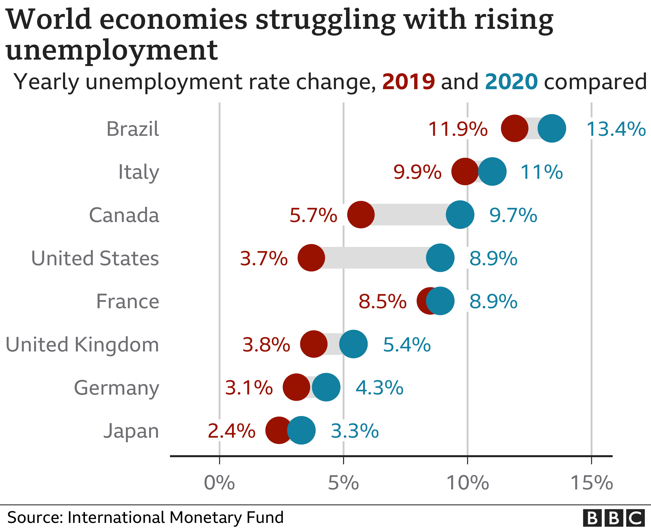

(Jones, Palumbo, and Brown, 2021).

Appendix 3
(Lock, 2021).

Appendix 4
(Nutrition & Marketing Practices, 2021).

Appendix 5

Appendix 6
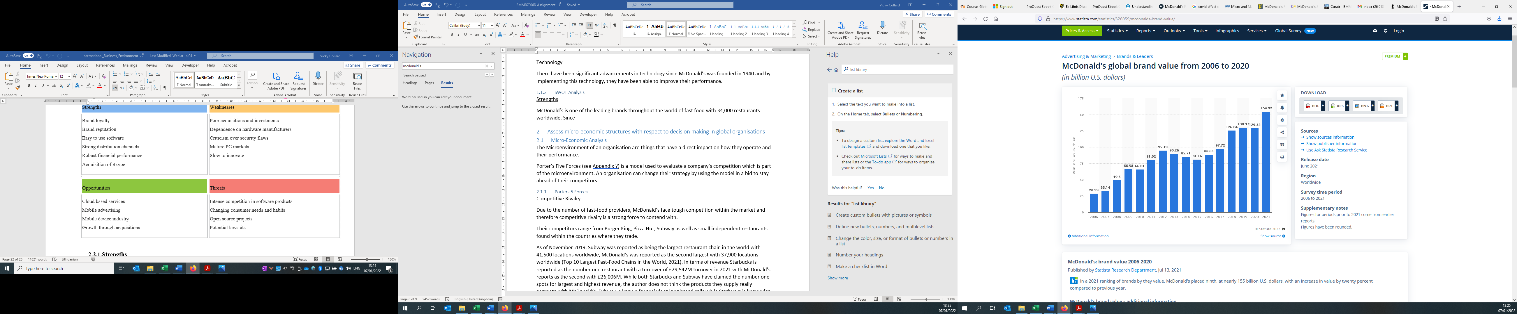
(Lock, 2021).

