University Of Wales Trinity Saint David

Wales institute of science and arts



Project Planning

Engineering Management (ACHA5012)

Jacob Christian Jones

2005053

November 2023

Table of contents

Table of Contents
Table of contents 2
1 Introduction 3
2 Roles and Responsibilities 4
2.1 Skills and Personality traits 5
3 Overall tasks and timings 6
4 Detailed list of my tasks 7
4.1 Bill of materials 9
5 Milestones 10
5.1 Gateway objective 10
6 Areas of concern 11
7 Gantt chart 12
References 13

1 Introduction

The Institution of Mechanical Engineers (imeche) has tasked universities across the country to compete in a design challenge consisting of the creation of a repeatable autonomous vehicle. The Mechanical, energy and environmental and mechanical and manufacturing streams in UWTSD have been chosen to compete in this year’s competition as a group of 5. In the group we have 3 students from the mechanical stream and 2 from energy and environmental. This provides the group with varied ideas coming from different engineering backgrounds to ensure all possible designs and manufacturing processes are considered.

The challenge set by the imeche requires the vehicle to travel to a vertical barrier at 3 ranges of length in separate runs. The three lengths are as follows: Short range: 1.4m-2.4m, medium range: 2.4m-3.2m and long range 3.2m-4.0m (imeche,2023). The aim is to travel to the vertical barrier, stop instantaneously using some form of braking system and then return to its original location. The starting location is marked by a bullseye of four colours, with each colour corresponding to a value. Our aim is to complete the run correctly and score high upon return whilst impressing the judges with the design of the vehicle. The vehicles performance will give us an inkling on how successful we have been as designers.

2 Roles and Responsibilities

Max Oliver – Accuracy and Control

Max’s role within our group consists of programming the accuracy and control of our vehicle. His role requires him to research and decide on what accuracy system the vehicle will need for when it must stop at the targets/barriers in the challenge. He must also take charge of what control system will be in place.

Morgan Davies – Energy and environmental ability of the vehicle

Morgan is tasked with making our project as environmentally friendly as possible. As noted in the introduction, our group contains 2 energy and environmental engineering students meaning it would be best to use their skills to try and make our vehicle environmentally friendly. He will do this by researching alternative energy sources, rather than alkaline and lithium batteries used in previous competitions.

Dewi Miller – Movement of vehicle and Solidworks design

Dewi oversees the movement aspect of our vehicle. He will decide what form of movement system will be used i.e. Four wheels, two wheels, tracks etc. He must research previous designs to inspire some ideas for our project. He is also in charge of generating the solidworks designs and engineering drawings.

Ben Slade – Propulsion systems

Ben is in charge of researching and selecting the propulsion system for our vehicle. He must research previous competition entries to gain inspiration but also keep the environmental aspect in mind. The systems chosen must also comply with the rules and regulations of the design challenge.

Jacob Jones – Material selection and budgeting

My role within the group will be to research possible materials that could be used in our final design. I must determine whether a material is suitable for our project by analysing its positives and negatives. Once I have decided on a material, I will contact the group and review their thoughts on the chosen material. When we have all agreed upon a material, my role will require me to source the product whilst being money savvy.

2.1 Skills and Personality traits

As written in the roles and responsibilities section of this report, I have been tasked with the research and sourcing of materials. I am also in charge of ensuring as a group, we do not exceed the budget. I must research all possible materials that could be used in all components of our vehicle, from the chassis to the wheels and so forth. Once a material is decided upon by the whole group, I am tasked with sourcing the material. This also consists of sourcing the motor and electronic systems used. I will look at suppliers close to our area as this will reduce costs wasted on deliveries and reduce the carbon footprint of our project. Communication will be key when sourcing the components for other members of the group. It must be clearly discussed what components are needed at certain milestones of the project for me to order them within that timeframe.

My role requires a wide-ranging array of skills and key personality traits for the role to be carried out correctly and efficiently. An example of a skill required is great organizational skills. A budgeting role withing a group must be organized throughout. A lapse in concentration when dealing with the groups budget could have large consequences. I am confident that I will be able to stay organized throughout the project. I will do this by taking notes of any work done, record times at which I have been researching and noting every helpful resource I find for further down the line. A personality trait that is key for my role is the ability to think strategically. When selecting a material for a final design or prototype, my role will require me to strategically think and plan how the material will fix together, be machined, react with other materials etc. I must carry out extensive research on all the above listed. I would consider that as strategically thinking.

An efficient method of deciding upon what role is best fit, is the Belbins model. The Belbins model is a self-perception inventory developed by DR R Meredith Belbin. It is designed to give participants a method of assessing their contributions to a team and role deciding. We completed this inventory in class. I scored high in three skills, implementer, shaper and monitor evaluator all with a score of 14. I feel that the implementer and monitor evaluator skills apply the best to my role. An implementer plans a workable strategy and efficiently carries out that task. Their strengths consist of being very reliable and practical. A weakness of being an implementer is that they might not be too confident with changing their idea until it is necessary. (Belbin, The nine belbin team roles 2023). The second skill I scored very high in was the monitor evaluator. This skill allows me to provide logical decisions without any bias involved. A monitor evaluator sees all options available and strategically judges. A weakness of being a monitor evaluator is that I might be overly critical when it comes to others’ ideas. (Belbin, The nine belbin team roles 2023).

3 Overall tasks and timings

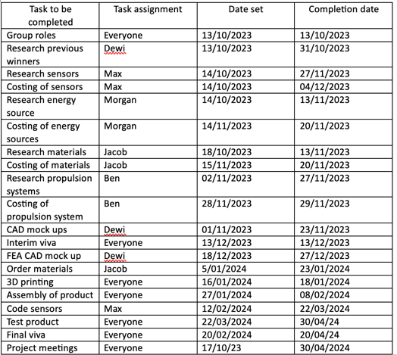

Figure 1. Group Tasks

4 Detailed list of my tasks

Task | General description | Explanation of task | Completion of task | Time taken
Group roles | Deciding as a group who would be most suitable for each role | I felt I was most suited for my role as I have good organizational skills and I can work efficiently. I also thought back to my scores from the Belbin module when deciding on what role I would take on | 13/10/2023 | 1 Hour
Material Research | Researching possible material selection. | I was tasked with researching materials that could be used in our project. It was important that I spent a decent amount of time on this task due to its impact on the whole challenge. I also researched possible sources for such materials. | 13/11/2023 | 15 Hours
Material selection | Final selection of materials before purchase | In this task I had to finalize my research and decide upon materials needed with regards to my groups needs. I had to brief the group on what materials I have found that fit our budget but also keep in with the environmental aspect of our design. It was essential to communicate with my team. A lack of communication would cost us massively. | 20/11/2023 | 5 Hours
Budgeting | Research reliable sources for the purchase of our materials and components. | This task consisted of me creating a preliminary bill of materials and components needed to give us an inkling of how budget friendly our project was. I had to heavily research each material regarding their cost but also cost of delivery and other additional fees. I had to have full trust in my colleagues with their choice of components as this would be the final task before purchase. | 23/1/2024 | 10 hours
Purchase of materials | Place an order for the materials needed to complete our project | Following the material selection process, I must purchase the materials and components needed to start building our prototypes/final design. This is my final opportunity to confirm my choices with the group. I need to present all products to our group leading lecturer (Kelvin Lake) before purchase to ensure they are obtained safely and correctly. | 23/1/2024 | 2.5 Hours
Preparing to present | Summarising our data into a presentation | This task requires me to create some slides in our PowerPoint to aid me in presenting my part of the presentation. These slides contain summarised information that will be helpful for me as a presenter and easily understandable for the listeners. | 10/12/2023 | 20 Hours
Interim Viva presentation | This is essentially a presentation to show how we are progressing as a group. | This presentation will consist of us describing how we are to go about the final project. We will display possible designs, materials, movement systems etc. My role in the presentation is to showcase the materials we have decided upon. I also must show and explain the preliminary bill of materials. | 13/12/2023 | 1 hour

Task | General description | Explanation of task | Completion of task | Time taken
Finalise vehicle manufacture | Complete the manufacturing of the vehicle | This task will require me to complete the manufacturing process of our vehicle. I will aid in the manufacturing of the body and wheels. Following the manufacturing, testing must be carried out. This will be essential for the success of our project. | 08/2/2024 | 15 hours
Final Viva Presentation | Our final presentation as a group to our lecturers. | All prior tasks will be complete, and our autonomous vehicle will be fully functional for us to present. I will be presenting the material section of our project and also giving the listeners an in depth explanation of the bill of materials. | 20/3/2024 | 1 Hour
Final report | Complete technical report of our project. | This task requires me to create a technical report on the group project. In this, I will include all the pros and cons of the project and summarise how I think the project could have been completed more efficiently. | 20/3/2024 | 25 Hours
Group meetings | Weekly meet ups to discuss progression | A weekly meet up as a group is essential for our success as a group. Within these meetings we must discuss work carried out, work that needs to be completed by the next meeting and brainstorm any ideas we may have. | 30/4/2024 | 50 Hours

4.1 Bill of materials

The preliminary bill of materials for our project with estimated prices and a budget of £80.

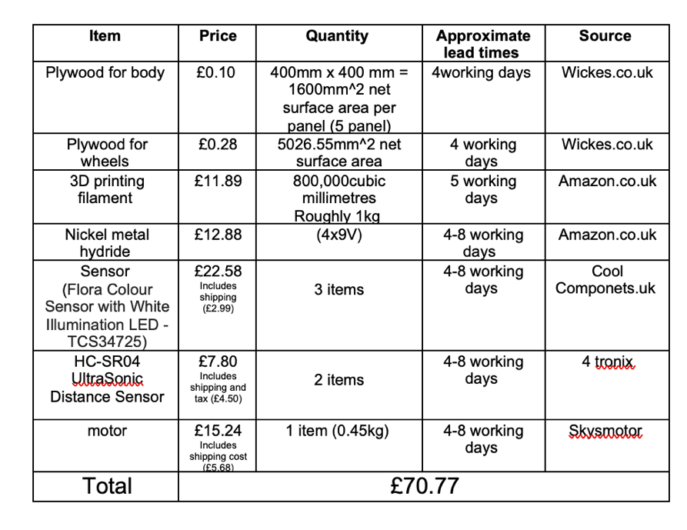
Figure 2. Preliminary bill of materials

5 Milestones

When working on a project as a group, setting milestones is essential for the progression and success of such project. Within our group, the first milestone set was role allocation. We did this as a group out of lecture hours following our initial meeting with our group leading lecturer. We did this to ensure we had sufficient time to think of our individual skills before allocating, rather than thoughtlessly deciding. This milestone was completed in an hour on 13/10/2023. Following our role allocation, as a group, we decided on checking in every week with any progression made. All research would be added to a shared google docs document so that our ideas could be viewed at any time by all members. This was our next milestone that needed to be completed weekly. Our next major milestone as a group is the design of our vehicle. This task requires the assistance of all group members. Each member has some specific input into the final design, whether it be the materials, or the specific sensors needed etc. Without the participation of the whole group, this milestone will not be met. We expect to meet this deadline by the 21/11/2023. The completion of the vehicle design will lead us onto the next milestone, the interim viva presentation. This is essential for the progression of our project. As a group we can grasp how well we are progressing with our project. All the organization skills used throughout the challenge would be displayed in the PowerPoint slideshow and presented effectively. The date for our interim viva is the 13/12/2023. The final milestone set by our group is completing the manufacturing of our design. This task is either make or break for our project. It is essential for our success that the vehicle can be manufactured correctly, corresponding with our budget and the rules and regulations of the challenge. We have set a completion date of 08/2/2023 at latest to allow extensive time for testing before our final viva.

5.1 Gateway objective

My main gateway objective within the project was sourcing and purchasing all the components and materials needed to complete our vehicle. It was essential for me to carefully research multiple sources to decide upon the best fit for our groups budget and design. Incorrectly ordering components could be catastrophic for the progression of our design and could affect our deadlines significantly. If an incorrect component is ordered without realisation, it could put a hold on the whole project. An example of this would be acquiring the wrong power source. If I was to order a power source with a lower voltage than needed, the whole electrical system of the project would fail. For me to succeed in my tasks I must communicate with my group and team leading lecturer before any purchase is made to truly know the component in question is correct. This gateway objective is aimed to be completed by the 27/1/2024 latest.

6 Areas of concern

A group project will always consist of problems and setbacks, but how a group react to these setbacks will determine the success of the project. When a problem is reported, as a group we must come together to resolve the problem. This is done by communication and strategical thinking. However, some areas of concern might be specific to a group members role. My main area of concern during my specific role was the incorrect selection and purchase of materials. I know as a material selector; it is essential that the correct material is acquired to progress through the project. Choosing a material that is not suited for our group would slow down our progression significantly. For example, if I had chosen a material such as mild steel sheet metal for the main body, it would increase the vehicles weight. Which in turn, would require a larger power source (more batteries) resulting in a larger chunk of the budget being used. To mitigate this problem from occurring, I had to extensively research all possible materials and then check over with my group members if they agreed with my choices.

Another concern of mine within this group project would be the input of other group members. A group project must consist of all members giving equal amounts of effort to their specific roles. Some personal tasks within our project require work to be completed by another member before the task can be carried out. For example, If I was slow in selecting a material to use for the body. The design lead would not be able to complete their work as they would not know what material would be needed for the CAD mock-up. To overcome this issue, we decided as a group that weekly meet ups will be needed. In these meetings we will be able to show other members how much we have progressed with our individual tasks and provide deadlines. This will allow the other members to plan around those deadlines and carry out other tasks if possible.

7 Gantt chart

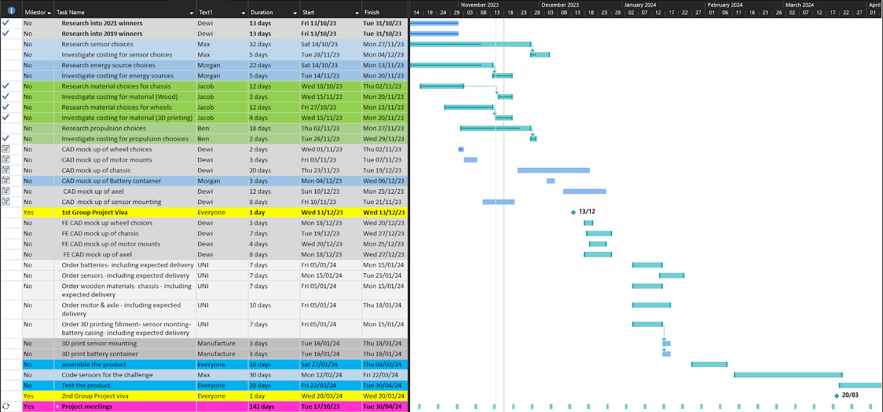

Figure 3. Gantt chart of all tasks carried out

References

- imeche (2023) Repeatable vehicle - imechedesignchallenge.org. Available at: https://www.imechedesignchallenge.org/wp-content/uploads/2023/09/IMechE-Design-Challenge-Project-Specification-and-Rules-2024-V1.1.pdf (Accessed: 02 November 2023).
- Belbin, M. (2023) The nine belbin team roles, Belbin. Available at: https://www.belbin.com/about/belbin-team-roles (Accessed: 07 November 2023).

