Student Name: Raducu – Viorel Ciolpan  Student ID:2221478  Module Title: Foreign Language & Cultural Awareness  Module Code: BMIH 5003  Lecturer: Heidi Prosser | 
ASSIGNMENT 1: PORTFOLIO
(4 Components)

Component 1: Professional Reflection (500 words +/- 10%)

Weighting: 25%
The incident took place in the hotel breakfast buffet which I have witnessed as an F&B employee. I was performing my job responsibilities and tasks as a server in the Grand Majestic hotel in London. I was catering to an international client on a daily basis for quite a few days. On that day, there was a seemingly simple request from a Japanese guest which eventually triggered a cascade of cultural misunderstandings which created and developed higher level of determination and humbleness within me to continuously learn more things, improve my skills and develop new aptitudes to advance in my career and achieve higher success in the professional life.
The incident began with ‘tamago’ when the Japanese customer asked for it. I said, ‘lovely choice. Would you like the sunny side up or scrambled version?’ her smile was hesitant and polite which created confusion in me. For this reason, I repeated my question and still got no clear response from her. After a while, finally another gentleman and guest at the table interjected by saying that she would like the omelette but without the bell peppers and onions. Tamagoyaki is a famous, popular and delicate Japanese omelette which was far from fluffy western version. My mistake was to assume a direct translation and failing to delve deeper to understand the actual order of the Japanese customer. The subsequent order from the customer was for toast which she requested to be cut into bite sized squares created further cultural distances and confusion for me. It is a custom in japan to prevent food waste which was foreign to my British perspective.
This incident created the necessity as well as significance of developing effective linguistic knowledge in my professional life and line of career. It also created a better understanding within me about the pitfalls of having high level of reliance on limited linguistic knowledge. There is a high possibility of misinterpretation of cultural references, food references among customers (Parks, 2020). In addition to that, there are also possibilities of seemingly mundane gestures which can often be misunderstood and misinterpreted without effective cultural awareness and knowledge of different cultures.
According to studies and research activities conducted by Barmeyer and Berg (2020) and Ting-Toomey (1985), there are high levels of significance of both the "high-context" and "low-context" communication styles as well as approaches which must be considered with high level of sincerity by students, managements and professionals working in the hotel management sector (Barmeyer & Berg, 2020). There is a significant role of implicit meaning and nonverbal cues in the Japanese culture. On the other hand, western cultures are usually more direct and explicit which focuses significantly on the verbal clarification and words (Ting-Toomey, 1985). My reliance of high level on the verbal clarification was not effective and efficient to bridge the cultural gap and created confusion as well as misunderstanding in the communication process.
It was a valuable and important lesson for me to understand the importance of cultural sensitivity to perform better and successfully in the hospitality industry. I am determined to have high level of priority in the cultural awareness training for actively seeking opportunities to develop more understanding about the backgrounds, nationality, language and cultures of the guests.

References:
Parks, E. (2020). Developing Critical Cultural Awareness in Modern Languages. Routledge.
Barmeyer, A. W., & Berg, J. K. (2020). The intercultural communication reader. Routledge.
Ting-Toomey, S. (1985). Cross-cultural communication. Guilford Publications.
Component 2: Training Plan (500 words +/- 10%)

Weighting: 25%

Identified cultural misunderstanding:
My encounter with the Japanese guest created the understanding and feelings of the importance of cultural awareness to maintain the efficiency and success in the hospitality industry to perform better and achieve higher success. This training plan has developed with the aim of improving the linguistic efficiencies and skills among professionals working in the hospitality industry.

Training objectives
- Increasing the level of awareness about different cultural differences and their effects on communication process and operations activities in the hospitality industry.
- Supporting the equipping the employees with nonverbal communication skills, active listening skills and intercultural empathy improving skills.
- Developing higher level of confidence among the employees with diverse guest interactions and communications in a highly professional way.

Training plan:
Training modules
- Introduction to cultural awareness
There are interactive lectures, case studies and group discussions included in the process. The students and trainee professionals will learn to define the cultural awareness. In addition to that, they will get the opportunity to explore different cultural dimensions and analyse real life situations to develop a more comprehensive understanding.

- Communication skills for cultural awareness
Active listening, nonverbal communication, empathy and cultural sensitivity are included in this part of the training (Ting-Toomey, 1985). The trainee employees get the scope of practicing techniques of open ended questions, attentive body language and summarizing for developing better understanding about the concepts. In addition to that, they will also learn the processes and activities of nonverbal cues in different cultures.

- Cultural insights for the hospitality services
This training module will include aspects of regional and national customs, communication expectations and styles, food and beverage cultures. It will provide an overview of common cultural practices which are related to the hospitality industry. The trainee employees will also get the opportunity of exploring diverse food preferences, cultural significance and dietary restrictions among customers from different nationalities and cultures.

Evaluation process
There will be pre-training and post-training surveys for evaluating the effectiveness of the training process, measuring the success and failure of the training process, identifying the knowledge level among the employees (Barmeyer & Berg, 2020). The ongoing feedback and support will be used for encouraging the staff members and continuing the sharing of the training experiences. The evaluation process will also include ongoing support providing to the employees for the successful and effective application of the learned skills in the daily life performances, operations activities, and job responsibilities within the organization and in the workplace. There will also be regular updates and revisions of the training process and activities. It will be effective for reviewing the training program periodically for successfully ensuring the relevance of the training process (Landis & Bennett, 2018). The regular updates will also be focused for successfully incorporating the new and effective cultural insights and best practices within the training process and workplace environment in the hospitality industry.

Expected outcomes
There are several expected outcomes which are aimed to be accomplished through the proper implementation and performing of this particular training plan. These include:
- Decreasing the cultural misunderstandings.
- Improving the levels of guest satisfaction.
- Increasing the confidence level among the staff members, employees and professionals.
- Improving the communication skills and intercultural empathy skills among hospitality sector employees.

References:
Barmeyer, A. W., & Berg, J. K. (2020). The intercultural communication reader. Routledge.
Ting-Toomey, S. (1985). Cross-cultural communication. Guilford Publications.
Landis, D., & Bennett, J. M. (2018). Handbook of intercultural training (4th ed.). SAGE Publications.
Component 3: Student Self-Reflection (500 words +/- 10%)

Weighting: 25%
I have got the opportunity to learn a lot of new things and develop new skills after experiencing challenging situations in my professional life. Each and every challenges in the professional life have supported me to improve myself as a successful professional working in the hospitality industry. I had limited knowledge of cultural awareness and diversity which was limiting my scopes and opportunity of improving myself as a successful professional in the hospitality industry.
I have successfully applied the Graham Gibbs' reflective cycle in my learning and skill development process and activities. The reflection of myself as a professional working in the hospitality industry is presented below in this part of the report.
- Description: my approach towards learning and skill development was transactional at the initial stage. I had a strong focus on fulfilling the orders from the guests and customers. I was also oblivious towards the cultural nuances which lurks beneath the surface and experienced a lot of challenges as well as complications as a result of this approach. The hesitant smiles from the guests, the confusions between me and the guests are some of the most common challenging situations experienced by myself. There were missed cues which made the inefficient and confused in the process of serving the guests and performing the job responsibilities effectively and efficiently.
- Feelings: I was feeling confused and demotivated at the beginning of the learning process after experiencing some failures and challenges. I was also feeling less confident and started questioning my ability as an efficient professional capable of working successfully in the hospitality industry. However, after successfully and efficiently planning the learning process and strategies, starting the learning process and activities, I have started feeling more confident and positive about myself and my ability as a professional.
- Evaluation: my training and skill development activities in the past were effective and successful for supporting me in the process of developing effective skills and aptitudes which are important to work as a professional in the hospitality industry. However, these training activities lack the training and knowledge development of different foreign languages and cultural awareness.
- Analysis: the concepts of "high-context" and "low-context" communication styles proposed and discussed by Ting-Toomey's (1985) were resonated and related deeply in the learning process and experiences of myself. I had a high level of reliance on direct and explicit language which created challenges and problems to understand and perform the nonverbal communication of the guests. The emphasis on developing proper understanding about cultural dimensions are proposed by Barmeyer and Berg's (2020).
- Conclusion: the failures and challenges in the training and learning process of myself acted as an effective catalyst for significant changes and improvement in the learning and skill development process of myself. These learning processes were dedicated towards redefining my approach as a professional working in the hospitality industry towards cultural awareness and foreign language learning. I have also successfully communicated with other colleagues and co-workers from different cultures, nationalities and backgrounds to learn about their language and cultural practices.

References:
Barmeyer, A. W., & Berg, J. K. (2020). The intercultural communication reader. Routledge.
Ting-Toomey, S. (1985). Cross-cultural communication. Guilford Publications.
Landis, D., & Bennett, J. M. (2018). Handbook of intercultural training (4th ed.). SAGE Publications.
Component 4: Training Presentation (6 Slides)

Weighting: 25%
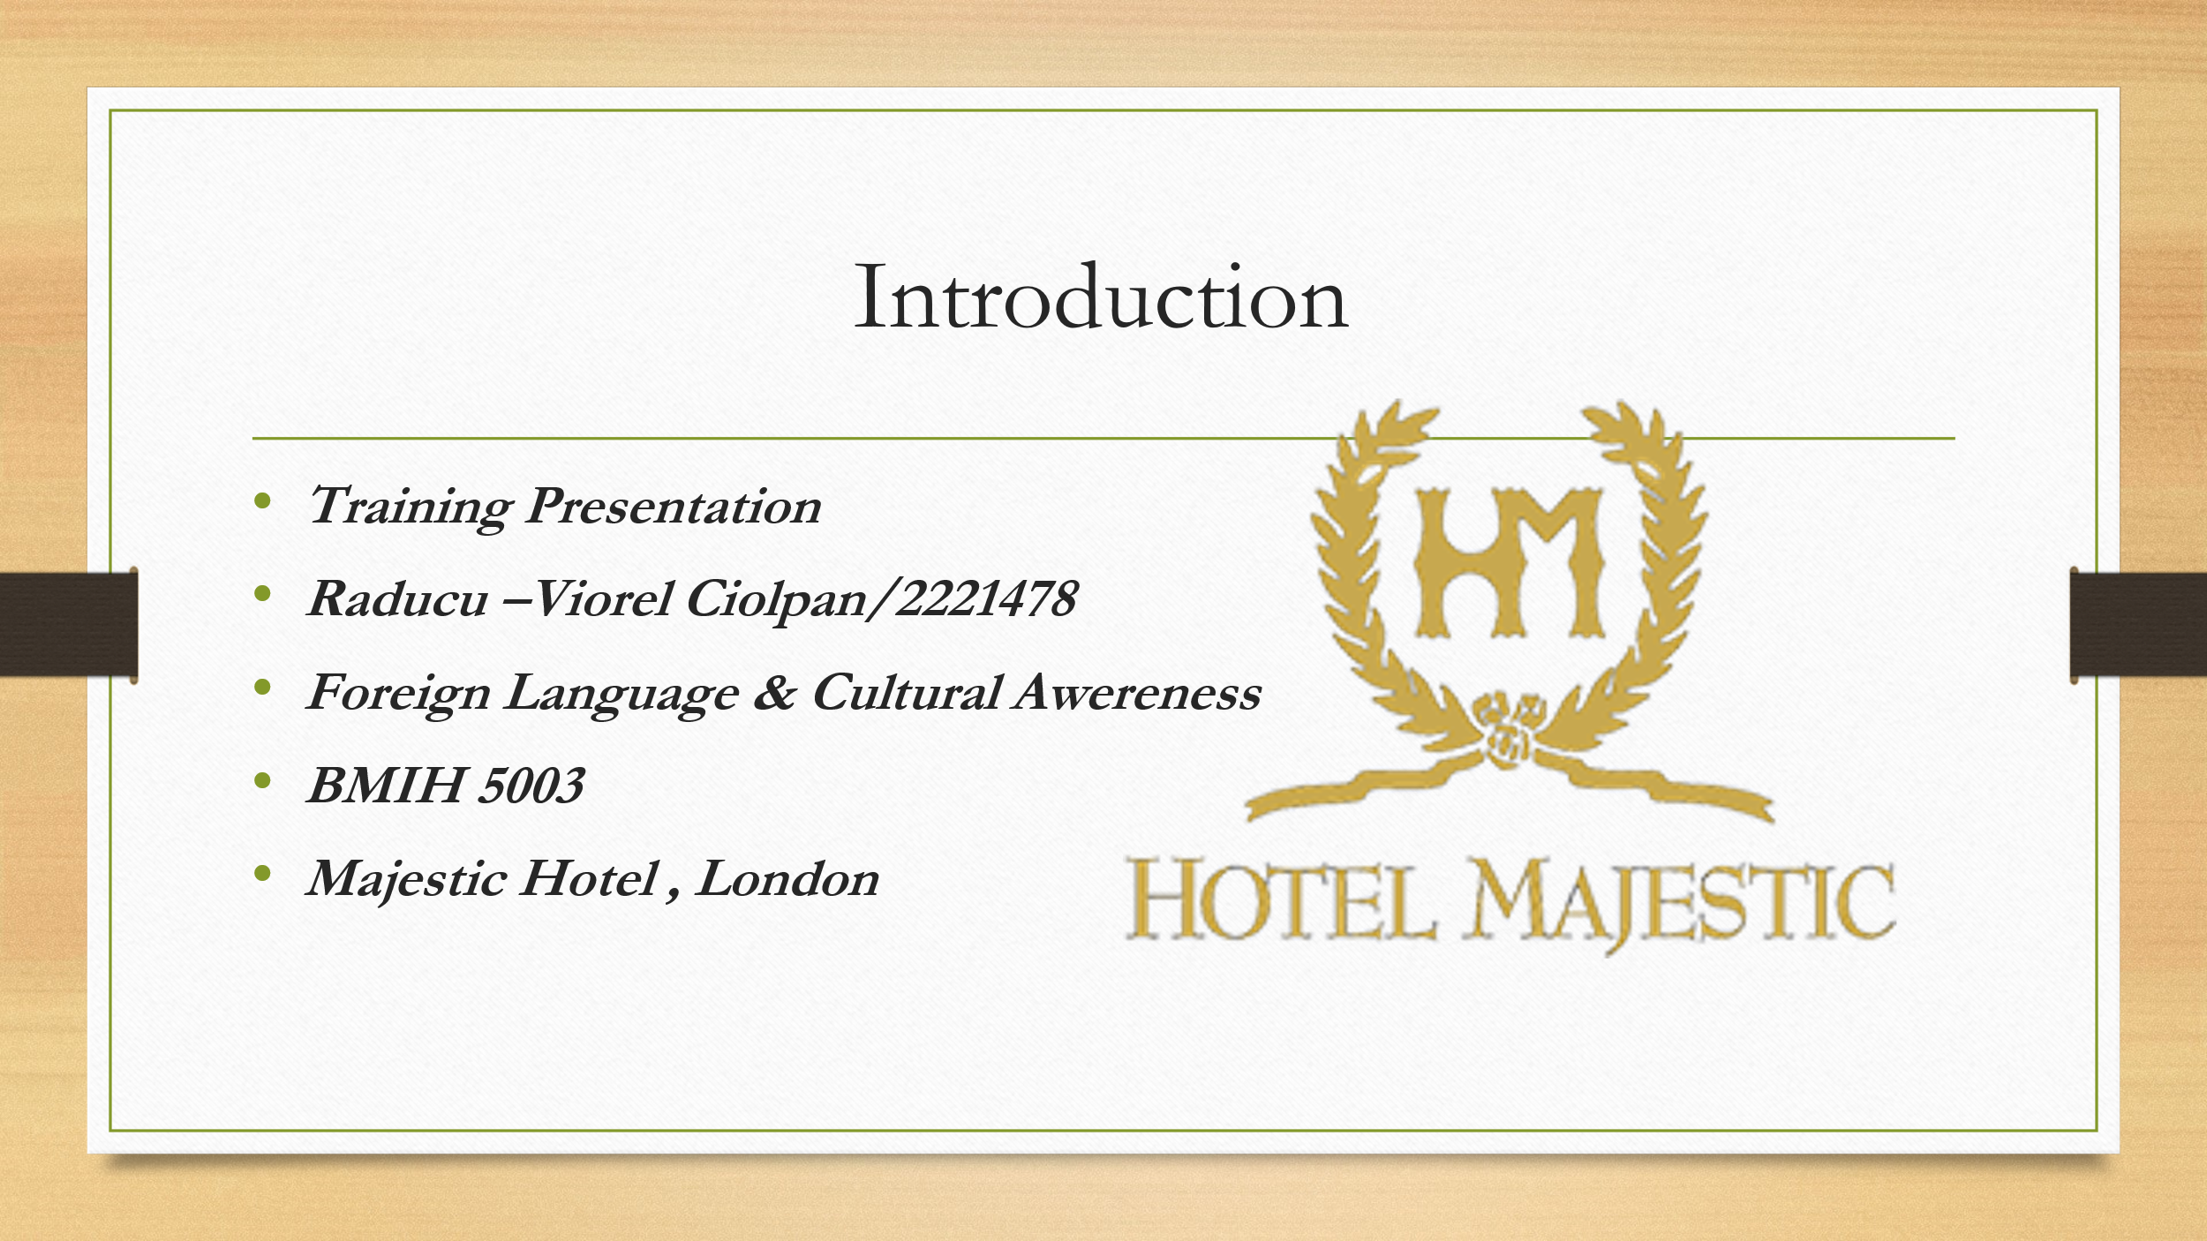
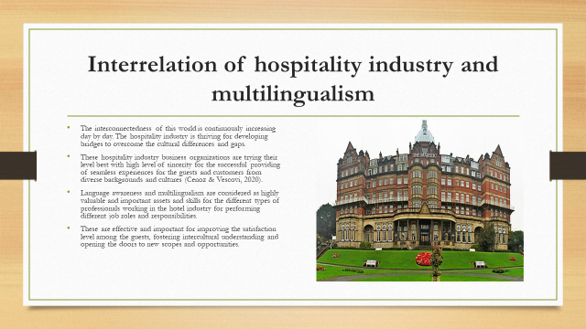
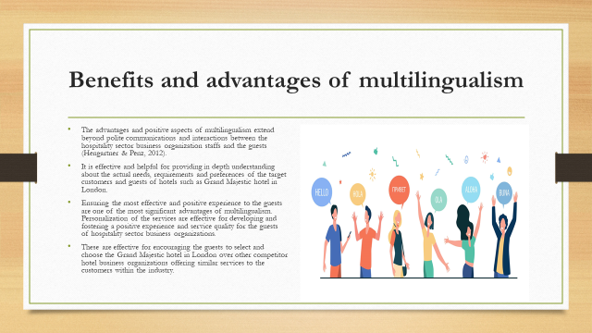
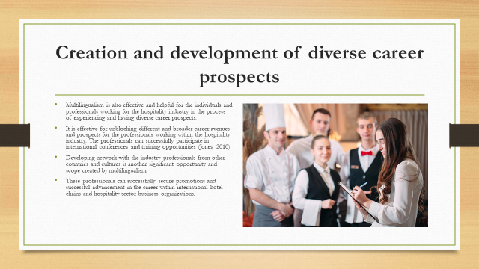
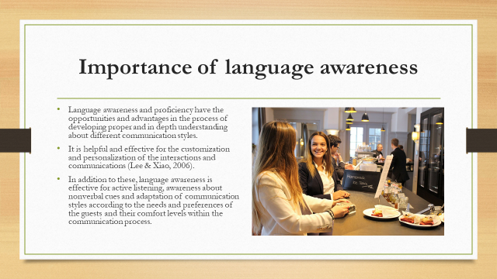
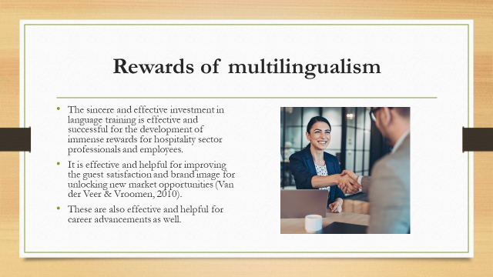
References
Cenoz, J., & Vescovi, L. (2020). Multilingualism, language awareness and intercultural competence in the hotel industry: A conceptual framework. International Journal of Hospitality Management, 86, 104071.
Hengartner, C., & Penz, H. (2012). The economic value of multilingualism in tourism: Lessons from Switzerland. Journal of Travel & Tourism Research, 41(5), 506-527.
Jones, C. M. (2010). Language awareness and cross-cultural communication in the hotel industry. International Journal of Hospitality Management, 29(3), 426-435.
Lee, J. W., & Xiao, H. (2006). Language skills and career advancement in the international hospitality industry. International Journal of Hospitality Management, 25(2), 225-239.
Van der Veer, A. W., & Vroomen, J. (2010). Language use in intercultural hospitality encounters: A framework for analysis. International Journal of Hospitality Management, 29(3), 415-425.

