University of Wales Trinity Saint David
Wales Institute of Science & Art

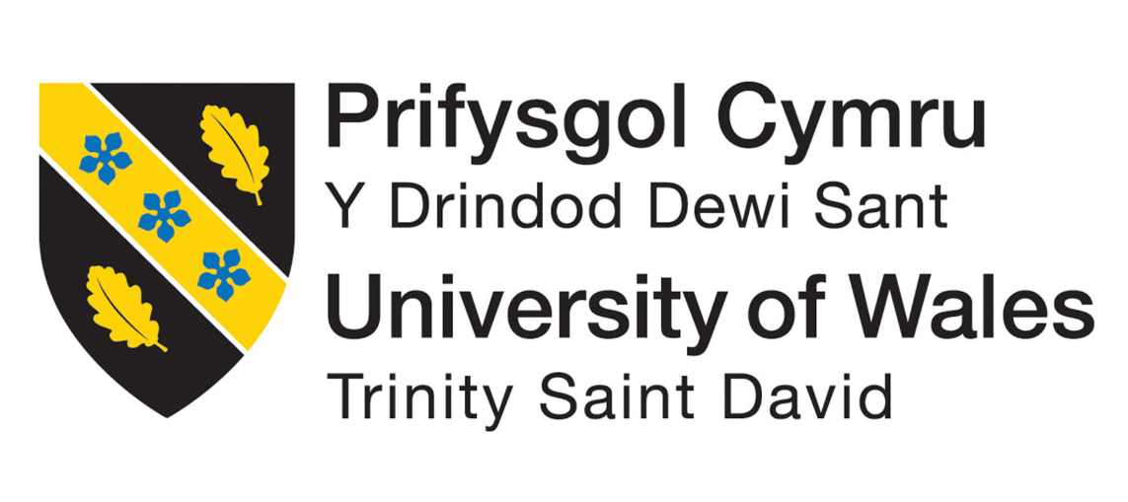

What Engineers face in society

Louis Jongejan
2201122
12/2023

Contents
Introduction 3
Health and Safety with Risk Assessments 4
Engineers’ role in society 6
Problem Solving 8
Team structure 9
Personal Development Plan 10
Conclusion 11
References 12

Introduction
This report aims to cover some things that an engineer will encounter in his/her career including health and safety, problem solving, working in a team and their role in society.

Health and Safety with Risk Assessments
Health and safety are the regulations and procedures put in place by the government “securing the health, safety and welfare of persons at work, for protecting others against risks to health or safety in connection with the activities of persons at work” (Great Britain, HSE, 1974) The Heath and Safety at Work Act 1947 is the primary legislation in the UK
All activities have different risks associated with them therefore a risk assessment must be completed to identify theses risks. A risk matrix is used to work out the severity and likelihood of the risk and helps work out what precautions need to be put in place to reduce the risks. The precautions taken include changing the way the activity is conducted or making it a requirement to wear PPE (personal protective equipment).

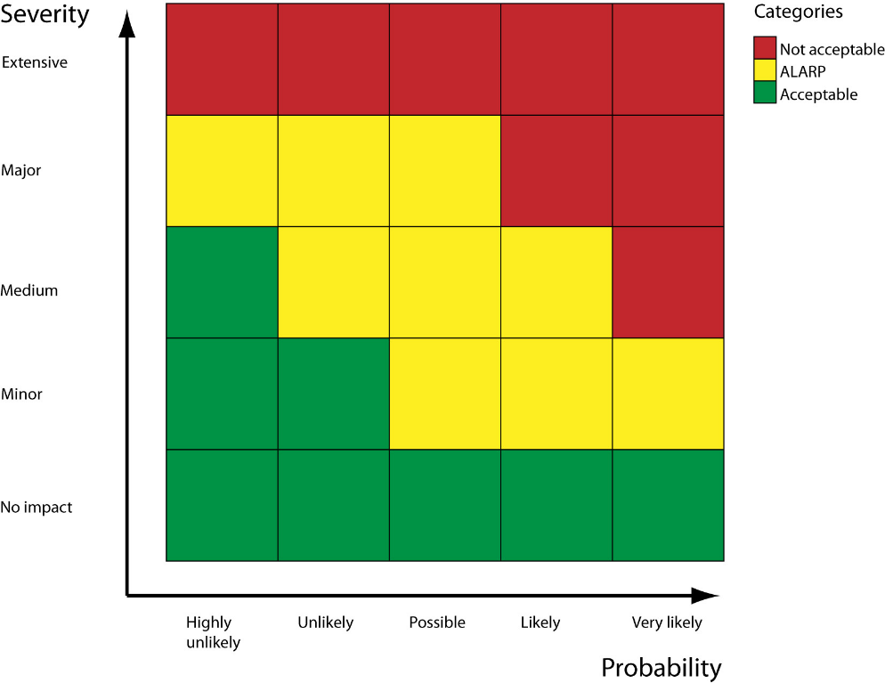
Figure 1- risk matrix

Below is an example of the risks identified in completing an engine strip and rebuild and the PPE that can be used to reduce them.
Chemical Exposure:
Likelihood: Possible
Severity: Major
Control measures: Use appropriate gloves and coveralls to stop contact with chemicals such as oil on skin and to stop chemicals from entering wounds.
Dropping something onto your foot:
Likelihood: Likely
Severity: Medium to Major
Control measures: Ensure proper footwear is worn in compliance with EN ISO 20345:2011 (European and UK standard.
By assessing the risks in this manner, you can prioritize control measures and PPE to mitigate potential hazards during an engine strip. Remember to involve employees in the risk assessment process and reviewed yearly and update assessments as needed.

Engineers’ role in society
Numerous organizations play a pivotal role in delineating codes of conduct that serve as ethical compasses for engineers. Two prominent entities in this regard are the Institution of Mechanical Engineers (IMechE) and the Institution of Civil Engineers (ICE), both steadfastly committed to fostering ethical behaviour and upholding professional standards within the engineering community.

IMechE's Code of Conduct is a comprehensive document that underscores ethical behaviour, professional competence, and social responsibility among its members. Principles such as integrity, respect, and responsibility form the bedrock of this code, guiding engineers in their professional pursuits.

In the realm of sustainability and environmental responsibility, IMechE recognizes the paramount importance of these considerations in engineering practices. Particularly in the dynamic field of motorsport, engineers affiliated with IMechE are tasked with conscientiously evaluating the environmental impact of their work. The code of conduct askes member to “take account of the needs of a diverse environment” (IMechE, 2022). This involves not only the development of sustainable technologies but also initiatives to curtail carbon footprints and the incorporation of eco-friendly engineering solutions into the motorsport industry's fabric.

Similarly, the Institution of Civil Engineers (ICE) champions a Code of Professional Conduct that sets forth principles encompassing honesty, competence, and accountability. Notably, ICE places a distinct emphasis on the responsibility of civil engineers to safeguard the environment and the well-being of the public they serve. The code of conduct states “prevent avoidable adverse impact on the environment and society” (ICE, 2020)

Within the unique context of motorsport, ICE members are entrusted with the duty to seamlessly integrate sustainability into their engineering practices. This involves a holistic approach, encompassing considerations for the environmental impact of motorsport events, the materials employed, and the technologies developed. Engineers are not merely expected to comply but are encouraged to actively contribute to the development and implementation of environmentally friendly practices within the motorsport industry.
It is imperative to acknowledge that the specifics within these codes of conduct may undergo changes, and practitioners are urged to consult the latest versions directly from the respective organizations for the most current and relevant guidance.

Problem Solving
Engineers face many issues on a regular basis during all stages of production from development to once a product is in the market. Part of the role of an engineer is to resolve these issues as efficiently as possible.
There are seven main steps that are taken during the problem solving process
1.Describe the problem: for this the engineer need to clearly state the problem as it gives basis to the whole process and helps to understand where the problem is coming from
2.Describe the results you want: the result must be specific to the problem and determines how the engineer will know that the problem is solved
3.Gather information: research! This can be needed for both the problem and the solutions. Engineers can use past experiences and can look at other designs that can lead to better designs
4.Think of solutions: brainstorming ideas is the best way to go about this, listing and sketching as many ideas as possible
5.Choose the best solution: the solutions that the engineer came up with then need to be evaluated by comparing them against the result wanted. It may be that compromises need to be considered to identify the ‘best’ one
6.Implement the solution: the solution then needs to be developed into a plan with the tasks and resources that are required so that it can be implemented
7.Evaluate results and make any necessary changes: compare the result to the desired result and make any modifications for a different or better result

Team structure
In this section I will be discussing an experience I have of working in a team. I have worked in teams many times throughout my time in the army cadets. One of the main areas where teamwork took place was when doing an attack on an enemy position. I lead a group of 10 people and had to assess the situation as it developed and give them orders as to how to conduct the attack. In this example the team was based on a hierarchical structure. This is where the team is structured in a pyramid shape with the tiers of people who follow the orders of the tier above them.
In this situation it is the best type of structure to use as it creates clear and strong boundaries where roles are clearly defined. It puts one person in charge overall which is very important in a life-or-death scenario as it stops conflicting ideas from confusing those involved.
Part of being in charge of the attack also meant I had to know the strengths and weaknesses of my group; the hierarchical structure allowed me to capitalize on this by giving specific roles to suit each individual. During the attack I decided to split into two groups to, one of which flanked the enemy position and the other providing covering fire, I was able to pick someone to take charge of the one of the groups as I know they had the knowledge necessary to confidently take charge and lead them to complete the task I had given them.
I do not believe that in this scenario it is viable to use a different team structure as there are no inherent problems with using it and it is the tried and proved method of the British army.
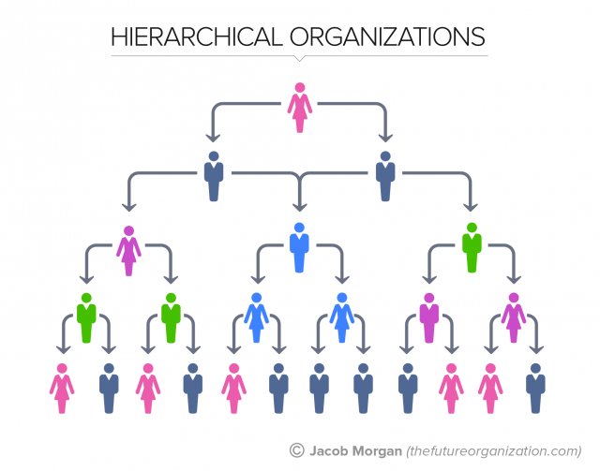
Figure 2- hierarchical structure

Personal Development Plan

Conclusion
Throughout this report some of the things an engineer will encounter have been discussed. It highlights the fact that being an engineer is has many challenges. There are strict rules and regulations they must follow such as the heath and safety ate work act to difficult decision making to solve problems where is there is a path that can be followed to make the process easier to go through but can be very challenging to get the solution needed.
Engineers also have a huge social responsibility to look after the earth and its current and future inhabitants.
Overall, the job of being an engineer is not an easy task, but it is because of their hard work that the world thrives.

References

Institution of Mechanical Engineers (IMechE). (2022). "Code of Conduct." https://www.imeche.org/docs/default-source/1-oscar/About-us/governance/royal-charter-by-laws-(new-appd-by-pc-29-9-21)---final---updated-25-04-22.pdf?sfvrsn=2

Institution of Civil Engineers (ICE). (2020). "Code of Professional Conduct." https://www.icheme.org/media/15407/code-of-professional-conduct-2020-effective-from-1-january-2021-f.pdf

Great Britain. (1974). “Health and Safety at Work” https://www.legislation.gov.uk/ukpga/1974/37/contents

Figure 1- “risk matrix” https://www.wolterskluwer.com/en/solutions/enablon/bowtie/expert-insights/barrier-based-risk-management-knowledge-base/risk-matrices

Figure 2- “hierarchical structure” https://www.forbes.com/sites/jacobmorgan/2015/07/06/the-5-types-of-organizational-structures-part-1-the-hierarchy/

