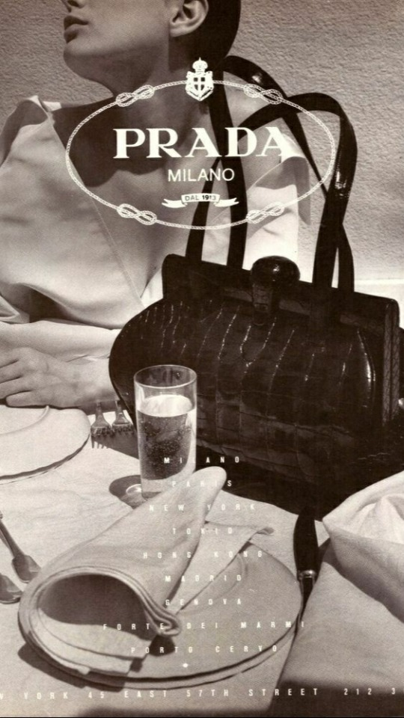
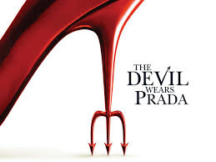


The company was founded in 1913

Founded by: Martino Prada

Director of the company: Miuccia Prada

Country: Italy

How Prada got its name: The story behind the brand

The brand Prada is considered to be one of the most iconic in fashion history. Along with maintaining a classically refined style, the brand's designers have consistently tried to innovate. A legacy like that of Prada will ensure that its name will remain popular for years to come. Here is a glimpse into the brand's history.
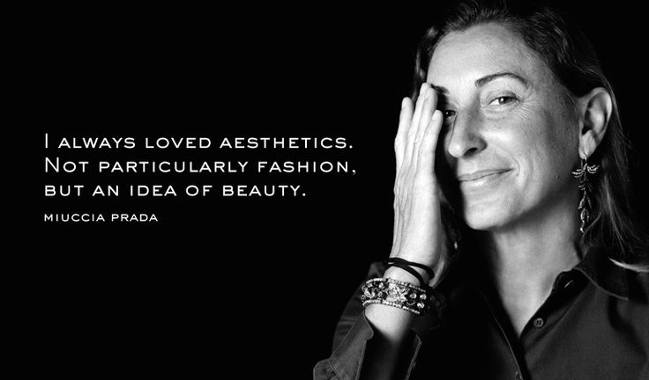
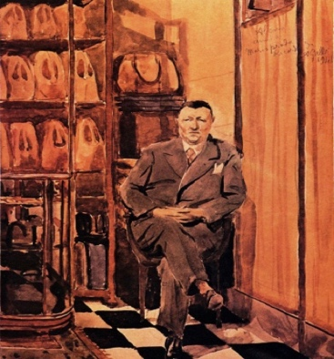
Founded by Mario and his brother Martino Prada in Milan in 1913, the company's first store was located in the prestigious Galleria Vittorio Emmanuele II. Among their products were suitcases, steamers, and trunks.

Even more interesting is the history of Prada. At the time, Mario Prada believed women should not work outside the home due to patriarchal beliefs. His company did not hire female family members. His only son did not care about continuing the family business. As Mario Prada's successor, Luisa Prada ran the family business for almost twenty years. (dotLuxury)

The iconic bag
Prada bags need no introduction if we are talking about bags. It's no surprise that if the Italian power house is renowned for challenging fashion conventions, it has become one of the biggest names in the fashion world.
When it debuted on the Prada Spring/Summer 2000 runway, the Prada Bowler Bag was 15 years ahead of the athleisure trend.
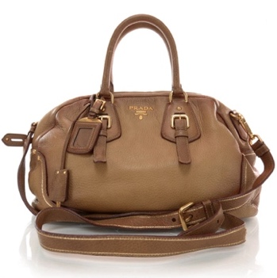
Its curved lines and rounded shape are reminiscent of bowler bags from the 1950s, which were used to transport bowling balls. This light brown calfskin leather version of the Prada Cervo Antik Bowler Bag grabs our attention. Wear it on your shoulders or attach the top handles to your wrist. (NABILA KAULIKA 2021)
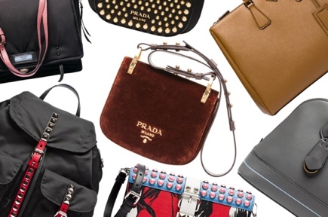

Prada Nylon Bag
In 1984, Prada's first nylon bag - a backpack, of course - shook up the fashion world by introducing nylon into luxury fashion . It was even dubbed "anti-luxury". Prada's nylon bag introduced a new era of utilitarian chic and became a symbol of the fashion house's innovative spirit.
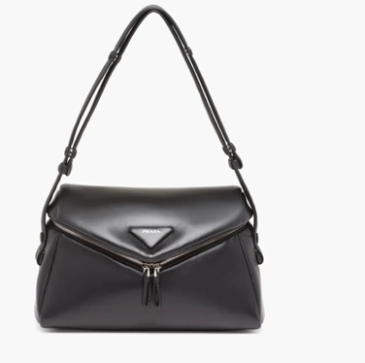
The Prada nylon bags have been reissued over and over again since then, including a sustainable Re-Nylon collection made from recycled nylon. ( NABILA KAULIKA 2021)
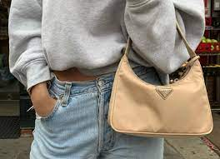
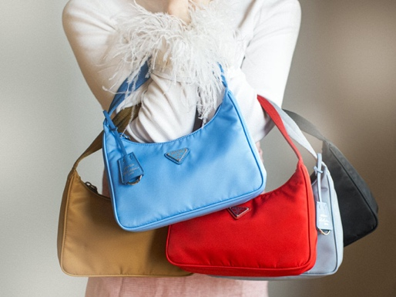

The Prada Tote Bag
Prada's Galleria tote bag is made from Saffiano leather and is one of the most popular bags in the Prada collection. Aside from its architectural shape and triangular logo plaque at the front, this bag features a removable shoulder strap, branded lining and interior zip and slip pockets to help keep your valuables secure. With a few colour options, the Prada Galleria tote bag can be worn for both work and weekend activities. (Prada Tote bag)
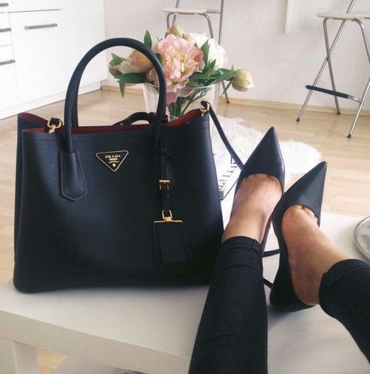
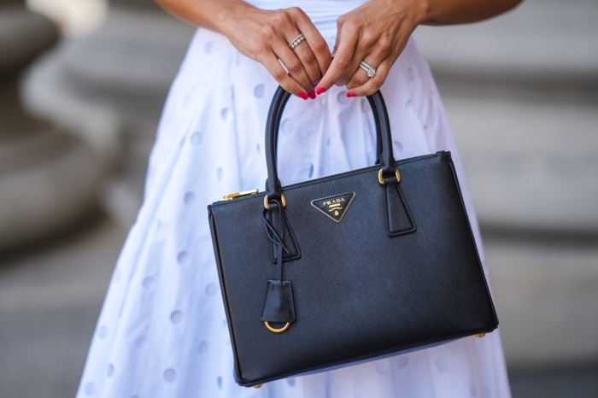

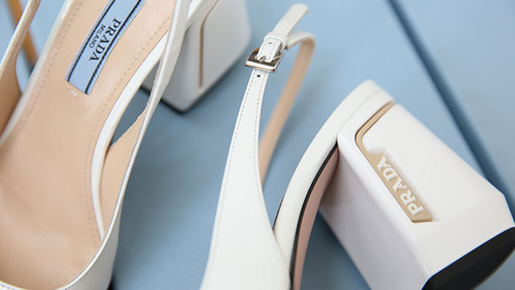

Introducing PRADA: the world's most innovative shoes
In the luxury sector, Prada has been one of the leading brands with its avant-garde style since 1913.
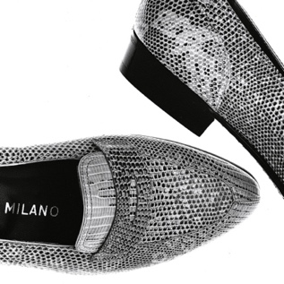
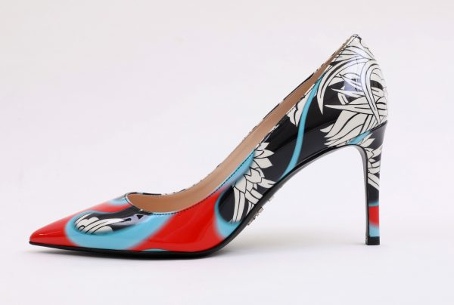
Due to her innovative and creative approach, Miuccia Prada revolutionized the brand and transformed the family business into a luxury empire. Known today for its leather accessories, clothing, and shoes with an innovative design, Prada is a reference point in international fashion. (Brandsdistribution 2019)
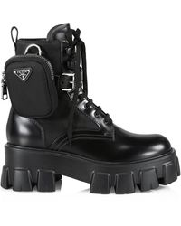

CAR SHOE
A deconstructed loafer by Italian artisan Gianni Mostile, featuring a rubber sole set on tiny studs, translated his passion for race cars and handmade shoes in 1963. Innovative footwear that encapsulates passion and intuition. There have been a number of international figures who have chosen the car shoe, such as John Fitzgerald Kennedy, Giovanni Agnelli, Lapo Elkann, Elle Macpherson and Sofia Coppola.
Through a wide range of products, Church's interpretation of casual style has been built upon the iconic loafer.
Quality materials, shape, and precision of artisanal technique are the added values of Car Shoe, as well as distinctive soles and comfortable design. The combination of these elements will inspire future collections.
Car Shoe footwear features a unique style that emphasizes attention to every detail, suggesting a style that blends sports passion with artisanal excellence, suggesting a style that's equally at home in leisure and travel. (By Lawrence "Mac" Moore on Friday, January 26, 2018)
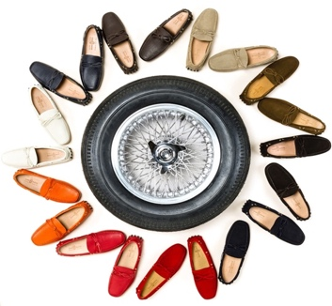
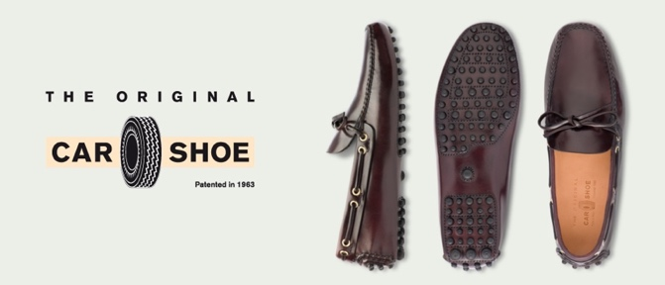

Market And Research Analysis
Marketing has the most contact with customers of any business function. Even though we will soon explore more detailed definitions of marketing, perhaps the simplest is this: Marketing involves engaging customers and maximizing profits. By offering superior value, marketing is focused on attracting new customers and on retaining and growing their current customers. (Kotler, Phil T., et al.)
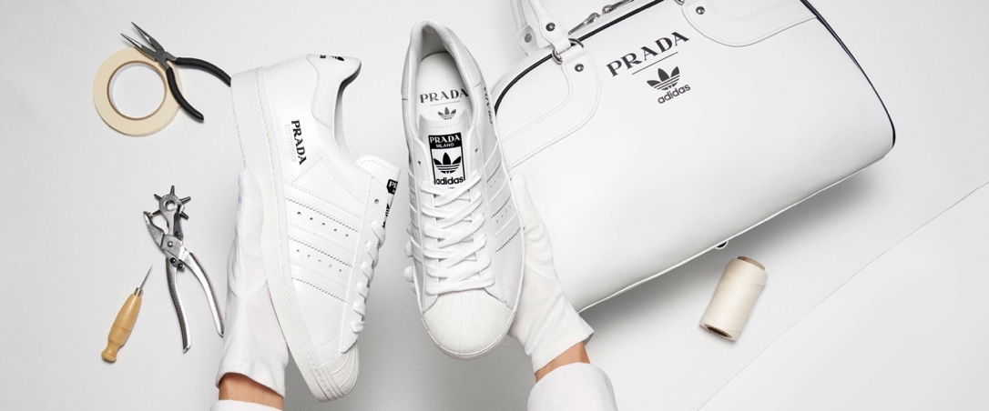
Introducing of Market – In addition to luxury cosmetics, cuisine, fashion, and automobiles, Prada thrives within the global luxury market (Statista). Luxury markets around the world offer the highest quality services to consumers. The growth of this industry can be attributed to key regions such as Europe, Asia, and America. At current exchange rates, luxury retail sales in Europe grew by 6% at current exchange rates, reaching €87 million. (Bain & Company)

Marketing Mix & Prada Marketing Strategy
To analyse the Prada brand, the 4Ps (Product, Price, Place, Promotion) are incorporated into the marketing strategy. Among the marketing strategies are product innovation, pricing approaches, promotion planning, etc. This business strategy contributes to the success of Prada by using the Prada marketing mix.
As a result of its marketing strategy, Prada positions itself competitively and achieves its goals and objectives. (MBA Skool Team 2022)

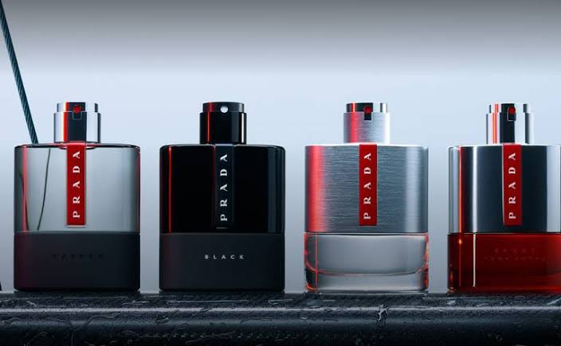
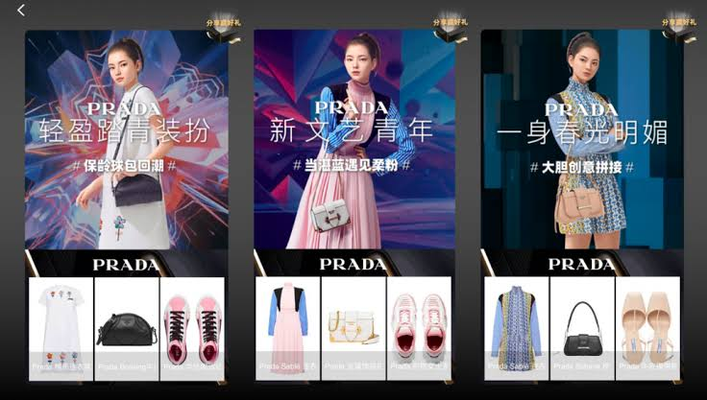

Prada Product Strategy:
As part of Prada's marketing strategy, the following products are being offered:
Prada's sophisticated, luxury products are known across the board. They also offer a wide range of high-end clothing, leather goods, eye wear, fragrances, home products, footwear, watches, and clothing for men and women, in addition to their marketing mix product strategy. Jewellery, cosmetics, and handbags are some of Prada's women's products. In addition, they have Miu Miu products and a line of children's apparel. Prada offers a lifestyle brand called Linea Rossi in addition to its sports and lifestyle lines. Prada and LG Electronics are also exploring the possibility of collaborating on mobile phones.
. (MBA Skool Team 2022)
Pricing Strategy:
Prestige and luxury are the hallmarks of the Prada brand. In order to meet the needs of upper-class society, the products are carefully curated; pricing is likely to be extremely high. Due to its high-quality products and good brand value, the luxury fashion house charges a premium price for its products. The market for luxury fashion is large.
The net sales for the year 2019 were about 3 billion euros. Its sales and revenues fell 40% as a result of a pandemic in 2020. In July, retail sales at the fashion brand grew by 66%, while sales in Mainland China rose 60% in June. In spite of the easing of the restrictions in European markets, the situation remained negative due to a lack of tourists. ( Aditya Shastri)
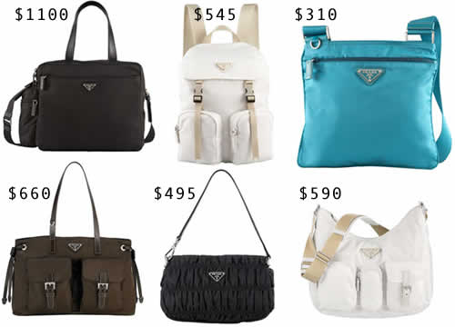

Price List for Prada Bags
Here is a guide to the price of Prada bags. To keep track of any price changes in the future, this price list will be used
There is a new Inside Tote and Saffiano Lux bags from Prada. There may be variations in your personal experience depending on your country and the particular retailer.
It is important to note that seasonal stock, taxes, customs and duties may vary. (Spotted Fashion 2013)
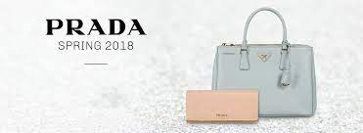

Spring/Summer 2018
STYLE | PRICE
Prada Woman Print Frame Shoulder Bag | $2,400.00 (USD)
Prada Comic Print Elektra Crossbody Bag | $2,330.00 (USD)
Prada Elektra Shoulder Bag | $2,840.00 (USD)
Prada Concept Top Handle Bag | $2,210.00 (USD)
Prada Concept Duffel Bag | $2,070.00 (USD)
Prada City Calf Etiquette Small Carryall Bag | $1,940.00 (USD)
Prada Black Nylon Shoulder Bag with Canvas Strap | $1,680.00 (USD)
Prada Embroidered Raffia Cahier Crossbody Bag | $2,850.00 (USD)

REFERENCE GUIDE FOR PRADA BAG PRICE LIST
By product line, Prada's worldwide net sales in 2020 (in thousand euros)
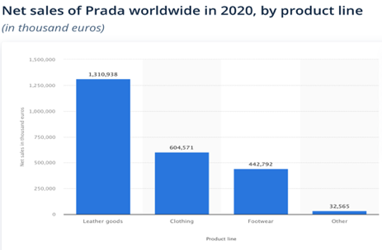
It was a momentous year for Prada, but the outbreak of Covid-19, which is spreading across many luxury brands, could stop progress in 2020. (Tugba Sabanoglu , Nov 1, 2021)

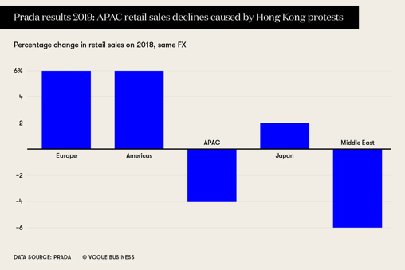
Prada Group's largest markets, excluding Japan, are Europe and Asia Pacific, but the two regions exhibit opposite growth trends. APAC saw a decline of 1.7% in 2019, as full-price sales increase was not enough to counteract the effects of Hong Kong protest. In Europe, sales increased by 3.2% and in Asia by 1.7%. The group said retail sales declined by 3.7% at constant exchange rates, but full-price sales in the region, excluding Hong Kong, grew by 8.8%. (ANNACHIARA BIONDI 18 MARCH 2020)

Prada's net sales around the world in 2020, by geography (in million euros)
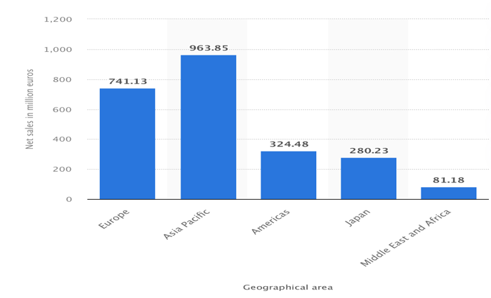
Prada's net sales by region globally in 2020 are depicted in this graph. Around 741.13 million euros were sold by Prada in Europe in 2020. ( Tugba Sabanoglu , Nov 1, 2021)

Prada Place & Distribution Strategy:
Prada's marketing mix includes the following distribution strategy:
In order to maintain the brand's essence, Prada ensures its brand presence matches it. In conjunction with internationally renowned architects Rem Koolhaas and Herzog & De Meuron, Prada has designed multiple flagship stores called "Prada Epicentres" across the globe. The stores are designed to provide customers with a unique Prada experience. New York's first epicentre opened on Broadway and is the most successful of all contemporary stores worldwide. As well as in Australia, Indonesia, India, Canada, Austria, U.K., Germany, Hong Kong, South East Asia, Russia, Europe, and the U.A.E., they have flagship stores in the following countries.
Various boutiques are located in malls, megastores, and multi-purpose buildings worldwide where they sell their products. Mall of the Emirates is their largest boutique. Milan is the oldest of the 618 Prada boutiques. In Venice, Ca' Corner della Regina, a 13th century palace, was acquired by the Prada Foundation and converted into an exhibition space. In addition to stores, they also have an online presence on their own e-store and on famous e-commerce sites. There is a robust ecommerce store on the Prada website that allows users to buy its products around the world. Additionally, the brand is available on several multi-brand e-commerce platforms, allowing users to shop online. ( MBA Skool Team 2022)
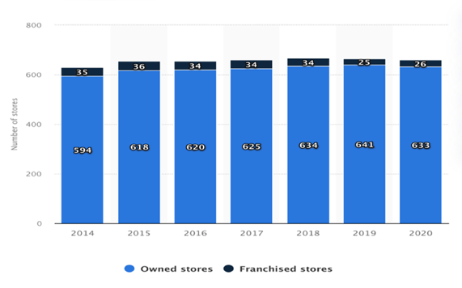
Prada operated 633 own stores and 26 franchisees worldwide in 2020. ( Tugba Sabanoglu , Nov 1, 2021)

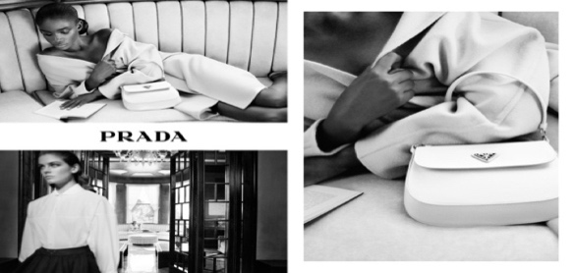
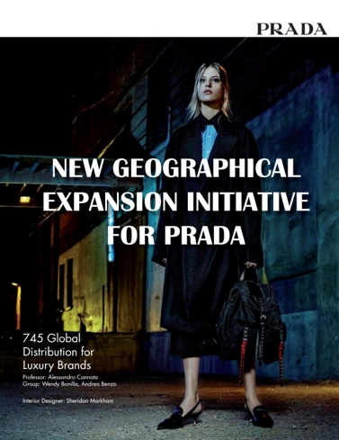

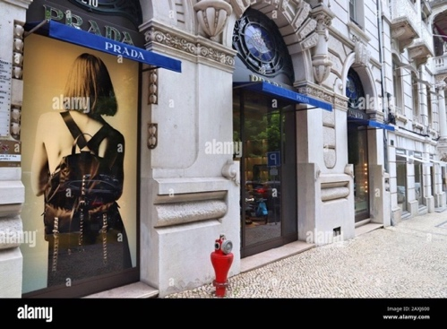
Locations
- Lisbon Avenida Liberdade, 206/210, 1250-096 Lisbon
+351 213199490
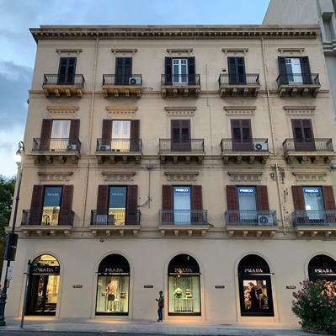

- Palermo Via della Libertà, 1, PA, 90139 Palermo
+39 0913806066

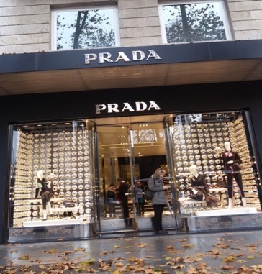
- Madrid Donna Calle de Serrano, 26, 28001 Madrid
+34 91 4362088

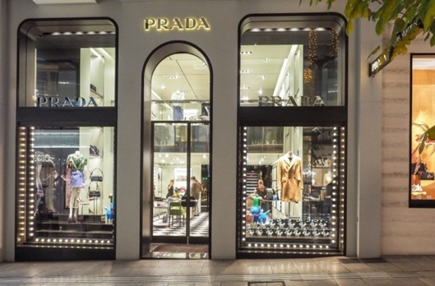
- Athens 17, Voukourestiou, 106 71 Athens
+30 2103388386

- United States, U.S. Route 90 in Jeff Davis County, Texas, 14880 US-90, Valentine, TX 79854,
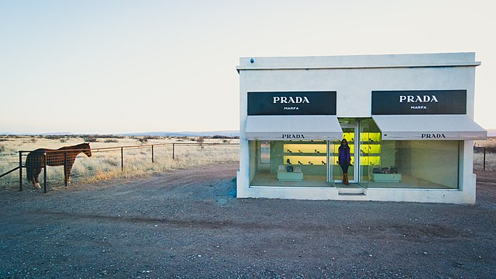
+1 432-729-3600

The Prada Advertising & Promotion Strategy:
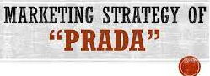
In order to promote and advertise Prada's marketing strategy, the following is done:
A company's primary purpose is to earn profits by satisfying customer demands and to achieve a better position in the market. The only way to grab the attention of customers and secure a place in the competitive market is through marketing. Marketing helps an organization identify its target customers and their needs and wants and supply their requirements according to those needs and wants.(Md. Shadequr Rahaman)
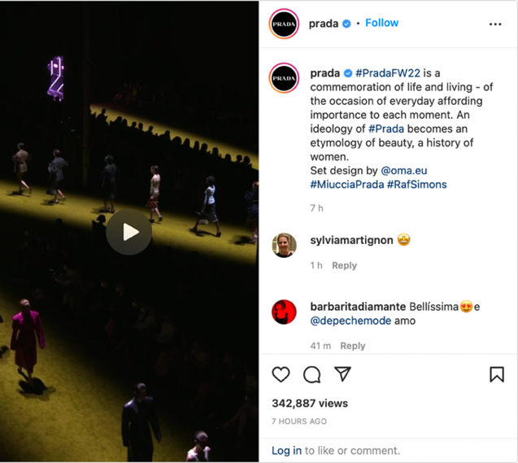


Each of Prada's products is represented on the company's website with complete details, so customers can get more insight into the product. In the fashion industry, Prada shows have been very productive and persuasive. Their runaway shows used music made by a French artist along with a number of models and actors who later appeared in their advertisements to create a stronger impact on customers.

A variety of advertisements were also published in magazines such as Vogue and Elle. Using Miu Miu, Miuccia Prada organized a travelling art exhibition to reach the younger generation. They also participated in a charity event in Milan to help prevent Breast Cancer. They have succeeded in creating a strong global presence through all these promotional activities. That concludes Prada's marketing strategy and marketing mix. (PRADA 2007 - 2021)

References

- https://successstory.com/companies/prada (Date accessed: 23 February 2022)
- https://qz.com/996233/big-luxury-labels-like-gucci-prada-and-louis-vuitton-arent-in-the-business-of-selling-clothes/ (Date accessed: 23 February 2022)
- https://www.pradagroup.com/en/sustainability/prada-impact/impact.html.html (Date accessed: 23 February 2022)
- https://www.mbaskool.com/brandguide/lifestyle-and-retail/3574-prada.html (Date accessed: 23 February 2022)
- https://www.pradagroup.com/en/perspectives/stories/sezione-know-how/visiting-scandicci.html (Date accessed: 24 February 2022)
- Principles of Marketing by Phil T. Kotler, Gary Armstrong, Lloyd C. Harris, and Hongwei He (Date accessed: 24 February 2022)
- https://www.spottedfashion.com/prada-bag-price-list-reference-guide/ (Date accessed: 24 February 2022)
- https://www.businessoffashion.com/opinions/global-markets/top-10-risks-luxury-industry/ (Date accessed: 25 February 2022)
- https://blucactus.blue/what-is-pradas-marketing-strategy/ (Date accessed: 28 February 2022)
- https://www.mbaskool.com/marketing-mix/products/16733-prada.html (Date accessed: 28 February 2022)
- https://www.pradagroup.com/en/brands/prada.html (Date accessed: 28 February 2022)
- https://www.statista.com/statistics/592386/number-of-owned-and-franchised-stores-of-prada/( Date accessed: 28 February 2022)
- https://www.prada.com (Date accessed: 1 March 2022)
- https://www.instagram.com/p/CaXPTJBMF0L/ (Date accessed: 1 March 2022)
- Schwarzbaum, Lisa (June 21, 2006). "The Devil Wears Prada". Entertainment Weekly. Retrieved February 10, 2019. “Lauren Weisberger, who wrote the hiss-and-tell roman à clef best-seller on which the picture is based, was herself an assistant to Wintour” (Date accessed: 1 March 2022)
- Memmott, Carol (June 21,2006) "Chick lit, for better or worse, is here to stay".USA Today. Retrieved May 5, 2014.” Industry observers and booksellers say a glut of pedestrian chick lit has new fans returning to proven, now-classic novels such as Nanny Diaries (2002), Bergdorf Blondes by Plum Sykes (2004) and The Devil Wears Prada.” (Date accessed: 1 March 2022)
- "'The Devil Wears Prada' is getting a sequel! — Exclusive". Entertainment Weekly. May 31, 2012. Retrieved May 31, 2012. (Date accessed: 14 March 2022)
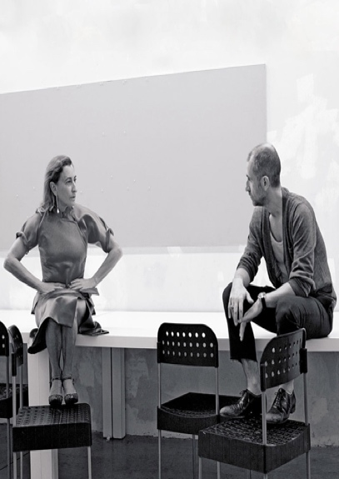
- "Revenge Wears Prada: The Devil Returns Gets A Very Red Cover". Cinemablend.com. March 17, 2013. Retrieved August 23, 2014. (Date accessed: 14 March 2022)
- ^ "'The Devil Wears Prada'". Author Q&A. Random House. Retrieved July 4, 2009. (Date accessed: 14 March 2022)
- Hudders, L. (2012). Why the devil wears Prada: Consumers’ purchase motives for luxuries. Journal of Brand Management, 19(7), pp.609-622. (Date accessed: 14 March 2022)
- Jones, R. (1996). Report on the UK clothing industry and market. Journal of Fashion Marketing and Management: An International Journal, 1(1), pp.83-96. (Date accessed: 15 March 2022)
- Palmer, A. and Hartley, B. (1999). The business and marketing environment. London: McGraw-Hill. (Date accessed: 15 March 2022)
- Diaconu, V. and Cerceloiu, M. (2017). Challenges Faced By Brand Managers in the Luxury Industry: Attitudes and Motivations of Luxury Clothing Consumers. Journal of Marketing Research and Case Studies, pp.1-11. (Date accessed: 17 March 2022)
- Iacobucci, D. (2018). Marketing management. Boston, MA: Cengage Learning. (Date accessed: 17 March 2022)
- Kotler, P. and Armstrong, G. (2012). Principles of marketing. Boston: Pearson Prentice Hall. (Date accessed: 19 March 2022)
- Rosenbloom, B. (1976). The Trade Area Mix and Retailing Mix: A Retail Strategy Matrix. Journal of Marketing, 40(4), p.58. (Date accessed: 19 March 2022)
- Zhang, L. and Cude, B. (2018). Chinese Consumers’ Purchase Intentions for Luxury Clothing: A Comparison between Luxury Consumers and Non-Luxury Consumers. Journal of International Consumer Marketing, 30(5), pp.336-349. (Date accessed: 23 March 2022)

