BMSW4001 Academic and Employability Skills June 2019


PRIFYSGOL CYMRU: Y DRINDOD DEWI SANT

School of Business
London Campus

Academic and Employability Skills
BMSW4001
Lecturer: Joanna Walsh

Student: Ludwig Jaime Rupp Menacho
Student No.: 1917416

Contents
- Introduction 2
- Skills 2
- Academic Skills 3
- Employability Skill
4.1 Hard Skills 3
4.2 Soft Skills 4
4.2.1 Communication 4
4.2.2 Working with a team 5
4.2.3 Time Management 6
5. SWOT Analysis 7
6. Academic Skills 8
7. Research and Note taking 8
8. Academic Writing 9
9. Referencing and Avoiding Plagiarism 10
10. Paraphrasing and Summarising 11
11. Communicating and Presenting information 11
12. Personal Development Plan (PDP) 12
13. Conclusion 12
14. References 13

- Introduction

In this assignment I am going to develop the concepts of each subtitle, I will provide examples and graphics in the concepts that warrant it. When developing the concepts, I will apply all the rules and regulations according to the academic guidelines that were given to me.

I also hope to demonstrate my skills acquired in my studies.

- Skills

Skills is the ability to do something well, especially something that is difficult for most people¹. Some individuals lack the necessary skills to set up and mage a business.

- Academic Skills

Is defined academic skills as aspects of behaviour learned by students while studying at University that are required to operate successfully at the level of higher education; practising these skills leads to the development of graduate attributes, such as problem solving and analytical ability, effective communication, and creativity and innovation. Academic skills are made up of core skills, such as academic writing, presentation skills and referencing, which underpin more complex skills, such as critical thinking and reflective practice’².

Thus, we recognise the importance of academic skills not only in achieving success on your programme of study but also after you leave the University, as you look for employment as a graduate. Developing and practising these skills while you are studying will therefore better equip you for the workplace.

The core skills referred to in the definition include:

- Time management.
- Critical thinking.
- Essay writing.
- Research and library skills
- Quantitative skills
- Analytical skills
- Report writing
- Group working
- Reading skills
- Communication skills
- Presentation skills
- IT skills

- Self-awareness

- Employability Skill

Employability skills are transferrable skills that are useful in every job. They involve the development of an expertise, knowledge base or mindset that makes you more attractive to employers. Employability skills are also often referred to as employment skills, soft skills, work-readiness skills or foundational skills. They often improve your performance, minimize mistakes and promote collaboration with your co-workers, enabling you to perform your role more effectively.
Employability skills may not be listed in a job description, but they are important skills that can make you more attractive to prospective employers. The main benefit of having these traits is that it can help you stand out among other job candidates who are vying for the same position. While other candidates may have the same qualifications and experience, you may have a better chance of getting hired if you have employability skills that are particularly useful for the role.
Certain employability skills are more sought after in specific industries. You can prepare yourself for an interview or write your resume for a particular position by researching which employment skills are essential in your industry³.
Example:

- Critical thinking/cognitive skills
- Problem solving
- Decision making
- Oral communication
- Written communication
- Numeracy
- Communication IT skills
- Self-management
- Team-working
- Listening skills
- Influencing others
- Research skills
- Self-reflexion
- Business acumen/awareness
- Proactive attitude
- Leadership

  - Hard Skills

Hard skills are specific abilities which help people carry out different jobs.
They are teachable, meaning that you can develop them through dedicated training. And, for some careers, certain hard skills will be considered prerequisites.

Examples of hard skills
Hard skills are usually related to a particular field and require specific knowledge in order for them to be gained.
Some of the most common examples of hard skills include:
- A degree (or other academic qualification)
- An industry specific certification
- Coding ability
- Foreign language skills
- Typing speed
- SEO marketing
- Bookkeeping
- Computer skills
- Proofreading

  - Soft Skills

Soft skills are self-developed attributes, that are not specific to a particular role.
They are usually picked up through your life and work experiences, meaning no training is needed to build them. And because they can be applied to a number of roles, soft skills are in demand in a wide range of different industries.
Examples of soft skills
Soft skills are a combination of many different things, including social skills, character traits and employment qualities.
Some of the most common examples of soft skills include:
- Interpersonal skills
- Leadership
- Project management
- Problem solving
- A good work ethic
- Team working
- Adaptability
- Perseverance
- Communication skills

    - Communication
Being able to communicate effectively is perhaps the most important of all life skills. It is what enables us to pass information to other people, and to understand what is said to us. You only have to watch a baby listening intently to its mother and trying to repeat the sounds that she makes to understand how fundamental is the urge to communicate.
Communication, at its simplest, is the act of transferring information from one place to another. It may be vocally (using voice), written (using printed or digital media such as books, magazines, websites or emails), visually (using logos, maps, charts or graphs) or non-verbally (using body language, gestures and the tone and pitch of voice). In practice, it is often a combination of several of these.
Communication skills may take a lifetime to master—if indeed anyone can ever claim to have mastered them. There are, however, many things that you can do fairly easily to improve your communication skills and ensure that you are able to transmit and receive information effectively.
Professionally, if you are applying for jobs or looking for a promotion with your current employer, you will almost certainly need to demonstrate good communication skills.
Communication skills are needed to speak appropriately with a wide variety of people whilst maintaining good eye contact, demonstrate a varied vocabulary and tailor your language to your audience, listen effectively, present your ideas appropriately, write clearly and concisely, and work well in a group. Many of these are essential skills that most employers seek⁵.

    - Working with a team⁶

Teamwork skills are the qualities and abilities that allow you to work well with others during conversations, projects, meetings or other collaborations. Having teamwork skills is dependent on your ability to communicate well, actively listen and be responsible and honest. There are many other additional soft skills that can help you be an exceptional teammate at work we will discuss more below.

Why are teamwork skills important?
You will be required to work alongside others in every industry at every level in your career. Doing so in an empathetic, efficient and responsible manner can help you accomplish career goals, grow your resume and contribute positively to your organization. It can also help you build rapport with others. Building rapport can lead to deeper working relationships, new connections and possibly new opportunities.

Examples of teamwork skills
Teamwork skills are made up of many other soft skills you can work to develop over time. Here are just a few examples of qualities that can help you improve your teamwork skills:

- Communication.
- Responsibility.
- Honesty
- Active listening.
- Empathy.
- Collaboration
      - Awareness

    - Time Management

“Time management” is the process of organizing and planning how to divide your time between specific activities. Good time management enables you to work smarter – not harder – so that you get more done in less time, even when time is tight and pressures are high. Failing to manage your time damages your effectiveness and causes stress.

Time management refers to the way that you organize and plan how long you spend on specific activities.
It may seem counter-intuitive to dedicate precious time to learning about time management, instead of using it to get on with your work, but the benefits are enormous:
- Greater productivity and efficiency.
- A better professional reputation.
- Less stress.
- Increased opportunities for advancement.
- Greater opportunities to achieve important life and career goals.
Failing to manage your time effectively can have some very undesirable consequences:
- Missed deadlines.
- Inefficient work flow.
- Poor work quality.
- A poor professional reputation and a stalled career.
- Higher stress levels.
Spending a little time learning about time-management techniques will have huge benefits now – and throughout your career⁷.

- SWOT Analysis⁸

Use SWOT Analysis to assess your organization's current position before you decide on any new strategy.
Find out what is working well, and what is not so good. Ask yourself where you want to go, how you might get there – and what might get in your way. These are big issues, and you will need a powerful but simple technique to help you: SWOT Analysis.

- A SWOT analysis is a compilation of your company strengths, weaknesses, opportunities and threats.
- The primary objective of a SWOT analysis is to help organizations develop a full awareness of all the factors involved in making a business decision.
- Perform a SWOT analysis before you commit to any sort of company action, whether you are exploring new initiatives, revamping internal policies, considering opportunities to pivot or altering a plan midway through its execution.
- Use your SWOT analysis to discover recommendations and strategies, with a focus on leveraging strengths and opportunities to overcome weaknesses and threats.

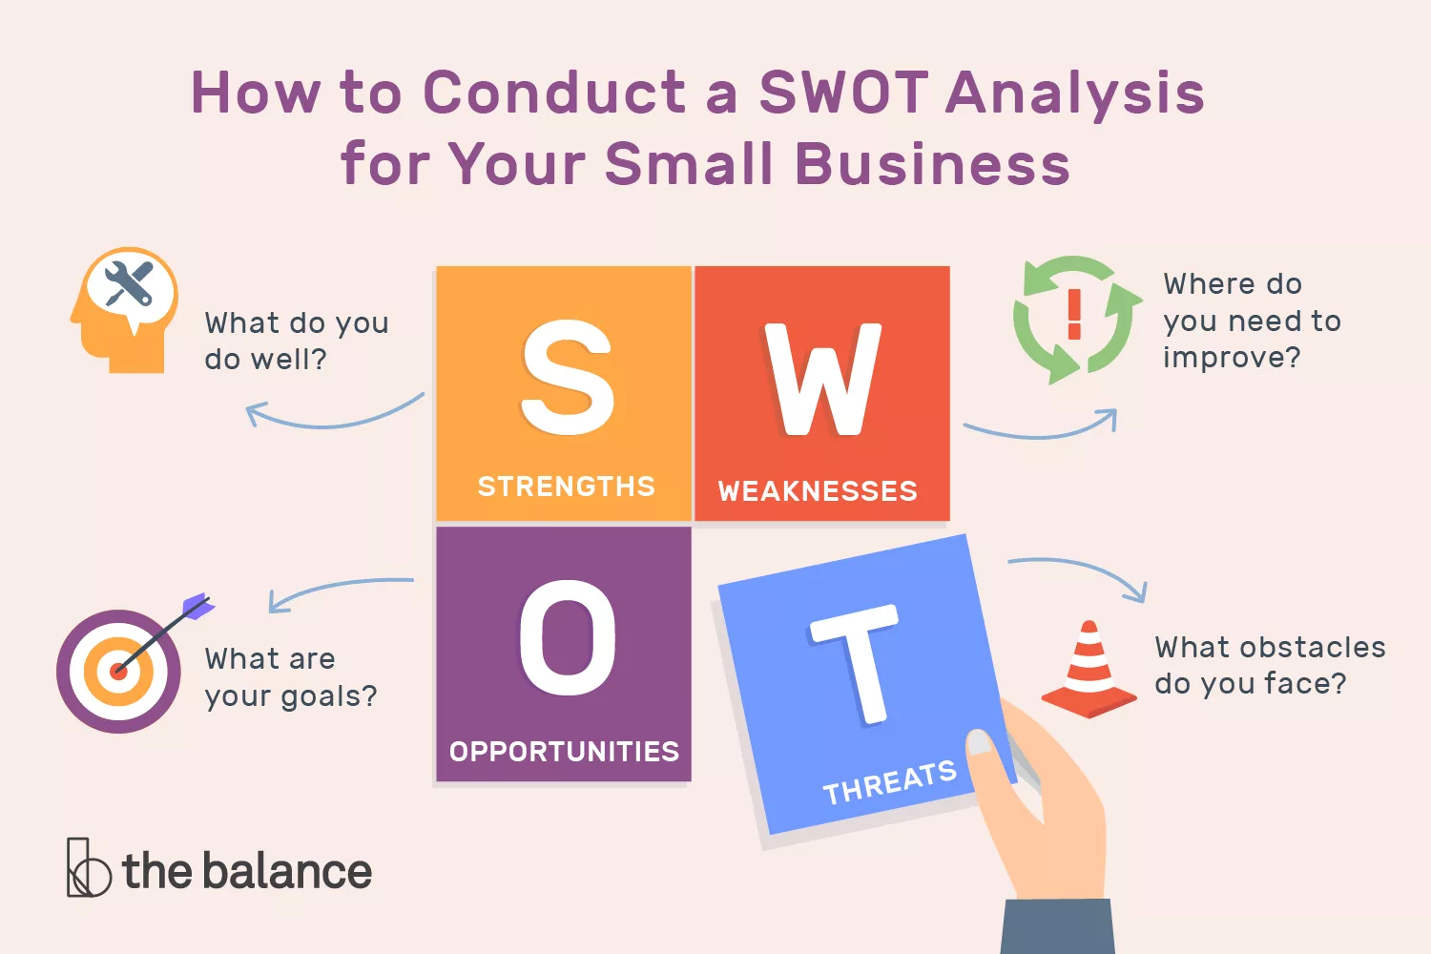Figure # 1

- Academic Skills

Academic skills encourage students to become more efficient learners. They give students the confidence to participate fully in English-speaking courses and are invaluable outside of the classroom and after they graduate. These skills, which include critical thinking and note-taking, are also highly transferable, and therefore vital for success in any career
Students are expected to have a number of these skills when they start in higher education. The Global Scale of English (GSE) Teacher Toolkit organizes them into five categories⁹:
- Academic Discourse – skills for communicating effectively in debates, discussions and presentations
- Academic Text Strategies – skills for analyzing academic texts in greater detail
- Academic Strategies – skills for understanding and responding critically to lectures
- Composition – skills for effective academic writing
- Comprehension – skills for understanding academic texts and lectures

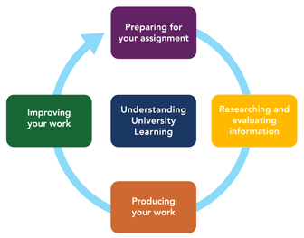
Figure # 2

7. Research and Note taking

Note-taking is the practice of writing down or otherwise recording key points of information. It's an important part of the research process. Notes taken on class lectures or discussions may serve as study aids, while notes taken during an interview may provide material for an essay, article, or book. "Taking notes doesn't simply mean scribbling down or marking up the things that strike your fancy," say Walter Pauk and Ross J.Q. Owens in their book, "How to Study in College." "It means using a proven system and then effectively recording information before tying everything together."
Note-taking involves certain cognitive behavior; writing notes engages your brain in specific and beneficial ways that help you grasp and retain information. Note-taking can result in broader learning than simply mastering course content because it helps you to process information and make connections between ideas, allowing you to apply your new knowledge to novel contexts, according to Michael C. Friedman, in his paper, "Notes on Note-Taking: Review of Research and Insights for Students and Instructors," which is part of the Harvard Initiative for Learning and Teaching.
Shelley O'Hara, in her book, "Improving Your Study Skills: Study Smart, Study Less," agrees, stating:
"Taking notes involves active listening, as well as connecting and relating information to ideas you already know. It also involves seeking answers to questions that arise from the material."
Taking notes forces you to actively engage your brain as you identify what's important in terms of what the speaker is saying and begin to organize that information into a comprehensible format to decipher later. That process, which is far more than simply scribbling what you hear, involves some heavy brainwork¹⁰.

8. Academic Writing

An ability to write clearly is essential if you are to achieve success on your programme of study. The majority of the assessments you will undertake require the completion of a piece of written work; the marks you receive for these pieces of work will reflect, in part, your ability to convey your ideas clearly and persuasively.
Writing to a high standard is a difficult skill for many people to develop. In the first place, it requires conscious effort; for example, if you know that you have difficulties in using the apostrophe properly, consider each instance of its use when you come across it in a book or a journal article and try to understand why it has been employed in that way. Developing this ability will take time; it is not easily corrected by reading a textbook or a study guide. However, with effort and application, your writing ability will be enhanced.
Developing your writing skills will not only enhance the quality of your work; it will also provide you with highly effective written communication skills, which are particularly sought after by employers.
Academic Writing
Academic writing refers to the ability to write for an academic audience. It is somewhat different from writing a blog entry, for example, or a piece of reflection. Academic writing is more formal in tone and requires an authoritative and confident style. This is achieved by using the third person, for example (‘it is argued that’), rather than the first (‘I think that’), adding references, and confidently using technical vocabulary.
English language
Gaining a sound understanding of English language and the principles of grammar is not an easy process, but it is possible to improve the quality of your writing by developing an awareness of the most common mistakes¹¹.

9. Referencing and Avoiding Plagiarism
Referencing is when you acknowledge other peoples’ work and allow the reader to locate the sources you have used. Referencing is one aspect of developing good academic practice, an essential skill to learn at University. Referencing your sources also means you can avoid plagiarising the work of others.
You should always refer to your module materials to check which referencing style to use for your assignment, or ask your tutor for advice if you're not sure. Listed below are some guides which show you how to use referencing styles common in OU modules¹².
At university, we all need to read and use other people's thinking and ideas in developing our own thinking and ideas. This means you need to be able to "reference" other people's ideas and thinking properly in your assignments; failure to do this can result in what is called "plagiarism". In simple terms, "plagiarism" is the use of other people's ideas and thinking without giving a "reference" to that person in your writing. "Plagiarism" and "referencing" are therefore essential things to understand at university ¹³.

10. Paraphrasing and Summarising
Paraphrasing This section will help you to get on top of paraphrasing by examining what, why and how to paraphrase. What is paraphrasing? Paraphrasing is not producing a direct copy of another persons’ ideas or work. Paraphrasing is re-writing another person’s words so that the original meaning of their idea is maintained, but the structure and words you use are quite different to theirs.
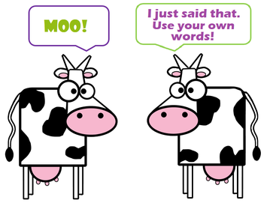Figure # 3
When you paraphrase, the words and structures you use should sound like something you would normally say or write. Therefore, paraphrasing is... • Presenting the ideas and information of others in your own voice. • Not necessarily presenting the original text in an elaborate way, but in a way that flows with your expression. • If you want to write very closely to the original text, then you may need to consider whether it’s worthy of a direct quote – or if you have to work more at expressing it in your own voice. ¹⁴

11. Communicating and Presenting information
Effective communication & presentation skills are key to business success. In addition to learning how to deal with difficult people, students acquire techniques for connecting with people quickly and easily as well as clearly presenting their ideas. Students also discover their own communication style and learn how to identify the communication preferences of others. Morale and productivity improve because their personal and professional relationships improve skills and knowledge gained from learning how to effectively communicate and make memorable presentations¹⁵.

12. Personal Development Plan (PDP)
Personal development does not necessarily imply upward movement; rather, it is about enabling individuals to improve their performance and reach their full potential at each stage of their career¹⁶
Personal development planning is the process of:
- establishing aims and objectives (or goals) - what you want to achieve or where you want to go, in the short, medium or long-term in your career
- assessing current realities
- identifying needs for skills, knowledge or competence
- selecting appropriate development activities to meet those perceived needs.

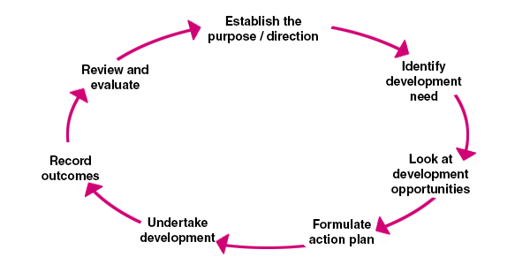Figure # 4

13. Conclusion (What have you done so far) 100 Words Max
I have learned to develop my personal skills as well as academic ones. Throughout my academic studies I am also learning transferable skills that allow me to easily develop my workplace.
Through this course, new job opportunities and a new way of life have open up for me. I am so excited to continue developing my academic skills at the next level.
From now on I am using my skills acquired in this university to better plan my personal life as well as the academic one.

14. References
1 Oxford dictionary academic.
2 https://study.cardiffmet.ac.uk/AcSkills/Pages/About.aspx ' (Academic Skills Specialists, 2013)
3 https://www.indeed.com/career-advice/finding-a-job/employability-skills
4 https://www.reed.co.uk/career-advice/hard-skills-vs-soft-skills/
5 https://www.skillsyouneed.com/ips/communication-skills.html
6 https://www.indeed.com/career-advice/career-development/teamwork-skills
7 https://www.mindtools.com/pages/article/newHTE_00.htm
8 https://www.mindtools.com/pages/article/newTMC_05.htm
9 Global Scale of English (GSE) Teacher Toolkit
10 https://www.thoughtco.com/note-taking-research-1691352
11 http://learnenglish.britishcouncil.org/en/english-grammar
12 https://www.open.ac.uk/library/help-and-support/referencing-and-plagiarism
13 https://unihub.mdx.ac.uk/study/writing-numeracy/online-resources/referencing-and-avoiding-plagiarism
14 http://studyskills.curtin.edu.au/wp-content/uploads/2014/12/Section5-Paraph-Summ-text-version.
15 https://www.pierobon.org/courses/angola.htm
16 https://www.managers.org.uk/knowledge-bank/personal-development-planning

Figure # 1 https://www.thebalancesmb.com/thmb/wB5Aux5KzsdZN1_XEsAeYO_gkpU=/1500x0/filters:no_upscale():max_bytes(150000):strip_icc():format(webp)/swot-analysis-for-small-business-2951706-v02-5b3b809dc9e77c001afe8f7e.png
Figure # 2 https://www.staffs.ac.uk/assets/circle-of-learning-2_tcm44-70869.gif
Figure # 3 https://www.virtuallibrary.info/uploads/2/6/9/3/26930678/editor/two-cows2.png?1492934922
Figure # 4 https://www.managers.org.uk/~/media/Images/Shop%20Images/cycle2.png

