  Component One:  What are the key skills required when working in the housekeeping team? | Student No: | 2127114
 | Module Title: | Operating Hotel Facilities
 | Module Code: | BMIH4006
 | Lecturer: | Lola Villard
To conduct the processing and analysis of my student journal, I was involved in Delta hotel which mainly operated with the support of Marriott Swindon. To perform my duty, I was appointed as a receptionist and I mainly engaged in several jobs like serving food and drinks, cleaning tables, attending guests and other relevant performances that are generally formulated by a receptionist in a hotel. As an appointed member of C&B, I also used to refill the container related to both lunch and dinner time to provide a proper service facility to an individual customer.
During my performing career, I initiated a significant volume of knowledge and experienced a positive approach as a bartender mainly. At the time of my first three weeks, I realised my general ability and also understood how to attend to a customer and serve a positive approach to conduct the general duty with a delegated order. I also realise the general business functions as well as basic gestures regarding performing duties and responsibilities on a supportive basis. Associated with the general functional approach within the next three weeks I realised the general approach and the performances which are needed to be initiated as a waiter mainly including positive behavioural support for an individual customer (Pang, 2022).
The presence of this knowledge approach also provides systematic and compatibility support related to capability including positive department identification on an effective and compatible base. The general engagement of placement experience widely initiates a systematic volume of ability-enhancing and experience formulation support to me which provides positive and systematic progress related to compatibility analysis and basic characteristics development in me. It also provides proper formulations and knowledge processing support to acquire some of the systematic gestures in a more developing order that can be utilised to formulate a positive experience for an individual customer during their service engagement (Buonocore et al., 2022)
The basic opportunity of placement in this particular Hotel provides systematic and compatible knowledge-enhancing support to me, associated with a proper volume of serving approach to the customer. In the present situation, along with initiating some positive and supportive knowledge approach I can easily formulate and perform my service as a bartender. I can also attend to an individual customer at a single time along with providing equality of services according to their expectations. It also provides a positive functional approach including performance stability support as well that is sustainable for the feasibility growth of knowledge mainly (Lin and Hou, 2022). During the formulation of my working approach, I used to enhance my conversation quality, which provides positive performance development and a proper communication processing approach on an effective basis.
With the initiative of this particular process, I also share my general skills and abilities in an extended position so that I can easily handle any situation to the best ability. With the application of a proper generating and experience formulation approach, I also gain the benefit of emotional intelligence in a supportive basis that generally provides a proper opportunity to contact my functional engagement as well as evaluate the sources of the hospital in this organisation more systematically (Samei et al., 2019). Along with the initial approach of evaluation, I was also able to conduct the performance with a supervisory approach as well that is generally initiated to conduct the compatibility benefits and a proper responsibility approach mainly. Associated with the same approach I also realise the significance of managing a proper confidentially approach and knowledge performances in a proper order which can be initiated to formulate the structural compatibility and some of the stability support of performances on a more systematic basis.
It provides an opportunity to maintain the cultural attribute and performance development processing support as well which is influential for managing the compatibility benefit in me in a progressive manner. During the continuation of my performances, I have gained a proper amount of knowledge related to international experience which provides a positive hospitality service and cultural diversity formulation on a compatible basis. It also provides a proper volume of responsibility initiative approach as well as a highly capable fragmented and development knowledge approach mainly which is sustainable for stability reasons (Zhao and Burke, 2021). The presence of this particular approach and compatibility benefit also provides a proper amount of planning and objectifying capability in me that brings the ultimate benefit of standardisation and formulated growth initiative. I realised the general performance stability as well as compatibility growth related to the hospitality sector mainly formulates the quality of knowledge and abilities during my career.

Word Count | 750

Component Two:
In this scenario – You have just been promoted to team leader for a floor within the hotel. A guest complains that on their arrival, their room had not been properly cleaned. Create an action plan and answer the following questions.

Problem | Why did it happen? | What are you going to do? | How will you prevent this from happening in the future? | What measures would you introduce to improve team effectiveness?
Internal working structure | A proper evaluation of primary attendance related to the individual employee who is directly or indirectly involved with the performance needs to be checked (Klietsova and Mykhailova, 2021). Including the basic approach, a positive facility related to the relevant performances also needs to be evaluated in a systematic and compatible manner. | Initiating a small meeting to inform fellow colleagues and request their cooperation for smooth operations in the absence of the manager (Mishra et al., 2019). | It is able to provide proper marketing development including employee interaction support that initiates a progressive support for objective completion support (Suárez-Eiroa et al., 2019) | Maintaining a proper decision-making approach which provides positive productivity and service-related development along with customer-handling capability
Business operating issues | All the necessary performances including the operating approach are needed to be handled on a proactive basis so that a proper managerial structure including the operating growth is balanced (Odarenko, 2019). Additionally, a proper arrangement related to guest engagement and luggage maintenance and relevant transportation availability also needs to be structured properly so that a quality service can be initiated. | Processing and formulation support an effective demonstration of leadership skills. | For managing proper leadership quality and compatibility associated with individual employee engagement | Evaluate the engagement of risk management processing including performance stability approach related to different situational support
Customer maintenan  ce issues | A proper addressing support related to an individual complaint by the customer on a prompt basis needs to be formulated in a supportive order so that proper stability and maintenance of performance growth along with organisation reputation can be effectively coordinated (Tepavicharova et al., 2020). | Through the application of proper planning structure related to scheduling maintenance basis with the application of proper and efficient employee engagement related to individual complaints from customers | Application of time management in order to provide proper planning and formulated engagement related to performance stability and other task management performances properly (Bag et al., 2020)  The processing of dividing responsibility and proper allocations among the employee depends on the adequacy of support so that proper Task Management and equality initiatives can be balanced (Ganda, 2019 | Formulation and processing of strategic development and support that can be initiated for managing the smooth performance of operating compatibility  Prioritising individual problems related to the situational approach with proper handling abilities to formulate the quality management and operating progress approach
 | For providing effective food quality support, proper analysis and evaluation of the current menu also need to be evaluated daily so that positive food processing including a proper satisfactory approach for individual customers can be initiated according to their expectations.
Communication issues | A positive development including proper communication engagement with individual guest and employee also needs to be conducted with a proper interaction basis so that the quality services including the compatibility approach can be balanced (Edo and Uzoma, 2019). Additionally, a proper feedback box also needs to be arranged in order to recognise the general feedback of individual customers about the currently provided performances. | Application of proper task allocation support related to the individual employee along with their compatibility and adequacy basis (Iqbal and Kim, 2022). | An appointment of a specific feedback department related to evaluating individual problems and complaints from customers and providing a positive strategic development approach on such behalf | Evaluating the ability to accomplish individual tasks in a positive and objectified manner that can be initiated to manage and formulate the situational approach along with strategic development and basis. Additionally, proper planning and implementation of such a planning approach also needs to be established for the positive development

Component Three:
Your task is to create and prepare a presentation following the detailed scenario provided below.

As the floor housekeeping manager and given the recent guest complaints you need to put together a basic training presentation for your colleagues within the housekeeping team to get the best out of them, ensure that brand standard is being achieved and that Health and Safety procedures are also being followed.

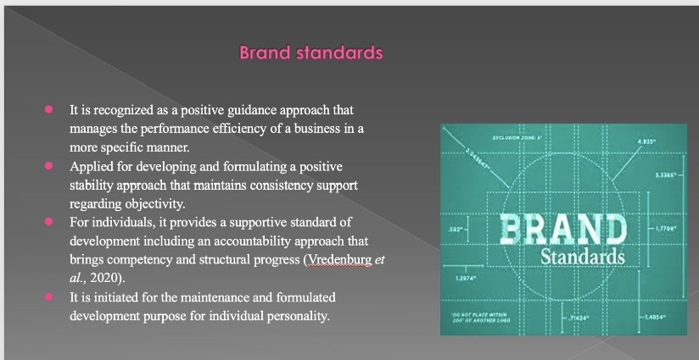

Training Notes: Brand standards
It is recognized as a positive guidance approach that manages the performance efficiency of a business in a more specific manner. Applied for developing and formulating a positive stability approach that maintains consistency support regarding objectivity. For individuals, it provides a supportive standard of development including an accountability approach that brings competency and structural progress (Vredenburg et al., 2020). It is initiated for the maintenance and formulated development purpose for individual personality.

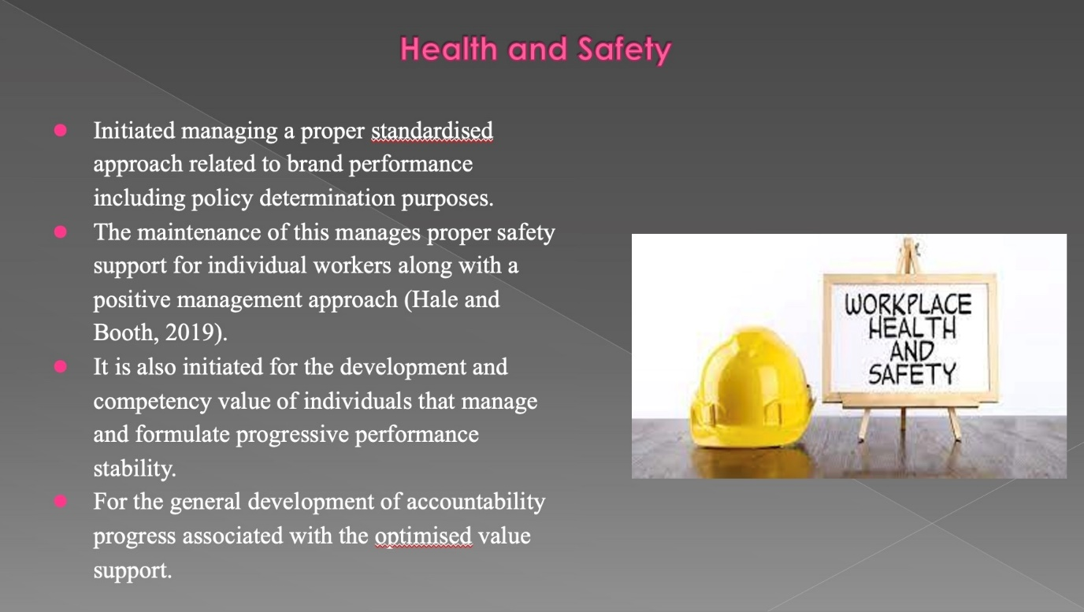

Training Notes: Health and standards
Initiated managing a proper standardized approach related to brand performance including policy determination purposes. The maintenance of this manages proper safety support for individual workers along with a positive management approach (Hale and Booth, 2019). It is also initiated for the development and competency value of individuals that manage and formulate progressive performance stability. Applied for the general development of accountability progress associated with the optimized value support

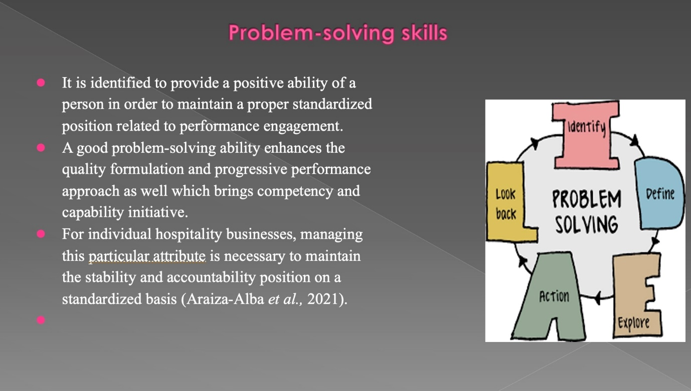

Training Notes: Problem-solving
It is identified to provide a positive ability of a person to maintain a proper standardized position related to performance engagement. A good problem-solving ability enhances the quality formulation and progressive performance approach as well which brings competency and capability initiative. For individual hospitality businesses, managing this attribute is necessary to maintain the stability and accountability position on a standardized basis (Araiza-Alba et al., 2021).

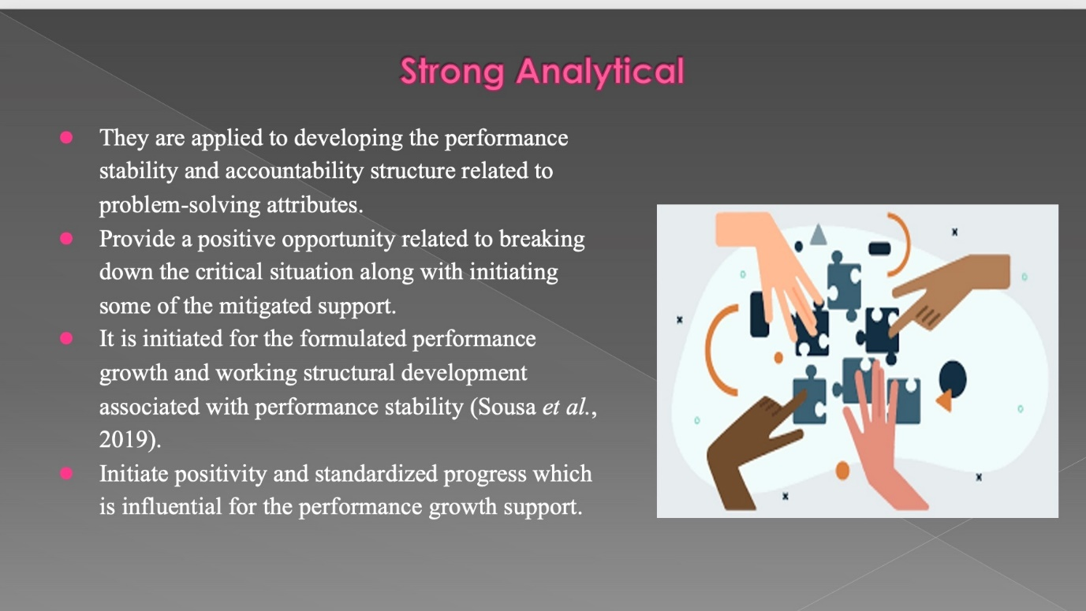

Training Notes: Strong Analysts
They are applied for developing performance stability and accountability structure related to problem-solving attributes. Provide a positive opportunity related to breaking down the critical situation mainly along with initiating some of the mitigated support. It is initiated for the formulated performance growth and working structural development associated with performance stability (Sousa et al., 2019). Initiate positivity and standardized progress which is influential for the performance growth support.

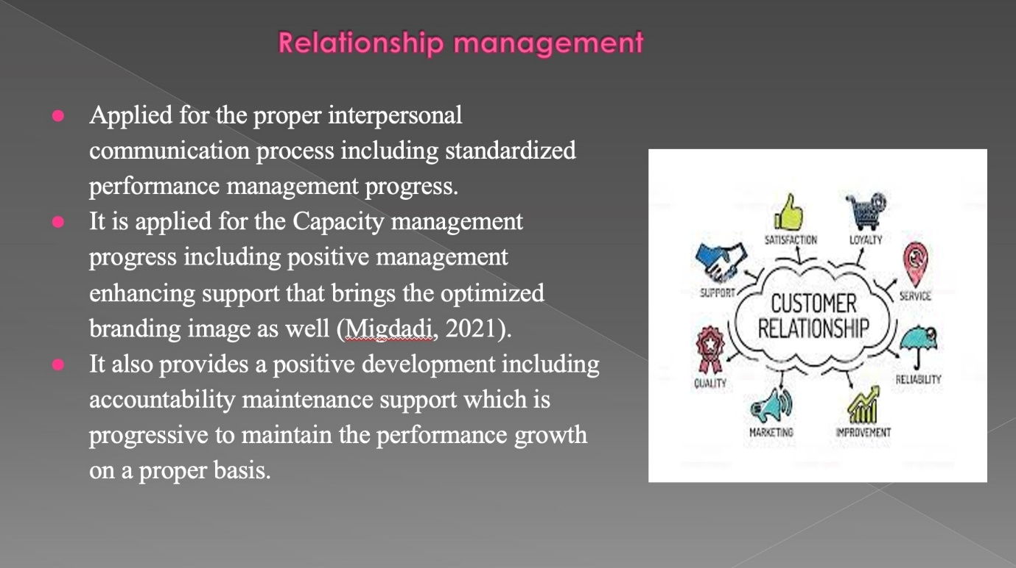

Training Notes: Relationship Manager
Applied for the proper interpersonal communication process including standardized performance management progress. It is applied for the Capacity management progress including positive management enhancing support that brings the optimized branding image as well (Migdadi, 2021). It also provides a positive development including accountability maintenance support which is progressive to maintain the performance growth on a proper basis.

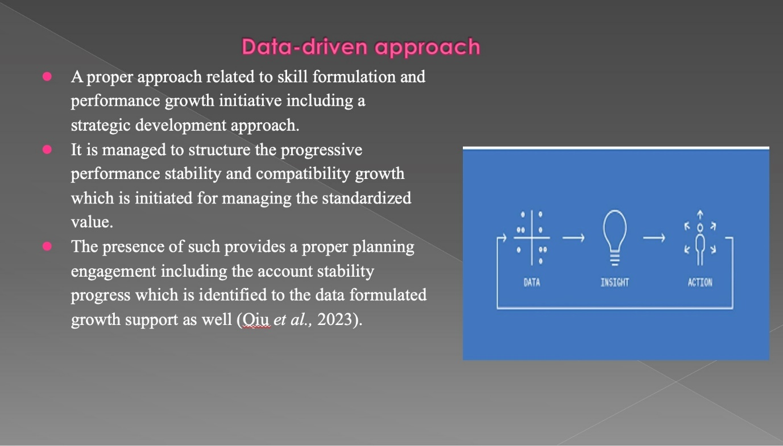

Training Notes: Data driven approach
A proper approach related to skill formulation and performance growth initiative including a strategic development approach. It is managed to structure the progressive performance stability and compatibility growth which is initiated for managing the standardized value. The presence of such provides a proper planning engagement including the account stability progress which is identified to the data formulated growth support as well (Qiu et al., 2023).

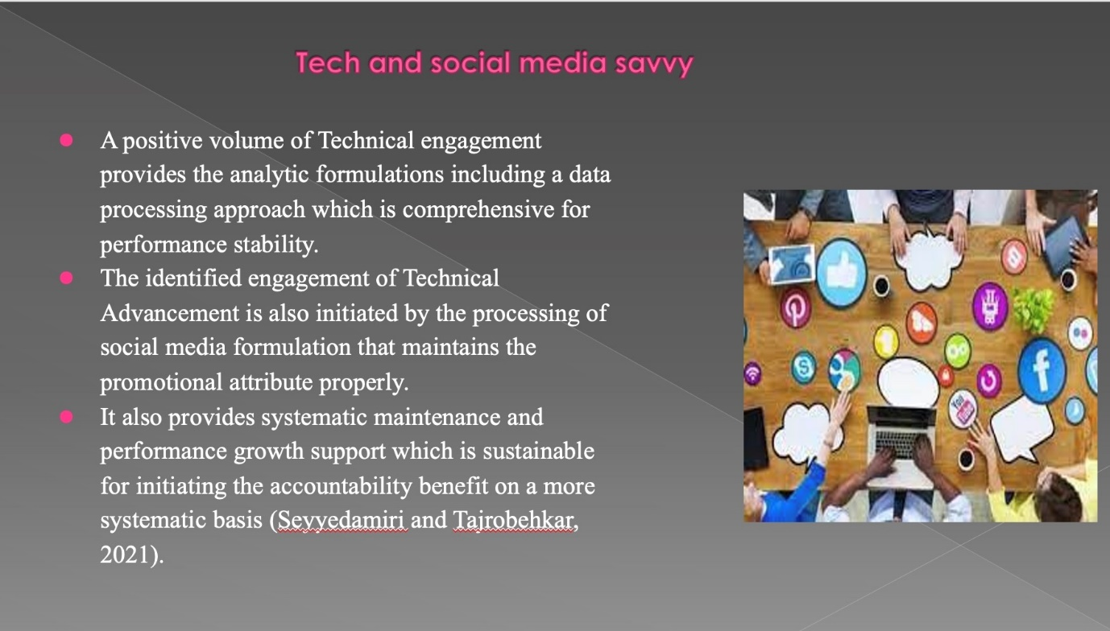

Training Notes: Tech and social media savvy
A positive volume of technical engagement provides the analytic formulations including a data processing approach which is comprehensive for performance stability. The identified engagement of Technical Advancement is also initiated by the processing of social media formulation that maintains the promotional attribute properly. It also provides systematic maintenance and performance growth support which is sustainable for initiating the accountability benefit on a more systematic basis (Seyyedamiri and Tajrobehkar, 2021)

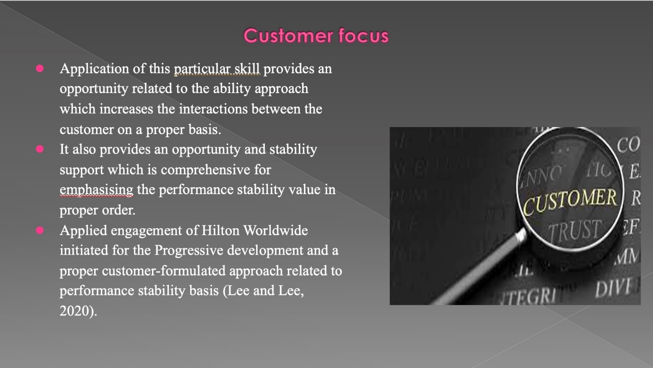

Training Notes: Customer focus
Application of this skill provides an opportunity related to the ability approach which increases the interactions between the customer on a proper basis. It also provides an opportunity and stability support which is comprehensive for emphasizing the performance stability value in proper order. Applied engagement of Hilton Worldwide initiated for the Progressive development and a proper customer-formulated approach related to performance stability basis (Lee and Lee, 2020).

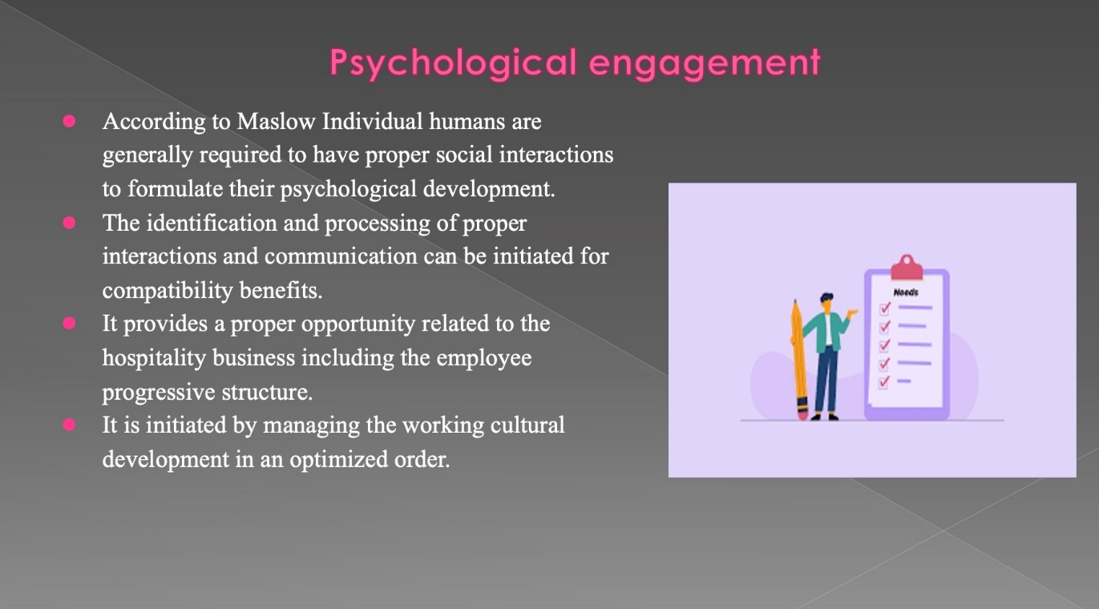

Training Notes: psychology engagement
According to Maslow Individual humans are generally required to have proper social interactions to formulate their psychological development. The identification and processing of proper interactions and communication can be initiated for compatibility benefits. It provides a proper opportunity related to the hospitality business including the employee progressive structure. It is initiated by managing the working cultural development in an optimized order.

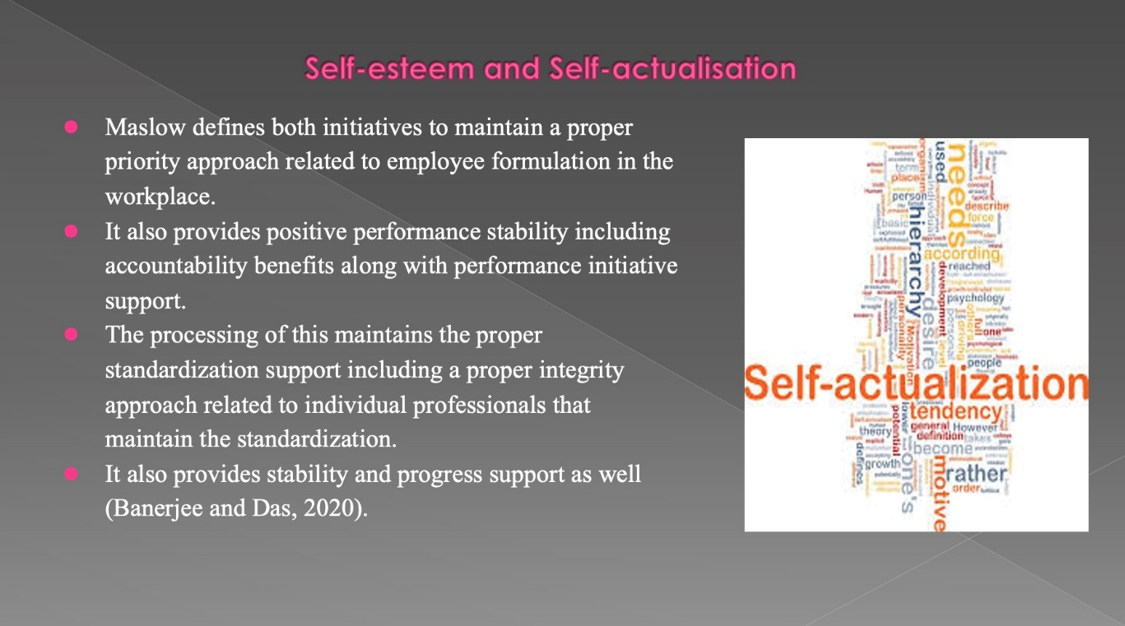

Training Notes: Self-esteem and Self-actualisation
Maslow defines both the Initiative to maintain a proper priority approach related to employee formulation in the workplace. It also provides positive performance stability including accountability benefits along with performance initiative support. The processing of this maintains the proper standardization support including a proper integrity approach related to individual professionals that maintain the standardization. It also provides stability and progress support as well (Banerjee and Das, 2020).

References
Araiza-Alba, P., Keane, T., Chen, W.S. and Kaufman, J., 2021. Immersive virtual reality as a tool to learn problem-solving skills. Computers & Education, 164, p.104121.
Banerjee, P. and Das, J., 2020. Relationship between Happiness and Self Esteem among University Teachers. PalArch's Journal of Archaeology of Egypt/Egyptology, 17(9), pp.3621-3631.
Hale, A. and Booth, R., 2019. The safety professional in the UK: Development of a key player in occupational health and safety. Safety Science, 118, pp.76-87.
Lee, S.M. and Lee, D., 2020. “Untact”: a new customer service strategy in the digital age. Service Business, 14(1), pp.1-22.
Migdadi, M.M., 2021. Knowledge management, customer relationship management and innovation capabilities. Journal of Business & Industrial Marketing, 36(1), pp.111-124.
Qiu, R., Ma, L. and Sun, M., 2023. A robust omnichannel pricing and ordering optimization approach with return policies based on data-driven support vector clustering. European Journal of Operational Research, 305(3), pp.1337-1354.
Seyyedamiri, N. and Tajrobehkar, L., 2021. Social content marketing, social media and product development process effectiveness in high-tech companies. International Journal of Emerging Markets, 16(1), pp.75-91.
Sousa, M.J., Pesqueira, A.M., Lemos, C., Sousa, M. and Rocha, Á., 2019. Decision-making based on big data analytics for people management in healthcare organizations. Journal of medical systems, 43, pp.1-10.
Vredenburg, J., Kapitan, S., Spry, A. and Kemper, J.A., 2020. Brands taking a stand: Authentic brand activism or woke washing?. Journal of public policy & marketing, 39(4), pp.444-460.
Bag, S., Wood, L.C., Xu, L., Dhamija, P. and Kayikci, Y., 2020. Big data analytics as an operational excellence approach to enhance sustainable supply chain performance. Resources, Conservation and Recycling, 153, p.104559.
Bridger, E. (2018) Employee engagement: a practical introduction. 2nd ed. HR Fundamentals. London: CIPD and Kogan Page.
Buonocore, S., Grazioso, S. and Di Gironimo, G., 2022, August. Virtual Teleoperation Setup for a Bimanual Bartending Robot. In Extended Reality: First International Conference, XR Salento 2022, Lecce, Italy, July 6–8, 2022, Proceedings, Part II (pp. 306-325). Cham: Springer Nature Switzerland.
Cottrell, S. (2019) The Study Skills Handbook. 5th ed. London: Red Globe Press.
Edo, B.L. and Uzoma, L., 2019. Legal Implications of Staff Management in Public Secondary Schools in Rivers State. International Journal of Innovative Social Sciences & Humanities Research, 7(1), pp.67-77.
Ferdinand, N. and Kitchin, P. (2017) Events Management - An International Approach. 2nd ed. London:SAGE Publications Ltd.
Ganda, F., 2019. The impact of innovation and technology investments on carbon emissions in selected organisation for economic Co-operation and development countries. Journal of cleaner production, 217, pp.469-483.
Iqbal, N. and Kim, D.H., 2022. Iot task management mechanism based on predictive optimization for efficient energy consumption in smart residential buildings. Energy and Buildings, 257, p.111762.
Klietsova, N. and Mykhailova, I., 2021. International Experience in Staff Management in the Process of Staff Recruitment for Vacant Positions with the Application of Social Networks in the Conditions of Digitalisation. Edukacja Ekonomistów i Menedżerów, 59(1).
Leiter, M. P. and Bakker, A. B. (2010) Work Engagement: A Handbook of Essential Theory and Research.Hove [England]: Psychology Press.
Lin, Y.C. and Hou, H.T., 2022. The evaluation of a scaffolding-based augmented reality educational board game with competition-oriented and collaboration-oriented mechanisms: differences analysis of learning effectiveness, motivation, flow, and anxiety. Interactive Learning Environments, pp.1-20.
Mishra, K.V., Shankar, M.B., Koivunen, V., Ottersten, B. and Vorobyov, S.A., 2019. Toward millimeter-wave joint radar communications: A signal processing perspective. IEEE Signal Processing Magazine, 36(5), pp.100-114.
Mullins, L. and Dossor, P. (2013) Hospitality Management and Organisational Behaviour. 5th ed. Harlow:Pearson.
Odarenko, T.Y., 2019. Perspectives of digitization in staff management. In CEUR Workshop Proceedings (Vol. 2522, pp. 121-130).
Pang, P.C.I., 2022, June. Performance Evaluation of Text Embeddings with Online Consumer Reviews in Retail Sectors. In 2022 IEEE/ACIS 22nd International Conference on Computer and Information Science (ICIS) (pp. 170-175). IEEE.
Quick, L. (2020) Managing Events. Real Challenges, Real Outcomes. London: SAGE Publications Ltd.
Raghubalan, G. and Raghubalan, S. (2016) Hotel Housekeeping - Operations And Management. 3rd ed.India: Oxford University Press.
Samei, E., Bakalyar, D., Boedeker, K.L., Brady, S., Fan, J., Leng, S., Myers, K.J., Popescu, L.M., Ramirez Giraldo, J.C., Ranallo, F. and Solomon, J., 2019. Performance evaluation of computed tomography systems: summary of AAPM Task Group 233. Medical physics, 46(11), pp.e735-e756.
Sharma, N., Chaudhary, N. and Singh, V. (2019) Management Techniques For Employee Engagement InContemporary Organizations. Hershey, Pennsylvania: IGI Global.
Suárez-Eiroa, B., Fernández, E., Méndez-Martínez, G. and Soto-Oñate, D., 2019. Operational principles of circular economy for sustainable development: Linking theory and practice. Journal of cleaner production, 214, pp.952-961.
Tepavicharova, M., Aleksejeva, L. and Vazov, R., 2020. Interaction of Subordinate Staff Management and Factors of Economic Performance of Companies in the Bulgarian Mining and Quarrying Sector. In E3S Web of Conferences (Vol. 174, p. 04031). EDP Sciences.
Zhan, S. and Chong, A., 2021. Data requirements and performance evaluation of model predictive control in buildings: A modeling perspective. Renewable and Sustainable Energy Reviews, 142, p.110835.
Zhao, J. and Burke, A.F., 2021. Review on supercapacitors: Technologies and performance evaluation. Journal of energy chemistry, 59, pp.276-291.

