Applied Computing
Network Operating Systems and Services (ACCA5023)
Research, build, and deploy a Virtualized Enterprise network

Submitted by:
Aleem Uddin Ali
Student ID:
2442557
Course Name:
BSC Applied Computing
Lecturer’s Name:
MD Sadeque Imam Shaikh

Submission Date: 31/07/2026

This report documents the design, configuration, and verification of a virtualised multi-subnet enterprise network using Oracle VirtualBox, Windows Server Active Directory, and Debian hosts.

Table of Contents

Task 1 – Research Report 3
1.1 Hypervisors 3
1.2 IP Addressing 3
1.3 Routing 4
1.4 Network Services 5
Task 2 – Technical Documentation 6
2.1 Introduction 6
2.2 Network Design Overview 6
2.3 Windows Server Network Configuration 6
2.4 Windows Client Network Configuration 7
2.5 Active Directory Domain Services Deployment 8
2.5.1 AD DS role installation 8
2.5.2 Domain controller promotion 9
2.5.3 DNS options 10
2.5.4 Forest verification 11
2.6 Domain Join 11
2.7 Debian Server Network Configuration 12
2.8 Debian Client Network Configuration 13
2.9 Connectivity Testing and Segmentation Evidence 13
2.10 Discussion 15
2.11 Conclusion 16
Task 3 – Personal & Technical Reflection 17
References 17

Task 1 – Research Report

1.1 Hypervisors
Hypervisors are traditionally Type 1 (bare-metal) or Type 2 (hosted) hypervisors, the software that virtualizes physical hardware so that multiple guest operating systems can be run independently on a single physical machine. (Oracle, 2025)
Type 1 hypervisors like Hyper-V or ESXi are installed on hardware and generally more efficient, with enhanced isolation and scalability features in production data centers, while Type 2 hypervisors are an application that is installed on top of a host operating system, sacrificing some performance for ease of installation and desktop use.
Oracle VirtualBox is a type-2 hypervisor, and its architecture relies on the host OS for scheduling, storage and driver support, resulting in less stringent requirements than the bare-metal hypervisors but an extra thin layer between guests and hardware. (Oracle, 2025)

1.2 IP Addressing
An address is divided into a network portion and a host portion and both IPv4 and IPv6 have 32 bits of information.IPv4 has 32 bits per address, grouped into four octets, and IPv6 has 128 bits per address, designed to address the problem of a shortage of addresses in IPv4 and to make header processing easier.
ICANN has eliminated fixed class-based addressing by implementing Classless Inter-Domain Routing (CIDR) notation; for example the /24 notation throughout this coursework.
The topology uses two /24 subnets: 172.16.1.0/24 for the Windows hosts and 172.16.2.0/24 for the Debian hosts. This separation provides future routing and access control support as well as enterprise network segmentation.
Windows Segment | Debian Segment
172.16.1.0/24 | 172.16.2.0/24
BDC .1 | A-CL .10 | L-CD .1 | M-CL .10
No router present between subnets — no cross-subnet path

1.3 Routing
Static routing is the process of manually programming routes into a device's routing table, works well where topologies are small and stable, and is predictable and low overhead.
Dynamic routing protocols like OSPF or RIP share reachability information among routers automatically, allowing the protocol to grow in size and complexity with larger or changing networks, but at the expense of an increased protocol overhead and configuration complexity.
In this assignment it was not necessary to implement a routing device between 172.16.1.0/24 and 172.16.2.0/24 since it was only an isolated host and directory service assignment. This is because ping packets were sent to M-CL or L-CD, but went to the destination segment and the destination host was determined to be outside the local network, and there was no default gateway or static route to forward the ping packets.

1.4 Network Services
Dynamic Host Configuration Protocol (DHCP) was used extensively in enterprise networks for automatic IP address assignment but this coursework was run with static addresses so that BDC, A-CL, L-CD, and M-CL would have stable and predictable addresses to support directory and DNS services.
In this coursework Active Directory Domain Services (AD DS) is installed on BDC as the BIRMINGHAM.When domain controller is promoted, DNS is installed with AD DS for providing location information for services and the centralized authentication and policy of Windows clients is precisely why. (Microsoft, 2025)
Once a directory service is in place, an enterprise best practice is to deploy an internal CA so as to encrypt internal web, LDAP, and VPN traffic instead of relying on unencrypted protocols to handle that traffic.

Task 2 – Technical Documentation

2.1 Introduction
This section provides details of the actual construction of a virtualized enterprise network with Windows and Linux roles distributed into separate subnets. The goals were to install a Windows Server domain controller (BDC) with Active Directory Domain Services, join a Windows 10 client (A-CL) to a domain, configure the Debian server (L-CD) and client (M-CL) to have static IP addresses, and test connectivity and segmentation between the resulting subnets. (Microsoft, 2025)
Each of the four guests was placed inside Oracle VirtualBox, and NAT was used to keep the guests able to access the internet, and an internal adapter was used to provide the private lab addressing. (Oracle, 2025)

2.2 Network Design Overview
Two private IPv4 subnets represent distinct segments in the lab: 172.16.1.0/24 (Windows domain segment: BDC 172.16.1.1, A-CL 172.16.1.10) and 172.16.2.0/24 (Debian segment: L-CD 172.16.2.1, M-CL 172.16.2.10).
As for connectivity, different /24 subnets need to be connected with each other for inter-network communication which is why the connectivity results are as mentioned.
The Internet Protocol specification provides a description of how hop-by-hop delivery would work and why the hosts that do not have a route between these subnets report destinations as unreachable, as others do in connectivity testing. (Postel & J., 1981)

2.3 Windows Server Network Configuration
Prior to promotion, interfaces were checked using ipconfig and the domain controller published a stable address as AD and DNS are installed to specific interfaces. (Microsoft, 2024)
Ethernet was used for NAT connectivity on BDC and Ethernet 2 used the internal address as 172.16.1.1/24. The verification was to check for the reporting of the addresses to be installed, and to ensure that no address conflicts were found prior to the installation of the role.
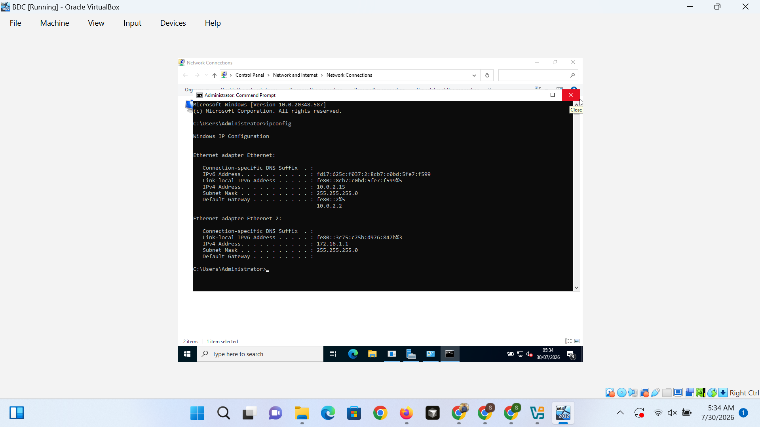
Figure 1. BDC Windows Server ipconfig output verifying NAT address 10.0.2.15 and internal static address 172.16.1.1.

2.4 Windows Client Network Configuration
A-CL was given 172.16.1.10/24 as its internal adapter; having the same broadcast domain as BDC is required for domain join and for DNS queries to be sent directly to the domain controller.
A decision was made to use static addressing as opposed to DHCP, to make it reproducible - otherwise later steps of domain-join would be unable to be repeated. Prior to the join procedure, local interface checks were performed which showed A-CL could reach 172.16.1.1.
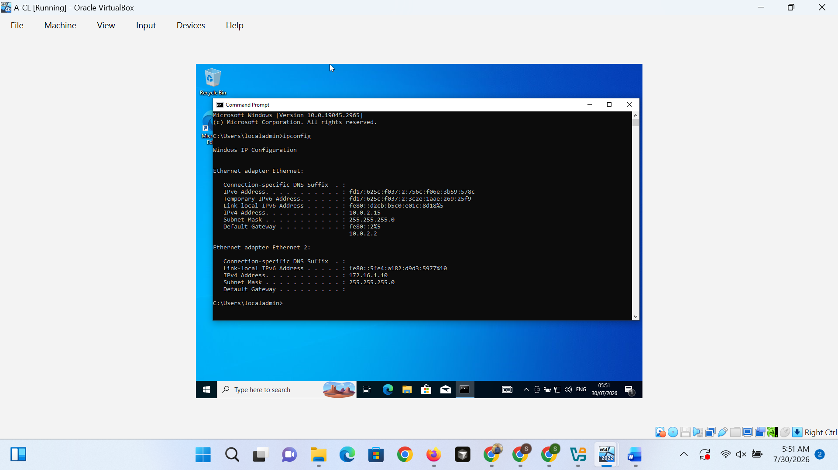
Figure 2. Windows 10 client A-CL ipconfig output showing NAT address 10.0.2.15 and internal static address 172.16.1.10.

2.5 Active Directory Domain Services Deployment

2.5.1 AD DS role installation
The Active Directory Domain Services was installed with the Add Roles and Features Wizard, which is the default supported way to install the Active Directory Domain Services. (Microsoft, 2025)
This was necessary since there is no way to promote AD DS without the role and tools for managing this role. Created and displayed the promote-to-domain-controller link, which is verified by the promote-to-domain-controller notification.
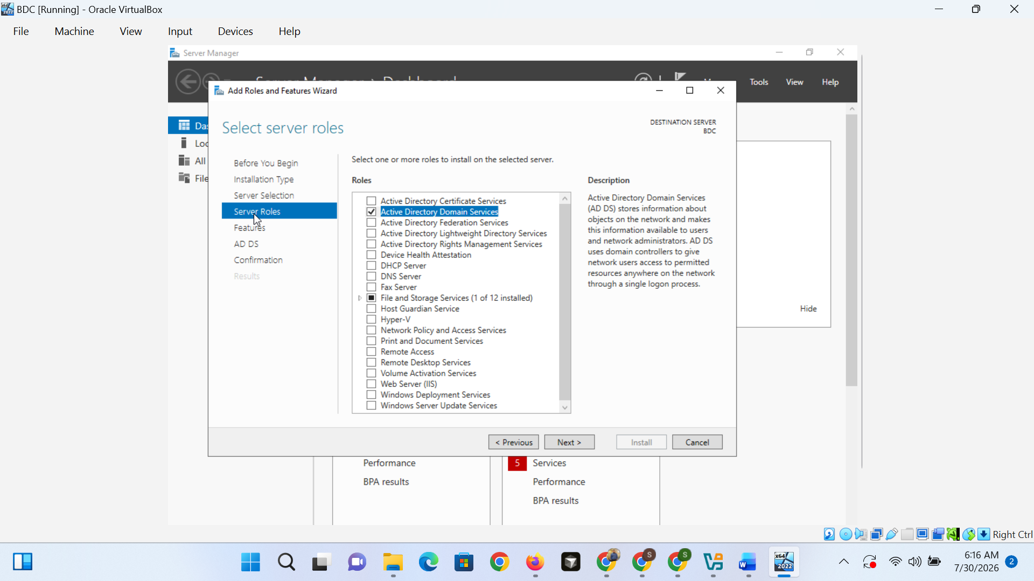
Figure 4. Selecting the Active Directory Domain Services role in the Add Roles and Features Wizard on BDC.
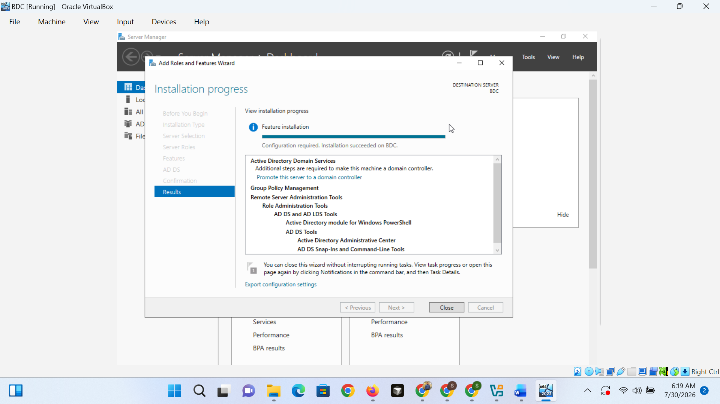
Figure 5. Successful AD DS role installation on BDC with the promote-to-domain-controller option available.

2.5.2 Domain controller promotion
The forest and domain functional levels, the capability of a DNS server, Global Catalog, and the Directory Services Restore Mode password were all configured during promotion, and are required for a server to be an authoritative domain controller. (Microsoft, 2025)
The features of Active Directory that were required were supported by Windows Server 2016 functional levels.
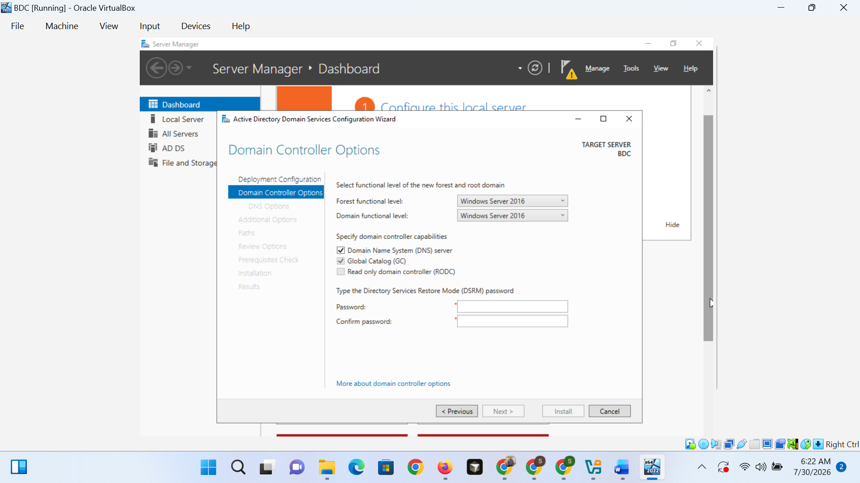
Figure 6. Domain Controller Options during AD DS promotion, including Windows Server 2016 functional levels and DSRM password.

2.5.3 DNS options
DNS was installed as a part of promotion as domain controller because it is used as a locator and service records for Active Directory. (Microsoft, 2025)
The common warning message from the parent zone "Creating a forest root called BIRMINGHAM" is in accordance with the hierarchical delegation behaviour.ACCA on an isolated lab forest, as the wizard does check for delegation records it does not expect to find on an isolated forest. (Mockapetris & P., 1987)
The delegation was left unchecked, which was appropriate for a forest stand-alone in a forest authoritative for its own zone; no delegation errors were detected after promotion completed.
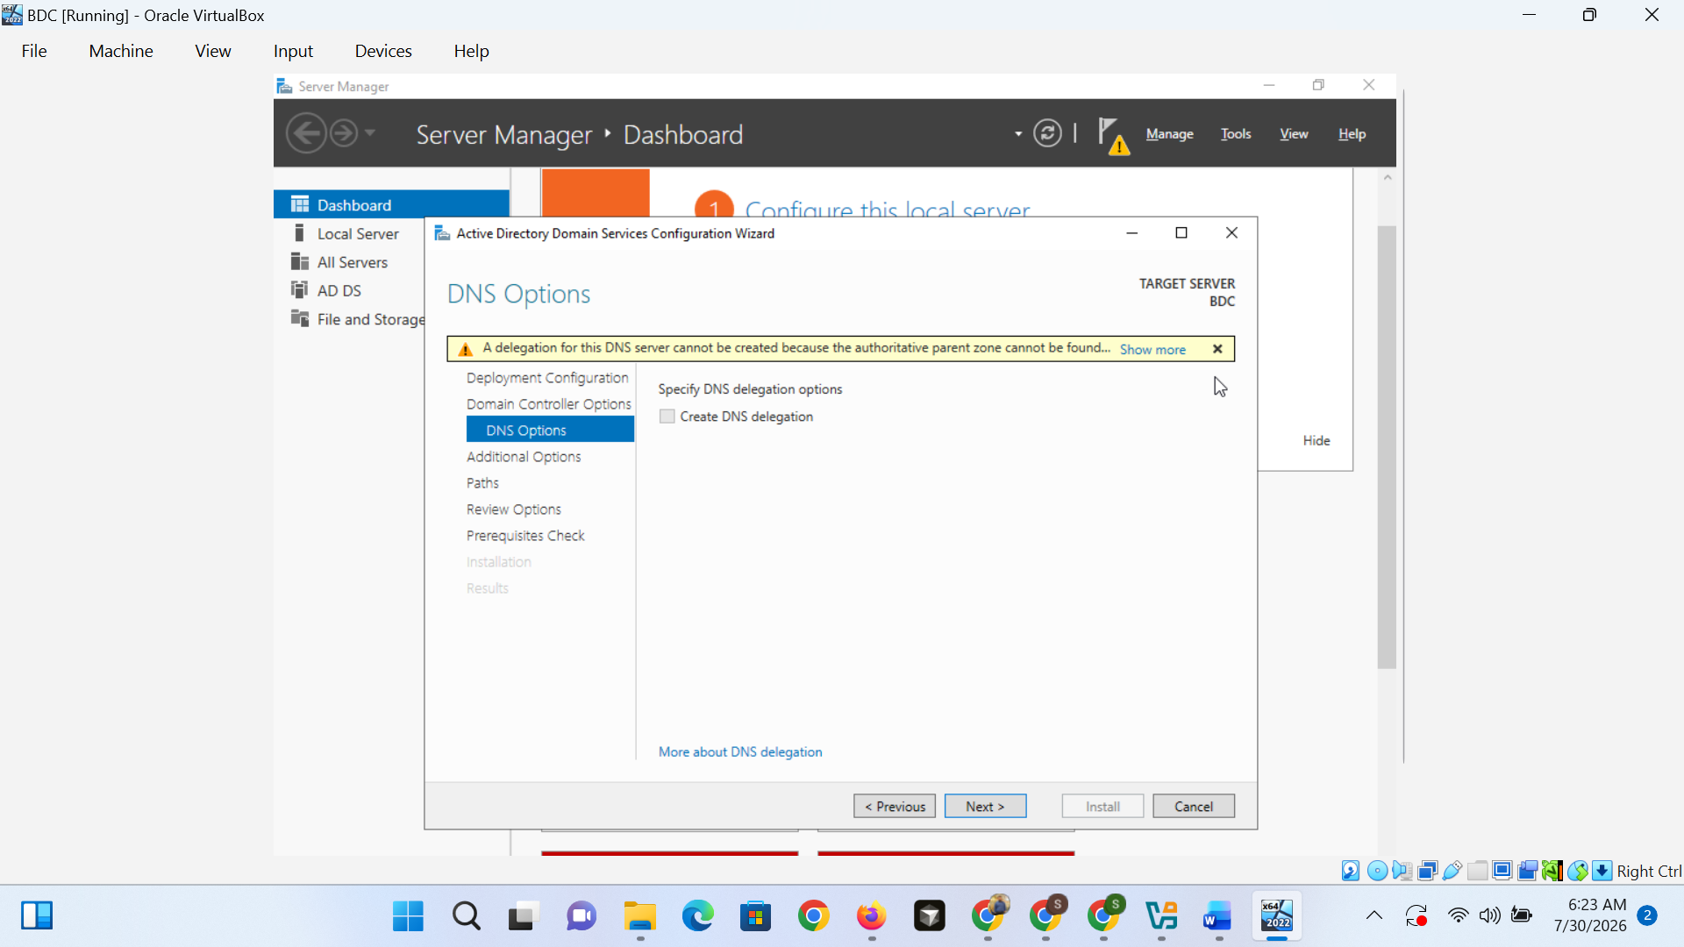
Figure 7. DNS Options step during AD DS promotion showing the parent-zone delegation warning on BDC.

2.5.4 Forest verification
Active Directory Users and Computers was opened after a reboot to make sure the forest was successfully promoted at boot time, otherwise it would not be noticed until the domain join. The BIRMINGHAM.The default containers (Builtin, Computers, Domain Controllers, Users) were found in the domain with the name ACCA.
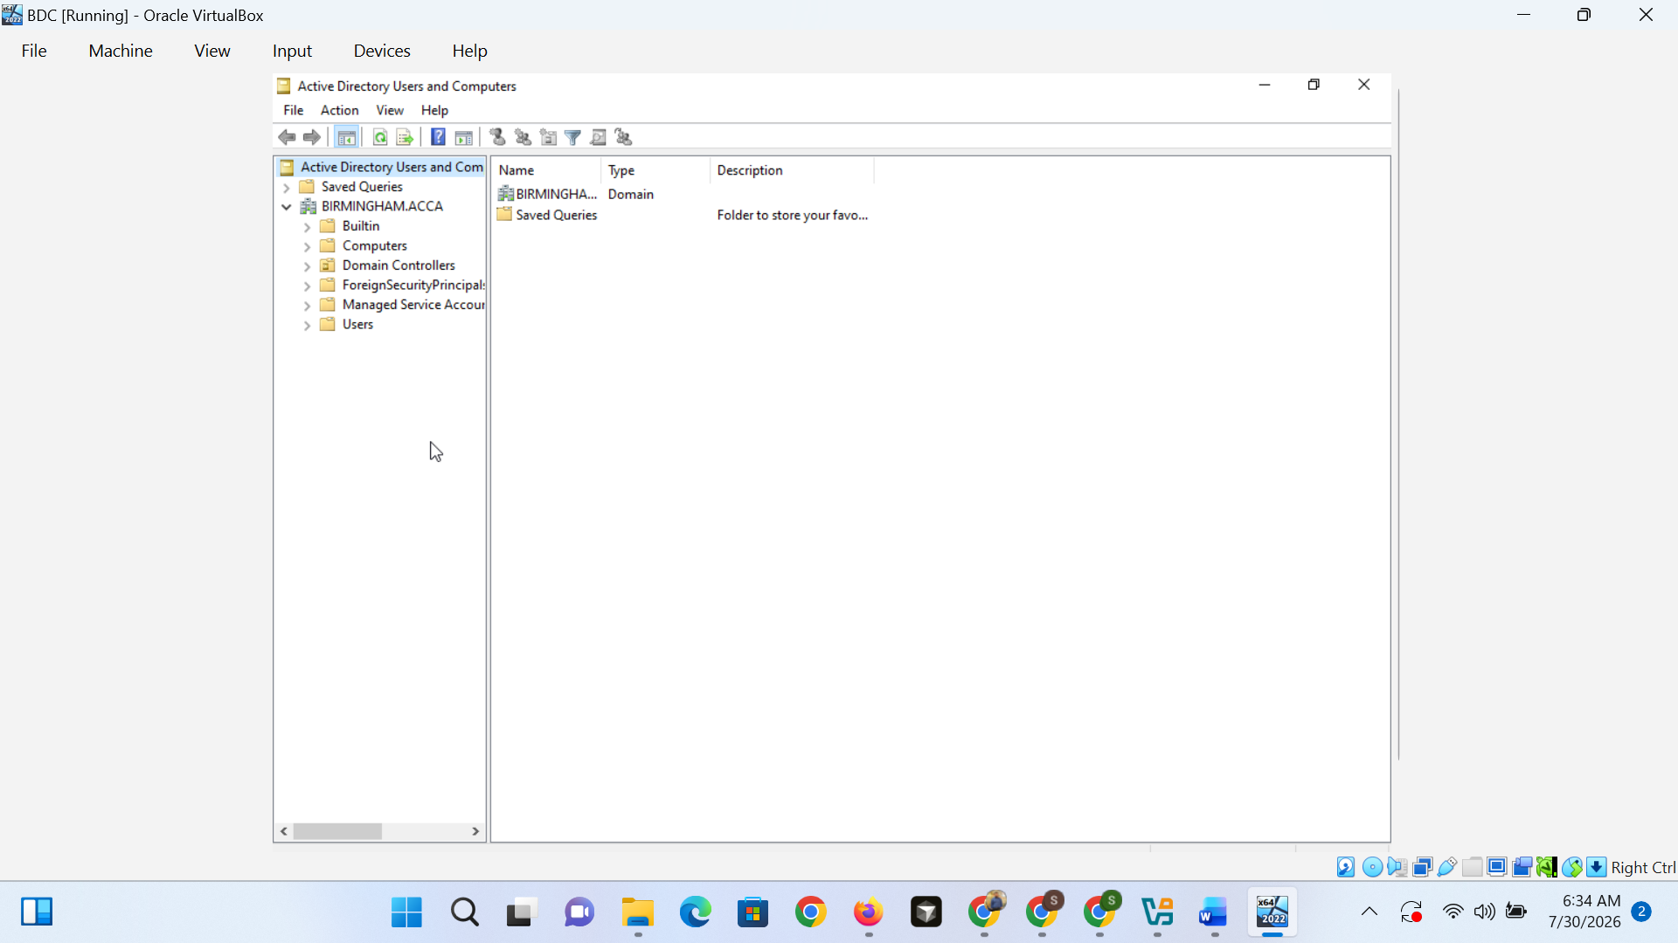
Figure 8. Active Directory Users and Computers confirming the BIRMINGHAM.ACCA domain structure after forest creation.

2.6 Domain Join
Since DNS was able to resolve the domain controller, the Windows client joined BIRMINGHAM.The default way of domain joining is via the Computer Name/Domain Changes window (ACCA). (Microsoft, 2025)
Thus, by the time this was sent, everything was set up – this was sufficient to let the client authenticate without any intervention. The welcome dialog was up and it tells me that it created a machine account, and after restarting and logging on to the domain it was successful.
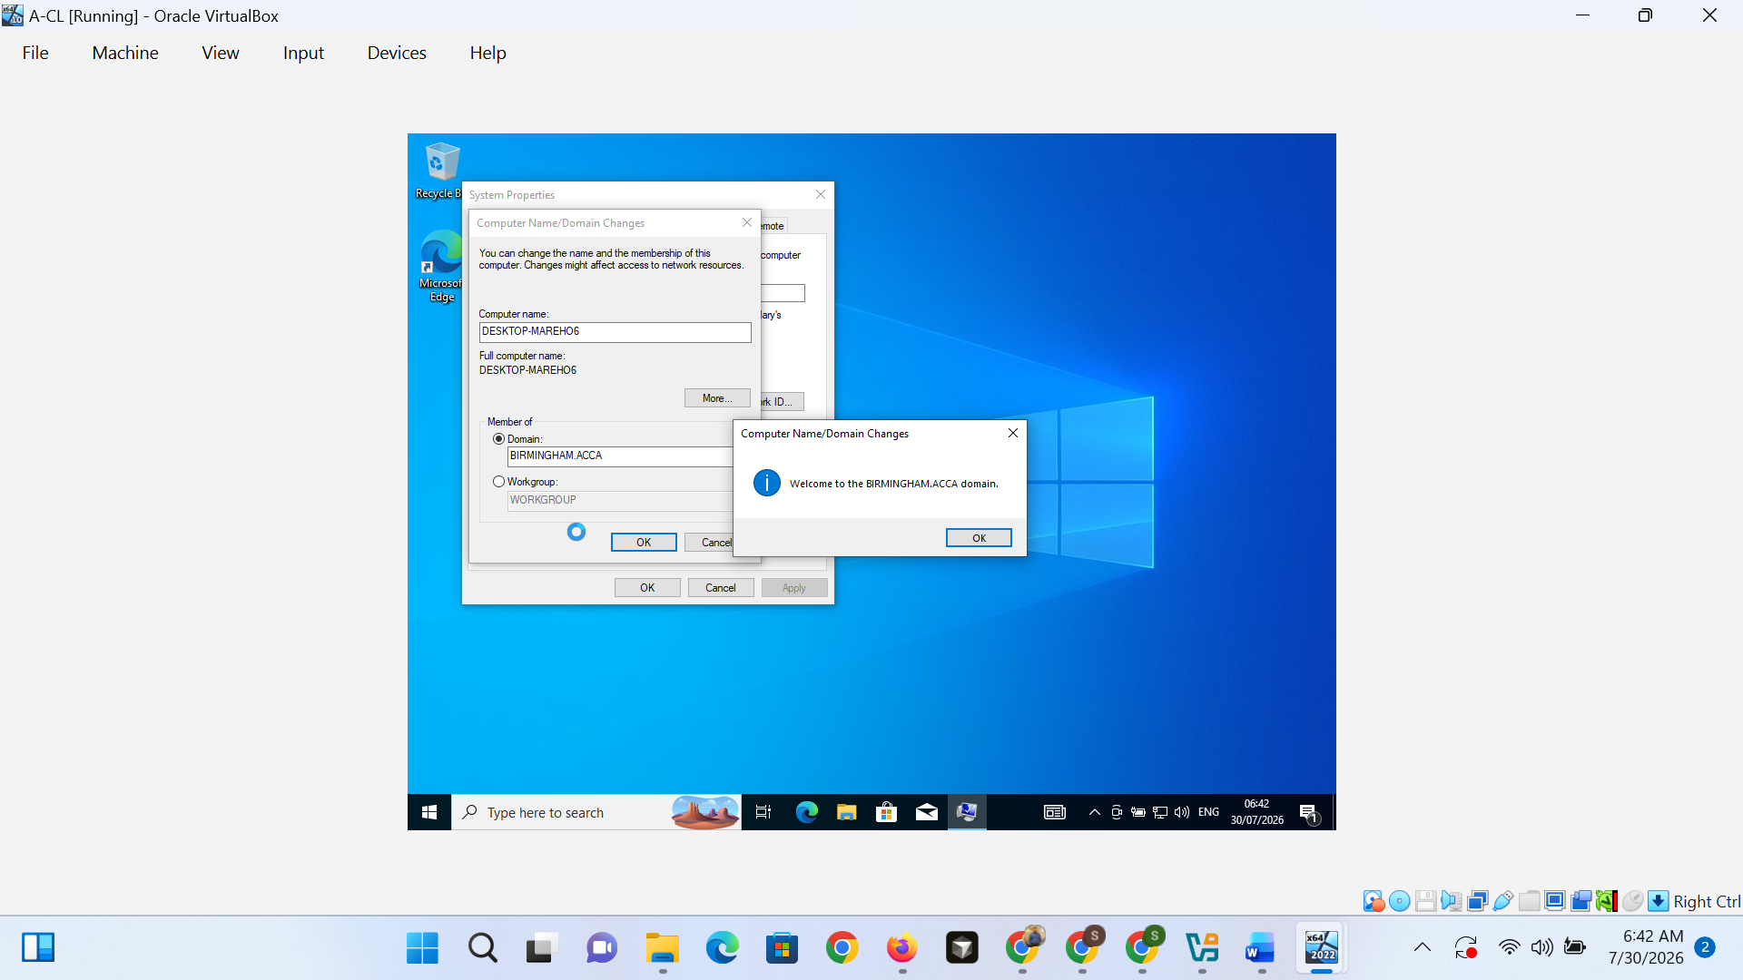
Figure 9. Windows 10 client A-CL successfully joined to the BIRMINGHAM.ACCA Active Directory domain.

2.7 Debian Server Network Configuration
In Debian, the normal way to survive reboots is to have persistent interface settings, which were stored in /etc/network/interfaces, where DHCP was configured on the NAT (wired) adapter and a fixed address was set on the internal (wired) adapter. (Debian Project, 2025)
This is because, without the interactive commands, the commands would not be able to survive a restart. Prior to any clients being attached, L-CD's 172.16.2.1/24 was assigned to enp0s8, which was checked via local interface checks and same-host ping tests.
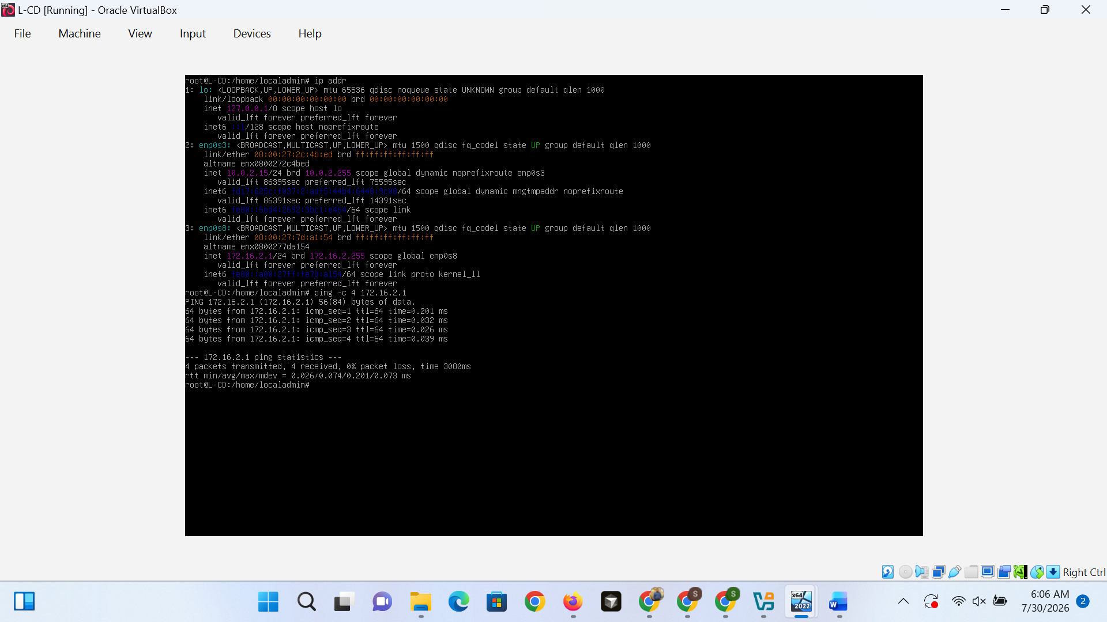
Figure 3. Debian host L-CD showing static address 172.16.2.1 on enp0s8 and a successful local ping test.
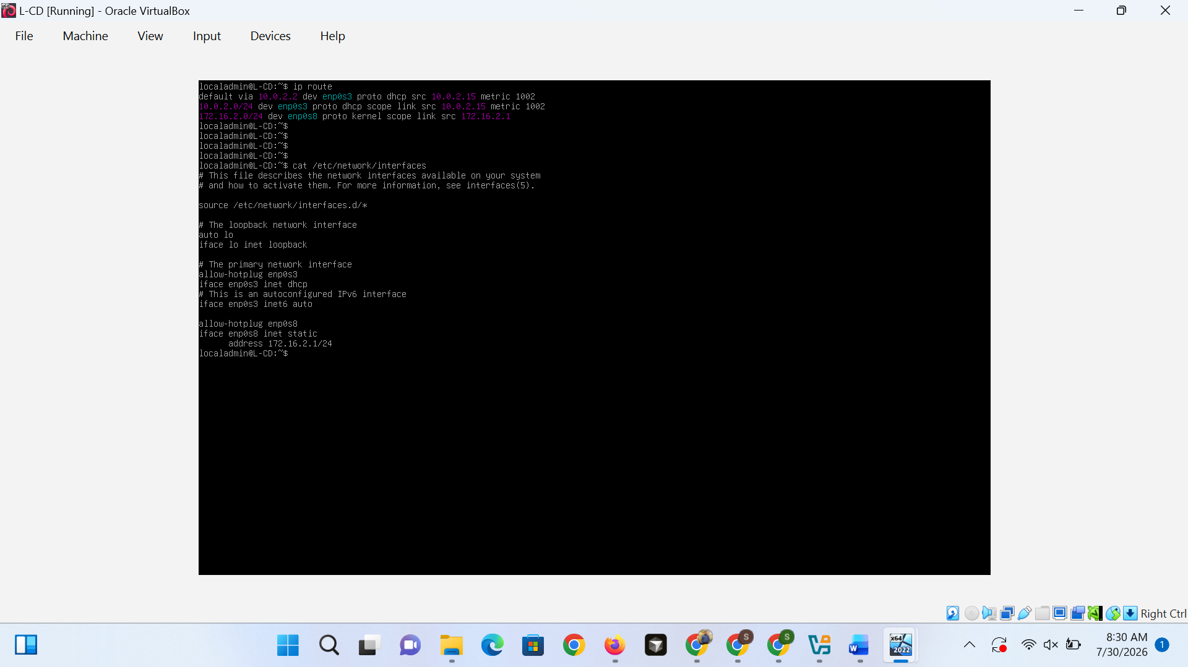
Figure 12. Debian /etc/network/interfaces on L-CD showing DHCP on enp0s3 and static address 172.16.2.1 on enp0s8.

2.8 Debian Client Network Configuration
The configuration of M-CL was set to static address 172.16.2.10/24, with L-CD having the same configuration, with the two Debian hosts sharing a predictable, reproducible subnet.
This assisted the second host to be reachable against on 172.16.2.0/24. Reachability for layer 3 has been achieved with reachability of L-CD 172.16.2.1 - No packet loss.Layer 3 reachability is confirmed and was possible to connect to L-CD at 172.16.2.1, no packets lost.
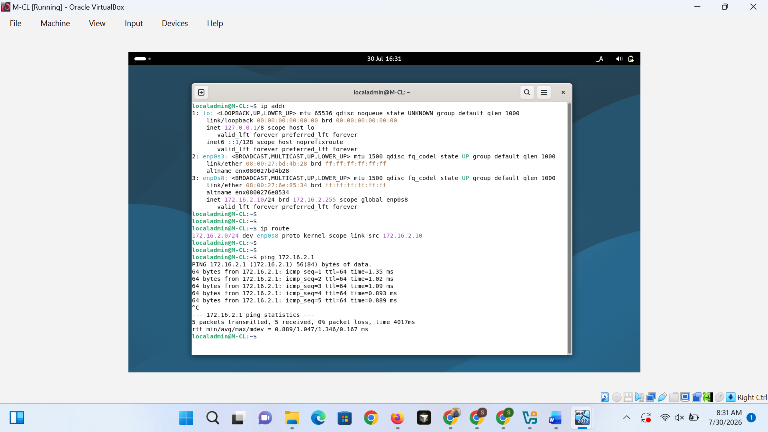
Figure 13. Debian client M-CL with static address 172.16.2.10 and successful ping to L-CD at 172.16.2.1.

2.9 Connectivity Testing and Segmentation Evidence
Connectivity tests showed intended communication paths within each subnet and it was shown that there was intentional isolation between subnets.
Ping to 172.16.1.1 was successful from A-CL which implies that Layer 3 is working on the Windows segment.
L-CD ping to 172.16.2.10 was successful, ping to 172.16.1.1 was unsuccessful, meaning that there is no Layer 3 device between these two /24 subnets, which indicates that they are two broadcast domains.
M-CL ping: Network is unreachable: No host forwarding. This is typically addressed by the use of a router or firewall between subnets, and is not considered a problem in this instance; it is expected to see this behaviour in an enterprise, where two subnets are not connected by a gateway.
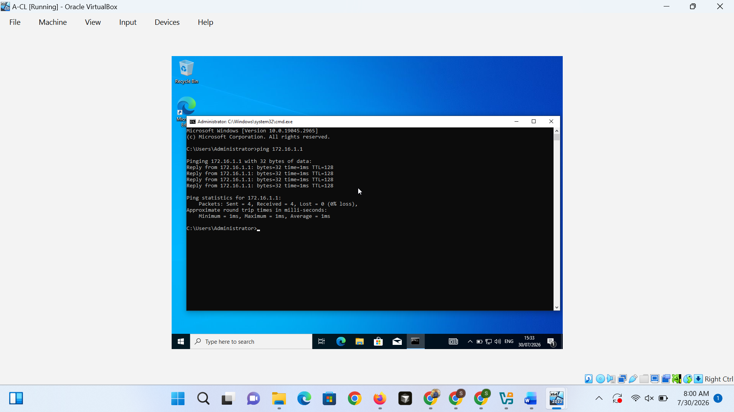
Figure 10. Successful ping from Windows client A-CL to BDC at 172.16.1.1 confirming same-subnet connectivity.
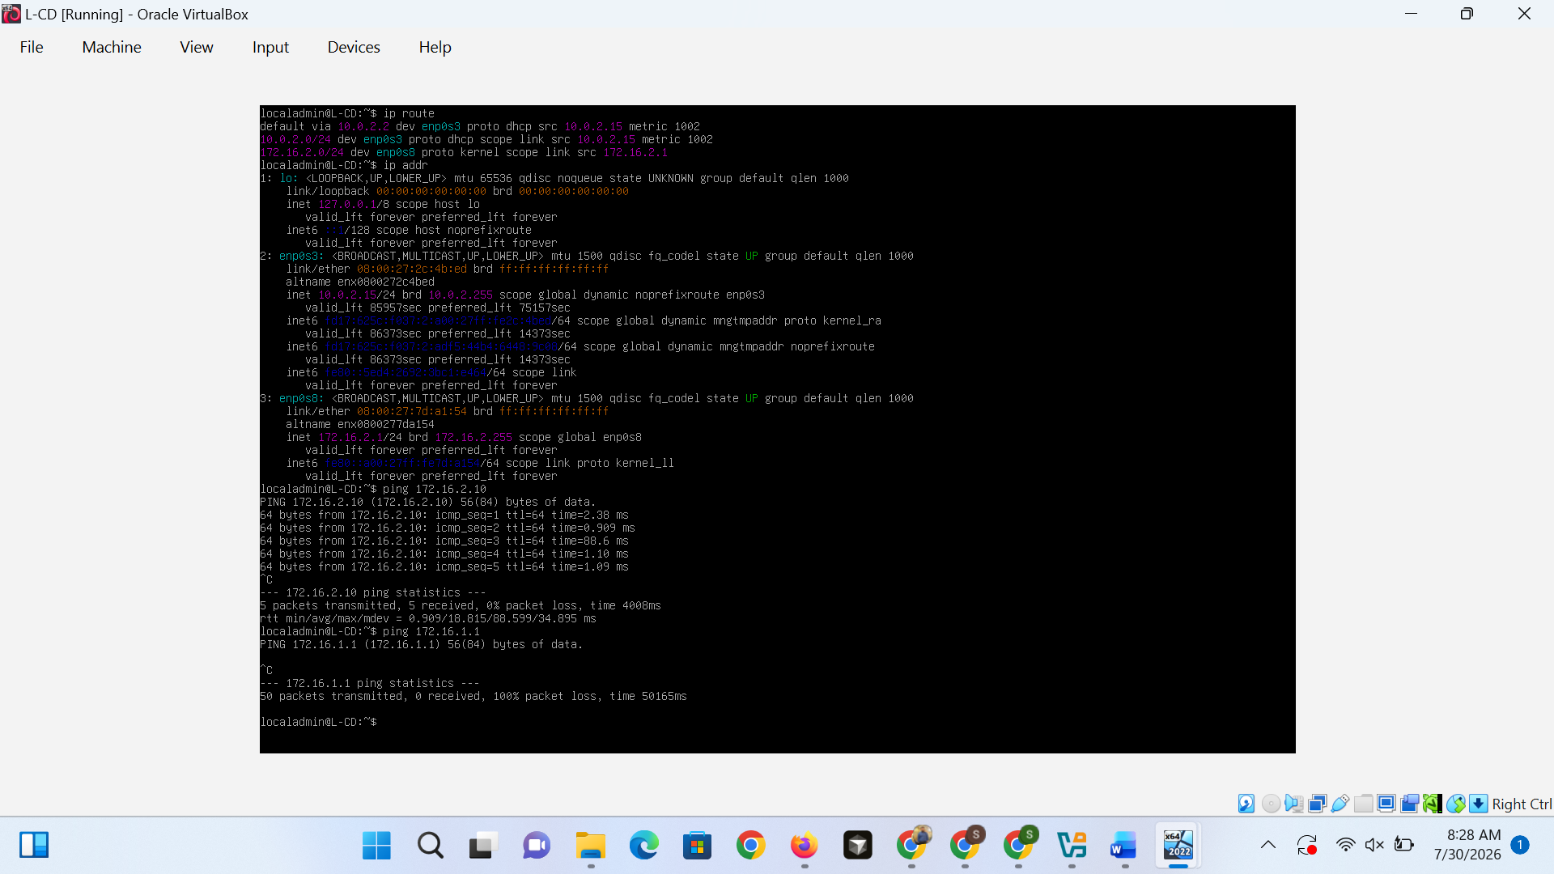
Figure 11. L-CD connectivity checks: successful ping to 172.16.2.10 and failed ping to 172.16.1.1 across subnets.
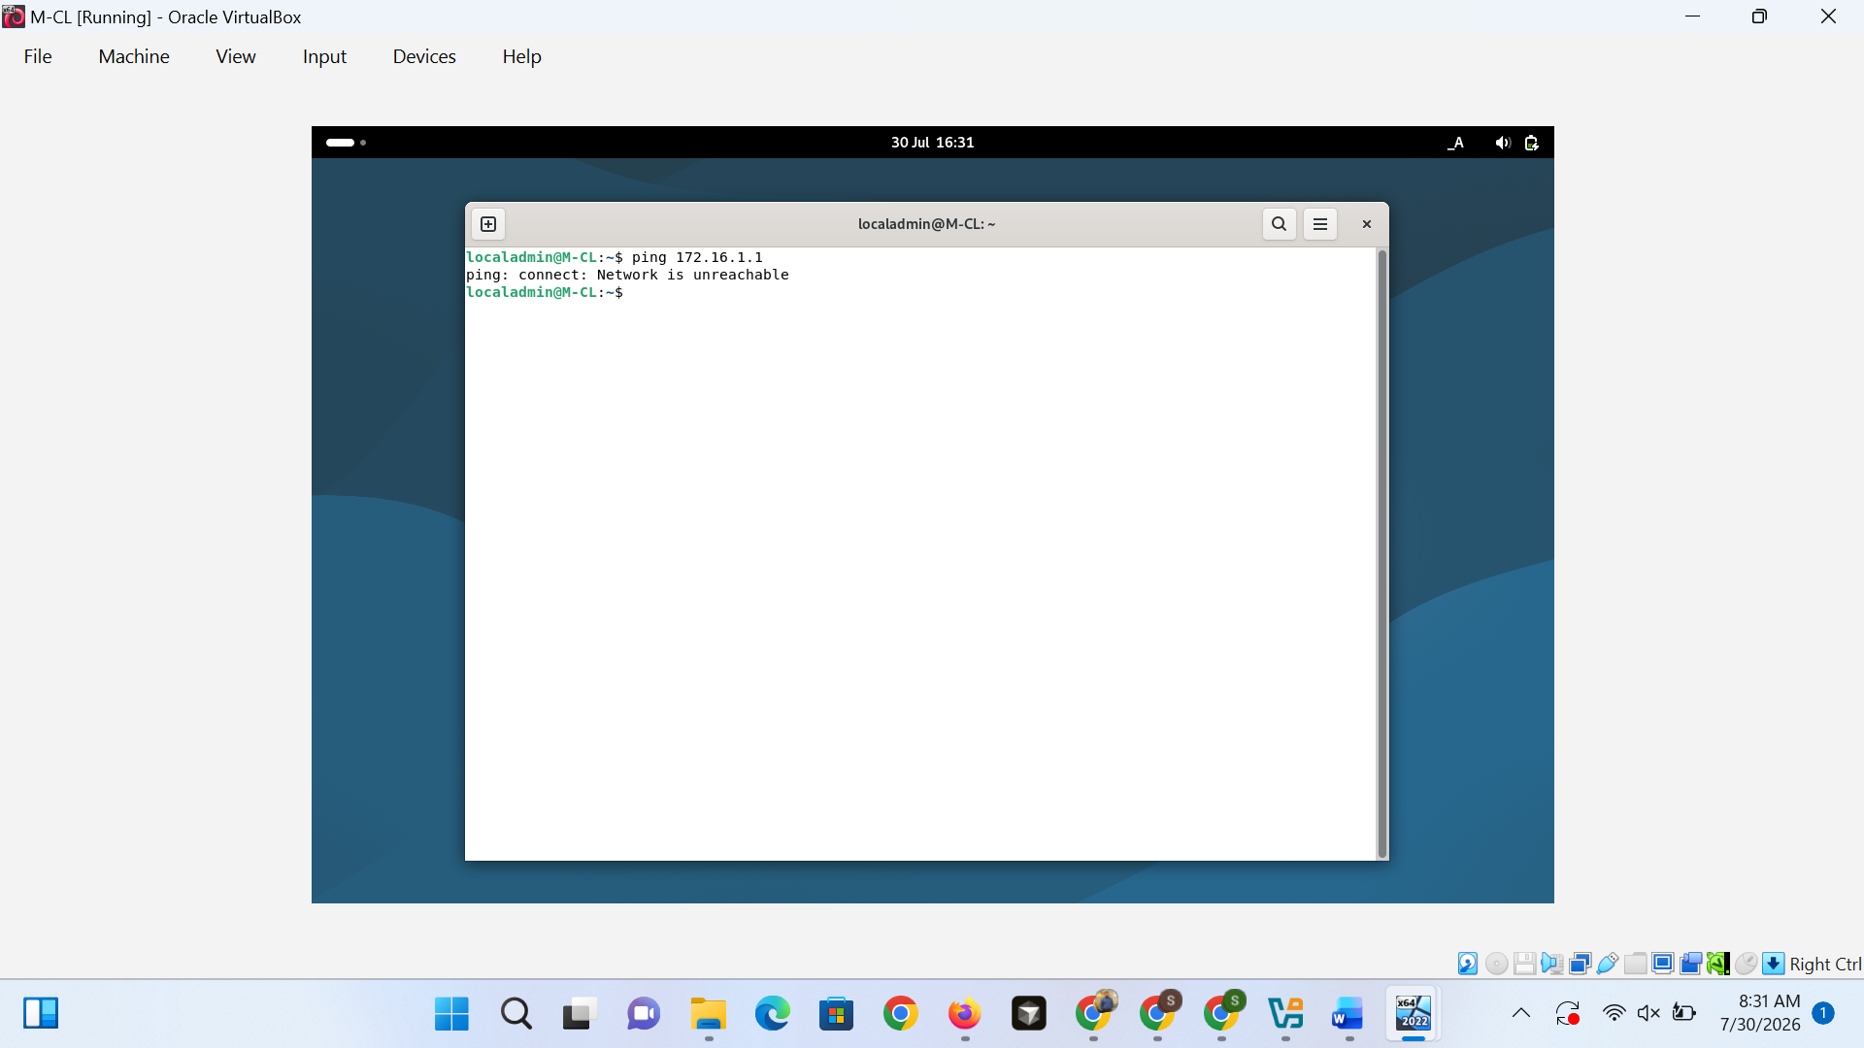
Figure 14. Ping from M-CL to 172.16.1.1 returning Network is unreachable, confirming isolation between 172.16.2.0/24 and 172.16.1.0/24.

2.10 Discussion
The implementation proves a practical division between the Windows management via the directory and the independent Linux workloads, a typical scenario in mixed-OS enterprise environments.
The Vendor guidance for configuring AD DS was adhered to for role selection, for integrating DNS and for configuring domain controller options, thus minimizing the risk of misconfiguration when creating the forest. (Microsoft, 2025)
When two networks with IPv4 do not have a router between them, what is observed are failures that occur between them and they are not expected to happen by chance. The same elements that make a lab topology different from an enterprise deployment would need to be added to extend the design: enabling IP forwarding on a dual-homed gateway, adding routes, deploying DHCP, integrating DNS forwarding, and implementing firewall policy between the segments.

2.11 Conclusion
The aim of this section was to create and test a virtualized enterprise network across Windows Server Active Directory and Debian hosts and that was achieved: BDC hosts the BIRMINGHAM.ACCA forest, A-CL joins the domain on 172.16.1.0/24, and L-CD with M-CL operate on 172.16.2.0/24.
Verification evidence includes checking that the IP configuration is correct, installing and promoting AD DS, checking DNS options, domain join, Debian static addressing, successful pinging across the subnet, and intentional failure across the subnet, verifying that the topology is as expected for deliberate enterprise segmentation.

Task 3 – Personal & Technical Reflection
This coursework has provided me with real-life experience that would only be possible to gain through lecture work. I learned how to set a persistent static addressing on Debian hosts (in /etc/network/interfaces) without using transient commands, join a Windows client to a domain created by Windows Server acting as a domain controller and plan a dual-subnet topology in Oracle VirtualBox.
Being on a journey into Active Directory, I learned that it is very interconnected with DNS, forest creation, and domain join; a mistake made in the early stages of deployment only became confusing to troubleshoot later when it was time to join. Once I was able to see that pings were going out to 172.16.1.0/24 and returning from 172.16.2.0/24, but not between them and not for the reason that the theory foretells, abstract concepts like boundaries and gateways became real.
The main problem was to understand that a pings that seemed to be failing, but really wasn't, was not a problem, but rather it was the normal behavior of routing theory, in line with the correct absence of a route. Consistency across reboots of Windows and Debian reinforced a good idea of the value of having persistent configuration rather than quick fixes in the interactive fashion.
Future: Add a router or firewall between subnets, DHCP, centralized DNS and Group Policy. This project helped improve my Windows and Linux administration capabilities and my knowledge of how the segment decisions relate to real-world decisions, which is applicable to a future position in network administration and cybersecurity.

References
Debian Project. (2025). Network configuration. The Debian Administrator's Handbook. https://www.debian.org/doc/manuals/debian-handbook/sect.network-config.en.html
Microsoft. (2025). Install Active Directory Domain Services (Level 100). Microsoft Learn. https://learn.microsoft.com/en-us/windows-server/identity/ad-ds/deploy/install-active-directory-domain-services--level-100-
Microsoft. (2025). Install a new Windows Server Active Directory forest (Level 200). Microsoft Learn. https://learn.microsoft.com/en-us/windows-server/identity/ad-ds/deploy/install-a-new-windows-server-2012-active-directory-forest--level-200-
Microsoft. (2025). Join a computer to a domain. Microsoft Learn. https://learn.microsoft.com/en-us/windows-server/identity/ad-ds/manage/join-computer-to-domain
Microsoft. (2025). DNS overview in Windows Server. Microsoft Learn. https://learn.microsoft.com/en-us/windows-server/networking/dns/dns-overview
Microsoft. (2025). TCP/IP addressing and subnetting. Microsoft Learn. https://learn.microsoft.com/en-us/troubleshoot/windows-client/networking/tcpip-addressing-and-subnetting
Microsoft. (2024). ipconfig. Microsoft Learn. https://learn.microsoft.com/en-us/windows-server/administration/windows-commands/ipconfig
Mockapetris, P. (1987). Domain names - concepts and facilities (RFC 1034). Internet Engineering Task Force. https://www.rfc-editor.org/rfc/rfc1034
Oracle. (2025). Virtual networking. Oracle VM VirtualBox User Manual. https://www.virtualbox.org/manual/ch06.html
Postel, J. (1981). Internet Protocol (RFC 791). Internet Engineering Task Force. https://www.rfc-editor.org/rfc/rfc791

