

Programme: Master of Business Administration
Module: Financial Management
Module code: LCMB7002
Lecturer: MD KALAM

Assignment Title: Assessment component: Financial performance
and
Management

Organization Chosen : Marriott International

Student Name: Kavya Nareshbhai Kankotiya
Student ID Number: 2537035
Word Count: 5264 Words

Table of contents
1. Financial Health Check of Marriott International (2021–2025) 4
1.1 Overview of Five-Year Financial Performance 4
1.1.1 Income statement analysis 4
1.1.2 Balance sheet analysis 4
1.2 Liquidity Ratios 6
1.3 Efficiency Ratios 7
1.4 Profitability Ratios 8
1.5 Gearing Ratios 9
1.6 Investment Ratios 11
1.7 Cash Flow Ratios 12
1.8 Liquidity Benchmarking Against Industry Standards 13
1.8.1 Industry Liquidity Benchmarks 13
1.8.2 Comparison with Competitors of Marriott International in managing Liquidity Position 13
2. Working Capital Management Analysis 14
2.1 Cash Operating Cycle 14
2.1.1 Receivables Collection Period 14
2.1.2 Payables Deferral Period 14
2.1.3 Cash Operating Cycle Evaluation 14
2.2 Working Capital Challenges 15
2.3 Recommendation to improve liquidity of working capital 15
2.3.1 Receivables Management Improvements 15
2.3.2 Payables Management Optimisation 15
2.3.3 Cash Management Reforms 16
2.4 Comparison of financing option 16
2.4.1 Short-Term Financing Options 16
2.4.2 Long-Term Financing Options 16
2.4.3 Comparative Evaluation 17
3. Strategic Financial Restructuring Plan 18
3.1 Discussion on the requirement of a Financial Restructuring Option 18
3.2 Recommended for Financial Restructuring Options 18
3.2.1 Divestiture of Non-Core Assets 18
3.2.2 Equity Injection Strategy 18
3.2.3 Merger and Acquisition Opportunities 18
3 Discussion on the Impact Assessment 19
3.3.1 Impact on Shareholder Value 19
3.3.2 Impact on Debt Structure 19
3.3.3 Impact on Operational Flexibility 20
3.4 International Financial Considerations 21
3.4.1 Taxation Considerations 21
3.4.2 Currency Risk Management 21
3.4.3 Inflation Risk 22
3.5 Discussion on the Ethical and ESG Operations 23
3.5.1 Corporate Social Responsibility 23
3.5.2 Environmental Sustainability 23
3.5.3 ESG Performance and Reporting 23
4. Investment Appraisal and Capital Budgeting 24
4.1 Project Overview 24
4.2 Discuss About Project Viability 24
4.2.1 Project A Appraisal 24
4.2.2 Project B Appraisal 27
4.2.3 Project C Appraisal 29
4.3 Recommended Project Selection 31
4.3.1 Selection of project 31
4.3.2 Financial Justification 31
4.3.3 Non-Financial Risk Assessment 32
4.4 Capital Rationing Analysis (£100 Million Limit) 33
5. Critical Reflection on Artificial Intelligence Usage 34
5.1 Tool Disclosure and AI Acknowledgement 34
5.2 Verification of AI Outputs 34
5.3 Contribution Analysis 35
5.3.1 AI-Generated Contributions 35
5.3.2 Independent Critical Analysis 35
5.4 Ethical and Professional Reflection 35
References 37
Appendices 43
Appendix 1: Ratio analysis 43
Appendix 2: Capital investment analysis 47
Appendix 3: Income Statement 48

1. Financial Health Check of Marriott International (2021–2025)

1.1 Overview of Five-Year Financial Performance

1.1.1 Income statement analysis
Marriott International showcases its revenue growth of about $13, 857 in 2021, which tends to rise to $26,186 in 2026 (Macrotrends, 2025). The company highlights its fluctuation of net income to about $3.08 billion during 2023, which decreased to about $2.06 billion in 2025 (Macrotrends, 2025). The operating income is about $3,114 in 2021 which tends to rise to $$4.141B in 2025 by showcasing its significant demand of customers towards leisure travel reflect strong pricing power. The operating income in 2023 is about $3.924 and $4,136 in 2025, indicating a significant improvement in core profitability, showcasing operational efficiency in the hospitality industry,
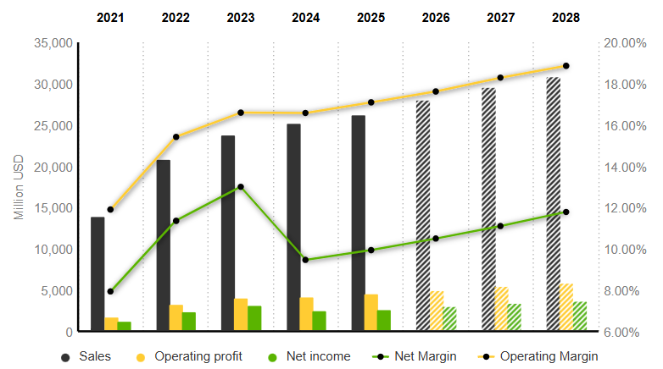
Figure 1: Income Statement of Marriott International
(Source: MarketScreener, 2025)

1.1.2 Balance sheet analysis
Marriott International showcases its “asset-driven model” that addresses this through significant reinvestment and repurchasing of shares. The steady rise of assets is about $25.674billion in 2023, leading to high rises of about $27.54billion in 2025 (Macrotrends, 2025). Significant rises of asset leads to rises about 7.7% that address through account received and managing of other tangible assets. The total liabilities is about $24,247 in 2021 which tends to rise to a high $31,311 in 2025, that have been addressed through strong cash flow and through aggressive expansion of business.
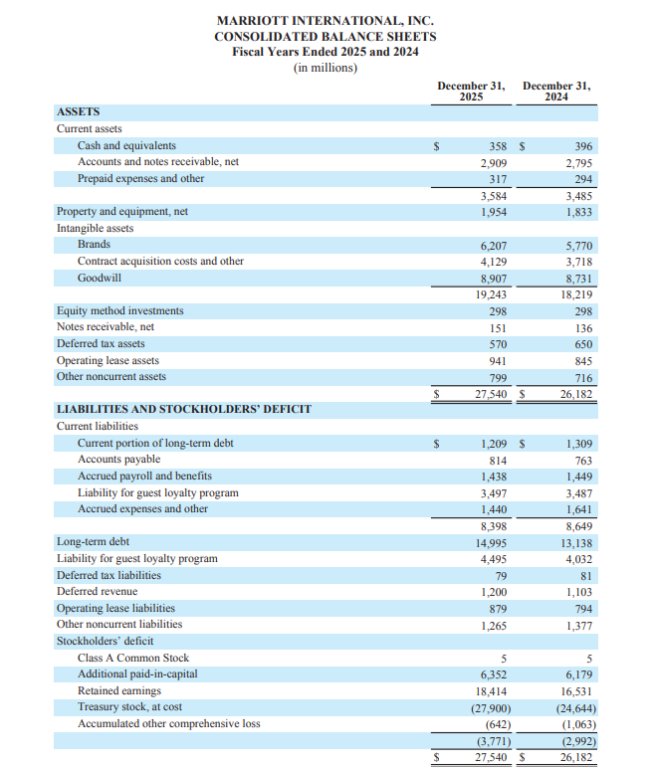
Figure 2: Balance sheet of Marriott International
(Source: Marriott International, 2025)

1.2 Liquidity Ratios
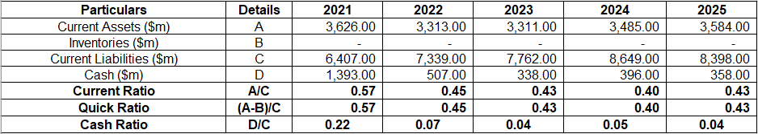
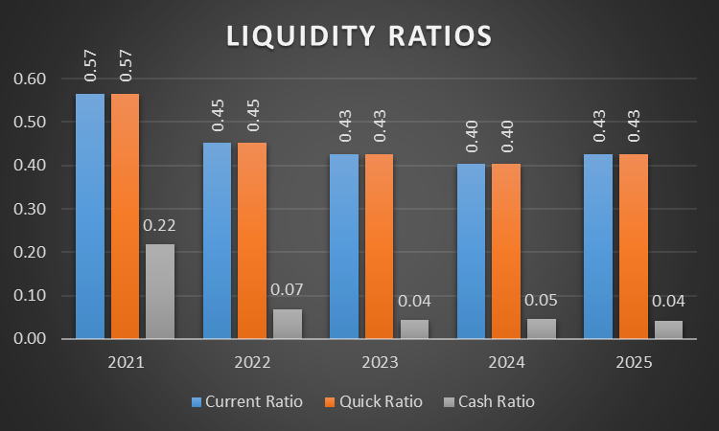
Figure 3: Liquidity Ratios
(Source: Marriott, 2021; Marriott, 2023; Marriott, 2025)
Identification of trend
Marriott International has observed improvements in the quick ratios by 7.5% from 0.40 in 2024 “(Current Assets - Inventory)/ Current Liabilities” due to purchase of new inventory. The organisation has strengthened its inventory management activities to enhance its product quality. For example, Marriott has invested $14bn in acquiring 130 properties to expand its business in 2025 (Marriott International, 2025). The acquisition of operational units has helped the organisation in meeting its consumer demand. On the other hand, Marriott has also reduced its current ratios to 0.43 “Current Assets/ Current Liabilities” due to decline in the asset value in 2025. In addition, the organisation has also reduced its cash ratio to 0.04 due to lowering of financial income in 2025 “Cash/ Current Liability”. Overall, the lowering of the asset value has hampered the operational stability of the company.

Strength
The acquisition of business properties has helped Marriott expand its services to remote customers.
Weakness
The decline in the current assets has also reduced the working capital of Marriott and caused delays in the completion of the business operations.

1.3 Efficiency Ratios
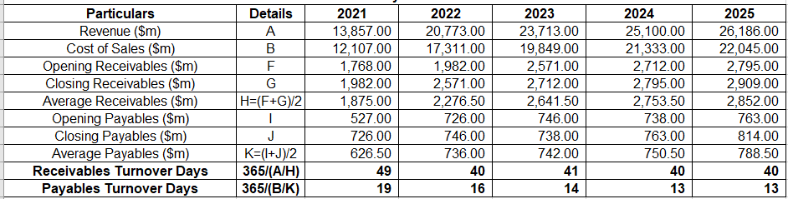
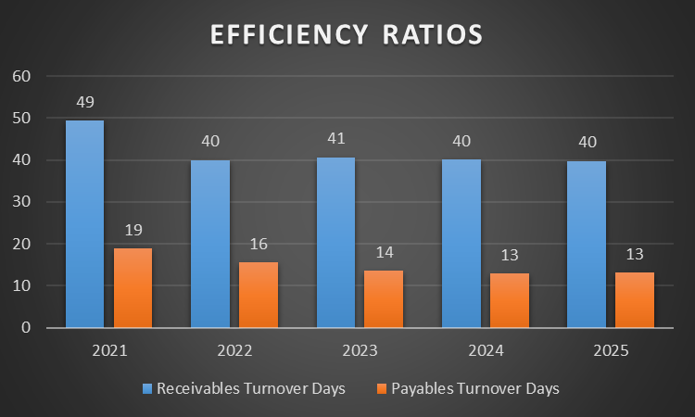
Figure 4: Efficiency Ratios
(Source: Marriott, 2021; Marriott, 2023; Marriott, 2025)
Identification of trend
Efficiency Ratios help organizations to generate revenue through significant resource utilization by accelerating cash, which in term directly boosts the overall profitability of the business. The receivable turnover days is calculated using "365 ÷ (Revenue ÷ Average Receivables)", which decreases about 18.37% through significant improvement in fund operation. The payable turnover days is calculated using “365 ÷ (Cost of Sales ÷ Average Payables)" which decreased about 31.85%, leading to high rise of credit rate which in term strengthened suppliers relation. The company has its ability to manage capital expenditure addressed through significant day-to-day transactions by ability to maximize its overall revenue of business.
Strength
Marriott International showcases its operational efficiency that addresses through significant generation of profit and through efficient cost control.
Weakness
Reducing payment limits and seasonal fluctuation of the product strictly affect the operational revenue of the business.

1.4 Profitability Ratios
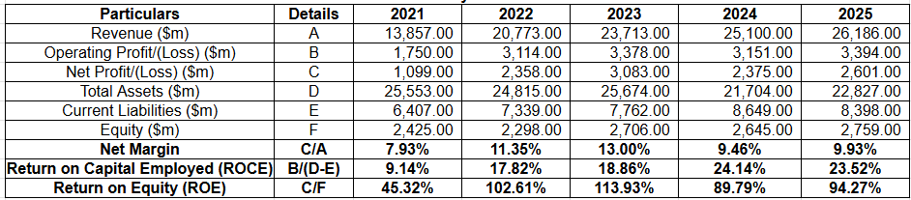
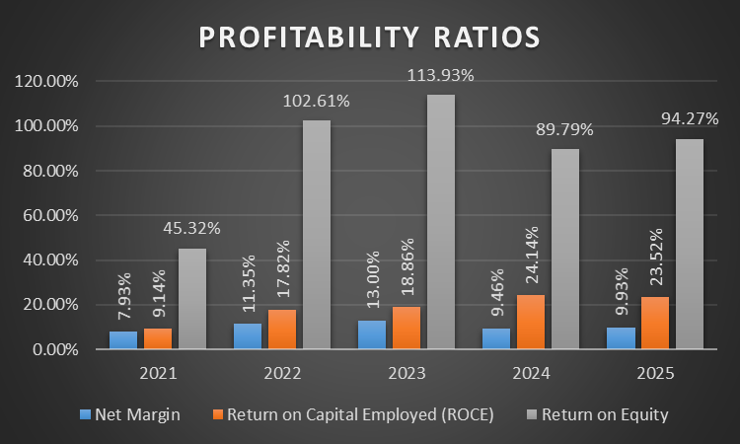
Figure 5: Profitability Ratios
(Source: Marriott, 2021; Marriott, 2023; Marriott, 2025)
Identification of trend
Profitability Ratios help a company by its ability to generate revenue through significant cost control by utilizing resources through significant value creation. Net margin is calculated through “(Net Profit ÷ Total Revenue) × 100” which increases about 25.22% that is due to the significant seasonal demand of accommodation service at a convenient rate. Return of capital is calculated through “(Operating Income/ Capital Employed)” which increases about 14.38%, leading to the repurchasing of shares, and constant cash limit. Return of Equity is calculated through (Net income/Shareholder Equity), leading to an increase of about 108.01%. This has its ability to generate profit through shareholder investment that is addressed through the buyback of shares.
Strength
The company has the ability to boost its operating margin by showcasing its immense efficiency which leads to enhancing the overall revenue of the business.
Weakness
Rising prices affect overall profit due to high rises of inflation, which erode significant purchasing power.

1.5 Gearing Ratios
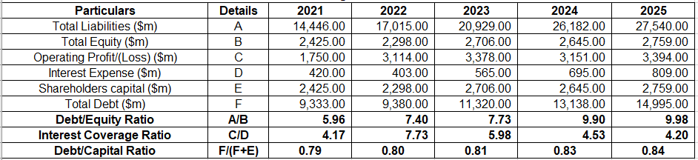
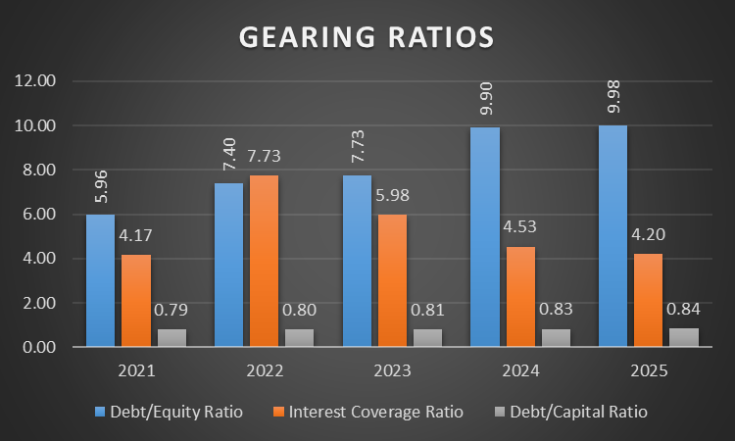
Figure 6: Gearing Ratios
(Source: Marriott, 2021; Marriott, 2023; Marriott, 2025)
Identification of trend
The gearing ratio provides details regarding the capital structure composition adopted by the organisation in its business operations. Marriott has observed growth in its debt/equity value by 79.4% in 2025 “Total Debt/Total Equity” signifying enhancement in increasing risk level in business operations. This has also increased the risk level within the business operations of the company. For instance, the equity capital value of the hotel company has declined to $648m in 2026 (Marriott International Inc, 2026). On the other hand, Marriott has also reduced its interest coverage value to 4.20 in 2025 calculated by “Operating Income/ Interest Expense”. Thus, the decline in the internal financial resources has hampered the operational stability of the organisation.
Strength
The enhancement in the debt capital has helped Marriott in meeting the increase in its business expenses.
Weakness
The decline in the equity share value has adversely influenced the financial stability of the company.

1.6 Investment Ratios
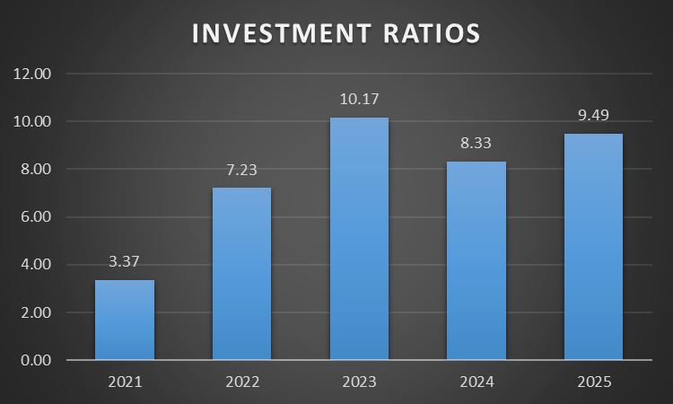
Figure 7: Investment Ratios
(Source: Marriott, 2021; Marriott, 2023; Marriott, 2025)
Identification of trend
The investment ratio is an important method that helps in analysing the investor relationship of the organisation. Marriott International has achieved growth in the value of its “Earnings Per Share (EPS)” calculated by “Net Income/Outstanding Shares” 181.23% in 2025 due to enhancement in investments from shareholders. The organisation has stressed upon meeting the financial requirements of its investors for achieving brand popularity. For instance, the organisation has increased its shares to $396 due to improvement in its market capital by $104.65bn in 2025 (Investing News, 2026). Overall, the enhancement in the business investments has helped the hotel company in acquiring a competitive advantage over other organisations.
Strength
The improvement in the market shares has increased the investments within the business operations of Marriott.

Weakness
The consistent growth of the market capital has caused overvaluation of the shares that has also increased the withdrawal of investments by shareholders.

1.7 Cash Flow Ratios
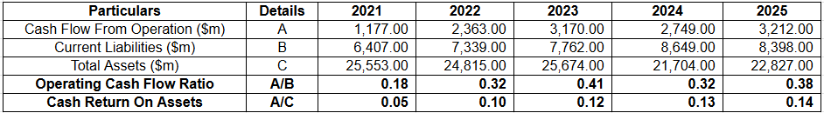
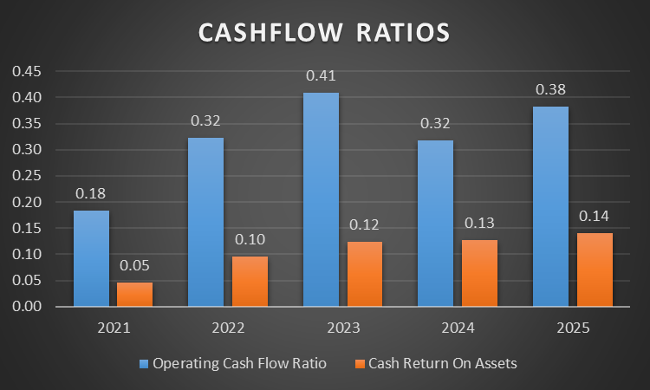
Figure 8: Cash Flow Ratios
(Source: Marriott, 2021; Marriott, 2023; Marriott, 2025)
Identification of trend
Cash Flow Ratios have the ability to measure operational efficiency, which is addressed through significant cash generation by the ability to pay off debts. Operating cash ratio is calculated through “Cash Flow from Operations ÷ Current Liabilities", which increases by about 111.11%, due to a significant improvement in cash flow, leading to high rise in revenue. Cash return on assets is calculated through "Cash Flow from Operations ÷ Total Assets,” which increases by about 180% by the ability to optimize inventory maintenance, which in term boosts overall cash flow. The company has the ability to return capital by deploying $1.2 billion, which is based on managing dividends and repurchasing of shares.

Strength
Ability to deal with short-term debt that has been addressed through significant generation of cash flow.
Weakness
The fluctuation of cash flow affects significant growth of the business by the ability to ignore cash transactions.

1.8 Liquidity Benchmarking Against Industry Standards

1.8.1 Industry Liquidity Benchmarks
Marriott International showcases its significant cash flow address through franchise models and capital maintenance leads to enhancing the overall revenue of the business. This strategy is more reliable through excessive generation of cash through dividend payout and through significant shareholder returns. Total debt of Marriott is about $16.5 billion in 2025, with its cash equivalent of about $0.5billion in 2026. The cash equivalence is measured through significant repurchasing of shares (Marriott, 2026). On the other hand, repurchasing of shares is about to rise to 2.1million that are addressed through significant stock maintenance.

1.8.2 Comparison with Competitors of Marriott International in managing Liquidity Position
Marriott International has observed financial issues that have adversely influenced the smooth completion of its business operations. For instance, the company has achieved an liquidity ratio value of 0.40 as compared to the industrial standard for 2.0 in 2025. The decline in the assets has hampered the product efficiency of the organisation. Marriott International has increased its operational expenses to $21.33bn in 2025. The enhancement in the product cost has reduced the preference level of the company. On the other hand, Hilton Group has achieved a higher cash value than Marriott of $37m in 2025 (Hilton, 2025). Thus, the lowering of the financial resources has lowered the market stability of the company.

2. Working Capital Management Analysis

2.1 Cash Operating Cycle

2.1.1 Receivables Collection Period
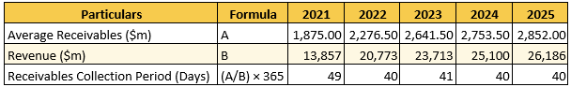
Figure 9: Receivable Collection Period
(Source: Marriott, 2021; Marriott, 2023; Marriott, 2025)
Marriott has reduced its “receivable collection period” to 40 days in 2025. On the other hand, the company has also observed revenue growth of 89.1% in 2025 (Marriott, 2025). Thus, the improvement in the business income has helped Marriott in improving its operational efficiency.

2.1.2 Payables Deferral Period
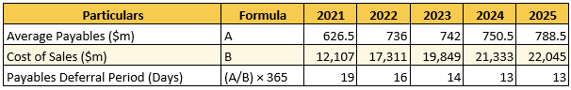
Figure 10: Payable Deferral Period
(Source: Marriott, 2021; Marriott, 2023; Marriott, 2025)
The payable period of Marriott has also declined by 31.5% from 19 days in 2021. In addition, the company has also increased its cost of sales value to $22045m in 2025. The enhancement in expenses has reduced the product demand of the company. Marriott has reduced its income to $445m due to enhancement in the inventory expenses in 2025 (Marriott International, 2025). Thus, the lowering of the income has hampered the goodwill of the company.

2.1.3 Cash Operating Cycle Evaluation
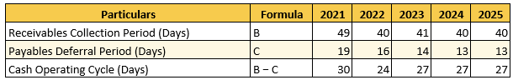
Figure 11: Cash Operating Cycle Evaluation
(Source: Marriott, 2021; Marriott, 2023; Marriott, 2025)
The “Cash Operating Cycle Evaluation” of Marriott has been addressed through the “asset-light model” and “free cash flow”. The cash operating cycle is about 27 days in 2025, which has been addressed through significant collection of cash. Marriott showcases its significant growth which is about 271million that is for “Marriott Bonvoy programme” encounter potential profit in market (Marriott, 2025d).

2.2 Working Capital Challenges
Marriott International faced inflationary cost pressure due to the significant sugaring off the utility cost and high rises of suppliers' charges, which in turn affect the overall profit margin. The company has the ability to deal with massive operational liquidity by eliminating working capital. However it in term showcases its significant profitability by the ability to drive its capital address through significant shareholder returns. On the other hand, “RevPAR” showcases its significant growth about 6.7% in the different international markets and 0.1% decline in Canada and in the US market (Marriott, 2025b). This in term reduces the overall flow of operating cash by the ability to strain short term liquidity of business.

2.3 Recommendation to improve liquidity of working capital

2.3.1 Receivables Management Improvements
Marriott has adopted digitalisation techniques for strengthening its supply chain operations and improving productivity. For example, the organisation has developed the “Marriott Bonvoy Application” that has streamlined the booking process for the guests in 2025 (Marriott Bonvoy, 2025). In addition, the initiative has also provided opportunities for the company to acquire the financial requirements of its suppliers. Overall, the strengthening of the debtor relationship has helped Marriott in improving its product quality.

2.3.2 Payables Management Optimisation
Marriott has developed the “ESupplier platform” that has helped in executing timely payments to the creditors in 2026 (Kostuch Media , 2025). In addition, the technique has also helped the company in monitoring the funds acquired from the stakeholders. Thus, the inclusion of digitalisation has helped Marriott in strengthening creditor relationships.

2.3.3 Cash Management Reforms
Marriott has increased its cash margin value from $0.33bn in 2024 to $0.39bn in 2025. The enhancement in the income has helped the organisation in meeting the requirements of the business activities (Macrotrends, 2026a). Overall, the improvement in the financial resources has strengthened the operational efficiency of the company.

2.4 Comparison of financing option

2.4.1 Short-Term Financing Options
Trade credit
Marriott International has the ability to deal with trade credit that has been addressed through the “asset-free model” by the ability to optimize its liquidity, which leads to enhancing its overall revenue of the business. The company has the ability to increase its “co-branded credit-card,” which is about to rise about 35% by showcasing its significant growth leading to high rise in customer base (O’Neill, 2026b).
Lines of credit
Marriott International showcases its solid investment address through “S&P Global Ratings”. This helps the company to raise interest rates and its ability to manage public debt by showcasing its significant growth in the market. On the other hand, the company has the ability to deal with credit lines which is about $4.3 billion by ability to resolve its credit facility through significant acquisition (Marriott, 2025).

2.4.2 Long-Term Financing Options
Equity financing
Marriott International has invested $1.1 billion in buybacks, with $1.2 for “capital return strategy” by ability to showcase its significant pipeline growth in the market (Marriott , 2026b). Thus, sustaining of the new share have been addressed through significant cash flow and through buyback share by ability to resolve overall credit facilities
Retained earning
Marriott showcases its retained earnings about $18.884 billion in 2026, which leads to a rise of about 11.39% that has been addressed through shareholder returns and EBITDA growth (Marriott, 2026c). Thus aggressive push for earnings has its ability to strengthen its business properties through dividend payout leads to significant growth.

2.4.3 Comparative Evaluation
Marriott International has the ability to manage short and long-term finance through significant acquisitions and vendor payments which is more reliable to manage capital structure. The company has its ability to manage revenue through significant loyalty and resolving credit facilities through significant demand fluctuation.

3. Strategic Financial Restructuring Plan

3.1 Discussion on the requirement of a Financial Restructuring Option
Marriott has observed a rise in external loans that has adversely influenced its operational stability. For example, the organisation has increased its debt value to $16.2bn due to the adoption of business expansion in 2026 (Marriott Group, 2025). The enhancement in the external financial resources has increased the risk level and also reduced the brand image of the company among its investors. Marriott International has lowered the value of its shares from $305 in 2024 to $295 in 2025 (McColl, 2026). Thus, the decline in their market capital has hampered the financial growth of the organisation.

3.2 Recommended for Financial Restructuring Options

3.2.1 Divestiture of Non-Core Assets
Marriott international showcases its significant transition in managing cash address through strategic realignment which in term showcases its significant profitability. The company manages its operational efficiency which is about $4.0 billion through long-term shareholder value addressed through share repurchase and dividends (Marriott, 2025a). Although the ability to manage non-core assets is expected to generate about $125 million gross profit through significant recycling.

3.2.2 Equity Injection Strategy
Marriott international showcases “asset-driven-franchise model” which leads to enhanced shareholder returns through robust cash flow. The company repurchases its shares of about 2.1million by showcasing its significant stock about $0.7billion in 2026 (Marriott International, 2026). This in term leads to expanding its brand portfolio by highlighting strong travel demand of the customers.

3.2.3 Merger and Acquisition Opportunities
Marriott International has been acquired by CitizenM, which is about $355million by ability to expand its brand portfolio in the market (Marriott, 2025b). This in turn, showcases its significant growth by ability to showcase its unique identity in adoption of “affordable luxury model” leads to enhancing overall brand value.

3 Discussion on the Impact Assessment

3.3.1 Impact on Shareholder Value
Marriott has focused on providing financial rewards to its investors with an intent to achieve consistent funds for its business operations. The organisation has increased its share price from $260 in 2025 to $385 in 2026 (US Global, 2026). Hence, the improvement in the market income has helped Marriott in strengthening its brand loyalty.
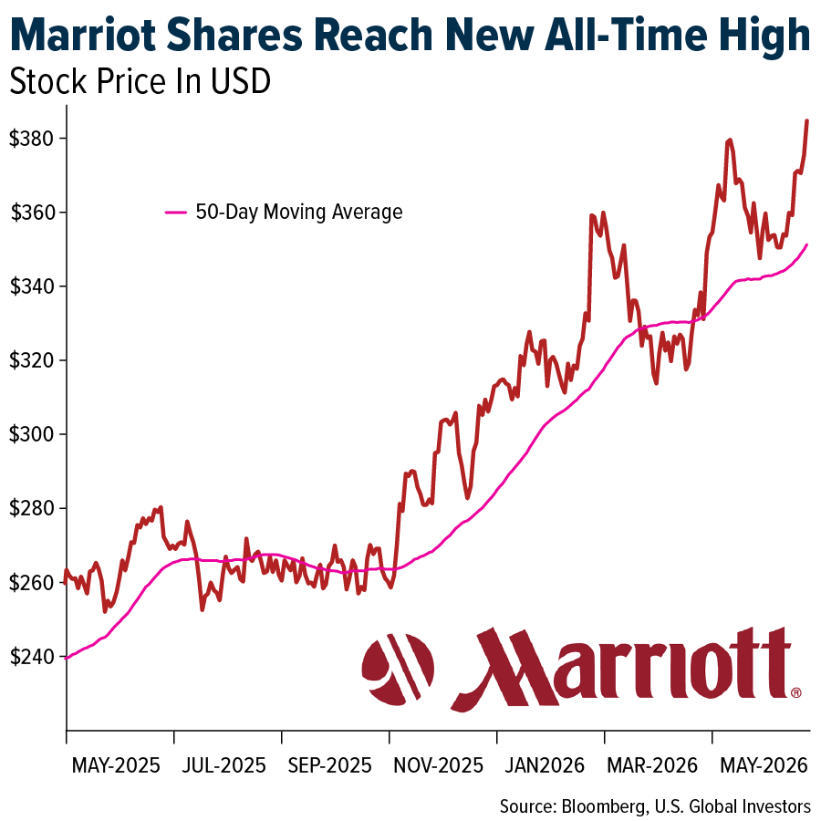
Figure 12: Shares of Marriott
(Source: US Global, 2026).

3.3.2 Impact on Debt Structure
Marriott has also prioritised on balancing the internal and external financial structure to meet the requirements of its business operations. For example, the company has increased its market capital to $68bn in 2025 (Marriott Group, 2026). Overall, the consistent enhancement in the fund value has helped Marriott in overcoming market uncertainties.
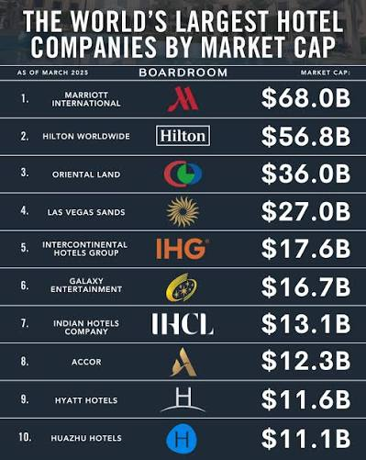
Figure 13: Market Capitalisation of Marriott
(Source: Marriott Group, 2026).

3.3.3 Impact on Operational Flexibility
The improvement in the capital structure has helped Marriott in improving its productivity and regaining the trust of its customers. For example, the organisation has increased its consumer loyalty score to 82% due to an enhancement in its service quality in 2025 (Marriott Group, 2025b). Hence, the existence of higher brand popularity has helped Marriott in acquiring a competitive advantage over other companies.
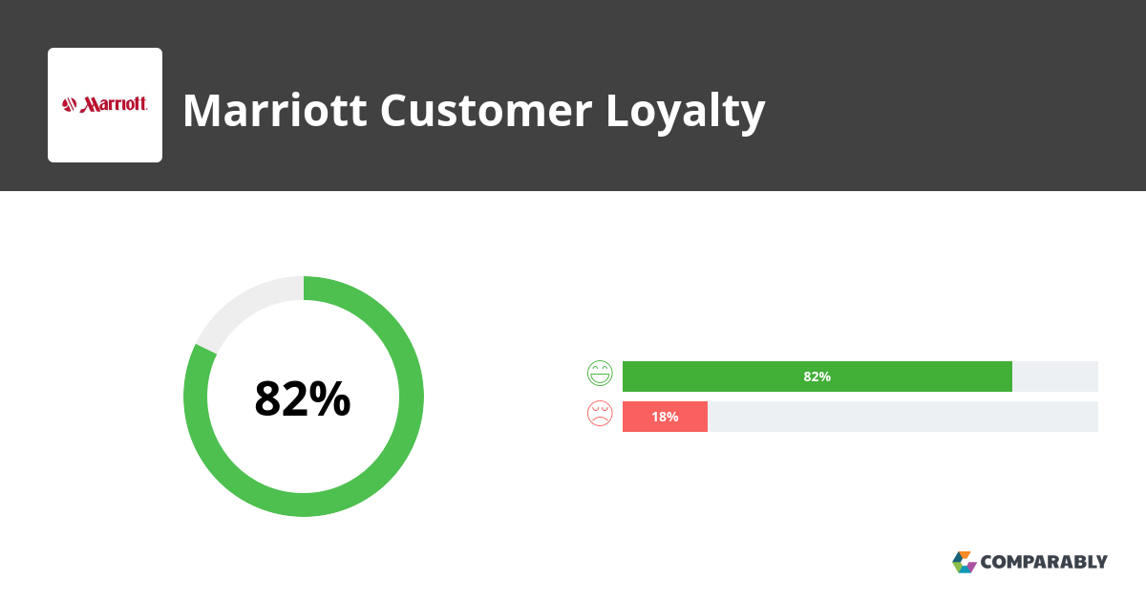
Figure 14: Consumer Loyalty Score
(Source: Marriott Group, 2025b)

3.4 International Financial Considerations

3.4.1 Taxation Considerations
Marriott showcases its income tax rate of about $210M which tends to increase about 112.12% from the previous year (Marriott, 2025a).The high rises of tax burden have its significant impact in managing cash flow by ability to squeeze its net profit that is due to high rises of operational cost. Thus, high rises of tax provision have its significant impact on net income that directly affect overall cash flow through efficient investment.

3.4.2 Currency Risk Management
Marriott declined its net income about $648 million in 2026 which decreases about 2.56%due to macroeconomic instability in the market (Marriott, 2025d).The company faced currency volatility risk which in term disrupted cash flow and affected financial performance by ability to slow down overall earnings.
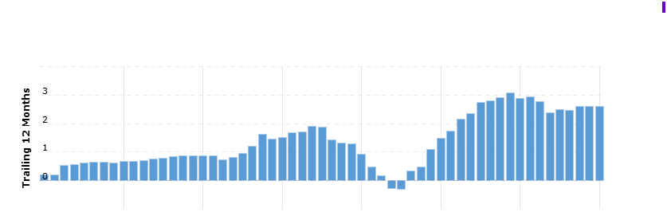
Figure 15:Income income of Marriott
(Source: Marriott, 2025d)

3.4.3 Inflation Risk
The US inflation rate is about 4.2% which in term leads to the purchasing power of customers and high rises of tariff rate affecting overall production cost (Taborda, 2026). Marriott is affected due to inflation that is due to high rises of operating cost and ability to shift consumer budgets which in term affect profitable performance of business.
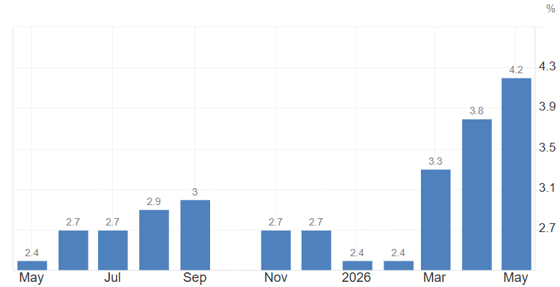
Figure 16: Inflation rate of US
(Source: Trading Economics, 2025)

3.5 Discussion on the Ethical and ESG Operations

3.5.1 Corporate Social Responsibility
Marriott has developed platforms such as “Serve 360: Doing Good in Every Direction” for promoting sustainability and increasing the employee participation level within its business operations (Marriott International, 2026a). Thus, the strengthening of the engagement level has helped the hotel company improve its workforce relationship.

3.5.2 Environmental Sustainability
Marriott has emphasised on promoting sustainability in its business operations to enhance product popularity among customers. For example, the hotel industry will reduce the volume of its carbon emissions to 3.6m tonnes in 2030 (UK parliament, 2029). Thus, the lowering of the footprints has helped Marriott in strengthening its brand loyalty among communities.
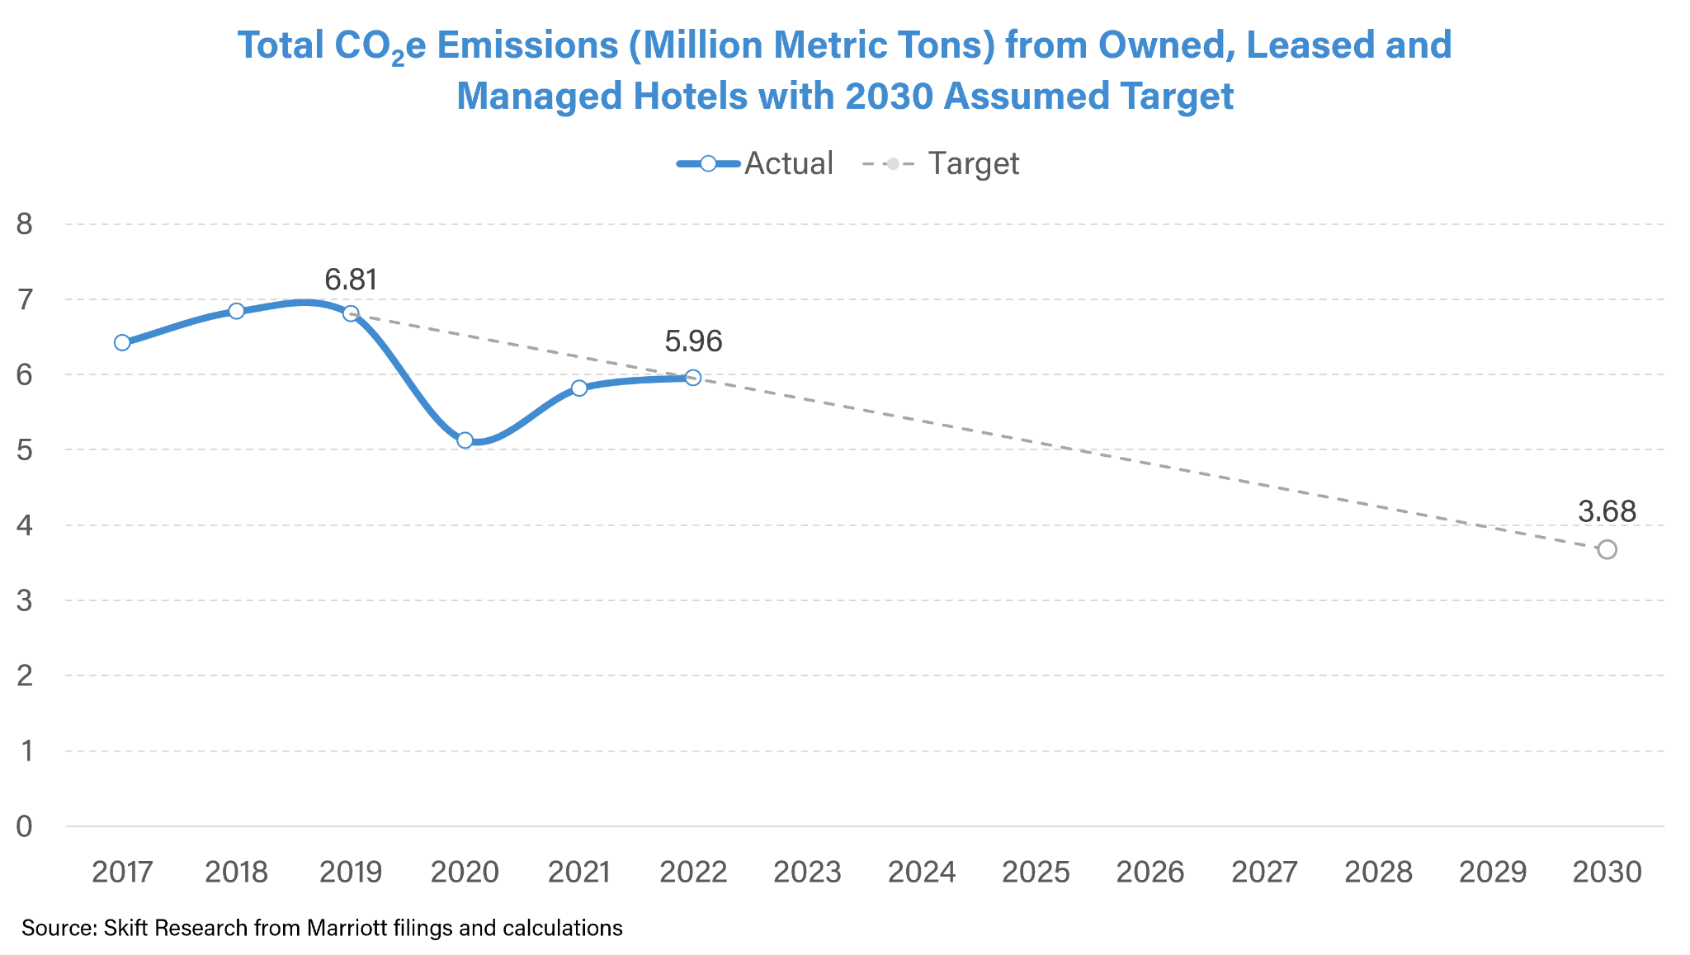
Figure 17: Carbon Emission Volume
(Source: Geerts, 2025)

3.5.3 ESG Performance and Reporting
Marriott has developed the “Voyage Leadership Development Programme” that has provided opportunities for employees in improving communication and leadership activities in 2025 (Marriott International, 2025). Thus, the improvement in skill development initiatives has assisted Marriott in improving its operational productivity.

4. Investment Appraisal and Capital Budgeting

4.1 Project Overview
The investment appraisal is also based on choosing three different types of investment project such as Project A, B and C for Marriott International with expansion capital through diversified key risk effectively. Hence, the capital expenditure for string boat all projects also be assured £50 million and total project period for investment about five years. Each project associated with different cash flow prediction for analysis most viable project that produced higher capital project with less time period for recovering within particular time period. As per the view of Hayes (2026), the capital rationing approach is the most suitable method that ensures investors burnout risk of the project while adhering to its profitability aspect of the future in a detailed manner. All of the project only project C derived as stable cash flow of about £11 million throughout the investment horizon. For application of straight line depreciation assure 8% discounting rate most suitable for calculation within against the initial investment criteria of the project.

4.2 Discuss About Project Viability

4.2.1 Project A Appraisal
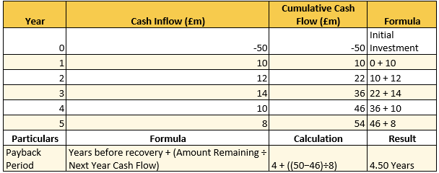
Figure 18: PBP
(Source: Self-developed)
The Payback Period (PBP) is generally for project A assured as 4.50 years illustrated that initial value about 90% of capital has also been recovered in fourth consecutive years. However, a total of remaining £4 million is generally recovered through fifth consecutive years within the recovering whole of £50 million. In addition, projects generate a total cash flow of £54 million with highest inflow also being acquired within the time period of third consecutive years effectively.
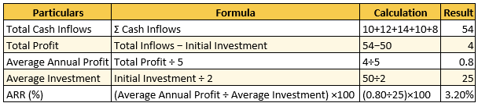
Figure 19: ARR
(Source: Self-developed)
The ARR value of 3.20 also indicated a modest benchmark of profitability against the investment of £50 million. Hence, total cash outflow of about £54 million also dictated generating profitability within the time period of £4 million.
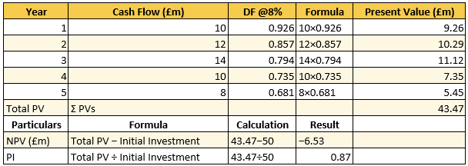
Figure 20: NPV and PI
(Source: Self-developed)
The NPV is most significant that illustrates future cash flow prediction against the acquired discount rate selection of the project (Walsh, 2025). Hence, in this case total cash inflow of project about £43.47 million within discounting rate 8% formulated negative NPV of £6.53 million. Overall, it is indicated the PI value from the project has also been £0.8 million within the time period of five years.

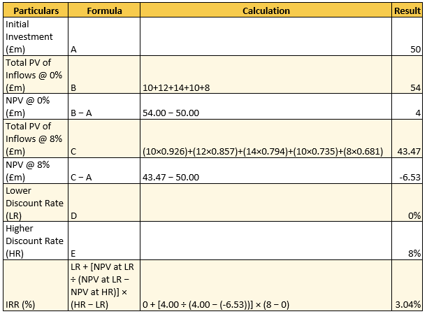
Figure 21: IRR
(Source: Self-developed)
The IRR is also calculated within the highest and lowest discounting factors such as 0% and 8% discounting rate. Thus, 0% discounting rate generated NPV of £4 million and 8% discounting rate declining NPV value of negative £6.53 million assured insufficient cash flow reduction with IRR 3.04%.

4.2.2 Project B Appraisal
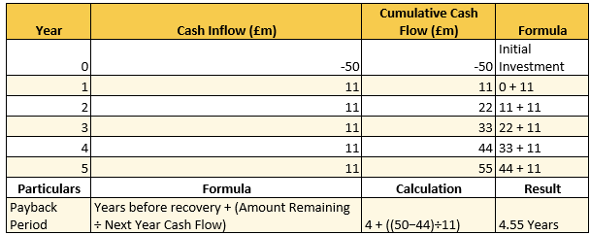
Figure 22: PBP
(Source: Self-developed)
Total of recovering the initial amount of £50 million in case of project B has 4.55 years. Thus, due to the stable cash flow it is also less fluctuated within the total recovery time period of five years. Overall, 88% of total invested also can be recovered within a fixed stipulated time period of five years effectively.
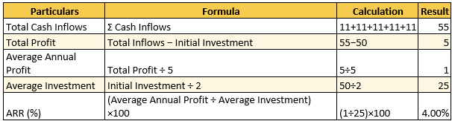
Figure 23: ARR
(Source: Self-developed)
The ARR value of 4% indicated stable benchmarked annual return from the investment. However, total annual cash flow of £55 million over five years generates a total profit of £5 million after deducting all initial investment costs. Overall, it indicated ARR generated profitability throughout its operational period with better-contributing financial inflow.
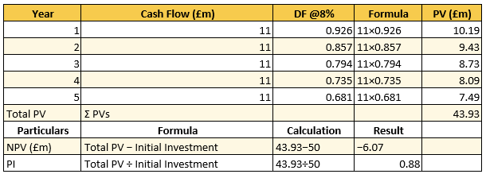
Figure 24: NPV and PI
(Source: Self-developed)
The fixed discounting rate of 8% indicated generated total cash flow in case of project B about £43.93 million. Hence, total generated value of cashflow also be lower than initial investment that makes NPV with negative value £6.07 million. Overall, it reduces shareholders value with a diluting PI index from 0.88 through five years.
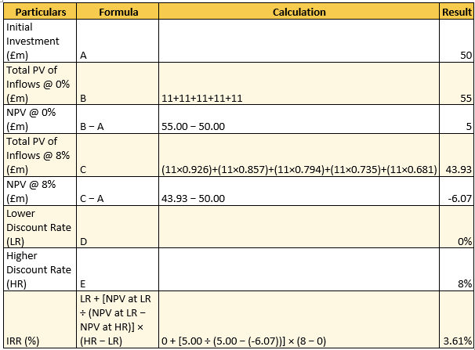
Figure 25: IRR
(Source: Self-developed)
The project IRR also consolidated at a 3.61% rate that indicated viable return potentiality in project B. In addition, the minimal 0% discount rate considered NPV value of £5 million and 8% discounting rate assured declines to negative £6.07 million. Overall, it ensures a risk factor for reducing present value associated with cash flow of the project.

4.2.3 Project C Appraisal
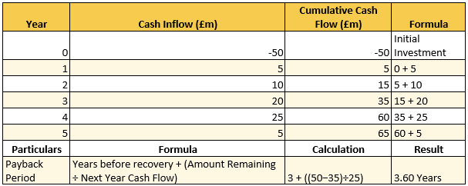
Figure 26: PBP
(Source: Self-developed)
The PBP value of 3.60 years also indicated that the initial invested value of £50 million recovered more fast within a four year time period. It is an opportunity for investors towards better inflow projection with investment of project C for the long term.
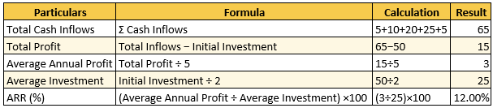
Figure 27: ARR
(Source: Self-developed)
Project C also be attributed about 12% ARR value indicated above industry benchmark project to ensure more risk free return from investment. Hence, total profit value left after covering the initial amount of £50 million also be £15 million. Overall, higher cash flow apart from investment value ensures more opportunity for investors.
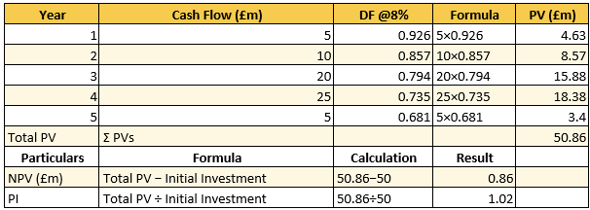
Figure 28: NPV and PI
(Source: Self-developed)
The initial investment of £50 million against a discount rate of 8% is generally to develop cash inflows of £50.86 million. As a result, it is enabled towards maintaining a positive info of the project with an acquired Net Present Value (NPV) of £0.86 million. Overall, this additional shareholders value generates PI index 1.02 with more stability in the project.
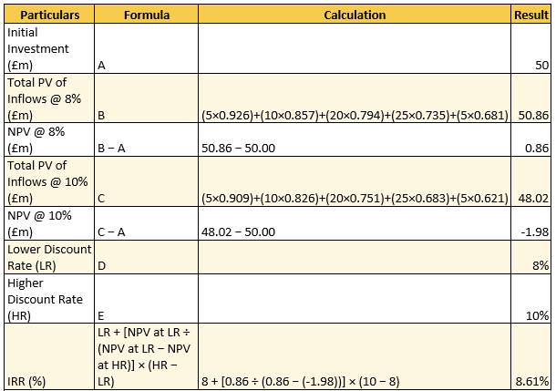
Figure 29: IRR
(Source: Self-developed)
Project C achieves an IRR of 8.61% indicated generated annual return also higher within the selected discounting rate of 8%. However, 8% discounted rate provides a positive NPV of £0.86 million, while increasing the discount rate to 10% results in a negative NPV of £1.98 million. Overall, IRR also created more value with fixed discounting rate return by 0.61 percentage points effectively.

4.3 Recommended Project Selection

4.3.1 Selection of project
Marriott needs to execute investments in project C due to the positive NPV of the business plan. In addition, the scheme has also increased its ARR value to 12% that provides improved returns to the investors. Overall, the investment in project C will help Marriott in improving its business operations.

4.3.2 Financial Justification
Marriott has adopted partnership techniques with an intent to improve its product quality and overcome market uncertainties. For example, the company has collaborated with Fitwell Ltd for improving the occupational health of the workers in 163 business units in 2025 (Travel Today, 2025). The business tie-up has also improved the service demand of the organisation. Marriott has increased its revenue from $6000m in 2024 to $6500m in 2025 (Market Screener, 2025). The improvement in the sales value has helped the company in achieving financial stability. On the other hand, Marriott has also observed growth in the government investment value by 2% in 2025 (Rennie, 2025). Overall, the improvement in the funds has helped the hotel in ensuring smooth completion of its business operations.
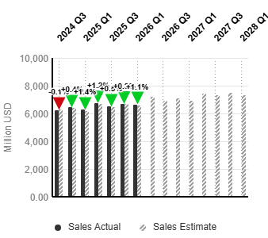
Figure 30: Sales of Marriott
(Source: Market Screener, 2025)

4.3.3 Non-Financial Risk Assessment
Political risk
Project C faced significant political risk that is due to the high rise of geopolitical disruption and significant changes in tax rate affecting the overall reputation of the project. For instance, the UK hospitality industry faced significant political risk that is due to rising international conflict and surging labor costs, affecting overall revenue of the business. The hospitality industry cut VAT by about 20%, leading to high rises in energy prices due to the ability to absorb significant costs, which affects overall profit (Neidle, 2026).
Customer loyalty
Project C showcases its significant cash flow with its NPV about -6.53%, which leads to high rises of cost maintenance issues. Dropping of the customer loyalty at the early stage is due to a significant selection of products and failure to pay out addresses through significant investment. In 2026, the UK consumer showcases its significant engagement which leads to a rise of about 80% by highlighting exceptional services and through repeat booking (Green, 2026).

4.4 Capital Rationing Analysis (£100 Million Limit)
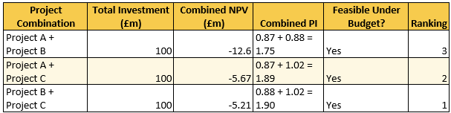
Figure 31: Capital rationing
(Source: Self-developed)
The application of the capitalisation method is significant towards identifying the most suitable project combination against the investment cost of £100 million. Thus, analysis also revealed that project B and C are most suitable projects for investment with generating higher profitability ascot form investment. This combination achieves the highest combined Profitability Index (PI) of 1.90, compared with 1.89 for Projects A and C and 1.75 for Projects A and B. As it is also to ensure lower negative NPV of £5.21 million compared to other combinations of projects. On the other hand, Project A and C are generally assured negative NPV of -£5.67 million illustrated less viability for the project. Overall, project C has a stable NPV of £0.86 million and an IRR of 8.61% and project B also has annual cash inflows of £11 million.

5. Critical Reflection on Artificial Intelligence Usage

5.1 Tool Disclosure and AI Acknowledgement
In the current investigation process, I have utilized AI tools such as “Jenni AI” for acquiring information regarding the operational performance of Marriott Hotels. As stated by Gerlich, (2025), the application of the technique has provided reliable and accurate data regarding the organisation which has improved the quality of the research work. In addition, I have included the use of tools such as “Google Gemini” with an intent to understand the share growth of the organisation. According to Nabil, (2026), the adoption of Google Gemini has provided opportunities in summarising financial statements of the organisation that also reduced delays in the completion of the investigation process. The acquisition of financial data has helped me in understanding the operational strength and weakness of the hotel company. Overall, the inclusion of the AI tools mentioned above has helped me in increasing the efficiency of my report.

5.2 Verification of AI Outputs
The verification of the financial statement has been addressed through uses of AI through “Retrieval-Augmented Generation” and through “cross-model verification”. AI-generated financial interpretation showcases its significant accuracy address through Marriott international. Traceability and grounding help to carry out exact documents related to transitioning financial performance, SEC filing and through significant earnings (Khan et al., 2022). The automated data insights gathered from the AI help in designing significant information addresses through a seasoning purchase order and bank statement which in term showcases its significant accuracy. I have its ability to carry out logical error and Hallucinations that have been addressed through significant balance checks and showcases its traceability which leads to enhancing overall revenue of business. This can be addressed through “real-time search” by ability to carry out initial responses through self correction.

5.3 Contribution Analysis

5.3.1 AI-Generated Contributions
The inclusion of AI tools such as “AI Jenny” and “Google Gemini” has helped me in developing a flexible structure of my report. In addition, the technique has also assisted me in providing keywords associated with the topic that has reduced delays in acquiring information regarding the business activities of Marriott. Overall, the inclusion of AI tools has improved my research capacity and strengthened the quality of my report.

5.3.2 Independent Critical Analysis
As per my own contribution in the report, I have carried out the financial calculations that showcase the business performance of Marriott Group and its investment decisions. In addition, I have also provided a graphical representation of the company and aligned it with its management activities. Overall, I feel that my efforts have increased the authenticity of my investigation process.

5.4 Ethical and Professional Reflection
Transparency and Accountability
The incorporation of AI is more reliable for managing finance by ability to manage transparency through setting a loan, insurance claim and managing of interest rate. As stated by Chopra (2024), adoption of AI is more reliable for managing financial services by ability to showcase its transparency through credit score rating and lending. This AI adoption enhances transparency by ability to manage “black box” problems through efficient decision making.
Data Privacy and Confidentiality
The integration of AI has the ability to follow data privacy by the ability to deal with significant risk exposure and the ability to manage confidentiality by protecting sensitive information following the "Copyright Act”. “Data Protection Act 2018 (DPA 2018)” helps organizations in protecting personal data by describing up-to-date information in prohibiting unauthorized access (Government of UK , 2018).

Risks of Over-Reliance in Decision-Making
Over-resilience in carrying out significant decisions through AI has been addressed through flawed output by ability to carry out significant errors through critical thinking processes. AI helps in advancing real -time information by ability to analyze significant struggles through geo-political shifts and ability to respond with consumer sentiment which is more reliable to deal with strategic insights.

References
Chopra, N.P. (2024). Ethical Implications of AI in Financial Services: Bias, Transparency, and Accountability. International Journal of Scientific Research in Computer Science Engineering and Information Technology, 10(5), pp.306–314. doi:https://doi.org/10.32628/cseit241051017.
Geerts, W. (2025). Marriott on Track For Emissions Goal – but Trending in Wrong Direction. [online] Skift. Available at: https://skift.com/2023/09/14/marriott-on-track-for-emissions-goal-but-trending-in-wrong-direction/.
Gerlich, M. (2025). AI Tools in Society: Impacts on Cognitive Offloading and the Future of Critical Thinking. Societies, [online] 15(1), p.6. doi:https://doi.org/10.3390/soc15010006.
Government of UK (2018). Data Protection Act 2018. [online] legislation.gov.uk. Available at: https://www.legislation.gov.uk/ukpga/2018/12/contents.
Green, B. (2026). 80% of UK Consumers Now Use a Loyalty Scheme - Retail Focus Magazine - Retail Design. [online] Retail Focus Magazine - Retail Design. Available at: https://retail-focus.co.uk/80-of-uk-consumers-now-use-a-loyalty-scheme/.
Hayes, A. (2026). Introduction to Capital Rationing. [online] Investopedia. Available at: https://www.investopedia.com/terms/c/capitalrationing.asp.
Hilton (2025). Hilton Reports First Quarter Results; Raises Full Year Outlook. [online] Available at: https://ir.hilton.com/~/media/Files/H/Hilton-Worldwide-IR-V3/quarterly-results/2026/q1-2026-earnings-release.pdf.
Investing News (2026). Marriott International stock hits all-time high at 396.94 USD. [online] Investing.com India. Available at: https://in.investing.com/news/company-news/marriott-international-stock-hits-alltime-high-at-39694-usd-93CH-5446800.
Khan, M., Parvaiz, G.S., Dedahanov, A.T., Abdurazzakov, O.S. and Rakhmonov, D.A. (2022). The Impact of Technologies of Traceability and Transparency in Supply Chains. Sustainability, [online] 14(24), p.16336. doi:https://doi.org/10.3390/su142416336.
Kostuch Media (2025). Marriott International Implements Digital Transformation Plan - Hotelier Magazine. [online] Hotelier Magazine. Available at: https://www.hoteliermagazine.com/marriott-international-implements-digital-transformation-plan/.
Macrotrends (2026a). Marriott Cash on Hand 2010-2024 | MAR. [online] Macrotrends.net. Available at: https://www.macrotrends.net/stocks/charts/MAR/marriott/cash-on-hand.
Macrotrends (2026b). Marriott Income Statement 2009-2022 | MAR. [online] www.macrotrends.net. Available at: https://www.macrotrends.net/stocks/charts/MAR/marriott/income-statement.
Macrotrends (2025). Marriott Total Assets 2006-2020 | MAR. [online] www.macrotrends.net. Available at: https://www.macrotrends.net/stocks/charts/MAR/marriott/total-assets.
MarketScreener (2025). MarketScreener. [online] MarketScreener. Available at: https://uk.marketscreener.com/quote/stock/MARRIOTT-INTERNATIONAL-IN-14633490/finances/.
Marriott (2021). Available at: https://marriott.gcs-web.com/static-files/33ba0a19-8a68-4f3f-9f73-fef2c458c22e.
Marriott (2023). 2 0 2 3 A N U A L R E P O R T. [online] Available at: https://marriott.gcs-web.com/static-files/bb2be39e-790e-49c3-b247-3ce75f0e3ee8.
Marriott (2025a). Marriott Income Taxes 2012-2026 | MAR. [online] Available at: https://www.macrotrends.net/stocks/charts/MAR/marriott/total-provision-income-taxes.
Marriott (2025b). Marriott International Reports Fourth Quarter and Full Year 2025 Results | Marriott International. [online] Marriott International. Available at: https://marriott.gcs-web.com/news-releases/news-release-details/marriott-international-reports-fourth-quarter-and-full-year-2025.
Marriott (2025c). Marriott International to Acquire the citizenM Brand | Marriott International. [online] Marriott International. Available at: https://marriott.gcs-web.com/news-releases/news-release-details/marriott-international-acquire-citizenm-brand.
Marriott (2025d). Marriott International, Inc. [online] Available at: https://marriott.gcs-web.com/static-files/64b4d100-a06e-44b0-8989-d13bad2eb39e.
Marriott (2025e). Marriott Net Income 2006-2021 | MAR. [online] www.macrotrends.net. Available at: https://www.macrotrends.net/stocks/charts/MAR/marriott/net-income.
Marriott (2025f). Available at: https://marriott.gcs-web.com/static-files/9cf0e9b0-bbfa-48a6-9e21-ffbdbc4b2d78.
Marriott (2026). Marriott International Reports First Quarter 2026 Results | Marriott International. [online] Marriott International. Available at: https://marriott.gcs-web.com/news-releases/news-release-details/marriott-international-reports-first-quarter-2026-results.
Marriott (2025). ANNUAL REPORT - Investor Relations | Marriott International. [online] Available at: https://marriott.gcs-web.com/static-files/a7664c0f-5bd1-4066-9fc9-b05eb6c93772.
Marriott (2026a). Marriott International Reports First Quarter 2026 Results | Marriott International. [online] Marriott International. Available at: https://marriott.gcs-web.com/news-releases/news-release-details/marriott-international-reports-first-quarter-2026-results.
Marriott (2026b). Marriott International Reports First Quarter 2026 Results | Marriott International. [online] Marriott International. Available at: https://marriott.gcs-web.com/news-releases/news-release-details/marriott-international-reports-first-quarter-2026-results.
Marriott (2026c). Marriott Retained Earnings (Accumulated Deficit) 2012-2026 | MAR. [online] Macrotrends.net. Available at: https://www.macrotrends.net/stocks/charts/MAR/marriott/retained-earnings-accumulated-deficit
Marriott Bonvoy (2025). Mobile App. [online] Marriott.com. Available at: https://www.marriott.com/marriott-brands/mobile-app.mi.
Marriott Group (2025a). Marriott International Reports Fourth Quarter and Full Year 2025 Results | Marriott International. [online] Marriott International. Available at: https://marriott.gcs-web.com/news-releases/news-release-details/marriott-international-reports-fourth-quarter-and-full-year-2025.
Marriott Group (2025b). Marriott NPS & Customer Reviews. [online] Comparably. Available at: https://www.comparably.com/brands/marriott.
Marriott Group (2026). [online] Instagram. Available at: https://www.instagram.com/p/DJWhtI8yIrS/.
Marriott International (2025). Marriott International Careers | Find Job & Career Opportunities. [online] Marriott International Careers | Find Job & Career Opportunities. Available at: https://careers.marriott.com/career-journeys/early-careers/.
Marriott International (2026a). csr-marriott. [online] csr-marriott. Available at: https://serve360.marriott.com/.
Marriott International (2026b). Marriott International Reports First Quarter 2026 Results. [online] Prnewswire.com. Available at: https://www.prnewswire.com/news-releases/marriott-international-reports-first-quarter-2026-results-302763318.html.
Marriott International (2025). Marriott International . [online] Available at: https://marriott.gcs-web.com/static-files/9cf0e9b0-bbfa-48a6-9e21-ffbdbc4b2d78.
Marriott International Inc (2026). Marriott International Reports First Quarter 2026 Results. [online] Prnewswire.com. Available at: https://www.prnewswire.com/news-releases/marriott-international-reports-first-quarter-2026-results-302763318.html.
Marriott Internationals (2025). Around The World Highlights. [online] Available at: https://serve360.marriott.com/wp-content/uploads/2025/07/2025AroundTheWorld.pdf.
McColl, B. (2026). [online] Investopedia.com. Available at: https://www.investopedia.com/thmb/tE8c89v8mIpO2XbjXKtTH8Ko28Q=/1500x0/filters:no_upscale():max_bytes(150000):strip_icc()/MAR_2025-02-11_10-45-27-c5e1323c42714bc2b640640a6da05d69.png.
Nabil, O. (2026). Artificial Intelligence Tools for Preparing Scientific Reviews: A Comparative Applied Study. Education for Information. doi:https://doi.org/10.1177/01678329261425828.
Neidle, D. (2026). The £12bn VAT cut for hospitality. Who really benefits? [online] Tax Policy Associates. Available at: https://taxpolicy.org.uk/2026/06/12/hospitality-vat-cut-who-benefits/.
O’Neill, S. (2026a). Marriott Hotel Owners Want a Bigger Cut of Loyalty Income. [online] Skift. Available at: https://skift.com/2026/06/16/marriott-hotel-owners-want-a-bigger-cut-of-loyalty-income/
O’Neill, S. (2026b). Marriott Hotel Owners Want a Bigger Cut of Loyalty Income. [online] Skift. Available at: https://skift.com/2026/06/16/marriott-hotel-owners-want-a-bigger-cut-of-loyalty-income/
Rennie, A. (2025). Marriott’s Declining US Government Demand Leading to ‘Softer’ Growth. [online] Investopedia. Available at: https://www.investopedia.com/marriott-s-declining-us-government-demand-leading-to-softer-growth-11729069.
Taborda, J. (2026). US Inflation Rate Stable at 2.7%, Core Below Forecasts. [online] Tradingeconomics.com. Available at: https://tradingeconomics.com/united-states/inflation-cpi/news/516655.
Trading Economics (2025). United States Inflation Rate. [online] Trading Economics website. Available at: https://tradingeconomics.com/united-states/inflation-cpi.
Travel Today (2025). Available at: https://www.traveltrendstoday.in/marriott-international-partners-with-fitwel.
UK parliament (2029). GCE0025 - Evidence on Growing a circular economy. [online] Parliament.uk. Available at: https://committees.parliament.uk/writtenevidence/50374/html/.
US Global (2026). [online] X (formerly Twitter). Available at: https://x.com/USFunds/status/2061835493818409361.
Walsh, J. (2025). Net present value | EBSCO. [online] EBSCO Information Services, Inc. | www.ebsco.com. Available at: https://www.ebsco.com/research-starters/business-and-management/net-present-value.

Appendices

Appendix 1: Ratio analysis
Profitability Ratios:
Particulars | Details | 2021 | 2022 | 2023 | 2024 | 2025
Revenue ($m) | A | 13,857.00 | 20,773.00 | 23,713.00 | 25,100.00 | 26,186.00
Operating Profit/(Loss) ($m) | B | 1,750.00 | 3,114.00 | 3,378.00 | 3,151.00 | 3,394.00
Net Profit/(Loss) ($m) | C | 1,099.00 | 2,358.00 | 3,083.00 | 2,375.00 | 2,601.00
Total Assets ($m) | D | 25,553.00 | 24,815.00 | 25,674.00 | 21,704.00 | 22,827.00
Current Liabilities ($m) | E | 6,407.00 | 7,339.00 | 7,762.00 | 8,649.00 | 8,398.00
Equity ($m) | F | 2,425.00 | 2,298.00 | 2,706.00 | 2,645.00 | 2,759.00
Net Margin | C/A | 7.93% | 11.35% | 13.00% | 9.46% | 9.93%
Return on Capital Employed (ROCE) | B/(D-E) | 9.14% | 17.82% | 18.86% | 24.14% | 23.52%
Return on Equity (ROE) | C/F | 45.32% | 102.61% | 113.93% | 89.79% | 94.27%
Liquidity Ratios:-
Particulars | Details | 2021 | 2022 | 2023 | 2024 | 2025
Current Assets ($m) | A | 3,626.00 | 3,313.00 | 3,311.00 | 3,485.00 | 3,584.00
Inventories ($m) | B | - | - | - | - | -
Current Liabilities ($m) | C | 6,407.00 | 7,339.00 | 7,762.00 | 8,649.00 | 8,398.00
Cash ($m) | D | 1,393.00 | 507.00 | 338.00 | 396.00 | 358.00
Current Ratio | A/C | 0.57 | 0.45 | 0.43 | 0.40 | 0.43
Quick Ratio | (A-B)/C | 0.57 | 0.45 | 0.43 | 0.40 | 0.43
Cash Ratio | D/C | 0.22 | 0.07 | 0.04 | 0.05 | 0.04
Gearing Ratios:-
Particulars | Details | 2021 | 2022 | 2023 | 2024 | 2025
Total Liabilities ($m) | A | 14,446.00 | 17,015.00 | 20,929.00 | 26,182.00 | 27,540.00
Total Equity ($m) | B | 2,425.00 | 2,298.00 | 2,706.00 | 2,645.00 | 2,759.00
Operating Profit/(Loss) ($m) | C | 1,750.00 | 3,114.00 | 3,378.00 | 3,151.00 | 3,394.00
Interest Expense ($m) | D | 420.00 | 403.00 | 565.00 | 695.00 | 809.00
Shareholders capital ($m) | E | 2,425.00 | 2,298.00 | 2,706.00 | 2,645.00 | 2,759.00
Total Debt ($m) | F | 9,333.00 | 9,380.00 | 11,320.00 | 13,138.00 | 14,995.00
Debt/Equity Ratio | A/B | 5.96 | 7.40 | 7.73 | 9.90 | 9.98
Interest Coverage Ratio | C/D | 4.17 | 7.73 | 5.98 | 4.53 | 4.20
Debt/Capital Ratio | F/(F+E) | 0.79 | 0.80 | 0.81 | 0.83 | 0.84
Efficiency Ratios:-
Particulars | Details | 2021 | 2022 | 2023 | 2024 | 2025
Revenue ($m) | A | 13,857.00 | 20,773.00 | 23,713.00 | 25,100.00 | 26,186.00
Cost of Sales ($m) | B | 12,107.00 | 17,311.00 | 19,849.00 | 21,333.00 | 22,045.00
Opening Receivables ($m) | F | 1,768.00 | 1,982.00 | 2,571.00 | 2,712.00 | 2,795.00
Closing Receivables ($m) | G | 1,982.00 | 2,571.00 | 2,712.00 | 2,795.00 | 2,909.00
Average Receivables ($m) | H=(F+G)/2 | 1,875.00 | 2,276.50 | 2,641.50 | 2,753.50 | 2,852.00
Opening Payables ($m) | I | 527.00 | 726.00 | 746.00 | 738.00 | 763.00
Closing Payables ($m) | J | 726.00 | 746.00 | 738.00 | 763.00 | 814.00
Average Payables ($m) | K=(I+J)/2 | 626.50 | 736.00 | 742.00 | 750.50 | 788.50
Receivables Turnover Days | 365/(A/H) | 49 | 40 | 41 | 40 | 40
Payables Turnover Days | 365/(B/K) | 19 | 16 | 14 | 13 | 13
Investment Ratios:-
Particulars | Details | 2021 | 2022 | 2023 | 2024 | 2025
No Of Share (m) | A | 326.00 | 326.00 | 303.00 | 285.00 | 274.00
Net Income ($m) | B | 1,099.00 | 2,358.00 | 3,083.00 | 2,375.00 | 2,601.00
Earning Per Share | B/A | 3.37 | 7.23 | 10.17 | 8.33 | 9.49
Cash Flow Ratios:-
Particulars | Details | 2021 | 2022 | 2023 | 2024 | 2025
Cash Flow From Operation ($m) | A | 1,177.00 | 2,363.00 | 3,170.00 | 2,749.00 | 3,212.00
Current Liabilities ($m) | B | 6,407.00 | 7,339.00 | 7,762.00 | 8,649.00 | 8,398.00
Total Assets ($m) | C | 25,553.00 | 24,815.00 | 25,674.00 | 21,704.00 | 22,827.00
Operating Cash Flow Ratio | A/B | 0.18 | 0.32 | 0.41 | 0.32 | 0.38
Cash Return On Assets | A/C | 0.05 | 0.10 | 0.12 | 0.13 | 0.14

Appendix 2: Capital investment analysis
Criteria | Project A | Project B | Project C | Ranking
Initial Investment (£m) | 50 | 50 | 50
Total Cash Inflows (£m) | 54 | 55 | 65 | C > B > A
Total Profit (£m) | 4 | 5 | 15 | C > B > A
Payback Period (Years) | 4.5 | 4.55 | 3.6 | C > A > B
Average Annual Profit (£m) | 0.8 | 1 | 3 | C > B > A
Average Investment (£m) | 25 | 25 | 25 | Equal
ARR (%) | 3.20% | 4.00% | 12.00% | C > B > A
Total PV of Inflows @ 8% (£m) | 43.47 | 43.93 | 50.86 | C > B > A
NPV (£m) | -6.53 | -6.07 | 0.86 | C > B > A
PI | 0.87 | 0.88 | 1.02 | C > B > A
IRR (%) | 3.04% | 3.61% | 8.61% | C > B > A
Investment Decision | Reject | Reject | Accept

Appendix 3: Income Statement


