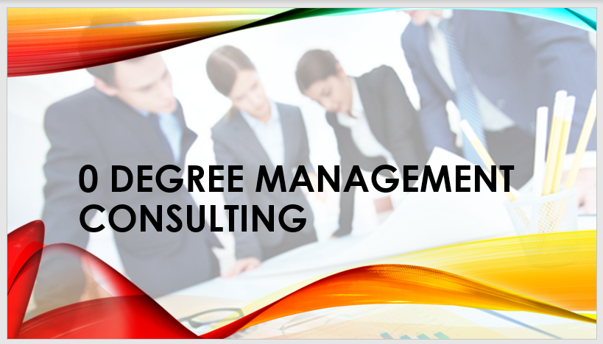

Speech note:
TEAM MEMBERS
Kelvin Kpenosen (Group Leader) - 1908380
Ugochi Precious Emejuru – 1908381
Martins Uwugiaruoyi (1907286)
Hugh Benain (1908226) – No Submission
Jerry Osho (1908942 – No Submission
ROLES
Introduction - KELVIN
Benefits of team working - PRECIOUS
Stages of team development - KELVIN
Team roles - KELVIN
Managing conflicts - MARTIN
Successful team development - KELVIN
Conclusion - KELVIN, PRECIOUS, MARTIN
References – KELVIN, PRECIOUS, MARTIN
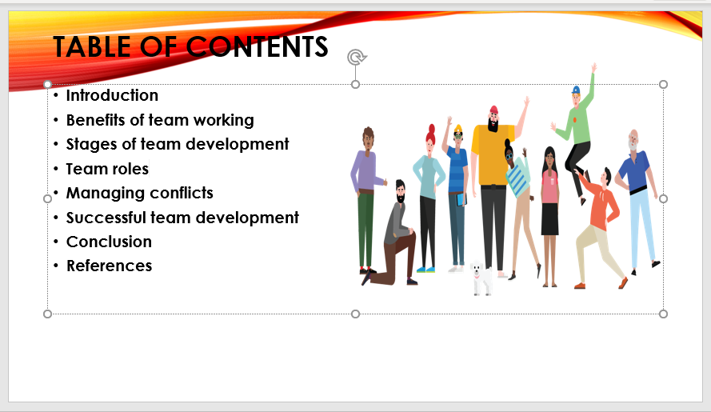

Speech note:
As it can be seen on the slide sheet, we will be covering these topics on team working.

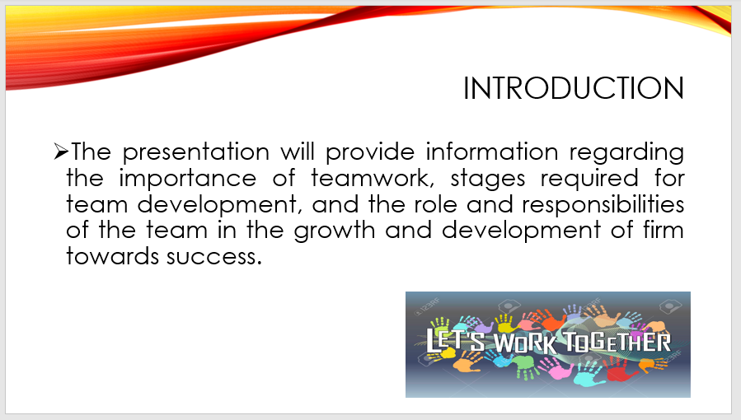

Speech note:
Team working is a great part of organisation success. The team working reflects the potential of the management team. Which one can simply say “two head is better than one”. Individuals have potentials but working together as a team can maximise the organisational production which will reflect on their profit.

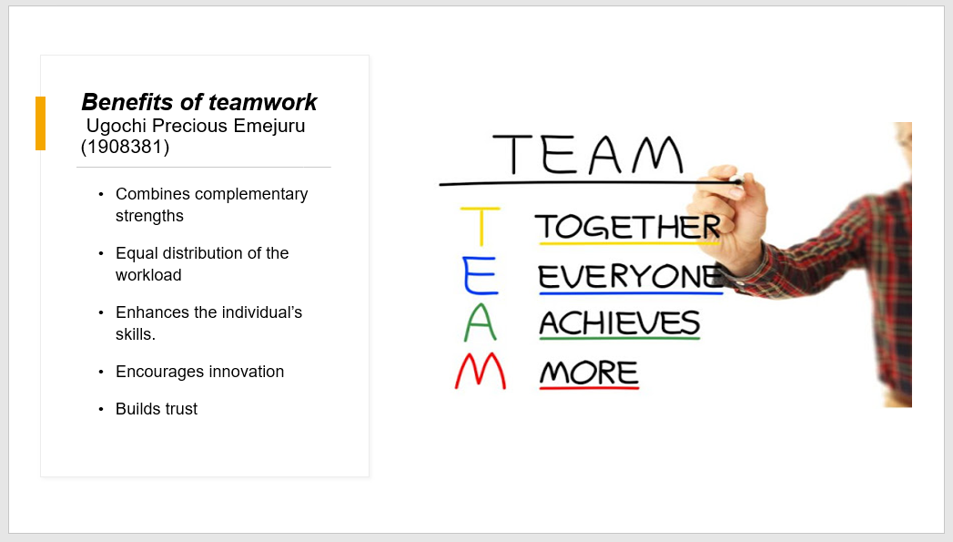

Speech note:
Teamwork is a valuable skill used by everyone to accomplish a task and making great achievements. This consist in having a group of people, where each person with their strengths and weaknesses completes the other. These different bodies work together to achieve one common goal
A team is a group of people with diverse skills and tasks who work together to give a vast number of individual from the age of 16 to the age of 40, an excellent and satisfying experience in our stores.
Both professionally and academically speaking effective teamwork is the capacity both as a group and as an individual of being proactive and innovative for themselves and the group. Over the centuries It has been widely suggested that organizations have moved towards more decentralized patterns of responsibility, which offer employees greater initiative and control over their jobs, and which thereby better engage their creative potential and productive capacities. (Ducan Gallie, 2012)

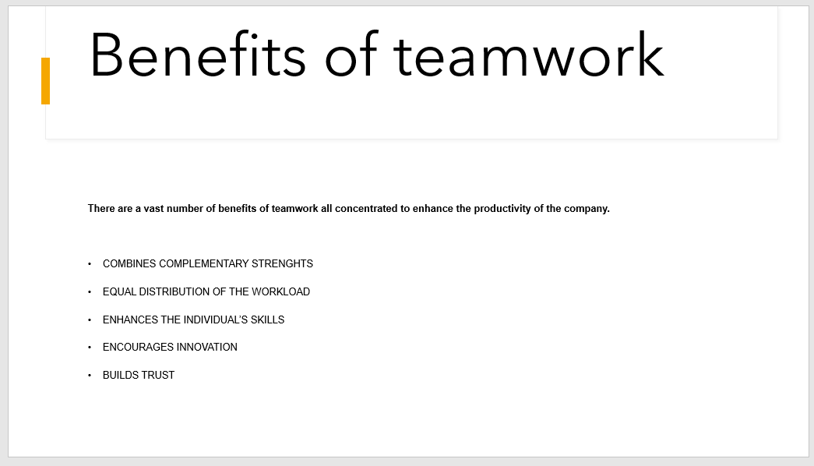
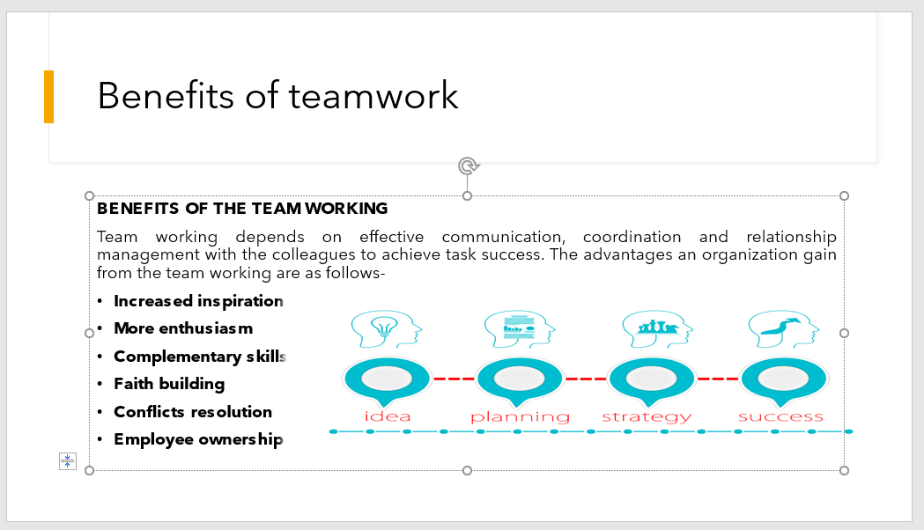

Speech note:
COMBINES COMPLEMENTARY STRENGHTS: Working with a vast number of people comports having diverse cultures, backgrounds, point of views and skills. Each person has his or her own point strengths and weaknesses but by working in a group everyone will learn how to blend each strengths to someone’s weakness to make it stronger ( for example when building a puzzle, different pieces are put together used to create and image).
Therefore, by identifying the various strengths and by distributing them correctly to the separate roles in the company, a great and effective team could be created. Also, an excellent achievement would be made.
EQUAL DISTRIBUTION OF THE WORKLOAD: This is an essential asset that both professionally and academically speaking, a group can not do without. When working in a team at times it is quite challenging to perform because of the excessive workload but by identifying each strengths and skills, this can be equally divided also, according to the qualifications each person has.
The equal distribution of the workload can also boost the productivity as the tasks are completed faster and more efficiently.
ENHANCES THE INDIVIDUAL’S SKILLS: Working in a team does not only mean achieving goals as a group but also means advancing the individual skills. Working with others helps you improve your skills as well as learning and mastering new ones.
ENCOURAGES INNOVATION: Working as a group also helps the management to come up with new ideas and innovations to improve the business.
BUILDS TRUST: Teamwork also consists of relying on each other, these also helps to build a strong relationship among co-workers.

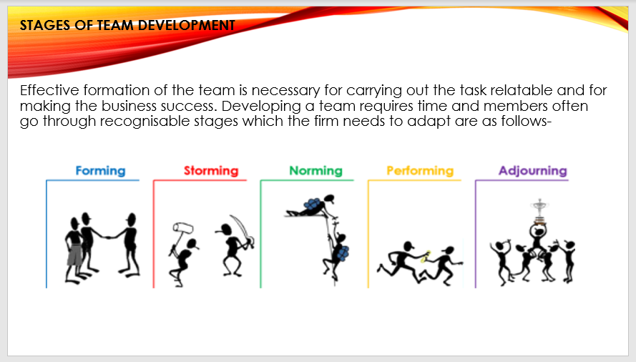

Speech note:
Stages of team development
The five major stages of team development that an organization needs to implement for carrying out an energetic and attractive team are forming, storming, norming, performing, and adjourning.
Forming- meeting of team members with each other for the first time for completion of the task with the same purpose.
Storming- storming phase provides an opportunity to the team members to share their idea, opinions and suggestion regarding the task.
Norming- the beginning of the work is carried out in this stage by the team members with a focus on single objectives.
Performing- trust-building and achievement of the goals of the task are carried out by the team members in the performing stage.
Adjourning- moving off of the team members into different areas after successful completion of the task is considered into the adjourning stage.

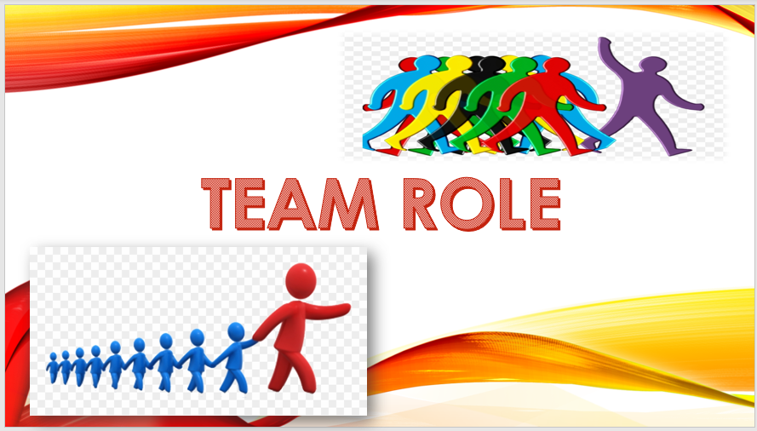

Speech note:
Working effectively with colleagues, clients, managers and other people in the organization significantly help in completing the work properly and efficiently. It is required to understand the individual’s role in the team so that quality work is produced for which Belbin’s 9 team role model is very effective.

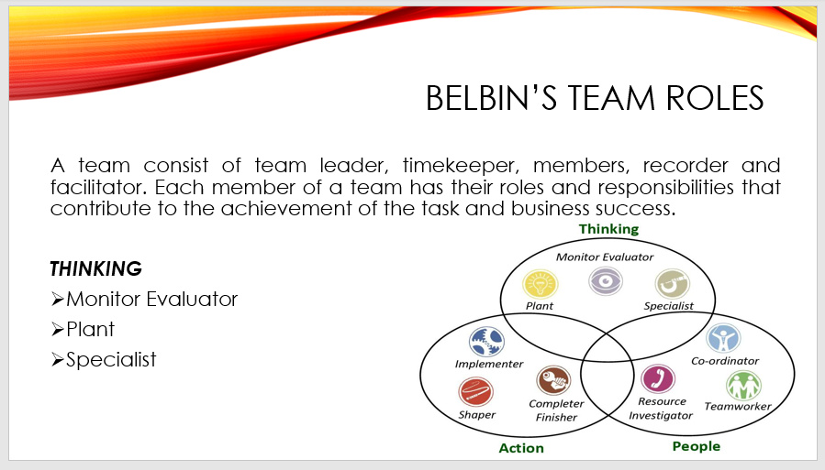

Speech note:
BELBIN THEORY
The nine major roles of the team as per the theory of Belbin that will contribute to making the task success, achievable and more effective beyond the expectations are specialist, implementer, shaper, complete finisher, monitor evaluator, team worker, coordinator, plant, and resource investigator. Understanding the roles and responsibilities of team member along with the utilisation of the role effectively. It essential for the team for completion of the task as per expectations and for leading the business towards success.
THINKING
Monitor evaluator- Monitor evaluator is a critical thinker and dispassionately make impartial choices. They analyse the information before making any choice.
Plant- Plants role members are the creative members of the team and solve difficulties in unconventional ways for overcoming the challenges.
Specialist- Specialist is the indispensable member of the group that contributes to carrying out depth information of the key task along with working in a particular area of knowledge for completion of the task.

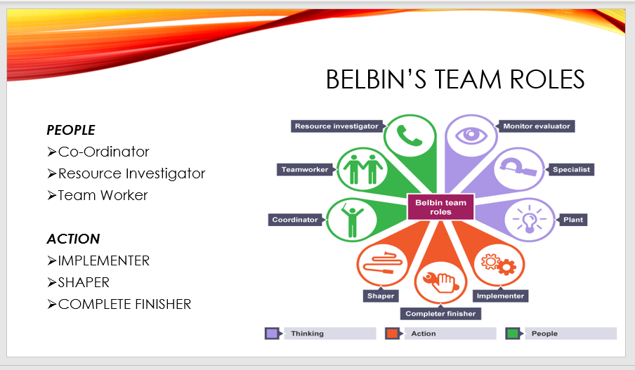

Speech note:
PEOPLE
Resource investigator-. With the help of networking skill, investigator develops external contacts, find ideas to bring back to the team, and negotiates for the team resources.
Team worker- team workers, maintains the unity of the team along with identifying and completing the task by supporting each other and working with the appropriate operations.
Co-ordinator- Co-ordinator emphasis on team goals, identifies ability and delegate work along with guiding the operations and activities to the team related to the goal.
ACTION
Shaper- shapers are dynamic in nature and maintains the focus and momentum of the team, along with maintaining the positive mentality & attitude to find out the best solutions to the problem.
Implementer- implementer is professional, well organised and efficient. They provide a workable strategy for task completion by turning the idea into actual plans.
Complete finisher-finisher is the perfectionist of the team that scrutinise and polishes the work for quality achievement along with detecting the errors and problems with the work for effective solutions.

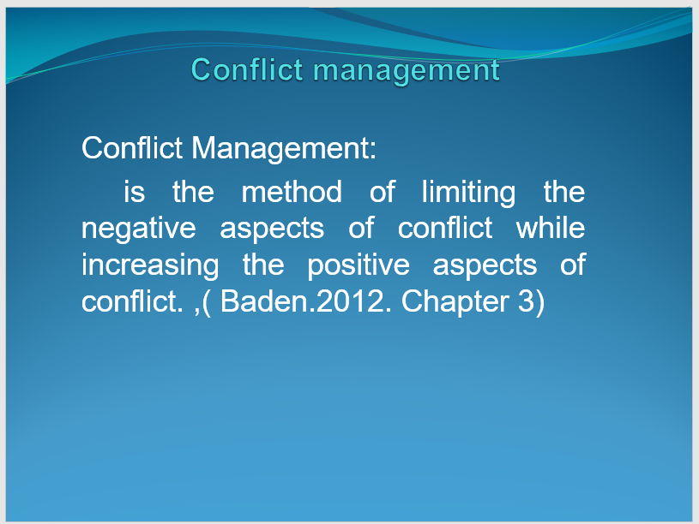

Speech note:
The aim of conflict management is to reinforce learning and group outcomes, including effectiveness or performance in an organizational setting.

Why conflict happen?
- Conflict stems from poor communication: this may cause the team to feel slighted, which may transform into animosity among the team. Failing to speak within the team may cause team members to form incorrect assumptions.
- Beware of personality clashes: a personality clash occurs when two or more people find themselves in conflict not over a specific issue or incident, but because of a fundamental incompatibility in their personalities.
- Different work styles and values: meet them where they are because as a team leader your job is to adapt your style to induce the foremost out of the people around the team.
- Unhealthy workplace competition: Assess the situation; Do not lose focus; Talk to the team; Form Alliance; Be competitive of yourself; Talk with the team; Try to work things out with the team; Be integrity

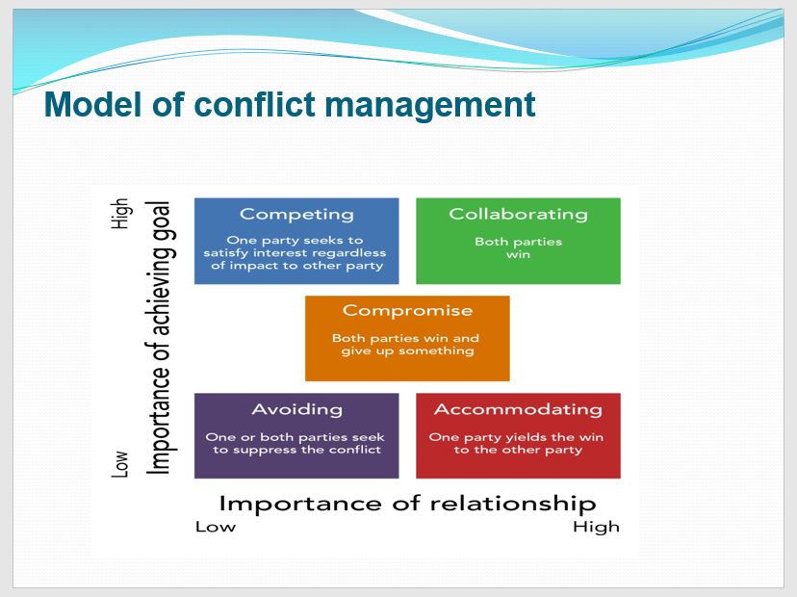

Speech note:
According to Thomas and Kilmann model of conflict management instrument {TkI}, utilized by human resource (HR) professionals round the world are:
Competing: to strive to outdo or excel. Having a way of rivalry and of striving to try and do ones best.
Collaborating: means to work with person or group so as to attain or do something.
Compromising: is when two sides hand over some demand to satisfy somewhere within the middle.
Avoiding: to come back through a potentially harmful or unpleasant experience.
Accommodating: people who are easy to induce together with and willing to assist you.

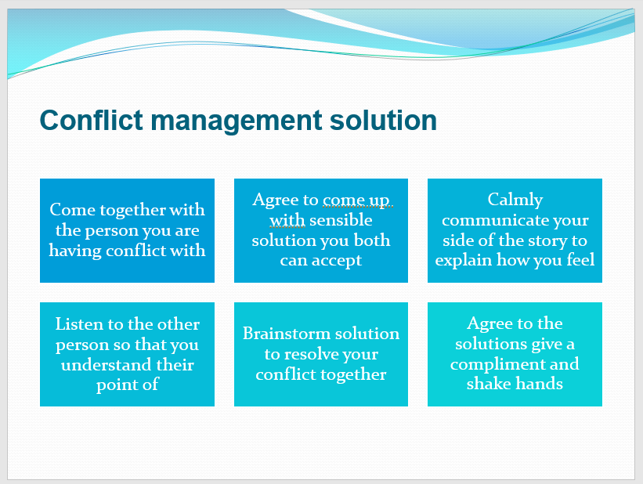

Speech note:

After more and more researching online and reading some books, it can be said that, the best way to manage conflict is to:
- Come together with the person you are having conflict with
- Agree to come up with sensible solution you both can accept
- Calmly communicate your side of the story to explain how you feel
- Listen to the other person so that you understand their point of view
- Brainstorm solution to resolve your conflict together
- Agree to the solutions and give a compliment

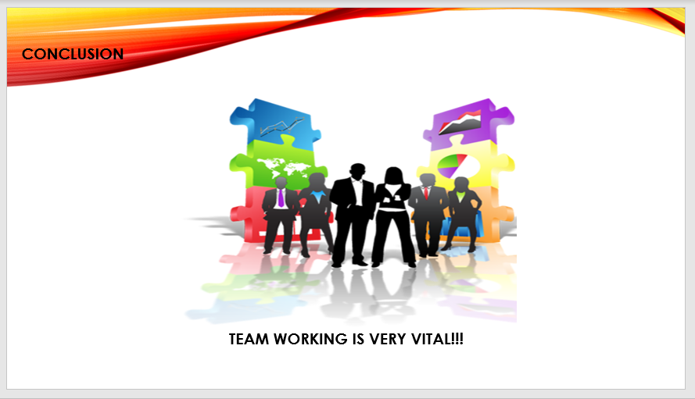

Speech note:
The presentation contributed to finding the significance of team, and the roles and responsibilities of the team in making a task successful and effective. The five stages of team building help an organization in making a successful and effective team that contributes to goal achievement. Also, the Belbin theory provided information regarding the different roles and responsibilities of the team member in creating, implementation and completing an operation successfully which is essential for analysing the significance of team in business success.
Successful and effective team have the potential to grow, develop and expand the business at an international level along with providing high status to the firm in the commercial world. The factors that play a crucial role in developing a successful and effective team are focus on the role, respect of each role, communication with each other, selection of objectives, celebration of failures and success, and maintaining understanding with each other.
The overall understanding and conclusion reflect the requirement and significance of an effective team building in the business sector. The Belbin theory provided information regarding different roles embedded in the team that makes an effective team along with an effective strategy to develop a successful team.

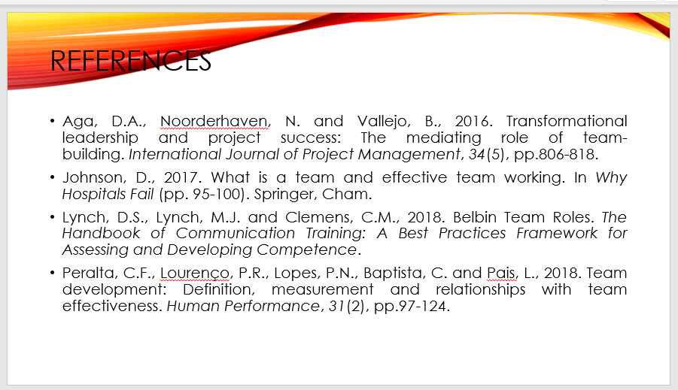

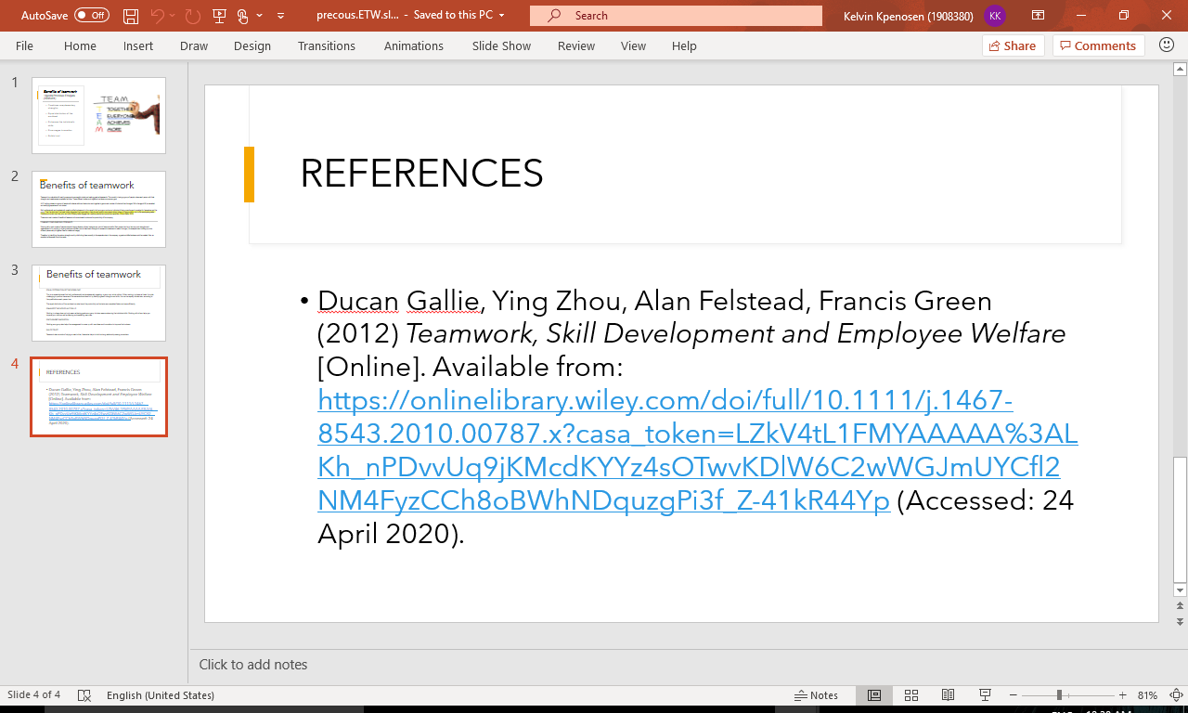

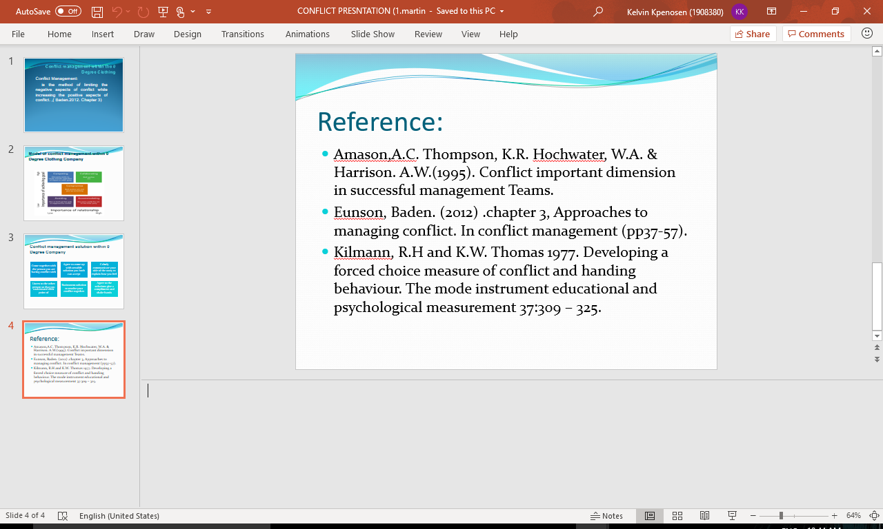

REFERENCES
Aga, D.A., Noorderhaven, N. and Vallejo, B., (2016). Transformational leadership and project success: The mediating role of team building. International Journal of Project Management, 34(5), pp.806-818.
Amason,A.C. Thompson, K.R. Hochwater, W.A. & Harrison. A.W.(1995). Conflict important dimension in successful management Teams.
Ducan Gallie, Ying Zhou, Alan Felstead, Francis Green (2012) Teamwork, Skill Development and Employee Welfare [Online]. Available from: https://onlinelibrary.wiley.com/doi/full/10.1111/j.1467-8543.2010.00787.x?casa_token=LZkV4tL1FMYAAAAA%3ALKh_nPDvvUq9jKMcdKYYz4sOTwvKDlW6C2wWGJmUYCfl2NM4FyzCCh8oBWhNDquzgPi3f_Z-41kR44Yp (Accessed: 24 April 2020).
Eunson, Baden. (2012) .chapter 3, Approaches to managing conflict. In conflict management (pp37-57).
Johnson, D., (2017). What is a team and effective team working. In Why Hospitals Fail (pp. 95-100). Springer, Cham.
Kilmann, R.H and K.W. Thomas (1977). Developing a forced choice measure of conflict and handing behaviour. The mode instrument educational and psychological measurement 37:309 – 325.
Lynch, D.S., Lynch, M.J. and Clemens, C.M., (2018). Belbin Team Roles. The Handbook of Communication Training: A Best Practices Framework for Assessing and Developing Competence.
Peralta, C.F., Lourenço, P.R., Lopes, P.N., Baptista, C. and Pais, L., (2018). Team development: Definition, measurement and relationships with team effectiveness. Human Performance, 31(2), pp.97-124.

