
BMIH6007
International Meetings Management for the Hotel Industry
Assignment 1: Feasibility Plan for an International Meeting
Event Theme: Winter
Event: Halloween
Name: Nargis Begum
ID: 2212000
Lecturer: Kathryn Flynn

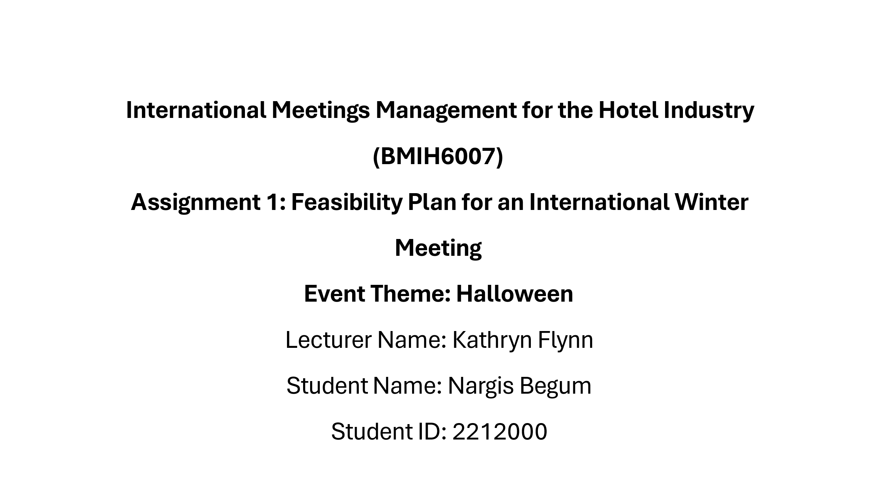
Slide 1
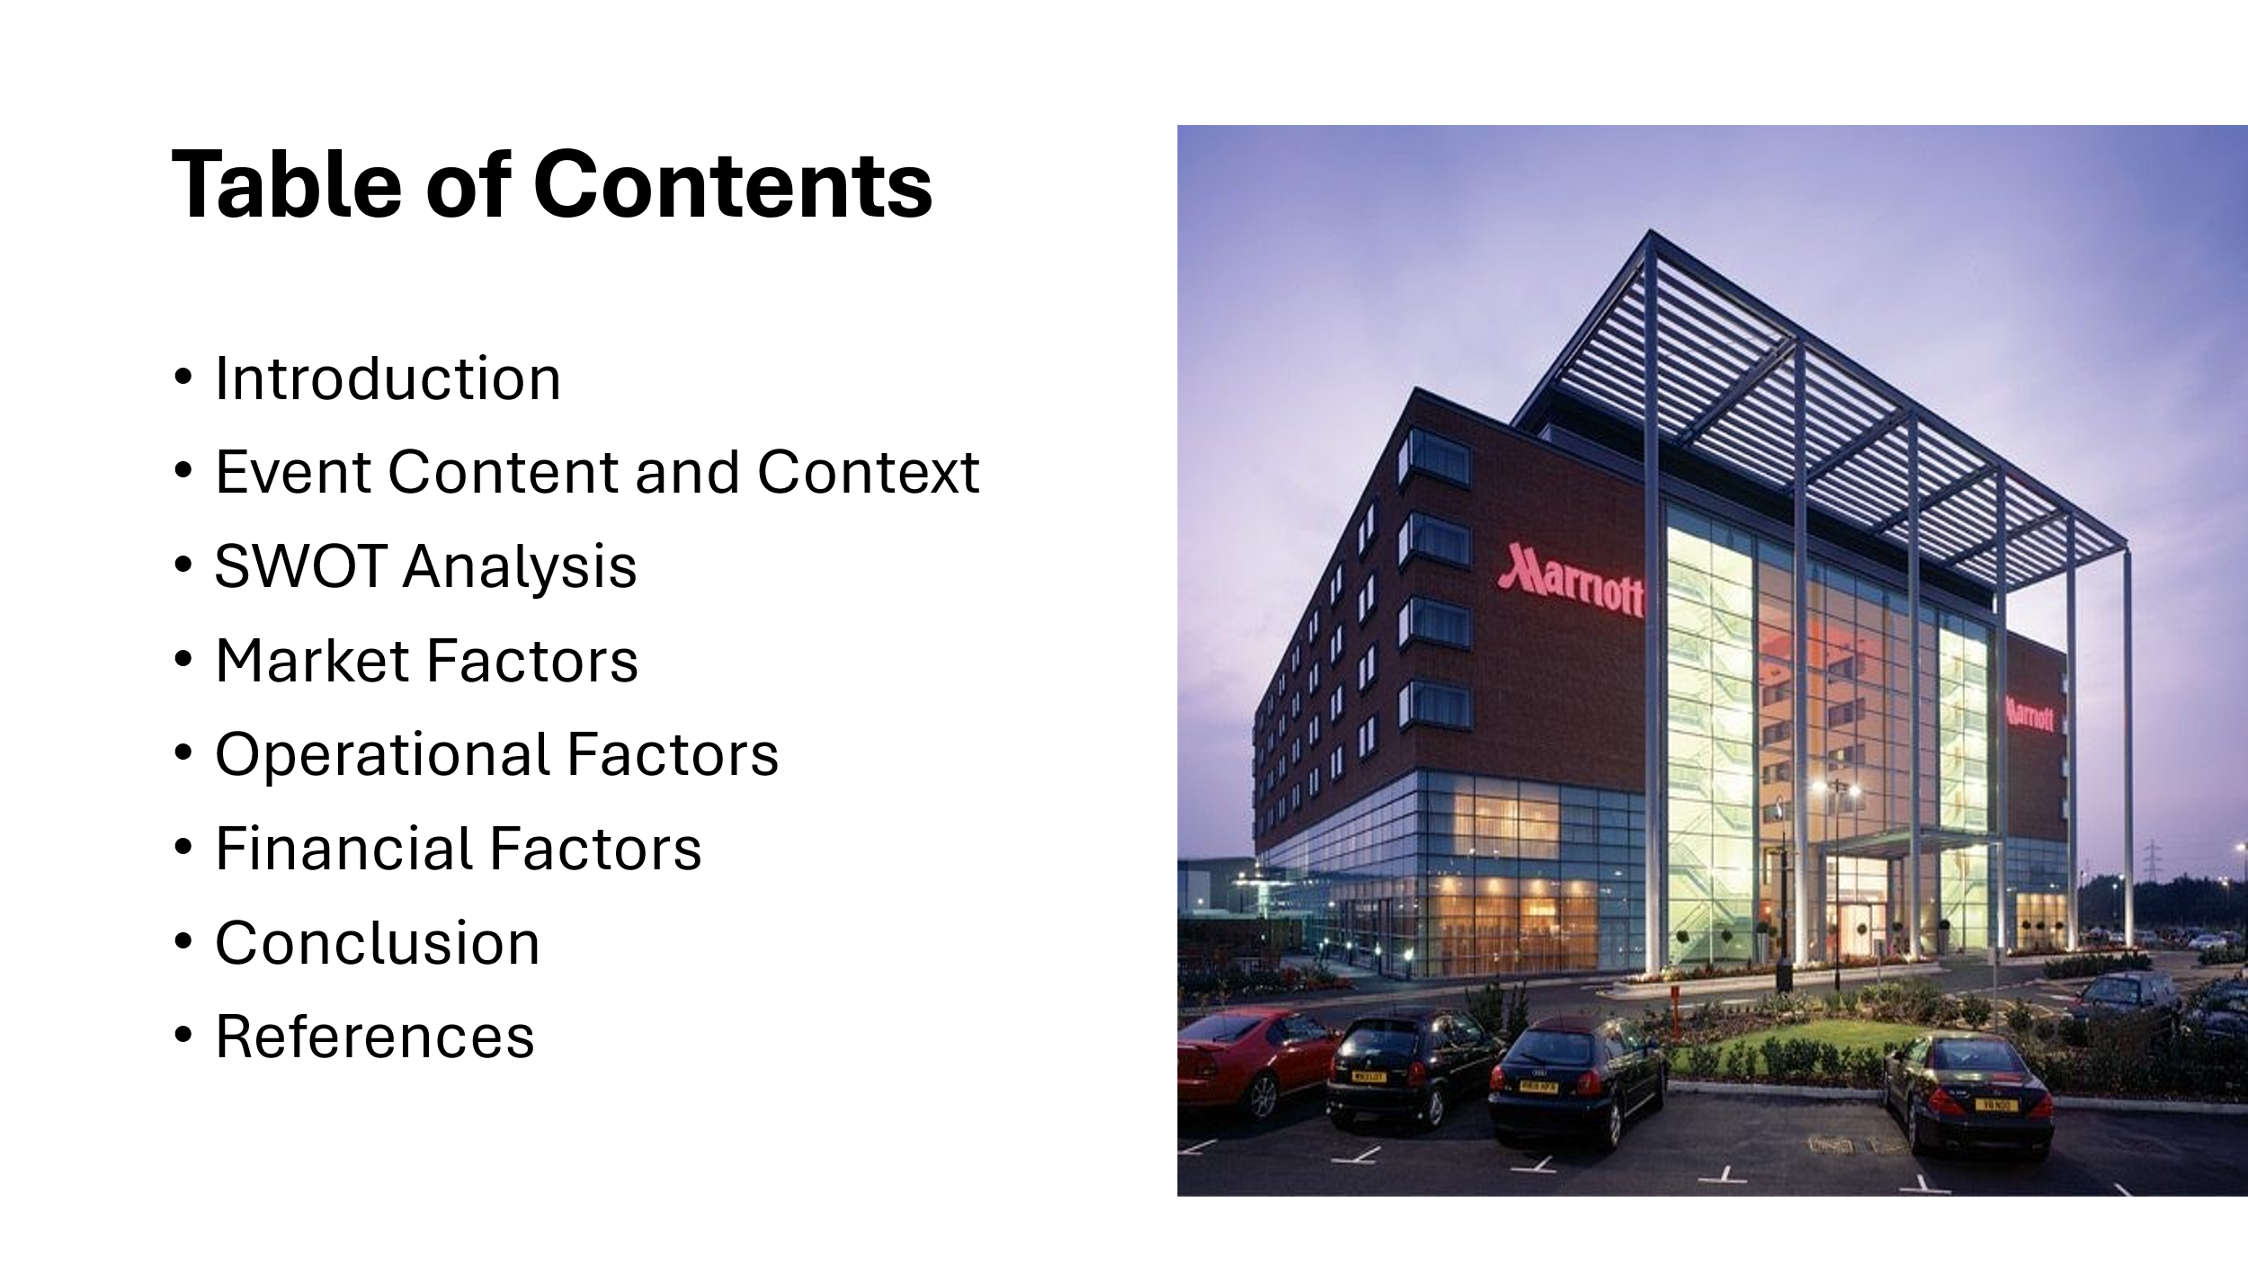
Slide 2
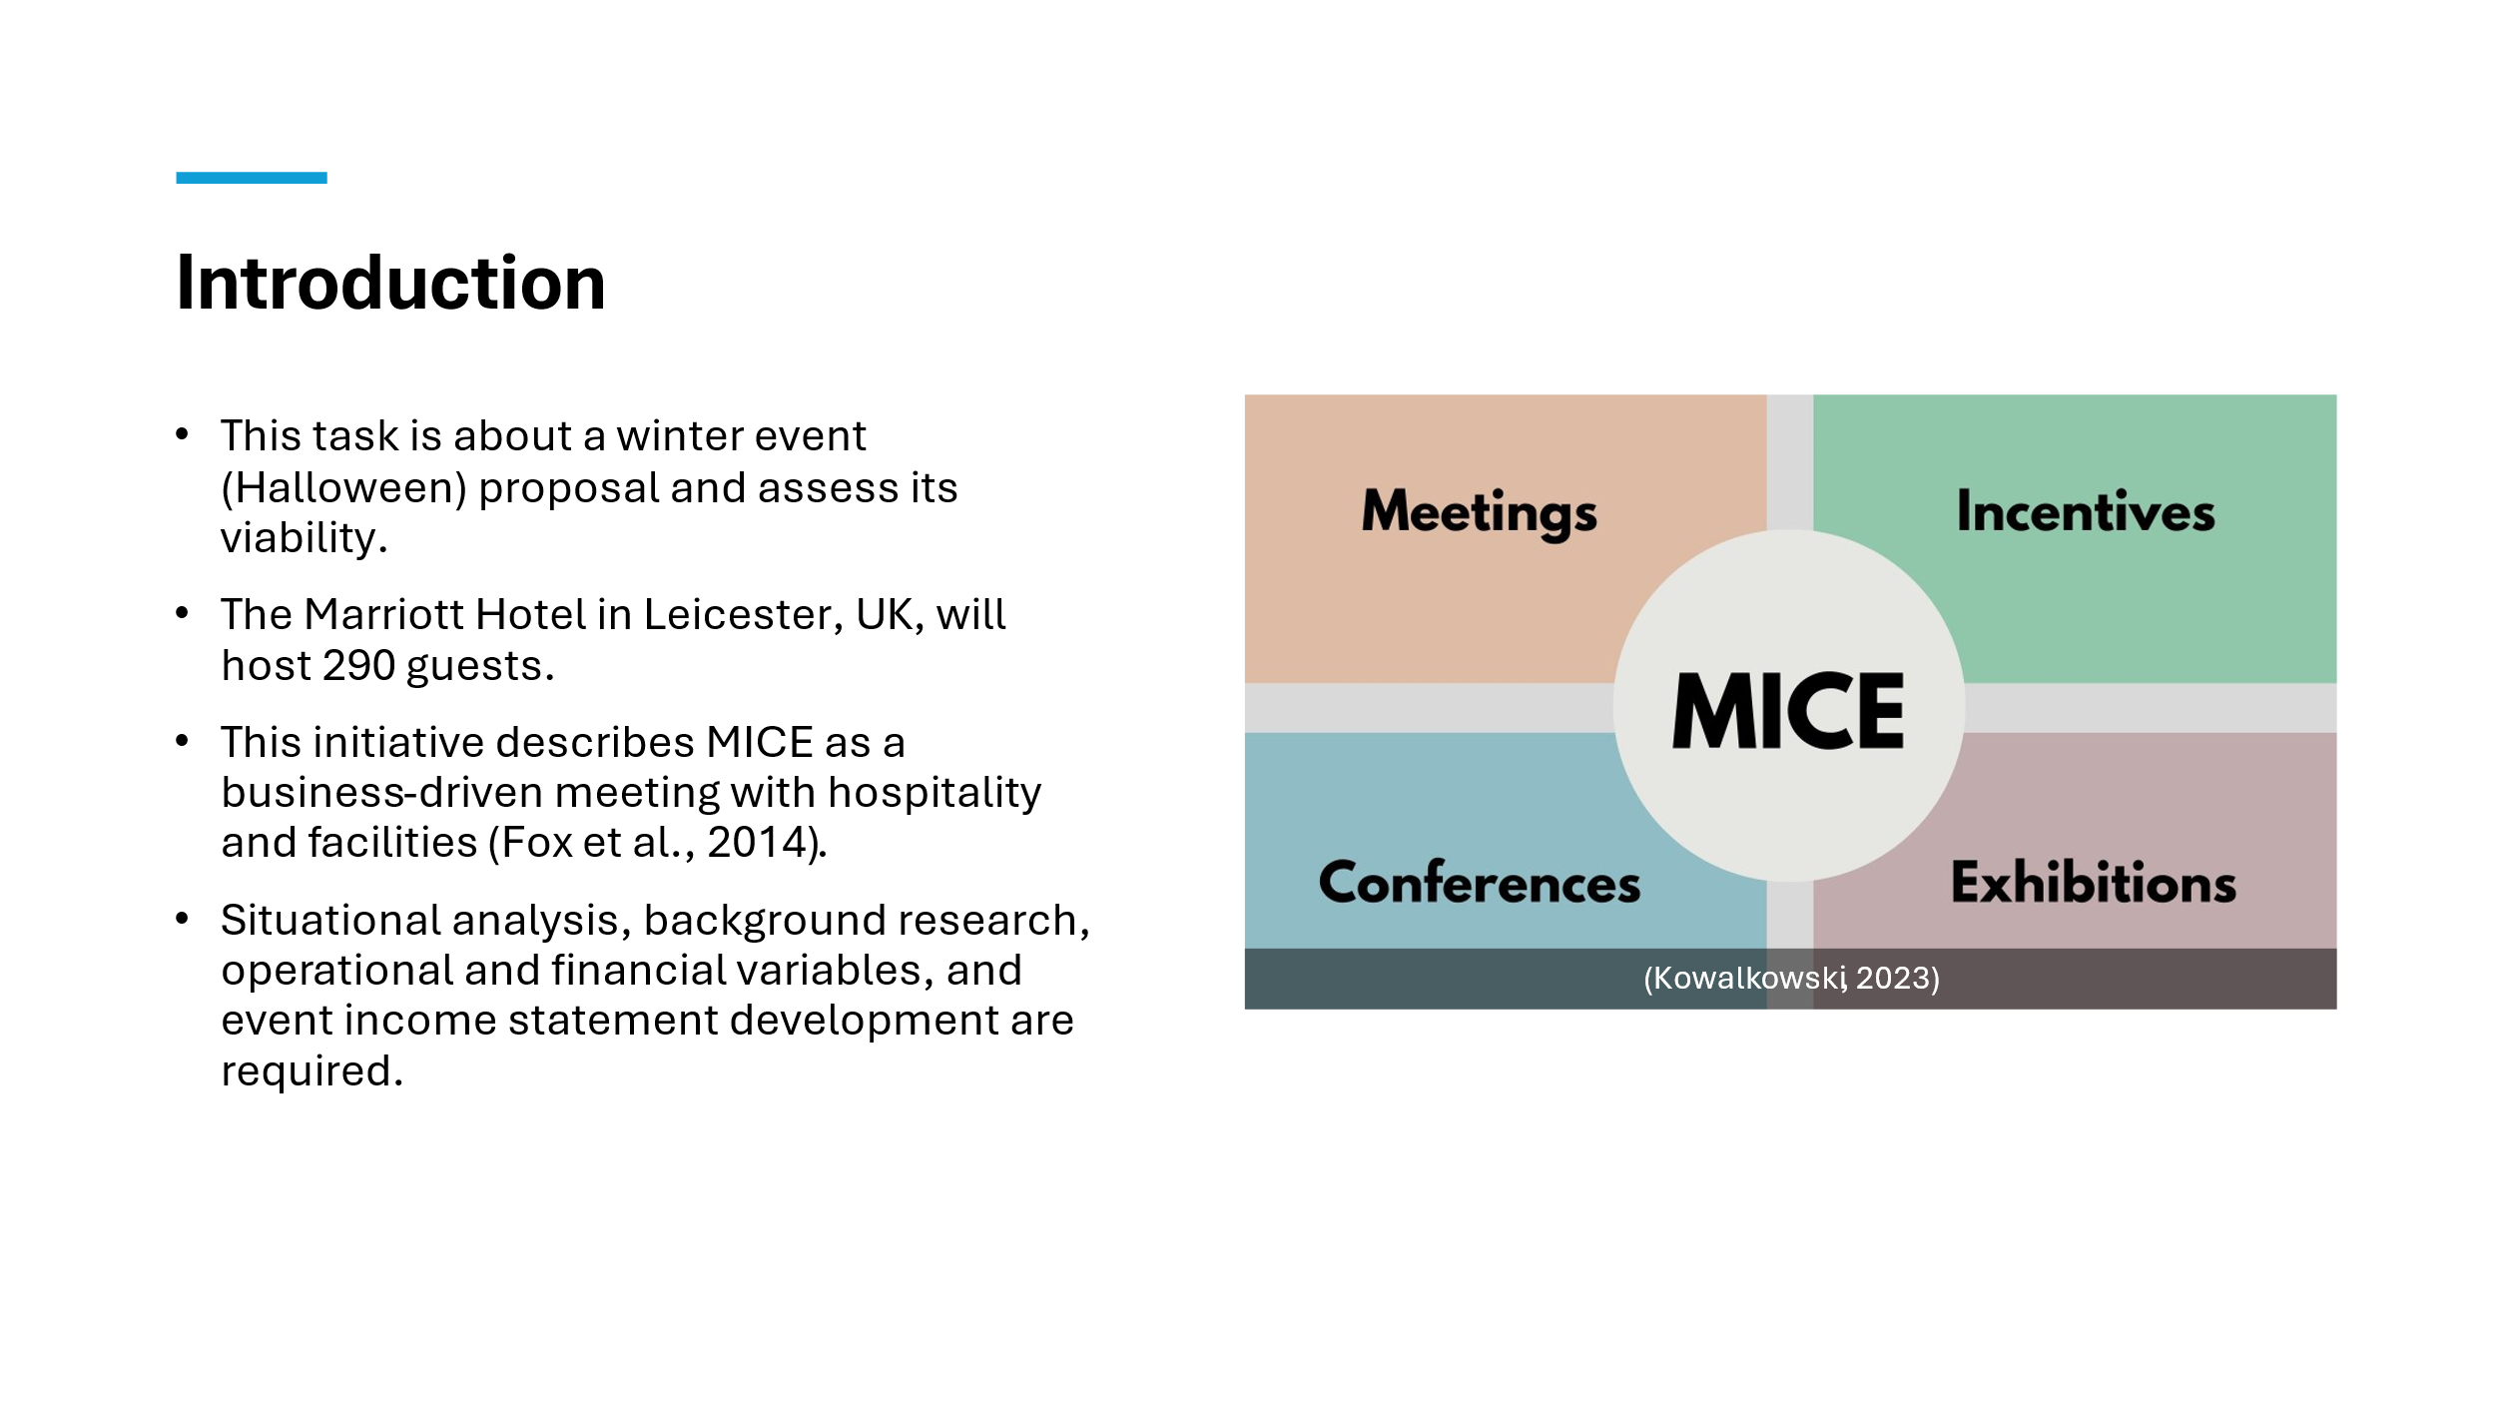
Slide 3
This winter Halloween celebration at the Marriott Hotel in Leicester, UK, is proposed. Halloween and winter make this 290-person gathering interesting. This proposal includes scene analysis, market, operational, and financial background to determine event viability. MICE events provide business hospitality and customised services (Getz and Page, 2019). This query concerns winter Halloween party needs.
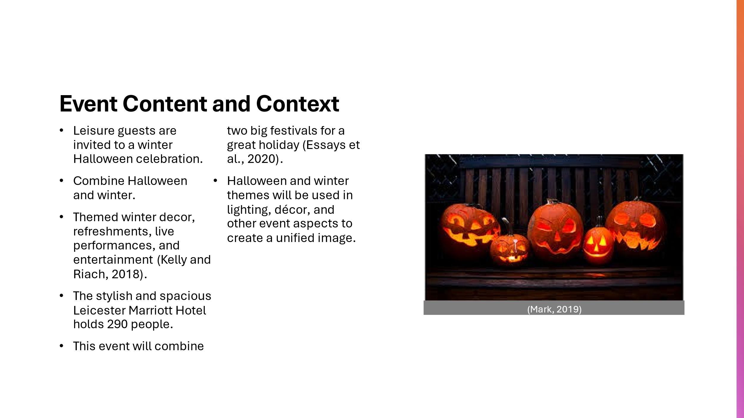
Slide 4-- The unique holiday combines Halloween and winter. Halloween is scary and exciting, while winter is cosy, family, and happy. The event combines these aspects to produce an immersive, broad-appeal experience. Halloween and winter decorations stir nostalgia (Cooper, 2024). This unusual combination distinguishes the event in the competitive seasonal event market. It will offer guest-friendly activities. This event will have themed decor, cuisine, and live entertainment. The Leicester Marriott Hotel provides enough space and amenities for this event. Halloween and winter treats, drinks, and food will be served. Expect Halloween and winter music, dance, and entertainment (Marsh, 2022). Enjoy a live band playing seasonal music, a themed photo booth, and interactive games. Event design and staging encourage socialising. All event elements should match the winter theme and include Halloween for a great experience.
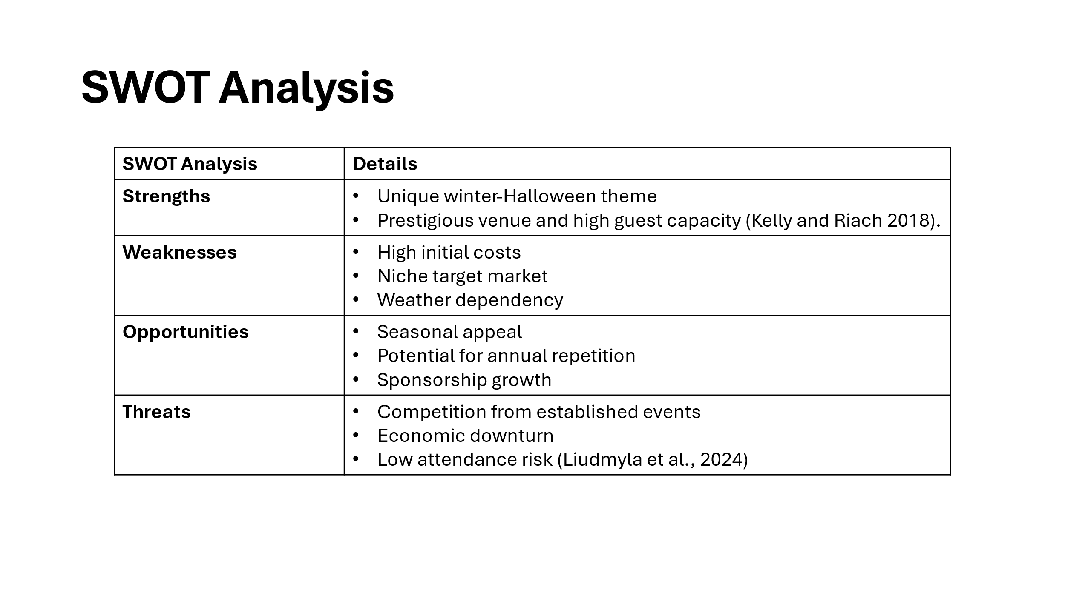
Slide 5 The Marriot Hotel in Leicester will host a winter Halloween party. The festival draws a diverse demographic, notably families seeking new experiences, with winter and Halloween themes (Liudmyla et al., 2024). The Marriott Hotel’s beautiful surroundings and adequate amenities can accommodate 290 persons for huge events. Despite significate starts-up costs, ticket sales and sponsorships should bring in £9,300. The leisure event stands out since the target market needs fresh seasonal activities and low competition planning, and stakeholder participation, the event might become an annual fixture, taking advantage of seasonal appeal and sponsorship opportunities.
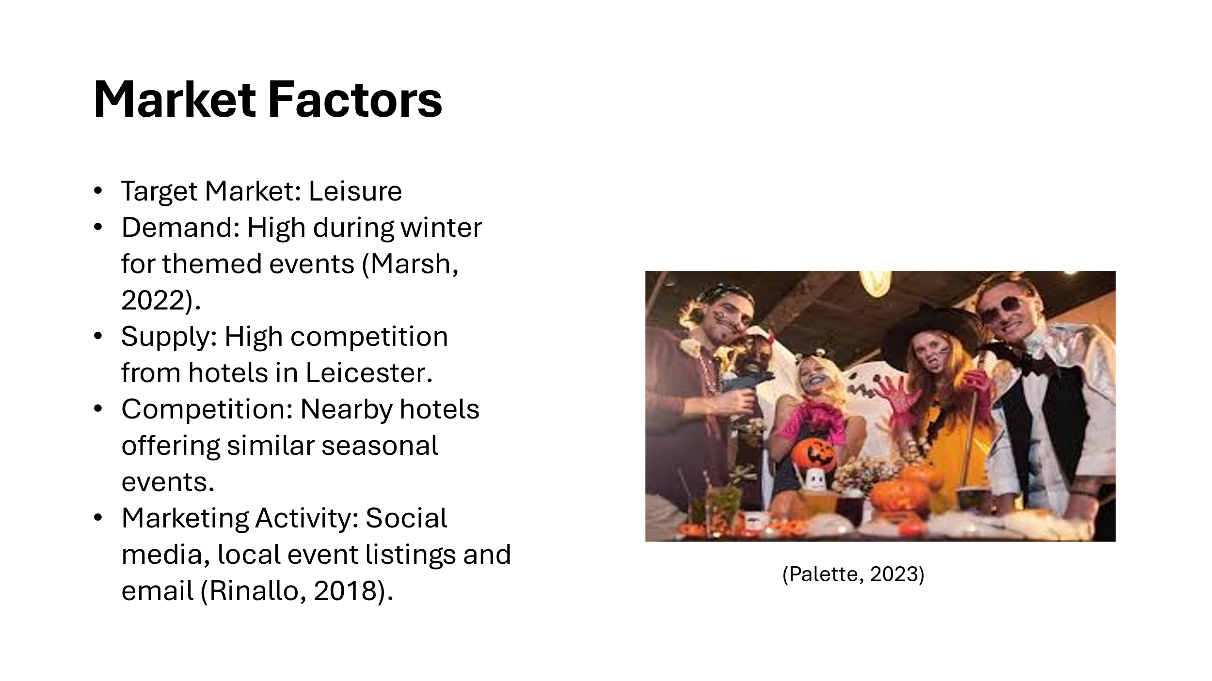
Knowing market elements that affect event success is crucial. Families and friends seek seasonal pleasure at this event. Research shows that winter events, especially seasonal ones, are popular (Lakshmi, 2017). Winter and holiday parties and unconventional activities are rising. Assess demand and competition. Leicester hotels may host winter events, especially around Halloween. Integrated theme distinguishes suggested event. It needs effective marketing to stand out and attract customers (Nufer, 2019). Social media, local business partnerships, and event directories boost publicity. Promotion of the event's uniqueness and unique experience will increase attendance and market visibility.
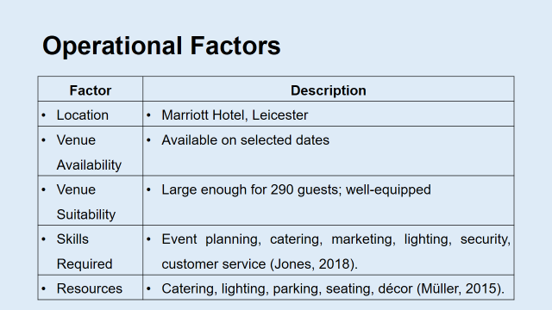
Marriott Hotel operations will also impact event viability. Leicester is convenient for locals. Service, modern facilities, and 290 guests made the Marriott Hotel a fantastic choice (Day, 2017). The hotel's structure supports events in winter. Beyond capacity, venue suitability includes event facilities. Hotel services include cuisine, events, audio-visual, and décor. Logistics can be coordinated with hotel management. Event success involves stakeholder involvement. Hotel management, caterers, decorators, performers, and event planners are stakeholders (Chalupa, 2020). These stakeholders will collaborate to ensure a clear vision and successful planning. Each partner will provide event planning, catering, marketing, lighting, security, and customer service.
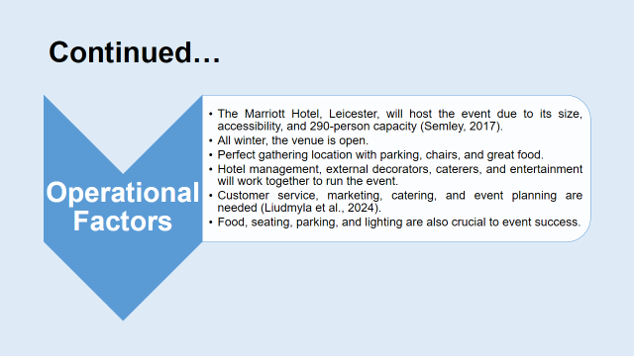
Staffing is an aspect related with the event. Event management requires multidisciplinary teams. Invite event coordinators, caterers, security, and AV technicians. Effective staff management improves visitor experience and ensures enough support. Decorations, catering, lighting, parking, and seats are included (Hudson, 2017). The culinary staff will create a winter and Halloween buffet with seasonal cuisine and drinks. Warm, themed lights set the mood. Parking must be handled to meet expected guests and venue access.
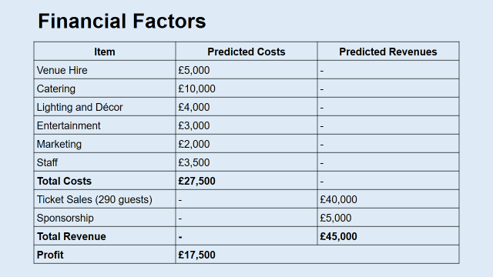
Examine event finances for profitability and sustainability. Venue, food, lighting, décor, entertainment, promotion, and staff cost around £27,500. The event's financial sustainability requires breaking down these costs. A detailed income statement forecasts ticket and sponsorship sales to generate revenue. Costs and profit will be covered by tickets (Mcmurtry and Hiam, 2017). Tickets will be the main revenue source with 290 expected attendees. Sponsorships and ticket sales boost event funds. Winter and Halloween-themed local businesses, suppliers, and brands may sponsor events to cover costs. Effective marketing boosts ticket sales and sponsor interest. Attendance will rise via social media, innovative content, and influencer or local leader partnerships. Local company collaborations provide cross-promotion and marketing (Mark, 2019). Finance and marketing must be planned to avoid financial loss. Event success depends on cost reduction and revenue maximisation.
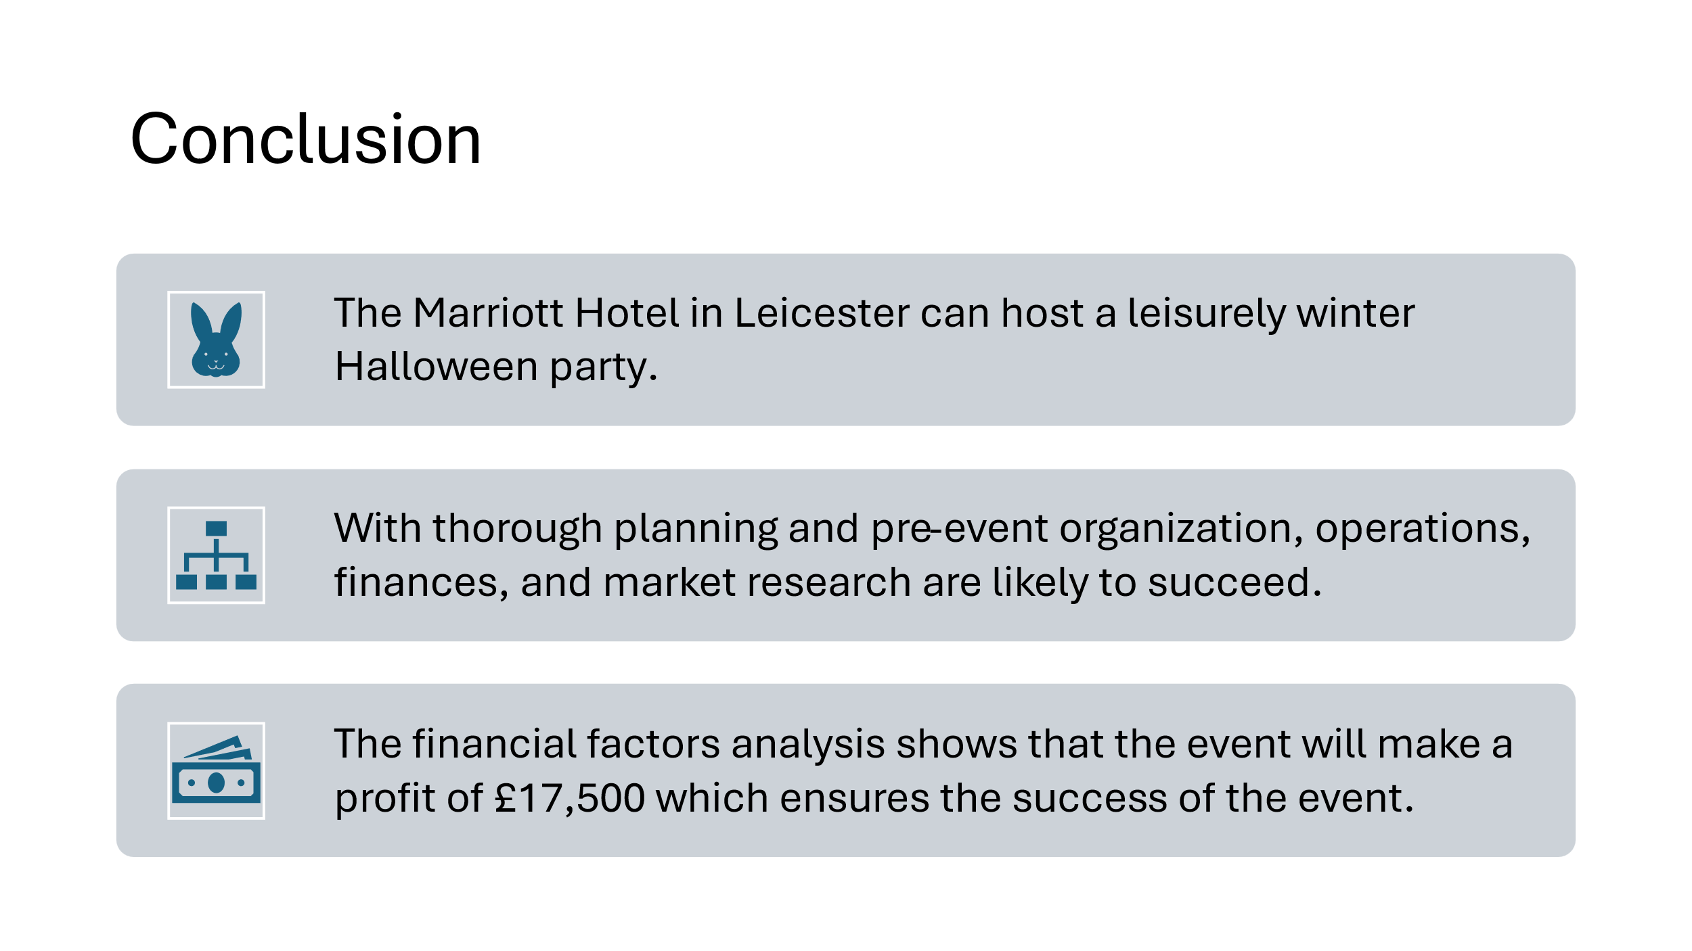
Leicester Marriott Hotel's winter-themed Halloween event offers a unique chance to wow leisure guests. Smart location, seasonal themes, and careful preparation make events successful. A thorough market, operational, and financial research shows the event's inventiveness and feasibility. The event uses efficient marketing and stakeholder collaboration to give participants an unforgettable experience and stand out in the competitive seasonal celebration landscape.
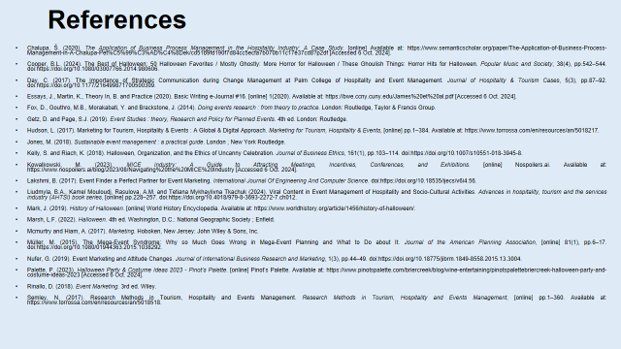
- Chalupa, Š. (2020). The Application of Business Process Management in the Hospitality Industry: A Case Study. [online] Available at: https://www.semanticscholar.org/paper/The-Application-of-Business-Process-Management-in-A-Chalupa-Pet%C5%99%C3%AD%C4%8Dek/cd51b9fd190f7d84cc5ecfa7b070b11c17e37cd8?p2df [Accessed 5 Oct. 2024].
- Cooper, B.L. (2024). The Best of Halloween: 50 Halloween Favorites / Mostly Ghostly: More Horror for Halloween / These Ghoulish Things: Horror Hits for Halloween. Popular Music and Society, 38(4), pp.542–544. doi:https://doi.org/10.1080/03007766.2014.980606.
- Day, C. (2017). The Importance of Strategic Communication during Change Management at Palm College of Hospitality and Event Management. Journal of Hospitality & Tourism Cases, 5(3), pp.87–92. doi:https://doi.org/10.1177/216499871700500309.
- Essays, J., Martin, K., Theory In, B. and Practice (2020). Basic Writing e-Journal #16. [online] 1(2020). Available at: https://bwe.ccny.cuny.edu/James%20et%20al.pdf [Accessed 6 Oct. 2024].
- Fox, D., Gouthro, M.B., Morakabati, Y. and Brackstone, J. (2014). Doing events research : from theory to practice. London: Routledge, Taylor & Francis Group.
- Getz, D. and Page, S.J. (2019). Event Studies : theory, Research and Policy for Planned Events. 4th ed. London: Routledge.
- Hudson, L. (2017). Marketing for Tourism, Hospitality & Events : A Global & Digital Approach. Marketing for Tourism, Hospitality & Events, [online] pp.1–384. Available at: https://www.torrossa.com/en/resources/an/5018217.
- Jones, M. (2018). Sustainable event management : a practical guide. London ; New York Routledge.
- Kelly, S. and Riach, K. (2018). Halloween, Organization, and the Ethics of Uncanny Celebration. Journal of Business Ethics, 161(1), pp.103–114. doi:https://doi.org/10.1007/s10551-018-3945-8.
- Kowalkowski, M. (2023). MICE Industry: A Guide to Attracting Meetings, Incentives, Conferences, and Exhibitions. [online] Nospoilers.ai. Available at: https://www.nospoilers.ai/blog/2023/08/Navigating%20the%20MICE%20Industry [Accessed 5Oct. 2024].
- Lakshmi, B. (2017). Event Finder a Perfect Partner for Event Marketing. International Journal Of Engineering And Computer Science. doi:https://doi.org/10.18535/ijecs/v6i4.56.
- Liudmyla, B.A., Kamel Mouloudj, Rasulova, A.M. and Tеtiana Mykhaylivna Tkachuk (2024). Viral Content in Event Management of Hospitality and Socio-Cultural Activities. Advances in hospitality, tourism and the services industry (AHTSI) book series, [online] pp.228–257. doi:https://doi.org/10.4018/979-8-3693-2272-7.ch012.
- Mark, J. (2019). History of Halloween. [online] World History Encyclopedia. Available at: https://www.worldhistory.org/article/1456/history-of-halloween/.
- Marsh, L.F. (2022). Halloween. 4th ed. Washington, D.C.: National Geographic Society ; Enfield.
- Mcmurtry and Hiam, A. (2017). Marketing. Hoboken, New Jersey: John Wiley & Sons, Inc.
- Müller, M. (2015). The Mega-Event Syndrome: Why so Much Goes Wrong in Mega-Event Planning and What to Do about It. Journal of the American Planning Association, [online] 81(1), pp.6–17. doi:https://doi.org/10.1080/01944363.2015.1038292.
- Nufer, G. (2019). Event Marketing and Attitude Changes. Journal of International Business Research and Marketing, 1(3), pp.44–49. doi:https://doi.org/10.18775/jibrm.1849-8558.2015.13.3004.
- Palette, P. (2023). Halloween Party & Costume Ideas 2023 - Pinot’s Palette. [online] Pinot’s Palette. Available at: https://www.pinotspalette.com/briercreek/blog/wine-entertaining/pinotspalettebriercreek-halloween-party-and-costume-ideas-2023 [Accessed 6 Oct. 2024].
- Rinallo, D. (2018). Event Marketing. 3rd ed. Wiley.
- Semley, N. (2017). Research Methods in Tourism, Hospitality and Events Management. Research Methods in Tourism, Hospitality and Events Management, [online] pp.1–360. Available at: https://www.torrossa.com/en/resources/an/5018518.

