

Topic - The use of social media platforms in customer relationship management: A case study an analysis of Coca-Cola

Student Name: Smit Thomas Macwan
Student ID: 2245268

Declaration
I, hereby declare that the work presented in this study “The use of social media platforms in customer relationship management: A case study an analysis of Coca-Cola”, is my original research work. All the sources cited in this research study have been appropriately taken from authentic sources and acknowledged. I confirm that this research has not been submitted at any other institution. The content of this study is the result of my dedication, hard work and adherence to the academic standards. I also affirm that the assistance I got during this course has been fully disclosed and acknowledged. This declaration is made in the full understanding of my responsibility for the integrity and accuracy of the study.

Acknowledgement
I would like to extend my heartfelt thanks to all the committed individuals who assisted in the making of this study, “The use of social media platforms in customer relationship management: A case study an analysis of Coca-Cola” First of all, I give much thanks to my mentors who supported, guided, or provided resources. They accompanied me patiently and advised me in the most difficult moments in my journey. As well, I am offering my words of thank you to the participants who so kindly contributed their insight and experience. I would like to extend my appreciation to the participants involved in this research, without whom contributing would not have been possible.

Abstract
Introduction and Purpose: This dissertation examines “The use of social media platforms in customer relationship management: A case study an analysis of Coca-Cola”. This is followed by an evaluation of the research context, with reference to the manner employed by Coca-Cola in utilising social sites such as Facebook, Instagram, and twitter in engaging and improving customer experience. The main areas of this research reveal the absence of awareness of the ethical and some aspects of strategic application of social media by major companies and necessitate further investigation of the case of Coca-Cola.
Method: The research used positivism philosophy, employing a deductive method for the collection of quantitative data from 50 participants in relation to their use of social media with the brand ‘Coca-Cola’. As for elaborating patterns and relationships, quantitative analysis is carried out with reference to Charts, Cross Tabulation & Test of Independence, Regression Analysis, etc. with the help of Statistical Packages such as SPSS.
Result: This reveals high frequency of use with an emphasis on daily use especially on Facebook and Instagram where visual content is considered more important. According to the respondents, overall satisfaction with the product was high, although 18% of them noted that they were dissatisfied and indicated areas of further potential development. The research further shows that social media campaigning and updates are very important in the overall marketing mix, and the role that Coca-Cola plays in the social media has an impact on the customers’ perception as well as their loyalty to the brand.
Conclusion: This dissertation argues that Coca-Cola has embraced social media in the management of customer relationship but delivers that there are concerns of dissatisfaction amongst the customers, hence the organisation should strive to improve their engagement levels. Leakage management recommendations are the incorporation of Augmented Reality and live question/answer sessions for enhanced communication and clarity. In sum, the findings indicate possible ways in which social media can be effectively utilised to build strong consumer relations and offer potential recommendations to facilitate improved relationships between marketers and customers.
Table of Contents
Acknowledgement 2
Declaration 3
Abstract 4
Chapter 1: Introduction 10
1.1 Chapter Introduction 10
1.2 Background 10
1.3 Research problem 12
1.4 Rationale 13
1.5 Aims & objectives 13
1.6 Research questions 14
1.7 Research scope 14
1.8 Chapter Summary 15
Chapter 2: Literature Review 16
2.1 Chapter Introduction 16
2.2 Literature review 16
2.2.1 Examining the different types of social media platforms used by Coca-Cola for managing its consumer relationship 16
2.2.2 Describing the social media marketing strategies used by Coca-Cola 18
2.2.3 Exploring the Landscape: Challenges and Opportunities in Social Media 21
2.2.4 Elevating Customer Relations: Enhancing CRM Strategies via Social Media 24
2.3 Empirical Review 25
2.4 Literature gap 26
2.5 Theoretical Framework 27
2.5 Conceptual Framework 29
2.6 Chapter Summary 30
Chapter 3: Research Methodology 31
3.1 Chapter Overview 31
3.2 Research Philosophy 32
3.3 Research Approach 32
3.4 Research Strategy 33
3.5 Type of investigation 34
3.6 Data Collection 35
3.7 Data Analysis 35
3.8 Ethical Considerations 36
3.9 Chapter Summary 37
4.0 Findings 38
4.1 Chapter Overview 38
4.2 Results 38
4.3 Chapter Summary 50
5.0 Discussion 51
5.1 Chapter Overview 51
5.2 Chapter Discussion 51
5.2.1 Analysing the many social media channels Coca-Cola uses to manage its customer relationships 51
5.2.2 Outlining Coca-Cola's social media marketing tactics 53
5.2.3 Surveying the Terrain: Social Media's Potential and Difficulties 55
5.2.4 Improving Customer Relations: Using Social Media to Strengthen CRM Techniques 57
5.3 Chapter Summary 60
6.0 Conclusion and Recommendations 61
6.1 Chapter Introduction 61
6.2 Summary of Findings 61
6.3 Recommendations 62
6.4 Linking with Objectives 62
6.5 Limitations of the Research 63
6.6 Chapter Summary 64
References 65
Chapter 1 65
Chapter 2 66
Chapter 3 71
Chapter 5: 74
Appendix 75
Appendix 1: Survey Questionnaire 75
Appendix 2: Survey Results 79

Table of Figures
Figure 1: The logo of Coca-Cola 9
Figure 2: YouTube marketing strategies of Coca-Cola 10
Figure 3: Theory of social influence 16
Figure 4: Social Identity Theory 18
Figure 5: The Use and Gratifications Theory 21
Figure 6: Stakeholder theory 24
Figure 7: Theoretical Framework 27
Figure 8: Conceptual Framework 28
Figure 9: Research onion 30

Chapter 1: Introduction

1.1 Chapter Introduction
This introduction chapter has a basic background to understand this study. This chapter will cover the study context within a couple of pages which include background, research problem, aims and objectives, research questions, research scope, and theoretical basis which will be concluded by the chapter summary. The research problem is also outlined as well as this chapter includes a theoretical framework that has been used and lastly it has the summary of the chapter.

1.2 Background
This research aims to point out the changes brought by social media platforms to the society with a special focus on Coca-Cola's widespread use of such digital channels in order to advance its Customer Relationship Management (CRM) campaigns. It can be done via a variety of promotion tools on platforms like Instagram, Facebook, and Twitter, Coca-Cola constantly seeks to master the ever-evolving digital landscape to establish conscientious and ethical interactions with its widening target markets (Patel, 2020). Inside the context of this relationship, the brand is able to understand the pivotal role social media is playing. Using social media, the brand can develop attachments, conversations and brand images that will support it over long periods.
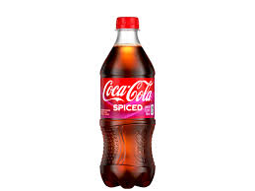
Figure 1: The logo of Coca-Cola
Source: (Coca-Cola, 2024)
The fast-evolving business environment, now digital renaissance marks, has witnessed social media channels taking the place of the critical tools that businesses use to connect their clients and chat with them. Coke, as the harbinger of corporate innovation and the master of its digital era, has cleverly embraced this trend in the digital age by not just using social media platforms as the mode of advertising but also making them talk communities for consumers where they can converse (Syahchari et al. 2023). Through this approach, the company attempts to create true connections with its wide and varied consumer base that goes beyond entertaining superficial engagement. Therefore, they bypass the promotion of mere superficial engagement tactics in favour of creating mutually rewarding relationships that emanate from a genuine bond.
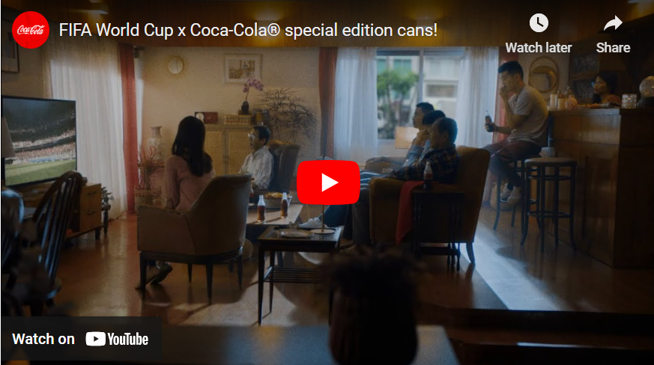
Figure 2: YouTube marketing strategies of Coca-Cola
Source: (Digital Scholar, 2022)
At the core of Coca-Cola's digital strategy is its dedication to incorporate ethics and responsible practice in all platforms with social media being included. As per the views of Khan, (2023), these digital platforms serve as conduits of power, the company connects with its customers in a way that is responsible as it realises that its online engagements may have both positive (i.e. brand exposure, boosted sales, social media influencers' new customers) and negative (i.e. generalising, stereotyping, traditional prejudices' artillery, low-quality sales). Coca-Cola plans to do this through speaking openly, authenticity, and honesty in their digital interactions. This not only increases their interactions with clients but it also helps to win their sympathy.
Within the dynamic and ever-evolving realm of social media, Coca-Cola confronts a multifaceted challenge like to tackle the problems of catering to the consumer idea of taste, technological evolutions and societal opinions while simultaneously maintaining its company mission and the corporate character (Khan, 2023). Hence, social media provides for the brand more than just a promotional channel. Rather, it becomes a dynamic hub where a brand's responsibility towards its consumers, innovation, and eco-stewardship finds common grounds.

1.3 Research problem
Coca-Cola management has to grasp the stunning use of social media platforms that promote CRM amongst its customers. Social media emergence has been a vital component in modern business practices. On the other hand, corporate organizations, including giant corporations such as Coca-Cola, still have many areas that remain underexplored with regard to using social media tools that can boost relationships with their customers.
The research not only tries to explore the ethical dimension of Coca-Cola's social media practices to see how the company balances brand awareness and promotional aspects with transparency, authenticity, and consumer trust. In this era where companies are tackling the issues of corporate responsibility and digital responsibility, the ethical issues of their digital involvement are now of utmost importance (Arora et al. 2021). Through this study, the researchers aim to explore the complexities and character of the social media strategies of Coca-Cola, to provide invaluable lessons for academicians and professionals both of the marketing field and communication disciplines, as well as, the realm of digital media. In conclusion, key findings as well as practical recommendations for the sustainable growth of Coca-Cola' social media practices in keeping with its wider business goals and corporate social responsibility are among the main points that the study seeks to contribute to and realise.

1.4 Rationale
This research is based on the facts of social media platforms which has become a highly crucial medium for businesses to connect with their customers and thus have better success. While the digital arena continues to undergo constant transformation, Coca-Cola understands the urgency of this situation and will adeptly control these platforms for the purpose of engendering loyal customers and boosting the company’s brand. On the one hand, it is almost universally acknowledged that social media has brought about a major revolution in the current state of marketing and consumerism (Sánchez Huguet, 2021). On the other hand, the field has very few studies that discuss how companies the size of Coca-Cola overcome the hurdles of social media marketing. To fill the existing gap in the knowledge bases of consumers, this research will plunge into the social media practices used by Coca-Cola. By revealing the key principles and practices which are simultaneously employed by the company in relationship management with customers, the study will become a breakthrough in the modern digital age, yet it is Coca-Cola's case study – not only with its theoretical but also the practical value for the companies trying to perfect their digital promotion (Khan, 2023).
The ethical thorns of Coca Cola’s use of social media marketing are another issue to ponder over given the rising information gap due to the lack of regulations on consumer privacy, data security and corporate social responsibility. This chapter distinguishes Coca-Cola's promotional goals and how the organisation aligns them with the ethical considerations as the research wants to add to the debates on using digital media responsibly in a corporate environment. Besides that, the investigation tries to give e.g. actual best practices based on empirical evidence and theoretical understandings so that Coca-Cola and other companies can make the best use of all the information found (Jacobson et al. 2020). Through the social media strategy alignment with overall corporate objectives and ethical performance, the companies can satisfy customer expectations and build their brand value a

1.5 Research scope
This research, however, has a wide scope, and it focuses on how Coca-Cola engages its consumers through social media platforms but through Customer Relationship Management functions. It narrows down on the examination of Coca-Cola Company’s strategic strategies, ethical concerns, and practical duties as well when it comes to mass media involvement. The research work would look at the different mixes of this strategy as content type, audience engagement methods, privacy issues, and addressing social media as an appropriate tool for customer relationship management. Though the first priority would be on the fundamental practices of Coca-Cola, the research may still have excerpts and literature references from other industries because these would be valuable in providing comparative insights. The geographical reach of the research will primarily cover Coca-Cola's outreach to the globe, though regional differences in social media strategies might as well be considered (Xue, 2023). Eventually, this research will assist in visualising the complete picture of the social media practices of Coca Cola as well as in studying these practices against the backdrop of modern-day digital marketing and CRM environments.

1.6 Aims & objectives
Aim: This research study aims to analyse the effective use of social media platforms in the CRM practices of Coca-Cola. A detailed analysis of the case study will explore the influences, challenges, opportunities and potential strategies to improve consumer engagement and satisfaction.
Objectives
- To investigate different social media marketing strategies utilised by Coca-Cola.
- To analyse the use of different social media platforms by Coca-Cola for customer relationship management (CRM).
- To examine challenges and opportunities regarding the use of social media platforms.

1.6 Research questions
- What is the current IMC social media marketing strategies utilised by Coca-Cola?
- How does the use of social media platforms influence the CRM of Coca-Cola?
- What challenges and opportunities does Coca-Cola face regarding the use of social media platforms?

1.7 Chapter Summary
This chapter offers a thorough description of the research-related circumstances. It presents the research background, issues, aims and objectives, research problems, research parameters, conceptual framework, and justification. This presents the reader with an introduction to the exposition where the fundamental themes and objectives of the study are highlighted.

Chapter 2: Literature Review

2.1 Chapter Introduction
This chapter investigates Coca-Cola’s social media strategies with existing literature. With various platforms, the company uses CRM or delivery of CRM practices. In context, it also deals with problems and prospects related to social media. Then, it discusses the underlying principles of successful customer relationships, which come down to substantial brand recognition and loyalty.
Social Media: Social media refers to interactive technologies that enable the production, sharing, and collection of material, ideas, interests, and other forms of expression within virtual communities and networks.
IMC: The process through which multiple communication methods are applied to attract consumers for the products is known as Integrated marketing Communication.
CRM: Customer relationship management is the systematic management of interactions and relationships between a business or organization and its customers. This is achieved through the utilization of data analysis to examine extensive volumes of information.

2.2 Literature review

2.2.1 Examining the different types of social media platforms used by Coca-Cola for managing its consumer relationship
Social media marketing encompasses the utilisation of different social media platforms to make connections with consumers and promote products and services. To enhance customer relationship management, Coca-Cola utilises different types of social media websites to maintain relationships with their consumers. According to the description of Chaulagain, and Maharjan, (2020), the efficiency of social media is much higher in terms of engaging with consumers than the traditional mode of communication. In customer relationship management, Coca-Cola did not limit itself to some of the popular social media platforms. It utilises Facebook, Twitter, Instagram, TikTok, YouTube, LinkedIn, Google and others. Similar views can be observed in the study of Wiese et al., (2020), Facebook can be regarded as an effective marketing tool to understand the attitudes of the consumers towards the brand. Coca-Cola took advantage of the huge use-base of Facebook, sharing information about their promotional activities, videos of their advertising campaign and others to the audience. The company shares some of the behind-the-scenes moments to build an emotional connection with the audience. Coca-Cola also makes use of Twitter for other purposes. On the other hand, Puventheran et al., (2021) described that Twitter can be regarded as a medium for understanding the engagement of the consumers. To manage the relationship with the consumers, Coca-Cola uses Twitter to answer the questions of their consumers raised by them. The company shares the news of any important events related to the organisation or any kind of introduction of new products to the users of Twitter. It can engage with the consumers about the trendy topic and continue their conversation with them.
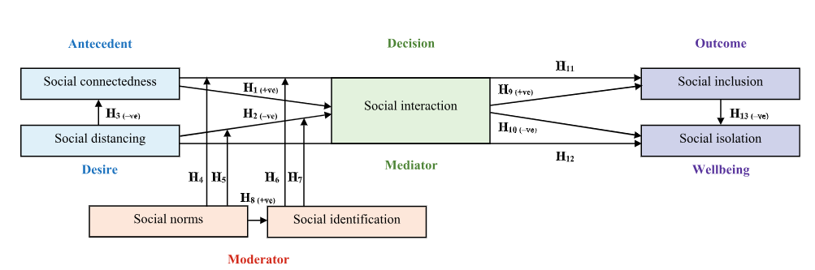
Figure 3: Theory of social influence
Source: (Lim, 2022)
The theory of social influence can be mentioned in this connection. Lim, (2022) described that social interaction can lead to a good relationship with the people and the society they belong to. This theory can help Coca-Cola to understand the attitudes and beliefs of people which can be influenced by their advertising methods or the celebrities they are hiring for promoting their products. However, there is a chance to fill the ideas with bias, it can surely help in understanding the nature of consumers. Customer relationship management is the systematic management of interactions and relationships between a business or organization and its customers. This is achieved through the utilization of data analysis to examine extensive volumes of information. In Customer relationship management, Coca-Cola uses YouTube to make video content and share it with consumers. The company takes advantage of YouTube to share the arrival of their products or some kind of tutorial videos. It also captures the interview of other people who share the experience they have with Coca-Cola. A study by Fanta, and Ayman, (2021) described that the company wisely uses all the social media platforms to make the consumers more connected with the brand.
Instagram is also employed by Coca-Cola to exhibit its range of products. A similar view can be found in Park, and Namkung, (2022), to build an appropriate amount of brand equity, Instagram can be regarded as an effective social media platform. Coca-Cola utilises the Instagram platform to innovatively showcase its different products. It uses the platforms for storytelling so that it can manage its relationship with its consumers effectively. The company hires influences to discuss the refreshments that the products by Coca-Cola provide to gain more consumers to purchase their products. On the other hand, Davis et al., (2020), explained that most people make use of LinkedIn to build connections with others. Coca-Cola can use LinkedIn to make connections with other industries to gain insight into the behaviour of consumers. They are also able to find the strategies of other companies in customer relationship management. The company understands how to use the trend to enhance their relationship with their consumers. As people are getting interested in the short videos, they took this opportunity to share some short videos on TikTok to try to start a trend with the consumers. It is an effective way to make the consumers engaged with the brand.

2.2.2 Describing the social media marketing strategies used by Coca-Cola
According to the study by Nuseir (2020), Using social media sites like Instagram, Twitter, and Facebook to market your business and sell goods or services is known as social media marketing. Social media marketing is when a company releases a new product and plans to use social media to promote the launch. As per the observation of Zollo et al., (2020), in the contemporary scenario, the brands are leveraging social media to build a meaningful conversation with their consumers. Coca-Cola is using the social media platform in different ways. Storytelling is one of the techniques that has been used by Coca-Cola to improve its relationship with its consumers. The company tells inspiring stories to consumers through their social; media websites or in its advertising campaigns. It is to make the consumers psychologically connected with the brand. Through the storytelling method, the brand unites its audience with emotional or inspiring content. On the other hand, Koivisto, and Mattila, (2020), user-generated content can help the company to gain much attention from social media platforms. Coca-Cola arranged some contests on social media platforms, where many users participated. The company can also use it to share the experiences of the consumers in consuming the products of Coca-Cola. The social identity theory sometimes oversimplifies things and creates problems in the judgement. The relationship with the brand is enhanced when the consumers feel that others have a positive experience with the brand.
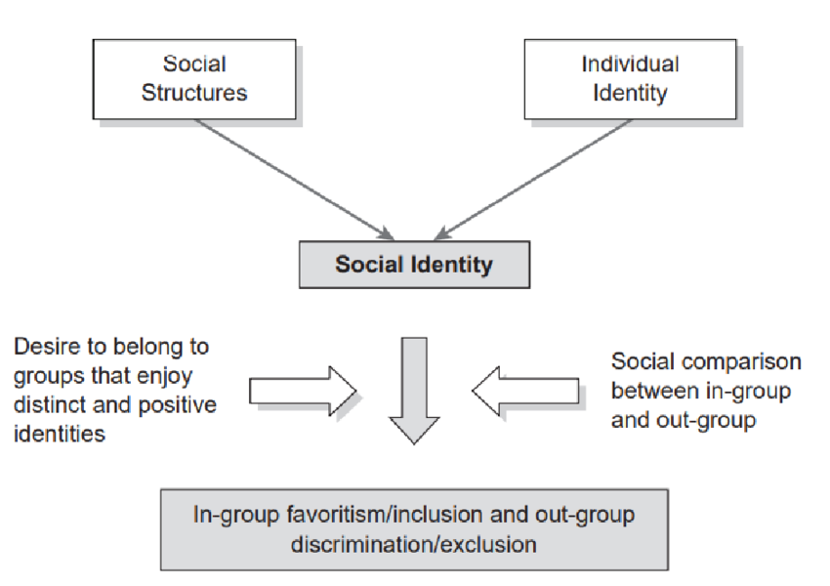
Figure 4: Social Identity Theory
Source: (Irene et al., 2023)
A study observed by Murray, Koulanova and Sabiston (2022), The part of a person's self-concept that stems from their perceived affiliation with a particular social group is known as their social identity. The social identity theory can be discussed in evaluating the effectiveness of the social media strategies adopted by Coca-Cola. A similar view by Demirden, (2021), social identity theory has largely been utilised in the field of social psychology for clearing different concepts related to identity in society. By understanding the different identities of the consumers, the company can be able to use to make them feel a sense of belonging. Coca-Cola can be able to use this theory to make the consumers loyal to the brand. Coca-Cola’s social media strategies correlate with Social Identity Theory as the latter promotes group focus and adherence to the brand through specific appealing campaigns that appeal to the like-mindedness of the targeted improved cooperation between members of a certain group.
On the other hand, a different view can be observed in studies like Dwivedi et al. (2021) social media has developed to a great extent as a device for companies to generate connections with customers and advertise their products. Coca-Cola is a visible example of the social networking effect as a marketing tool. The literature review aims to describe the social media marketing techniques applied by Coca-Cola, focusing on evaluating the online campaign effectiveness and outcomes. Coke's social media presence on multiple platforms, such as Facebook, Twitter, Instagram, and YouTube, drags along with what has monotonously. The company is involved in various platforms with consumers to develop loyalty and inspire them to purchase. Telling captivating stories about Coca-Cola is one of its remarkable strategies. As per the view by Adeola, Hinson and Evans (2019), The business, through its social media channels, tells its stories so that the audience will be influenced and feel a special connection with the consumers. Storytelling helps Coca-Cola manifest its brand identity and stand out from competitors in the soft drinks market. As identified by Adeola, Hinson, and Evans (2019), Coca-Cola’s approach to utilizing social media as a source of storytelling also supports CRM by building an array of bonds with consumers and making it possible for the company to establish itself in the intensely competitive soft drink market.
As per the observation by Nikolinakou and Phua (2019), Another critical component of Coca-Cola's social media plan is to spread the news among the users so that the Users generate the content (UGC). Coca-Cola regularly promotes user-generated content on social media. They increase their brand's reach by utilising their customers' passion, originality, and genuineness. Using this strategy, their customers voluntarily become brand ambassadors who tell their Coca-Cola tales. The company is building a consumer space to exchange the content it creates with Coca-Cola goods (Bağcan and Duygun, 2022). As a result, customers recognise that it creates a positive environment for community building. Besides the brand's synergies with social media influencers and celebrities in promoting products, it also partners with them in marketing. Through collaboration with celebrities, Coca-Cola can leverage and extend its reach and spread the brand name to the public.
Social identity theory emphasises the sense of belonging and focuses on how people's perceptions of their connection with social groupings affect how they see themselves. The theory of social influence, on the other hand, emphasises the significance of social interactions and conformity demands as it investigates how people's behaviours, attitudes, and beliefs are influenced by others.

2.2.3 Exploring the Landscape: Challenges and Opportunities in Social Media
This theme discusses the challenges and opportunities in social media. According to the study by Bimo (2022), In social media, all things are transformed and interact on an endless spectrum. Some changes and difficulties may emerge due to the emergence of this media. Social media has undeniably been a transformative experience, allowing for a great process of community communication and dissemination of information and being the driving force behind specific social changes. On the one hand, the digital age has produced many advantages. However, at the same time, it has created undeniable headaches like cyberbullying, mental health problems, fake news, and security and privacy.
This review delves into the specifics and the dynamics of this sphere, emphasising the main problems and resources of the media network domain. A view by Liu, Min and Han (2019), The uses and gratifications hypothesis were developed in the early 1940s and was first presented by Katz and Blumler (1974). It aims to explain why individuals use particular media, what requirements they have that need their usage and the satisfaction they derive from doing so. The Uses and Gratifications Theory theoretical insights into social media user behaviour. As per the view of Cao (2023), the uses and gratifications hypothesis were developed in the early 1940s and was first presented by Katz and Blumler (1974). It aims to explain why individuals use particular media, what requirements they have that need their usage and the satisfaction they derive from doing so. This idea holds that people actively search for media to meet demands like knowledge, amusement, or social contact. Organisations may better engage users and satisfy their expectations by tailoring their social media strategy with an understanding of these demands.
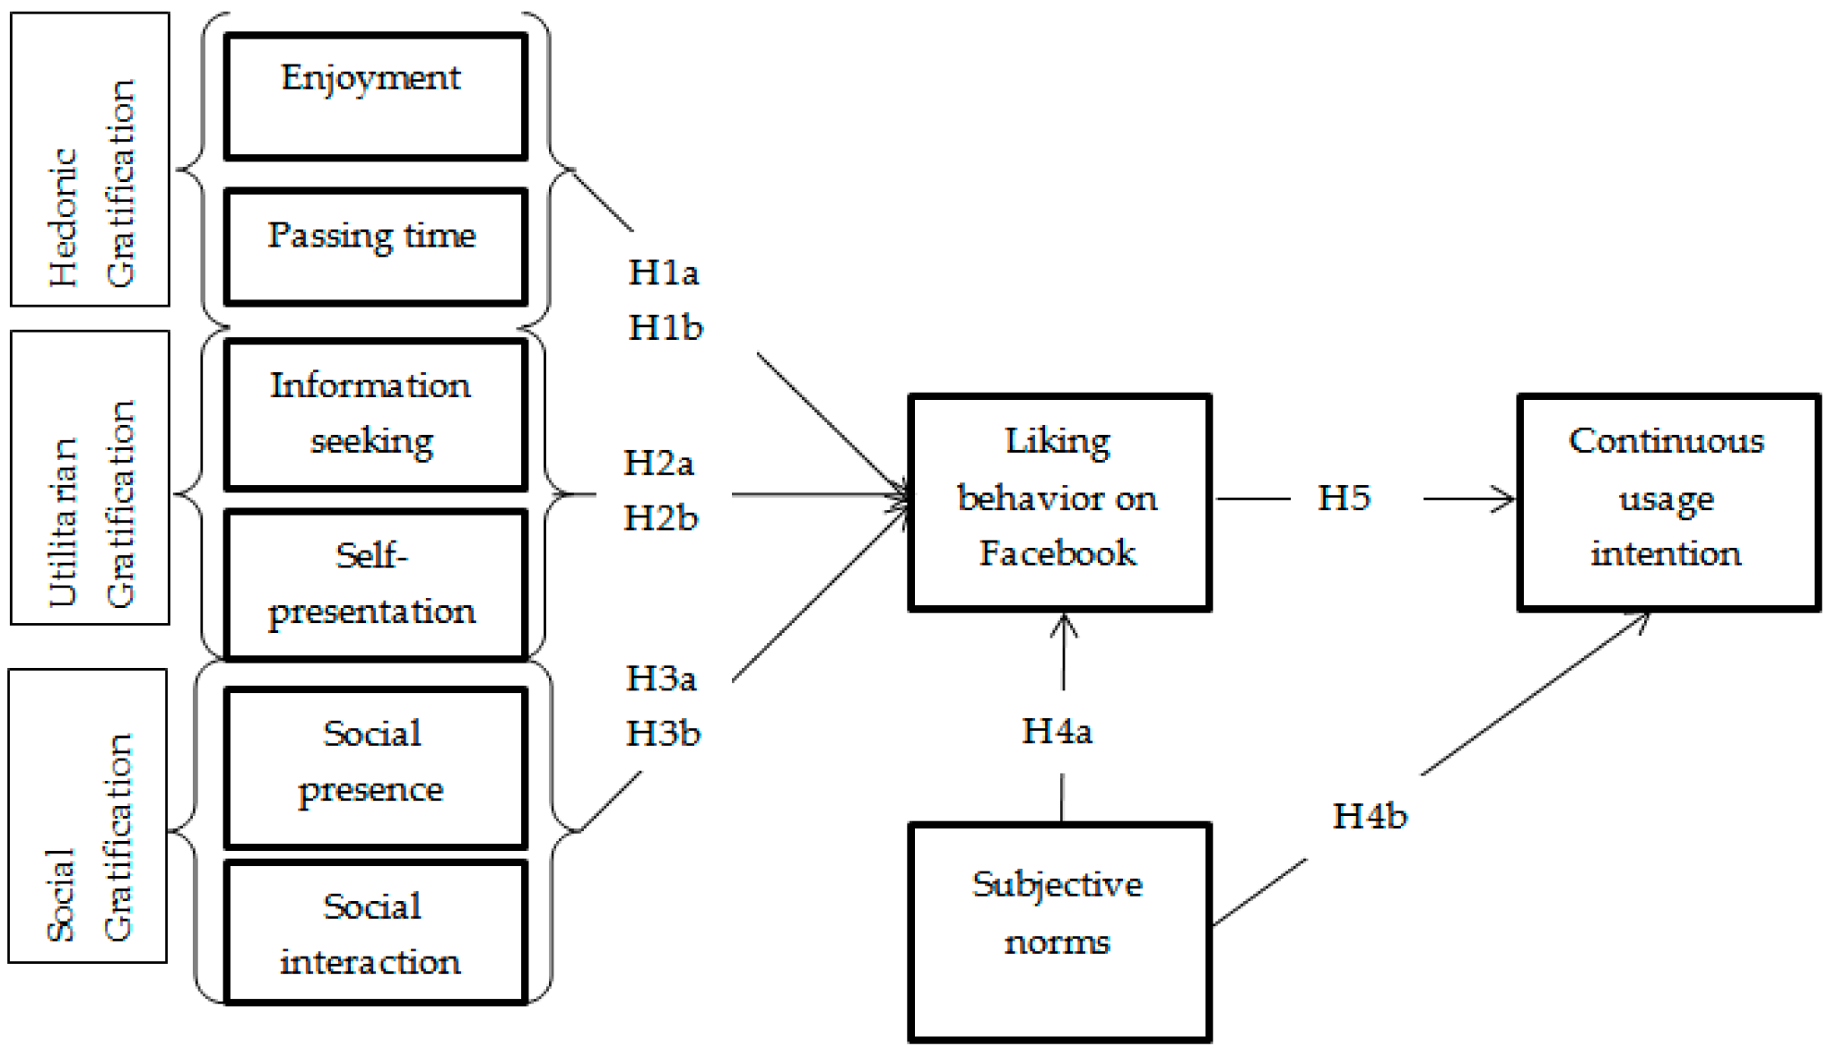
Figure 5: The Use and Gratifications Theory
Source: (Hossain, Kim and Jahan, 2019)
By producing interesting material that satisfies users' requirements for identification, entertainment, and social connection, Coca-Cola's social media approach is in line with the Uses and Gratifications Theory and promotes stronger emotional bonds and brand loyalty. One of the most severe issues for social networks is that multiple types of false and counterfeit news are circulating. As observed by Muhammed and Mathew (2022), The spread of information has become a more manageable task, resulting in the rapid flow of information without a verification system, which has, in turn, led to the spread of rumours that may affect how the public perceives a situation and make their decision. These efforts could involve technological and conceptual solutions that address user problems, users, and fact-checking organisations when mitigating this challenge. Data application on an individual scale will also bring security threats and privacy problems. A similar view can be seen from the work of Obar and Oeldorf-Hirsch (2020) state that privacy issues are involved in most personal data shared on social media networks. They include questions about data protection and user privacy. According to Obar and Oeldorf-Hirsch (2020), personal data that people actively share on these sites must protect people’s privacy, which is CRM’s area of emphasis in managing client communication and data safely and in a way that respects privacy. Such things as the GDPR intends to address these issues; however, there is a need to stay watchful and create new ways to keep citizens secure.
While social media has both a positive and a negative effect on companies and individuals, its promotional potential is beyond competition. There is a likelihood of reaching a global audience at a much lower budget than other media, such as television. Similarly, the study by Chaker et al. (2022), The social network platform allows businesses to maintain their relations with clients, develop and sustain the devotion of subscribers, and generate sales. In this respect, an additional channel is opening up in the form of inventiveness and partnership. On the other hand, the study by Iglesias-Sánchez et al. (2020) showed that social media has opened innovation, and organisations can work with external partners such as customers and competitors. This will enable them to create value jointly. This cooperative approach helped the organisations create new goods, services, and business designs. In order to sustain client connections, improve loyalty, and boost sales, integrated marketing communications (IMC) takes use of social media's worldwide reach and affordability, as noted by Chaker et al. (2022). Also, it supports the work of Iglesias-Sánchez et al. (2020), which focuses on fostering cooperative relationships to foster innovation and value creation.
Social identity theory emphasises the sense of belonging and focuses on how people's perceptions of their connection with social groupings affect how they see themselves. The Uses and Gratifications Theory, on the other hand, highlights people's active quest for media to suit certain demands like information, entertainment, or social interaction. It also explains why people use media and what requirements it fulfils.

2.2.4 Elevating Customer Relations: Enhancing CRM Strategies via Social Media
Customer relationship management is regarded as the strategy that brands apply to interact with their consumers. To enhance its relationship with the consumers, Coca-Cola should consider various methods to build trust in the consumers for the brand. On one hand, an observation by Dastane, (2020) stated that the companies are using search engines, social media campaigns and mothers to attract the attention of the consumers. Social media platforms have been taken as an effective medium to enhance the engagement of consumers with the brands. However, Coca-Cola Should consider certain strategies while it is managing the CRM practices through the social media platforms. In customer relationship management, Coca-Cola should understand the preferences of their consumers. A consumer-centric approach can allow Coca-Cola to deal with the issues that they face while dealing with the different changes in the tastes of its consumers. Esper et al., (2020) conveyed a similar idea that the marketing strategies and the practices related to managing the supply chain of the companies should be centred around their expectations of the consumers. The consumers are showing their concerns related to the improvement of health. The products offered by Coca-Cola contain high amounts of Sugar which might affect the health of the consumers if they consume it on a daily basis. Coca-Cola should utilise substitutes of sugar in their products to improve the health of their consumers. It can enhance the relationship with Coca-Cola when the consumers realise that the brand is thinking about the health of its consumers.
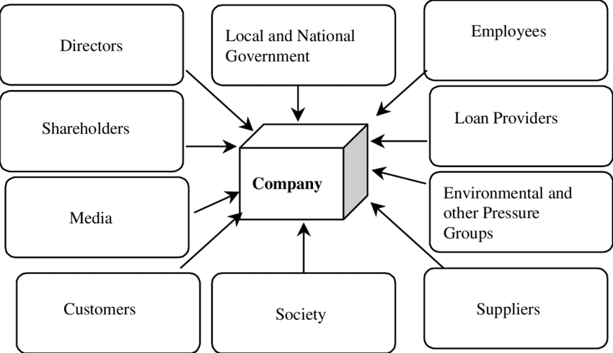
Figure 6: Stakeholder theory
Source: (Hardwick, and Letza, 2022)
The Stakeholder theory can help Coca-Cola to analyse the situation of their consumers. As per the description of Valentinov, and Chia, (2022), the stakeholder theory can be treated as practices to offer the companies a view of corporate governance. It is quite different from the theory of social influence which depends on the social identity to build relationships with consumers. Though stakeholder theory focuses on the internal people of the organisation and excludes the external environment, it is essential to build CRM with consumers. In the field of consumer relationship management, the brand needs to make sure that it involves the stakeholders of the brand including the employees. Investors, consumers, suppliers and others in their planning process. This can help Coca-Cola understand the expectations that the consumers have from the brand. This theory can help the company to solidify its relationship with its consumers.
On the other hand, Kumar, (2024) discussed that businesses should consider their responsibility when conducting their business and think about transparency in accounting. To enhance the trust in the brand, Coca-Cola should focus on maintaining the regulations enforced by the government and pay their taxes properly. They should avoid any kind of legal obligation when it is focusing on using social media platforms in customer relationship management. Coca-Cola should exhibit their sustainability initiatives through social media websites. They can post the initiatives of the brand to use sustainability practices in their daily activities. Some different views can be observed in the statement of Li, and Kallas, (2021), consumers would like to pay extra for the products if they came to know that it is abiding by the sustainability guidelines. Whether in the materials or in the packaging, Coca-Cola should incorporate sustainability practices to please the consumers with the brand. The company can also focus on incorporating the CSRT principles and work for the betterment of the community to enhance its relationship with consumers.

2.3 Empirical Review
Coca-Cola is utilising different social media platforms to enhance its relationship with its customers. In terms of consumer relationship management, social media platforms are effective in building the trust of consumers. Chaulagain, and Maharjan, (2020) stated that businesses are utilising social media marketing methods to build connections with consumers. Facebook, Twitter, Instagram, TikTok, YouTube, LinkedIn and other platforms have been utilised by Coca-Cola in consumer relationship management. Koivisto, and Mattila, (2020) described that user-generated contempt can attack consumers by sharing their experiences of the business. The company uses the exchange of content to interact and make positive connections with its consumers. However, the company often faces technological problems where they are unable to provide information or resolve the queries of the consumers. But the company can understand the demands of its products through social media platforms. Esper et al., (2020) commented that companies should be thinking of trying ethical methods in their marketing and management of the supply chain. Abiding by the sustainability and regulations of Coca-Cola can provide consumers with satisfaction for the brand.
The literature review was conducted via the traditional method of research. It helps the researcher find the effectiveness of the usage of social media platforms by the Coca-Cola Company in managing the relationship with their consumers. The research discussed the social identity theory, theory of social influence, stakeholder theory and the uses and gratifications theory to strengthen the relationship between the brand and its consumers. The research provides an analysis of how a brand can utilise its social media platform to build connections with its consumers and generate products for the company. It critically focuses on analysing the challenges that Coca-Cola can face while maintaining its relationship with social media websites. The study can serve as a guideline to offer Coca-Cola or some other companies to improve their connections with their consumers.

2.4 Literature gap
An abundance of literature presents ideas on the best brand strategies to use social media and customer relationship management tools. However, there is a gap in the literature regarding how people should specifically use social media platforms to work with customers. Chaulagain and Maharjan's (2020) and similar view can be noted that Wiese et al. (2020) studies provide a short overview of the social media strategies Coca-Cola uses but provide a short in-depth with a partial perspective of the company. Moreover, despite the research on CRM and social media, there exist a gap on how Coca-Cola relates stakeholder theory and sustainability measures through social media. Valentino and Chia (2022) did not emphasise stakeholder theory as the core of corporate governance. Moreover, from this point of view, insufficient evidence indicates that the stakeholder theory has been applied to Coca-Cola's strategic marketing tactics through social media. Likewise, Li and Kallas (2021) concluded that sustainability-related practices are crucial in consumers’ perception and loyalty. Still, the issue of how Coca-Cola includes these practices in its social media-savvy CRM (customer relationship management) strategy is overlooked by most research. By thoroughly examining Coca-Cola's social media platforms and customer relationship management tactics, this study seeks to close this gap. This study will shed light on Coca-Cola's CRM procedures by examining how the corporation interacts with customers and builds brand loyalty through social media channels. However, there might need to be more research in the literature to comprehensively summarise all the strategies that work to keep meaningful and ongoing engagement. The focus is usually on short-term successes; however, there might be less research on the long-term practice of social media platforms in customer relationship management issues and success factors. Few publications and journals could assist researchers in gathering more accurate data for their research papers. The research does not provide insight into the utilisation of CRM and ICM strategies in different cultural aspects of consumers. The quick development of the technologies created a gap in the knowledge in the successful implementation of social media in enhancing CRM and IMC management.

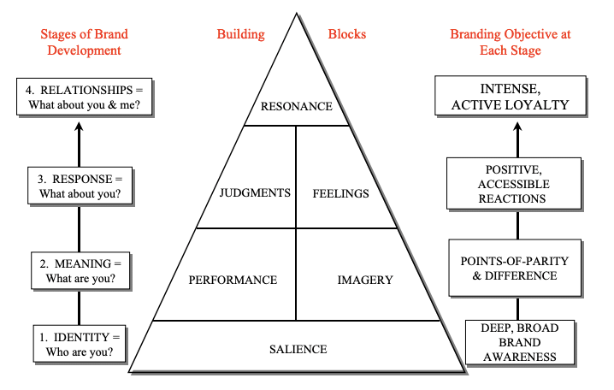
Figure 7: Customer Based Brand Equity model proposed by Keller
Source: (Francis et al., 2019)
The Customer Based Brand Equity model proposed by Keller offers businesses a solid foundation with brand identity, brand meaning, brand response and brand resonance. It is quite different from stakeholder theory which focuses on maintaining the relationship with stakeholders rather than on brand. The brand equity model by Keller can be effective for Coca-Cola to gain a solid foundation in the business industry.
Advantages of kellers brand

2.5 Theoretical Framework
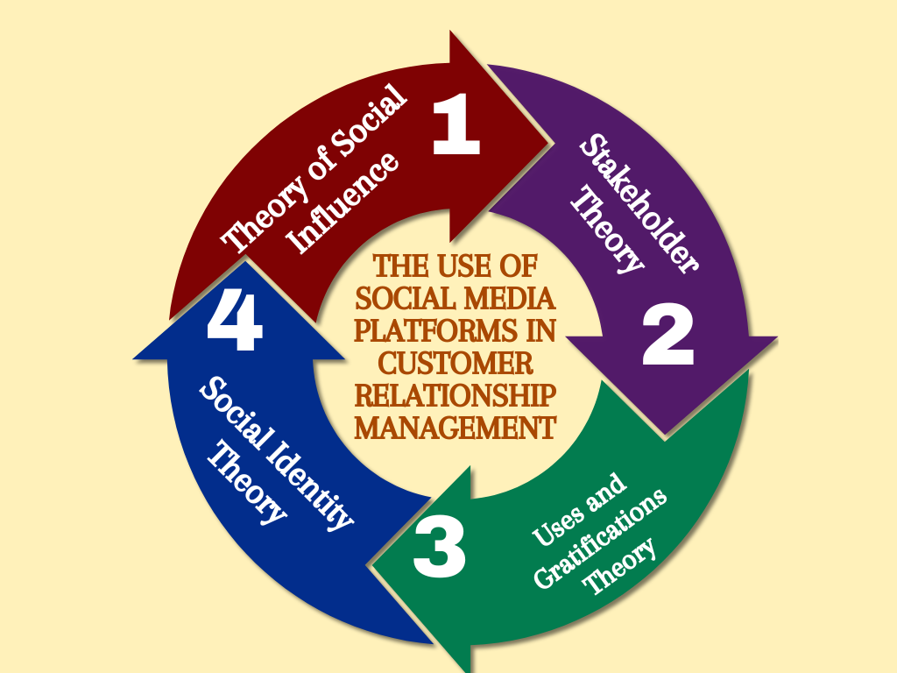

Figure 7: Theoretical Framework
Source: Self-made

2.5 Conceptual Framework
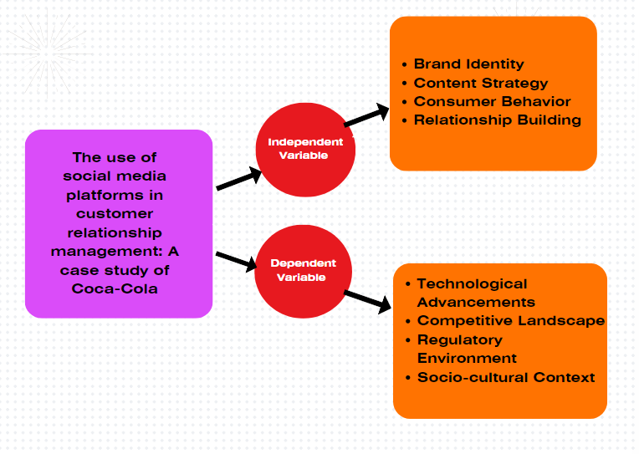
Figure 8: Conceptual Framework
Source: (Self-Made)
The literature review shows four critical theories that can help to understand Coca-Cola's activities in the social media channels aimed at customer relationship management. The Social Influence Theory sustains that a person's attitude and behaviours are susceptible to social interactions. Thus, this encourages Coca-Cola to craft social media content, considering the direct impact. Social Identity Theory can help Coca-Cola develop a feeling of belonging and of their consumers being true loyalists by applying this theory wisely and adequately. Stakeholder Theory stresses the importance of the interests of all stakeholders as a whole, including the customers. Thus, the goal is to ensure that everything connected to the company’s social media practices meets those needs. With the help of the Uses and Gratifications Theory, Coca-Cola can figure out why consumers satisfy their social needs via social media and what kind of content they wish to receive from Coca-Cola, which will lead to implementing this content in a correct and relevant way. Such theories can be an invaluable resource, offering cognitive mechanisms that can aid in creating and developing strategies of engagement with the customers through the company's activities on social media.

2.6 Chapter Summary
An extensive review of Coca-Cola's social media initiatives concludes this chapter. It looks at the CRM systems, talks about social media marketing tactics, and looks at prospects and problems. In order to improve consumer connections and brand loyalty, the chapter also incorporates ideas like stakeholder theory and social identity theory.

Chapter 3: Research Methodology

3.1 Chapter Overview
This chapter of methodology summarises a set of procedures designed to provide an unbiased testing of research hypotheses and target of the paper. It looks into first research methods, then data collection methods, later it analyses data, in the last, elaborate on the challenges faced. The whole research process with the research approach, methodology, and ethical issues are clearly described in this chapter which is about transparency and reliability.
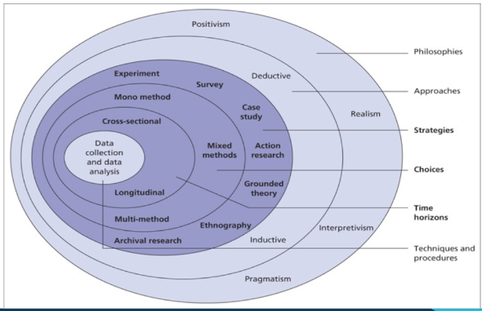
Figure 9: Research onion
Source: Seuring, Stella, and Stella, (2021)
The above-mentioned figure is the Research onion model given by Saunders et al. (2014) for the methodology used in a specific research study (Seuring, Stella, and Stella, 2021)

3.2 Research Philosophy
The research philosophy refers to certain beliefs related to the nature of study to be investigated. It can be Objectivism, constructivism, positivism, realism, interpretivism or pragmatism (Ugwu et al. 2021). In this research, positivism philosophy is used as the primary research philosophy. Positivism assumes that knowledge can be extracted from what is observed in studies and the researcher is supposed to remain only an observer and detached trying for empirical proofs and data that can be quantified (Zyphur and Pierides, 2020). This philosophy is well suited for the objective of the research in which the investigator is guided by the principles of systematic observations and measurements in error-free finding and testing of relevant hypotheses. Utilising positivism in the research design means the adoption of methodology based on structure, with this presenting accessible approaches to data collection and analysis, such as surveys, experiments and, statistical techniques designed to find rules and regularities of the obtained data (Al-Ababneh, 2020). In positivism the main goal is to make research experiences to be objective and replicated. This adds to the accuracy and applicability of the study to the broader society.
Additionally, positivism philosophy inspired transparency in the research process by orienting the researcher towards clear definitions of sources, well-devised methods, and commitment to the widely accepted scientific principles of a particular area. This philosophy further increased the confidence that resulting outcomes are authentic which enables peers and stakeholders to use the results (Amin et al. 2020). Moreover, it helped to enhance the verification, objectivity, and the reliability of research that strengthened the good quality and a good reputation of the research.

3.3 Research approach
The study employs deductive approach, considered appropriate when the research seeks to test existing theories, with creation of hypotheses out of existing knowledge in the subject area and then formulating a research plan through which the hypotheses are tested. They conformed perfectly with the positivist paradigm because it supports the objective and systematic analysis to make certain that the issues encountered and the outcomes of the study are measurable and can be validated.

3.4 Type of investigation
According to Mazhar et al. (2021), there are 2 types of investigation of a study which has primary and secondary research. First is primary research which uses surveys, interviews or any other method to collect data from people. Second includes secondary data which uses already published data to interpret for existing research. This research employs a direct primary approach that gives preference to the collection of the data over data gathering throughout the available studies or other investigations. In this type of investigation, scholars directly participate in data gathering by involving themselves in first-hand data collection activities along with serious academic studies.
Though quantitative research is used as a primary approach, the focus is on collecting the numerical data that can be analysed statistically to identify the patterns, relationships, and trends that may arise, or be apparent, from the data (Taherdoost, 2021). This technique typically involves performing the studies with the help of different survey tools, the experiments, or observations, which will produce quantitative data, for instance, measurements or responses to the questions that were already predetermined.
The fact that primary quantitative research comes with measurement claims that are amenable and susceptible to statistical analysis is another of its key strengths. For this, researchers establish the relative importance of different predictors and test their hypotheses with a high degree of precision (Bauer et al. 2021). However, quantitative research permits the collection of data that targets precisely the research aims, providing both relevancy and a valued-added depth to the results. The logistics of primary quantitative research are not easy to execute as it requires an excessive amount of time, resources and expertise.

3.5 Research Strategy
The third layer of the Onion includes research strategies. These are the methods which are used in the research to conduct it successfully. These include experiment, grounded theory, case studies, survey, action research, ethnography or archival research (Abdelhakim, 2021). The researcher used a survey method as a research strategy, which is in line with the deduction approach that they have revealed previously. According to Mahafzah et al. (2020), individual work focuses on examining the application of social media in the current customer relationship management approach. Surveys are deemed suitable in this context, creating a systematic template for collecting information from different categories of stakeholders of Coca cola. Issues addressed through surveys are thereby directly relevant to the research problem, specifically in terms of consumer relationships involving beverage brands.
Standardised surveys provide the ability to unbiased data collection and link them across different specific audiences of Coca-Cola or over different time frames. Moreover, surveys also mask identity to responders in that they are honest enough to provide accurate data thus diminishing any form of bias and promoting data credibility. The surveys may be administered with diverse methods that are either online, by mail or during face-to-face interviews thus, particularly the age groups, regions, and gender that are essential to Coca-Cola's consumers and products are reached (Ling et al. 2023).
The target population was young adults (18–45 years) only in urban areas of the United States; 25 males, 25 females were included in the sample. Convenience sampling was employed, due to the fact that it offered the most efficiency and practicality to obtain participants. The sample used in the study was contacted through emails and posts on social media platforms. Despite this simple and quick approach, there rises the question of bias and non-representative outcomes.
Nevertheless, despite the fact that the survey method has its pluses, there are also drawbacks. Low response rates might become the news feed to the data being incomplete and may impact the representativeness of the data collected. In addition, these studies may be subject to biases such as response bias or sampling bias (Holtom et al. 2022). Therefore, they may not appear to be as accurate.

3.6 Data Collection
Data collection is significant in the whole research process as it uses the best choices of methodologies and tools for collecting the data. A cross-sectional quantitative research method is used in this research work. Such choice of methodology implies focusing on information at one particular point of time to investigate how the link between social media engagement and customer relationship management evident itself within Coca-Cola (Ye et al. 2022).
The survey for the presented research was analysed and Coke was chosen as the product for the analysis. The analysis was conducted online survey over a period of two weeks. The items were tailored to find out about the audience’s level of Coca-Cola’s social media engagement and were ordered using multiple-choice and Likert scale structures. In this research, 50 participants were chosen through random selection methods, and invites mail and social media sites were the media used to send them.
This research took two weeks and comprises an online survey that was designed to assess Coca-Cola’s product engagement. The survey items were designed to assess the extent to which the audience is active on the social media platform on behalf of Coca-Cola, in a multiple choice and Likert scale format. The participants included 25 males and 25 females, 18-45 years of age, were recruited through convenience sampling, from the urban centres in the United States, and each participant completed an online self-administered questionnaire. These embraces e-mail messages as well as posts on social media platforms.
In this study, the type of sampling was random since all the participants had equal probabilities of being selected, making the sample more representative. Selection bias is minimised and the study is awarded higher external validity. However, it can be time consuming and may necessitate higher sample size to effectively work hence expanding our costs and complication.

3.7 Data Analysis
As per the views of Popenoe et al. (2021), data analysis is a process looking into the data in order to obtain the meaningful conclusions which relate to the research objectives. In this study on "The use of social media platforms in customer relationship management: A case study and analysis of Coca-Cola," the correlations between the social media activity and the customer relationship management strategies targeted at Coca-Cola will be critically esteemed. The data will be analysed from the data collected via online survey with close ended questions. For the study performed, statistical data were analysed using a program such as SPSS (Statistical Package for the Social Sciences) or Microsoft Excel. The researcher used the SPSS analysis because the tools involved in this process were very easy to determine whether quantitative data is descriptive statistics or inferential tests or regression analysis for the purposes of looking for trends, patterns, and relationships in the data. As per the views of Salkind and Frey, (2021), these software like SPSS or Microsoft Excel were used because these enable precise analysis of statistical data, distinguishing between descriptive statistics, inferential tests, or regression analysis. Such instruments or tools allow for an easier search, identification and illustration of the existing pattern, trends and connections within the dataset.

3.8 Ethical Considerations
As per the Stommel and Rijk (2021), ethics are inextricably linked to any research activity, so that the participants' rights and wellbeing, the use of rigorous and ethical data collection and analysis methods and the results validity of study are guaranteed.
During the process, their confidence was gained because the researcher decided to make the survey as well as the other data collection methods anonymous. With this move, some of the responders opened up and the process became much quicker. The information regarding the aims and the methods of the study, the rights of participants and the way their data would be stored and used were provided to them. Alongside the lines of Xu et al. (2020), assessment of participants' anonymity and confidentiality was considered standard status during the study. Participants were assured anonymity and confidentiality, in order to effectively protect them from possible harm or repercussions. Besides there was a curiosity that the work was conducted in accordance with ethical directives and principles that the Coca-Cola system established.. Research ethics are important in research with respect to the participants’ rights, the data quality and, the validity of studies. Participants' identities and information was kept anonymous to ensure that trust was established and the responses were genuine. The study complied with Coca-Cola’s ethical policies and ethics committee approvals which elevated the credibility of the study.

3.9 Chapter Summary
This research is referred to as a model which has various methods such as systematic approach, frameworks which are based on positivism as a philosophy, and deductive reasoning. The study preferred to survey as its data gathering method, coding the data obtained in a quantitative manner for evaluation of the link that exists between social media activities and connection strategies. Ethical responsibilities were on the forefront in all the research phases that the drug was used and safety and rights of individuals were respected. Statistics tools adopted by any small or famous business assist to understand properly the characteristics of a loyal customer and the strategy created can be of very high quality. The research was done with the aim of finding the truth and enhancing the establishment of learning.

4.0 Findings

4.1 Chapter Overview
The chapter reports on the results of a survey aimed at investigating customer engagement and the perception of Coca-Cola’s social media presence. This finding section examines how these digital strategies influence customer-brand relationships and brand image. Thus, showing the outcomes of Coca-Cola’s online customer communication and interactions.

4.2 Results
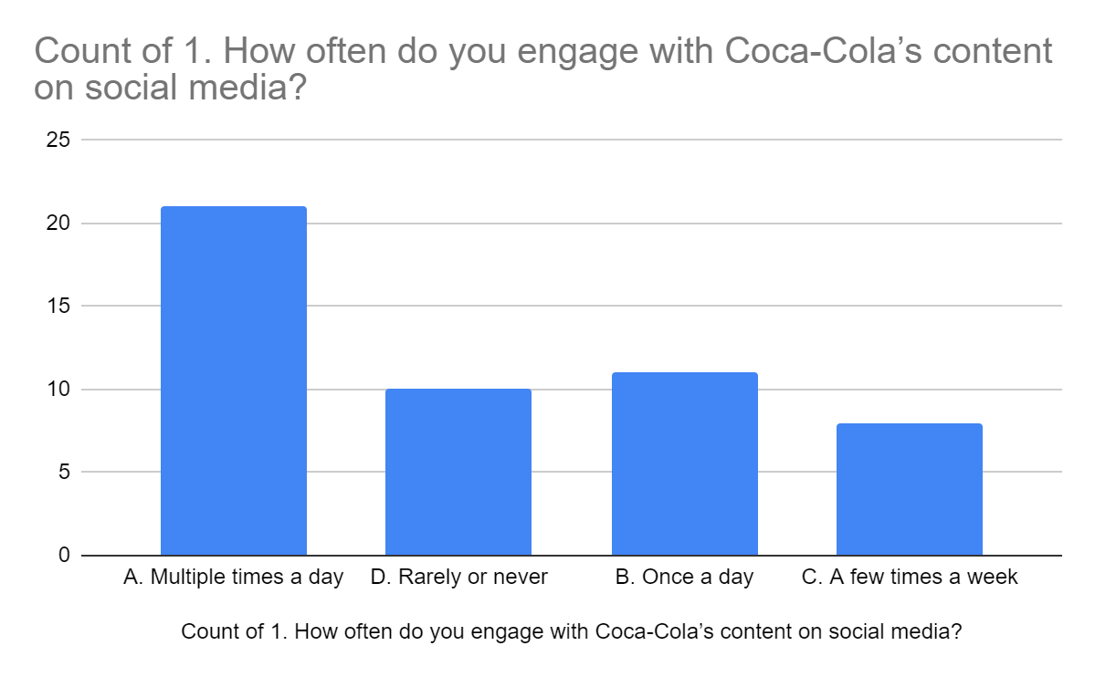
The survey results show that there is a large degree of interaction among the participants with Coca-Cola’s social media content. 42% and 22% of the respondents stated that they were using the brand’s content many times a day and at least once a day respectively, which means a strong daily interaction with the brand on social media platforms. This constant communication of the brand proves its success in keeping its online image active and attractive which would always be able to catch and keep the consumer’s attention on a frequent basis. On the other hand, a smaller proportion of the audience, i.e. 16%, stated that their interactions were less frequent, and they occurred only a few times a week or rarely. The fact that a core group of users is highly engaged, but there still remains a part of the audience that interacts with the brand’s content more sporadically, means that while in the core group of users, there is a high level of engagement, some of the audience still interacts with the content of the brand less often.
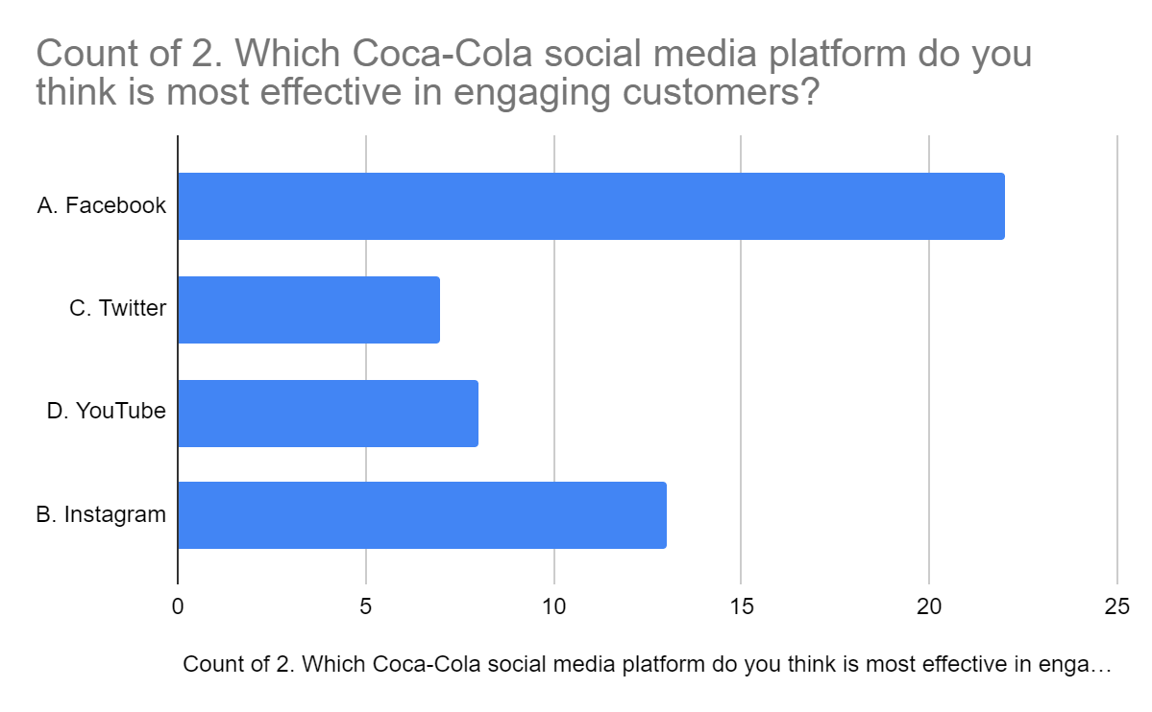
The results of the survey show that among the Coca-Cola social media platforms, Facebook appears to be the most powerful in attracting customers, as 44% of the people did their primary interaction with the brand on this platform. This being the social media platform that dominates Facebook shows that it is the channel of choice for Coca-Cola’s target audience. It is probably due to its huge reach, the different types of content formats, and the interactive features thus Coca-Cola uses Facebook.
Instagram is next to the most effective platform for customer engagement, managing to captivate the attention of 26% of respondents. Instagram’s visual-oriented approach and the storytelling which it implies, are in agreement with Coca-Cola’s brand image, hence it is a suitable choice for building up close relationships with the consumers via the attractive pictures and the videos.
At the same time, YouTube and Twitter are not as popular as Facebook, because only 16% and 14% of the participants in these platforms have chosen these channels as their means of communication. Despite the fact that Twitter’s real-time updates and concise messaging, YouTube offers the possibilities for longer-form video content and storytelling may not be the ones that fit Coca-Cola’s branding objectives and, thus, the engagement rates are not as high as in Twitter.
In general, the results highlight the necessity of customising the content strategies according to the distinct features and the audience preferences of each social media platform which will result in increased customer engagement and stronger brand-relatedness.
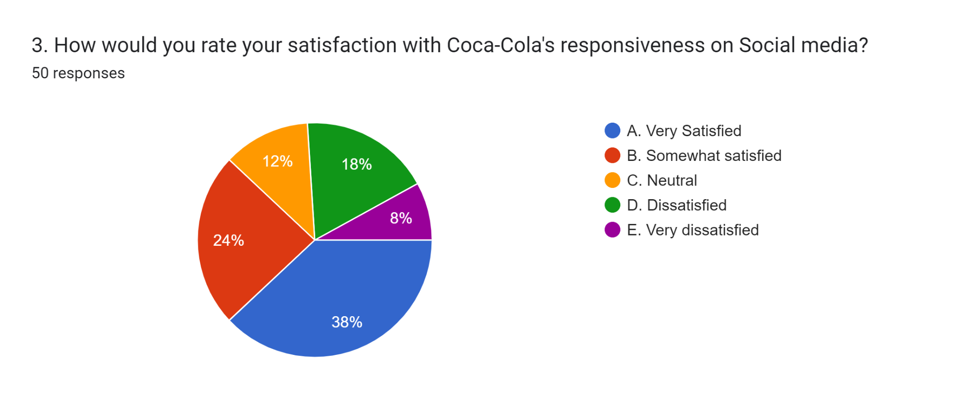
The survey results bring a new understanding of the level of satisfaction of the participants with respect to Coca-Cola’s activity on social media platforms. A big percentage of the respondents, which is 38% of respondents, said they were very satisfied with Coca-Cola’s approach to social media and therefore, a considerable part of the people who really like the brand were also satisfied with the brand’s social media stuff. This indicates that Coca-Cola is successfully fulfilling the demands of a large number of its audience by giving them the appropriate and meaningful responses on time, hence the result is satisfaction and brand loyalty.
Besides, 24% said they were partially satisfied with Coca-Cola’s responsiveness. This means that although the brand is looking for ways to reach out to customers on social media, there may be some areas that need to be improved in terms of the speed of response or the degree of interaction.
Conversely, 18% of the respondents were not satisfied with Coca-Cola's answer on social media. This small group of disappointed people points out the areas where the brand must improve its strategies to deal with customer questions or feedback faster and better. Even 8% of consumers are very dissatisfied with the brand. Making the worries of the unhappy users recognisable and taking the necessary steps to correct these problems could help to improve the general customer satisfaction and remove the negative attitudes.
Besides, a further 12% of people said they did not have any opinion on Coca-Cola’s social media responsiveness. This implies that there is a part of the audience who does not have a strong opinion about how the brand engages its users or who needs more interaction or persuasion to form a clear opinion.
In conclusion, although most of the people surveyed indicated that they were happy with Coca-Cola’s social media customer service, the brand can still improve its methods and processes in order to guarantee the same level of outstanding customer engagement experience on all social media platforms.
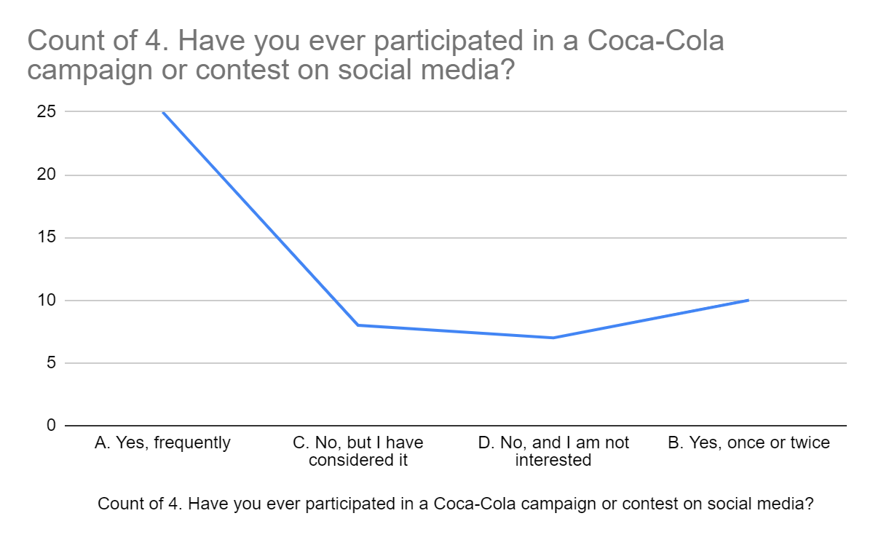
As per the survey results, it seems that a large number of respondents have been involved in Coca-Cola campaigns or contests on social media. Precisely, 50% of the respondents said that they participated frequently in the Coca-Cola campaigns or contests, which means that they are very enthusiastic and involved with the brand promotion activities. Moreover, 20% of the respondents admitted that they had taken part in such campaigns or contests once or twice indicating that the level of participation among the participants was much, but still significant enough. On the contrary, 16% of answers stated that they had not participated in any Coca-Cola campaigns or contests on social media, while 14% of the respondents declared that they did not like such activities at all. These results highlight the different levels of involvement and the degree of interest among the consumers in Coca-Cola's social media campaigns and contests, thus giving the brand some useful information for its marketing strategies and outreach programs. These insights supply the company Coca-Cola with valuable instructions on how to create its marketing strategies, thus Coca-Cola will be able to adjust its outreach methods to fit the consumer interests and preferences on social media platforms.
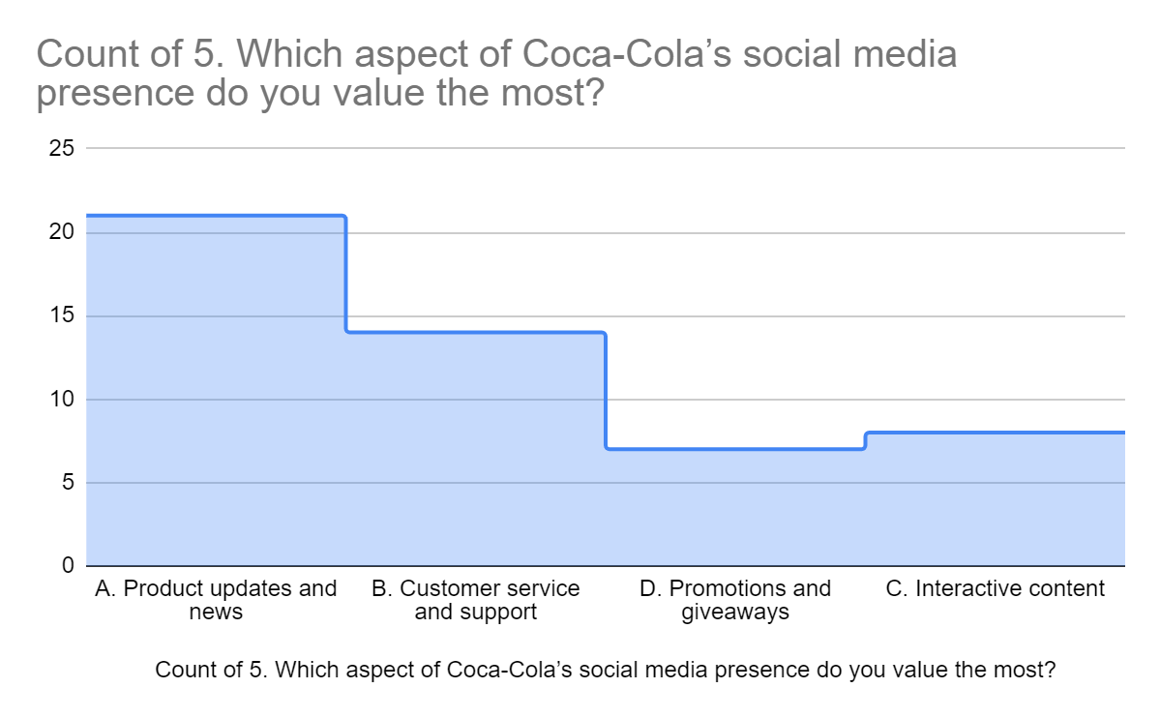
A survey was conducted to gain insight into the strategies related to the customer relationship management of Coca-Cola. 50 participants were invited to take part in the survey where they were asked about their opinions on different matters. The respondents were asked 12 questions about the different social media activities of the Coca-Cola company and their impact on the participants. In the question when they were asked about the aspect of social media presence, they like the most, different views can be observed in the responses of the participants. Through this question, the researcher can understand the aspect that rings in the minds of the consumers about Coca-Cola. Among the participants, 42% of them agreed that they like the update of the products and news about Coca-Cola. The updates related to the products and any kind of news related to the company were given priority by the majority of the participants. This suggests that the product updates and news related to Coca-Cola create more impact than the other options. However, 28% of the participants believe that customer service and support through social media is the most memorable aspect of the organisation. There is also another segment of consumers who believe that the interactive content of Coca-Cola they value the most. 16% of the respondents belong to this category where they value the interactive content posted on the several social media websites of the company. There are also 14% of the respondents who still value promotion and giveaways. Investigating this question showed that the promotional activities and giveaways of the company were least valued by the consumers and they would be interested in the product updates and news of the company.
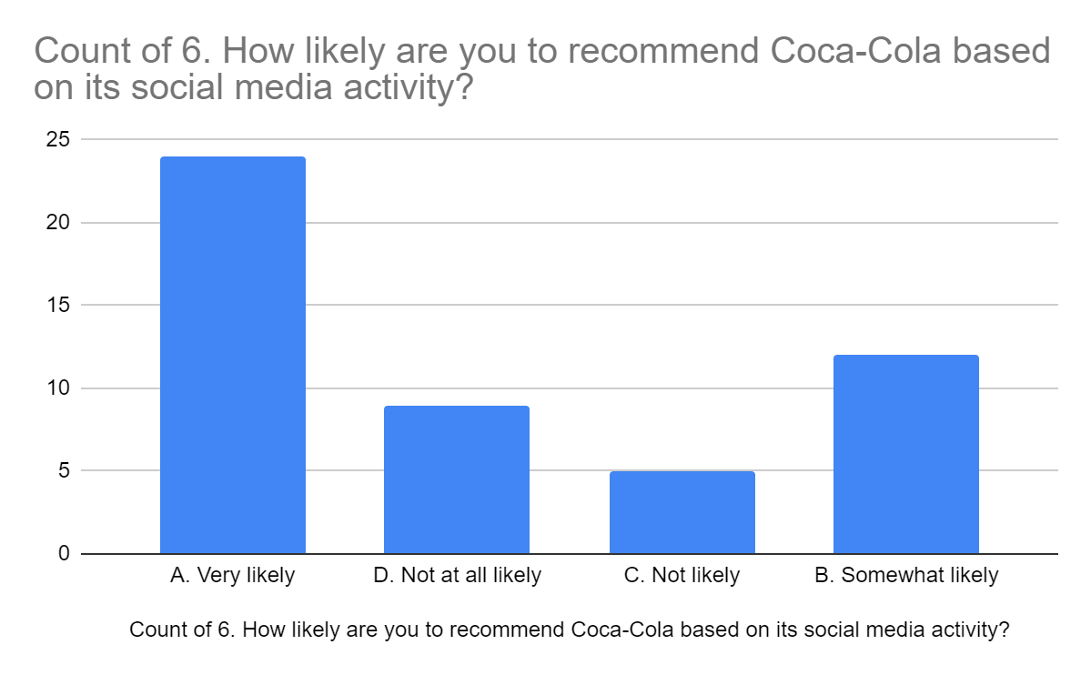
In order to learn more about the customer relationship management activities of Coca-Cola, through their social networking sites, a survey was undertaken. Several questions were posed regarding the several topics of the activities of Coca-Cola to 50 people. 12 questions concerning the various social media initiatives of Coca-Cola and their effect on the minds of the consumers were asked of the participants. Different points of view are evident in the answers of the participants when the researcher queried about the extent to which they would recommend Coca-Cola for its activity on social media. The majority of participants, 48% of the total number of participants, shared that they were very likely to recommend others about the company. 24% of the respondents agreed that they were also likely to recommend Coca-Cola based on its social media activities. A major portion of the participants thought that the social media activities of the company need to be improved and they would recommend the company about its activities on social networking websites. However, there were other portions of the participants who thought that they would not like to recommend Coca-Cola for its Social media activities. 10% of the participants were not likely to recommend the company for their social media activity. 18% of the participants were not at all likely to recommend the company to improve their social media activity. This survey results depict that when it comes to the social media activity of Coca-Cola they need to work on this matter. Though there are some portions who were not likely to recommend the company for its activity, the majority of the people agreed to give a hand to the company towards its activities on social networking websites.
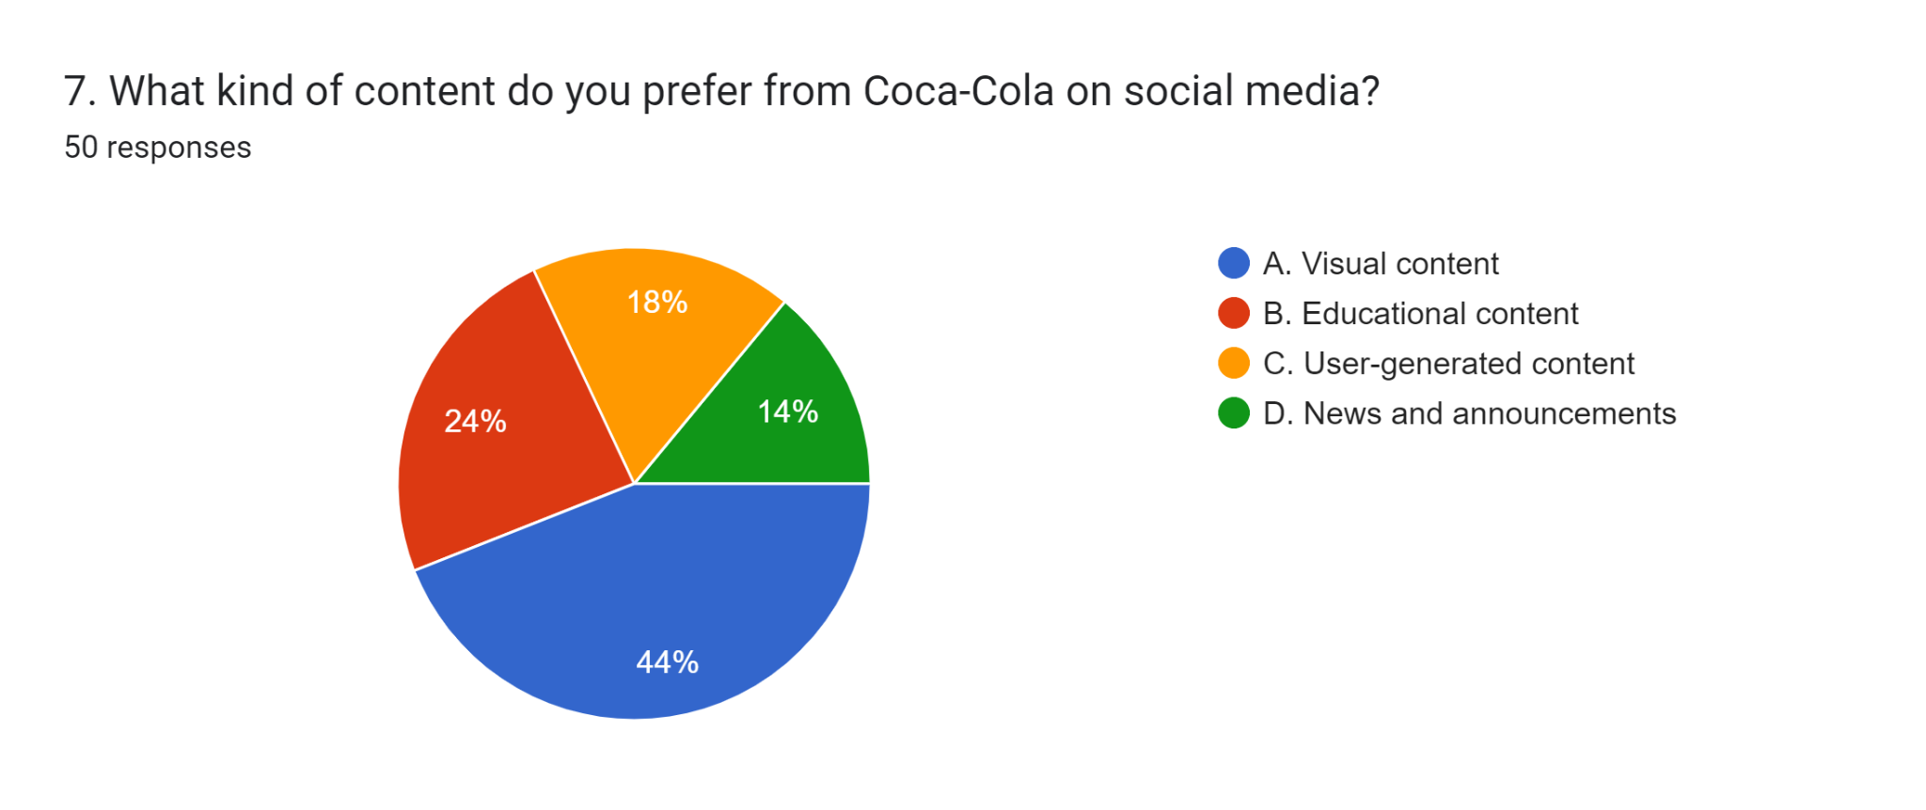
In the survey regarding the customer relationship management of Coca-Cola company through different social media sites, the views of the consumers were captured. 50 participants were asked different questions regarding the activities related to the customer relationship management of the company. Through 12 questions, the researcher tried to understand the different activities of Coca-Cola on their social networking sites. They were asked questions regarding the type of content they prefer in the social media platforms. 44% of the participants, which is regarded as the lion’s share of the total participants, described that they were attracted to visual content on social media platforms. This exhibits that the visual content posted by Coca-Cola attracted most of the people towards the brand. However, 24% of the respondents revealed that they prefer educational content from Coca-Cola. This describes that the educational content made by the company is getting popular and can capture the minds of the audience. There was also a category of 18% of the participants who shared that user-generated content was the most that they preferred. There are also 14% of the participants who like to watch the news and recommendations of the company. The results regarding this question show that the visual content produced by Coca-Cola is the type of content that people prefer the most.
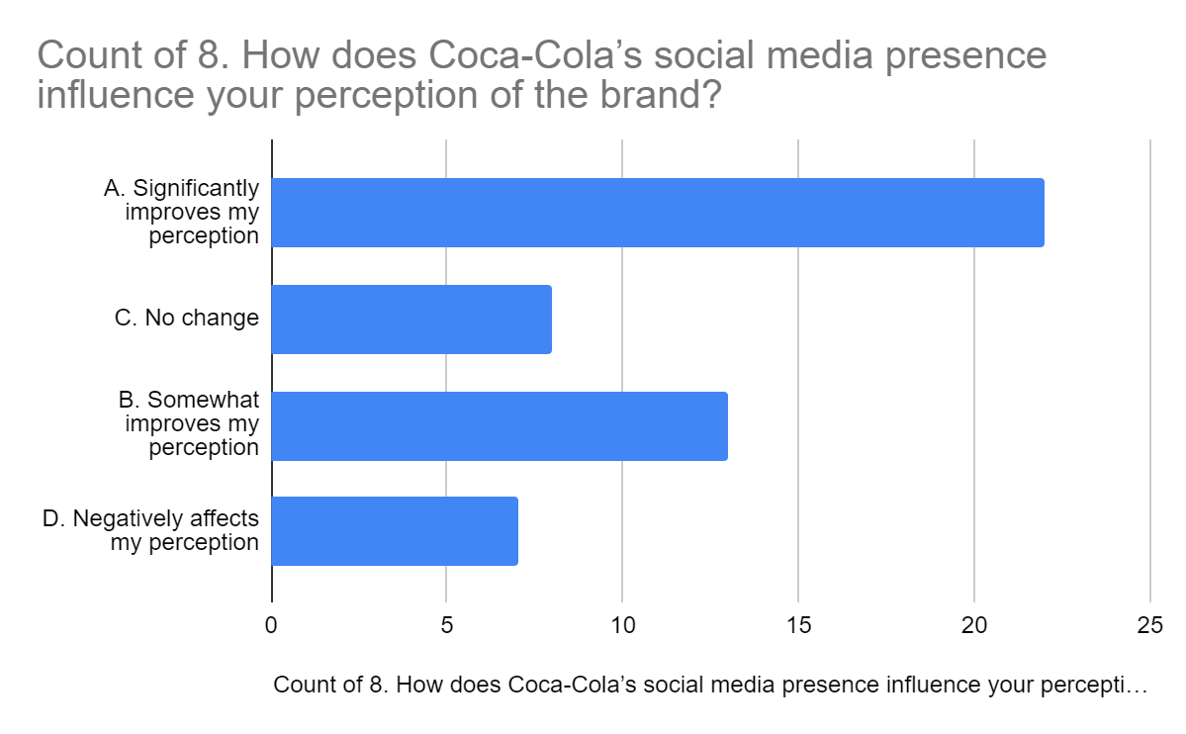
Different opinions of the people were captured in the survey and 50 people participated in it. They were asked 12 questions related to the customer relationship management activities of Coca-Cola via several social networking sites. They were inquired regarding the influence of the presence of Coca-Cola on social media sites on their perception. According to the survey results, the opinions of the consumers are described below. Among the participants, 44% of them stated that the activities of Coca-Cola on social networking sites have contributed to the change in their perception. These results illustrate that the several strategies of the company are affecting the perception of its consumers. For about 26% of the respondents, the presence of the company on different social media platforms has somewhat enhanced their perceptions. However, there were also some parts of the participants who described that they had no reaction to the social-media presence of Coca-Cola. 16% of the participants exclaimed that their perceptions were affected by the social media presence of the company. Additionally, there are also 14% of the respondents stated that the presence of the brand through different social media had affected their perception negatively.
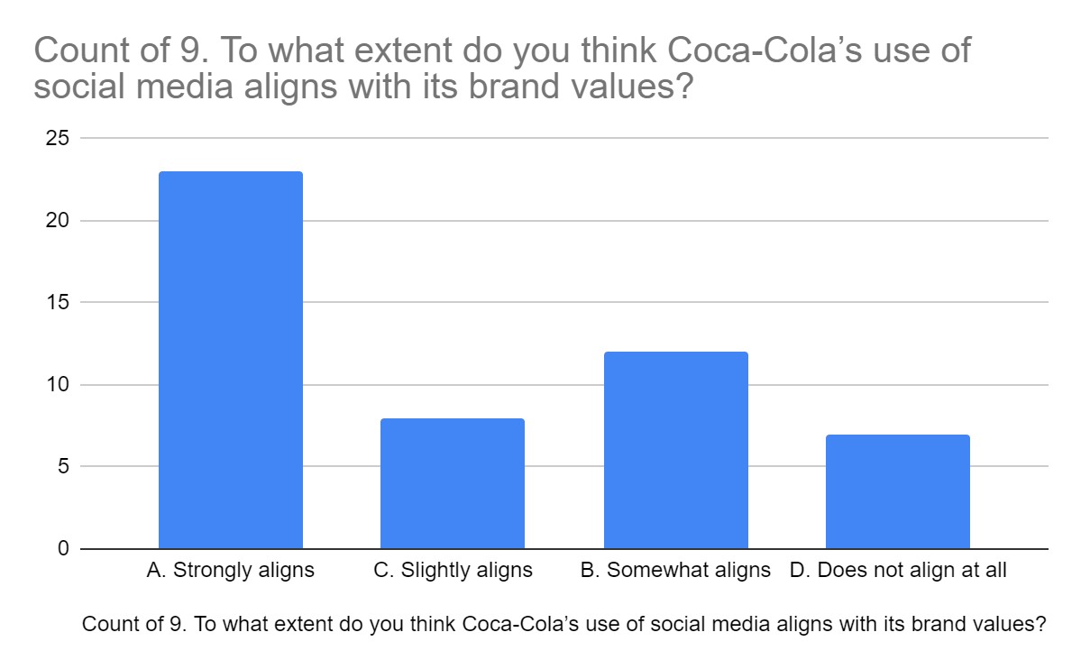

The survey shows a distressing pattern of public opinion of Coca-Cola's social media strategy regarding its brand values. A significant part of respondents, 46%, think that the company's social media usage must align with its brand values. This feeling is even more apparent by the 24% who think it somewhat and the 16% who consider it slightly aligns. The fact that only 46% of the people believe that Coca-Cola's social media use strongly corresponds with its brand values is scary. 14% of the participants said that Coca-Cola's social media use does not correspond with the company's brand values. 24% of the people said it was close to what they had in mind. 16% said it is the way it should be. From some of the participants, the social media use of Coca-Cola is not aligned with the company's brand values to the extent of 14%. The survey points out the possible gap between Coca-Cola's social media scene and its brand values but does not look into the exact reasons for this feeling. It still needs to be made clear which brand values people think are being undermined and how they believe Coca-Cola should have better aligned its social media strategies with its brand ethos. The survey points out the need for Coca-Cola to reconsider its social media strategy to ensure it reflects the company's values and the desires of its audience.
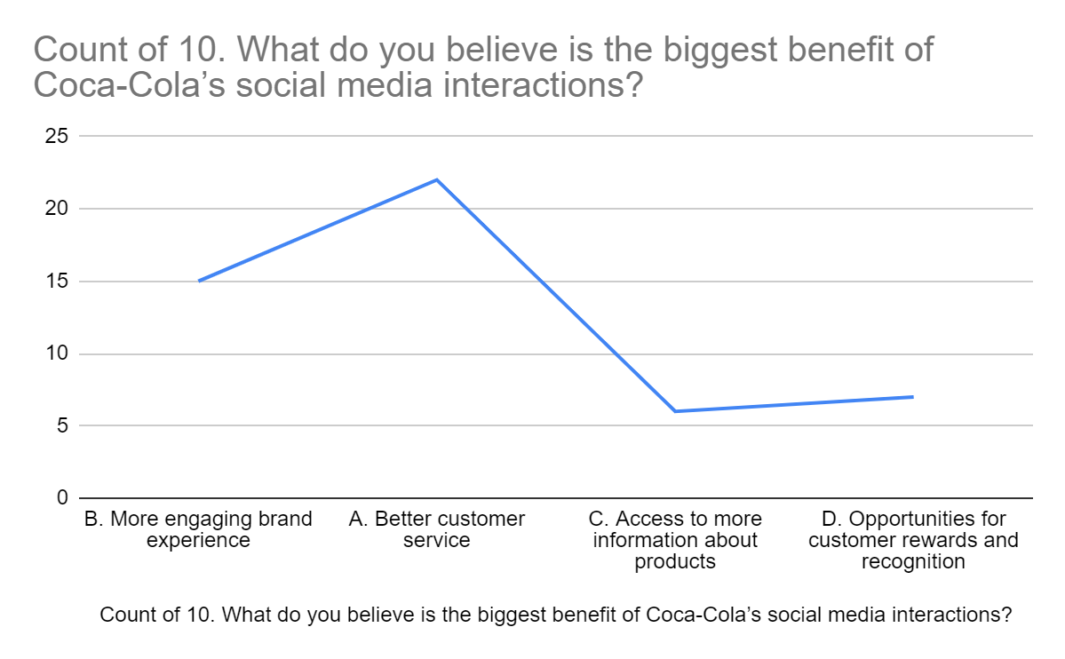
The above poll represents the survey that asked people to identify the most significant benefits of Coca-Cola's social media interaction. The study revealed that 44% of the people said that the main benefit of Coca-Cola's social media activity was better customer service. This indicates that a lot of people like the fact that social media is not only accessible but also responsive, which makes it easier for them to contact the company and get help from it. They feel they are being heard and their concerns are being addressed. Similarly, 30% of people think the primary advent is to create a more attractive brand experience. Thus, shows the importance of people connecting with Coca-Cola more personally and interactively. This social media platform will reveal the brand's personality and ethos. Besides, 12% of the respondents pointed out that the most crucial advantage of this solution is access to more product data. The fact that Coca-Cola’s social media channels are a popular resource with customers who want to know their companies, no program, promotion and other relevant updates shows that this channel is an essential focus for those who want to keep up the company. More than 14% of people point out that customer rewards and recognition of the most important benefits. This reveals that some customers are motivated and appreciated by the incentives and the compliments.
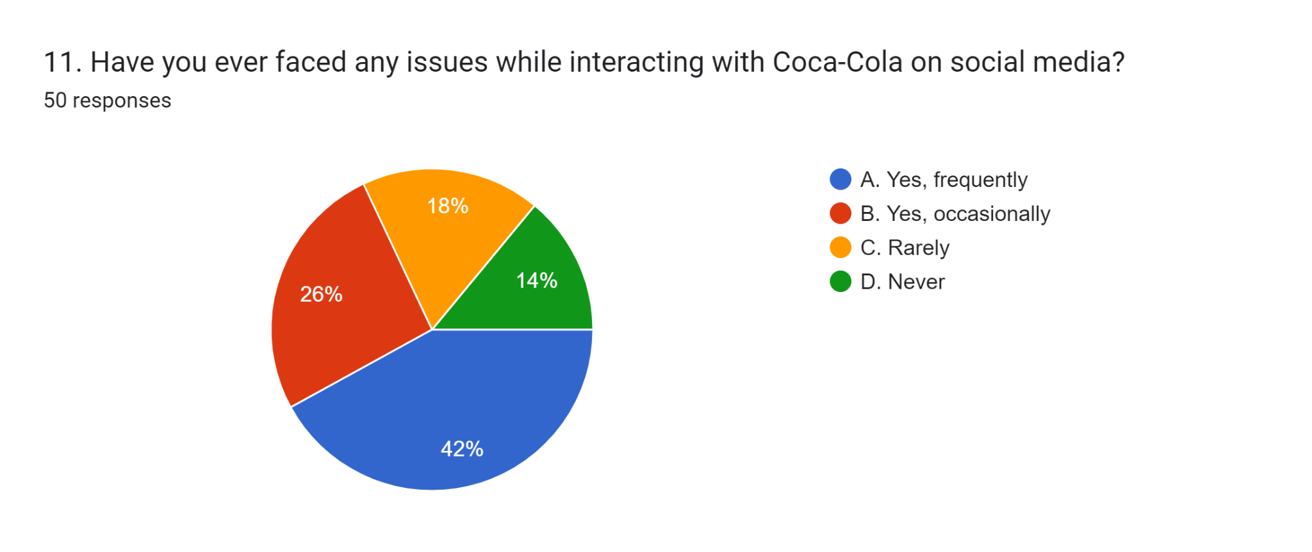
The pie chart shows what people said about having problems while talking to Coca-Cola on social media. Based on the survey, 42% of people said they often have problems, and 26% said they sometimes have issues. Furthermore, 18% of people said they hardly ever had problems, and 18% said they never had any problems at all. In general, the survey indicates that most of the people the researcher asked, 68%, have encountered one or more difficulties with Coca-Cola's social media platforms. This suggests that over half of the respondents have had less than ideal experiences with the brand's social media channels. Nevertheless, the analysis needs to show the study's limitations. The fact that there are only 50 respondents in the sample makes the population size relatively low regarding its capability to cover the larger audience of Coca-Cola's social media followers. Notwithstanding this difficulty, the discovery encourages Coca-Cola to sustain and improve its social media interaction to eliminate and lessen all these issues.
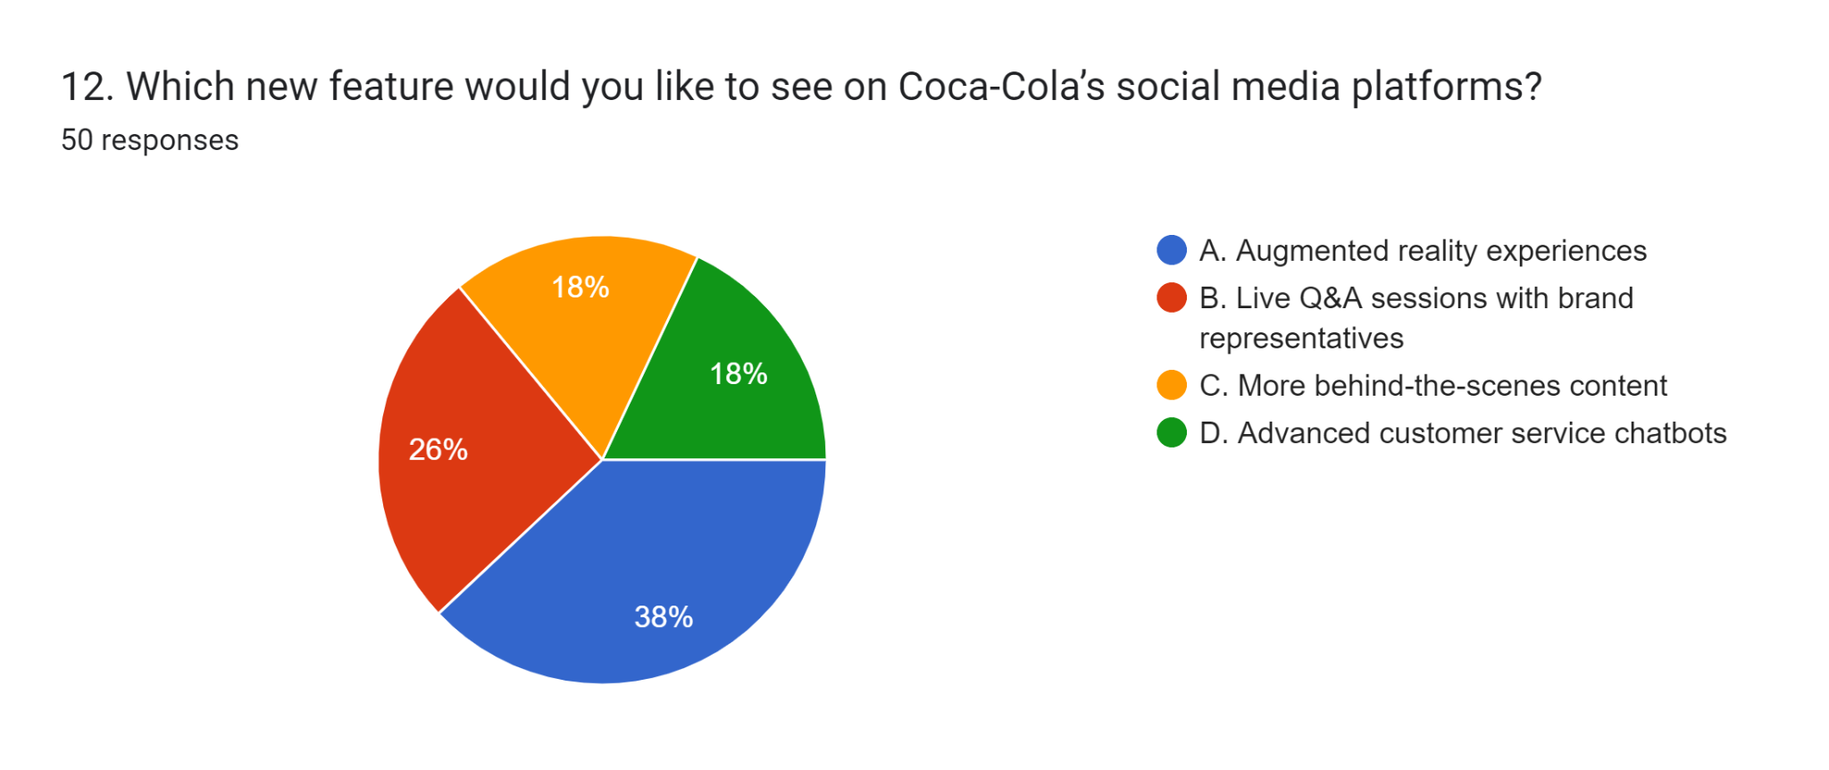
The pie chart reflects the lead results of a survey aimed at Coca-Cola customers to learn which new features they prefer to see on the company’s social media channels. The results indicate a trend in the choice of features, which suggests that 38% of respondents responded that they had an interest in the augmented reality (AR) experience. AR can take many forms, such as creating filters or games users can access on social accounts through their devices. Those attractions will entertain and provide new opportunities for the customers to interact with the brand, which may improve the customers’ experience and connection with Coca-Cola. Furthermore, more respondents indicated their favour for the live Question-and-Answer sessions with the brand representatives at 26%. At this moment, the company would allow customers to interact directly with the latter, including asking questions and coming up with instant replies. Transparency and trust would be greatly fostered, the strategy or production methods of the brand would be clear, and the customers would get valuable experiences through personalised engagement. It was found that after that, 18% of respondents tended to choose features that allow for sharing experiences with friends. This could encompass the development of networks that enable customers to publish materials, including photos or stories about their emotionally binding experiences involving Coca-Cola products, generating community and engagement. Last but not least, 18% of survey participants preferred customer service chatbots with higher levels of intelligence or artificial intelligence. This demand might be justified by a particular audience who prefers quick responses and swift solutions to customers' issues.

4.3 Chapter Summary
This Chapter concludes with taking the survey from 50 participants, The obtained outputs reveal a solid social media interaction, especially on Facebook and Instagram, being given by Coca-Cola. The feedback received is mostly positive, but there are aspects for perfection, specifically, quicker response time and brand values that correspond to it. This feature could be used in AR experiences and live Q&A to contribute more to customer satisfaction and interaction.

5.0 Discussion

5.1 Chapter Overview
The chapter examines Coca-Cola's calculated use of social media to maintain ties with its customers. It examines the business's online presence across many channels, including Facebook, Instagram, TikTok, and YouTube, emphasizing how well it engages customers. Coca-Cola has been successful in using social media for marketing and advertising, improving customer contact management, and increasing brand loyalty, according to research and survey results. Although the organization consistently exhibits excellent levels of client satisfaction and engagement, there is room for development in terms of connection and responsiveness.

5.2 Chapter Discussion

5.2.1 Analysing the many social media channels Coca-Cola uses to manage its customer relationships
Social media structural activities are effectively managed by Coca-Cola to address its patron through a various array of social media structures, and this is underlined in both the literature review section, as brought out in the 2.2.1 phase and empirical research findings which might be indicated in the 4.2 phase. In this regard, Chaulagain, and Maharjan, (2020), explained that social media advertising and marketing which involves the use of various social platforms to communicate with purchasers and sell products, plays a vital role in Coca-Cola’s consumer contact management. Such as the emblem of integrated advertising communique in several social media platforms is implausible. Furthermore, it is pivotal to appreciate how Coca-Cola has deployed various social media platforms to acquire customers more effectively compared to typical advertising media. Likewise, Chaulagain, and Maharjan, (2020), described that marketing effectiveness in acquiring customers on social media platforms is higher than in traditional methods. The most critical and vital social networking platforms like Facebook, Twitter, Instagram, TikTok, YouTube, LinkedIn, Google+ etc. are being used by Coca-Cola to sustain and adorn consumer relationships. The article by Wiese et al. (2020), brings into focus Facebook that functions as a tool for understanding the perception/attitude of buyers and in doing so, Coca-Cola could harness a wide populace to share promotional activities or allow bee-withdrawn content material, thus, building a counselling relation with the audience.
At the same time, the survey evidence supports this current literature by finding that 44% of the main participants interact with Coke on Facebook, which further reveals its pre-eminence as the channel of choice. It can be attributed to the extensive reach of Facebook and the interactivity that the platform supports (Wiese et al., 2020). TikTok is another large platform, and 17% of respondents reported attractive often to this platform, which is primarily identified with creativity and storytelling through pictures. Park and Namkung (2022), backed this up, pointing towards how Instagram plays a role in building brand equity, leveraging new product display concepts and influencer campaigns. Nevertheless, they have their roles and significance even though they are not as famous as Facebook and Instagram such as Twitter and YouTube. Similarly, from the experience of Puventheran et al. (2021), Twitter has been recognized as a means of ultimate purchaser interaction where the Coca-Cola company responds to inquiries and posts information regarding new products and activities. Although the relative involvement levels appear to be slightly lower (at 16% for YouTube and 14% for Twitter,) these sorts of architectures contribute to a holistic strategy of social media interaction since they provide live feeds and extended-form video respectively.
In the same manner, the utilisation of LinkedIn to connect with varied industries and gain perception into patron actions and TikTok for the modern and revolutionary motion pictures to interact with customers also, with numerous ranges of movement, exhibits that the enterprise has a complicated approach (Davis et al., 2020). These structures, while far less related to direct purchaser engagement, additionally assist extra common branding and enterprise-wanting aims. In this study, the results indicate that Coca-Cola’s stakeholder engagement through social media influences consumer profile and satisfaction. The outcomes of the survey mixed for a very high level of progressive cooperation with the content created by Coca-Cola, as proven by 42% replaying oftentimes in a day and 22% doing it at least as soon as a day. This constant interplay plays a great role in emphasizing that the brand can maintain its fresh and engaging social media profile. However, while 16% said they interact much less regularly, the call is to engage more actively in this phase, implying that there is a need for continuous strategy and planning to achieve this better. Further, an overwhelming majority of customers have a positive attitude towards the mentioned social media and sports where 38% said they were very satisfied and 24% partially happy. This implies that Coca-Cola customarily does a pretty good job of satisfying purchasers' expectancies during timely and compelling responses. However, 18% of employees indicated their dissatisfaction concerning specialisation in regions for interplay and responsiveness. These should be tackled to enhance basic client satisfaction and retention. Another crucial aspect of engagement includes participation in other social media activities such as contests and campaigns by Coca-Cola. A response to the same question showed that half of the respondents claimed to be frequently involved, thus pointing to a promising engagement level about the brand’s promotional events. Such a high involvement proves that campaigns and contests are effective tools for building purchaser relationships and enhancing brand affinity.
In accordance, it can be concluded that Coca-Cola has a powerful technique to manage patron relationships as seen through its sound utilisation of multiple offline and online social media platforms supported by sharing empirical research and academic findings. Coca-Cola effectively communicates with customers, turns efforts into enjoyable experiences, and builds long-standing connections through adapting content marketing strategies to the best attributes and identified audiences of each station. Accountabilities and logo values, nonetheless, would require continual emphasis and evaluation to address points of converging client expectations and achieve consistency.

5.2.2 Outlining Coca-Cola's social media marketing tactics
Coca-Cola has been the prime example of an immaculate beverage company worldwide. This has been possible with efficient marketing tactics initiated by the company. In section 2.2 .1, Wiese et al., (2020) mentioned that among social media platforms such as Facebook, Twitter, Instagram, TikTok, YouTube, LinkedIn, Google, and others. Facebook has been one of the most effective marketing tools, enabling the brand to include several promotional activities and advertising campaigns. Moreover, the study of Dwivedi et al. (2021) in section 2.2.2 has also supported that Coca-Cola has been maintaining significant connections with consumers with the help of advertisements. In this context, social media platforms have been an ample platform in fulfilling the tactics of social networking, leading to the attainment of consumer loyalty and further influencing the consumers to make a purchase.
Indeed, social media platforms are the most efficient marketing tactic, enabling social networking and also increasing the presence of the brand in different channels. This has led to a storytelling marketing tactic for the company acting as extremely remarkable and maintaining an emotional connection with the consumers as per the observation of Adeola, Hinson and Evans (2019). On the other hand, the respondents from the survey have also positively responded on the factors of engagement with the company with the help of social media. The propaganda initiated by the company by providing emotional content on social media platforms has been extremely efficient in obtaining brand loyalty and have also led to a significant rise in the consumers. Nevertheless, there is also a requirement of greater research in the context of the efficiency of the marketing tactic initiated by Coca-Cola. Detailed research on understanding the benefits of the marketing tactics initiated by the brand, backed by company reports and detailed statistics can further help in improvising research associated particularly with Coca-Cola.
On the other hand, Nikolinakou and Phua (2019), has mentioned that Coca-Cola utilises user-generated content as an important component in spreading awareness in the social media platforms. This process facilitates in creating a new space for the consumers to provide facts regarding the goods of Coca-Cola. This initiative is indeed an efficient process to improve the synergy of the brand and has also been backed by several social media influencers and celebrities in promoting different products as per Bağcan and Duygun, (2022) in section 2.2.2. User-generated content has also helped the brand to leverage its existence in the market and further promote a sense of belongingness to influence the perception of the consumers with the help of social connection. The results obtained from the survey have also led to significant facts which have proven that 38% of the respondents are satisfied with the responsiveness of Coca-Cola and social media platforms. Moreover, 50% of the respondents have also frequently participated in the campaigns and contests created by the brand on social media platforms. These factors further prove that the brand has been maintaining a strong recognition in the market leading to significant marketing tactics with effective collaboration of celebrities and other social media influencers.
The effectiveness of the marketing tactics initiated by Coca-Cola can also be identified with the help of Social Identity Theory where according to Murray, Koulanova and Sabiston (2022), social identity emphasises the level of belongingness felt by individuals towards a product or a group. Detailed understanding and analysis of different entities associated with the marketing factors of Coca-Cola have led to the conclusion that the brand has been maintaining an effective sense of belongingness and brand loyalty. Moreover, there is also scope for Coca-Cola to increase its connection with the consumers leading to enhancement of consumer engagement.
Overall, the social media marketing tactics included by Coca-Cola help in engaging the consumers with the help of storytelling, user-generated content or collaborations with celebrities and influencers. Nevertheless, it is also important for Coca-Cola to understand that the company must maintain its position in the market as a prime brand in beverages and also inculcate new tactics in physical stores as well to improve its strategies.
Concisely put, some of the approaches through which Coca-Cola saturates social media advertising effectively streamline numerous systems to enhance brand affinity and advocacy. They incorporate going for interactive campaigns, creating content material based on what the users contribute, as well as partnerships with personalities, thus creating a living brand image. Through the use of promotions such as advertisements and immediate reaction, they develop a strong connection with the audience they have. Coca-Cola’s efforts at storytelling and physical appeal are also ideal for bolstering its emblem construction. These strategies illustrate their capacity to align with virtual trends and patron opportunities which guarantees long-term viability and competitive engagement inside the adventurous beverage enterprise.

5.2.3 Surveying the Terrain: Social Media's Potential and Difficulties
Societal media has transformed how groups connect and spread information, creating huge societal shifts. As per the view by Bimo (2022) shows that while social media offers several benefits, it also adds obstacles including cyberbullying, mental health issues, bogus news, and privacy concerns. The Uses and Gratifications Theory, created by Katz and Blumler (1974), explains why individuals utilise various media and the enjoyment they get. A similar view can be seen in the study by Liu, Min, and Han (2019) stress that individuals actively seek media to satisfy demands such as information, amusement, or social contact. Organisations may exploit this information to engage users more successfully. Coca-Cola's social media approach satisfies consumers' demands for identity, amusement, and social connection, which is in line with the Uses and Gratifications Theory. This strategy strengthens brand loyalty and emotional ties. On the other hand, disinformation spreading is a serious problem. According to Muhammad and Mathew (2022), rumours that sway public opinion might result from the fast dissemination of information without proper vetting.
Privacy is one of the biggest concerns when it comes to exploring the dynamics of social media. As Obar and Oeldorf-Hirsch (2020) noted, in today’s social networks, people share personal information, and this data needs protection. Preserving the confidentiality of data and following privacy requirements are necessary to establish and build trust between users and organisations. The promotional utility of social media is immense. It cannot be compared to any other traditional form of promotion as it can reach as broad an audience as possible at a relatively cheap cost. Chaker et al. (2022) state that businesses can continue a business relationship through social media networks, increase customer commitment and stimulate consumption. Moreover, Iglesias-Sánchez et al. (2020) also reveal that social networks can support innovation by engaging with members of external value networks. The reasons people use social media and whether those media change their self-esteem and relations can be explained with the help of the Social Identity Theory and the Uses and Gratifications Theory. Thus, while social media offers promising potential for communication and collaboration with people from different countries, there are pertinent issues, including misguidance and leaked personal data.
On the other hand, the survey results indicates that Coca-Cola’s social media consumers demonstrated high brand entropy, with 42% being present more than once daily on the brand’s content. Facebook was the most used platform, and Instagram came second among them. The survey conducted in the study revealed that participants considered visual content very helpful, with 44% opting for it. Another critical finding from the survey was that 38 percent of the participants were very satisfied with how Coca-Cola deals with social media, meaning that the company has engaged the public appropriately. However, 18% responded that they were not satisfied, which points to the areas of possible improvement of the site for the aspect of responsiveness and interaction with the visitors.
A potential challenge of utilising social media can be the circulation of false information. According to the observation of Muhammed and Mathew (2022), rumours can indeed affect the perception of the public and create a detrimental impact on the sales of the products created by Coca-Cola. Since the brand is famous worldwide, the organisation needs to maintain technological upgrades to address such problems. Moreover, there is also a probability that false information circulated on social media platforms could create a negative influence on the values fulfilled by the brand. As identified from the server results, 42% of the respondent’s value product updates and news related to Coca-Cola from social media. Moreover, 50% of the respondents also frequently participate in the campaigns created by the brand on social media platforms.
Therefore, false rumours or negative information regarding the brand can directly impact the sales of the company, creating a major setback for the brand, not only in a particular country but also worldwide. The fact that social media platforms are an emerging trend, offering new perspectives for the brand and opportunities to engage with the consumers cannot be overlooked. Moreover, the level of data and analytics that social media platforms provide can further help Coca-Cola to refine its marketing strategies and understand consumer behaviour, thereby adjusting the required campaigns according to the real-time insights.

5.2.4 Improving Customer Relations: Using Social Media to Strengthen CRM Techniques
The systemic adoption of social media by Coca-Cola and the constant improvement of CRM techniques and strategies were found helpful to increase customer relations and strengthen Customer Relationship Management (CRM). This is also underlined by recent works, for example, the works of Dastane (2020) are devoted to describing the engagement of consumers through campaigns and activity on social media. As impressive as the platforms are, Coca-Cola needs to approach CRM implementation on these platforms strategically to fully unlock their potential.
Furthermore, listening to the consumers is very crucial, hence it is important to begin the process with a focus on the consumer. In marketing context, goal setting, planning, implementation, evaluation and control of resources must be in congruence with the consumers’ expectations according to Esper et al. (2020). Applied to Coca-Cola this may involve tackling issues of health risks arising from the compound utilised through less use of sugar or provision of healthier products, therefore showing concern in the consumers’ well-being. It is therefore easier to improve trust and make the consumer-brand bond stronger.
In a larger sense, Valentinov and Chia (2022) have captured the idea of applying stakeholder theory in the sense that it would help Coca-Cola to understand consumer expectations. This theory also emphasises the involvement of the stakeholders in the decisions such as the employee, investors, consumers and the supplier. In this manner, Coca-Cola will be able to better understand and incorporate strategies in its management that are better suited to address the specific needs and requisites of its various stakeholders towards the ultimate formation of more resilient and long-term relationships.
Other factors for consideration include business accountability and transparency. Kumar (2024) obesity ethical responsibilities and transparency seeks to be a vital component in building consumer confidence. The supply chain for Coca-Cola should be a regulation of its policies as well as informing consumers about sustainability on social media. Li and Kallas (2021) note that consumers will pay a premium for goods from organisations that meet sustainability standards; thus, establishing that such practices deliver not only customer loyalty but also a competitive edge.
A majority of the survey participants reported they frequently come across some or all of Coca-Cola’s social media posts, which may include those on FACEBOOK and INSTAGRAM. But simultaneously, it was possible to identify certain reactions of audiences with less frequency, therefore there is potential here to develop. According to the specific characteristics and popularity of each site, greater attention should be paid to the syndication to the small following sites and the adjustment of the content type to brand the followers more effectively.
Evidently, the majority of customers are satisfied with the usage of social media by Coca-Cola, but some aspects require further improvement. On average, the scores stand at 38% concerning high satisfaction, and 18% concern dissatisfaction because customers expect quick replies to queries. Solving them on the spot will go a long way towards increasing the satisfaction level and perceived customer loyalty. Social media’s use for campaign activities is also engaged with high frequency as 50% of respondents engaged often. This suggests that entertainment and frequent updates for the consumer are also among the most important aspects of any content. Additionally, 44% of participants expect visually appealing and informative content posts; therefore, posts must be appropriately sized and laid out.
Similarity, according to survey data, 42% of respondents engage with Coca-Cola's social media material numerous times a day, indicating strong involvement. With 44% of respondents, Facebook is the most effective platform; Instagram comes in second with 26%. It is possible to improve brand connections and boost customer engagement by tailoring content strategy to each platform. The majority of respondents to the survey expressed satisfaction with Coca-Cola's social media strategy, while they believe that response and involvement may be enhanced. Another Survey results indicates that with 50% of respondents regularly participating, Coca-Cola's social media campaigns and contests enjoy significant participation rates. The poll also showed a range of preferences for social media material, with 44% of respondents saying they like visual content the most. 44% of consumers say their attitudes have changed for the better as a result of Coca-Cola's social media presence. The survey findings indicate that Coca-Cola fans engage with the firm selectively and do not necessarily feel happy about it. On the one hand, the % of those who interact with Coca-Cola’s content many times a day is 42%, while 22% interact with it at least once a day. According to the data, Coca-Cola has a very high daily engagement rate.
On the other hand, specific to the frequency of use, 16% of these individuals communicate less frequently, several times a week or less. It is also interesting to note the platform loyalty; Facebook leads the group with 44% of the subjects using it primarily, and Instagram follows with 26%. In this case, blogs lead with 54%, while Facebook comes in second at 37%, YouTube at 16%, and Twitter at 14%. As for the customer satisfaction level, 38% are 'delighted' with the Responsiveness of Coca-Cola in social media, while 24% are 'partially satisfied'. Still, 18 percent are dissatisfied with it, and 8 percent are very dissatisfied, pointing towards the potential for perfecting the system. More importantly, the strength of those two values is relatively high, with the percentage of agreement on social media activities being in line with the Coca-Cola brand at 44%, while the percentage of disagreement stands at 14%. Thus, the indicated popularity of Coca-Cola on social media proves that it should focus on improving the issue by adapting to the population's expectations.

5.3 Chapter Summary
The chapter concludes by examining how Coca-Cola has efficiently handled customer relationships by leveraging social media platforms such as Facebook, Instagram, TikTok and YouTube. It complements the company’s market plan, especially regarding advertising, marketing, and consumer opinion changes on its products, thus boosting brand identity and loyalty. However, in general, the social media activity described above and Coca-Cola’s general activity reflects the willingness of the company to continue to invest in social media to engage loyalty and positive associations among the target audiences.

6.0 Conclusion and Recommendations

6.1 Chapter Introduction
This conclusion and recommendations chapter mainly provide valuable insights from the overall research work. Concluding the information from thematic analysis and findings of the survey results this chapter focuses on each research objective and its learning outcomes. Providing a summary of findings and a conclusion of objectives this chapter recommended various strategies for Coca-Cola to improve its weaknesses and research limitations.

6.2 Summary of Findings
In this research work the findings chapter analyses the result from the survey of 50 participants. Overall findings chapter provides in-depth insights about product preferences, social media engagement, face issues and further recommendations for Coca-Cola. Each question highlights consumer relationship management of the brand by using social media platforms. Regarding the first objective, the result proves 38% of respondents are very satisfied with the social media platforms of the brand. The results showcase strong engagement with the content of the brand particularly on Facebook and Instagram platforms.
Despite this high engagement of customers, some participants highlighted the need for different platform-specific strategies. The result also demonstrates participants' satisfaction level with the social media presence of Coca-Cola is generally positive. However, 18% of participants expressed their dissatisfaction which indicates the brand needs to improve its interaction method in a responsive manner. 44% of participants mostly prefer visual content for more engagement. Preferences for social media content type vary with respondents' product preferences.
As per their responses, it is clear that visually compelling content is the most popular followed by user-generated content. The brand positively influenced customers and handled negative feedback effectively to highlight the better alignment of brand values. In this survey, key benefits identify improved customer service and more engaging brand experiences to mitigate issues with social media communication. Coca-Cola identifies AR technology's importance and live Q&A sessions to enable more transparent communication efforts. The overall chapter helps to understand the key strengths, and weaknesses of Coca-Cola and identify areas for improvement based on participants' responses.

6.3 Recommendations
Based on the research findings and discussion various recommendations need to be provided for Coca-Cola to improve its CRM through social media platforms.
- Improve Responsiveness: Caca-Cola should prioritise the improvement of efficiency and speed of customer inquiry response on different platforms. Providing training and adequate support to customer service teams and implementing responsive chatbots may ensure satisfactory and timely communication and enhance customer satisfaction.
- Alignment with Brand Values: The brand needs to maintain its consistency on social media aligning with core brand values. Ensuring messaging to consumers and content resonate with brand identity reinforces its unique positioning and connections with the target customer base.
- Diversity in Content: The company should diversify its content strategies on social media that involve the incorporation of surveys. The brand should showcase behind-the-scenes content for customers to deepen their connection with customers.
- Innovative Features: Coca-Cola can differentiate their brand positioning from competitors by leveraging innovative technologies. The company needs to use AR technologies and live Q&A sessions for customers that may enhance their experiences and satisfaction.

6.4 Linking with Objective 1
The first research objective mainly demonstrates that Coca-Cola uses a variety of social media marketing strategies to engage with its targeted customer base. The brand focuses on Facebook and Instagram platforms through regular content updates, responsive consumer service and interactive campaigns. These platforms are mostly used for broader consumer reach and diverse content marketing through visual content. Besides the integrated marketing communications (IMC) strategy also ensures engagement with customers aligns with brand values and customer preferences. Finally, an in-depth analysis of the first objective helps to understand different social media marketing strategies used by Coca-Cola in its ongoing business operation.

6.5 Linking with Objective 2
The second research objective indicates that Coca-Cola leverages different social media platforms to boost customer relationship management (CRM). The key performance through Instagram and Facebook has a significant role in leveraging user engagement due to its broader content and customer reach abilities. The brand uses visually appealing content, interactive social media campaigns and continuous updates to improve relationships with consumers. These approaches improve consumer satisfaction levels and promote community engagement. The thematic analysis and research findings of primary data provide valuable insights regarding the use of social media platforms by Coca-Cola to enhance CRM efforts.

6.6 Linking with Objective 3
The third objective of this research highlight significant opportunities and challenges faced by the brand to leverage social media platforms for customer engagement. The analysis identifies key challenges related to timely responses to customers' questions and concerns and alignment with social media activities to ensure brand values. Besides, Coca-Cola identifies opportunities regarding CRM that demand the incorporation of AR tools and Q&A sessions. These opportunities may increase consumer satisfaction and engagement levels. The overall analysis of these objectives supported by survey and industry research demonstrates the idea of opportunities and challenges faced by Coca-Cola.

6.7 Limitations of the Research
The overall research identifies various limitations of this work that hinder the quality and create difficulties for in-depth analysis of the findings. The sample size of the survey was only 50 participants which is relatively small and represents limited data about the social media engagement of Coca-Cola. Responses may be influenced by self-reporting biases that provide answers as favourable options rather than real opinions. This research predominantly uses quantitative data that limits the depth of the findings about consumers' responses and experiences. Future research needs to be more diverse in sampling methods and should incorporate qualitative methods to offer a more comprehensive understanding of social media engagement in CRM strategies.

6.8 Future Research
In this research study, future research should examine the social media platforms to improve consumer relationship management (CRM) for Coca-Cola. Understanding the application of different technologies like ML and AI this research may customise the social media communication strategy of the company. Moreover, the role of social media platforms and marketing strategies during crisis management will enhance brand image. Comparative analysis with competitors in future can highlight innovative methods for Coca-Cola. An in-depth investigation of consumer sentiments enhances brand engagement and loyalty efforts for the future.

References

Chapter 1
Arora, L., Singh, P., Bhatt, V. and Sharma, B., 2021. Understanding and managing customer engagement through social customer relationship management. Journal of Decision Systems, 30(2-3), pp.215-234. Available at: https://doi.org/10.1080/12460125.2021.1881272 (Accessed on 27 April, 2024).
Coca-Cola, 2024. The Coca-Cola Company. [online] The Coca-Cola Company. Available at: https://www.coca-colacompany.com/. (Accessed on 27 April 2024).
Digital Scholar, 2022. Coca-Cola’s Digital Marketing Strategies - Case Study. [online] Available at: https://digitalscholar.in/coca-colas-digital-marketing-strategies/. (Accessed on 27 April 2024).
Jacobson, J., Gruzd, A. and Hernández-García, Á., 2020. Social media marketing: Who is watching the watchers?. Journal of retailing and consumer services, 53, p.101774. Available at: https://doi.org/10.1016/j.jretconser.2019.03.001 (Accessed on 27 April, 2024).
Khan, I., 2023. A Study of sales promotion of coca cola’ (Doctoral dissertation, Rashtrasant Tukadoji Maharaj Nagpur University). Available at: https://gscen.shikshamandal.org/wp-content/uploads/2023/07/37.pdf (Accessed on 27 April, 2024).
Patel, R., 2020. CORPORATE SOCIAL RESPONSIBILITIES: A WINNING STRATEGY TO BUILD CUSTOMER RELATIONS. Changing Landscape of Corporate Governance & Corporate Social Responsibility, p.94. Available at: https://www.researchgate.net/profile/Ram-Singh-63/publication/354522151_CORPORATE_SOCIAL_RESPONSIBILITY_MAJOR_TENDS_IN_INDIA/links/629c3014a3fe3e3df85dd3e6/CORPORATESOCIALRESPONSIBILITYMAJOR-TENDS-IN-INDIA.pdf#page=100 (Accessed on 27 April, 2024).
Sánchez Huguet, C., 2021. Seizing big marketing opportunities in Europe: a roadmap for efficient big data implementation in Spanish SMEs. Available at: https://academica-e.unavarra.es/bitstream/handle/2454/40204/Memoria_TFE_1.pdf?sequence=1&isAllowed=y (Accessed on 27 April, 2024).
Syahchari, D.H., Herlina, M.G. and Omar, A., 2023. The Role of Social Capital, Social Media Marketing, and Entrepreneurial Orientation in the Success of Small and Medium Enterprises in the Tourism Industry. Binus Business Review, 14(3), pp.331-341. Available at: https://doi.org/10.21512/bbr.v14i3.1035 (Accessed on 27 April, 2024).
Xue, J., 2023. Social media marketing, customer relationship management strategies, and e-commerce strategies: Basis for marketing performance framework. International Journal of Research, 12(2), pp.155-166. Available at: https://www.researchgate.net/profile/Xue-Jingjing-2/publication/379839334_SOCIAL_MEDIA_MARKETING_CUSTOMER_RELATIONSHIP_MANAGEMENT/links/661e4af743f8df018d0edfa8/SOCIALMEDIAMARKETINGCUSTOMER-RELATIONSHIP-MANAGEMENT.pdf (Accessed on 27 April 2024).

Chapter 2
.Bağcan and Duygun., 2022. A MULTIDIMENSIONAL MARKETING COMMUNICATION MODEL ON SOCIAL MEDIA FOR GLOBAL BRANDS: THE CASE OF COCA-COLA TURKEY. Turkish Online Journal of Design Art and Communication, [online] 12(2), pp.469–482. Available at: https://dergipark.org.tr/en/pub/tojdac/issue/68757/1057300 [Accessed 27 April 2024].
Bimo, S., 2022. Why’s Everyone on TikTok Now? The Algorithmized Self and the Future of Self-Making on Social Media - Aparajita Bhandari, Sara Bimo, 2022. [online] Social Media + Society. Available at: https://journals.sagepub.com/doi/full/10.1177/20563051221086241 [Accessed 27 April 2024].
Cao, P., 2023. Exploring Primary Demands of Chinese Network Literature Audience: Uses and Gratifications Perspective. Advances in Social Science, Education and Humanities Research/Advances in social science, education and humanities research, [online] pp.323–334. Available at: https://doi.org/10.2991/978-2-38476-098-5_28. [Accessed 27 April 2024].
‌Chaker, N.N., Nowlin, E.L., Pivonka, M.T., Itani, O.S. and Agnihotri, R., 2022. Inside sales social media use and its strategic implications for salesperson-customer digital engagement and performance. Industrial marketing management, [online] 100, pp.127–144. Available at: https://doi.org/10.1016/j.indmarman.2021.10.006. [Accessed 27 April 2024].
Chaulagain, S. and Maharjan, S., 2020. Social Media as a Strategic Marketing Tool to Study the Consumer Behavior of Coca-Cola by K-Means Cluster Analysis: Evidence from Facebook. Available at: http://conference.ioe.edu.np/publications/ioegc8/ioegc-8-081-80111.pdf [Accessed 27 April 2024].
Dastane, D.O., 2020. Impact of digital marketing on online purchase intention: Mediation effect of customer relationship management. Journal of Asian Business Strategy, DOI, 10, pp.142-158. Available at: https://www.researchgate.net/profile/Omkar-Dastane/publication/341479818_Impact_of_Digital_Marketing_on_Online_Purchase_Intention_Mediation_Effect_of_Customer_Relationship_Management/links/5ec36a53458515626cb4cf1e/Impact-of-Digital-Marketing-on-Online-Purchase-Intention-Mediation-Effect-of-Customer-Relationship-Management.pdf [Accessed 27 April 2024].
Davis, J., Wolff, H.G., Forret, M.L. and Sullivan, S.E., 2020. Networking via LinkedIn: An examination of usage and career benefits. Journal of Vocational Behavior, 118, p.103396. Available at: https://doi.org/10.1016/j.jvb.2020.103396
Demirden, A., 2021. The critical examination of social identity theory. Politik Psikoloji Dergisi, 1(2), pp.39-56. Available at: https://www.politikpsikolojidergisi.com/index.php/pub/article/download/7/7 [Accessed 27 April 2024].
Dwivedi, Y.K., Ismagilova, E., D. Laurie Hughes, Carlson, J., Raffaele Filieri, Jacobson, J., Jain, V., Heikki Karjaluoto, Hajer Kefi, Krishen, A.S., Kumar, V., Rahman, M.M., Raman, R., Rauschnabel, P.A., Rowley, J.E., Salo, J., Tran, G.A. and Wang, Y., 2021. Setting the future of digital and social media marketing research: Perspectives and research propositions. International journal of information management, [online] 59, pp.102168–102168. Available at: https://doi.org/10.1016/j.ijinfomgt.2020.102168. (Accessed on 27 April, 2024).
Esper, T.L., Castillo, V.E., Ren, K., Sodero, A., Wan, X., Croxton, K.L., Knemeyer, A.M., DeNunzio, S., Zinn, W. and Goldsby, T.J., 2020. Everything old is new again: The age of consumer‐centric supply chain management. Journal of Business Logistics, 41(4), pp.286-293. Available at: https://doi.org/10.1111/jbl.12267 [Accessed 27 April 2024].
Fanta, B.A. and Ayman, B., 2021. Social media as effective tool for understanding customer experience: a systematized review. Marketing & Menedzsment, 55(4), pp.15-25. Available at: https://doi.org/10.15170/MM.2021.55.04.02 [Accessed 27 April 2024].
Francis, Stuart., Rospigliosi, Asher and Samuel, Bruce. (2019). The Digital Marketing Power of Transmedia: Applying Keller’s Brand Resonance Pyramid to the Marvel Cinematic Universe. 10.17230/9789587206289ch13. Available at: https://www.researchgate.net/publication/341840657_The_Digital_Marketing_Power_of_Transmedia_Applying_Keller's_Brand_Resonance_Pyramid_to_the_Marvel_Cinematic_Universe/citation/download?_tp=eyJjb250ZXh0Ijp7ImZpcnN0UGFnZSI6Il9kaXJlY3QiLCJwYWdlIjoiX2RpcmVjdCJ9fQ [Accessed 15 June 2024].
Hardwick, Philip and Letza, Stephen. 2022. The Relative Performance of Mutual and Proprietary Life Insurance Companies in the UK: An Exploratory Study. Available at: https://www.researchgate.net/publication/237711067_The_Relative_Performance_of_Mutual_and_Proprietary_Life_Insurance_Companies_in_the_UK_An_Exploratory_Study/citation/download?_tp=eyJjb250ZXh0Ijp7ImZpcnN0UGFnZSI6Il9kaXJlY3QiLCJwYWdlIjoiX2RpcmVjdCJ9fQ [Accessed 27 April 2024].
Hossain, Kim, M. and Jahan, N., 2019. Can ‘Liking’ Behavior Lead to Usage Intention on Facebook? Uses and Gratification Theory Perspective. Sustainability, [online] 11(4), pp.1166–1166. Available at: https://doi.org/10.3390/su11041166. [Accessed 27 April 2024].
Iglesias-Sánchez, P.P., López-Delgado, P., Correia, M.B. and Jambrino-Maldonado, C., 2020. How do external openness and R&D activity influence open innovation management and the potential contribution of social media in the tourism and hospitality industry? Information technology & tourism, [online] 22(2), pp.297–323. Available at: https://doi.org/10.1007/s40558-019-00165-y. [Accessed 27 April 2024].
Irene, Julius., daniels, chux., Kelly, Mary., Irene, Bridget., Frank, Regina and Okpara, Kingsley. 2023. A Social Identity Approach to Understanding Sustainability and Environmental Behaviours in South Africa. 10.20944/preprints202311.0362.v1. Available at: https://www.researchgate.net/publication/375409534_A_Social_Identity_Approach_to_Understanding_Sustainability_and_Environmental_Behaviours_in_South_Africa/citation/download?_tp=eyJjb250ZXh0Ijp7ImZpcnN0UGFnZSI6Il9kaXJlY3QiLCJwYWdlIjoiX2RpcmVjdCJ9fQ [Accessed 27 April 2024].
Koivisto, E. and Mattila, P., 2020. Extending the luxury experience to social media–User-Generated Content co-creation in a branded event. Journal of Business Research, 117, pp.570-578. Available at: https://doi.org/10.1016/j.jbusres.2018.10.030 [Accessed 27 April 2024].
Kumar, T.A., 2024. Ethical Dilemmas In State And Local Tax Planning: Balancing Profit Maximization And Social Responsibility. Educational Administration: Theory and Practice, 30(4), pp.667-678. Available at: https://doi.org/10.53555/kuey.v30i4.1534 [Accessed 27 April 2024].
Li, S. and Kallas, Z., 2021. Meta-analysis of consumers' willingness to pay for sustainable food products. Appetite, 163, p.105239. Available at: https://upcommons.upc.edu/bitstream/handle/2117/367784/Paper%20Congreso%20E%20Agr%20Cartagena.pdf?sequence=3 [Accessed 27 April 2024].
Lim, W.M., 2022. Toward a theory of social influence in the new normal. Activities, Adaptation & Aging, 46(1), pp.1-8. Available at: https://doi.org/10.1080/01924788.2022.2031165
Muhammed and Mathew, S.K., 2022. The disaster of misinformation: a review of research in social media. International journal of data science and analytics, [online] 13(4), pp.271–285. Available at: https://doi.org/10.1007/s41060-022-00311-6. [Accessed 27 April 2024].
‌Nikolinakou, A. and Phua, J., 2019. ‘Do human values matter for promoting brands on social media? How social media users’ values influence valuable brand‐related activities such as sharing, content creation, and reviews’. Journal of consumer behaviour, [online] 19(1), pp.13–23. Available at: https://doi.org/10.1002/cb.1790. (Accessed on 27 April, 2024).
Obar, J. and Oeldorf-Hirsch, A., 2020. The biggest lie on the Internet: ignoring the privacy policies and terms of service policies of social networking services. [online] Information, Communication & Society. Available at: https://www.tandfonline.com/doi/abs/10.1080/1369118X.2018.1486870 [Accessed 27 April 2024].
Ogechi Adeola, Robert Ebo Hinson and Evans, O., 2019. Social Media in Marketing Communications: A Synthesis of Successful Strategies for the Digital Generation. Springer eBooks, [online] pp.61–81. Available at: https://doi.org/10.1007/978-3-030-08277-2_4. (Accessed on 27 April, 2024).
Park, C.I. and Namkung, Y., 2022. The effects of instagram marketing activities on customer-based brand equity in the coffee industry. Sustainability, 14(3), p.1657. Available at: https://doi.org/10.3390/su14031657
Puventheran, S., Bakar, J.A., Katuk, N. and Sharipudin, M.N.S., 2021. Dashboard for Social Media Marketing Analysis Between B2B Company (Pepsi vs Coca-Cola). Multidisciplinary Applied Research and Innovation, 2(3), pp.207-211. Available at: https://publisher.uthm.edu.my/periodicals/index.php/mari/article/download/5119/1540
Valentinov, V. and Chia, R., 2022. Stakeholder theory: A process‐ontological perspective. Business Ethics, the Environment & Responsibility, 31(3), pp.762-776. Available at: https://doi.org/10.1111/beer.12441 [Accessed 27 April 2024].
Wiese, M., Martínez-Climent, C. and Botella-Carrubi, D., 2020. A framework for Facebook advertising effectiveness: A behavioral perspective. Journal of Business Research, 109, pp.76-87. Available at: https://doi.org/10.1016/j.jbusres.2019.11.041
Zollo, L., Filieri, R., Rialti, R. and Yoon, S., 2020. Unpacking the relationship between social media marketing and brand equity: The mediating role of consumers’ benefits and experience. Journal of Business research, 117, pp.256-267. Available at: https://doi.org/10.1016/j.jbusres.2020.05.001 [Accessed 27 April 2024].
Liu, X., Min, Q. and Han, S., 2019. Understanding users’ continuous content contribution behaviours on microblogs: an integrated perspective of uses and gratification theory and social influence theory. [online] Behaviour & Information Technology. Available at: https://www.tandfonline.com/doi/abs/10.1080/0144929X.2019.1603326 [Accessed 4 May 2024].
Murray, R., Koulanova and Sabiston, C. 2022. Understanding Girls’ Motivation to Participate in Sport: The Effects of Social Identity and Physical Self-Concept. Frontiers in sports and active living, [online] 3. Available at: https://doi.org/10.3389/fspor.2021.787334. [Accessed 4 May 2024].

Chapter 3
Abdelhakim, A.S., 2021. Adopted Research Designs by Tourism and Hospitality Postgraduates in The Light‎ of Research Onion. International Journal of Tourism and Hospitality Management, 4(2), pp.98-124. Available at: https://ijthm.journals.ekb.eg/article_206774_39a512b92a6470df762792c8d0c60a12.pdf [Accessed 06 May 2024].
Al-Ababneh, M., 2020. Linking ontology, epistemology and research methodology. Science & Philosophy, 8(1), pp.75-91. Available at: http://eiris.it/ojs/index.php/scienceandphilosophy/article/viewFile/500/732 [Accessed 06 May 2024].
Amin, M.E.K., Nørgaard, L.S., Cavaco, A.M., Witry, M.J., Hillman, L., Cernasev, A. and Desselle, S.P., 2020. Establishing trustworthiness and authenticity in qualitative pharmacy research. Research in social and administrative pharmacy, 16(10), pp.1472-1482. Available at: https://doi.org/10.1016/j.sapharm.2020.02.005 [Accessed 06 May 2024].
Bauer, G.R., Churchill, S.M., Mahendran, M., Walwyn, C., Lizotte, D. and Villa-Rueda, A.A., 2021. Intersectionality in quantitative research: A systematic review of its emergence and applications of theory and methods. SSM-population health, 14, p.100798. Available at: https://doi.org/10.1016/j.ssmph.2021.100798 [Accessed 06 May 2024].
de Mast, J., Steiner, S.H., Nuijten, W.P. and Kapitan, D., 2023. Analytical problem solving based on causal, correlational and deductive models. The American Statistician, 77(1), pp.51-61. Available at: https://doi.org/10.1080/00031305.2021.2023633 [Accessed 06 May 2024].
Holtom, B., Baruch, Y., Aguinis, H. and A Ballinger, G., 2022. Survey response rates: Trends and a validity assessment framework. Human relations, 75(8), pp.1560-1584. Available at: https://doi.org/10.1177/00187267211070769 [Accessed 06 May 2024].
Ling, G.Y., Yuang, G., Zhicheng, G., Xuan, G.T.X., Maharani, C.D., Genira, C.F., Tyagi, N. and Saidhanyakumar, M., 2023. Analysis of factors affecting brand loyalty: A study of Coca-Cola. Asia Pacific Journal of Management and Education (APJME), 6(3), pp.16-29. Available at: https://doi.org/10.32535/apjme.v6i3.2635 [Accessed 06 May 2024].
Mahafzah, A.G., Aljawarneh, N.M., Alomari, K.A.K., Altahat, S. and Alomari, Z.S., 2020. Impact of customer relationship management on food and beverage service quality: The mediating role of employees satisfaction. Humanities & Social Sciences Reviews, 8(2), pp.222-230. Available at: https://doi.org/10.18510/hssr.2020.8226 [Accessed 06 May 2024].
Mazhar, S.A., Anjum, R., Anwar, A.I. and Khan, A.A., 2021. Methods of data collection: A fundamental tool of research. Journal of Integrated Community Health (ISSN 2319-9113), 10(1), pp.6-10. Available at: http://medicaljournalshouse.com/index.php/ADR-CommunityHealth/article/download/631/496 [Accessed 06 May 2024].
Pearse, N., 2021. Guidelines for theory development using qualitative research approaches. Electronic Journal of Business Research Methods, 19(2), pp.pp95-103. Available at: https://academic-publishing.org/index.php/ejbrm/article/download/2512/2015 [Accessed 06 May 2024].
Salkind, N.J. and Frey, B.B., 2021. Statistics for people who (think they) hate statistics: Using Microsoft Excel. Sage publications. Available at: https://citeseerx.ist.psu.edu/document?repid=rep1&type=pdf&doi=2b0ca135749f90cfd07b74359ba7e7fa275a5927 [Accessed 06 May 2024].
Seuring, S., Stella, T. and Stella, M., 2021. Developing and publishing strong empirical research in sustainability management—Addressing the intersection of theory, method, and empirical field. Frontiers in Sustainability, 1, p.617870. Available at: https://doi.org/10.3389/frsus.2020.617870 [Accessed 06 May 2024].
Singh, D., 2020. Hypothesis: Meaning, Types and Formulation. Journal of Legal Studies and Research, 6(6), pp.146-163. Available at: https://thelawbrigade.com/wp-content/uploads/2021/01/Dasvinder-Singh-JLSR.pdf [Accessed 06 May 2024].
Stommel, W. and Rijk, L.D., 2021. Ethical approval: None sought. How discourse analysts report ethical issues around publicly available online data. Research Ethics, 17(3), pp.275-297. Available at: https://doi.org/10.1177/1747016120988767 [Accessed 06 May 2024].
Taherdoost, H., 2021. Data collection methods and tools for research; a step-by-step guide to choose data collection technique for academic and business research projects. International Journal of Academic Research in Management (IJARM), 10(1), pp.10-38. Available at: https://hal.science/hal-03741847/document [Accessed 06 May 2024].
Ugwu, C.I., Ekere, J.N. and Onoh, C., 2021. Research paradigms and methodological choices in the research process. Journal of Applied Information Science and Technology, 14(2), pp.116-124. Available at: https://www.jaistonline.org/14vol2/12.pdf [Accessed 06 May 2024].
Xu, A., Baysari, M.T., Stocker, S.L., Leow, L.J., Day, R.O. and Carland, J.E., 2020. Researchers’ views on, and experiences with, the requirement to obtain informed consent in research involving human participants: a qualitative study. BMC medical ethics, 21, pp.1-11. Available at: https://doi.org/10.1186/s12910-020-00538-7 [Accessed 06 May 2024].
Ye, J., Wang, Z. and Hai, J., 2022. Social networking service, patient-generated health data, and population health informatics: national cross-sectional study of patterns and implications of leveraging digital technologies to support mental health and well-being. Journal of medical Internet research, 24(4), p.e30898. Available at: https://doi.org/10.2196/30898 [Accessed 06 May 2024].
Zyphur, M.J. and Pierides, D.C., 2020. Making quantitative research work: From positivist dogma to actual social scientific inquiry. Journal of Business Ethics, 167, pp.49-62. Available at: https://doi.org/10.1007/s10551-019-04189-6 [Accessed 06 May 2024].

Chapter 5:
Dastane, D.O., 2020. Impact of digital marketing on online purchase intention: Mediation effect of customer relationship management. Journal of Asian Business Strategy, DOI, 10, pp.142-158. Available at: https://www.researchgate.net/profile/Omkar-Dastane/publication/341479818_Impact_of_Digital_Marketing_on_Online_Purchase_Intention_Mediation_Effect_of_Customer_Relationship_Management/links/5ec36a53458515626cb4cf1e/Impact-of-Digital-Marketing-on-Online-Purchase-Intention-Mediation-Effect-of-Customer-Relationship-Management.pdf [Accessed 30 May 2024]
Esper, T.L., Castillo, V.E., Ren, K., Sodero, A., Wan, X., Croxton, K.L., Knemeyer, A.M., DeNunzio, S., Zinn, W. and Goldsby, T.J., 2020. Everything old is new again: The age of consumer‐centric supply chain management. Journal of Business Logistics, 41(4), pp.286-293. Available at: https://doi.org/10.1111/jbl.12267 [Accessed 30 May 2024].
Valentinov, V. and Chia, R., 2022. Stakeholder theory: A process‐ontological perspective. Business Ethics, the Environment & Responsibility, 31(3), pp.762-776. Available at: https://doi.org/10.1111/beer.12441 [Accessed 30 May 2024].
Kumar, T.A., 2024. Ethical Dilemmas In State And Local Tax Planning: Balancing Profit Maximization And Social Responsibility. Educational Administration: Theory and Practice, 30(4), pp.667-678. Available at: https://doi.org/10.53555/kuey.v30i4.1534 [Accessed 30 May 2024].

Appendix

Appendix 1: Survey Questionnaire
1. How often do you engage with Coca-Cola’s content on social media?
A. Multiple times a day
B. Once a day
C. A few times a week
D. Rarely or never

2. Which Coca-Cola social media platform do you think is most effective in engaging customers?
A. Facebook
B. Instagram
C. Twitter
D. YouTube

3. How would you rate your satisfaction with Coca-Cola's responsiveness on social media?
A. Very satisfied
B. Somewhat satisfied
C. Neutral
D. Dissatisfied

4. Have you ever participated in a Coca-Cola campaign or contest on social media?
A. Yes, frequently
B. Yes, once or twice
C. No, but I have considered it
D. No, and I am not interested

5. Which aspect of Coca-Cola’s social media presence do you value the most?
A. Product updates and news
B. Customer service and support
C. Interactive content
D. Promotions and giveaways

6. How likely are you to recommend Coca-Cola based on its social media activity?
A. Very likely
B. Somewhat likely
C. Not likely
D. Not at all likely

7. What kind of content do you prefer from Coca-Cola on social media?
A. Visual content
B. Educational content
C. User-generated content
D. News and announcements

8. How does Coca-Cola’s social media presence influence your perception of the brand?
A. Significantly improves my perception
B. Somewhat improves my perception
C. No change
D. Negatively affects my perception

9. To what extent do you think Coca-Cola’s use of social media aligns with its brand values?
A. Strongly aligns
B. Somewhat aligns
C. Slightly aligns
D. Does not align at all

10. What do you believe is the biggest benefit of Coca-Cola’s social media interactions?
A. Better customer service
B. More engaging brand experience
C. Access to more information about products
D. Opportunities for customer rewards and recognition

11. Have you ever faced any issues while interacting with Coca-Cola on social media?
A. Yes, frequently
B. Yes, occasionally
C. Rarely
D. Never

12. Which new feature would you like to see on Coca-Cola’s social media platforms?
A. Augmented reality experiences
B. Live Q&A sessions with brand representatives
C. More behind-the-scenes content
D. Advanced customer service chatbots

Appendix 2: Survey Results

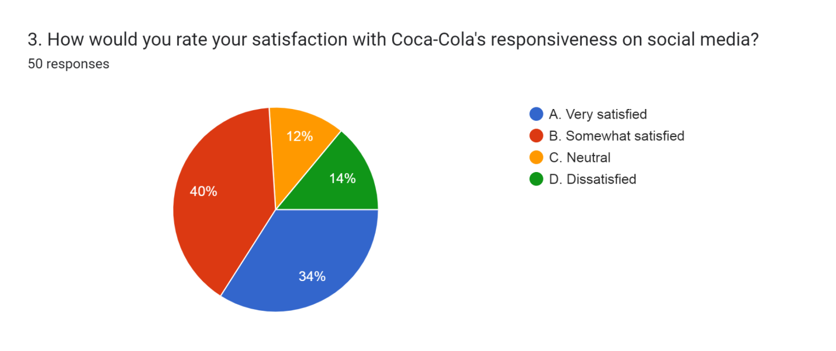

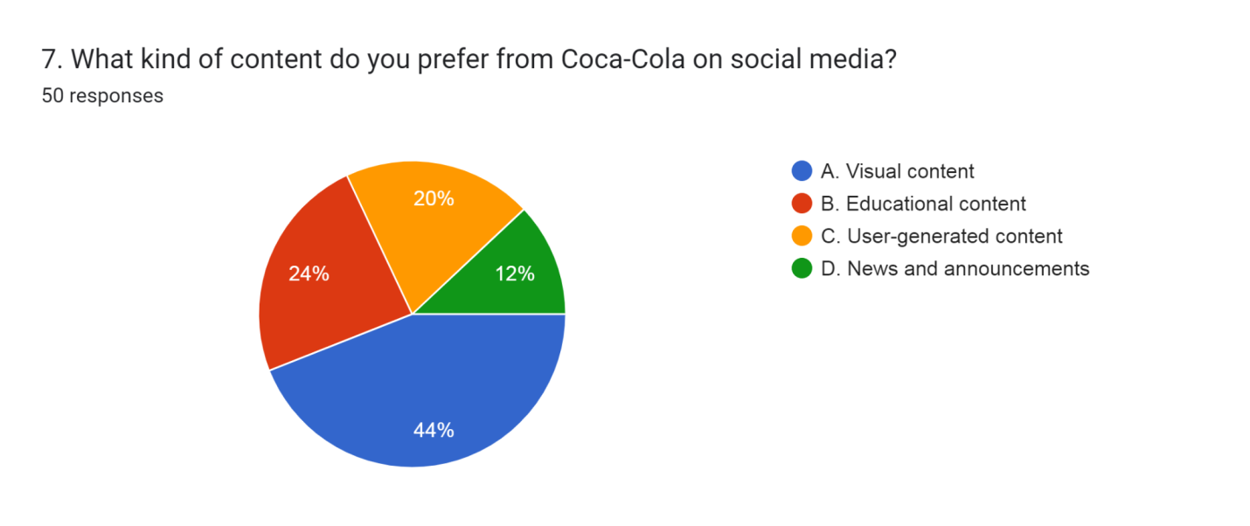

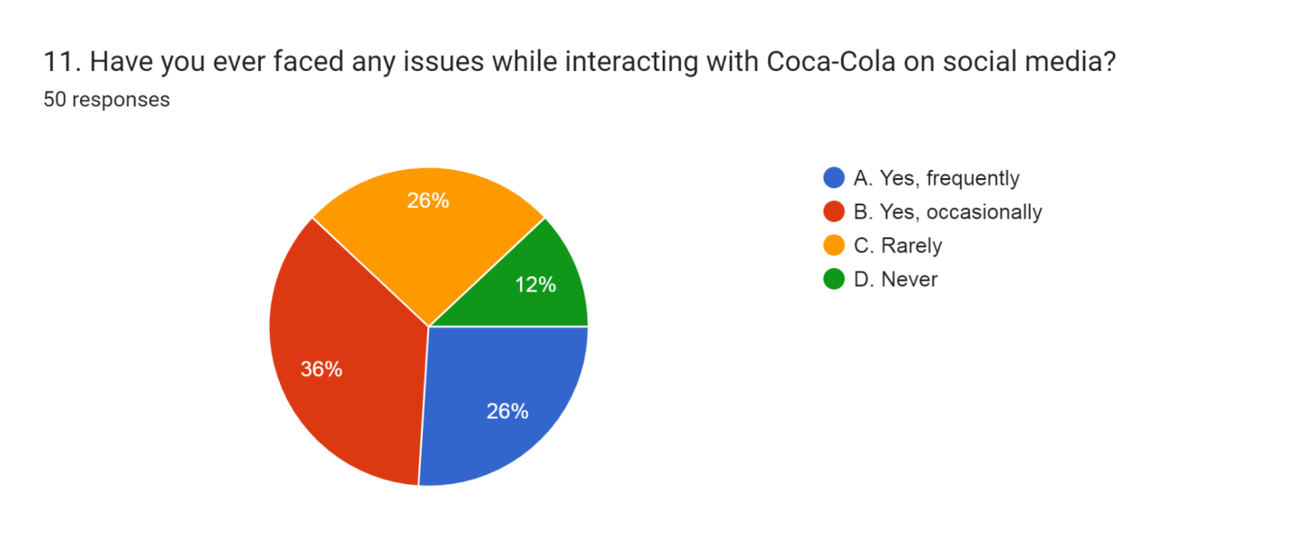

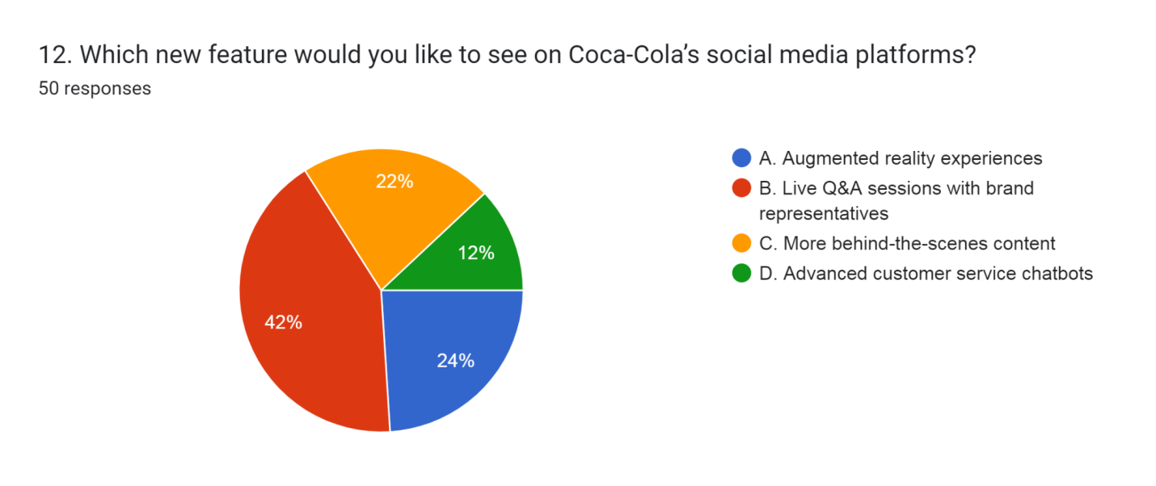
Screenshot of Survey Results


