A comparison of the marketing methods of two multinational hotel brands

Student name: Mihu Sidonia Bianca
Student id: 2231047
Module: Marketing Essentials BMIH4005
Lecturer name: Luciana Suardi
Word count : 1475

Marketing has become an essential attempt that is exercised by firms to learn and interact with their customers and ensure that the right set of information is provided to the consumers. Marketing boosts brand awareness and tailors the specific needs and wants of the customers. However, in the modern era, the focus on digital marketing is elevating, which means that customers are interacting and kept aware via the use of digital and social media channels (Mekonnen and Larner 2021). The aim of the current essay is to shed light on the marketing methods employed by two multinational hotel brands. The two hotels under investigation are the Six Senses and Moxy Hotel. The marketing activities and tactics of the two hotels are compared throughout the essay. Six Senses has been serving since the early 1990s and has established a benchmark in the hospitality industry. The portfolio of the Six Senses hotel is unique, sustainable and innovative and ensures to maintain an individual personality (Six Senses 2023). Contrary to this, the Moxy Hotel is a well-known brand of Marriott International and was first established in 2014 in Milan. The focus of the hotel is on sociable services and is fun and affordable (Moxy Hotel 2023). However, the two hotels differ in their marketing tactics.
According to Hanaysha et al. (2021), to understand the products and services offered by a firm to the customer, the use of a marketing mix is appropriate as it highlights the successful product offering. In terms of the product aspect of the Six Senses, the hotel attracts its consumers via its exotic resorts, private clubs, spas, luxurious and adventurous residences and the outstanding and unique beauty of the location. The hotel follows a consistent quality infused with a local touch to attract potential customers (Piuchan and Prachansit 2019). The products and services of Moxy Hotel are different, and every inch of space is maximised with big delights. The rooms are spacious and comprise LED guide lights, walk-in showers, cloth hanging and all likely accessories and services. The rooms are designed with modern features, and their restaurants are embellished with a lively atmosphere. For the pricing aspect of the two hotels, Six Senses is thought to be for the luxurious customers and prefers premium pricing, whereas the Moxy Hotel is light on the pockets but does not compromise on the quality standards delivered to the customers. Furthermore, to shed light on the place and distribution, Moxy Hotel has its roots in three continents, North America, Europe and Asia. This shows the widespread presence of the hotel brand. In comparison, Six Senses Hotel operates in almost 20 countries. However, considering the traffic share by country, for Six Senses, about 37.5% of traffic share comes from the US, whereas for Moxy, it is about 62.5%. In addition, from the UK, Six Senses have a traffic share of 37.2%, whereas, for Moxy, it is about 62.8% (Similar Web 2023a) (refer to Appendix A).
The last aspect of the marketing mix element is promotion. The promotional activities are important to be analysed as it helps capture the attention of the customer and ensure that they remain aware of the products and services (Xu et al., 2022). The focus of Six Senses is mainly on print advertising and the use of digital marketing channels. The major traffic that comes to the Six Senses is due to the organic search (refer to Appendix B). Comparatively, the Moxy Hotel shows lesser consideration for marketing and promotional activities. They are also not active on social media channels, and though they have maintained their presence on popular social media sites, their level of interaction and engagement is still less compared to the Six Senses Hotel.
In addition to this, the target audience of the two hotels also differs. Varadarajan (2020) provided that it is important to have knowledge about the target audience to tailor it to the specific needs and wants of the customer. To shed light on this aspect, the use of the STP model is appropriate. Segmentation is the ability to divide the market based on the subgroups of the customers (Dolnicar 2020). Six Senses focus on a segmentation strategy and mainly targets luxury travellers who show a willingness to pay a premium to seek pleasure and comfort. These individuals have a high disposable income and belong to the upper and upper-middle classes. By highlighting the segmented market, Six Senses is able to tailor to the guest’s needs and wants and ensure that utmost superiority in services is maintained. According to Similar Web (2023b), the gender and age distribution of Six Senses is present (Refer to Appendix C). It has been identified that the target audience of Six Senses mainly belongs to the age category 25-34 years and is 51.39% male, whereas 48.61% female. These also include business executives and leisure and family travellers.
Contrary to this, the target market for the Moxy Hotel includes budget-conscious travellers who look for a fun travelling experience in an affordable price range. Therefore, the target market for the Moxy Hotel includes middle-class individual and family travellers who ensure to have a light-on-the-pocket experience. This means that the two hotels focus on a separate market, and therefore, their marketing tactics are also tailored and personified based on their audience (George 2021).
In addition to this, the marketing communication of the two hotel brands is also compared. Kushwaha et al. (2020) provided that marketing communication comprises the media and messages that are used by marketers to communicate with the target market. The most commonly employed marketing communication channels are direct marketing, social media marketing, traditional advertising and other sponsorships. Six Senses makes effective use of both traditional and digital marketing channels. In view of Melovic et al. (2020), digital marketing channels provide better connectivity with the audience and ensure that brand reputation and awareness are achieved. For Six Senses, the use of Facebook and Pinterest leads the game, as evident by their increasing usage. Comparatively, the marketing communication channel used by Moxy Hotel is YouTube, and there is no data available on the similar web regarding other social media channels for Moxy Hotel (refer to Appendix D).
Furthermore, based on the discussion of marketing communication, Momen et al. (2020) provided that the website maintained by an organisation is also of utmost importance as it provides a detailed insight into the related information of the products and services. Both hotel brands show a higher level of engagement with the audience by making use of their websites. In terms of website traffic, Six Senses wins again compared to the Moxy Hotel. This is because the total number of visits secured at Six Senses hotel is approximately 1.374 Million, whereas, for Moxy Hotel, it is approximately 724,870 (refer to Appendix E). From this perspective, the position of the two hotels can be analysed. The Moxy Hotel has a greater chance of failure and loss of consumers as they are unable to keep their customer engaged through the use of interactive content.
In terms of the social concerns of the two hotel brands, it is evident that the two hotels show greater concern for the environment and have tailored their services based on sustainable approaches. The hotel brands have ensured to make the travel responsible that is free from any harmful toxins and chemicals to be added to the environment. All the services offered by the hotel take into account the wider social issues and problems. Especially after the pandemic, the hotel focused on higher cleaning practices and the provision of safe, secure and more accessible services (Stombelli 2020).
Overall, from the discussion, several recommendations are provided for the two hotel brands. Firstly, both hotels need to emphasise more on marketing practices. This is because of the growing social and digital audience that influences travel decisions. An active and adequate presence on social media channels such as Facebook, Twitter, Instagram and YouTube. Furthermore, establishing collaboration with the travel blogger and focusing on influencer marketing is also the right approach that will help the brands boost their marketing activities. In addition, offering a promotional discount to business and leisure travellers will also serve as a robust measure to capture a wider audience base and boost brand awareness.
Based on the above discussion, the importance of marketing can be highlighted. It can be said that the two hotels follow various marketing approaches. However, the increasing reliance on social media is important for businesses to create a buzz in the market. The target audience of Six Senses are mainly luxury consumers, and therefore, the business marketing should be personalised to meet the changing trends and patterns of the travellers. In addition, Moxy Hotel mainly targets budget-conscious consumers; therefore, the marketing activity should revolve around this area which will help the brand penetrate the market effectively.

References
Dolnicar, S., 2020. Market segmentation analysis in tourism: a perspective paper. Tourism Review, 75(1), pp.45-48.
George, R., 2021. Market Segmentation, Targeting, and Positioning. In Marketing Tourism and Hospitality: Concepts and Cases (pp. 221-246). Cham: Springer International Publishing.
Hanaysha, J.R., Al Shaikh, M.E. and Alzoubi, H.M., 2021. Importance of marketing mix elements in determining consumer purchase decisions in the retail market. International Journal of Service Science, Management, Engineering, and Technology (IJSSMET), 12(6), pp.56-72.
Kushwaha, B.P., Singh, R.K., Varghese, N. and Singh, V.N., 2020. Integrating social media and digital media as new elements of integrated marketing communication for creating brand equity. Journal of Content, Community & Communication, 11(6), pp.52-64.
Mekonnen, A. and Larner, L., 2021. Digital Marketing in Luxury Fashion: From Crisis to Strength. The Art of Digital Marketing for Fashion and Luxury Brands: Marketspaces and Marketplaces, pp.199-219.
Melović, B., Jocović, M., Dabić, M., Vulić, T.B. and Dudic, B., 2020. The impact of digital transformation and digital marketing on the brand promotion, positioning and electronic business in Montenegro. Technology in Society, 63, p.101425.
Momen, M.A., Sultana, S. and Haque, A.A., 2020. Web-based marketing communication to develop brand image and brand equity of higher educational institutions: A structural equation modelling approach. Global Knowledge, Memory and Communication, 69(3), pp.151-169.
Moxy Hotel 2023. Explore. [Online] Available at https://moxy-hotels.marriott.com/explore/ [Accessed on 9 February 2023].
Piuchan, M. and Prachansit, S., 2019. Hotel pioneers' leadership styles: A case study on the founders of Oberoi Group and Soneva and Six Senses Resort and Spa. Tourism: An International Interdisciplinary Journal, 67(4), pp.375-388.
Similar Web 2023a. Geography. [Online] Available at https://pro.similarweb.com/#/digitalsuite/websiteanalysis/audience-geography/*/999/3m?key=sixsenses.com,moxy-hotels.marriott.com&webSource=Total [Accessed on 9 February 2023].
Similar Web 2023b. Demographics. [Online] Available at https://pro.similarweb.com/#/digitalsuite/websiteanalysis/audience-demographics/*/999/3m?webSource=Total&key=sixsenses.com [Accessed on 9 February 2023].
Six Senses 2023. About Us. [Online] Available at https://www.sixsenses.com/en/about-us [Accessed on 9 February 2023].
Stombelli, V.M., 2020. Corporate Social Responsibility in hospitality: are sustainability initiatives really sustainable? Case examples from CitizenM, Lefay and Six Senses. Worldwide Hospitality and Tourism Themes, 12(5), pp.525-545.
Varadarajan, R., 2020. Customer information resources advantage, marketing strategy and business performance: A market resources based view. Industrial Marketing Management, 89, pp.89-97.
Xu, Z., Zhu, G., Metawa, N. and Zhou, Q., 2022. Machine learning based customer meta-combination brand equity analysis for marketing behaviour evaluation. Information Processing & Management, 59(1), p.102800.

Appendices

Appendix A: Traffic share by Country
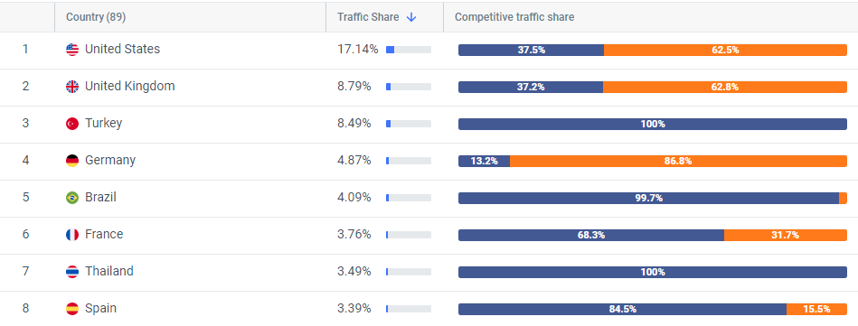

Appendix B: Marketing Channels
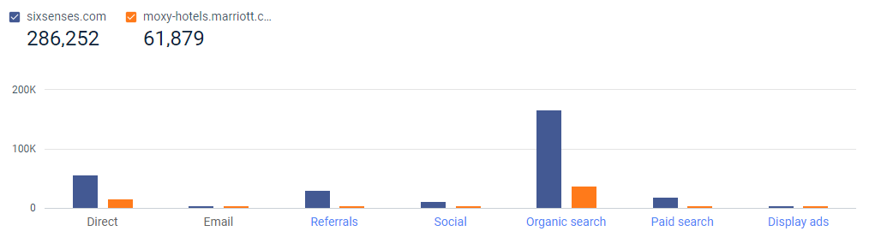

Appendix C: Demographics
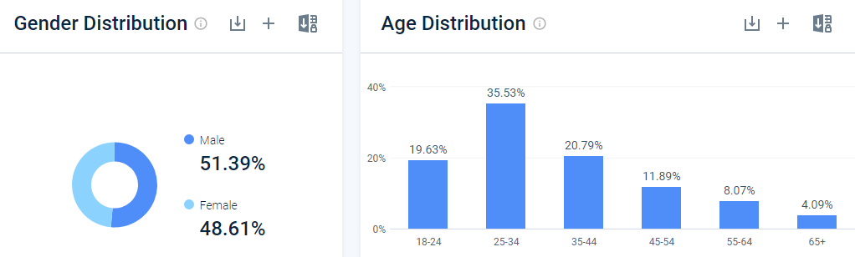

Appendix D: Social Traffic
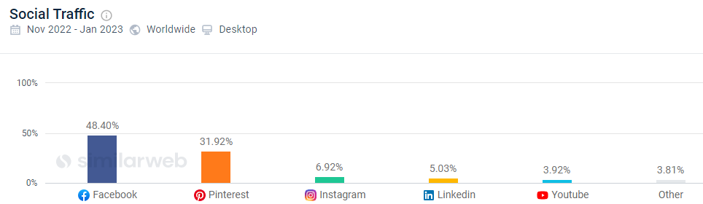
Figure 1: Social Traffic of Six Senses
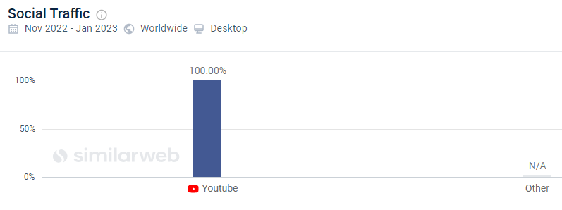
Figure 2: Social Traffic of Moxy Hotel

Appendix E: Website traffic and engagement
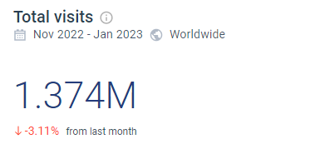
Figure 3: Total visits of Six Senses
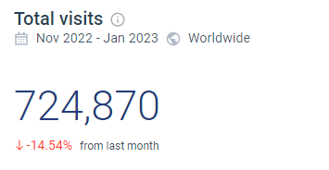
Figure 4: Total Visits of Moxy Hotel

