

Coca-Cola’s International Marketing Strategies in the United Kingdom and India
A Comparative Analysis

(LCMB7026)

Lecture Name: Dr. Tushara Blendran
Student Name: Joseph Nirappel Mathew
Student ID: 2437157

Table of Contents

1. Introduction 4
2. Brand Overview 4
3. Comparison of the Socio-Cultural Context of the UK and India 5
3.1 PESTLE Analysis: United Kingdom vs. India 5
3.2 Cultural Dimensions and Marketing Implications 9
4. Segmentation-Targeting-Positioning (STP) Strategies 11
4.1 Segmentation 11
4.2 Targeting 13
4.3 Positioning 13
4.4 VALS Consumer Personality Types in the UK and India 16
4.5 Evaluation of Localisation vs. Global Standardisation 16
5. Comparison of Marketing Mix (7Ps) Strategies in the UK and India 17
5.1 Product Strategies 18
5.2 Price Strategies 18
5.3 Place Strategies 19
5.4 Promotion Strategies 20
5.5 People Strategies 20
5.6 Process Strategies 21
5.7 Physical Evidence Strategies 21
6. Evaluation of the Performance of Marketing Strategies 22
6.1 Market Performance in the United Kingdom 22
6.2 Market Performance in India 23
6.3 Comparative Evaluation of Performance 25
7. Evaluation of Marketing Ethics Practise 25
7.1 Ethical and Sustainability Issues 25
7.2 Differences in Ethical Challenges and CSR Initiatives 26
7.3 Alignment with Global Ethical and Corporate Responsibility Frameworks 27
8. Recommendation and Conclusion 27
8.1 Strategic Recommendations 27
8.2 Conclusion 28
9. References 29

1. Introduction
In an increasingly connected global economy, international marketing, which involves planning, pricing, promoting, and distributing goods and services across national borders, has become a vital function for multinational companies(Castanho, 2025). International marketing involves balancing global standardisation with local adaptation to meet various cultural, economic, and regulatory conditions. Coca-Cola, one of the most recognisable brands of beverages in the world, is a good example of how a company can design its strategies to succeed in different markets. It has presence in more than 200 countries and its Asia-Pacific segment alone represents an industry retail value of approximately US $510 billion(CocaCola, 2025a, 2025b; Market.us, 2025). India is still a high-growth market of Coca-Cola, and its per-capita consumption around nine eight-ounce bottles per year, which is a significantly lower compared to developed economies, offering enormous growth opportunities(Management, 2024).
This report is a critical analysis of international marketing strategies of Coca-Cola in the United Kingdom and India. It starts by providing a background of the brand and its business in the two countries followed by a comparative PESTLE analysis of their macro-environments. Later parts discuss the segmentation, targeting, and positioning (STP) strategies and the marketing-mix (7Ps). The report further analyses the comparative success of the marketing strategies in both markets and ethical considerations, concluding with recommendations for future development of international marketing.

2. Brand Overview
Coca-Cola Company (hereafter referred to as Coca-Cola) is one of the most iconic and valuable beverage companies in the world. It is recognised globally for its large brand portfolio and successful marketing(CocaCola, 2025a). The company began on May 8, 1886, when a pharmacist Dr. John Stith Pemberton first sold a glass of Coca-Cola at Jacobs Pharmacy in Atlanta, Georgia(Company, 2024b). Coca-Cola was officially established in 1892 by Asa Candler, has since then evolved into a diversified global beverage enterprise. The company has its head office in Atlanta, Georgia, and its mission is to “refresh the world and make a difference,” and its vision focuses on creating value using a total beverage company model that provides products in the range of sparkling drinks, juices, teas, coffees, and bottled water(Company, 2024c).
As of 2024, Coca-Cola net revenues had reached USD 47.1 billion, with the net revenue growth of 3% compared to the previous fiscal year(Company, 2024a). The reach of the company spreads to more than 200 countries and it supplies about two billion servings a day(Management, 2024). Its business model follows a franchise system:: Coca-Cola produces the beverage concentrate, and then sells it to Licenced bottling partners that produce, package, distribute, and sell it(Institute, 2024). This decentralised bottling system allows the company to combine global brand consistency with local market responsiveness, which is vital ingredient in its international marketing success.
Coca-Cola is strategic in balancing standardisation and adaptation. It differentiates flavours, packaging, and promotional activities according to the interests, cultural differences, and regulatory frameworks of the local consumers. The Coca-Cola Zero Sugar and use of the local flavours are examples of this dual approach to regional innovations(Alon, Jaffe, Prange, & Vianelli, 2020). Moreover, the company’s historical expansion during World War II, when it supplied beverages to U.S. troops abroad, driven its globalisation and established the brand in different cultural markets(Company., 2025).

3. Comparison of the Socio-Cultural Context of the UK and India
It is important to understand the macro-environmental and cultural factors of the UK and India to measure the international marketing strategies of Coca-Cola. The PESTLE framework (Political, Economic, Social, Technological, Legal, Environmental) offers a methodical way of evaluating the external forces affecting the company’s operations in each country(Perera, 2017). Meanwhile, the cultural dimensions model by Hofstede can be used to understand the behavioural and value-based aspects of consumer perception and buying behaviour(G. Hofstede, 2011).

3.1 PESTLE Analysis: United Kingdom vs. India

United Kingdom PESTLE Analysis
Political: The UK has a stable parliamentary democracy that supports predictable governance, although though post-Brexit adjustments to trade, labour, and import policies have slightly added uncertainty to the operations of the global companies(Garcia, 2023; PestleAnalysis.com, 2023). In the case of Coca-Cola, this political climate is partially favourable as the institutional stability contributes to the long-term planning, yet it is unfavourable as well since Brexit-related friction may raise the costs and complexity of the operation.
Economic: High per capita GDP and developed consumer market in UK enable high end positioning of beverages. However, inflation and tightening of the economy have increased sensitivity on prices which affect the promotional mix and discounting tactics of Coca-Cola(Das). Thus, the economic factor is favourable to Coca-Cola in terms of the high purchasing power and sophistication of the market, but unfavourable in terms of the inflationary pressure and increasing price-sensitivity among the consumers in the UK.
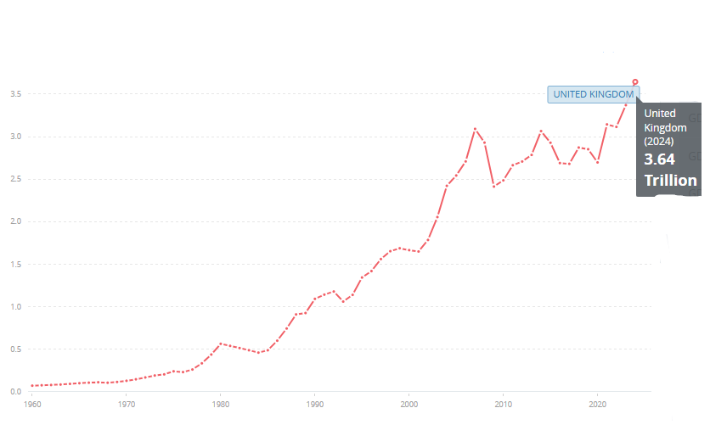
Fig: UK GDP Growth(WorldBank, 2025)
Social: UK consumers are very aware of health, wellness, and environmental issues. The growing attention to obesity and sugar intake has changed the preferences to healthier products(Muddassir, 2025). This is a social environment favourable to the diversified portfolio of low- and no-sugar drinks of Coca-Cola, but not the traditional high-sugar cola product of the company. Consequently, the UK product strategy of Coca-Cola focuses on “Coca-Cola Zero Sugar”, and “Diet Coke”, with campaigns about moderation and active lifestyles.
Technological: The UK's high digital reach and mature e-commerce landscape allow Coca-Cola to use digital marketing tools like personalised advertisements, influencer collaborations, and interactive campaigns via social media and online platforms(ITA, 2023). With QR codes incorporated in the packaging, consumer interaction and data analytics becomes easy. Therefore, the technological forces prove to be highly favourable to Coca-Cola in the UK for advanced, information-driven, and engaging marketing campaigns
Legal: Regulatory compliance is crucial in the UK, where food and beverage laws are rigorous. Reduced-sugar content is promoted by the Soft Drinks Industry Levy (introduced 2018) and driving Coca-Cola to reformulate them(Gov.UK, 2024b). Also, there are strict advertising standards require transparency in marketing to children and responsible marketing with regard to health and sustainability. These legal forces are unfavourable for high-sugar variants due to the heightened regulatory and reformulation pressure, but may favour Coca-Cola's zero-sugar range.
Environmental: Sustainability is a prevailing societal issue. The UK government’s single-use plastics ban (2024) and carbon-neutral initiatives align with Coca-Cola’s “World Without Waste” programme, which targets 100% recyclable packaging and net-zero emissions by 2050(Ben, 2021; Gov.UK, 2024a). Consequently, environmental forces are favourable as they support the global sustainability strategy of Coca-Cola, but they are unfavourable because they place pressure on the company to continuously innovate in packaging and waste reduction.

India: PESTLE Analysis Overview
Political: The political climate in India is stable and pro-business reforms are in progress through Make in India program(Ghosh, 2023). The liberalisation of foreign direct investment (FDI) and the Goods and Services Tax (GST) have made it easier for multinationals to enter the market(PestleAnalysis.com, 2024). A different state regulatory environment and bureaucracy however demand Coca-Cola to localise compliance plans. Overall, the political climate is favourable, as Coca-Cola can enjoy the reforms and openness to FDI at the national level, but unfavourable due to bureaucratic delays and complex state-level regulations.
Economic: India’s GDP exceeded US $3.9 trillion in 2024 and had a high GDP growth of 6.5% in 2024-25, making it a major engine of growth in Asia(Bureau, 2025; WorldBank, 2025). The beverage industry benefits from the increasing disposable income and the young population; however, there are still issues of income inequality and cost sensitivity of the products. Therefore, the economic aspect is very favourable regarding the growth potential, market size, but unfavourable since high price-sensitivity limits premium pricing policies.
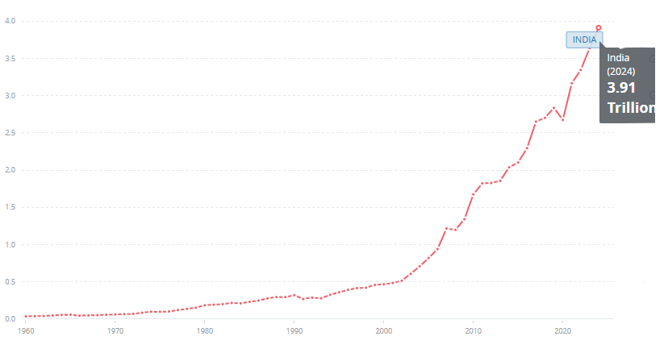
Fig: India’s GDP Growth(WorldBank, 2025)
Social: India’s population of over 1.4 billion is young (median age ≈ 28) and socially diverse(PIB, 2024). The consumption related to family events and festivals is influenced by cultural pluralism and collectivism. Marketing communication focuses on unity, happiness, and sharing, which fits the theme of the global Open Happiness of Coca-Cola but is executed through regional languages and cultural symbols. Overall, social forces are favourable to Coca-Cola as collectivist values and festival culture favour shared consumption of beverages, whereas the emergence of health awareness is a moderate-term, and the company should handle the situation with care.
Technological: The mobile internet revolution in India, which is driven by low-priced smartphones and schemes like the Digital India, has increased the options of digital marketing(Bainsla, Ahamed, & Karmakar, 2025). Coca-Cola uses social media platforms such as Instagram, YouTube, and regional influencers to reach out to younger audiences. Thus, technological factors are favourable for reaching urban and semi-urban youth and are unfavourable in rural areas where digital access is rather low, requiring a hybrid marketing that will be a combination of digital and traditional media.
Legal: The Food Safety and Standards Authority of India (FSSAI) control the formulation of any product, labeling, and safety. The federal system of India implies that local understanding can be different in each state, and it is necessary to adjust to it. Legal debates around plastic packaging and water extraction rights further adds pressure to the business of Coca-Cola, requiring its transparent CSR initiatives(FSSAI, 2023). The legal environment is thus mostly unfavourable to Coca-Cola, as it faces scrutiny over health, packaging, and water usage.
Environmental: The environmental issues in India are the water shortage, pollution, and waste disposal. The water consumption by Coca-Cola has been criticised in certain areas, leading to stronger sustainability commitments, such as “Water Neutrality”, returning an equal share of water consumed in production to the community and nature(Franssen, 2023). In turn, the environmental forces are predominantly unfavourable towards Coca-Cola in India because of the resource limitations and social disapproval, yet they provide opportunities to gain goodwill through the evident CSR programs.
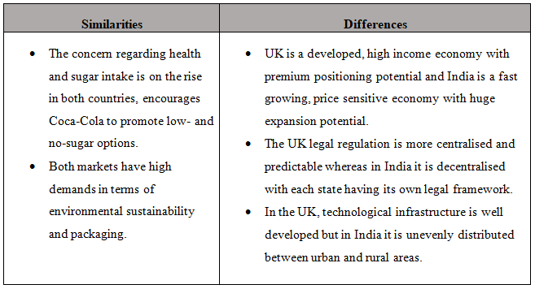

3.2 Cultural Dimensions and Marketing Implications
According to Hofstede’s cultural dimensions, India and the UK display notable differences(Hofstede, 2025). The benefits of using Hofstede model in this specified context is that it provides a quantifiable and organised method of contrasting cultures of nations and will allow Coca-Cola to adjust its manner of communication, way it presents messages, and visuals that it uses to the local values in the UK and India. Nevertheless, a notable drawback is that Hofstede dimensions can oversimplify complex and dynamic nature of culture especially in a heterogeneous country like India and the model is informed by data that might be old and might not be entirely reflective of the modern society.
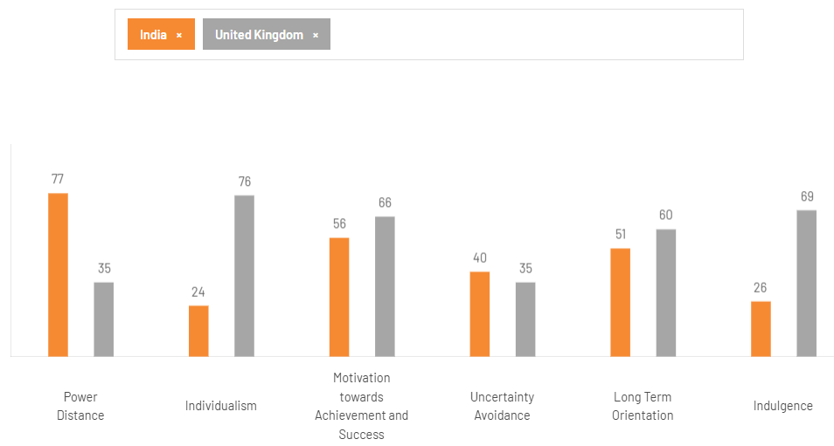
Fig: Hofstede’s cultural dimensions comparison of India and UK(Hofstede, 2025)

Dimension | United Kingdom | India | Marketing Implications for Coca-Cola
Power Distance | Low (35) [Egalitarian] | High (77) [Hierarchical] | Indian ads highlight respect, family and authority; UK ads stress equality and individual empowerment.
Individualism | High (76) | Low (24) | UK messaging appeals to personal choice (“Taste the Feeling”), India emphasises group enjoyment and community bonding.
Uncertainty Avoidance | Moderate (35) | Moderate (40) | Both tolerate innovation; Coca-Cola can introduce product variants easily.
Motivation towards Achievement and Success | High (66) | High (56) | Both values achievement and status; inspirational advertising is effective.
Long-Term Orientation | Very High (60) | High (51) | Both cultures appreciate brand heritage, Coca-Cola can leverage its global legacy.

These cultural differences imply that Coca-Cola UK marketing focuses on the individual experience, lifestyle, and health-friendliness, whereas in India, the company uses collectivist, family-based, and aspirational stories. The packaging sizes, prices, and the promotion messages are all varied, i.e., high-end smooth cans to consumers in the urban UK market and low-cost PET bottles to consumers in the Indian mass market.

4. Segmentation-Targeting-Positioning (STP) Strategies
In global marketing, the Segmentation-Targeting-Positioning (STP) framework is a key to strategic market planning. It enables companies to define, analyse, and serve to customer populations in a more efficient way across national and cultural contexts(Kotler, Keller, & Chernev, 2022).

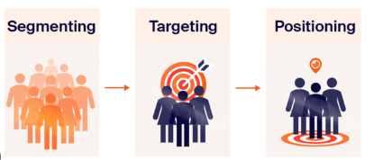
Fig: Segmentation-Targeting-Positioning (STP) model(Kotler et al., 2022)

4.1 Segmentation
In international marketing, Segmentation is the concept used to subdivide large market segments into smaller segments of consumers whose needs and preferences are similar(Schlegelmilch, 2022). Coca-Cola uses demographic, psychographic and behavioural segmentation globally.
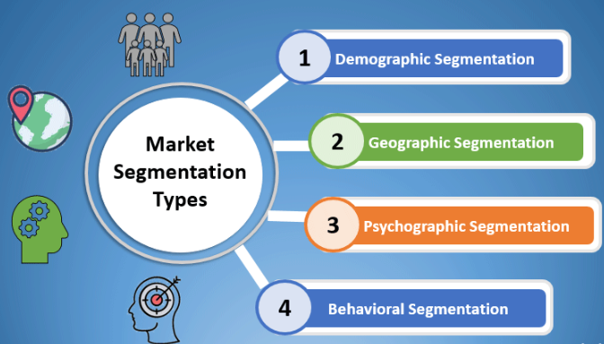
Fig: Market Segmentation Types(Larsen, 2010)
UK
- Demographic segmentation: Coca-Cola focuses on young adults between 18 and 35 who are the most active customers of soft-drinks and older groups of customers (35-50) who prefer low- or zero-sugar alternatives.
- Psychographic Segmentation: The consumers in UK believe in individuality, convenience and wellness. The brand is targeted at highly social professionals who would prefer quick refreshment and brand authenticity.
- Behavioural segmentation: Coca-Cola focuses lifestyle and occasioned consumption, such as social events, sporting events and leisure activities. Such campaigns like Share a Coke make the experience personal, increasing emotional attachment and repeat purchase behaviour(Riegel & Pellerano, 2020).
India
- Demographic segmentation: India’s younger demographic (median age of 28) and expanding middle class create large growth potential. The major groups are urban youth (15-30 years), families in the tier-2 and tier-3 cities, and rural consumers.
- Psychographic segmentation: Indian consumers are collectivist, aspire modernity, and have a rich cultural background. Coca-Cola is appealing to their desire for modern lifestyles and shared enjoyment through emotionally resonant campaigns linked to family and festivals.
- Behavioural segmentation: Social occasions and affordability play a critical role in purchase behaviour. The small, low-cost packs are frequently used by rural and semi-urban markets, whereas larger bottles are used at family events and festivals.
Country | Major Segments
UK | Young adults 18-35 (urban, lifestyle), Health-conscious adults 35-50, Convenience buyers.
India | Youth 15-30 (urban/rural), Families (tier-2/3 cities), Value-seeking rural shoppers.

4.2 Targeting
This process is the selection of segments to serve (target) in accordance with size and growth potential, profitability, and alignment with the brand’s capabilities(Camilleri, 2017).

UK
In UK, Coca-Cola is marketed mainly to the urban middle to high-income earners who appreciate luxury drinks, convenience, and communication. The brand also focuses on health-conscious groups through its zero-sugar products. Therefore, the focus is largely on differentiated targeting: separate offers to mainstream drinkers of cola and more specialised ones to low-sugar options.
India
In India Coca-Cola targets a wide group of consumers, starting with urban youth to rural families. The company has a mixed targeting approach: they sell extremely low priced small-pack sizes to mass markets, while also marketing premium versions to aspirational urban buyers.

4.3 Positioning
Positioning determines how the brand will be perceived by the targeted segments compared to the competitors(Nadube & Didia, 2018). Coca-Cola has a very strong brand identity (refreshment, happiness, sharing) globally with a local positioning in every market.

UK
In the UK, Coca-Cola is positioned as a refreshing, fun, premium global brand with a health-conscious message. The marketing campaigns are based on the message of “taste the feeling”, individual pleasure, and modern lifestyle(Li, 2025). In the case of the health-segment, the coca-cola zero sugar positioning will focus on the same taste without sugar aligning with UK regulatory and social pressures for healthier products.
India
Positioning in India is based on social sharing, togetherness, festivals and local relevance. Advertising campaigns usually rely on the Bollywood stars, local languages, and cultural events (e.g., cricket, Indian festivals). Coca-Cola is positioned not only as a refreshing drink but as part of celebratory, communal experiences. This is supported by affordable pack sizes and local flavours. The international brand image is present but is mixed with the domestic attention (such as employing local celebrities or association with major festivals).
Similarities and Differences in STP: UK vs. India
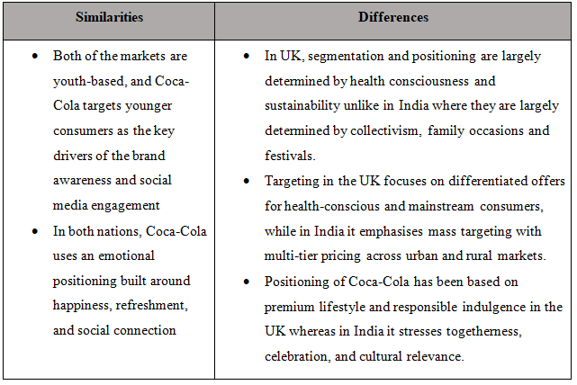

Perceptual Map - UK
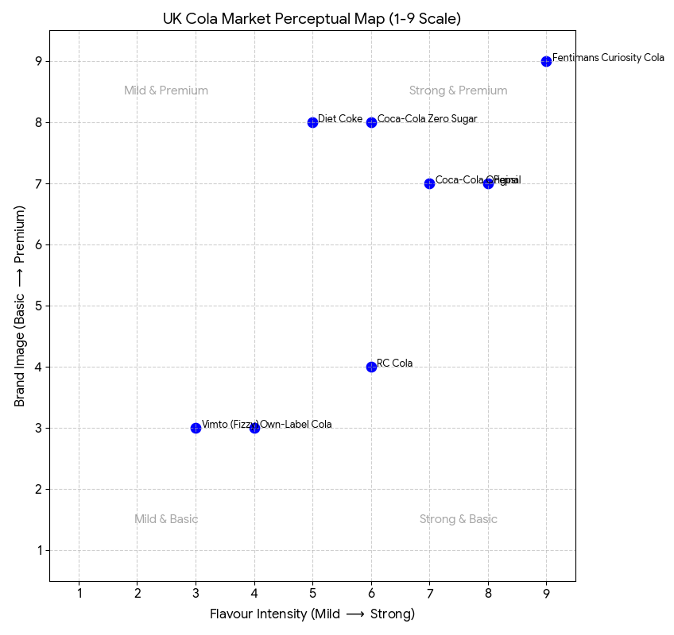

Perceptual Map - India
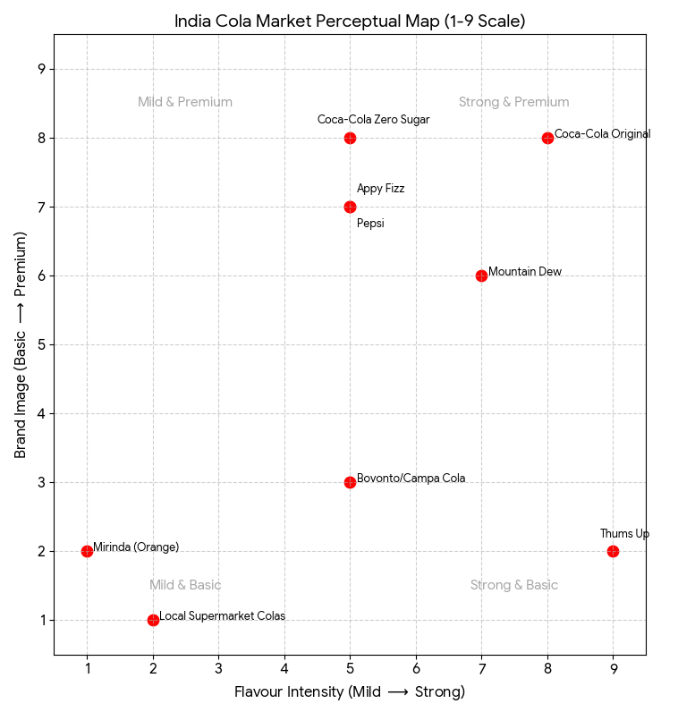

4.4 VALS Consumer Personality Types in the UK and India
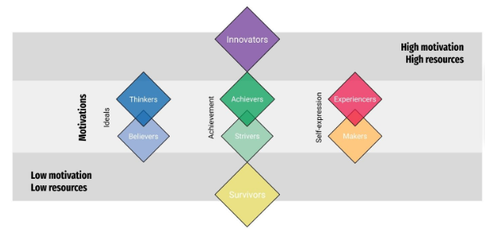Fig: VALS Framework(Kendal, Ford, Anderson, & Farrar, 2015)
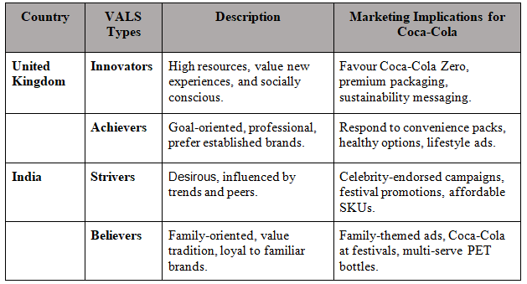

4.5 Evaluation of Localisation vs. Global Standardisation
Coca-Cola’s STP strategy shows a hybrid approach, blending global brand consistency with local adaptation to remain competitive across markets.
- Standardisation: In both the UK and India, Coca-Cola uses its international heritage, iconic branding (logos, bottle shape, red colour), unified taste triggers, and global campaigns (e.g., “Share a Coke”). Such standardisation promotes brand awareness, cost efficiencies in marketing and coherence of brand image(Meron, 2020).
- Localisation: In the UK, the localisation is achieved by the use of small-pack convenience formats, sugar-free options, digital personalisation campaigns, and sustainability communications. The localisation is more aggressive in India: small affordable price-points, regional tastes, local language communications, rural market distribution, festival tie-ins, and messages of togetherness.
- Risks and trade-offs: A possible consequence of over-standardisation in India a mismatch in consumer relevance (e.g. high price, urban-based messaging). On the other hand, the over-localisation in the UK would dilute the global brand image and add more cost. Coca-Cola seems to cope with it by tiered offers and dual positioning: the legendary core product and variations that are locally specific to each market.

5. Comparison of Marketing Mix (7Ps) Strategies in the UK and India
7Ps of Marketing mix, Product, Price, Place, Promotion, People, Process, and Physical Evidence, will give a multifaceted perspective of comparing the strategic approach employed by Coca-Cola in the United Kingdom and India(Jain, Jain, & Jain, 2022).

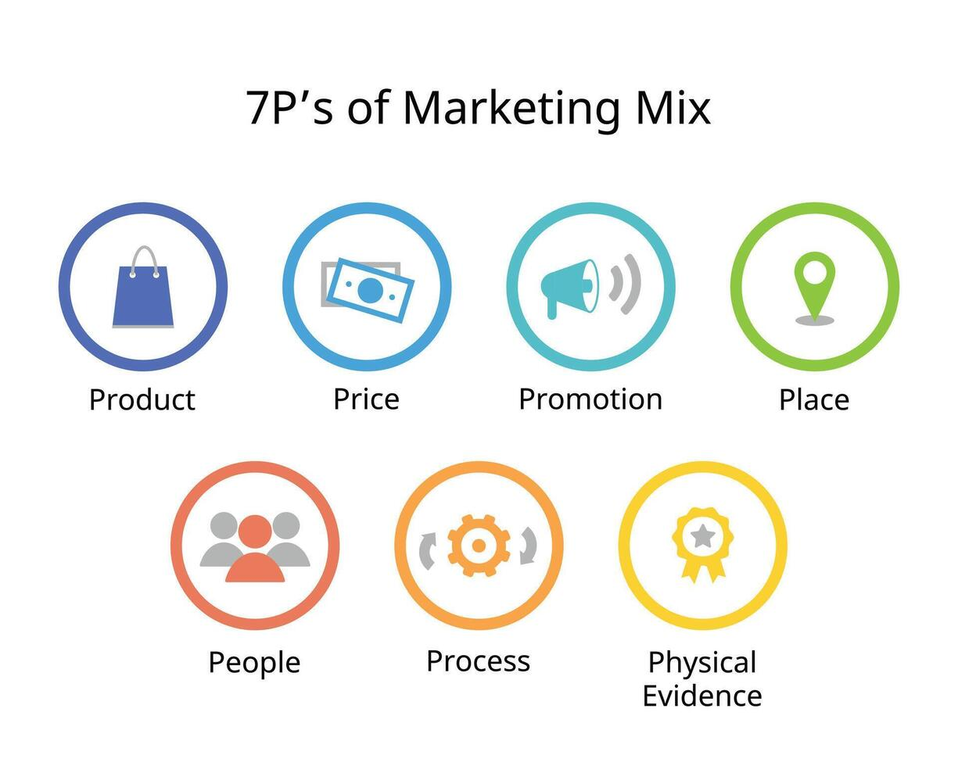
Fig: 7Ps of Marketing mix(Jain et al., 2022)

5.1 Product Strategies
Coca-Cola maintains its globally standardised i product image with the iconic logo, contour bottle shape, and its philosophy of core tastes (“great taste, open happiness”). Nonetheless, product adaptations differ greatly in the UK and India.
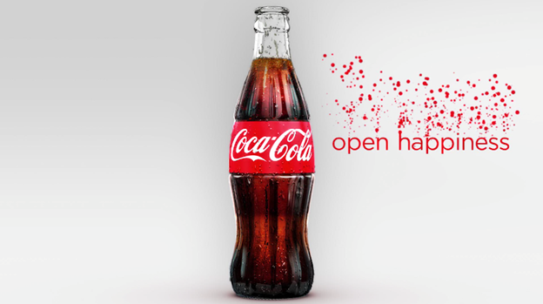
The UK product strategy is greatly affected by health awareness and regulatory impact, especially, the Soft Drinks Industry Levy (SDIL), which incentivises the use of less sugar in drinks(Gov.UK, 2024b). The product range of Coca-Cola thus focuses on Coca-Cola Zero Sugar, Diet Coke, and sugar-reformulated Fanta and Sprite. As of 2024, over 68% of Coca-Cola portfolio is low- or no-sugar, explaining both the consumer demand and the regulatory compliance(CocaCola, 2024).
Product strategy in India is inclined towards taste, price sensitivity and culture. The Coca-Cola Original is the leading SKU, supported by localised flavours (e.g. Minute Maid Pulpy Mango), festival-related variants and smaller pack sizes like the Rs.10 affordability packs, significantly increasing the penetration in rural area. Contrary to the UK, low-sugar versions occupy less percentage of the sales, even though demand of Zero Sugar in urban areas is steadily growing(Restaurantindia.in, 2024).

5.2 Price Strategies
There are also variations in pricing strategies based on economic structure and purchasing power of the consumer.
Coca-Cola in UK has value-based and competitive pricing strategy. Prices are relatively premium compared to prices of private-label colas, but promotional prices are common in supermarkets and convenience stores. The price elasticity is also high as there are alternatives available, including Pepsi Max and supermarket own-brand alternatives(Mintel, 2025). Multipack and bundling are common practise to incentivise repeat buying.
Coca-Cola in India employs penetration pricing and affordability strategy, given that the price sensitivity is very high and markets vary greatly. Between Rs.10-20 Small-pack pricing (180ml-250ml) allows penetration into rural and low-income market. The target audience of premium PET bottles and cans is urban youth, which results in the formation of two-tier pricing. This is in line with the diverse socioeconomic environment in India(Economictimes, 2016).

5.3 Place Strategies
One of the key determinants of Coca-Cola’s global success is distribution. The comapny has a hybrid distribution network based on the framework of each market(Czinkota, Kotabe, Vrontis, & Shams, 2021).
UK Place Strategy
UK market is advantageous in terms of high levels of retail consolidation, advanced logistics, and well developed e-commerce. Coca-Cola uses:
- Direct store delivery (DSD) for large supermarket chains (Tesco, Asda, Sainsbury’s).
- Indirect distribution through wholesalers for small retailers.
- Digital grocery platforms such as Amazon, Ocado, and Tesco Online.
- Foodservice alliances and vending machines, sponsored by Coca-Cola Europacific Partners (CCEP).
India Place Strategy
The Indian market needs geographical localisation due to geographical diversity and fragmented roadside retail. Coca-Cola uses(Sarangi, 2018):
- A multi-level distribution structure comprised of bottling partners, distributors and rural stockists.
- Last-mile delivery via bicycles, auto-rickshaws, and vans in rural areas.
- Micro-entrepreneur programs such as Coca-Cola Parivartan and retailer training for small Kirana stores.
- Cold-chain investments to overcome India’s climate challenges.
Comparison of the Market Entry Methods
- United Kingdom: Coca-Cola entered through direct investment and making alliances with local bottlers and consolidating operations under CCEP. The UK is a high-controlling, standardised entry strategy(Chu, 2020).
- India: Coca-Cola entered through the franchise bottling system (1990s) and later pulled out because of the regulations in 1993, and through the wholly owned subsidiary + franchise bottlers(Greer, 2018). Nowadays, the company adheres to a mixed ownership bottling model, allowing high geographic coverage and local responsiveness.

5.4 Promotion Strategies
Coca-Cola applies a dual strategy of global brand consistency and local adaptation, and the methods of marketing the product in the UK and India are quite different(Deliceırmak, 2022). In the United Kingdom, promotions focus on wellness, sustainability and modern lifestyle, reflecting mature market demands and regulatory factors like Soft Drinks Industry Levy(Gov.UK, 2024b). The UK promotions are based on digital personalisation ("Share a Coke"), social media interaction, and sponsorships of mass sporting and cultural events. Messaging focuses on individuality, responsible fun, and less sugar options.
Promotional communications in India are deeply rooted culturally and are associated with emotions. Advertisements are typical with Bollywood actors, local languages and festivity narratives, aligning with the Indian culture of collectivism and celebratory consumption. Cricket sponsorships, large-scale outdoor advertising, and multilingual campaigns allow Coca-Cola to reach diverse segments across urban and rural markets.

5.5 People Strategies
The people strategy of Coca-Cola shows the capacity of the company workforce, customer-facing roles, and retail partnerships. UK depends on the professional merchandising teams, trained retail staffs and organised systems of performance supported by Coca-Cola Europacific Partners. Technologically enabled operations are incorporated for employees, ensuring efficient customer service and retail coordination.
In India, people management is more labour-intensive due to a fragmented retail structure. Coca-Cola uses mass sales force whereby its salespeople make daily visits to the Kirana shops, regulate stock visibility and ensure that relationships between retailers and the company are maintained. Programs including Parivartan train micro-retailers on merchandising and store management, reinforcing last-mile performance(Coca-Cola, 2025e).

5.6 Process Strategies
Process design varies in accordance to the market of each country. Automated ordering, digital warehousing, and data-oriented inventory management are used in the UK, which guarantees a high level of efficiency and consistency of its services in the technologically advanced environment(Menaria, 2015). Omni-channel fulfilment using supermarkets, convenience stores and online platform represents lean operations.
Conversely, processes in India must be flexible to infrastructural variability, hot climates and rural market dispersion. The distribution is multi-level, more manual, and is assisted with the use of cold-chain investments and adaptable delivery solutions (e.g., bicycles, auto-rickshaws)(Singaram, Ramasubramani, Mehta, & Arora, 2019). These processes are not highly automated and bring extensive geographic coverage.

5.7 Physical Evidence Strategies
The physical evidences of Coca-Cola in the UK include the use of high quality packaging, recyclable materials, clean displays in the stores, and hi-tech vending machines. These indicators promote the standard of quality, sustainability, and professional retail.
Physical evidence in India is concerned with visibility and accessibility. There are branded coolers, red refrigerators, festival related exhibitions, and outdoors hoardings that are strategically positioned at Kirana outlets and roadside sellers. Brand salience is guaranteed in a competitive and diverse marketplace through high-visibility retail assets.

Overall Strategic Comparison
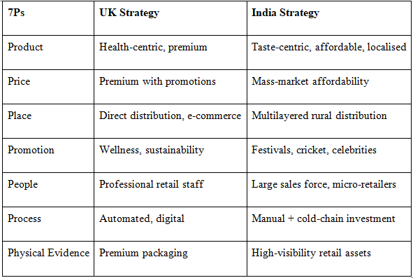

6. Evaluation of the Performance of Marketing Strategies
When analysing the performance of Coca-Cola in the United Kingdom and India, the market performance must be considered based on sales growth, market share, distribution penetration, online engagement, and brand loyalty. These indicators show the extent to which the STP and 7Ps strategies of the company are well suited to the country context in terms of culture, economy, and regulations.

6.1 Market Performance in the United Kingdom
Coca-Cola holds a leading role in the UK carbonated soft drinks (CSD) business, with a high rate of brand loyalty and in line with the health consumer-focused trends. According to Statista, Coca-Cola had the largest sales among soft drinks sold in convenience stores in the UK(Statista, 2025). The low-and-no-sugar drink trend has already provided certain results: the sales volume of Coca-Cola Zero Sugar increased by more than 10% in 2025 because of effective health-oriented repositioning and advertising(Coca-Cola, 2025a).
Its performance is further boosted by the firm’s distribution strategy. Coca-Cola company serves more than 430,000 retail stores in the UK, such as supermarkets, convenience stores, and on-the-go formats, via Coca-Cola Europacific Partners (CCEP)(CCEP, 2024). There is also an improved performance in e-commerce whereby online grocery sales of Coca-Cola have been boosted by 8.5% annually, due to the collaboration with Tesco Online, Ocado and Amazon Fresh(Coca-Cola, 2025a). The digital campaigns like Share a Coke continue to generate high engagement, and the UK campaign reaching over 18 million consumers via social media(Mintel, 2025).

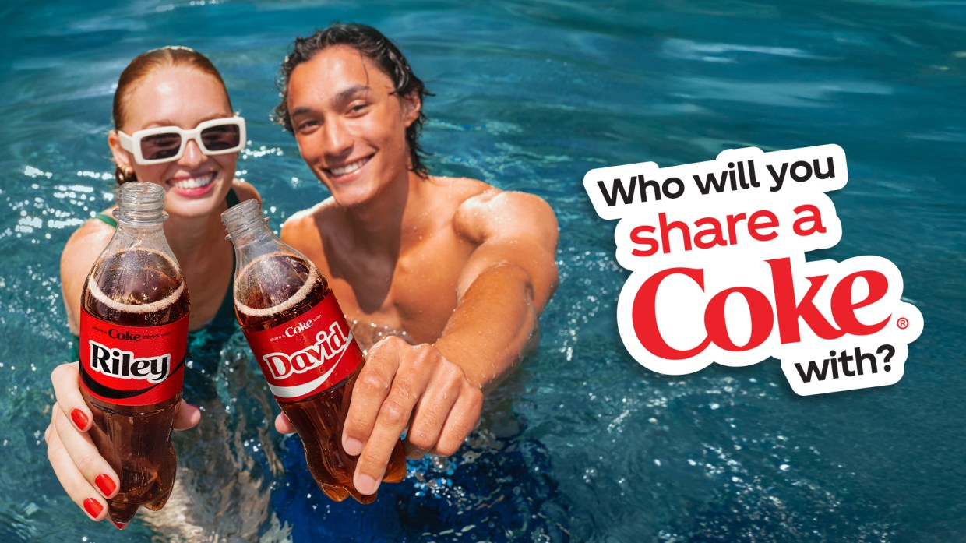

Fig: Coca-Cola 'Share A Coke' Advertisement(Adweek, 2025)

The performance of brand equity is also high. Coca-Cola remains one of the top 5 most positively perceived FMCG brands in the UK, scoring highly on attributes such as familiarity, satisfaction, and purchase intent(Menaria, 2015). These results shows a strong fit between Coca-Cola’s health-focused products, sustainability messaging, digital promotions, and the UK’s cultural individualistic, health-conscious and environmentally conscious market.

6.2 Market Performance in India
The performance of Coca-Cola in India shows that it has fast growth based on localisation, affordability, and strong distribution. In 2024, India was the fifth-largest global market of Coca-Cola with double-digit volume growth in various beverage types(Economictimes, 2025a). Thums Up, owned by Coca-Cola, was able to provide incredible success that became the first Indian CSD brand to pass USD 1 billion in sales annually(EconomicTimes, 2025b).
The greatest strength of the company is distribution reach. In India, Coca-Cola products are sold in more than 2.9 million outlets, such as Kirana stores, small retailers and modern trade channels(Singaram et al., 2019). The high penetration of affordable packs have greatly enabled the coca-cola to gain entry in the rural markets which has led to greater volume growth.
There is an abrupt increase in the use of digital channels especially by younger customers. The coca-cola India campaigns with Bollywood celebrity endorsements and the IPL associations created more than 320 million impressions through its campaigns on major platforms, making it one of the most successful FMCG online campaigns in 2023(A4M, 2025). The brand awareness level is also high, and Coca-Cola enjoys a top place among the most recognised brands of beverages in India.
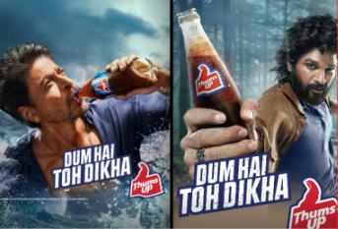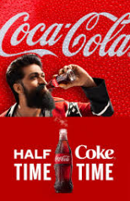
Fig: Cocacola Ads in India(A4M, 2025)
The success of these strategies is closely tied to contextual fit. The Indian collectivistic culture is receptive to celebratory, festive-oriented story-telling. The economic diversity necessitates the use of a tiered pricing, and the infrastructural issues explain why Coca-Cola has invested in cold-chain and widespread rural distribution. The localisation, affordability and emotional branding have thus delivered good performance in the market.

6.3 Comparative Evaluation of Performance
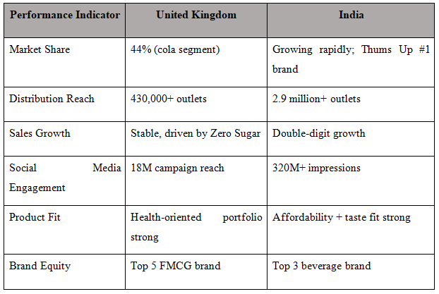

7. Evaluation of Marketing Ethics Practise
Evaluating Coca-Cola’s marketing ethics requires examining health-related concerns, environmental issues, sustainability issues, and adherence to ethical marketing standards across the UK and India. Although Coca-Cola has a corporate responsibility and sustainability policy on marketing and promoting its products across the globe, the ethical implication is quite different in the two markets because of the contextual, environmental, and regulatory differences(Coca-Cola, 2025c).

7.1 Ethical and Sustainability Issues
One of the major ethical concerns around Coca-Cola globally is its contribution to public health issues, particularly those linked to sugar consumption and obesity(Gertner & Rifkin, 2018). In United Kingdom, the problem of high sugar consumption has become a national health concern, and the government has implemented the Soft Drinks Industry Levy(Gov.UK, 2024b). A classical version of Coca-Cola includes approximately 10.6g of sugar in 100ml, which is one of the reasons that the company has been ethically criticised due to the contribution to the spread of sugar-related diseases(Coca-Cola, 2025b). Coca-Cola responded by cutting sugar in its product lines, and promoted more low/no sugar drinks in its product lines like Coca-Cola Zero Sugar.
In India, there are health issues but they are compounded by environmental and water consumption problems. In places such as Kerala and Uttar Pradesh, Coca-Cola experienced a backlash for allegedly over-extracting groundwater near bottling plants(Kabra et al., 2025). Although the company refutes the accused misconduct, the scandals the controversies highlight gaps in perceptions of environmental responsibility. Coca-Cola India, Conversely, introduced CSR programmes like Water Neutrality and asserts that all the water that is consumed in its products will be replenished(Globalindiannetwork, 2024). The issue of marketing of sugary beverages among children is an ethical challenge in the two countries.

7.2 Differences in Ethical Challenges and CSR Initiatives
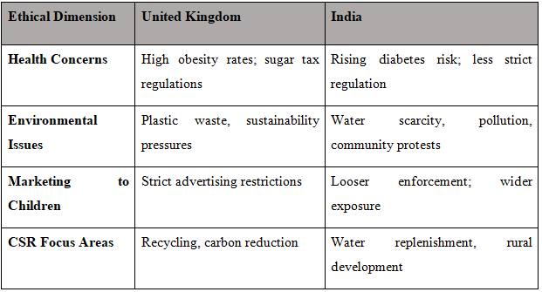
The major ethical concern in UK is health and sustainability. Strict advertising laws do not allow children under 16 years old to be targeted and plastic waste debate caused the use of recyclable PET packaging and a promise to use 100% recycled plastic in key products lines by Coca-Cola(CCEP, 2024). In India, on the other hand, ethical issues are resource-centric. Since water is a major issue that requires attention, Coca-Cola’s CSR efforts prioritise community water projects, rainwater harvesting, and local economic development programs. Though a great idea, critics claim that these measures might not be adequate to counter the environment effects of large scale bottling plant(Globalindiannetwork, 2024).

7.3 Alignment with Global Ethical and Corporate Responsibility Frameworks
Coca-Cola aligns its global operations with models like the UN Global Compact (UNGC), the Sustainable Development Goals (SDGs), and the New Plastics Economy by the Ellen MacArthur Foundation(Coca-Cola, 2025c). The global sustainability vision of the company, World without Waste, is to have all the bottles or cans that the company sells collected and recycled by the year 2030(Coca-Cola, 2025d). SDG 12 (Responsible Consumption and Production) is reflected in the UK with sustainable packaging and reformulation of lower sugar amounts. In India, alignment with SDG 6 (Clean Water and Sanitation) is observed in terms of water-replenishment and community projects.
Nonetheless, there are independent evaluations that indicate the gaps between policy and practise. An example is that Break Free From Plastic (2023) lists Coca-Cola as one of the largest plastic pollutants in the world, which casts doubts on the viability of its recycling pledges(Breakfreefromplastic, 2024). On the same note, despite India’s water-neutrality claims, local people still doubt the long term effects of bottling plants within the water stressed regions.

8. Recommendation and Conclusion

8.1 Strategic Recommendations
Based on the comparative analysis of Coca-Cola’s international marketing strategies in the UK and India, various strategic recommendations can help Coca-Cola in its future growth, sustainability, and cultural responsiveness.
- Enhance product innovation in line with health and local trends: The Coca-Cola Company must keep on developing its low-sugar and no-sugar products in the UK to cater to the increasing regulatory and consumer health requirements. In India, product innovation needs to diversify to culturally appropriate flavours, regionally specific beverages and functional drinks that can be used on different occasions.
- Improve sustainability through circular packaging and water stewardship: While significant progress has been made through initiatives like “World without Waste”, more should be done. Coca-Cola can accelerate the transition to 100% PET and expand refillable packaging pilots in the UK. In India, sustainability efforts should prioritise water stewardship by increasing community partnerships, rainwater harvesting, and a report system on the use of groundwater to mitigate deficiencies of trust.
- Expound digital marketing: Digital personalisation should be scaled across both markets. AI-based personalised advertisement and carbon-label transparency can reinforce brand positioning in the UK. In India, cultural relevance and expansion of rural penetration can be increased through hyper-local digital campaigns in regional languages, influencer partnerships and activities based on the festival.
- Strengthen ethical marketing and responsible communication: In both countries, Coca-Cola needs to strengthen ethical principles of marketing to children, communication regarding sugar, and responsible online messaging.
- Optimise distribution for future market Dynamics: Omnichannel and direct-to-consumer models will help to meet the changing consumption trends in the UK. Investments in cold-chain logistics and retailers capability-building will provide resilience and supply reliability in the rural setting and high-temperature conditions in India.

8.2 Conclusion
The comparative evaluation of Coca-Cola’s strategies in the UK and India demonstrates that balancing both global standardisation and local adaptation is an essential motif of the international marketing theory. The global brand strength, coupled with the localised pricing, product portfolios, distribution, and the promotional messages of coca-cola depicts a good match with the macro-environment, socio-cultural, and competition environment. Ultimately, the future success of Coca-Cola lies in its capacity to innovate in a responsible manner, be dedicated to sustainability, and be sensitive to the cultural diversity while maintaining a coherent global identity.

9. References
- A4M. (2025). Famous Coca-Cola Marketing Campaigns of 2024. Available at: https://www.advice4media.com/famous-coca-cola-marketing-campaigns-of-2024 [Last Accessed: 11/20/2025].
- Adweek. (2025). Coca-Cola Reimagines 'Share A Coke' For Gen Z Available at: https://www.adweek.com/brand-marketing/coca-cola-reimagines-share-a-coke-for-gen-z [Last Accessed: 11/20/205].
- Alon, I., Jaffe, E., Prange, C., & Vianelli, D. (2020). Global marketing: strategy, practise, and cases: Routledge.
- Bainsla, Y., Ahamed, A. A., & Karmakar, P. (2025). Recent Development in India@ 2025: Chyren Publication.
- Ben, B. (2021). Sustainability a business approach case: the non-alcoholic beverage industry.
- Breakfreefromplastic. (2024). 2023 Global Brand Audit: The Coca-Cola Company is once again the top global plastic polluter. Available at: https://www.breakfreefromplastic.org/2024/02/07/bffp-movement-unveils-2023-global-brand-audit-results [Last Accessed:11/20/2025].
- Bureau, G. o. I. P. I. (2025). India’s Economic Surge. Available at: https://www.pib.gov.in/PressNoteDetails.aspx?NoteId=154840&ModuleId=3 [Accessed 10 Nov 2025].
- Camilleri, M. A. (2017). Market segmentation, targeting and positioning. In Travel marketing, tourism economics and the airline product: An introduction to theory and practise (pp. 69-83): Springer.
- Castanho, P. (2025). Internationalization and International Marketing: Principles and Literature Issues. In Evolving Strategies for Organizational Management and Performance Evaluation (pp. 381-398): IGI Global Scientific Publishing.
- CCEP. (2024). 2024 CCEP Annual Report. Available at: https://www.cocacolaep.com/assets/Global/Investors/2024-Annual-Report/2024-CCEP-Annual-Report_2025.03.20_Interactive.pdf [Last Accessed:11/20/2025].
- Chu, B. (2020). Analysis on the success of Coca-Cola marketing strategy. Paper presented at the 2020 2nd International Conference on Economic Management and Cultural Industry (ICEMCI 2020).
- Coca-Cola. (2025a). Coca-Cola Reports Third Quarter 2025 Results. Available at: https://www.coca-colacompany.com/media-center/coca-cola-reports-third-quarter-2025-results [Last Accessed:11/20/2025].
- Coca-Cola. (2025b). Coca‑Cola Flavours, Calories & Nutrition Facts. Available at: https://www.coca-cola.com/pk/en/brands/coca-cola#accordion-920251f983-item-5f0f54b759 [Last Accessed:11/20/2025].
- Coca-Cola. (2025c). Sustainability. Available at: https://www.coca-cola.com/gb/en/sustainability [Last Accessed: 11/21/2025].
- Coca-Cola. (2025d). Sustainable Packaging: World Without Waste. Available at: https://www.coca-cola.com/it/it/sustainability/sustainable-packaging [Last Accessed:11/20/2025].
- Coca-Cola. (2025e). Value Chain Transformation. Available at: https://www.coca-cola.com/in/en/sustainability/value-chain-transformation [Last Accessed:11/20/2025].
- CocaCola. (2024). 2024-Portfolio Update. Available at: https://www.coca-colacompany.com/content/dam/company/us/en/reports/2024-portfolio-update.pdf [Last Accessed:11/20/2025].
- CocaCola. (2025a). About Us. Available at: https://www.coca-colacompany.com/about-us [Accessed 10 Nov 2025].
- CocaCola. (2025b). Segments. Available at: https://investors.coca-colacompany.com/about/segments [Accessed 10 Nov 2025].
- Company, T. C.-C. (2024a). Coca‑Cola Reports Fourth Quarter and Full Year 2024 Results. Available at: https://www.coca-colacompany.com/media-center/coca-cola-reports-fourth-quarter-and-full-year-2024-results [Accessed10 Nov 2025].
- Company, T. C.-C. (2024b). History of Coca-Cola. Available at: https://www.coca-colacompany.com/about-us/history [Accessed10 Nov 2025].
- Company, T. C.-C. (2024c). Mission, vision and values. Available at: https://www.coca-colacompany.com/about-us/faq/our-company [Accessed10 Nov 2025].
- Company., T. C.-C. (2025). How did Coca‑Cola grow as an international business? Available at: https://www.coca-cola.com/us/en/about-us/faq/how-did-coca-cola-grow-as-an-international-business [Accessed 10 Nov 2025].
- Czinkota, M. R., Kotabe, M., Vrontis, D., & Shams, S. R. (2021). Distribution and supply chain management. In Marketing management: Past, present and future (pp. 499-552): Springer.
- Das, R. Inflation and UK Economy in 2023.
- Deliceırmak, F. D. (2022). The glocal marketing strategies of global brands: Coca-Cola and McDonald’s. Journal of International Business and Management, 5(7), 1-22.
- Economictimes. (2016). India sells the cheapest, most accessible Coke: President and COO of Coca Cola James Quincey. Available at: https://economictimes.indiatimes.com/industry/cons-products/food/india-sells-the-cheapest-most-accessible-coke-president-and-coo-of-coca-cola-james-quincey/articleshow/52803742 [Last Accessed:11/20/2025].
- Economictimes. (2025a). Coca-Cola reports double-digit volume growth in Q1 in India, helped by Thums UP. Available at:
- https://economictimes.indiatimes.com/industry/cons-products/food/coca-cola-reports-double-digit-volume-growth-in-q1-in-india-helped-by-thums-up/articleshow/120734781.cms?utm_source=contentofinterest&utm_medium=text&utm_campaign=cppst [Last Accessed:11/20/2025].
- EconomicTimes. (2025b). soft drinks: Thums Up becomes a billion-dollar brand. Available at: https://economictimes.indiatimes.com/industry/cons-products/food/thums-up-becomes-a-billion-dollar-brand/articleshow/89486419.cms?from=mdr [Last Accessed: 11/21/2025].
- Franssen, N. (2023). Water neutrality in investment portfolios. In Water risk modeling: Developing risk-return management techniques in finance and beyond (pp. 247-276): Springer.
- FSSAI. (2023). Food Safety and Standards Authority of India (Financial) Regulations, 2023. Available at: https://fssai.gov.in/cms/food-safety-and-standards-regulations.php [Accessed 10 Nov 2025].
- Garcia, M. J. (2023). Post-Brexit trade policy in the UK: Placebo policy-making? Journal of European Public Policy, 30(11), 2492-2518.
- Gertner, D., & Rifkin, L. (2018). Coca‐Cola and the fight against the global obesity epidemic. Thunderbird International Business Review, 60(2), 161-173.
- Ghosh, M. (2023). Growth and development under alternative policy regimes in india: a political economy perspective. Journal of Asian and African Studies, 58(7), 1134-1155.
- Globalindiannetwork. (2024). Coke and Water Sustainability: An Analysis of Corporate Responsibility. Available at: https://globalindiannetwork.com/coke-and-water-sustainability [Last Accessed:11/20/2025].
- Gov.UK. (2024a). Single-use plastics bans and restrictions. Available at: https://www.gov.uk/guidance/single-use-plastics-bans-and-restrictions [Last Accessed: 11/10/2025].
- Gov.UK. (2024b). Soft Drinks Industry Levy: detailed information. Available at: https://www.gov.uk/government/collections/soft-drinks-industry-levy-detailed-information [Accessed 10 Nov 2025].
- Greer, G. (2018). Win in India: An Analysis of Market Entry Strategy into India’s Food and Beverage Industry.
- Hofstede. (2025). Country Comparison. Available at: https://www.theculturefactor.com/country-comparison-tool?countries=philippines [Accessed 10 Nov 2025].
- Hofstede, G. (2011). Dimensionalizing cultures: The Hofstede model in context. Online readings in psychology and culture, 2(1), 8.
- Institute, T. S. (2024). Coca-Cola’s global dominance: Decoding the beverage giant’s business strategy. Available at: https://www.thestrategyinstitute.org/insights/coca-colas-global-dominance [Accessed10 Nov 2025].
- ITA. (2023). United Kingdom - eCommerce. Available at: https://www.trade.gov/country-commercial-guides/united-kingdom-ecommerce [Last Accessed: 11/10/2025].
- Jain, R., Jain, S., & Jain, S. (2022). Analyzing and exploring the effectiveness of each element of 7Ps of marketing mix. International Journal of All Research Education and Scientific Methods (IJARESM), 10(1), 2455-6211.
- Kabra, S., Bhati, P., Aryan, A., Biswas, D., Gandhi, D., Midathada, P. P., & Tripathi, A. (2025). Coca-Cola's Impact in India: Economic Dynamics and Policy Recommendations.
- Kendal, D., Ford, R. M., Anderson, N. M., & Farrar, A. (2015). The VALS: A new tool to measure people's general valued attributes of landscapes. Journal of Environmental Management, 163, 224-233.
- Kotler, P., Keller, K. L., & Chernev, A. (2022). Marketing management (Sixteenth edition, Global Edition. ed.). Harlow, England: Pearson.
- Larsen, N. (2010). Market segmentation. Aarhus School of Business.
- Li, X. (2025). Consumer Insights in the Digital Age: Coca-Cola’s Innovative Responses in the Era of Healthy Beverages. Finance & Economics, 1(2).
- Management, S. A. (2024). Think local, act local: Coca-Cola’s localisation strategy. Available at: https://www.skerryvoream.com/uk/insights/long-view/think-local-act-local [Accessed10 Nov 2025].
- Market.us. (2025). Coca-Cola Statistics and Facts. Available at: https://market.us/statistics/food-and-beverage-companies/coca-cola-company/ [Accessed10 Nov 2025].
- Menaria, P. S. (2015). Analyzing the brand loyalty of soft drink companies in UK: A case study of Coca-Cola, UK. Dublin Business School,
- Meron, Y. (2020). Coke and design. In Decoding Coca-Cola (pp. 111-124): Routledge.
- Mintel. (2025). UK Carbonated Soft Drinks Market Report 2025. Available at: https://store.mintel.com/report/uk-carbonated-soft-drinks-market-report [Last Accessed:11/20/2025].
- Muddassir, M. (2025). Analyzing Customer Preference For Beverages, Considering Health Consciousness, Sustainability, And Flavor Preference As Driving Factors For Consumer Choice In The UK. Capstone Insights: Social Impact and Sustainability–2025 Volume 3, 46.
- Nadube, P. M., & Didia, J. (2018). Market targeting and strategic positioning. International Journal of Marketing Research and Management, 8(1), 32-45.
- Perera, R. (2017). The PESTLE analysis (Vol. 1): Nerdynaut Avissawella, Sri Lanka.
- PestleAnalysis.com. (2023). PESTLE Analysis of The United Kingdom: 6 Factors Affecting the UK. Available at: https://pestleanalysis.com/united-kingdom-pestle-analysis/ [Accessed 10 Nov 2025].
- PestleAnalysis.com. (2024). PESTLE Analysis of India. Available at: https://pestleanalysis.com/pestle-analysis-india/ [Accessed 10 Nov 2025].
- PIB. (2024). Understanding population-related issues, Tailoring solutions, and Driving progress. Available at: https://www.pib.gov.in/PressNoteDetails.aspx?NoteId=151925&ModuleId=3 [Last Accessed: 11/10/2025].
- Restaurantindia.in. (2024). What's Pushing the Growth of Low-Sugar Beverages in India. Available at: https://www.restaurantindia.in/article/whats-pushing-the-growth-of-low-sugar-beverages-in-india.11702 [Last Accessed:11/20/2025].
- Riegel, V., & Pellerano, J. (2020). Coke and the kids. In Decoding Coca-Cola (pp. 198-206): Routledge.
- Sarangi, S. (2018). Distribution in emerging markets: a strategic perspective. International Journal of Business and Emerging Markets, 10(3), 213-228.
- Schlegelmilch, B. B. (2022). Segmenting targeting and positioning in global markets. In Global Marketing Strategy: An Executive Digest (pp. 129-159): Springer.
- Singaram, R., Ramasubramani, A., Mehta, A., & Arora, P. (2019). Coca Cola: A study on the marketing strategies for millenniums focusing on India. International Journal of Advanced Research and Development, 4(1), 62-68.
- Statista. (2025). Leading soft drink brands ranked by convenience sales value in the United Kingdom in 2024. Available at: https://www.statista.com/statistics/629118/soft-drink-brand-ranking-in-the-united-kingdom-uk-by-convenience-sales-value/?srsltid=AfmBOorfUb0yqe3X7U3imWka94cZTxXWiQ0eVAHkgjKG01CRFfHr1aF [Last Accessed:11/20/2025].
- WorldBank. (2025). GDP (current US$) - India. Gov.UK. (2024). Single-use plastics bans and restrictions. Available at: https://data.worldbank.org/indicator/NY.GDP.MKTP.CD?locations=IN [Last Accessed: 11/10/2025].

