Name: Emriona Bushaj
Student Number: 2313944

TASK 1 — Dataset Exploration
Dataset Summary:
The dataset contains 1000 instances and 21 attributes
It includes both:
Numeric attributes ( duration, credit_amount, age)
Nominal attributes ( checking_status, purpose, housing)
The class attribute is credit risk classification (good vs bad)
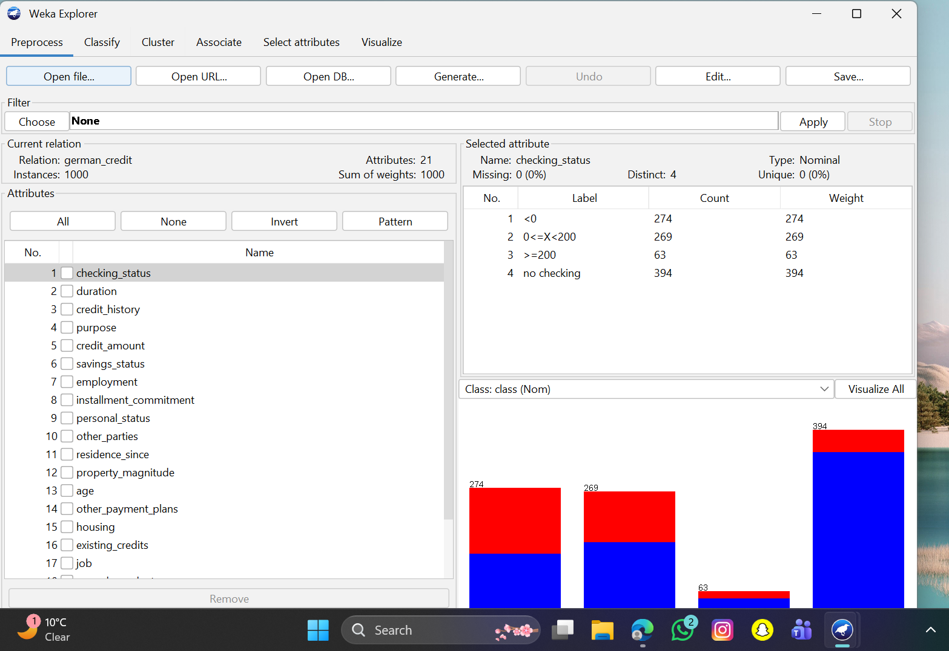

TASK 2 — Data Preprocessing
1. Missing Values
Missing: 0 (0%)
The dataset contains no missing values
If missing values were present:
Weka’s ReplaceMissingValues filter would be used

2. Encoding Categorical Data

The dataset contains several nominal attributes
Weka can process nominal data directly
Encoding ( NominalToBinary) may be applied for algorithms like Logistic Regression

3. Class Balance
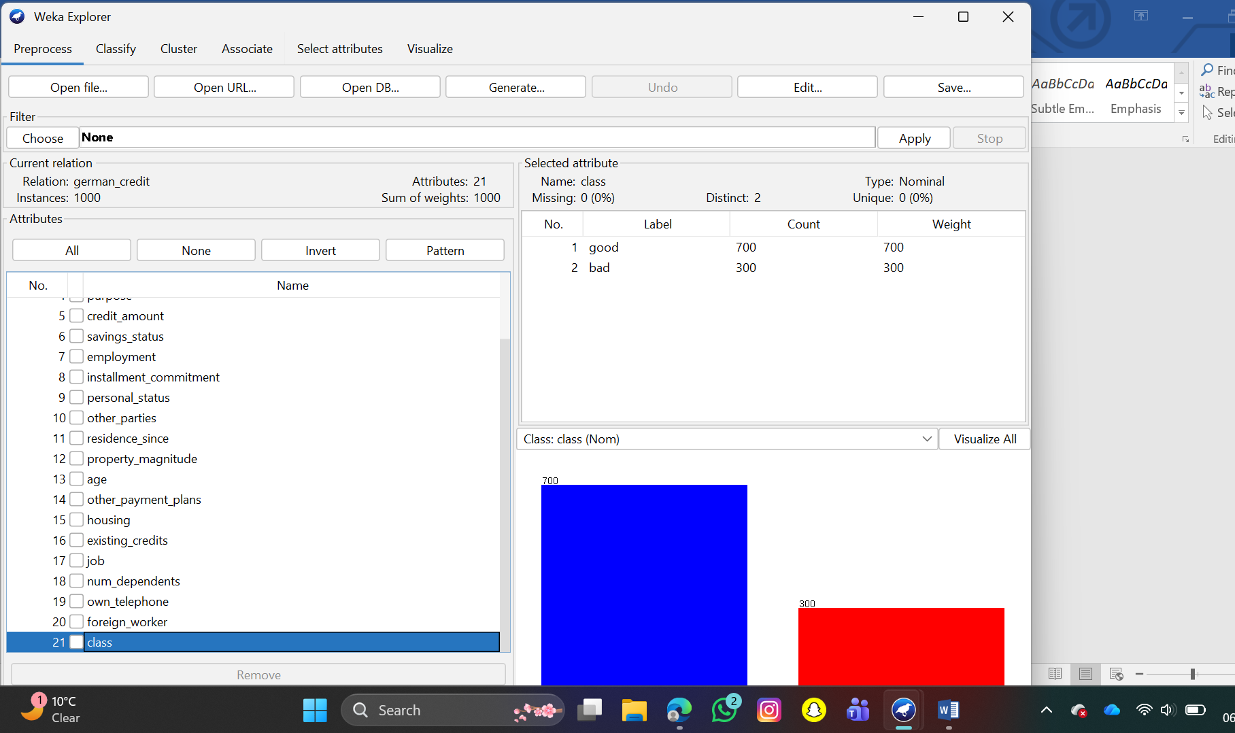

The dataset is imbalanced
Majority class: good credit
Minority class: bad credit

SMOTE
Due to class imbalance, models may be biased toward predicting the majority class
SMOTE (Synthetic Minority Oversampling Technique) can be applied
This improves detection of minority class (bad credit cases)

TASK 3 — BUILD MODELS
Models & Results
Two models were tested: J48 and Random Forest
10-fold cross-validation was used
Random Forest achieved higher accuracy (~76%) compared to J48 (~71%)

Comparison
Random Forest performed better due to handling complex patterns
J48 is easier to interpret but less accurate

Justification
Random Forest reduces overfitting and improves prediction accuracy
J48 provides understandable decision rules
Accuracy, precision, and recall were used to evaluate model performance

