Laboratory Report: Data Capture & Analysis of an OME Item.
Data Capture & Evaluation for OME – ACDA 6021
Alex Lamdin
22nd April 2026

Table of Contents
- Task Introduction
- Trial & Instrumentation Set-Up
  - Range, Safety and PPE
  - Arena Construction
  - Instrumentation – Velocity Foils
  - Instrumentation – Pressure Gauges
- Data & Analysis
  - Fragmentation Pattern & Type
  - Instrumentation – Velocity Foils
  - Instrumentation – Pressure Gauges
  - Post-Blast Forensic Analysis
- Discussion - Deduction of Munition
- Conclusion
- References
Annex 1 – Munition Options Datasheet

1. Task Introduction
As part of the “Data Capture & Evaluation” (DC&E) module, students on the OME course were tasked with setting up a static arena trial including a selection of instrumentation to gather data on an unknown munition, which would be placed by the teaching staff.
The students were to then use the data collected to determine the nature of an OME item from a predefined list. This had two aims; initially to develop the students’ knowledge of the range of OME trials and the equipment and techniques used to capture data from them, and secondly to introduce/support the students in developing the ability to conduct critical analysis of data collected from an OME event.

2. Trial & Instrumentation Set-Up
2.1. Range, Safety and PPE
The trial was conducted at the Cranfield (University) Ordnance Test & Evaluation Centre (COTEC), located on Salisbury plain. As the name suggests, this T&E facility is run by Cranfield University on land leased from the MoD. They have a variety of facilities available to them, most importantly in this case a range with a large danger area to be able to conduct outdoor firings of fragmenting munitions. The standing range safety limit at COTEC for anyone firing without an exemption waiver is 10kg NEQ. [1]
Prior to attending the trial site, all students were thoroughly briefed. This included an overarching safety brief and an explanatory lesson on the techniques and instrumentation that were to be used given several days prior, as well as a specific range safety brief given upon arrival at COTEC.
Appropriate PPE, in this case sturdy closed toe footwear, was worn, with protective gloves being worn for manual handling where necessary.
Once the set-up of the arena and instrumentation was complete, all students went and remained under hard cover until the firing was completed, obeying all instructions from the Trials Conducting Officer (TCO). The munition had been prepared previously and was placed by range staff out of view of the students.
2.2. Arena Construction
Fragmentation arenas used in the UK are generally constructed to International Test Operations Procedure (ITOP) 4-2-813, “Static Testing of High-Explosive Munitions for Obtaining Fragment Spatial Distributions”. [2] However due to this being written in 1993, there have been some accepted best practice modifications to his, particularly around the sizing of arenas – the ITOP specifies three sizes, namely:
- <0.6kg NEQ – Arena Radius 2m
- 0.6 – 10kg NEQ – Radius 5m
- >10kg NEQ – Radius 10m.
In practice, the arena size is often adjusted for the munition, and can be between these sizes, or significantly larger, depending on the munition being assessed.
The arena constructed at COTEC followed the principles Semicircular Fragmentation Arenas (SCFA) described in ITOP 4-2-813 and was a partial arena of radius ~1.5m with a horizontal arc of 113°, providing a vertical segment of 15°. This consisted of 4 stands, each with two 20 sheet packs of 3mm strawboard, for a total of 40 sheets depth. The stands were labelled 1-4 from left to right. The arena radius and the munition centre height of 0.5m were chosen by teaching staff. Students were also advised that the munition would be positioned vertically.
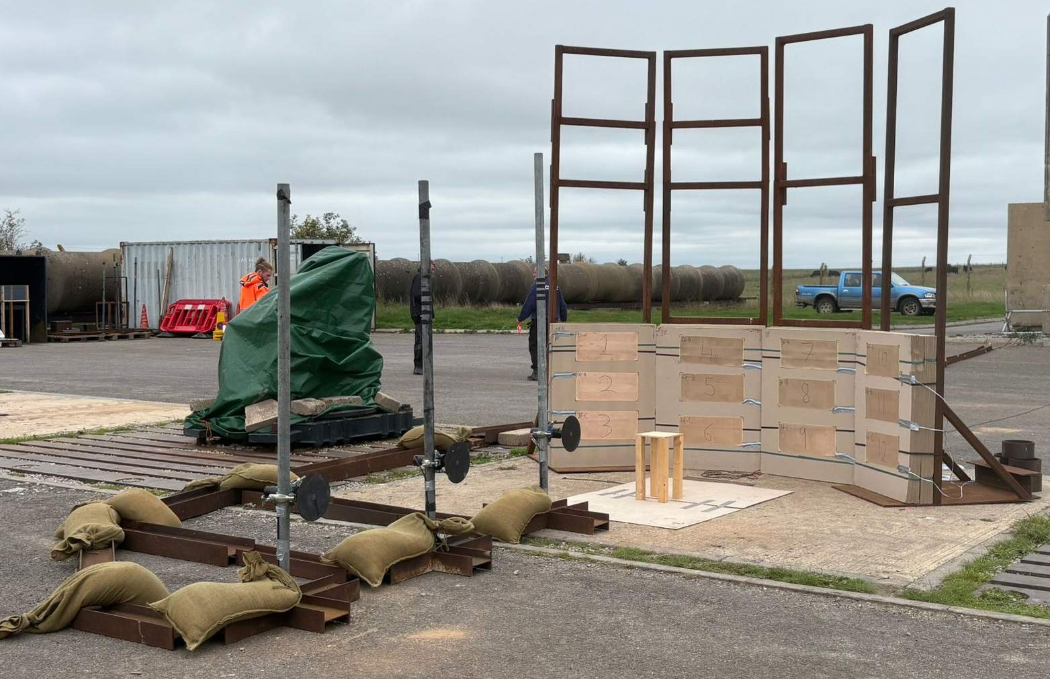
The strawboards used measured 105 x 80 cm and were positioned with the short side to the ground and the long side vertically. This was so when placed alongside each other, they provided a higher definition to the curve, more closely fitting the measured radius. The completed arena can be seen in the picture below.
Fig. 1 – Constructed Arena.
The arena was constructed such that it was facing away from the control room, with the arena centre and thus the munition placement being the opposite side. This was primarily due to the requirement to hide the munition from the students during firing, however would also provide some mitigation from any fragmentation.
2.3. Instrumentation – Velocity Foils
Velocity foils are basic Printed Circuit Boards (PCBs) which consist of copper tracks which, when struck by a projected fragment, either complete (“make” foils) or break (“break” foils) a circuit connected to them.
In the case of this trial, “make” foils were used. These were a standard A4 (210x297mm) size and consisted of two interleaved copper tracks, such that when a metallic fragment struck the two contacts would be bridged and the circuit completed. These were connected via a series of cables to a logic analyser, which was set up to be used as a data recorder and record when the circuits were connected.
When combined with a zero time, T₀, recorded by a break wire which was placed around the munition immediately prior to firing, the time taken until a foil ” break” can be used with the measured distance to the foils to calculate the fragment velocity.
The foils were positioned landscape, with 3 foils distributed onto the front of each strawboard face. Once their placement had been finalised, measurements were taken to the centre of foil from the point of detonation. The final locations and measurements can be seen in figure 2 and table 1 respectively.
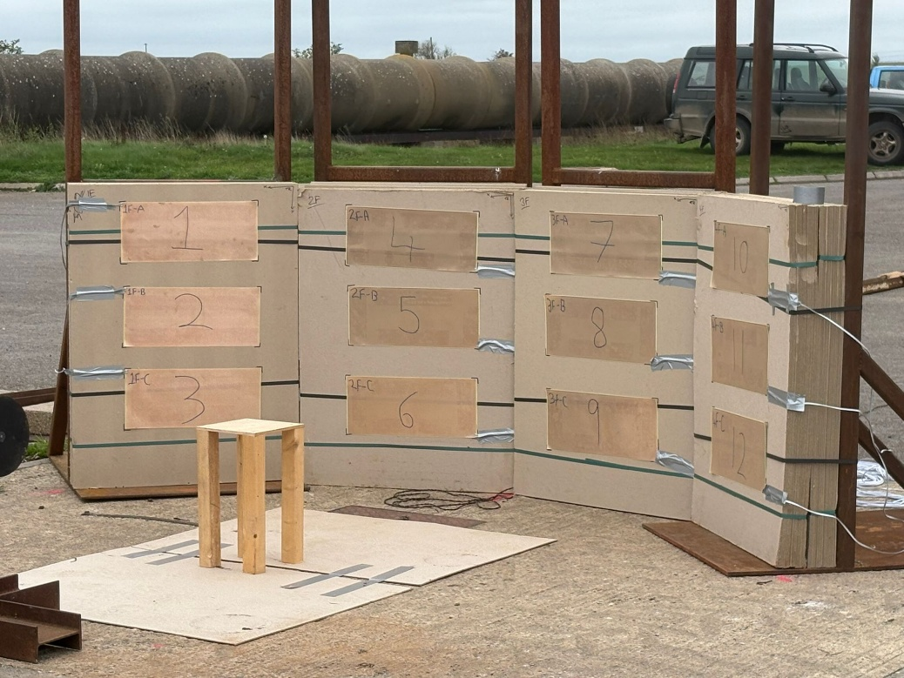
Fig. 2 – “Make” Foils Positioned on Strawboard Packs
Foil Position | Strawboard Number
Foil Position | 1 | 2 | 3 | 4
A | 1.462 m | 1.411 m | 1.452 m | 1.499 m
B | 1.337 m | 1.358 m | 1.392 m | 1.439 m
C | 1.327 m | 1.354 m | 1.390 m | 1.430 m
Table 1. – Final Foil Position Measurement
The foils were connected using breakout connectors to multicore cables which run back to the control room, where they were connected to the logic analysers.
2.4. Instrumentation – Pressure Gauges
A linear array of three pressure gauges was employed to measure the blast overpressure generated by the munition functioning. Supplied by the COTEC Senior Instrumentation Officer (SIO), these were integrated electronic piezoelectric (IEPE) gauges mounted in steel “mushrooms” which are mounted perpendicular to the event to allow for the mushroom to “slice” the blast wave, allowing for a clean read and minimise the potential for damage from fragmentation. An example of one of the gauges can be seen in figure 3. We were advised by the SIO that these gauges were amplified such that 10mV generated is equivalent to 1kPa of blast pressure.

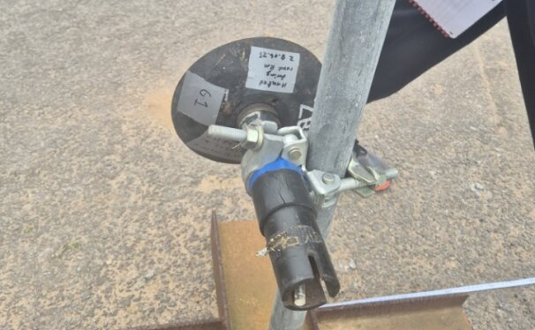
Fig. 3 – Piezoelectric Blast Gauge
The gauges were positioned in a line opposite the constructed arena wall. The gauges were positioned at approx. 1m intervals and positioned 0.5m off the ground, so as to be equal to the height of the centre of the munition. The gauges were staggered slightly perpendicularly to the array to ensure that each gauge was exposed to a clean wave with minimal turbulence form the gauges preceding it. The final measurements from the gauges to the munition location, as well as a picture of the completed array, can be seen in table 2 and figure 4 respectively.
Gauge Number | Measurement |  | Average Measurement (3 d.p.)
Gauge Number | 1 | 2 | Average Measurement (3 d.p.)
(Pos. 3) 1 | 3.099 m | 3.090 m | 3.095 m
(Pos. 2) 2 | 2.075 m | 2.076 m | 2.076 m
(Pos. 1)4 | 1.009 m | 1.015 m | 1.012 m
Table 2. – Gauge Measurements
The gauges were connected using coaxial cable and these ran back to the control room, where they were connected to the bespoke COTEC blast measurement hardware. The completed cable runs were shielded with steel beams and channels, as well as sandbags, to minimise the risk of them being damaged by fragmentation.
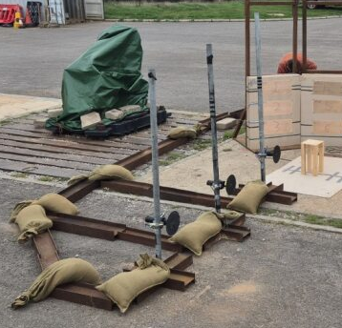
Fig. 4 – Completed Pressure Gauge Array

3. Data and Analysis
Once the TCO had declared the “all clear” following firing, the students proceeded forwards and recorded the immediate post-detonation observations, as well as liaised with the SIO and teaching staff for the transfer of the recorded data files.
3.1. Fragmentation Pattern & Type
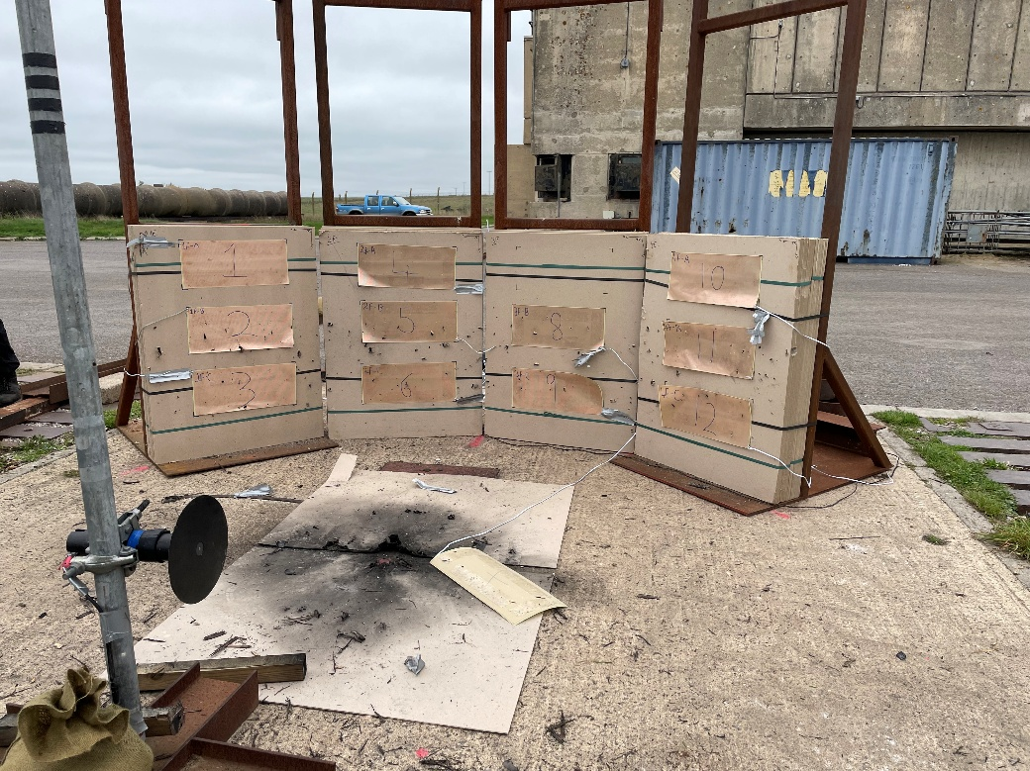
It was immediately obvious upon approaching the arena that the munition had produced a defined horizontal band of fragmentation across the width of the arena, centered vertically on the centre of the munition, with most of the fragmentation remaining within the band, and thus across the lower two rows of foils. This can be seen in the picture below.
Fig. 5 – Observed Fragmentation Pattern
The strawboard packs were disassembled for frag picking and inspection, and, where possible, the fragments within recovered. Due to time and logistical constraints, the depth of penetration of each fragment was not measured.
Also of note was a lack of substantiative damage to the concrete pad directly beneath the munition location. This suggests that minimal fragmentation was produced vertically downwards, with it being focused horizontally from the sides of the munition.
The fragmentation recovered was dark, silvery-grey in colour and appeared to be naturally formed. Of particular note was that much of the fragmentation was in the form of long, straight ribbons. This suggests that the munition was cylindrical, reasonably small diameter and that the casing split wholly naturally around the circumference during detonation. [3], [4]
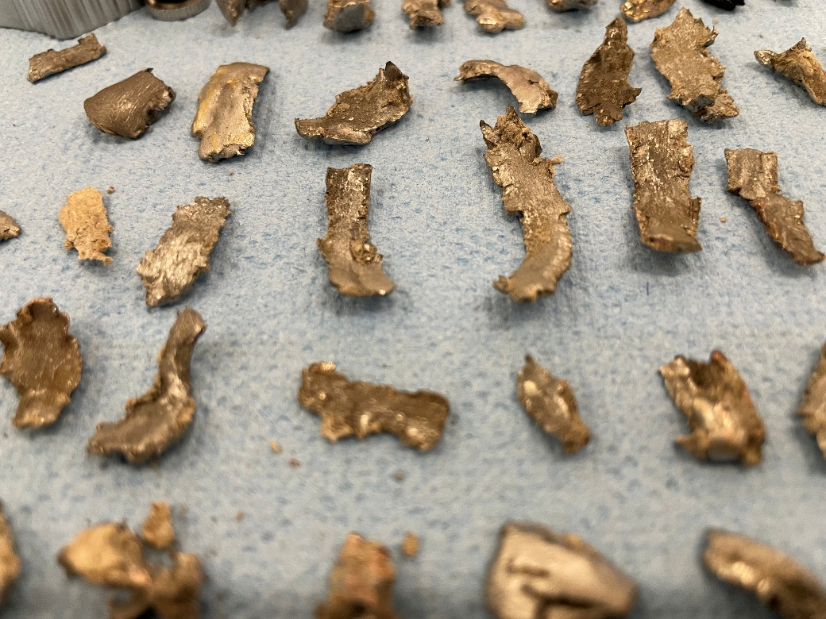
Fig. 6 – Retrieved Fragmentation
3.2. Instrumentation – Velocity Foils
Upon inspection, most of the velocity foils had been successfully penetrated, with a number of impacts recorded by the logic analyser. Unfortunately, following the initial circuit completion (first recorded strike) on each foil, it is not possible to determine whether the recorded strike times of subsequent fragments were in fact the initial fragmentation or just secondarily disrupted debris; without corroborating the recorded data with high speed video (HSV). Since HSV was not employed on this trial, only 16 of the recorded impacts can be used.
The recorded time to initial strike and the number of usable recorded strikes (as reported by the SIO) can be seen in the table below. It was identified that three foils’ data was anomalous, Foil 1A (highlighted in red) having taken an unusually long time to trigger, and foil 3A and 4C (orange) having no visible damage.
Foil Position | Strawboard Number
Foil Position | 1 | 2 | 3 | 4
A | 4.5953 (2) | 2.07088 (2) | 2.65346 (0) | 2.6625 (1)
B | 1.71048 (1) | 1.76334 (2) | 1.78502 (1) | 1.7422 (1)
C | 1.72476 (1) | 1.7305 (3) | 1.76556 (2) | 1.7822 (0)
Table 3. – Recorded Foil Trigger Times (ms)
These timings were then combined with the distance measurements taken prior to firing to calculate the average fragment velocity. The decision was made to exclude the anomalous values from the velocity calculations.
Foil | Distance (mm) | Time (µs) | Fragment Velocity (mm/µs)
1A | 1462 | 4595 | 0.318171926
1B | 1337 | 1711 | 0.781414378
1C | 1327 | 1725 | 0.769275362
2A | 1411 | 2071 | 0.681313375
2B | 1358 | 1763 | 0.770277935
2C | 1354 | 1731 | 0.782206817
3A | 1452 | 2653 | 0.547304938
3B | 1392 | 1785 | 0.779831933
3C | 1390 | 1766 | 0.787089468
4A | 1499 | 2663 | 0.562898986
4B | 1439 | 1742 | 0.826061998
4C | 1430 | 1782 | 0.802469136
Average Fragment Velocity (Excluding Anomalies) (mm/µs) |  |  | 0.74893
Table 4. – Calculated Fragment Velocities (mm/µs - km/s)
An estimation of the velocity at which a projected fragment is propelled from the detonation of a fragmenting munition can be calculated using the Gurney Equations, which use a selection of munition data and a model developed by Ronald Gurney in the 1940s. Whilst they will always be an estimation due to the huge variety of nuance in munition shape, use scenarios and surroundings; the equations are widely accepted as valid by the (W)OME community. [5]
$$\frac{V}{\sqrt{2E}}={\left(\frac{M}{C}+\frac{1}{2}\right)}^{-\frac{1}{2}}$$
Eqn. 1 – Gurney Equation (Cylindrical) [5]
$$\frac{V}{\sqrt{2E}}={\left(\frac{M}{C}+\frac{3}{5}\right)}^{-\frac{1}{2}}$$
Eqn. 2 – Gurney Equation (Spherical) [5]
As can be seen in table 4, an average (measured) fragment velocity was calculated at the 1.5m distance. This iwas found to be ~750m/s. Referring to the provided munitions list, the initial fragment velocities of the munitions vary from 1550-2050 m/s. Unfortunately, this strongly suggests that the data collected is flawed, and the lack of any correspondence between the calculated experimental value and those given for the possible munitions means that further calculation would be somewhat obsolete. It is regrettably concluded that therefore, the velocity foil data cannot offer much value to the final munition determination.
3.3. Instrumentation – Pressure Gauges
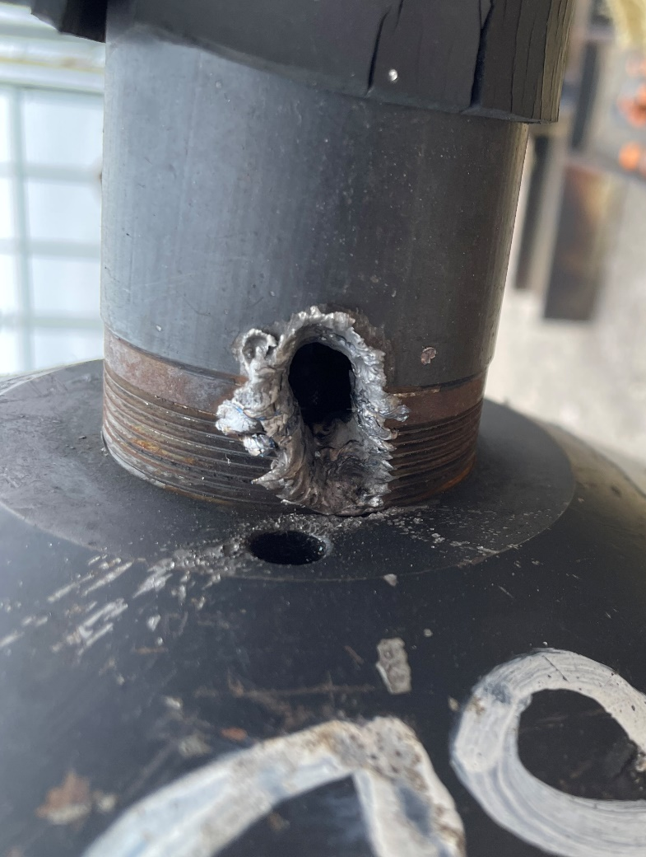
Post firing, it was immediately noted that the pressure gauge in position 1 (closest to the munition) at a distance of approx. 1m, had suffered a severe fragment strike to the front edge of the gauge mount. This was, as expected, reflected in the data collected and as such has been excluded from further evaluation.
Fig. 7 – Pressure Gauge 1 Post-Firing (Struck)
The remaining pressure data was extracted and smoothed, however it was immediately obvious that the data gathered included a large amount of noise. This will predominantly be due to reflection from structures and buildings on/adjacent to the firing pad, ground shock and equipment precision. The blast pressure data collected is shown in figure 8.
Initially focusing on the data collected by the blast gauge in position 2, the incident and reflective peaks are immediately obvious. Following the system specifications given by the SIO, which stated 10mV generated is equivalent to 1kPa of blast pressure, the incident peak appears to have generated approx. ~430mV and is therefore equivalent to ~43kPa of blast pressure.

Fig. 8 – Collected Blast Pressure Data
$$Z= \frac{R}{W^{\frac{1}{3}}}$$
$$W= {\left(\frac{R}{Z}\right)}^{3}$$
$W= {\left(\frac{2}{4.2}\right)}^{3}=0.1079kg=107.9g NEQ$ (uncased)
Eqn. 3 – Kingery-Bulmash Calculations [6]
Utilising the Kingery-Bulmash Blast Parameter Models (Figure 9, Equation 3), this would suggest an (uncased) free-air equivalent NEQ of ~110g of TNT or ~100g of 1.1-1.2 TNT equivalency modern explosive composition (RDX, HMX, C/PE-4 etc). [6]
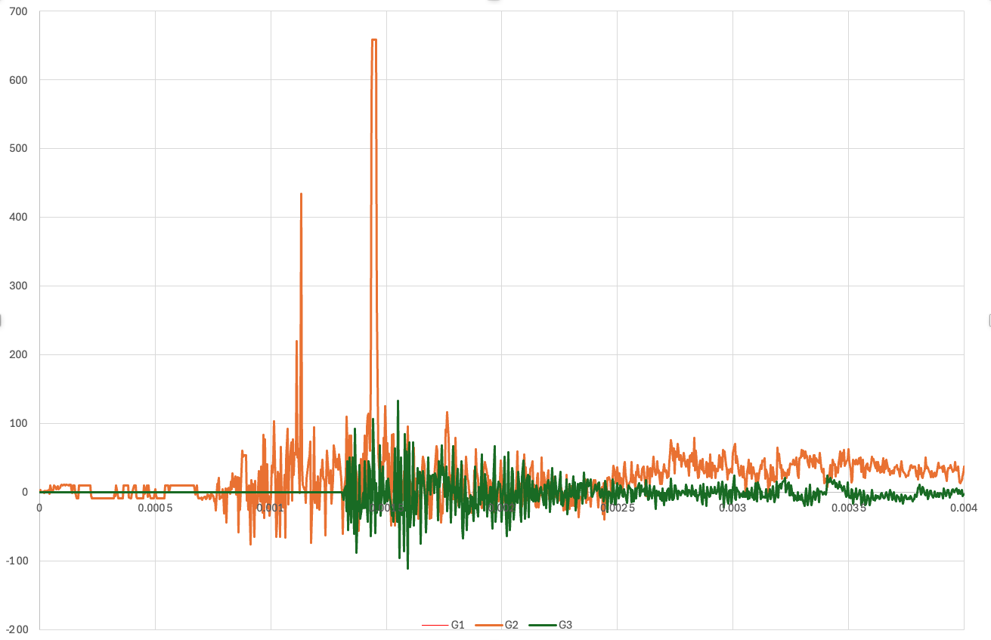
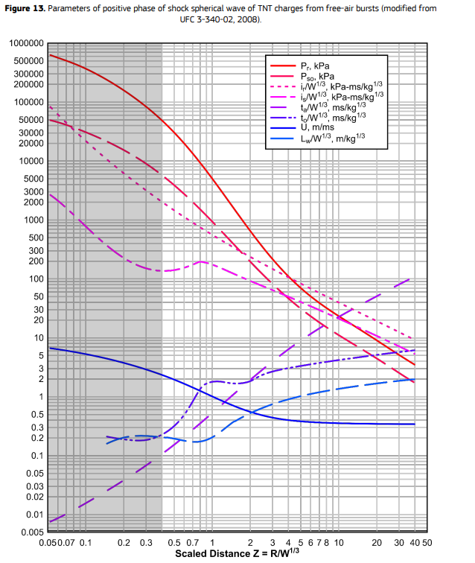
Fig. 9 – Table showing parameters of positive phase (spherical) blast pressure of TNT free-air bursts [7]

3.4. Post-Blast Forensic Analysis
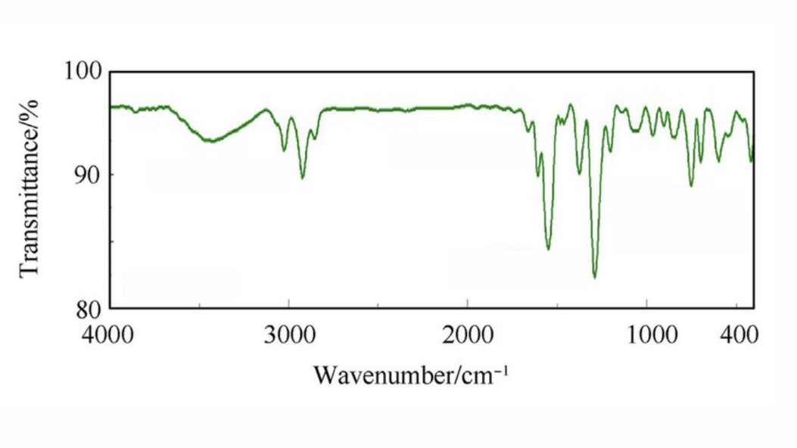
The fragmentation collected was cleaned in acetone, allowed to dry and then swabbed using clean forensic technique. The samples collected were then analysed using a PerkinElmer Spectrum Two Spectrometer fitted with a PerkinElmer UATR Two UATR module, connected to a PC running the PerkinElmer Spectrum IR Software. The acetone trace was digitally removed, providing a transmittance spectrum for the sample.
Fig. 10 – FT-IR transmittance spectra.
This transmittance spectra was then compared to known peak values for several functional groups. (Table 6)[8]. The following were identified:
Transmittance Peak | Strength | Likely Indication
~1250 cm⁻¹ | (Extremely) Strong | C-N
1000 -1100 | Medium | C-N
~1550 cm⁻¹ | (Extremely) Strong | Nitro Group
~1400 cm⁻¹ | Strong | -CH₂
3050cm⁻¹ | Medium | C-H Alkene
2900 cm⁻¹ | Strong
Table 5. – Characteristic FT-IR Peaks present in sample [8]
The presence of a strong peak in the ~1400cm⁻¹ range, indicating the presence of -CH₂ groups, alongside the presence of C-N bond and nitro groups, suggests an explosive composition such as RDX (C₃H₆N₆O₆) (Fig. 11) or HMX (C₄H₈N₈O₈) (Fig. 12).
There is also an area of interest showing a large peak over the 3100-3700cm⁻¹ range, as well as a strong peak at ~2850cm⁻¹. This is likely due to some other components within the explosive composition, such as a plasticizer or a taggant. Indeed, literature suggests that the strong ~2850cm⁻¹ peak is characteristic of DM(D)NB taggant within plastic explosives. [9]
It can be concluded that the FT-IR results strongly suggest that the explosive composition was a plasticized RDX based explosive composition with DM(D)NB taggant.
Table 6. – Characteristic IR Absorption peaks for common functional groups [8]
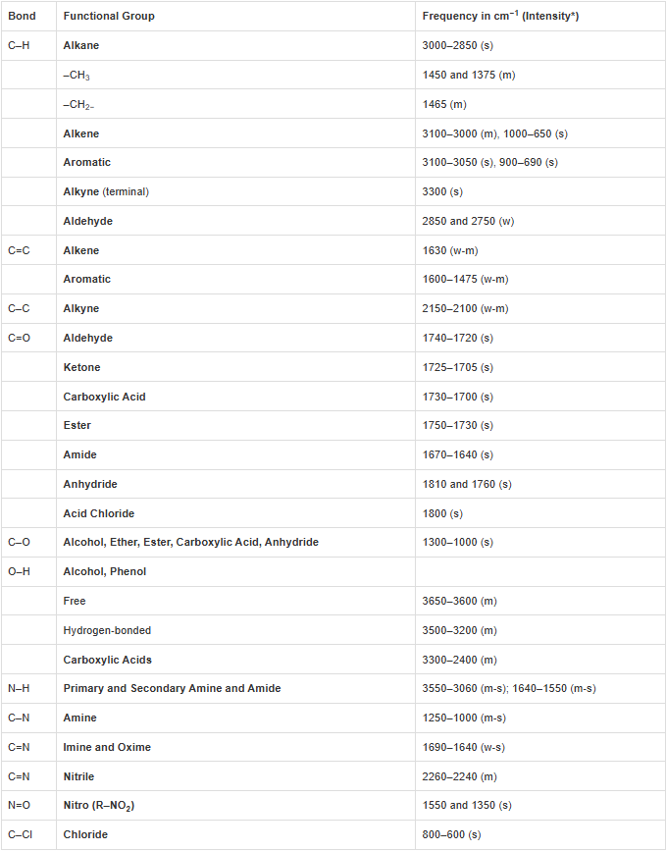

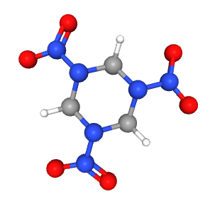
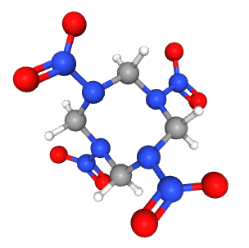
Fig. 11 – RDX Molecule [10]
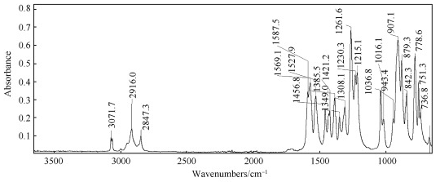
Fig. 12 – HMX Molecule [11]
Fig.13 – FT-IR trace showing DM(D)NB presence within RDX-based plastic explosive. [9]

4. Discussion – Deduction of Munition
Prior to the trial, a list of munitions was provided by the course teaching staff for the students to identify the tested OME item from. The provided list included a variety of technical specifications and can be seen in entirety in annex 1. For the purposes of reference, the list has been summarised below and the munitions numbered.
- Mk 83 air dropped munition
- M-67 grenade
- RGD-5 grenade
- 81 mm Mortar AR-M81
- RPG PG-7VL
- 155 mm (Artillery Shell)
- Pipe Bomb
Following the completion of the trial and the provision of the collected data, students were then able to use this to narrow down which munition could have been used in the firing.
Immediately, the Mk83 ADW and 155mm Artillery shell could be removed from consideration. This was due to them exceeding the COTEC range safety limit of 10kg, with NEQs of 225kg and ~11.5kg respectively (Note: The provided munitions data set quoted the NEQ for the artillery shell as 1150g. This is clearly incorrect, and has been assumed by the author to be a typographical error meant to read 11500g, which would be an expected figure for a munition of that type, as, for reference, the in service L15 HE 155mm artillery shell has an NEQ of 11.3kg [12]).
Munitions in either of these NEQ ranges would also be inconsistent with the constructed arena radius of 1.5m, which would suggest an NEQ of <0.6kg in accordance with ITOP 4-2-813. The positioning of the arena close to the forward battery building with no further protective mitigation would also support the charge being of a smaller NEQ. The students were informed that the detonator would be placed in the top of the vertically positioned munition. Had this been the PG-7VL, the shaped charge would have fired vertically downwards and created a hole in the concrete pad. Since no such hole was present, this excluded the PG-7VL from further consideration.
By far the most vital piece of data collected is the physical fragmentation data, both the pattern and the fragments themselves. They are clearly naturally formed fragmentation from a cylindrical munition with no design influence. Both the M-67 grenade and AR-M81 mortar feature preformed fragmentation [13] and would give a considerably different fragmentation pattern and type.
Both of the remaining munitions, the RGD-55 grenade and the pipe bomb are naturally fragmenting. However, the pattern, thickness and size of the fragments strongly suggest that the munition was a pipe bomb. This is confirmed by the FT-IR trace results which indicated that the explosive composition was a RDX-based plasticized explosive tagged with DM(D)NB. This aligns with the PE8 fill used on the given munitions list. [14] The presence of this taggant also provides further evidence to support the exclusion of every other possible munition from the given list. As such, the final determination of the author is that the munition used in the trial is the PE-8 filled pipe bomb.
Finally, it is worth highlighting that this determination was made whilst both the fragmentation velocity foils and the blast overpressure gauges did not produce data supportive of this final munition determination. Whilst, in this case, the fragmentation data and FT-IR results were enough to be conclusive, this could have presented severe issues had they not been so definitive.

5. Conclusion
The munition used in the trial was confidently determined to be the PE8 filled pipe bomb. This was primarily deduced through the pieces, type and pattern of fragmentation formed, and the post-blast residue FT-IR analysis. This was supported by the arena setup and location, as well as the limitations of the range and analysis of other damage to the surrounding area post firing.
The fragment velocity and blast overpressure data collected were found to contradict this conclusion, and had the evidence to support the final determination of the pipe bomb not been so conclusive, these could have presented serious issues with being able to correctly determine the munition used. This highlights how vital it is to collect as much data as possible during the test and evaluation of OME, and how easily unexpected issues can arise.
The arena trial experiment provided the OME students (many of whom did not have prior experience in a Test & Evaluation environment), with an excellent learning opportunity and hands-on experience in the set up and data analysis from a variety of data capture methods.
The identification exercise which followed proved to be a valuable experience in critical thinking and also encouraged students to use all of their munitions knowledge taught earlier in the course to help interpret the data and deduce the item of OME used.

6. References & Bibliography
- “Cranfield University Ordnance Test & Evaluation Centre (COTEC) Range Orders and Procedures”, Issue 4.5, January 2022.
- International Test Operations Procedure (ITOP) 4-2-813, “Static Testing of High-Explosive Munitions for Obtaining Fragment Spatial Distributions”, March 1993.
- I. A. Balagansky, “Fragmentation Ammunitions,” Damaging Effects of Weapons and Ammunition, pp. 31–92, Apr. 2022, doi: https://doi.org/10.1002/9781119779568.ch1.
- I. A. Balagansky, Yu. A. Karanik, V. A. Agureikin, and A. V. Vinogradov, “Fracture behavior of explosively loaded spherical molded steel shells,” Theoretical and Applied Fracture Mechanics, vol. 36, no. 2, pp. 165–173, Sep. 2001, doi: https://doi.org/10.1016/S0167-8442(01)00066-0.
- Cooper, Paul W. "Acceleration, Formation, and Flight of Fragments". Explosives Engineering. Wiley-VCH. pp. 385–394. (1996). ISBN 0-471-18636-8.
- C. N Kingery & G. Bulmash. Technical Report ARBRL-TR-02555, "Airblast Parameters from TNT Spherical Air Burst & Hemispherical Surface Burst" (April 1984).
- Karlos Vasileios and L. Martin, “Guideline - Building Perimeter Protection: Design Recommendations for Enhanced Security against Terrorist Attacks,” Jan. 2020, doi: https://doi.org/10.2760/20368.
- Northern Illinois University Department of Chemistry and Biochemistry, “Typical IR Absorption Frequencies For Common Functional Groups”. [Online] Available: https://www.niu.edu/clas/chembio/research/analytical-lab/ftir/ir-frequencies-table.shtml [Accessed 23/12/25]
- Jacky Cailes, R. Dunsmore, and K. L. Linge, “Assessment of portable FTIR and Raman spectroscopy for the detection of 2,3-dimethyl-2,3-dinitrobutane (DMDNB) in plastic explosives,” Defence Technology, Jun. 2023, doi: https://doi.org/10.1016/j.dt.2023.06.008.
- PubChem, “Cyclonite,” pubchem.ncbi.nlm.nih.gov. [Online] Available: https://pubchem.ncbi.nlm.nih.gov/compound/Cyclonite [Accessed 21/04/26]
- PubChem, “Octogen,” pubchem.ncbi.nlm.nih.gov. [Online] Available: https://pubchem.ncbi.nlm.nih.gov/compound/Octogen [Accessed 21/04/26]
- BAE Systems. (2023). 155mm Artillery Ammunition, www.baesystems.com. [Online]. Available at: https://www.baesystems.com/en-uk/product/155mm-artillery-ammunition [Accessed: 21/04/2026].
- “81mm Mortar Round AR-M81: High Explosive Round - bulcomersks,” bulcomersks, Sep. 25, 2019. https://bulcomersks.com/military-products/ammunition/mortar-rounds/81mm-mortar-round-ar-m81/ (accessed Apr. 22, 2026).
- Chemring Energetics UK. (August 2024). Plastic Explosive (PE8) (Datasheet), www.chemring.com. [Online]. Available: https://www.chemring.com/~/media/Files/C/Chemring-V3/documents/energetics/CEUK%20datasheets%20Oct%2024/highexplosive/PE8_Aug_24.pdf [Accessed: 21/04/2026].

Annex 1 – Munition Options Datasheet
Types of Munition of Potential Interest
Mk 83 air dropped munition
- Charge Mass – 225 kg
- Mass of case – 229 kg
- AUW – 454 kg
- Explosive – Comp B
- Average fragment area - 0.48 cm²
- Average fragment mass – 0.115 kg
- Frag drag coefficient – 0.82
- Density of air 1.23 kg m⁻³
- Frag Vi = 1950 ms⁻¹
- Frag Vf = 1911 ms⁻¹ at 92 m
M-67 grenade
- Charge mass – 185 g
- Mass of case – 213 g
- AUW – 398 g
- Explosive – Comp B
- Average frag area – 1.0 cm²
- Average frag mass – 2g
- Frag drag coefficient – 0.5
- Density of air – 1.29 kg m⁻³
- Frag V @ 5m -1674 ms⁻¹
- Frag V @ 15m – 1424 ms⁻¹
- Frag V @ 230 m – 44 ms⁻¹
RGD-5 grenade
- Charge mass – 110 g
- Mass of case – 200 g
- AUW – 310 g
- Explosive – TNT
- Average frag area – 1.0 cm²
- Average frag mass – 0.12 - 0.46g
- Frag drag coefficient – 0.5
- Density of air – 1.29 kg m⁻³
- Frag Vi = 1567 ms⁻¹
- Number of fragments 350
81 mm Mortar AR-M81
- Charge Mass – 0.76 kg
- Mass of case – 1.334 kg
- AUW – 4.15 kg
- Explosive – TNT
- Frag drag coefficient – 1.6
- Density of air 1.23 kg m⁻³
- Frag Vi = 1734 ms⁻¹
- Frag V @ 1m – 1700 ms⁻¹
- Frag V @ 4m – 1600 ms⁻¹
- Frag V @ 20m – 1150 ms⁻¹
- Frag V @ 32m – 900 ms⁻¹
- Frag V @ 77m – 357 ms⁻¹
RPG PG-7VL
- Charge mass – 730 g
- Mass of case – 1600 g (including rocket motor)
- AUW – 1975 g
- Explosive – RDX/TNT - 95% HMX 5% wax
- Average frag mass – 0.1 g
- Density of air – 1.29 kg m⁻³
- Frag Vi -1831.5 ms⁻¹
155 mm
- Charge mass – 1150 g
- Mass of case – 3105 g
- AUW – 4255 g
- Explosive – Comp B
- Average frag mass – 2.1g
- Density of air – 1.29 kg m⁻³
- Frag Vi -1551 ms⁻¹
Pipe Bomb
- Charge mass – 264 g
- Mass of case – 417 g
- AUW – 681 g
- Explosive – PE 8
- Average frag mass – 0.83 g
- Frag drag coefficient – 1.6
- Density of air – 1.29 kg m⁻³
- Frag Vi = 2047 ms⁻¹
- Frag V@ 1m = 2022 ms⁻¹
- Frag V@ 20m = 1602 ms⁻¹

