

Student Name: Md Forhad Hossen Rony

Student ID: 2433472

Programme Name: Master of Business Administration

Module Name: Marketing Management

Module Code: LCMB7024

Assignment Title: Assessment component 1: Marketing Environment Analysis.

Lecturer’s Name: Dr Laila Maazouz

Word Count: 2682

Date of Submission: 21 November 2025

Table of Contents
1. Introduction 1
Task 1: Macro Marketing Environment Critical Analysis 2
2.1 Macro Marketing Environment Overview 2
2.2 Selection of Two External Macro Marketing Actors 3
Technological Factors 3
Legal Factors 4
2.3 Critical Analysis of Each Actor 4
Task 2: Strategic Responses of Pioneering and Follower Organisations 7
3.1 Strategic Responses of Organisations Pioneer - Apple Inc. 7
3.2 Strategic responses of Follower Organisations - Samsung Electronics 9
4. Conclusion 11
5. References 12

List of Figures
Figure 1: PESTEL Analysis (Source: Akisconnect) 2
Figure 2: Matrix of Ansoff used to the battleground of Global Tech Industry 9
Figure 3: Porter's Generic Strategies (Source: Digitalleadership) 9

1. Introduction
The external marketing environment in the contemporary hyper-competitive global economy is a paramount part of strategic marketing management. It helps organisations to predict opportunities and threats, manage resources efficiently, and maintain competitive advantage (Kotler and Keller, 2023). Technology is a highly innovative sector, digital ecosystem convergence, and the industry is highly regulated, so it is a wonderful opportunity to study the environmental dynamics that influence marketing strategies (Grant, 2022).
The report concentrates on two priority macro-environmental factors of the PESTEL framework-Technological and Legal factors-that have brought about a transformative impact to the technology industry across the world. New products and customer engagement model can be achieved through technological change, such as artificial intelligence, automation, and cloud computing (Narver and Slater, 2020). In the meantime, legal settings, in particular, related to data protection, intellectual-property rights, and antitrust oversight provide both limitations and strategic demands on technology companies (Porter & Heppelmann, 2021).
The report uses Apple Inc. as an exemplary organisation that is a leader in innovation and Samsung Electronics as a follower company that has the skill to adapt strategically. Task 1 is a critical investigation into the opportunity and threat created by technological and legal change to these firms, whereas Task 2 is an assessment of their strategy responses through the lens of theory like Ansoff Matrix and Porters Generic Strategies. The conclusion will also summarise the most important findings to underscore the strategic significance of constant environmental scanning and dynamic marketing response.

Task 1: Macro Marketing Environment Critical Analysis
However, the performance of marketing of a firm is determined not only by internal capabilities of a firm but also by external macro-environmental forces that define the situation in the industry and strategic flexibility. In the case of technology companies operating in fast-paced markets, these external forces are critical to strategic marketing management (Kotler and Keller, 2023). The macro environment presents the general contextual forces which can affect consumer behaviour, innovations, and competitive positioning: political, economic, social, technological, environmental, and legal (Grant, 2022). This section uses the PESTEL model to critically examine two such factors namely technological and legal factors and assess the ways the factors present opportunities and threats to pioneering and follower organisations in the world of global technology.

2.1 Macro Marketing Environment Overview
The macro marketing environment can be defined by the external conditions which organisations cannot directly influence yet need to keep track of and adjust to at all time (Johnson, Scholes and Whittington, 2020). These are analysed together by the use of PESTEL model that classifies the environment into six dimensions-Political, Economic, Social, Technological, Environmental and Legal. The model helps the marketer to determine the impact of change in regulation, innovation, social-cultural values, or global trade patterns on strategic decision making (Yuksel, 2012).
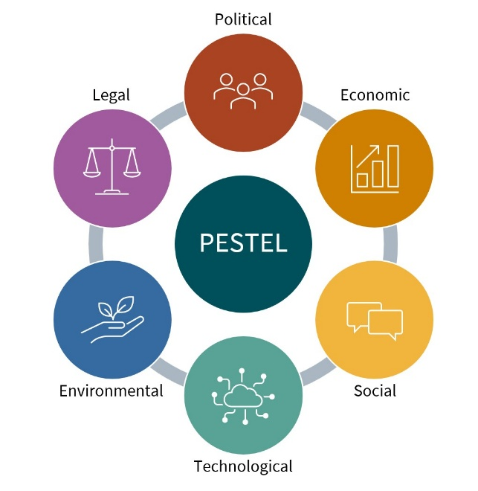
Figure 1: PESTEL Analysis (Source: Akisconnect)
Macro-environmental analysis in the technology sector is decisive in strategic marketing efforts, specifically on product development and market penetration and risk management (West, Ford and Ibrahim, 2015). The life cycle of innovation is driven by technology change which affects the rate at which new products are introduced and those ones are phased away. Law also limits the extent of competitive action, whether it is an obligation to protect data or a right to defend intellectual property (OECD, 2023).
In the case of innovating organisations like Apple Inc., the scanning of the environment enables them to foresee the trends and sustain the first mover position with the help of innovation and integration of the ecosystem (Narver and Slater, 2020). In the case of follower firms such as Samsung Electronics, the macro analysis facilitates the adaptive imitation, cost optimisation, and speedy reaction to the changes in regulations or technology (Porter and Heppelmann, 2021). As such, the macro environment does not only affect strategic opportunities but also distinguishes the ways in which pioneers and followers perceive and can utilise them.
In the sub-sections below, the two external macro actors that will be chosen and justified (Technological and Legal) will be critically analysed and how these two factors contribute to opportunities and threats of Apple and Samsung in the modern technology industry.

2.2 Selection of Two External Macro Marketing Actors
The technological and the legal aspect of the macro marketing environment are two of the most conclusive external factors that influence the global technology industry. The reasons why they were chosen to be analysed in detail are that these factors directly impact the innovation cycles, entering the market, data governance, and overall competitiveness-the pillars of strategic marketing management (Grant, 2022).

Technological Factors
The consumer electronic and digital services market is changing and differentiating at a rate that is shaped by technological advancement. New technologies (artificial intelligence (AI), Internet of Things [IoT], 5G connectivity, and cloud ecosystems) have reinvented the value creation and customer interaction (World Economic Forum, 2024). Statista (2025) predicts that worldwide revenues of AI market will surpass US550 billion in the year 2027 and it illustrates the potential magnitude of possible transformations.
In the case of Apple Inc., technological innovation is its strategic strength and risk at the same time. The company is also constantly using R&D investment-more than US 30 billion in 2024-to stay ahead in terms of first-mover in systems ecosystem-like Apple Intelligence and Vision Pro platforms (Apple Annual Report, 2024). On the contrary, Samsung Electronics, being historically a follower, strategically transforms and perfects such innovations with the help of agile production and wide market segmentation. The fact that Samsung was the first manufacturer to introduce foldable screens and AI-based mobile chips proves how its imitators could convert the technological diffusion into a dominant position in the market in certain product segments (IDC, 2025).

Legal Factors
Data privacy, intellectual-property rights, and competition-related issues have made the legal environment to be more complicated to technology firms. Recent laws and regulations like the EU General Data Protection Regulation (GDPR), Digital Markets Act (DMA), and changing AI liability concepts have a significant impact on marketing and data-driven innovation (European Commission, 2024).
To Apple, compliance with privacy has become part of its brand differentiation strategy, known as privacy as a product feature, though it has been under antitrust scrutiny regarding its App Store policies (OECD, 2023). In the meantime, Samsung enjoys a more lenient supply-chain frame of reference, but it needs to wrestle with patent litigation and trade-compliance matters in the international markets (Reuters, 2024).
The two external players: technological and legal were thus selected since they are both factors that describe the twin forces of innovation and regulation that both drive and limit strategic marketing in the technology industry. They are the analytical basis of assessing the macro-environmental challenges as interpreted and reacted to by pioneers and followers.

2.3 Critical Analysis of Each Actor
This section applies critical thinking to assess how technological and legal macro-environmental changes generate both opportunities and threats for pioneering (Apple Inc.) and follower (Samsung Electronics) organisations in the global technology industry.
We’ll begin with a comparative table (for clarity and academic presentation marks) and then a deeper analysis.
Table 1: Opportunities and Threats Created by Technological and Legal Factors
Macro Actor | Pioneering Firm (Apple Inc.) | Follower Firm (Samsung Electronics)
Technological Factors | Opportunities:  Use AI, AR, and IoT to integrate and lock customers in an ecosystem.  Innovation leadership to improve brand equity.  Threats:  High rate of obsolescence in the products.  Cost reduction in profit margins due to the high expenditure in R&D (~US$30bn, 2024). | Opportunities:  Take advantage of the fast-follower by embracing mature technologies.  Take advantage of a wide product line into new markets.  Threats:  Relying on the innovation cycles of pioneers.  Threat of technological imitation lawsuits (Reuters, 2024).
Legal Factors | Opportunities:  Enhance brand credibility by means of excellent adherence to privacy regulations (GDPR).  Differentiate data protection "Privacy as a Product feature).  Threats:  Antitrust investigations (EU, US) restricting dominance of App Store.  Tighter control over AI ethics and data use (EU, 2024). | Opportunities:  Bring to bear diversified legal structures mitigating the single-region risk.  The share of the market can be increased in case of regulatory punishment of competitors.  Threats:  Patent disputes, export-control laws, and data localisation laws (OECD, 2023).
Source: Developed by the author using data from Apple (2024), OECD (2023), Reuters (2024), European Commission (2024), and Statista (2025).
Technological Factors: Opportunities and Threats
The global technology industry is characterised by technological innovation. Due to their innovativeness, as first-mover companies, companies such as Apple Inc. gain competitive advantage by adding disruptive innovations and redefining product categories. An example is the 2024 release of the Apple Vision Pro, which combined spatial computing and AI, which supports the differentiation strategy of Apple ecosystem (Apple, 2024). This is in line with the first-mover advantage theory where the innovator becomes the leader in the brand and has customers remain loyal to his product (Lieberman and Montgomery, 1988). Nevertheless, the pace of technological change also amplifies the intensity of R&D and the threat of technological obsolescence, particularly as the product life cycle becomes shorter (Grant, 2022).
On the contrary, Samsung Electronics as a strategic follower utilises the fast-follower model to maximise the timing and cost effectiveness of innovation (Suarez and Lanzolla, 2020). Samsung is able to swiftly duplicate and enhance innovative inventions such as foldable screens and AI-powered cameras because of its versatile manufacturing systems, which are able to establish the early majority share of the market. However, the follower strategies have legal and brand-positioning risks, especially when imitation causes differentiation to disappear or intellectual property to arise in courts (Reuters, 2024). Therefore, the technological evolution is a two-sided process, both the innovators get strength in their innovation and the followers in their flexibility.
Legal Factors: Opportunity and threats.
The legal and regulatory environment has become a strategic predeterminer of marketing success, particularly in the case of technology companies that operate in data-driven business models. In the case of Apple, compliance with the rules is not only a necessity but a marketing instrument: privacy and security are presented as a brand promise (European Commission, 2024). This allows differentiation strategy (Porter 1985) and complies becomes a competitive advantage. Nonetheless, the vertical integration and control of its App Store by Apple has led to antitrust litigation in both the EU and the U.S., which has caused reputational and financial harm (OECD, 2023). Tighter control of AI, including the upcoming EU AI Act, is another way to undermine its autonomy in innovation.
On the other hand, Samsung has a presence in various jurisdictions thereby spreading legal risks to Asia, North America and Europe. Such geographic flexibility reduces single-market regulatory risk but complicates compliance management (PwC, 2023). Further, Samsung is dependent on worldwide supply chains, thus it is vulnerable to trade restrictions and export-control regulations especially on semiconductor technologies (Reuters, 2024). Although these limits exist, in some cases, legal frameworks also bring an advantage of entry into the market where more regulation punishes competitors, and the agile followers can rebrand themselves in a strategic way.

Task 2: Strategic Responses of Pioneering and Follower Organisations
Following the macro-environmental analysis in Task 1, this section critically analyses the strategies of pioneering and follower organisations in responding to the external environment in the technology industry. The ability to respond to strategic changes quickly and make marketing decisions is crucial to remaining competitive in the environment characterised by the fast pace of technological development and the increase in legal regulation (Grant, 2022; Kotler and Keller, 2023). The trend of pioneering firms, including Apple Inc., is that they are more likely to seek proactive innovation and differentiation to challenge the consumer expectations using first-mover benefits. Conversely, follower organisations, such as Samsung Electronics, tend to adopt either adaptive or cost-leadership approaches that allow quick imitation, localization, and cost competitiveness (Suarez and Lanzolla, 2020).

3.1 Strategic Responses of Organisations Pioneer - Apple Inc.
Apple being a first mover company engages in proactive strategic reaction, which is the product of innovation leadership and ecosystem differentiation. Ansoff Growth Matrix is evidenced by the company, which is working on product evolution and market penetration at the same time (Ansoff, 1957).

Table 2: Application of Ansoff’s Growth Matrix
Ansoff Strategy | Apple’s Implementation | Strategic Outcome
Market Penetration | Expanding ecosystem lock-in through integrated services (iCloud, Apple TV+, Apple Pay). | Increases customer lifetime value and loyalty.
Product Development | Launching new AI-driven devices (Apple Vision Pro, Apple Watch Series 10). | Sustains innovation reputation and revenue growth.
Market Development | Targeting emerging economies with lower-cost devices (iPhone SE). | Expands geographic footprint under varying legal regimes.
Diversification | Investing in health-tech and electric-vehicle research. | Builds resilience against market saturation.
Source: Developed by the author using Ansoff (1957); Apple Annual Report (2024).
The differentiation approach proposed by Porter (1985) fits the strategy used by Apple, as the company focuses on the uniqueness of its products, quality of design, and easy interoperability. Vertical integration defines the technological reaction of the company to AI and data-driven ecosystems: the company is developing proprietary chips (M-series) and software to safeguard the information of users and to optimise performance (Apple, 2024).
Legally, Apple absorbs the issue of compliance into its brand - positioning privacy and sustainability as value propositions. For example, its "Privacy. That's iPhone." legal compliance of campaigns is legal consumer empowerment (European Commission 2024). However, Apple also resorts to defensive legal tactics, including changing the policies of the App Store based on the Digital Markets Act and the antitrust decisions of the U.S. courts (OECD, 2023).
Most importantly, this two-step strategy demonstrates the dynamic capability of Apple (Teece 2018): it predicts a shift in regulation, modifies its technology structure, and sells compliance as brand equity. Nonetheless, the high reliance on differentiation subjects it to increased costs of innovation and slow adaptability in price-sensitive markets (Grant, 2022).
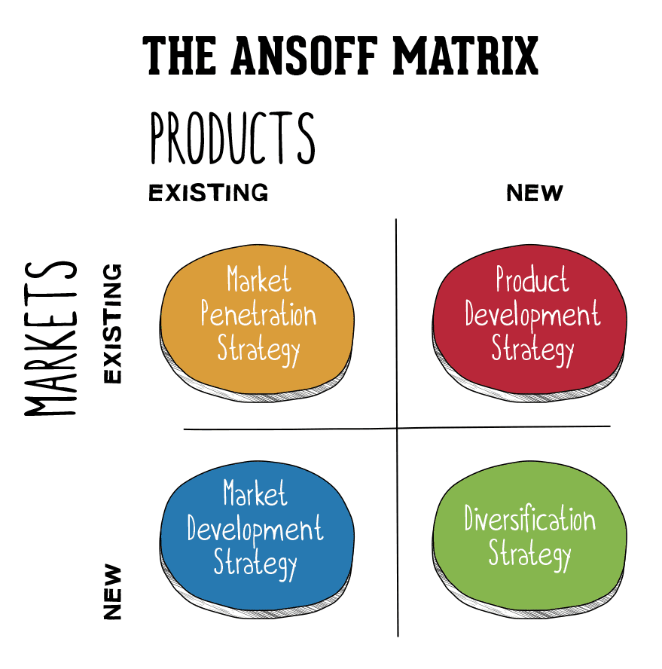
Figure 2: Matrix of Ansoff used to the battleground of Global Tech Industry
(Source: Smartinsights)

3.2 Strategic responses of Follower Organisations - Samsung Electronics
Samsung is a follower organisation and the strategic responses are based on adaptive imitation, cost leadership and speedy technological diffusion. The firm is agile, taking in innovations launched by innovators and redirecting them to various markets more quickly and at scale (Suarez & Lanzolla, 2020).
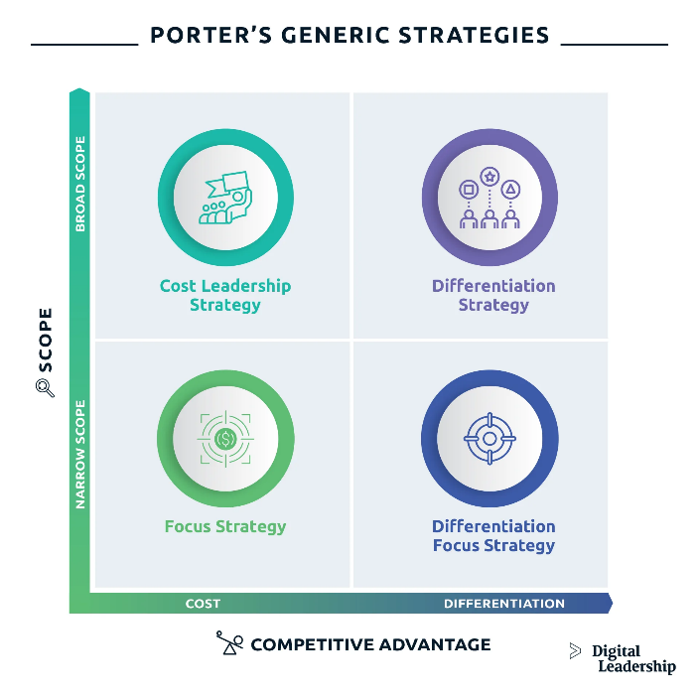
Figure 3: Porter's Generic Strategies (Source: Digitalleadership)
Table 3: Porter's Generic Strategies
Strategy | Samsung’s Approach | Impact
Cost Leadership | Economies of scale through global manufacturing and supply-chain optimisation. | Enables competitive pricing and broad market access.
Differentiation Focus | Incremental innovation (e.g. foldable screens, 200 MP camera sensors). | Attracts tech-savvy users while maintaining affordability.
Hybrid Strategy | Combines low-cost production with selective innovation. | Balances risk and profit across regions.
Source: Porter (1985); Samsung Annual Report (2024).
Technologically, Samsung uses open innovation, i.e. partnerships with Google, Qualcomm, and local startups to speed up the adoption of AI and ecosystems of wearable devices (IDC, 2025). This strategy emphasises fast-followers and has the advantage of the education effects of pioneers in the market (Suarez and Lanzolla, 2020).
Under the legal environment, the production base of Samsung, which is geographically diversified (South Korea, Vietnam, India, and Poland), assists in overcoming regional compliance risks. However, its semiconductor business is still problematic in patent lawsuits and trade restrictions in international markets (Reuters, 2024). The strategic reaction of Samsung includes improving IP portfolios, promoting harmonised AI and privacy, and enhancing environmental reporting (PwC, 2023).
In comparison to Apple, Samsung is more advantageous in terms of its strategic flexibility - it can quickly alternate suppliers, re-price its products, and change marketing storeys in different regions. Nevertheless, this responsiveness can negatively affect brand consistency and differentiation over time (Kotler and Keller, 2023).

4. Conclusion
The present report critically analysed the influence of macro-environmental forces of strategic marketing response in the global technology sector with reference to technological and legal forces. Based on the examples of Apple Inc. as a pioneering organisation and Samsung Electronics as a follower, the analysis has shown that the external changes pose an opportunity and threat that demand different strategic orientations. In the case of Apple, intense technology development and changes in regulatory requirements promote constant innovation, ecosystem integration and brand differentiation by privacy and design perfection. Conversely, the strength of Samsung is its flexibility, economies of scale and its operationalisation of the fast-follower strategies in a variety of legal jurisdictions.

5. References

Ansoff, H.I. (1957) ‘Strategies for diversification’, Harvard Business Review, 35(5), pp. 113–124. Available at: https://hbr.org/1957/09/strategies-for-diversification.
Apple Inc. (2024) Annual Report 2024. Cupertino, CA: Apple. Available at: https://investor.apple.com/investor-relations/financial-information/.
European Commission (2024) The Digital Markets Act and Artificial Intelligence Regulation. Brussels: EU Publications Office. Available at: https://digital-strategy.ec.europa.eu/en/policies/digital-markets-act.
Grant, R.M. (2022) Contemporary Strategy Analysis. 11th edn. Wiley. Available at: https://www.wiley.com/en-us/Contemporary+Strategy+Analysis%2C+11th+Edition-p-9781119812933.
IDC (2025) Global Smartphone Market Outlook 2025. International Data Corporation. Available at: https://www.idc.com/
Johnson, G., Scholes, K. and Whittington, R. (2020) Exploring Strategy. 12th edn. Pearson. Available at: https://www.pearson.com/en-gb/subject-catalog/p/exploring-strategy-text-and-cases/P200000004404/9781292282503.
Kotler, P. and Keller, K.L. (2023) Marketing Management. Global edn. Pearson. Available at: https://www.pearson.com/en-gb/subject-catalog/p/marketing-management-global-edition/P200000004480/9781292404813.
Lieberman, M.B. and Montgomery, D.B. (1988) ‘First-mover advantages’, Strategic Management Journal, 9(S1), pp. 41–58. Available at: https://doi.org/10.1002/smj.4250090706.
Narver, J.C. and Slater, S.F. (2020) ‘Market orientation and innovation in dynamic environments’, Journal of Marketing Theory and Practice, 28(4), pp. 377–392. Available at: https://doi.org/10.1080/10696679.2020.1763552
OECD (2023) Digital Economy Outlook 2023. Paris: OECD Publishing. Available at: https://doi.org/10.1787/5b2fceea-en
Porter, M.E. (1985) Competitive Advantage: Creating and Sustaining Superior Performance. New York: Free Press. Available at: https://www.hbs.edu/faculty/Pages/item.aspx?num=193.
Porter, M.E. and Heppelmann, J.E. (2021) ‘How smart, connected products are transforming competition’, Harvard Business Review, 99(3), pp. 66–88. Available at: https://hbr.org/2014/11/how-smart-connected-products-are-transforming-competition.
PwC (2023) Global Risk Outlook 2023: Regulation and Technology. London: PwC. Available at: https://www.pwc.com/gx/en/issues/global-risk-survey.html.
Reuters (2024) ‘Samsung faces patent and trade scrutiny amid chip-supply tensions’, Reuters Technology, 12 March. Available at: https://www.reuters.com/technology/
Statista (2025) Artificial Intelligence (AI) Market Revenue Forecast Worldwide (2020–2027). Available at: https://www.statista.com/statistics/1365158/global-artificial-intelligence-ai-market-size/.
Suarez, F.F. and Lanzolla, G. (2020) ‘The half-truth of first-mover advantage’, MIT Sloan Management Review, 61(4), pp. 12–19. Available at: https://sloanreview.mit.edu/article/the-half-truth-of-first-mover-advantage/.
Teece, D.J. (2018) Dynamic Capabilities and Strategic Management. 2nd edn. Oxford University Press. Available at: https://global.oup.com/academic/product/dynamic-capabilities-and-strategic-management-9780198832360.
West, D.C., Ford, J. and Ibrahim, E. (2015) Strategic Marketing: Creating Competitive Advantage. 3rd edn. Oxford University Press. Available at: https://global.oup.com/academic/product/strategic-marketing-9780199684098.
World Economic Forum (2024) Technology Futures 2024: AI and the Global Economy. Geneva: WEF. Available at: https://www.weforum.org/reports/technology-futures-2024-ai-and-the-global-economy.
Yüksel, I. (2012) ‘Developing a multi-criteria decision-making model for PESTEL analysis’, International Journal of Business and Management Studies, 4(2), pp. 63–78. Available at: https://dergipark.org.tr/en/pub/ijbms/issue/26049/274562.

