Reflective Writing Template
Student name number | Kwadwo Adjei Brempong 2334944
Module code and title | LCLM4001_BIRM RESIT Portfolio Submission
Name of Task | Task 3 - REFLECTIVE REPORT
Lecturer

Restructuring the Reflection Using the Gibbs Reflective Cycle

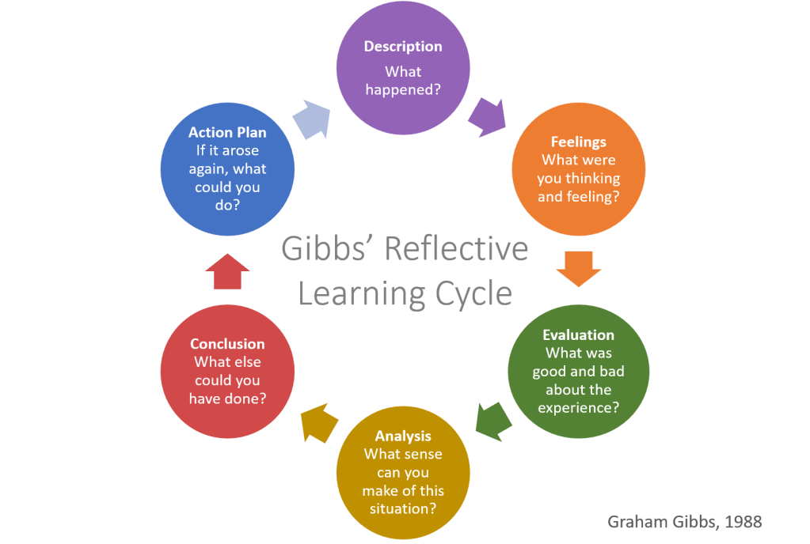

Figure 1 Gibbs Reflective Cycle
(Source: helendenheld, 2025)

Using the Gibbs reflective cycle, write a reflection of your learning journey on the LCLM 4001- Academic Skills Module. Your reflective writing should focus on your personal learning journey, including your strengths, areas for improvement, and the impact of the module on your academic and personal development. You should refer to specific experiences such as:
- Task 1 and Task 2
- Class activities and discussions (e.g., topics covered in class such as referencing and paraphrasing)
- Feedback received
- Skills you have developed

Activity one
The Week 4 session on referencing and academic integrity was one of the most effective experiences that I had in this Academic Skills module. The academic referencing as a concept appeared to be very overwhelming in the beginning and extremely technical, and after a series of guided discussions and numerous practice activities, I began to acquire a lot of insight (Boettcher, and Conrad, 2021). Using the Harvard method of references to actual materials, especially throughout the process of Task 1, was both complex and insightful, which is now considered the backbone of all my assignments, which keeps me out of academic misconduct and renders any credible work.
The module as a whole has positively impacted my learning experience in a very comprehensive way. It not only enhances my academic writing skills but also helps me become better at organisational and critical thinking. Lectures, group tasks, and formative quizzes together made me responsible towards my progress and gave me a good opportunity to correct the drawbacks. As an illustration, employing approaches of paraphrasing strategies and combining sources, as described in Trevor Day's work on Success in Academic Writing, made me respect and understand the ideas of people and integrate them into my reflective speech.
Feedback was also significant, as I received tips on how to structure the assignment, academic language and time, which helped me in developing. The Success in Academic Writing course by Trevor Day made me focus on clarity and efficient organisation of academic writing, as this can improve my interpretation of what I hear or read, as well as my communication. Being directed by the book on Skills of Success written by Stella Cotrell, I engaged in continuous self-assessment and setting of goals, which enabled me to have persistence and a sense of progress. Dr The strategies of mature students, as highlighted by Catherine Dawson, confirmed that it is all possible to get back to university provided that one has proper study habits and can manage their time. The combination of the lessons presented in each of the three texts gave me the strength to develop an effective academic approach to ensure perpetual success.

Write your reflection in the boxes below (The boxes will expand as you type)
Description  (What happened? Describe the experience ore experiences in class that you want to reflect on) | Week 4 of the Academic Skills module helped me immerse myself in a field that is academic referencing and integrity. This lesson included practical assignments, during which I was practising the use of the Harvard referencing style and talking to other students and tutors about the relevance of academic dishonesty.
Feelings  (What were you thinking and feeling at the time? How did you feel before / during / and after the experience?  Did you feel overwhelmed / confident / nervous?  Were you alone in feeling this way or did other students share your feelings?) | To begin with, I was extremely scared of referencing, as it appeared increasingly hard to do. These fears were, however, overcome by the detailed explanations and the group work during the classes. Little by little, as I became more secure in my reference, I became proud of my improvement and happy to know that I could prevent plagiarism.
Evaluation  (What was good and bad about the experience?) | The session was indeed very practical as it not only made the technical aspect of citation very clear but also persuaded me of the importance of academic honesty. After the feedback on Task 1, I noticed the level of improvement that occurred in my referencing. Even though I had a problem with paraphrasing, both the supportive environment and resources helped me understand.
Analysis  (What sense can you make out of the situation?) Why was the situation positive or negative?  When things went well, what role did you play? When things went badly, can you explain why? Do you know how if other students felt the same as you? Why or why not? | After this experience, I have realised the significance of this experience in academic development. Proper referencing forms the basis of good scholarly writing, and Trevor Day confirms this fact by emphasising methodical citation of scholarly writing in his article Success in Academic Writing (Day, 2023). The module brought forward the connection between the concept of referencing and critical thinking, whereby proper integration of sources would result in sound argumentation.
Conclusion  (What else could you have done? Or what could you have improved?) | Learning how to reference proved to be a turning point in my attitude towards university assignments. I also formed academic practices that will sustain me in my course of study.
Action Plan  (If you do it again, what would you do differently? What skills do you need to develop? And how do you plan to do this) | In the future, I will be practising paraphrasing consistently with the help of the available materials in the classes and will do my best to further get acquainted with academic integrity. Adding additional sources to my writing, as well as perfecting my citations with the Harvard style, has been my objective (Weerawardane and Byrne, 2021).  Incorporating Document B Passage into the Reflection  Reading the passages indicates that the way mature learners gain the benefits of setting up systematic organisational strategies and actively seeking support can echo what Dr Catherine Dawson has suggested in her reassurance guide to returning learners (Dawson, 2022). By using this knowledge in my own academic experience, I learned that the ability to utilise good study habits and time management did not just help me to be more productive, but also helped me be more confident to face complex tasks.  By incorporating the tips provided by Trevor Day in his publication, Success in Academic Writing, I adopted organised methods of taking notes and citing the sources that were used in strengthening my knowledge on academic integrity. The article by Stella Cotrell, Skills for Success, inspired me to set realistic expectations and self-evaluate on a regular basis and change the feedback into actions to be taken (Cottrell, 2021). My study practice has now become strong and consistent, drawing on all three sources and combining commitment with flexibility to guarantee a consistent progression and personal development.
Reference | Boettcher, J.V. and Conrad, R.M. (2021) The online teaching survival guide: Simple and practical pedagogical tips. John Wiley & Sons.  Cottrell, S. (2021) Skills for success: Personal development and employability. Bloomsbury Publishing.  Dawson, C. (2022) 100 activities for teaching research ethics and integrity.  Day, T. (2023) Success in academic writing. Bloomsbury Publishing.  helendenheld, (2025), Gibbs Reflective Cycle, (Blog). Accessed from<https://helendenheld.com/wp-content/uploads/2021/02/gibbs-reflective-learning-cycle-1.png> accessed on 24-11-25.  Weerawardane, D. and Byrne, P. (2021) An introduction to critical thinking, academic writing and Harvard referencing.  YouTube Links  https://www.youtube.com/watch?v=pyxR2pwqXEY&t=2s  https://www.youtube.com/watch?v=_TmUp3d7GDk&t=2s

