
Children, Young People and Families
Assignment Component 1
Case Study - Written Report
(BMHP 5004- LON)
Student name: Oluwaseun Akran
Student Number: 1908389
Group: 1
Lecturer name: Bianca Sanfilippo
Submission Date: 25/08/2021
Word Count: 2000
Learners declaration
This assignment is my own original work. No part of this work has been copied from any other source or person expect where due acknowledge is made, and no part of the work
has been previously submitted for assessment at this or any other institution.
I have read the student Academic Integrity Policy and understand its implications.
Student Signature: O. S Akran Date:25/08/2015

Table of Contents………………………………………………………………………………...........Page
1. Introduction…………………………………………………………………………………………......3
2. Identified Case Study: Caring For Vulnerable Children……………………………….3
3. Factors contributing to the risk of vulnerability of the child/young person
Family and their impact………………………………………………………………………………..3
4. Analysis of effectiveness of professional interventions of the health and
Social care agencies and current policy and decision making processes.........5
5. Evaluate current policy and case management initiatives used by multi- disciplinary services to meet diverse needs vulnerabilities of the children,
young people and families in the case study…………………………………………………..6
6. Conclusion……………………………………………………………………………………………………9
7. References…………………………………………………………………………………………………..9

1. Introduction
Adolescent and youth forms group of young people in a society and they are the most vibrant and energetic human resource for the future development in any society. Thus, their vulnerability may be exposed to deprivation, exploitation, abuse, neglect, and may be violence. World Health Organization and United Nations Children Fund view adolescent and youth as young people which occupies a sizeable proportion in the world and they are the most viable and valuable human resource which contribute more to future development. Moreover, vulnerability attached to young people is the risk of deprivation, exploitation, abuse, neglect, and may be violence (Arora et al., 2015). In view of this, the case in this report draw attention to a young child Kelly who is vulnerable because her father is not at home, mother is a drug addict and she cares for her younger siblings. This report examines elements of vulnerability of children and young people.
As for the rest of the report, it is divided into four sections. The first section focuses on the factors that contribute to a child's or young person's vulnerability and their impact. This is followed by an analysis of the effectiveness of professional interventions by health and social care agencies, as well as current policy and decision-making processes, an evaluation of current policy and case management initiatives used by multi-disciplinary services to meet the diverse needs and vulnerabilities of children, young people, and families in the case study, and a conclusion to the report.
2. Identified Case Study: Caring for Vulnerable Children
Kelly has reached the age of fourteen. She rarely attends school, and when she does, she falls asleep in class. Her guidance counselor suggested she see her. According to further investigation, her father abandoned the family two years ago. Her mother is a drugaddict. She nods off in class because she is caring for her 4 and 3-year-old siblings. She is concerned about her mother's well-being.
3. Factors contributing to the risk of vulnerability of the child/young person/family and their impact
Vulnerability attached to young people may be attributed to deprivation, exploitation, abuse, neglect, and may be violence (Arora et al., 2015). Moreover, vulnerability of children, young persons and family may be characterized by factors contributing to the risk of vulnerability. According to Public Health England (2020), understanding these risk factors could help identify How and where to intervene in order to avoid vulnerability? These risks factors may be identified in the identified case of Kelly e.g., individual, family and community and wider social risks levels.
The individual factor which contributed to the risk of vulnerability in the case includes child emotional maltreatment, low education attainment, poor physical and mental health, and looked after children. In the case, Kelly is only 14 years and lives with her drug addict mother and two younger siblings. She rarely attends school and when she does, she falls asleep. As a young person. Kelly was emotionally abused, which had a long-term negative impact on her emotional development.
Kelly's upbringing in such a low-income family, combined with her inability to attend school on a regular basis, may result in her leaving school with a significantly lower level of educational attainment. This is a major contributor to Kelly's vulnerability.
In the case, Kelly was reported to look after her younger siblings because her mother is a drug addict, her and father has moved out from the home which put her at a risk of vulnerability.
In fact, the United Nations Convention on the Rights of the Child puts a lot of emphasis on children's rights. Except in cases where it would be detrimental to the child's well-being, Article 9 focuses on the importance of family life. Due to Kelly's age and the fact that she has to take care of her younger siblings, the Children Act 1989 could have been used to see that they are properly accommodated by the local council and supervised by social workers from local council children service department.
The family factor which contributes to the risk of vulnerability of the child/young person and family includes substance abuse in the household, parental separation or divorce, poverty, and unemployment and low income. Poverty is a major factor contributing to the risk of vulnerability of child/young person and family. In the case, evidence showed that Kelly lives in poverty. Indeed, she lives in low income household with divorce parents; hence, she is at the risk of many negative outcomes such as absence from school, fall asleep during lesson times and teen care for younger siblings. According to Public Health England (2020), poverty has a significant effect on children development, particularly, when this occur in their early life. In addition, children in poverty have a lower cognitive ability and are likely to have emotional as well as behavioral challenges.
Household substance abuse contributes to risk of vulnerability of children and young persons which may have adverse impact on the family. In the case, Kelly’s mother Is a drug addict who hardly has time for her children, thus, the impact of drug abuse was maltreatment to Kelly life that end up looking after her younger siblings. With this, Kelly is at the risk of many negative outcomes such as absence from school, and fall asleep during lesson times.
Parent separation contributes to risk of vulnerability of the child, young persons and family in area of high physical health risk and lower quality of parent and child relationship. In the case, Kelly father has left home and she and her younger siblings lived alone with their drug addict mother. This separation or divorce will impact on Kelly and her sibling’s physical health. Meanwhile, in the case, Kelly physical health is already affected, because she rarely attends school and when she does, she always falls asleep. Also, there is a low quality of parent and child relationship in the case. Kelly and her siblings do not have any form of relationship with their parents. Their father is nowhere to be found, their mother is a drug addict who barely look after them, therefore, the burden of family upbringing falls on Kelly.
Family life is important, but only if it is in the child's best interest, as stated in the UN Convention on the Rights of the Child's Article 9. The Children Act 1989 which make provision for children to be properly accommodated by the local council and supervised by social workers from local council children service department.
4. Analysis of effectiveness of professional interventions of the health and social care agencies and current policy and decision making processes
Protecting vulnerable children and young persons from abuse and maltreatment is fundamental; hence, policy as well as procedures is needed to safeguard children and young people. To this end, effective professional intervention of health and social care agencies is required to protect children and young persons. According to HM Government (2018) effective professional intervention of health and social care agencies regarding children and young person vulnerability is underpinned by person centered approach, coordinated approach, assistance, information sharing, early identification of children and families needing assistance.
Person-centered approach: This is fundamental in considering the child and young person when making decisions about their lives and at the same time working in close partnership with them and their families. HM Government (2018) argues that all the professionals of health and social care agencies need to work with Children Act 1989 and 2004, Equality Act 2010, United Nations Conventions of the Right of a Child in protecting and promoting the welfare of children and young persons. In addition, children and young persons are vulnerable to abuse and maltreatment in the form of physical and emotional abuse, violence, neglect and many more hence, professionals in health and social care agencies need to consider the children first when proposing action.
Based on this, and drawing on the case, for effective professional interventions, it is important for professionals in the health and social care agencies to put Kelly and her young siblings first in making decision concerning their welfare. In fact, they the health professionals have to work in line with Children Act 1989 and 2004, Equality Act 2010, United Nations Conventions of the Right of a Child in protecting and promoting Kelly was emotionally abused, which had a long-term negative impact on her emotional development.
Coordinated Approach: All the professionals in the health and social care agencies have to work closely together to protect and promote vulnerable children. HM Government (2018) indicate that professionals from different health and social care agencies working with children and young person’s owe a duty of responsibility to keep them safe. This is because no single professional has the full knowledge of children needs, therefore, for children and young persons to have the right care, it is important for all professionals to work together, share information and ideas to take decisive actions. In view of this, and drawing on the case, the professionals of the different health and social care agencies have to share their knowledge and information in protecting the lives of Kelly and her young siblings.
Information Sharing: It is important for practitioner’s local councils and health and social care agencies to share information concerning the needs of children and young persons. According to HM Government (2018), information sharing amongst practitioners, local council and the health and social care agencies is vital to identify need, assessment and service provision in order to protect children. In fact, every agency involved has to be proactive in sharing information to assist in responding to the safety of vulnerable children. In the case of Kelly, for the safety and protection of Kelly and her young siblings, all agencies involved in the protecting and promotion of children welfare has to be proactive to share vital information concerning the needs of Kelly and her siblings.
5. Evaluate current policy and case management initiatives used by multi-disciplinary services to meet diverse needs and vulnerabilities of the children, young people and families in the case study
Policies and case management initiative used by multi-disciplinary services is crucial in protecting children and young persons including families. Case management is aimed at organizing as well as performing work to take care of children and their family’s needs in a proper way (Child Protection, 2015). This shows that case management focuses on a child and family needs, therefore, it is important for health and social care professionals from different agencies to work together in order to have an in-depth understanding of children situations and have a coordinated approach to address the issues. (NSPCC,2019) However.,case management initiatives used by multi-disciplinary services follow a number of core steps to meet individual child and family need e.g., identify and register, assess, develop individual case plan, start case plan, follow up and close case. See case management initiative process as shown below

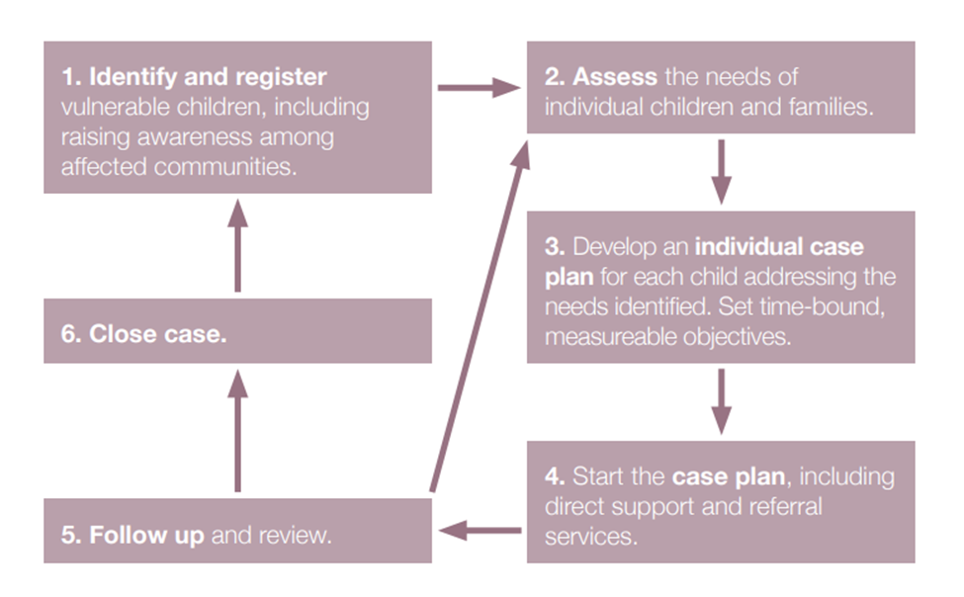
Source: Child Protection (2015) adapted by Student (2021

Identification and Registration: The multi-agency health and social care professionals can identify individual child for case management services and then register the child if he or she meets the vulnerable or risk criteria by collecting vital data (Child Protection, 2015). Drawing in the case, it is evident that Kelly and her younger siblings are vulnerable to abuse; hence, they need case management initiative services. To this end, the multi-agency professionals can identify Kelly and her sibling need and register them for case management services.
Assess: This is aimed at evaluating the child state of vulnerabilities or risk level including protective influence as well as strength and resilience of the child and family. Child Protection (2015) argue that a situation where there is an immediate risk to the child e.g., a child living with abuse or violence, a quick intervention is carried out assessment and a case plan is developed. On the contrary, in case there is no immediate risk to the child, a comprehensive assessment will be done to look at every concern. In the present case, Kelly and her younger sibling are confronted with immediate risk because their father has left the house and their mother is a drug addict who provides no care. This situation put Kelly and her sibling in a vulnerable situation and requires immediate intervention for assessment and case plan.
Case Planning: This helps to list the needs identified in the assessment and provide strategies to tackle the needs via direct service provision, referrals or community based programs (Child Protection 2015). In the present case, the multi-agency or inter-agency professionals have to list the needs of Kelly and her young siblings and provide available strategies to tackle the needs.
Implementing Case Plan: Direct support services and referral to other agencies are used to implement the case plan. According to Child Protection (2015), case workers or the manager coordinate the services, document progress and make sure that case objectives are met. In the present case, the inter-agency professionals can use direct support services and referral to other agencies to implement the case plan.
Follow Up and Review: This is to ensure that the child and family are receiving the right service and support, hence, the child situation as to be monitored and identify any changes and at the same time to reflect on whether the pan is progressing, objectives met, and make adjustment to the plan where necessary (Child Protection, 2015). In the present case, the inter-agency professionals have to monitor Kelly and her sibling situation and make sure that the right services and support is provided to them. In addition, the inter-agency professionals have to reflect on whether the plan is working, objectives met and if any need for adjustment.
Case Closure: This is to close the child situation based on certain reasons e.g., child situation resolved child move to another location, and organization not working in the location of the child (Child Protection, 2015). In the present case, when Kelly situation is resolved the case management initiative can be close for good.
6. Conclusion
Child protection is acknowledged as the responsibility of inter-agency organizations to ensure that health and social care professionals and programs put in pace safeguard children and young persons from any form of abuse. Indeed, inter-agency professionals must make sure they avoid exposing children and young persons from any risk of harm. This report has identified a case study of Kelly and her young siblings who are vulnerable and provided a good understanding of the elements of vulnerability of children and young people drawing attention to Kelly and her younger siblings.

7. References
Arora, S...K., Shah, D., A., Chaturvedi, S., Gupta, P. (2018) Defining and Measuring Vulnerability in Young People, Journal of Community Medicine, Vol. 40, (3): p 193-196
Child Protection (2015) Inter-Agency Guidelines for Case Management and Child Protection (online) http://www.cpcnetwork.org/wp-content/uploads/2014/08/CM_guidelines_ENG_.pdf. Accessed 20/8/2021
HM Government (2018) Working together to Safeguard Children: A Guide to Inter-Agency Working to Safeguard and Promote the Welfare of Children (online) https://assets.publishing.service.gov.uk/government/uploads/system/uploads/attachment_data/file/942454/Working_together_to_safeguard_children_inter_agency_guidance.pdf. Accessed 19/8/2021
NSPCC (2019) Child Protection System in the UK (online) https://learning.nspcc.org.uk/child-protection-system. Accessed 20/8/2021
University of Strathclyde, (2004) Caring for Vulnerable Children (online) https://www.futurelearn.com/info/courses/vulnerable-children/0/steps/5950. Accessed 19/8/2021
PHE (2020) No Child left Behind: A Public Health informed Approach to improving Outcomes for Vulnerable Children, Protecting and improving the Nation’s Health. (Online) https://assets.publishing.service.gov.uk/government/uploads/system/uploads/attachment_data/file/913764/Public_health_approach_to_vulnerability_in_childhood.pdf. Accessed 19/8/2021

