User Requirements and Prototype
Usability Engineering A1
Callum James

Contents
introduction 3
Research for Personas 3
Personas 4
Persona 1: Alex – Computing Student 4
Persona 2: Barbara – Mature postgraduate Student 4
Persona 3: Charlie – Business Student 4
Persona 4: Dilwyn – Non-gamer Support Staff 4
MoSCoW 5
Design Principles 5
Wireframe Designs 6
Home Screen/Main Menu 6
How to Play / Rules Page 7
Settings Screen 8
Player Turn Screen 9
Roll results overlay 10
Lost Focus Screen 11
End of game screen 12
General design considerations in the wireframes 12
Evaluation of Wireframes and User Feedback 13
Process Used to Collect Feedback 13
Summary of Positive and Negative Feedback from Evaluations 13
Positive Feedback 13
Negative Feedback 14
Conclusion 14
References 15
Appendix 18
Rules adjusted to UWTSD 18
MoSCoW 19
Jakob Nielsen’s 10 usability heuristics evaluation of the wireframes 19
Ratings 19
Wireframe 1: Home Screen/Main Menu 19
Wireframe 2: Settings Page 20
Wireframe 3: How to Play / Rules Page 20
Wireframe 4: Player Turn (Dice Rolling Screen) 20
Wireframe 5: Roll Results Overlay 20
Wireframe 6: Lost Focus Screen 21
Wireframe 7: End-of-Game Screen 21

introduction
This project focuses on designing a mobile game based on Zombie Dice, re-themed for the University of Wales Trinity Saint David (UWTSD), with the full adjusted ruleset in the appendix. Zombie Dice is a simple push-your-luck dice game in which players roll dice to accumulate “points” (represented by brains) but risk losing them if too many “penalties” (shotgun blasts) occur. In the UWTSD-themed version, the concept is adapted to student life: dice represent academic tasks of varying difficulty, and symbols represent typical student outcomes. Green, yellow, and red dice correspond to easy, medium, and hard tasks respectively. Each die face can show one of three symbols: Knowledge, Distraction, or Unfinished Task analogous to brains, shotguns, and footprints in the original game. A Knowledge symbol grants one point, representing academic progress. A Distraction causes the player to lose focus, counting as a strike against the turn, while an Unfinished Task means the work is incomplete and the die must be rerolled. On each turn, a player draws three dice at random and rolls them. The player may then choose to stop and bank their knowledge points or continue, rerolling any Unfinished Task dice and drawing new dice to make a total of three. If three Distractions are rolled in a single turn, no points are scored for that round. The game continues in turns until one player reaches 13 Knowledge points, mirroring the original win condition of collecting 13 brains[1].
The objective of this report is to develop initial wireframes for this re-themed portrait mobile version, ensuring that design decisions are aligned with Jakob Nielsen’s usability heuristics[2]. A user-centred approach is taken to meet the accessibility and experience needs of a diverse student population, laying the foundation for a more detailed prototype in future designs. Prioritised user requirements are established using the MoSCoW method to ensure core functionality is addressed first in the wireframe design[3,6,13].

Research for Personas
Understanding the student population at UWTSD is essential for informing early design choices, particularly when creating relevant and inclusive personas for a mobile board game interface. UWTSD's 2023 Equality and Diversity report shows the university's demographic profile. Just 14.8% of enrolled students are aged 20 or under, in contrast to the UK higher education sector average of 37.3%, suggesting a mature age profile across campuses[4,5]. Additionally, 13.9% of students at UWTSD disclose a disability, with many cases relating to mental health conditions or specific learning difficulties[4]. Gender distribution is relatively balanced, with 56.6% of students identifying as female and 42.2% as male[4]. UWTSD also has linguistically diverse students, with some students being bilingual in Welsh and English[4]. These factors highlight the importance of designing inclusive, flexible, and clearly structured interfaces, accommodating forr a broad range of user needs and preferences.
Along with this, current trends in mobile gaming provide further insight. Mobile board games are particularly popular among students due to their ease of access and casual gameplay style[5]. According to 2025 global data, mobile gamers span all adult age groups, with the average mobile player aged 36[5]. In terms of gender, 46% of mobile gamers identify as female, 52% as male, and 2% as other or prefer not to say[5]. Approximately 85% of mobile game users do not consider themselves “gamers,” indicating a preference for casual entertainment over a more intense game preference[5]. Usage patterns show frequent but short play sessions, typically lasting between 5–10 minutes[5]. These behavioural patterns suggest that mobile board games appealing to a broad student audience, such as a re-themed Zombie Dice should prioritise usability, speed of interaction, and clear visual feedback, making them suitable for both short breaks and longer gameplay sessions[4,5].

Personas

Persona 1: Alex – computing student
- Age: 20
- Course: BSc Computer Science, 2nd year
- Tech Ability: High
- Accessibility Need: None
- Preferences: Quick, competitive games, responsive UI, no forced tutorials
Scenario: Alex regularly uses mobile games between lectures. With a strong technical background, he expects fast-loading screens and intuitive controls. Games that respect his time by avoiding long tutorials and allowing rapid entry to play are favoured. He plans to play the game with his flatmates in student accommodation, and between classes with his classmates

Persona 2: Barbara – mature postgraduate student
- Age: 45
- Course: Master of Business (part-time)
- Tech Ability: Moderate
- Accessibility Need: Colour-blind support
- Preferences: Guided learning, readable fonts, relaxed pace
Scenario: Barbara returns to higher education after years in the workforce and seeks casual games to unwind. She needs clear instructions. Her play sessions are infrequent, often in quiet settings with classmates or with her partner, so she appreciates adjustable volume and accessible language.

Persona 3: Charlie – business student
- Age: 22
- Course: BA in Game design, 3rd year
- Tech Ability: High
- Accessibility Need: Hearing impairment
- Preferences: Social gaming, bold visuals, fast learning curve
Scenario: Charlie enjoys themed games and social experiences. He values clear, visual cues and dislikes interfaces that require sound to understand outcomes. Multiplayer capability, even local pass-and-play, is essential for engagement. Quick games are important as he often plays in social settings.

Persona 4: Dilwyn – library staff
- Age: 58
- Course/Role: Library Assistant
- Tech Ability: Low
- Accessibility Need: large buttons
- Preferences: first language is Welsh, supportive UX, no time pressure
Scenario: Dilwyn was drawn in by the UWTSD theme and plans to use it to relate with his younger coworkers and sudents. He rarely plays games, so he relies on in-game explanations and tutorials. Text that is too small or dense frustrates him. With occasional use, he needs the game to explain rules upon request and provide cues through both text and visuals. Ease of exit and navigation is also important.

MoSCoW
MoSCoW is a simple yet powerful method for prioritising features. The name stands for Must, Should, Could, and Won’t have, and each category indicates the importance and feasibility of different requirements. In this re-themed Zombie Dice design, using MoSCoW helps keep the focus on essential gameplay elements (Must), important but non-critical enhancements (Should), beneficial extras (Could), and out-of-scope ideas (Won’t) [3,6,13]. This approach helps clear decision making, ensuring the game remains both playable and inclusive for the UWTSD target audience[3,6,13]. By categorising requirements, the design can focus on delivering a more user-friendly experience without overloading potential development resources by adding unnecessary features in the design. This can be found in the appendix.

Design Principles
Norman’s Design Principles provide a foundation for designing clear, intuitive, and functional designs[7,8]. Each principle addresses a different aspect of how users interact with applications. In this project, the principles guided the wireframe designs to ensure the gameplay design remained accessible, engaging, and easy to learn, for the entire UWTSD audience base. There are 6 principles, which are:
Visibility refers to making the most important elements of a system clearly available to the user. In the wireframes, the player’s current score, turn indicator, and available actions such as "Roll" and "Hold" are always displayed on screen. This removes uncertainty and supports confident decision-making[7,8].
Feedback involves showing users the result of their actions. Dice rolls animate instantly, with results displayed both as icons and text. Players receive messages such as “You scored 2 Knowledge” or “Turn lost” to confirm each outcome[7,8].
Constraints help users avoid making mistakes. The app disables buttons like “Roll” after three Distractions are collected, ensuring users cannot accidentally break game rules[7,8].
Mapping ensures that the layout of controls reflects their real-world consequences. Roll and Hold buttons are placed near the dice area, making it clear what each one affects[7,8].
Consistency means using familiar visuals and terminology throughout. Icons such as the brain for Knowledge are repeated across gameplay, instructions, and the end screen, reducing the need for relearning[7,8].
Affordance relates to how an element’s design suggests its function. All interactive buttons look and behave like tappable objects, supporting users with varying levels of experience[7,8].
Fitts’ Law was also considered. Frequently used controls are placed near the bottom of the screen and made large enough for easy thumb access, reducing effort and improving speed of use on mobile devices[9,10].

Wireframe Designs
Each wireframe provided is designed to fulfil user requirements identified in the MoSCoW analysis in the appendix while incorporating Norman’s Design Principles. This ensures the interface is intuitive, accessible, and meets diverse student needs.

Home Screen/Main Menu
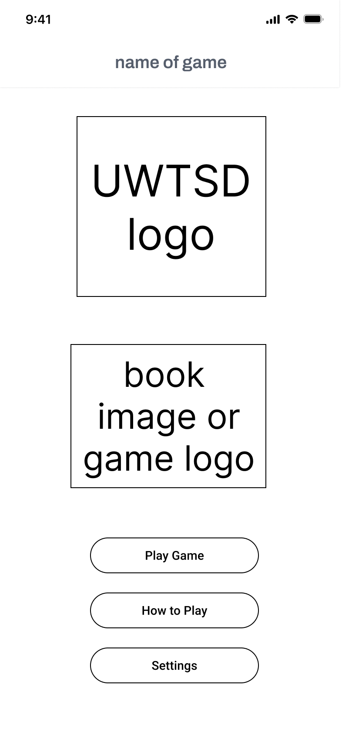
The home screen directly addresses Must-Have user requirements including two-player local pass-and-play gameplay, clearly labelled game elements, and straightforward navigation. The prominent buttons ("Play Game," "How to Play," and "Settings") provide immediate visibility, following Norman’s principle of visibility. Clear labels and consistent visual language simplify navigation for users such as Alex, who values rapid access, and Dilwyn, who benefits from clearly marked interactions. The accessibility to the settings menu from the home screen specifically addresses Barbara’s and Dilwyn’s needs for language, volume, and text adjustments.

How to Play / Rules Page
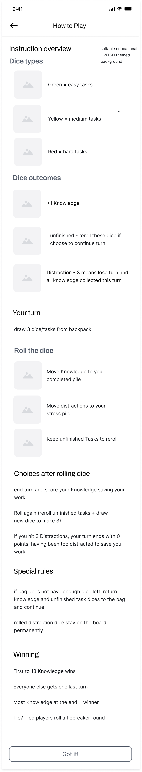
This screen fulfils the Should-Have requirement for on-demand game guidance. It uses clear headings and structured text to explain dice types (green, yellow, red), outcomes (Knowledge, Distraction, Unfinished Tasks), and gameplay mechanics. Aligning with Norman’s mapping principle, the explanations visually correspond to game elements, reducing confusion. The use of static instructions suites the Barbara persona, who prefers detailed textual guidance, and Dilwyn, who needs clear instructions available anytime.

Settings Screen
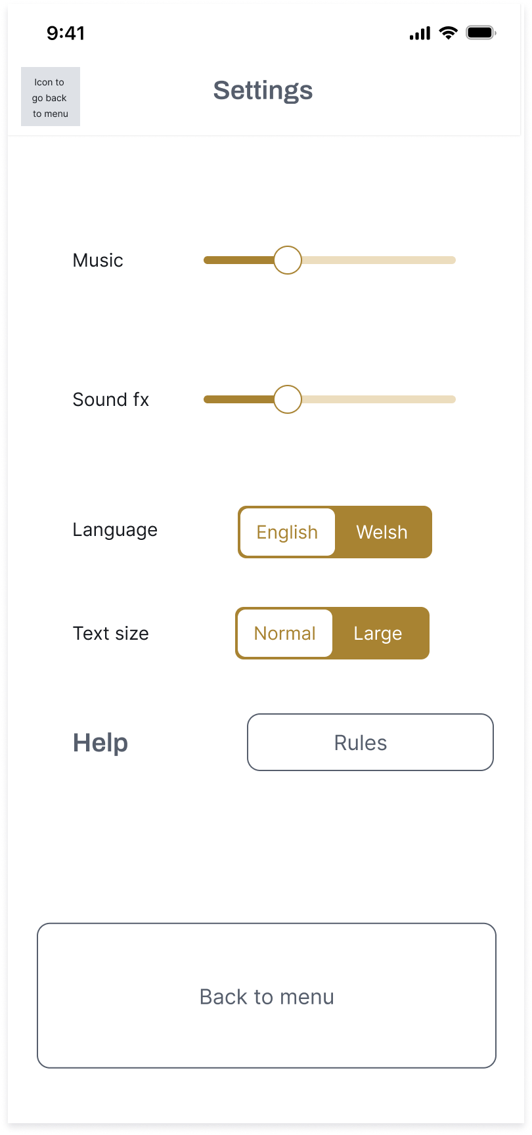
The Settings page explicitly meets user requirements for accessibility and personalisation. Key elements include volume sliders, language options (Welsh/English), and adjustable text size. This setup directly addresses Barbara’s moderate tech ability and colour-contrast concerns, as well as Dilwyn’s accessibility needs for readability. Affordances are clear, with interactive elements visibly indicating functionality. Norman’s principle of immediate feedback is addressed through visual responses to user changes. A future improvement could include direct settings access during gameplay to enhance flexibility, an issue currently noted but intentionally deferred for future development.

Player Turn Screen
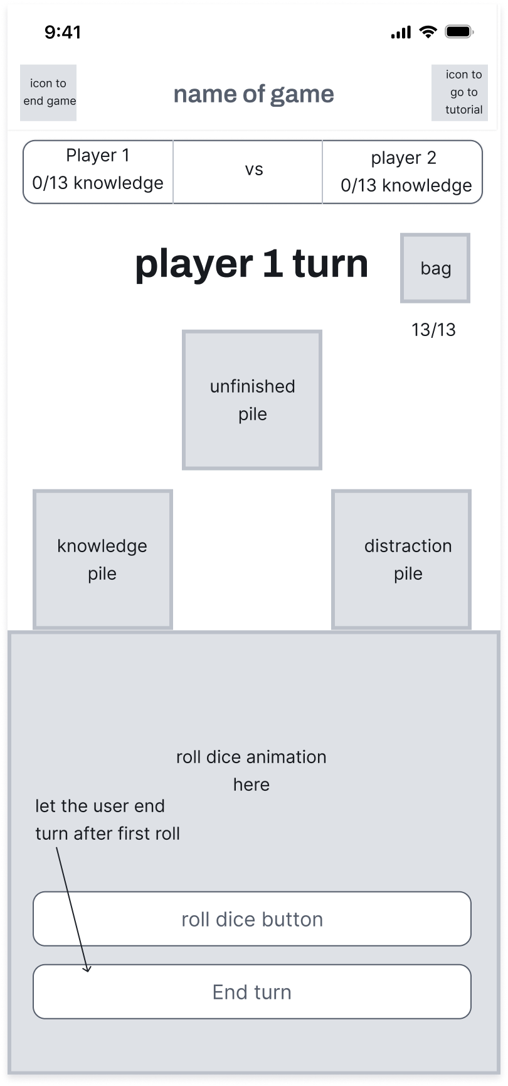
This main gameplay interface addresses several Must-Have user requirements, including visual-only feedback, large clearly labelled buttons, and consistent visual language. Prominent displays of the "knowledge pile," "unfinished pile," and "distraction pile" clearly communicate system status following Norman’s visibility principle. The "roll dice" and "end turn" buttons are large, explicitly labelled, and placed within comfortable thumb reach, complying with Fitts’ Law for usability. Icons are consistently applied, meeting Charlie’s requirement for visual clarity without relying on audio cues. The interface simplicity directly supports Dilwyn’s and Barbara’s ease of use, enhancing overall accessibility and quick interaction.
Dice roll animation and immediate visual results ensure prompt and understandable feedback, critical for user confidence during interactive gameplay. The arrangement clearly maps user actions (rolling dice) to their outcomes, reinforcing the intuitive nature of the design.

Roll results overlay
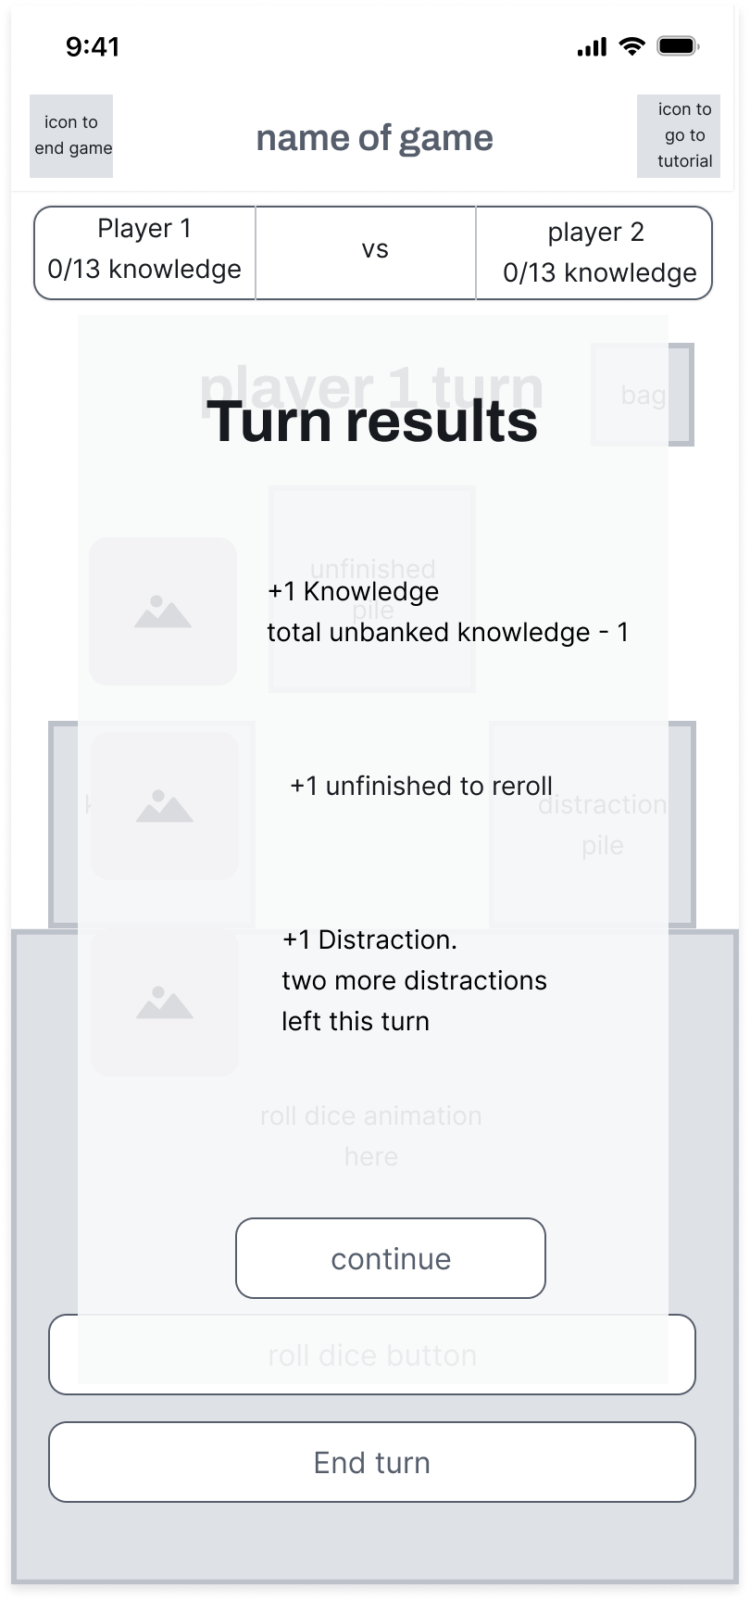
This overlay appears immediately after rolling dice, clearly summarising dice outcomes such as Knowledge gained, Unfinished tasks, and Distractions. Meeting Charlie’s need for immediate visual feedback, it uses icons to represent game states, following Norman’s principle of recognition rather than recall. The summary maintains consistency in icon usage, aligning with expectations set on the rules page. Future iterations might include brief textual labels under icons to further support users like Barbara and Dilwyn, who benefit from textual reinforcement. Nevertheless, current visual clarity effectively communicates results to users of varying technical abilities.

Lost Focus Screen
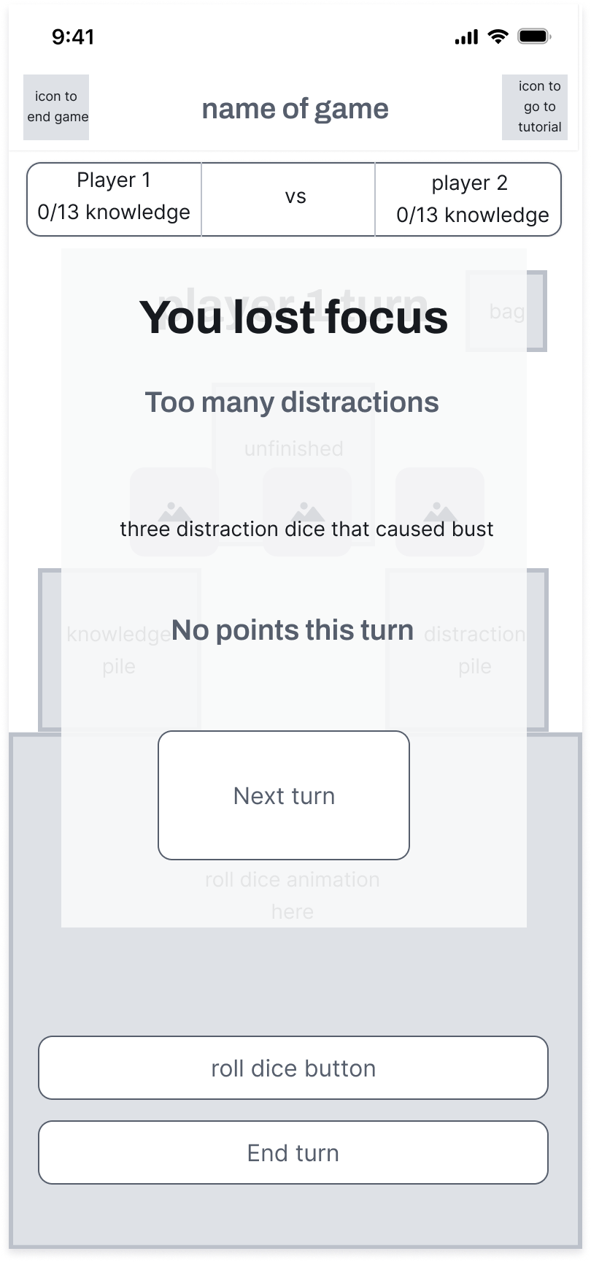
The Lost Focus screen clearly communicates when a user loses a turn due to accumulating three distractions. This feedback is presented immediately after the triggering event, following Norman’s immediate feedback principle. Clear textual feedback ("You lost focus," "Too many distractions") accompanied by a large, prominently positioned "Next turn" button ensures that users clearly understand their status and next steps. This design decision directly benefits Dilwyn, who appreciates explicit communication and minimal confusion, and Alex, who prefers rapid, clear interaction to resume gameplay swiftly.

End of game screen
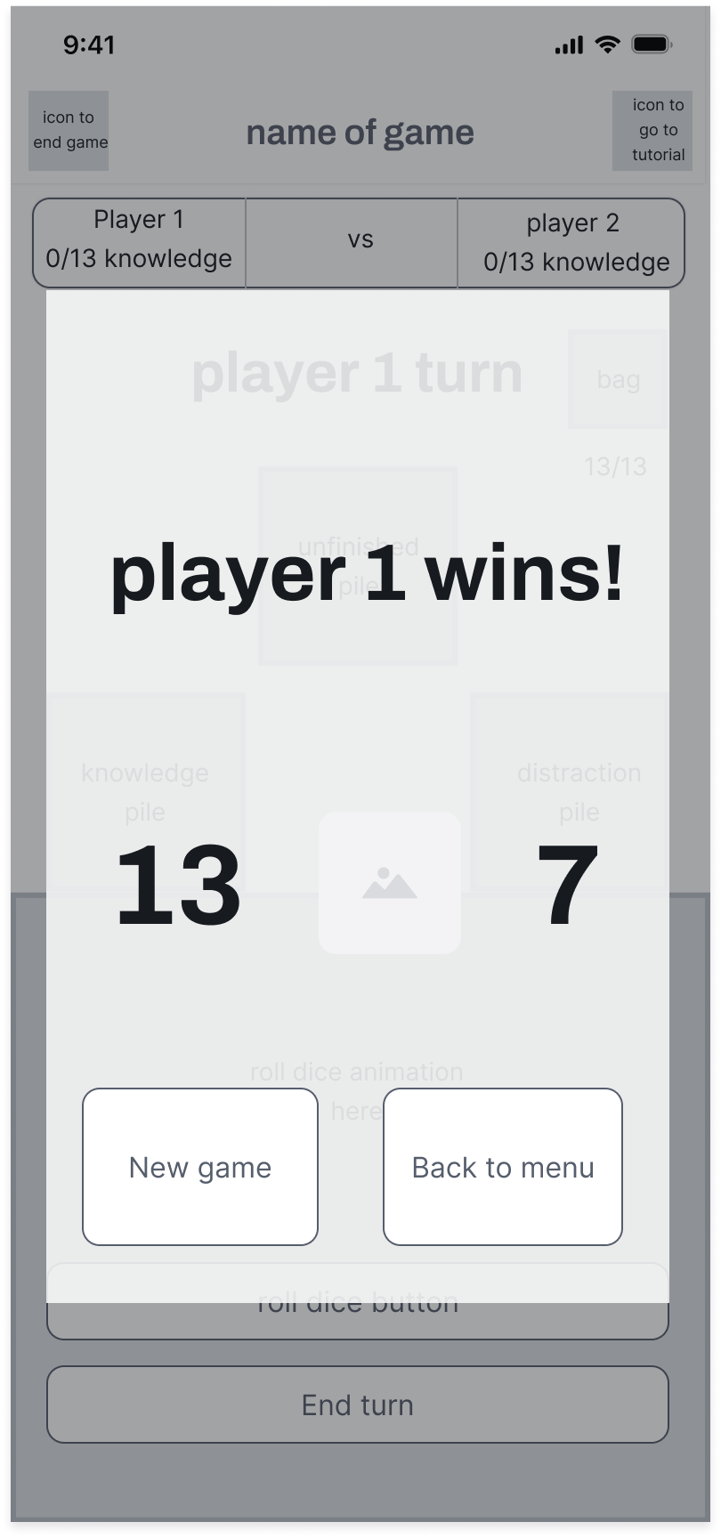
This final wireframe clearly addresses the Must-Have requirement of consistent visual language and clear game results display. By prominently showing each player's final Knowledge scores alongside a clear declaration of the winner ("Player 1 wins!"), it provides satisfying closure for competitive gameplay scenarios, essential for Alex’s competitive preferences. The inclusion of large, easily recognisable buttons ("New game," "Back to menu") directly follows Norman’s affordance principle, clearly indicating their interactive function, supporting Dilwyn’s accessibility needs[2]. The immediate availability of a new game option aligns with Alex’s preference for continuous, uninterrupted play.

General design considerations in the wireframes
Throughout these wireframes, careful consideration of Norman’s Design Principles ensures that the interface supports clear visibility, effective feedback, intuitive mapping, consistency, affordances, and appropriate constraints[2,7,9]. Frequent interaction elements, like dice-roll and navigation buttons, are carefully sized and positioned following Fitts’ Law, ensuring comfortable and efficient use, especially critical on mobile devices[9,10]. By balancing functionality and clarity, the wireframes provide an accessible, engaging, and satisfying user experience for the intended student demographic.
Overall, these wireframes reflect strategic and thoughtful integration of user requirements with usability best practices, laying a robust foundation for further refinement.

Evaluation of Wireframes and User Feedback

Process Used to Collect Feedback
Two primary evaluation methods were used to collect feedback on the wireframes: Jakob Nielsen’s 10 Usability Heuristics and a brief informal cognitive walkthrough. Jakob Nielsen’s usability heuristics provide a structured method to assess the usability of an interface. Evaluators systematically analyse each screen against ten usability principles, such as visibility of system status, user control and freedom, error prevention, and provision of clear documentation[2,7,8,11]. This method enables early detection of design issues that could hinder user interaction. The complete heuristic evaluation is included in the appendix, outlining identified strengths and weaknesses clearly.
In addition, an informal cognitive walkthrough was conducted, involving two potential users. a computing student and a recent business graduate, both from a university partnered with UWTSD. A cognitive walkthrough is an evaluation approach where participants attempt realistic tasks within an interface to reveal usability problems from a user's perspective. Its primary benefits include uncovering unexpected user difficulties, validating user paths, and gaining insights into the practical usability of the design[12,14].
Due to time constraints, the walkthrough was limited to a quick demonstration session using an interactive prototype created in Figma[15]. Testers navigated through the wireframes via simulated connections, as shown in the provided screenshots. For this demonstration, minor temporary modifications were made to the "Player Turn" wireframe by adding extra buttons. These buttons allowed participants to directly access specific screens such as "Lost Focus" and "End-of-Game" outcomes without actual game logic. Testers were informed that these buttons were for demonstration purposes only and were not considered as part of the final design.
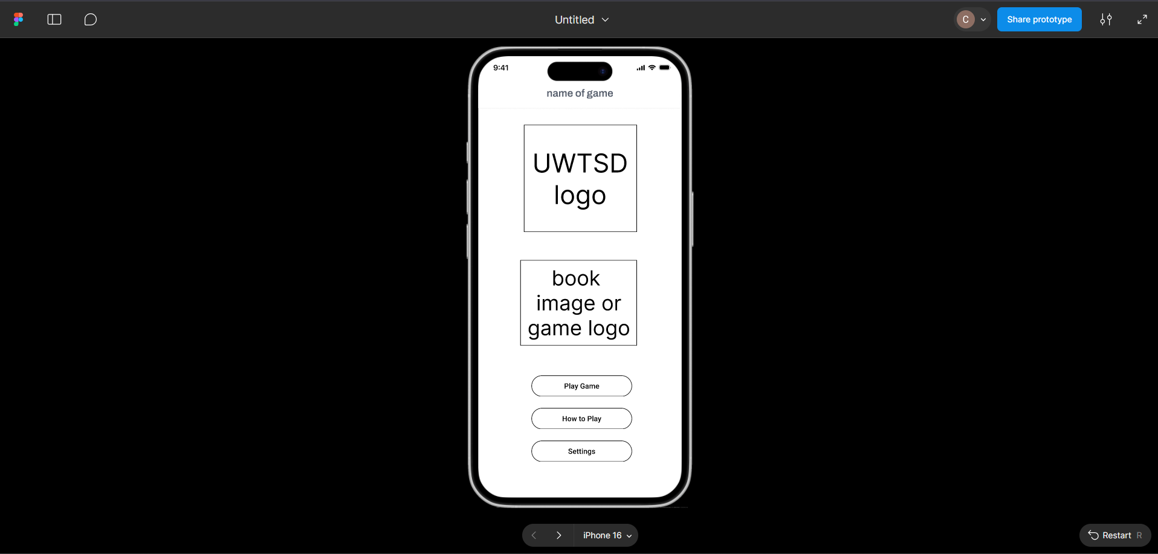
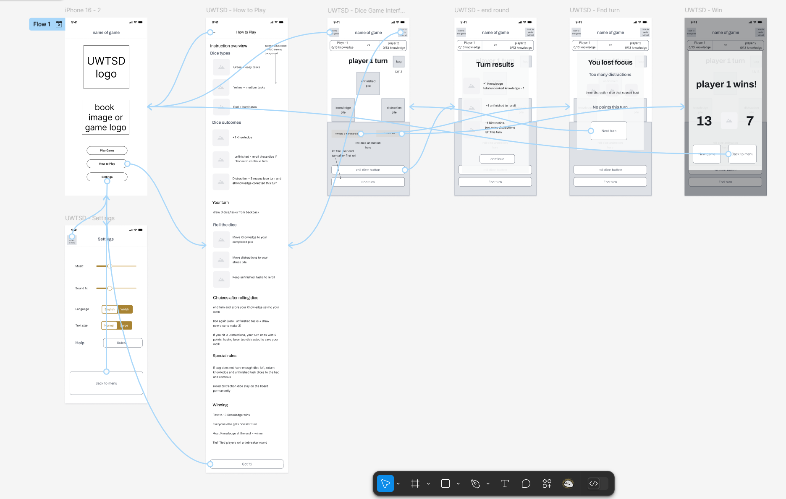

Summary of Positive and Negative Feedback from Evaluations

Positive Feedback
Participants provided favourable feedback regarding several aspects of the wireframes. They particularly praised the simplicity and intuitive nature of the user interface, noting that screens were uncluttered and easy to navigate, which made initial interactions straightforward. Consistent visual language and clear iconography were highlighted as effective, facilitating quick recognition and recall of gameplay mechanics such as Knowledge, Distraction, and Unfinished Task symbols. Additionally, the large, clearly labelled buttons enhanced usability, particularly benefitting users requiring accessible interaction points. Immediate visual feedback on dice roll outcomes was also positively received, aligning well with user expectations and Norman’s design principles.

Negative Feedback
Despite overall positive reactions, testers identified key areas requiring improvement. A significant issue raised was the inability to save or resume interrupted game sessions, limiting user control and negatively affecting casual gameplay experiences. Another notable problem was the lack of access to the settings menu during active gameplay, forcing users to return to the main menu for adjustments, reducing flexibility and convenience. Additionally, the static, text-only approach of the "How to Play" page was flagged as less effective, with the testers suggesting the introduction of interactive or contextual guidance. These issues collectively highlight design improvements needed in future iterations to enhance user experience, accessibility, and overall usability.

Conclusion
These wireframes represent the initial stage in the development of a mobile adaptation of Zombie Dice tailored for the UWTSD student audience. Designed with accessibility, usability, and clarity in mind, the layouts reflect user-centred priorities guided by recognised design principles and evaluation feedback. While overall response to the interface was positive, key usability concerns were identified, including limited in-game settings access and the need for more interactive tutorials. These findings will inform the next development phase, where full-colour mock-ups will incorporate refinements based on both heuristic analysis and user insights, ensuring the final product is engaging, inclusive, and aligned with the diverse needs of its intended audience.

References

1. STEVE JACKSON GAMES. Zombie dice rules english [Internet]. sjgames. [cited 2025 Apr 9]. Available from: https://www.sjgames.com/dice/zombiedice/img/ZDRules_English.pdf
2. Nielsen J. 10 Heuristics for User Interface Design [Internet]. Nielsen Norman Group. 2024 [cited 2025 Apr 9]. Available from: https://www.nngroup.com/articles/ten-usability-heuristics/
3. Interaction Design Foundation. Making Your UX Life Easier with the MoSCoW [Internet]. The Interaction Design Foundation. UX courses; 2015 [cited 2025 Apr 9]. Available from: https://www.interaction-design.org/literature/article/making-your-ux-life-easier-with-the-moscow
4. uwtsd. Annual Report: Equality and Diversity 2022/23 [Internet]. uwtsd. 2023 [cited 2025 Apr 9]. Available from: https://www.uwtsd.ac.uk/media/2554/download?attachment
5. Curry D. Mobile Game Demographics Data (2024) [Internet]. Business of Apps. 2025 [cited 2025 Apr 9]. Available from: https://www.businessofapps.com/data/mobile-game-demographics-data/
6. Vijayakumar NS, Prasad K, Raviraja Holla M. Assessing the Effectiveness of MoSCoW Prioritization in Software Development: A Holistic Analysis across Methodologies. EAI Endorsed Transactions on Internet of Things [Internet]. 2024 Oct 28 [cited 2025 Apr 9];10. Available from: https://openurl.ebsco.com/EPDB%3Agcd%3A4%3A31281076/detailv2?sid=ebsco%3Aplink%3Ascholar&id=ebsco%3Agcd%3A183567287&crl=c&link_origin=scholar.google.com
7. Norman DA. The design of everyday things. New York, New York: Basic Books; 2013.
8. Rizky Novensa S, Munggana W. Analysis and Development of Interface Design on DKI Jakarta & Tangerang’S Qlue Application based on Don Norman’s 6 Design Principles. 2018 [cited 2025 Apr 9];V(1). Available from: https://pdfs.semanticscholar.org/a0b6/3bf154e788353f3a5c3a469e90805e9ffa8f.pdf
9. Norman KL, Kirakowski J. The Wiley handbook of human computer interaction. Hoboken, NJ, USA: John Wiley & Sons Ltd; 2018.
10. Lin CJ, Ho SH. Prediction of the use of mobile device interfaces in the progressive aging process with the model of Fitts’ law. Journal of Biomedical Informatics [Internet]. 2020 Jul 1 [cited 2025 Apr 9];107:103457. Available from: https://www.sciencedirect.com/science/article/pii/S153204642030085X
11. Kendrick A. 10 Usability Heuristics Applied to Video Games [Internet]. Nielsen Norman Group. 2019 [cited 2025 Apr 9]. Available from: https://www.nngroup.com/articles/usability-heuristics-applied-video-games
12. Samrgandi N. User Interface Design & Evaluation of Mobile Applications. IJCSNS International Journal of Computer Science and Network Security [Internet]. 2021 Jan [cited 2022 May 10];21(1). Available from: http://paper.ijcsns.org/07_book/202101/20210109.pdf
13. Agile Business Consortium. Chapter 10: MoSCoW Prioririsation [Internet]. www.agilebusiness.org. Agile Business Consortium; 2022 [cited 2025 Apr 10]. Available from: https://www.agilebusiness.org/dsdm-project-framework/moscow-prioririsation.html
14. Abyudaya Tiyasa, Wirdiani NKA, Rusjayanthi NKD. Analysis and design of UI and UX of the Taring application using goal-directed design and cognitive walkthrough methods. Matrix : jurnal manajemen teknologi dan informatika/Matrix: Jurnal Manajemen Teknologi dan Informatika [Internet]. 2023 Nov 29 [cited 2025 Apr 9];13(3):142–56. Available from: https://ojs2.pnb.ac.id/index.php/MATRIX/article/view/1179
15. Figma. Figma: the Collaborative Interface Design tool. [Internet]. Figma. [cited 2025 Apr 10]. Available from: https://www.figma.com

Appendix

Rules adjusted to UWTSD
What the different dice are
- The game uses 13 dice of three colours
- Green dice represent easier tasks like reviewing notes
- Yellow dice represent medium tasks like writing a reference list
- Red dice represent hard tasks like completing final coursework
- Each dice has three possible outcomes when rolled
Dice Symbols
- Knowledge means you have completed a task and gain a point
- Distraction means you have lost focus and are closer to losing your turn
- Unfinished Task means the work was started but not done, and you will need to try again
How a Turn Works
- Start by drawing three dice randomly from the virtual backpack
- Roll all three
- Move Knowledge dice to your "completed pile"
- Move Distractions to your "stress pile"
- Keep Unfinished Task dice in front of you
After the First Roll
- You decide whether to stop and keep your score or keep going
- If you stop, you get one point for each Knowledge symbol you rolled
- If you keep going, you re-roll any Unfinished Task dice and add new random dice to make a total of three
- If you roll a total of three Distractions at any point, your turn ends, and you lose all progress from that round
Special Cases
- If there are fewer than three dice left in the backpack, return all your Knowledge and Unfinished Task dice to the backpack and continue
- Distraction dice stay out of the backpack for the entire game
Winning the Game
- The game continues until a player reaches 13 Knowledge points
- After that, everyone else gets one final turn
- The player with the most Knowledge at the end wins
- If there is a tie, only the tied players take a final tiebreaker round

MoSCoW
Must Have (M) | Should Have (S) | Could Have (C) | Won’t Have (W)
Two-player pass-and-play functionality for local games (Charlie, Alex) | On demand tutorial section or help guide (Barbara, Dilwyn) | Avatar selection for players (Charlie) | In-app purchases or microtransactions
Maintain colour contrast throughout (Barbara) | Text based description under symbols (Barbara, Charlie) | Customisable in-game icons or backgrounds (Alex) | Complex strategy modes or variable difficulty AI
Visual-only feedback for all game elements (Charlie) | Colour-blind accessibility mode (Barbara) | Multiplayer expansion beyond 2 players (future version) (Charlie) | Real-time voice or chat functionality
Large, clearly labelled buttons (Dilwyn) |  | Basic AI player for solo play (Dilwyn) | VR/AR integration features
No forced unskippable tutorial (Dilwyn, Alex) |  | Online multiplayer support ()
Basic settings for text size, volume control and Welsh language suppport(Barbara, Dilwyn)
Clear turn indicators and score display (all personas)
Consistent visual language and game elements labelling (Charlie, Barbara)

Jakob Nielsen’s 10 usability heuristics evaluation of the wireframes
Ratings
- 0: Not an issue
- 1: Cosmetic issue only
- 2: Minor usability issue
- 3: Major usability issue
- 4: Usability catastrophe; must fix before release

Wireframe 1: Home Screen/Main Menu
Heuristic | Issue Identified | Severity
#3 User Control and Freedom | No option provided for saving or resuming interrupted game sessions. | 3
#10 Help and Documentation | Tutorial button redirects to static rules page instead of interactive tutorial. | 2

Wireframe 2: Settings Page
Heuristic | Issue Identified | Severity
#7 Flexibility and Efficiency | Settings screen cannot be accessed during active gameplay. Users must return to the home menu first. With no saving this may cause the game to end. | 3
#4 Consistency and Standards | No clear indicator of whether setting changes apply immediately or require confirmation. | 2

Wireframe 3: How to Play / Rules Page
Heuristic | Issue Identified | Severity
#10 Help and Documentation | Only static textual instructions provided; lacks interactive or visual examples to reinforce learning. | 2
#8 Aesthetic and Minimalist Design | Large blocks of continuous text may overwhelm users, particularly those requiring larger fonts or simpler explanations. | 1

Wireframe 4: Player Turn (Dice Rolling Screen)
Heuristic | Issue Identified | Severity
#1 Visibility of System Status | Dice results not explicitly summarised immediately after roll completion it relies on secondary overlay although users could count themselves. | 1
#6 Recognition Rather Than Recall | Dice piles (Knowledge, Distraction, Unfinished) are shown without any textual labels on screen. | 2
#3 User Control and Freedom | No undo feature or confirmation step provided for accidental button presses ("Roll dice" or "End turn"). | 2
#7 Flexibility and Efficiency | Settings screen cannot be accessed during active gameplay. Users must return to the home menu first. With no saving this may cause the game to end. | 3

Wireframe 5: Roll Results Overlay
Heuristic | Issue Identified | Severity
#1 Visibility of System Status | Total accumulated Knowledge points not displayed clearly after each roll, although this is addressed when the user continues past this overlay by pressing the button. | 1

Wireframe 6: Lost Focus Screen
Heuristic | Issue Identified | Severity
#9 Help Users Recognise, Diagnose, and Recover from Errors | Clear indication of losing focus provided but lacks advice or guidance on how to avoid repeated errors, could add a tooltip on what this means and what caused it. | 1
#3 User Control and Freedom | No option to review the dice roll results that caused the turn loss this round, user must proceed immediately to end their turn after being shown the 3 distraction dices, they rolled throughout their entire turn | 1

Wireframe 7: End-of-Game Screen
Heuristic | Issue Identified | Severity
#5 Error Prevention | No confirmation prompt for ending the game session; users could accidentally exit without intending. | 1

