Within my proposal I will be looking at folk art. My passion for creating ornate deigns and

patterns, coupled with my appreciation of nature and whimsy has made folk art my

favourite style to mimic within my illustrations. I will use three key words, tradition,

decoration, and story to delve deeper, and further explore folk art and analyse it’s influence

on contemporary illustration. These words encapsulate what I enjoy about folk art, as well

as providing context for how it fits into my own Work. I will use my key words to further

explore folk art and discover how it may influence my Practice and inspire the question that

will be the focal point of my extended essay.

Tradition
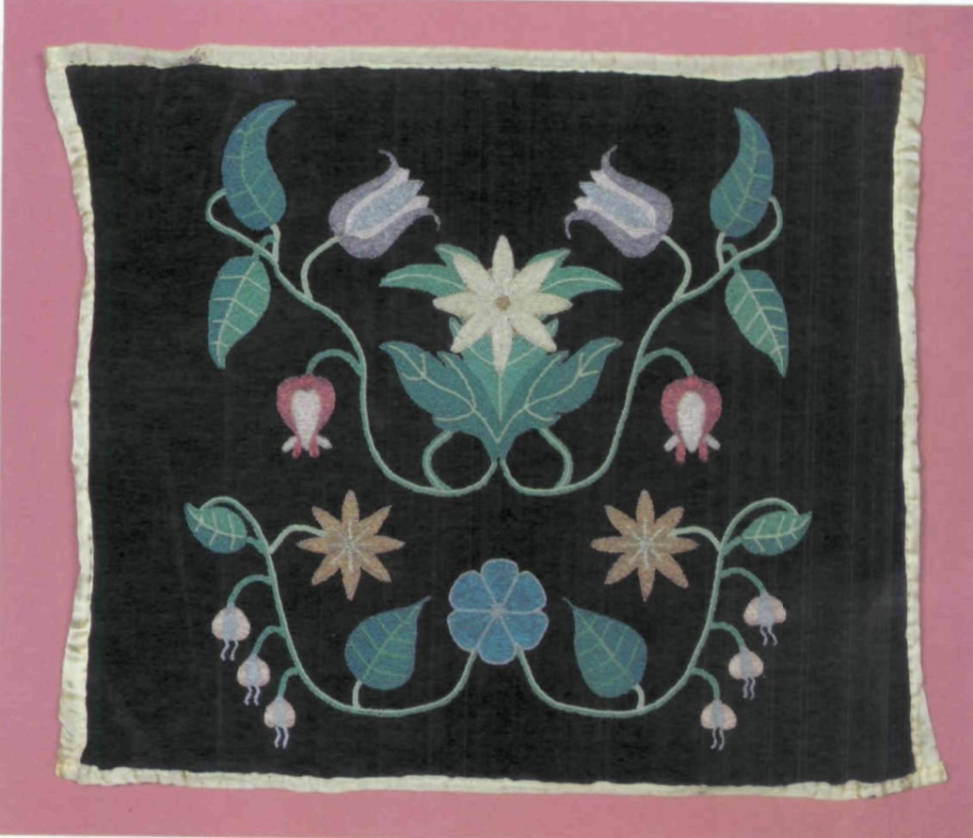
Fig 1, Beaded Baby Carrier Cover, Richard LaFromboise

Folk art was once practiced by “primitive artists”, who were “untrained” and would “paint

and sculpt for their own pleasure” (Abernethy, 1985). It was something that people could

partake in without formal education or training in the arts. Instead of creating artworks for

commercial purposes, folk artists were more interested in creating personal pieces that

honoured their cultures and identity. People would “learn a craft and the art that

embellishes it from their elders”, who learned it from the “ancients” (Abernethy, 1985).

They would grow up watching parents and grandparents create different crafts and then

learn the craft themselves, continuing the cycle for generations.

Bronner suggests that “Creativity and tradition are intertwined, and rep-resent the complex

processes of humans expressing themselves” (Bronner, 1992), this idea can be used to further explain

the relationship between traditional folk art and contemporary folk art. Today’s artists who

practice the art style are , wether intentionally or not, honouring the rich history of different

cultures. They may not know where the designs they are emulating originally came from,

but they are continuing the legacy of the craft by following the tradition of those before

them.

While historically folk artists would “learn their skills from their ancestors” (Waycott, et

al,2017), those who practice today can use social media and the internet to research

different artists and watch tutorials on different techniques. There is an argument to be

made about the loss of authenticity now that these techniques are readily available even for

those with no cultural ties to what they may go on to emulate in their art. As someone who

practices folk art, I believe that the best way to Immerse yourself in the craft is to research

the styles origin. Not only does it help contextualise what you are practicing, it also honours

culture you are borrowing from. In the book Imagine a Forest: Designs and Inspirations for

Enchanting Folk Art, Mirtalipova states that’s she was “willing to dig up books in libraries

and watch YouTube videos where people shared their knowledge” (Mirtalipova, 2017) to learn the

techniques that were necessary to progress her style as a contemporary

folk artist. While folk art may have lost its intergenerational nature, it has ultimately become

more accessible.

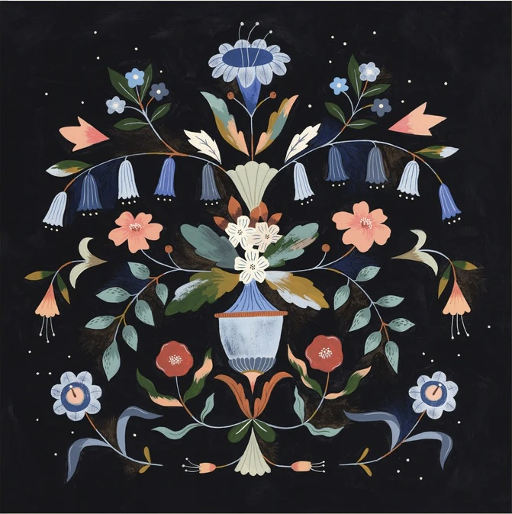

Fig 2, Flourish, Flora Waycott, (2021)

Some embellishments and details that were frequently painted in traditional folk art are still

used in illustration and decorative arts today. An example if this is the art of Rosemaling,

which is usually characterised by a painting with a “central image that is surrounded by

paisley prints, flowers, and roses” (Hallmark, et al, 2012). This style was popular in Norway

in “the first decades of the nineteenth century” (Martin, 1989). Illustrators are still using

rosemaling as a technique as floral and botanical pieces are in high demand amongst

consumers of the decorative arts.

Fig 1 shows a traditional piece that uses rosemaling. It is embroidered, this was a popular

medium of folk art as it was a way to decorate and personalise clothing and soft furnishings.

Figure two has aesthetic similarities, but was created by Flora Waycott who is a

contemporary illustrator. I picked these two images not only for the likeness between them,

but also the link to my work. Waycott has given me an introduction into how folk art has

evolved. In my own work I have adopted the similar style of black backgrounds and floral

details . I would like to bring elements of Rosmaling into my practice, particularly the details

shown in the two images. I think the use of symmetry particularly striking, it gives both

pieces a complete feeling and is pleasing to the eye.

Decoration

Folk art was traditionally used “to add decorative flair to interiors, household objects,

utilitarian items, and personal possessions” (Noble, 2013). People would favour having

beautifully painted, embroidered or decorated “walls, textiles, floors, furnitures”, and

possessions within their homes (Eff, 1978). Being able to craft the pieces themselves

would have made their belongings feel more personal. Today, having decorated belongings

is still sought after, meaning that products with visually appealing designs are always in

demand. This is where some illustrators find their work.

Illustration is a highly commercialised genre of the art world. The whole concept of being an

illustrator is to create art to be consumed by an audience. Every area of illustration has an

audience in mind. It’s worth noting that is the opposite of the intentions of traditional folk

art, as it was the art of creating pieces for one’s self. While the practices of contemporary

illustration and traditional folk art may be different, the art of decorating is present in them

both. An area of illustration that allows illustrators to decorate products is art licensing.

These illustrators will create pieces to go on “home furnishings fabrics, giftware, products,

apparel, stationery, and toys” (Roman, 2014), along with many other products that are

similar to those that a traditional folk artist would have worked on. While the final pieces

may be similar to those of folk art, art licensing is no where near as personal. While

traditional folk art was about decorating an object by hand, in art licensing the artist

creates the designs to send to a company for them to distribute on their products,“an artist

who chooses to license their art may not sell any originals at all, but simply license the

images for use on commercial products” (The abundant artist). I would like to explore the

world of art licensing and see how my folk designs would look on different products.

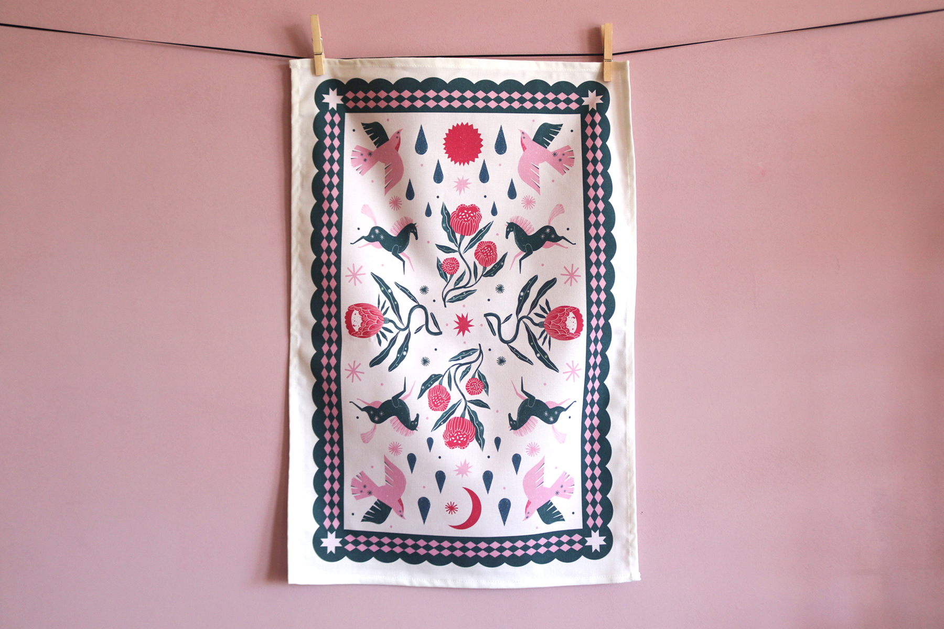
Fig 3, Illustrated Tea Towel, Flora and Fauna, Layla Holzer (2022)

Layla Holzer is a contemporary folk artist. She describes her practice as being inspired by

“flora, fauna and femininity” and “different branches of folk” (Holzer). There are folk

themed motifs within her pieces, mostly within the way she portrays nature. Her work has a

whimsical feel, from the way she draws animals leaping across her pages, to the I way

she draws flowers. Her designs go on an array of products, including prints, wrapping

paper, calendars and tea towels. I want to do something similar within my career. My pieces

of art have ornate details and feature patterns. I always have decoration in mind when

creating as I love the idea of making something to be put on something else, for example

creating a pattern to be put on wallpaper.

Another area of design that is reminiscent of folk art is surface pattern design. I consider it a

combination of illustration and textiles, making it similar to the practices these artists would

have partaken in through history. Surface pattern designers may digitise work and have it

printed on fabric, or some may use techniques like screen printing, hand painting, and

sublimation printing. I do not necessarily want to practice surface pattern design, but like in

art licensing, I’m keen to explore putting my art on surfaces. I think that using different

printing techniques and putting them on fabric would be the closest way to practice

historical folk art while still keeping up with modern techniques. I would like to experiment

with print making in my practice.

Story

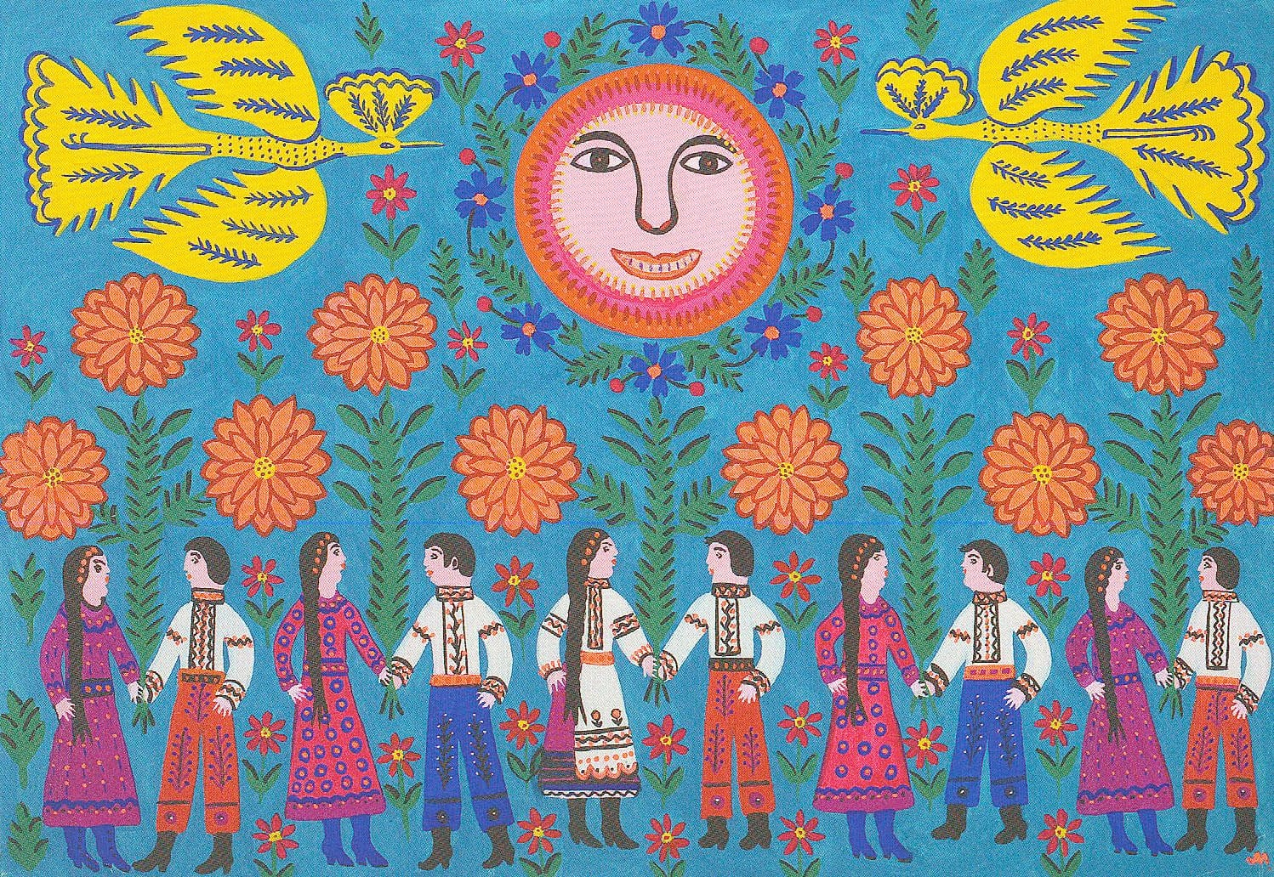
Fig 4, Our Army, Our Protectors, Maria Prymachenko, (1978)

Folk art designs are often detailed , this allows some artists to fit narratives in their

artworks. The paintings tell elements of or sometimes a whole story within them. These

artists often would have told the stories of where they are from, this may have been as a

way to document their lives, or as a way to pass on folklore.

In fig 4 Prymachenko is telling the story of. Her paintings always included stories that were

“deeply embedded in Ukrainian heritage” (Abravitova, 2022). Through the dire

circumstances Ukrainians are now facing, we can now see the significance of art that tells

stories of life in the artists country. Today, Prymachenko’s paintings are considered to be full

of hope as they portray a narrative of peace and community. She employs a “naïve” (Lowry,

et al, 2013) style to tell a story, making her paintings seem childlike in a way. In fig 1 there is

a figure with a smiling face, which is possibly represents the sun. It is reminiscent of his

children will often draw the sun, giving the piece a feeling of childlike optimism and

happiness. This further elevates the story of peace in which Prymachenko’s work is now

synonymous with.

The stories told in folk art don’t have to be reflective of personal stories like Prymachenko’s

were. There is also a link between folklore and biblical texts with folk art. “Folk arts include

oral narratives like stories” (Local Learnjng,2021), so artists would sometimes make paintings to help

visualise these stories.
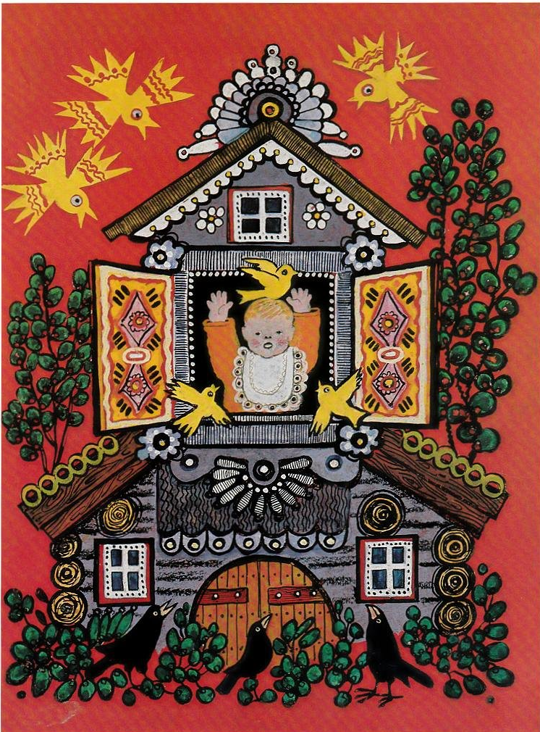
Fig 5, Pat-a-Cake, Yuri Vasnetsov, (1964)

Vasnetsov was a Russian folk artist who Illustrated various texts. In fig 5 his illustration was

to go along side “a collection of folk rhymes and tales for little ones” (Vasnetsov, 1964),

making him a narrative illustrator. Narrative illustration is the art of creating images to

accompany text. Children’s picture books and graphic novels are two of the most popular

areas of this medium. The typical format for illustrations in a children’s book would be one

On every or every few pages, each one demonstrating what is going on in that part of the

story. I am more interested in creating an illustration with a story that is present within it,

like the work of Prymachenko.

Compared to a typical narrative illustration that accompanies a small part of a story, I think

that you are able to delve deeper with pieces like Prymachenko’s. While creating that kind

of stand alone piece you would have to pay close attention to things like your composition

and consider how we read and understand images, seeing as there is no text. The stories

presented in folk art transcend text and language. Someone will be able to understand a

piece of narrative folk art, no matter of their culture or language because of the visual

“signifiers” (Lagopoulos, 2020) included. A signifier within a piece of art is a detail that

Signifies certain moods and themes, an example would be be the colour palette used. We

know that the piece in fig 4 has a positive narrative because of the bright and clear colours

that were included.

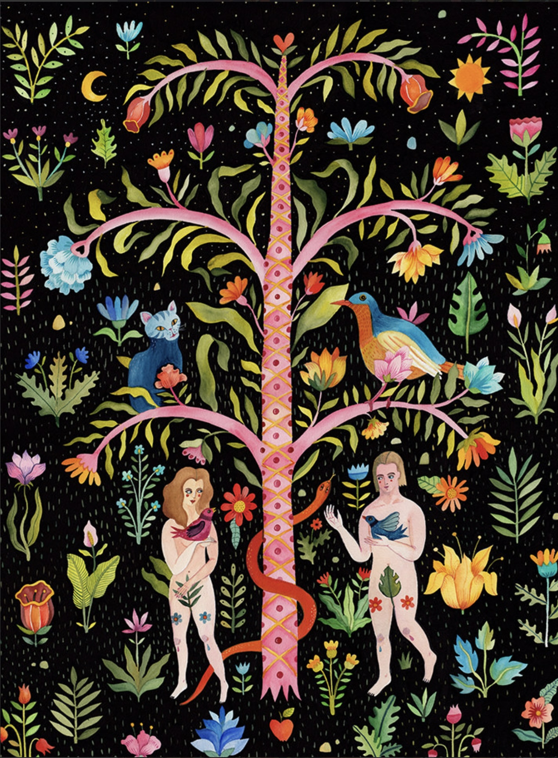
Fig 7, Adam and Eve, Aitch, (2022)

Aitch is a contemporary illustrator who shows stories in her pieces, the image in fig 6 shows

the story of Adam and Eve. They have illustrated some universally recognised parts of the

story, like the snake and the forbidden fruit. I like the way that these parts are not

immediately obvious in the image because of the level of detail, it makes looking at it more

enjoyable.

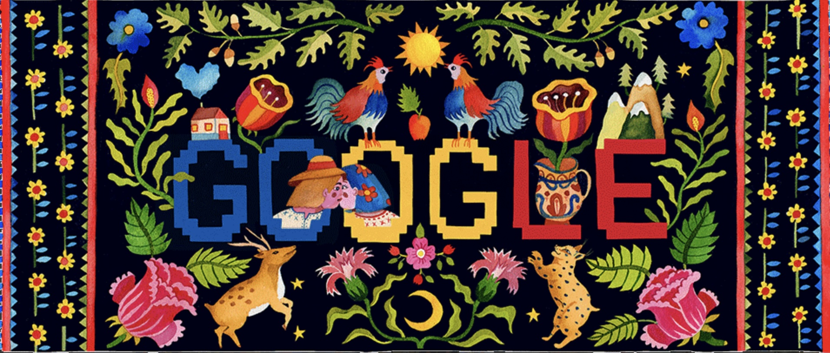
Fig 8, Google Doodle, Aitch, (2022)

Aitch’s work is telling if his these detailed narrative folk art pieces have evolved and are now

being used for commercial purposes. They have taken the idea of a piece was only made to

tell a story and progressed it to do that while serving other purposes. I may want to mimic

this technique by creating products or packaging that also tell a story.

The three key words that I have included within my proposal explain the history of folk art

and further show how illustrators today have developed their styles from the influence of

traditional folk art. I enjoy how todays folk artists have taken the signature details and

techniques and modernised them to fit in with the world of illustration. Congdon and

Hallmark suggest that “definitions of “art” and “folk” have expanded over the last century”

(Congdon, et al, 2012). This shows that folk has and will continue to evolve. While folk art

was once used to be shared within one’s culture, todays artists are spreading the style

worldwide. Folk art inspired pieces are present in all areas of illustration, like art licensing,

narrative, and decorative illustration. I personally would like to take this style and apply it to

art licensing, and perhaps packaging design, I believe that my work works best when it’s

taken off its original page and out on something else. My work is meant to decorate, much

like traditional folk art. My research within my proposal has started to help me think about

the relationship between folk art and illustration, however, through my extended essay I

would like to delve deeper. I would like to talk to practicing illustrators who are inspired by

folk art and ask them about their work and how folk art inspires them. I also want to delve

deeper into how each culture has their own style of art.

My main question will be “How has traditional folk art influenced contemporary

illustration?”, this will be backed up with the sub questions “why is folk art inspired

illustration popular with consumers?”, “What is the relationship between folk illustration

and the cultures that inspired it?”, “How will folk art continue to develop within the world of

illustration?” and “How will the popularisation of folk inspired illustration affect the practice

of folk art”

Bibliography

Abernethy, F., 1985. Folk Art in Texas. 1st ed. Southern Methodist University Press, p.3.

Bronner, S.J, 1992. Creativity and tradition in folklore new directions. Utah State University Press, p.3.

Waycott, F., Fry Kasuba, T., Befort, O., Otten, M, 2017. Creative Folk Art and Beyond: Inspiring Tips, Projects, and Ideas for Creating Cheerful Folk Art Inspired by the Scandinavian Concept of Hygge. United States: Walter Foster Publishing, p.6.

Mirtalipova, D., 2017. Imagine a Forest: Designs and Inspirations for Enchanting Folk Art. United States: Rock Point, p.1.

Hallmark, K. K., Congdon, K. G.,2012. American Folk Art: A Regional Reference [2 Volumes]: A Regional Reference. Ukraine: ABC-CLIO.

Martin, C.,1989. Prairie patterns : folk arts in North Dakota. North Dakota Council on the Arts. P.104

Noble, M., 2013. European Folk Art Designs. [edition unavailable]. Dover Publications

Eff, E. ,1978. Folk Art. United States: The Museum.

Roman, J. 2014. 50 Markets of Illustration: A Showcase of Contemporary Illustrators. United States: Adams Media.

Abravitova, L., 2022. The quest to save Ukraine’s cultural heritage embedded in the art of Maria Prymachenko, Daily Maverick [BLOG]. Cape Town: Daily Maverick.

Naïve Art: Naïve Painters, L. S. Lowry, Henry Darger, Henry Stockley, Sergey Zagraevsky, Antonia Gerstacker, Henri Rousseau, Edward Hicks, Karl Hurm,. 2013. Canada: General Books.

Vasnecov, J., 1984. Paintings, drawings, watercolours, book illustrations, lithographs, theatrical designs, porcelain. Leningrad: Aurora.

Lagopoulos, A. P., Boklund-Lagopoulou, K. (2020). Theory and Methodology of Semiotics: The Tradition of Ferdinand de Saussure. Germany: De Gruyter.

Congdon, K. G., Hallmark, K. K. (2012). American Folk Art: A Regional Reference. United Kingdom: ABC-CLIO.

Online sources

https://theabundantartist.com/art-licensing/

https://laylaholzer.com/about/

